

DEPARTMENT OF HOMELAND SECURITY
UNITED STATES COAST GUARD

US COAST GUARD ACADEMY
NEW LONDON, CONNECTICUT 06320
STATEMENT OF WORK (SOW)
FOR
U.S. COAST GUARD ACADEMY COMMENCEMENT BUS SERVICES
19 MAY 2026 – 20 MAY 2026

1.0 GENERAL
1.1 Background
The U.S. Coast Guard Academy (USCGA), located in New London, Connecticut, conducts annual commencement activities for graduating cadets, invited guests, faculty, staff, and dignitaries. Due to limited parking availability aboard the Academy, the Government requires contractor-provided transportation services to shuttle guests between designated satellite parking areas and the Academy during commencement-related events.
1.2 Scope
The contractor shall provide all personnel, supervision, dispatch capability, transportation vehicles, fuel, maintenance support, insurance, scheduling coordination, replacement vehicles, and associated operational support necessary to safely transport guests in support of Coast Guard Academy commencement activities scheduled for 19 May 2026 and 20 May 2026.
1.3 Objective
The objective of this contract is to safely and efficiently transport commencement guests between designated parking areas and the U.S. Coast Guard Academy while minimizing delays, maintaining passenger safety, and ensuring continuity of operations throughout commencement events.
1.4 Applicable Laws and Regulations
The contractor shall comply with all applicable Federal, State, and local laws and regulations, including all Department of Transportation (DOT), Federal Motor Carrier Safety Administration (FMCSA), ADA accessibility, and commercial passenger transportation requirements.
2.0 SPECIFIC REQUIREMENTS/TASKS
2.1 Vehicle Requirements
All buses shall be clean, fully operational, equipped with operational heating and air conditioning, restroom facilities where applicable, reclining seats, and lockable storage compartments. Vehicles shall meet all applicable Federal and State safety and inspection requirements and shall be operated by licensed drivers.
2.2 Wheelchair Accessibility
All motor coaches shall include fully operational wheelchair lift capability and ADA-compliant wheelchair securement systems. Drivers shall be trained in accessibility operations.
2.3 Vehicle Quantities – 19 May 2026
The contractor shall provide THREE (3) motor coach buses with a minimum capacity of 54 passengers per bus.
2.4 Vehicle Quantities – 20 May 2026
The contractor shall provide TWELVE (12) motor coach buses with a minimum capacity of 52 passengers per bus and ONE (1) shuttle bus with minimum capacity of 38 passengers.
2.5 Additional Contractor Staffing
The contractor shall provide TWO (2) on-site dispatch/liaison personnel on 20 May 2026.
2.6 Dispatch and Communication Requirements
The contractor shall maintain dispatch capability during all operational hours and designate a Project Manager responsible for coordination with the Government.
2.7 Vehicle Breakdowns and Replacement Requirements
In the event of a breakdown, the contractor shall immediately notify the Government and provide replacement transportation within two (2) hours.
2.8 Driver and Vehicle Submission Requirements
The contractor shall submit driver rosters, vehicle information, and license plate information no later than five (5) business days prior to performance.
2.9 Safety Requirements
Drivers shall comply with all DOT and FMCSA Hours-of-Service requirements and immediately report any accident or operational mishap.
2.10 Bus Arrival Requirements
All buses shall arrive no later than thirty (30) minutes prior to scheduled departure times.
3.0 SCHEDULING REQUIREMENTS
3.1 Government Coordination
The contractor shall coordinate directly with the Government-designated point of contact for all transportation scheduling and operational requirements.
3.2 19 MAY 2026 OPERATIONS
Transportation services shall begin at approximately 0700 from Crystal Mall – JCPenney Parking Area, 850 Hartford Turnpike, Waterford, CT 06385, to the U.S. Coast Guard Academy, 15 Mohegan Avenue Parkway, New London, CT 06320. Continuous shuttle operations shall continue until approximately 1630.
3.3 20 MAY 2026 OPERATIONS
Transportation services shall begin at approximately 0700 from Connecticut College South Lot, Crystal Mall – JCPenney Parking Area, and Connecticut National Guard Armory to the U.S. Coast Guard Academy. Buses shall arrive at the Academy by approximately 0730. Buses shall return to satellite parking areas to board additional guests and shall make several trips as required. Return transportation operations shall begin at approximately 1345 and continue until approximately 1600.
3.4 Schedule Changes and Cancellation
The Government reserves the right to modify operational schedules due to weather, operational requirements, security concerns, or unforeseen circumstances. Schedule changes may occur up to twenty-four (24) hours prior to performance without additional cost.
4.0 RECORD KEEPING AND REPORTING
4.1 Pre-Trip Reports
The contractor shall provide pre-trip operational reports prior to commencement of services.
4.2 Post-Trip Reports
Post-trip reports and invoices shall be electronically submitted within three (3) business days following completion of services.
4.3 Mishap/Accident Reporting
The contractor shall immediately notify the Government of any accidents, incidents, injuries, or operational mishaps.
5.0 INSURANCE REQUIREMENTS
The contractor shall provide proof of insurance prior to commencement of services with minimum combined coverage of $5,000,000.
6.0 CONTRACTOR PERSONNEL REQUIREMENTS
6.1 Qualified Personnel
The contractor shall provide fully qualified, licensed, trained, and certified personnel necessary to perform all requirements under this contract.
6.2 Employee Conduct
Contractor personnel shall maintain a professional appearance and conduct themselves appropriately while performing services under this contract.
7.0 SECURITY REQUIREMENTS
All contractor personnel entering Coast Guard Academy property shall possess valid government-issued identification and comply with all security requirements and installation access procedures.
8.0 PERIOD OF PERFORMANCE
The period of performance shall be 19 May 2026 through 20 May 2026. This contract shall be a Firm-Fixed-Price service contract.
9.0 PLACE OF PERFORMANCE
United States Coast Guard Academy, 31 Mohegan Ave Parkway, New London, CT 06320.
10.0 BILLING AND INVOICING
Invoices shall include trip reports, vehicle quantities, dates of service, and supporting documentation as required by the Government.
11.0 GOVERNMENT FURNISHED INFORMATION
The Government shall provide operational schedules, route maps, campus maps, parking instructions, traffic flow plans, staging instructions, emergency contact information, and designated points of contact.
12.0 CONTRACTOR FURNISHED PROPERTY
The contractor shall furnish all personnel, vehicles, fuel, supervision, dispatch capability, communication devices, equipment, and materials necessary to perform all requirements under this contract.
13.0 QUALITY ASSURANCE / PERFORMANCE STANDARDS
Bus arrival timeliness shall be within 15 minutes of scheduled arrival times. Replacement vehicle response shall occur within two hours. Vehicle cleanliness shall have no major deficiencies. Driver professionalism shall have no substantiated complaints.
14.0 CONTRACT ACCEPTANCE
Services shall be inspected and accepted by the Contracting Officer Representative (COR) upon satisfactory completion of transportation operations.
15.0 ATTACHMENTS
Potential attachments include satellite parking maps, campus bus routes, staging areas, traffic flow plans, security procedures, emergency contact rosters, and weather contingency plans.
16.0 POINTS OF CONTACT
Operational Questions:
Bill Martin
Bill.G.Martin@uscg.mil
(860) 701-6809
Contracting Questions:
LT Michael D. Edwards
Michael.D.Edwards@uscg.mil
(860) 444-8248
17. SAM.gov & CONTRACT ADMINISTRATION:
Contractor shall possess Active SAM.gov registration. Submit UEI (and CAGE if applicable) and proof of Active status with bid and again prior to award. Invoices must reference UEI and contract number. Submit a screenshot of the Active SAM.gov registration page as an attachment to your bid proposal.

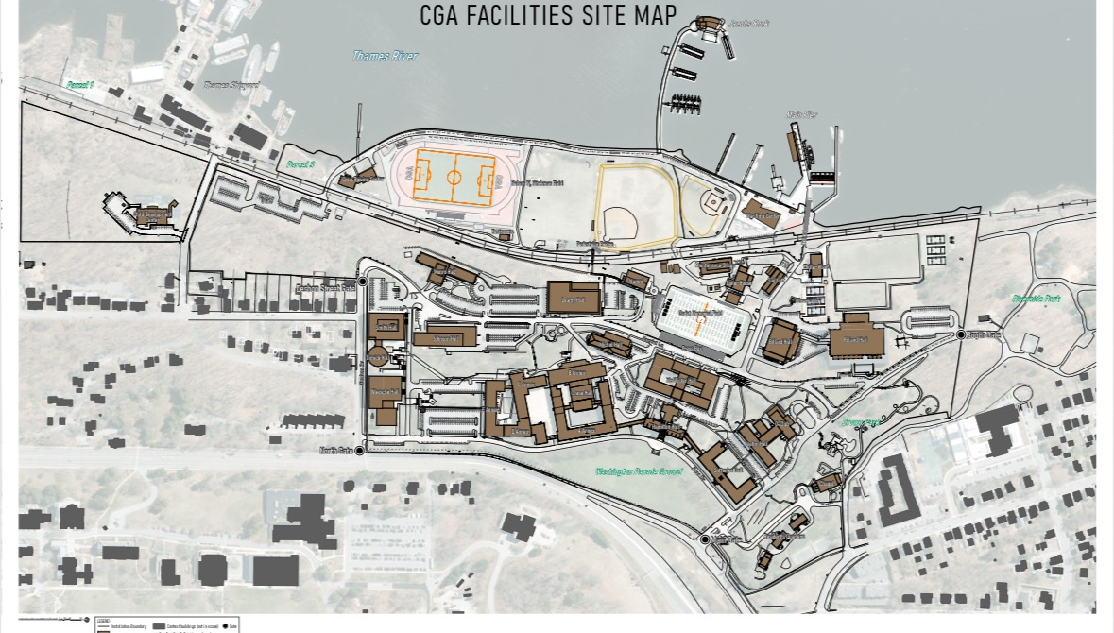
Main Gate
Deshon Gate
J-Lot (Parking Lot)
Picture 1: Location of Work at Coast Guard Academy

ATTACHMENTS PACKAGE
U.S. Coast Guard Academy Commencement Bus Services
19–20 May 2026
Attachment 1 – Satellite Parking Locations
Primary Satellite Parking Areas:
1. Crystal Mall – JCPenney Parking Area
850 Hartford Turnpike
Waterford, CT 06385
2. Connecticut College South Lot
270 Mohegan Avenue Parkway
New London, CT 06320
3. Connecticut National Guard Armory
249 Bayonet Street
New London, CT 06320
Purpose:
These locations shall serve as passenger pickup and return locations for commencement shuttle operations.
Government Notes:
• Final traffic flow instructions will be issued prior to commencement.
• Contractor shall coordinate staging with the Government COR.
• Contractor shall maintain continuous shuttle operations during peak periods.

Attachment 2 – Campus Bus Routes
Recommended Route Overview:
Inbound Route:
Satellite Parking Area → Route 32 → Mohegan Avenue Parkway → USCGA Main Gate
Outbound Route:
USCGA Main Gate → Mohegan Avenue Parkway → Designated Satellite Parking Area
Operational Notes:
• Buses shall comply with all security and traffic control instructions.
• Government security personnel may alter routes due to operational conditions.
• Drivers shall follow escort instructions if provided.
Attachment 3 – Bus Staging Areas
Primary Staging Area:
USCGA designated holding/staging area adjacent to commencement operations.
Requirements:
• Buses shall remain staged and secured during commencement ceremonies.
• Drivers shall remain reachable by dispatch radio or cell phone.
• Engines shall be shut down unless operationally required.
• Contractor dispatch personnel shall maintain accountability of all buses.
Attachment 4 – Commencement Traffic Flow Plan
Operational Traffic Flow:
Morning Operations:
• Continuous inbound shuttle transportation from satellite parking areas.
• Passenger unloading at designated Academy drop-off points.
Ceremony Operations:
• Buses staged in designated holding areas.
• Limited vehicle movement during ceremony operations.
Post-Ceremony Operations:
• Continuous outbound shuttle transportation returning guests to satellite parking areas.
Government reserves authority to modify traffic flow based on:
• Weather
• Security posture
• Traffic congestion
• Emergency response requirements
Attachment 5 – Security and Access Procedures
Security Requirements:
• All drivers shall possess valid government-issued identification.
• Contractor shall submit driver roster and vehicle information NLT five (5) business days prior to performance.
• Vehicles may be subject to inspection.
• Drivers shall comply with all installation access procedures and security instructions.
• Prohibited items are subject to Coast Guard installation security requirements.
• Failure to comply with security requirements may result in denial of installation access.
Attachment 6 – Emergency Contact Roster
Government Points of Contact:
Operational POC:
Bill Martin
Bill.G.Martin@uscg.mil
(860) 701-6809
Contracting POC:
LT Michael D. Edwards
Michael.D.Edwards@uscg.mil
(860) 444-8248
Emergency Procedures:
• Immediately contact the Government COR for accidents, injuries, or operational mishaps.
• Call 911 for life-threatening emergencies.
• Notify Coast Guard security for any installation-related security incidents.
Attachment 7 – Weather Contingency Plan
Weather Contingency Procedures:
The Government reserves the right to:
• Delay transportation operations
• Modify shuttle schedules
• Change staging areas
• Suspend operations due to severe weather
Contractor Requirements:
• Maintain communication capability throughout operations.
• Be prepared for operational adjustments.
• Coordinate all weather-related decisions with the Operational POC.
Examples of weather conditions impacting operations:
• Heavy rain
• Lightning
• Flooding
• High winds
• Severe traffic conditions
Attachment 8 – Recommended Operational Timeline
Date | Event | Approximate Time | Remarks
19 May 2026 | Driver Report Time | 0630 | Dispatch coordination begins
19 May 2026 | Shuttle Operations Begin | 0700 | Continuous operations
19 May 2026 | Operations Complete | 1630 | Final shuttle returns
20 May 2026 | Driver Report Time | 0600 | Dispatch coordination begins
20 May 2026 | Shuttle Operations Begin | 0700 | Inbound transportation
20 May 2026 | Bus Staging | 1015 | Ceremony support
20 May 2026 | Return Shuttle Operations | 1345 | Outbound transportation
20 May 2026 | Operations Complete | 1600 | Final shuttle returns

