Replace Trash Receptacles (PRPA)
National Park Service
Presidents Park (PRPA)
East Potomac Park Maintenance Yard
Washington, DC

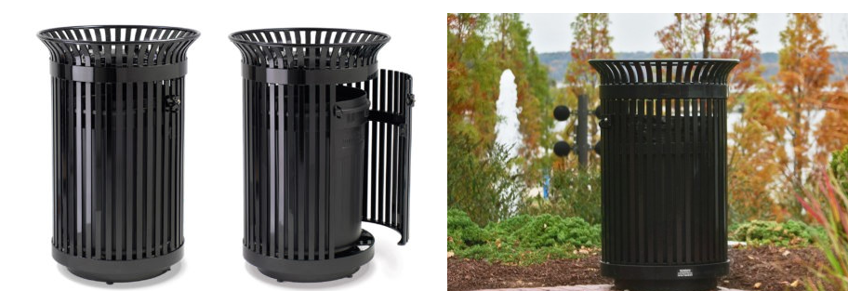

STATEMENT OF WORK
For
PRESIDENTS PARK

Victor Stanley Trash Receptacles

Background
National Park Service (NPS) Presidents Park (PRPA) located in downtown Washington, D.C. encompasses the White House, Lafayette Square, the Ellipse, the White House Visitors Center, and other adjacent buildings covering over 70 acres of historic, cultural, and recreational sites.

2.0 Purpose
The National Park Service (NPS) requires durable, vandal-resistant trash receptacles for installation throughout PRPA to support visitor services, improve waste management, and maintain consistent and aesthetically pleasing sites.

3.0 Scope NAICS 423850 – Garbage Container Receptacles (Wholesale)
This requirement is to purchase and receive twenty-five (25) Victor Stanley Ironsites Model SD-42 trash receptacles in High Gloss Black including plastic liners, to replace damaged and deteriorated units and support the increased visitation loads.

4.0 Delivery
East Potomac Park Maintenance Yard, 750 Buckeye Drive SW, Washington, D.C. 20024; the point of contact is Scott Sommers who may be reached at 202-536-6548 or (202) 426-6785.
Delivery must occur between the hours of 8:00 AM and 3:00PM Monday through Friday. Hours outside of this need to be requested in advance and approved by the government. Delivery is not allowed on Federal Holidays or weekends.

5.0 Work to be Performed
Deliver twenty-five (25) Victor Stanley Ironsites Model SD-42 trash receptacles (with plastic liners) in high Gloss Black.

6.0 Location of Work
East Potomac Park Maintenance Yard, 750 Buckeye Drive SW, Washington, D.C. 20024. Point of Contact is Scott Sommers (202)-536-6548 or (202) 426-6785.

7.0 Period of Performance
March 16, 2026 – December 31, 2026

8.0 Applicable Performance Standards

Perform all work in accordance with the most recent edition of the following standards unless otherwise instructed.
ASTM American Society for Testing and Materials
OSHA Occupational Safety and Health Administration

9.0 Any Special Requirements: N/A

