National Aeronautics and Space Administration
NASA Shared Services Center
Stennis Space Center, MS 39529-6000
5/4/2026

SUBJECT: Request for Quotation (RFQ) 80NSSC26932047Q, CIS Secure TSG Cisco 8851 Fiber VOIPs

This solicitation includes the following sections:
- Statement of Work/Bid Schedule – Section 1
- Instructions to Offerors – Section 2
- Solicitation Provisions/Representations and Certifications – Section 3
- Clauses/Terms and Conditions – Section 4
- Quote Evaluation Criteria – Section 5

SECTION 1
STATEMENT OF WORK/BID SCHEDULE

This is a Brand Name requirement.

ENTER SOW/BID SCHEDULE:

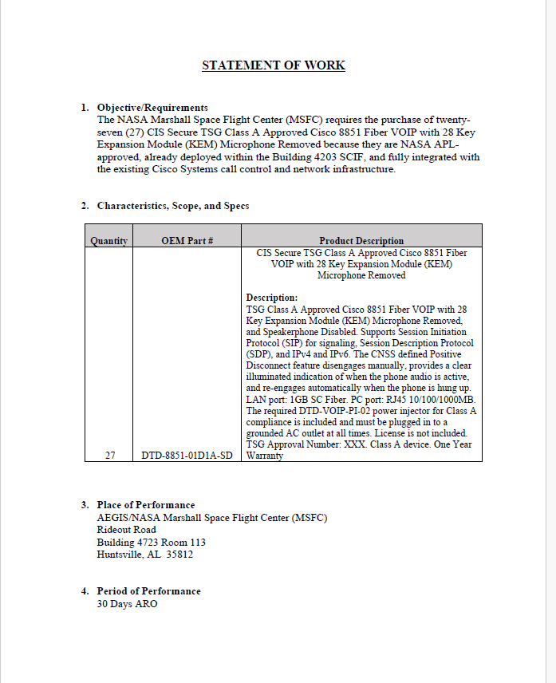

SECTION 2
INSTRUCTION TO OFFERORS

☒52.212-1 Instructions to Offerors – Commercial Products and Commerical Services. (OCT 2025)
Addendum to 52.212-1

Quotes for the item(s) described in the RFQ are due by 5/8/2026 by 3:00 p.m. CT to McKenzie Hanson at McKenzie.M.Hanson@nasa.gov in order to be considered for award. If it is in the best interest of the Government, quotes submitted after the due date may be accepted. Quotes shall remain valid for 30 days unless otherwise expressly stated on the quote. Submitted Quotes shall list two points of contacts including name, phone number, and email address.

All contractual and technical questions must be in writing (e-mail) to McKenzie Hanson at McKenzie.M.Hanson@nasa.gov no later than 5/7/2026 by 3:00 p.m. CT. Telephone questions shall not be accepted.
The NAICS Code for this procurement is 541512..

This procurement is set aside for small business.

Offeror’s shall be registered at www.sam.gov in order to be considered for award.

Delivery is FOB Destination.

SECTION 3
SOLICITATION PROVISION/REPRESENTATIONS AND CERTIFICATIONS

☒52.252-1 SOLICITATION PROVISIONS INCORPORATED BY REFERENCE (FEB 1998)

This solicitation incorporates one or more solicitation provisions by reference, with the same force and effect as if they were given in full text. Upon request, the Contracting Officer will make their full text available. The offeror is cautioned that the listed provisions may include blocks that must be completed by the offeror and submitted with its quotation or offer. In lieu of submitting the full text of those provisions, the offeror may identify the provision by paragraph identifier and provide the appropriate information with its quotation or offer. Also, the full text of a solicitation provision may be accessed electronically at this/these address(es):

FAR FAR | Acquisition.GOV
NFS NASA FAR Supplement

FEDERAL ACQUISITION REGULATION (FAR) PROVISIONS INCORPORATED BY REFERENCE:

☒52.204-7 System for Award Management (Oct 2025)
☒52.209-2 Prohibition on Contracting with Inverted Domestic Corporations – Representation (Oct 2025)
☒ 52 .222-90 Addressing DEI Discrimination by Federal Contractors (APR 2026)

FAR PROVISIONS IN FULL TEXT:

☐52.225-8 Duty-Free Entry (Oct 2010)

(a) Definition. "Customs territory of the United States" means the States, the District of Columbia, and Puerto Rico.

(b) Except as otherwise approved by the Contracting Officer, the Contractor shall not include in the contract price any amount for duties on supplies specifically identified in the Schedule to be accorded duty-free entry.

(c) Except as provided in paragraph (d) of this clause or elsewhere in this contract, the following procedures apply to supplies not identified in the Schedule to be accorded duty-free entry:

(1) The Contractor shall notify the Contracting Officer in writing of any purchase of foreign supplies (including, without limitation, raw materials, components, and intermediate assemblies) in excess of $20,000 that are to be imported into the customs territory of the United States for delivery to the Government under this contract, either as end products or for incorporation into end products. The Contractor shall furnish the notice to the Contracting Officer at least 20 calendar days before the importation. The notice shall identify the-

(i) Foreign supplies;
(ii) Estimated amount of duty; and
(iii) Country of origin.

(2) The Contracting Officer will determine whether any of these supplies should be accorded duty-free entry and will notify the Contractor within 10 calendar days after receipt of the Contractor’s notification.

(3) Except as otherwise approved by the Contracting Officer, the contract price shall be reduced by (or the allowable cost shall not include) the amount of duty that would be payable if the supplies were not entered duty-free.

(d) The Contractor is not required to provide the notification under paragraph (c) of this clause for purchases of foreign supplies if-

(1) The supplies are identical in nature to items purchased by the Contractor or any subcontractor in connection with its commercial business; and

(2) Segregation of these supplies to ensure use only on Government contracts containing duty-free entry provisions is not economical or feasible.

(e) The Contractor shall claim duty-free entry only for supplies to be delivered to the Government under this contract, either as end products or incorporated into end products, and shall pay duty on supplies, or any portion of them, other than scrap, salvage, or competitive sale authorized by the Contracting Officer, diverted to nongovernmental use.

(f) The Government will execute any required duty-free entry certificates for supplies to be accorded duty-free entry and will assist the Contractor in obtaining duty-free entry for these supplies.

(g) Shipping documents for supplies to be accorded duty-free entry shall consign the shipments to the contracting agency in care of the Contractor and shall include the-

(1) Delivery address of the Contractor (or contracting agency, if appropriate);

(2) Government prime contract number;

(3) Identification of carrier;

(4) Notation "UNITED STATES GOVERNMENT, _____ [agency] _____, Duty-free entry to be claimed pursuant to Item No(s) _____ [from Tariff Schedules] _____, Harmonized Tariff Schedules of the United States. Upon arrival of shipment at port of entry, District Director of Customs, please release shipment under 19 CFR part 142 and notify [cognizant contract administration office] for execution of Customs Forms 7501 and 7501-A and any required duty-free entry certificates.";

(5) Gross weight in pounds (if freight is based on space tonnage, state cubic feet in addition to gross shipping weight); and

(6) Estimated value in United States dollars.

(h) The Contractor shall instruct the foreign supplier to-

(1) Consign the shipment as specified in paragraph (g) of this clause;

(2) Mark all packages with the words "UNITED STATES GOVERNMENT" and the title of the contracting agency; and

(3) Include with the shipment at least two copies of the bill of lading (or other shipping document) for use by the District Director of Customs at the port of entry.

(i) The Contractor shall provide written notice to the cognizant contract administration office immediately after notification by the Contracting Officer that duty-free entry will be accorded foreign supplies or, for duty-free supplies identified in the Schedule, upon award by the Contractor to the overseas supplier. The notice shall identify the-

(1) Foreign supplies;

(2) Country of origin;

(3) Contract number; and

(4) Scheduled delivery date(s).

(j) The Contractor shall include the substance of this clause in any subcontract if-

(1) Supplies identified in the Schedule to be accorded duty-free entry will be imported into the customs territory of the United States; or

(2) Other foreign supplies in excess of $20,000 may be imported into the customs territory of the United States.

(End of clause)

NFS 1852.225-8(k): The following supplies will be given duty-free entry: [Insert the supplies that are to be accorded duty-free entry.]

(End of addition)

☐52.225-18 PLACE OF MANUFACTURE (Aug 2018)
(a) Definitions. As used in this clause—
“Manufactured end product” means any end product in product and service codes (PSCs) 1000-9999, except—
(1) FPSC 5510, Lumber and Related Basic Wood Materials;
(2) Product or Service Group (PSG) 87, Agricultural Supplies;
(3) PSG 88, Live Animals;
(4) PSG 89, Subsistence;
(5) PSC 9410, Crude Grades of Plant Materials;
(6) PSC 9430, Miscellaneous Crude Animal Products, Inedible;
(7) PSC 9440, Miscellaneous Crude Agricultural and Forestry Products;
(8) PSC 9610, Ores;
(9) PSC 9620, Minerals, Natural and Synthetic; and
(10) PSC 9630, Additive Metal Materials.
“Place of manufacture” means the place where an end product is assembled out of components, or otherwise made or processed from raw materials into the finished product that is to be provided to the Government. If a product is disassembled and reassembled, the place of reassembly is not the place of manufacture.
(b) For statistical purposes only, the offeror shall indicate whether the place of manufacture of the end products it expects to provide in response to this solicitation is predominantly—
(1)In the United States (Check this box if the total anticipated price of offered end products manufactured in the United States exceeds the total anticipated price of offered end products manufactured outside the United States); or
(2) Outside the United States.
(End of provision)

SECTION 4
CLAUSES/TERMS AND CONDITIONS

APPLICABLE COMMERCIAL ITEM CLAUSES

This order is for a commercial item subject to the terms and conditions of FAR 52.212-4, Terms and Conditions – Commercial Products and Commerical Serivces (Oct 2025), incorporated by reference attached to this order and any additional terms and conditions checked below or included as a Center specific requirements as addenda to 52.212-4.

☒52.252-2 CLAUSES INCORPORATED BY REFERENCE (FEB 1998).

This contract incorporates one or more clauses by reference, with the same force and effect as if they were given in full text. Upon request, the Contracting Officer will make their full text available. Also, the full text of a clause may be accessed electronically at this/these address(es): FAR and NFS Search (nasa.gov)

FAR CLAUSES INCOPORATED BY REFERENCE:

☒52.204-9 Personal Identity Verification of Contractor Personnel (Jan 2011)
☒52.204-13 System for Award Management Maintenance (Oct 2025)
☒52.223-23 Sustainable Products and Services (Oct 2025)
☒52.232-39 Unenforceability of Unauthorized Obligations (Jun 2013)
☒52.232-40 Providing Accelerated Payments to Small Business Subcontractors (Mar 2023)
☐52.245-1 Government Property (Sep 2021)
☐52.247-29 F.o.b. Origin (Feb 2006)
☒52.247-34 F.o.b. Destination (Nov 1991)

NASA FEDERAL ACQUISITION REGULATION (NFS) CLAUSES INCORPORATED BY
REFERENCE:

☒1852.203-71 Requirements to Inform Employees of Whistleblower rights (Sep 2025)(DEVIATION)
☒1852.237-73 Release of Sensitive Information (Dec 2025)(DEVIATION)
☐1852.245-76 List of government property furnished pursuant to FAR 52.245-2 (Dec 2025)(DEVIATION)
☐1852.242-72 Denied Access to NASA Facilities (Dec 2025)(DEVIATION)

NFS CLAUSES IN FULL TEXT:

☒1852.215-84 OMBUDSMAN (Nov 2023)

(a) An ombudsman has been appointed to hear and facilitate the resolution of concerns from offerors, potential offerors, and contractors during the preaward and postaward phases of this acquisition. When requested, the ombudsman will maintain strict confidentiality as to the source of the concern. The existence of the ombudsman is not to diminish the authority of the contracting officer, the Source Evaluation Board, or the selection official. Further, the ombudsman does not participate in the evaluation of proposals, the source selection process, or
the adjudication of formal contract disputes. Therefore, before consulting with an ombudsman, interested parties must first address their concerns, issues, disagreements, and/or recommendations to the contracting officer for resolution.

(b) If resolution cannot be made by the contracting officer, interested parties may contact the installation ombudsman, whose name, address, telephone number, facsimile number, and email address may be found at: https://www.hq.nasa.gov/office/procurement/regs/ProcurementOmbuds-Comp-Advocate-Listing.pdf. Concerns, issues, disagreements, and recommendations which cannot be resolved at the installation may be referred to the Agency ombudsman identified at the above URL. Please do not contact the ombudsman to request copies of the solicitation, verify offer due date, or clarify technical requirements. Such inquiries shall be directed to the
Contracting Officer or as specified elsewhere in this document.

(End of clause)

☒1852.216-78 FIRM FIXED PRICED (Dec 2025)(DEVIATION)

The total firm-fixed-price of this contract is $TBD.

(End of clause)

☒1852.225-70 EXPORT LICENSES (Dec 2025)(DEVIATION)
(a) The contractor shall comply with all U.S. export control laws and regulations,
including the International Traffic in Arms Regulations (ITAR), 22 CFR Parts 120 through 130,
and the Export Administration Regulations (EAR), 15 CFR Parts 730 through 799, in the
performance of this contract. In the absence of available license exemptions/exceptions, the
contractor shall be responsible for obtaining the appropriate licenses or other approvals, if
required, for exports of hardware, technical data, and software, or for the provision of technical
assistance.

(b) The contractor shall be responsible for obtaining export licenses, if required, before
utilizing foreign persons in the performance of this contract, including instances where the work
is to be performed on-site at [insert name of NASA installation], where the foreign person will
have access to export-controlled technical data or software.

(c) The contractor shall be responsible for all regulatory record keeping requirements
associated with the use of licenses and license exemptions/exceptions.

(d) The contractor shall be responsible for ensuring that the provisions of this clause
apply to its subcontractors.

(End of clause)

SECTION 5
QUOTE EVALUATION CRITERIA

Option 1.
The Government will award a contract from this solicitation to the responsible offeror whose offer conforming to the solicitation will be most advantageous to the Government and represents the best value, price and other factors considered. The following factors shall be used to evaluate offers to determine the best value to the Government:

- List Evaluation Factor
- List Evaluation Factor
- List Evaluation Factor
- List Evaluation Factor

An award will be made to the Offeror whose quotation representatives the best value to the Government when the above listed evaluation factors are considered.

Option 2.
The Government will award a contract from this solicitation to the responsible Offeror whose offer conforming to the solicitation is the lowest price technically acceptable (LPTA) offer. Offer’s not deemed technically acceptable will be removed from further consideration of the contract award. An Offeror’s quote will be deemed technically unacceptable and removed from further consideration for contract award if the Offeror’s quote does not demonstrate that all of the requirements listed in this solicitation can be met in a satisfactory manner.

