PERFORMANCE WORK STATEMENT (PWS)

On-Board Video Surveillance System (OBVSS) Services
For School Transportation Vehicles
Okinawa, Japan - DoWEA Pacific South District

Department of War Education Activity
4800 Mark Center Drive
Alexandria, VA 22350

Table of Contents

1. Introduction. 3
1.1 General Background 3
1.2 Scope of Work 3
2. Objectives 4
2.1 Objective One (1). On-board Video Surveillance System (OBVSS) on vehicles. 4
2.2 Objective Two (2). Preventive Maintenance 5
2.3 Objective Three (3). Unscheduled Corrective Maintenance/Repairs 5
2.4 Objective Four (4): Administrative Requirements 6
3. Constraints 6
3.1 Manufacturer’s Warranty 6
3.2 Installation Access 6
3.3 Contractor Personnel Standards 7
4. Performance Requirement Summary (PRS) 8
4.1 Contract Deficiencies 8
4.2 The PRS Table - Quality Standards 8
5. Quality Assurance Surveillance Plan (QASP). 9
6. Contract Data Deliverables 9
7. Acronyms and Definitions 10
8. TECHNICAL EXHIBITS 12
TECHNICAL EXHIBIT 1 - List of Existing OBVSS Locations
TECHNICAL EXHIBIT 2 - OBVSS Equipment Requirements
TECHNICAL EXHIBIT 3 - Camera Coverage Locations on Vehicles

Introduction.
The Department of War Education Activity, DoWEA, as one of only two Federally operated school systems, is responsible for planning, directing, coordinating, and managing pre-kindergarten through 12th grade educational programs on behalf of the Department of War (DoW). DoWEA is globally positioned, operating 161 accredited schools in 9 districts located in 11 foreign countries, 7 states, Guam, and Puerto Rico.
DoWEA employs about 14,000 employees who serve over 67,000 children of active-duty military and DoW civilian families. DoWEA is committed to ensuring that all school-aged children of military families are provided with a world-class education that prepares them for post-secondary education and/or career success and to be leading contributors in their communities as well as in our 21st century globalized society.
DoWEA operates as a field activity of the Office of the Secretary of War (Personnel and Readiness). It is headed by a director who oversees all agency functions from DoWEA headquarters in Alexandria, Virginia. DoWEA's schools are divided into 3 geographic areas: Europe, the Pacific, and the Americas.

General Background
In order to ensure the safe transport of DoWEA students, DoWEA requires the On-board Vehicle Surveillance System (OBVSS), a digital vehicle video camera system with audio capability designed to record on board images and sound. Data captured by the OBVSS would be transferred from the vehicle to a Student Transportation Office (STO) for review (of picture and sound) on a government computer or laptop. DoWEA requires that each student transportation vehicle be equipped with cameras with synchronized audio capability for monitoring passenger behavior on the vehicle and monitoring the loading and unloading of passengers. Periodically, buses/vehicles are retired and/or replaced at various locations in Okinawa, Japan. This causes the need to remove the OBVSS equipment from the retired vehicles and to reinstall the OBVSS equipment on replacement vehicles.

Scope of Work

The purpose of the contract is to provide vehicle On-Board Video Surveillance System (OBVSS) Services for vehicles transporting students attending DoWEA Pacific schools located within Okinawa, Japan. Safety is of the highest priority entrusted to the contractor under this contract. The contractor shall perform all services in a safe, prudent and professional manner, accepting full and sole responsibility for the prompt and proper delivery of services.

The Contractor shall provide all labor, tools, equipment, parts, wiring, conduits, and transportation/lodging required to provide maintenance, repair, and perform removal/installation services for OBVSS systems installed on DoWEA school vehicles throughout DoWEA schools located in the island of Okinawa, Japan. The Contractor is the expressed owner of the OBVSS equipment and all system parts. The Contractor is required to be authorized, in writing, by the applicable equipment manufacturer to import, repair and maintain their company’s hardware and DVR viewing software applications and accessories.

The Contractor shall perform the following:

Provide or maintain an integrated school bus video camera recording system for student transportation vehicles transporting students.

Remove existing Mobile Digital Video Recorder (DVRs) from vehicles that currently have the previously installed equipment as required.

Train designated government employees on the operation, maintenance and warranty program.

Provide digital video playback software needed for Viewing Camera Data that is Windows 11 capable of obtaining DoWEA IT approval for use.

Provide maintenance/repair services as needed.

OBVSS System: A complete OBVSS system consists of the required number of cameras, based on the vehicle's capacity (PAX), in addition to all associated equipment (e.g., DVR) and components (e.g., cabling, mounting hardware). Required number of cameras:

Buses (47-53 PAX) – require a minimum of 6 cameras each.

Microbuses (18-24 PAX) – require a minimum of 4 cameras each.

Vans (8 PAX) – require a minimum of 3 cameras each.

Objectives

Objective One (1). On-board Video Surveillance System (OBVSS) on vehicles.

Task 1 – Removal and disposal of any existing OBVSS: The Contractor shall remove existing Mobile Digital Video Recorder (DVRs) from vehicles that currently have the previously installed equipment as required OBVSS systems that are required for school buses/vehicles throughout Okinawa, as directed by the Contracting Officer’s Representative (COR). Also, cameras may need to be removed or replaced throughout the performance. The Contractor shall fulfill these minimum requirements:

At the discretion of the COR, the Contractor shall remove the OBVSS digital video cameras/mics, mounting bracket and DVR from one bus and reinstall it on a replacement bus. Cables shall be professionally installed in small conduits (cables shall not be visible). Contractor shall provide all required cables/mounting hardware required for the re-installation.

When removing systems from vehicles, the Contractor shall not cause damage to the bus or leave visibly abandoned cables, holes, or hardware.

Contractor shall complete Removal/Reinstallation requests by the COR within ten working days.

Task 2 – Installation: The Contractor shall install OBVSS systems that are required for school vehicles throughout Okinawa, Japan as indicated in Exhibit 1 - List of Existing OBVSS Equipment and Locations, and directed by the COR.

The Contractor shall coordinate Installation scheduling with the COR no later than 1 August of each calendar year.

OBVSS Equipment Requirements are detailed in Exhibit 2 - OBVSS Equipment Requirements. Contractors are encouraged to propose innovative solutions to achieve or exceed these objectives. This may include advanced data management systems, enhanced hardware configurations, or other technologies ensuring optimal performance.

All equipment shall be installed in a manner where it cannot be accessed by passengers during normal operations.

Wiring should be uniformly color-coded and tagged.

Diagram: the Contractor shall provide to the COR a wiring and cabling diagram upon completion of installation.

Warranty: The Contractor shall provide a warranty for the life of the contract on all components and software. The contractor shall provide a process to maintain operability of the system with minimum on‐site repair visits.

Liability: The contractor is responsible for all damages caused by their installation, equipment or systems to the vehicles outside of normal wear and tear.

Task 3 – Training: The Contractor shall provide training to designated Government members on the use of the newly installed OBVSS equipment following installation and any updates that alter operation procedures and interface. The Contractor shall provide the COR with a System Training Memorandum summarizing the training material within 5 business days of completion of training or before services begin, whichever date occurs first.

Objective Two (2). Preventive Maintenance

Task 1 – Bi-annual maintenance: The Contractor shall visit each site twice a year, in accordance with the Preventative Maintenance Schedule, and perform cleaning and inspection of the of On-board Video Surveillance System Equipment (OBVSS) on each bus. Inspections will consist of checking the system wiring, camera focus, camera picture quality, camera position, functionality of built-in microphones, the recording quality/capability of the DVR, and making necessary adjustments to make the system fully operational. When repairs or maintenance are required, the Contractor shall respond and repair within five (5) business days. The Contractor shall begin the preventative maintenance inspections within 30 days of the beginning of the contract performance period. These inspections shall be scheduled every six months of each calendar year.

Task 2 – Preventive Maintenance Report: the Contractor shall provide a Maintenance Report to the COR within five (5) working days after each preventative maintenance visit via electronic mail. The report, at a minimum, shall include the following:
        - Vehicle Identification Number
        - Date/Time Inspection Started/Work Completed (start time to finish)
        - Description of maintenance performed
        - Any identified issues and resolutions.
        - Incomplete repairs that require additional replacement of OBVSS parts, and estimated completion date.

Task 3 – Monthly System Performance monitoring: the Contractor shall provide the COR a systems diagnostic report, showing any changes in:
- System Uptime Statistics
- Data Transfer Success rates

Objective Three (3). Unscheduled Corrective Maintenance/Repairs

Task 1 – The Contractor shall respond to an Unscheduled Corrective Maintenance/Repair request by the COR within five (5) business days.

The Contractor shall notify the COR when the repair is completed. The COR shall accept the repair prior to the technician leaving the site.

Task 2 – Corrective Maintenance Report - The Contractor shall provide a Maintenance Report to the COR within five (5) working days after each corrective maintenance/repair visit via electronic mail. The report, at a minimum, shall include the following:
        - Vehicle Identification Number
        - Date/Time Inspection Started/Work Completed (start time to finish)
        - Description of maintenance performed
        - Incomplete repairs that require additional replacement of OBVSS parts, and estimated completion date

Task 3 – Replacement Parts and Materials: All components, software, parts and materials are covered under the warranty of this contract. However, in the event of unexpected physical damages, the Contractor may request COR approval to purchase all repair parts and/or materials and be reimbursed under the contracts’ subline item titled “Materials”, as necessary to maintain and sustain the OBVSS.

Objective Four (4): Administrative Requirements

Task 1 - Contract Manager: The Contractor shall appoint an employee located in Okinawa as their Contract Manager (CM) which shall be the representative responsible for managing this contract and supervising performance. The contractor shall notify the Contracting Officer Representative (COR) in writing of the appointment within 5 business days of contract award or prior to any replacement personnel assuming these duties.

The Contract Manager shall be located within 50 miles of the installation and must be able to attend face-to-face meetings as required.

The Contract Manager shall have full authority to act and make immediate decisions for the contractor on all matters relating to the daily operations of this contract.

The Contract Manager shall speak, read, and write the English language when communicating with the COR, Contract Specialist, and Contracting Officer.

The COR must be able to contact the Contract Manager any time issues arise regarding the OBVSS. The contract manager must be able to respond to any emergency requirements within 24 hours. Upon initial call, the Contract Manager must give the COR the maintenance plan and technician’s name eight (8) hours prior to arrival at the location.

Task 2 – Lead Technician: The contractor shall designate a technician to be the overall point of contact with the government COR for work performed under this contract. The technician shall be fluent in English to be able to read, write, and speak in order to communicate with the COR. Any maintenance/repairs must be accepted by the COR. The contractor shall notify the Contracting Officer Representative (COR) in writing of the appointment within 5 business days of contract award or prior to any replacement personnel assuming these duties.

Task 3 – Site Contractor lists: The Contractor shall provide a list of all contractor personnel that will be performing on each school or job prior to start of work.

Constraints

Manufacturer’s Warranty

The Contractor is the expressed owner of the OBVSS equipment and all system parts. The Contractor is required to be authorized, in writing, by the applicable equipment manufacturer to import, repair and maintain their company’s hardware and DVR viewing software applications and accessories. The Contractor shall provide a copies of the warranty and this authorization within 5 business days of equipment installation.

Installation Access

The contractor shall coordinate all installation/building access requirements with DoWEA security personnel to facilitate the proper entry of its staff into DoWEA facilities. This coordination is essential to ensure compliance with established security protocols and to maintain the safety of all personnel.

All locations are controlled access areas and require prior coordination before access will be granted to contractor personnel. A list of all contractor personnel and numbers of personnel that will be needed on each job shall be submitted to the Government COR prior to start of work. All personnel will be required to be escorted on base at all times.

The contractor shall provide advance notice for any personnel requiring building access, including relevant identification and security clearance documentation.

All contractor personnel must adhere to applicable security measures, including those related to badge issuance, visitor logs, and any other entry protocols mandated by DoWEA.

All Contractor personnel shall be required to conform to the applicable base regulations, to include:

Designated routes

Parking Regulations

Vehicle speed limits

Automotive liability insurance

Valid license plate

Valid Driver’s license

All contractor personnel and transportation modes to and from the Installation are subject to physical search.

Contractor Personnel Standards

Code of Conduct

The Contractor agrees that inappropriate conduct shall not be tolerated and may be grounds for suspension of base privileges of a Contractor employee, which will prohibit the ability to perform under this contract.

Contractor personnel shall not use verbal assault, foul language, personal or racial insults, threats of personal violence, or comment on the personal appearance of students in any language.

Contractor personnel shall be properly attired and present a neat and clean appearance.

Contractor personnel shall not engage in any conduct of a sexual nature, verbal or physical; including, but not limited to, the reading or display of nudity or pornographic material.

Contractor personnel shall not engage in physical contact with students, except as required for reasons of safety, first aid or CPR; show verbal or physical affection toward students; or take photographs of students.

Contractor personnel shall not use tobacco products, eat, or drink, or report for work under the influence of or impaired by alcohol, drugs, or medications which may affect the ability to perform safely under this contract.

Contractor personnel shall not sell, give to, or accept from students any beverage, food or tobacco product, or any gift or item, irrespective of monetary value.

Criminal Offenses

The Contractor shall not hire anyone with a criminal record to perform under this contract. The Contractor shall immediately inform the COR when it is learned that an employee has been arrested for a criminal offense. A past criminal offense of any nature shall be grounds for removal, as determined by the Contracting Officer. The Contractor shall also immediately inform the COR when any action is taken to suspend or revoke the driver’s license of any driver performing under this contract.

The Contractor shall not assign any person to perform duty under this contract whose background or criminal record includes both an arrest and a conviction of any of the offenses including but not limited to the following:
- Assault and battery, domestic violence / abuse, homicide, or manslaughter.
- Child abuse, child neglect, child sexual molestation, pedophilia, child pornography or any crime involving a child.
- Public indecency, sexual assault, rape, or any crime of a sexual nature.
- Use, possession, or distribution of any illegal drugs or controlled substance.
- Reckless driving or driving while under the influence of alcohol or drugs.
- That the individual has been held to be negligent in a civil adjudication or administrative proceeding concerning the death or severe injury to a child or dependent person entrusted to the individual's care.

The Contractor shall immediately inform the COR when an employee performing services under this contract is arrested for a criminal offense. The employee shall be immediately removed from performing under the resulting contract. Furthermore, the Contractor shall also immediately inform the COR when the driver’s license of any driver performing under this contract is suspended or revoked.

English Fluency

Contract Managers and Lead Technicians shall be fluent in the English (minimum of B1 Level) and Host Nation Language. They must be able to communicate at a minimum at the B1 Level, both in verbal and written communication, in the English language to converse with the COR and the STO.

Health & Appearance

All employees shall be free of communicable diseases and physical or mental impairment that would affect the ability of the individual to perform the duties of the position to include the use of alcohol or drugs while performing the duties set forth in this PWS.

Contractor personnel shall be properly attired and present a neat and clean appearance. Transportation drivers shall wear a nametag or display any identification badge(s) in a visible location in the driver’s compartment of the vehicle.

Shall not wear clothing with insignia reflecting religious, political or social messages or slogans; but shall dress in a neat, professional manner.

Shall not wear shoes with open toes and/or shoes with heels higher than 4 centimeters while performing under this contract

Performance Requirement Summary (PRS)

Contract Deficiencies

All requirements and objectives identified above must be fulfilled 100% of the time to meet the needs of a safe and efficient student transportation program.

In the event of non-performance or failure to meet an objective, the KO will issue a Contract Discrepancy Report (CDR) with instructions on further steps necessary for corrective action.

The PRS Table - Quality Standards

The table below provides a crosswalk summary of the objectives with the performance standards, Acceptable Quality Levels (AQL), and planned method of surveillance by the Government.

Quality Standard | PWS  Requirement | Acceptable Quality Level (AQL) | Method of Surveillance
Timely Installation / Removal of equipment | Objective 1 PWS 2.1 | 100% Compliance | Planned Sampling/ Validated Customer Complaint
System Training | PWS 2.1.5 | 100% Compliance | Planned Sampling/ Validated Customer Complaint
Preventive Maintenance | Objective 2 PWS 2.2 | 100% Compliance | Planned Sampling/ meeting suspense date
System Performance surveillance | PWS 2.2.3 | 100% Compliance | Planned Sampling/ Validated Customer Complaint
Unscheduled corrective maintenance / repair | Objective 3 PWS 2.3 | 100% Compliance | Planned Sampling/Validated Customer Complaint
Replacement Parts and Materials | PWS 2.3.3 | 100% Compliance | Planned Sampling/ Validated Customer Complaint
Contractor Personnel Standards | PWS 3.3 | 100% Compliance | Planned Sampling/ Validated Customer Complaint

Quality Assurance Surveillance Plan (QASP).

The Government will utilize a QASP to monitor the Contractor’s performance on the contract. The QASP is a living document and can change at any time during the life of the contract. As such, the Government reserves the right to unilaterally edit the QASP at the Government’s discretion.

Contract Data Deliverables

The Contractor shall provide all deliverables in accordance with the requirements set forth in this PWS. Each deliverable shall include clear, concise, and complete documentation, meeting the quality standards agreed upon in this contract and outlined in the table below:

Deliverable | PWS Section | Frequency | Format/Standard | Number of Copies | Delivery POC
Installation Diagram | 2.1.2.5 | Within 5 business days of Equipment installation | Contractor format | 1 | COR
System Training Memorandum | 2.1.5 | Within 5 business days of completion of training or before services begin, whichever date occurs first | Contractor format | 1 | COR
Preventive Maintenance Schedule | 2.2.2 | NLT 30 days after contract award | Contractor format | 1 | COR
System Performance Report | 2.2.3 | At the end of each month | Contractor format | 1 | COR
Maintenance Reports | 2.3.2 | Within 5 business days after each maintenance or repair visit. | Contractor format | 1 | COR
Appointment/ designation of Contract Manager and Lead Technician | 2.4.1, 2.4.2 | Within 5 business days of contract award or prior to any replacement personnel assuming these duties | PDF or WORD | 1 | COR and CS
Personnel List for school/site job (to process base access) | 2.4.3,  3.2.2 | As soon as service/repair call is scheduled | PDF, WORD, or COR-approved format | 1 | COR
Manufacturer’s Authorization to import, repair, or maintain OBVSS equipment | 3.1.1 | Within 5 business days of Equipment installation | Contractor format | 1 | COR

Acronyms and Definitions

The following is an alphabetical list of definitions of key words used or acronyms:

Alternate Contracting Officer Representative (ACOR) - An individual designated and authorized in writing by the Contracting Officer to perform specific technical or administrative functions.

Child Safety Restraint System (CSRS) - A restraining device, conforming to Host Nation laws, used to supplement a seat belt to secure a child during transportation. The age or size of a child requiring such a device is normally defined by Host Nation law but generally applies to children less than twelve years of age, or who are smaller than 150 centimeters (60 inches) in height.

Contract Discrepancy Report (CDR) - A formal, written documentation used to document unsatisfactory Contractor performance. The CDR requires the Contractor to explain, in writing, why performance is unsatisfactory; how performance shall be returned to satisfactory levels, and how recurrence of the problem shall be prevented in the future. The Contracting Officer (KO) shall make the final determination.

Contract Specialist (CS) – A Government employee working with the CO to perform a broad range of administrative duties, including preparation and processing of contractual documents, tracking funding, liaison between Contractor and Government personnel, and provision of accurate and appropriate information to the CO and other contractual parties.
Contracting Officer (KO) – A Government official assigned to the Contracting Office authorized by written warrant to enter into, administer, terminate, and issue delivery orders under contracts. The KO is the only Government official authorized to obligate funding. The KO provides written appointment for Performance Assessment personnel and has the final responsibility for Performance Assessment. The KO is the final decision authority for any performance-based deductions or other adjustments levied on the Contractor for failure to perform.

Contracting Officer’s Representatives (CORs) – Government employee(s) designated and authorized in writing by the Contracting Officer to perform specific technical or administrative functions such as monitoring, inspecting, and technically administering a contract, but without authority to change the contract. This contract will have two (2) or more Contracting Officer’s Representatives.

Contractor - A commercial activity that provides school transportation services IAW this Performance Work Statement (PWS).

Contract Manager (CM) – the contractor’s designated contract lead is responsible for the performance of all contracted services, and the primary point of contract (POC) designated to the government COR.

Danger Zone - The area around a student transportation vehicle at a stop where most student injuries occur. It is an area 1.83 meters (6 feet) to both sides of the vehicle and 3.05 meters (10 feet) in front of the vehicle. Particular care is required when a bus stop has less than 1.83 meters (6 feet) clearance between the road’s edge and the designated waiting area. The most critical areas are immediately to the front of the student transportation vehicle and at the right rear.

Department of War Education Activity (DoWEA) - An agency of the U.S. Department of War responsible for the operation of schools for eligible children of Government authorized personnel.

District Transportation Supervisor (DTS) – An employee within DoWEA who possesses supervisory authority over a given area of responsibility for student transportation operations.

Extended School Year (ESY) – A limited number of students who attend school after the regular school year has ended. ESY is typically in session for about 14-30 total days and is as needed. The ESY program is implemented as needed and determined towards the end of each school year.

Improvised Explosive Devices (IED) - Those devices placed or fabricated in an improvised manner incorporating destructive, lethal, noxious, pyrotechnic, or incendiary chemicals, designed to destroy, disfigure, distract, or harass.

Incidents - Any events that occur on/around the school loading/unloading zone or during school transportation services that have an adverse effect on either the performance of this contract or passengers.

Installation Access Control Office (IACO) – The security office on the military Installation where Contractor base passes are requested, processed, and issued.

Onboard Video Surveillance System (OBVSS) – System of cameras, microphones, data storage, and support equipment used to monitor and record activity on and around the bus.

Quality Assurance Surveillance Plan (QASP) - A plan used by the Government to inspect and evaluate Contractor- provided services.

School Year (SY) – A typical school year has about 180 instructional days in which students must attend school. Each school year has planned breaks in which students are not in school and include Thanksgiving (approximately 2 days), winter (approximately 10 days) and spring (approximately 5 days). The months that students are required to attend school are August through June. Some students may attend school after June, which is considered the Extended School Year (ESY).

Specialized Safety and Security Equipment – Transportation equipment including special or adapted devices, vehicles, lifts, and ramps used to facilitate the transportation of children with disabilities.

Sponsoring Official/Organization - A designated DoWEA-Europe individual and/or organization at the Student Transportation Office, District Transportation Supervisor, or District-level that performs Installation Pass responsibilities or has oversight based on the relationship to the Installation Pass applicant.

Student Transportation Office (STO) – Team located at each complex that provide transportation support and guidance. This includes student busing and DoWEA transportation requirements. The team provides a local Point of Contact for transportation requests and customer support.

Unsatisfactory/Incomplete Service - A service output that does not meet the standards of performance detailed in this contract.

TECHNICAL EXHIBITS

TECHNICAL EXHIBIT 1 - List of Existing OBVSS Locations

Camp Foster - STO: 68 Buses (45 – 54 passenger)
Camp Foster - STO: 13 Microbuses (18 – 24 passenger)
Camp Foster - STO: 2 Vans (8 passenger)
Total: 83 OBVSS systems required

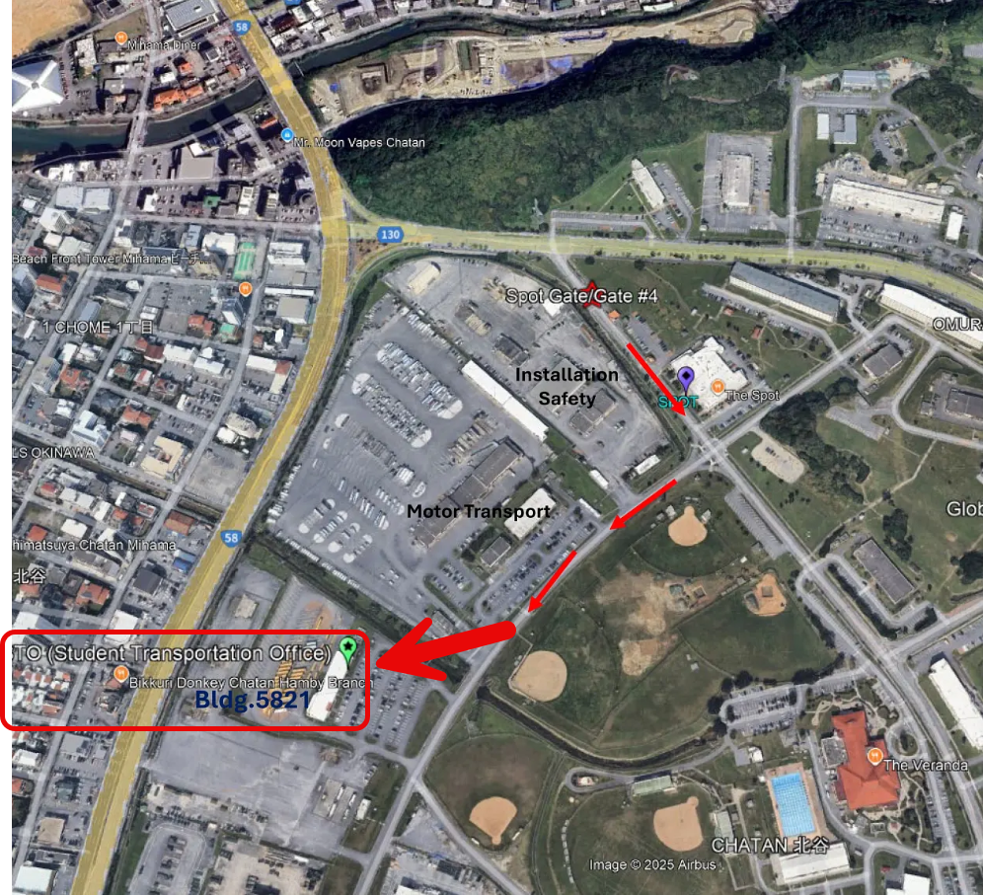

For shipping, use the following:

Mark for:
DoWEA Pacific South District Student Transportation Office
Camp Foster, Building 5821, Okinawa, Japan
Mailing Address:
DOW Dependent Schools
District Superintendent's Office - Okinawa
ATTN: Student Transportation Office
Unit 5166, APO AP 96368-5166

TECHNICAL EXHIBIT 2 - OBVSS Equipment Requirements

Mobile Digital Video Recorder (DVR):

The Contractor’s proposed solution shall meet the following minimum requirements:

  - Digital video cameras have 100% display and audio recording capabilities of all passengers and driver inside the vehicles.
  - 100% Solid State Digital memory SD card or other removable Hard Disk with 200GB (or greater) capacity with a minimum of 15 days of data, with optional on-line access.
  - Three (3) axis accelerometer and G‐sensor for charting playback.
  - Codec must be high compression for small video feedback.
  - Endless loop recording mode.
  - USB port for external video file storage when needed.
  - Equipment and disk media shall be securely housed to prevent theft or tampering.
  - Windows 11 compatible Computer Software Needed for Viewing Camera Data.

System Requirements:

The Contractor’s proposed solution shall meet the following requirements:
  - System shall not be equipped with a monitor for the Bus Driver to use while operating the vehicle.
  - Camera System must be able to begin recording when the ignition switch has been turned on.
  - The Camera System Hardware and Software should be resistant enough to withstand temperatures up to 110 degrees Fahrenheit and as low as -10 degrees Fahrenheit inside the vehicle.
  - The Camera System Hardware and Software Recording Quality must remain the same in environments when the bus will be driving through rural unpaved and harsh roads.
  - The Camera System will need to be installed on buses, microbuses, and vans.
  - Camera System shall be unaffected by having power removed suddenly, with no negative effect on the recording system, system hardware, operating system, stored data/video/Audio, or on the system’s ability to function normally once the power is fully restored.
  - All Data Recorded shall be time and date stamped in Video Playback.

DoWEA System Eligibility / Approval:

  - Software must be approved prior to operating on the DoWEA computer network.
  - Must be compatible with IT requirements.

Digital Video Playback System (DPS):

The Contractor’s proposed solution shall meet the following minimum requirements:
- 100% viewing coverage within the vehicles simultaneously while recording.
- Event indexing
- Easy to use on‐screen menu.
- Minimum 1080p Video Resolution or higher
- DVR Viewer compatible with Windows 11 (or compatible) Software for PC or Laptop
- Zoom capability.
- Side by Side video capability (video collaging capability).
- Video Playback Requirements:
    - Ability to download images with a fast retrieval to a PC.
    - Multi-tasking ability while downloading.
    - Tamper proof recording format - recorded data shall be deemed acceptable as evidence in legal proceedings.
    - Hardware design should easily allow all data (video clips and still images to be transferred to standard CD‐ROM, USB/Flash Memory Stick or DVD formats.

Camera Features and Specifications:

The Contractor’s proposed solution shall meet the following minimum requirements:
  - Able to operate using the vehicle’s electrical system.
  - Color Surveillance video.
  - 1080p cameras or better, with lens options such as: wide-angle, fisheye, 360, standard, etc.
  - Cameras to cover all areas inside the bus cabin (with zero (0) blind spots).
  - Overlapping camera coverage.
  - The Government requires cameras on vehicles with multiple channel capabilities to capture maximum visibility and complete coverage of the interior cabin. If the offeror determines that a quantity or quality other that those stipulated on the solicitation is needed to meet the requirements, then the Contractor is to provide rationale.
  - Capabilities to add additional cameras as necessary to capture all areas inside the bus cabin.
  - System must be able to record a minimum of ten (10) frames per second, per channel, minimum resolution of 1080p.
  - All cameras must be able to perform to facial recognition levels.
  - Cameras must be able to auto focus, especially in high sunlight or night recording. The quality must remain the same and not be compromised regardless of the lighting conditions.
  - Camera microphones must be able to record clear, comprehensible, and uninterrupted audio while not being affected by weather or vibration.
  - Cameras shall have Infrared or Night Recording capabilities that display clear imaging in the dark or with low light available.
  - All equipment (cameras/hard drives/cables) shall be under warranty for the life of the contract.
  - Tamper proof encased cameras.
  - Minimum 15 days of data storage capacity.
  - Optional Features:
    - Flush-mounted cameras
    - Online storage
    - If online storage is provided, admin rights for online account creation and deletion shall be provided.

TECHNICAL EXHIBIT 3 - Camera Coverage Locations on Buses

Camera locations may change depending on applicable bus design. The Contractor shall provide cameras configured to fulfill these minimum requirements:
  - Interior, front. Facing rear, covering all passenger compartment.
  - Interior, front (wide angle). Facing front door, capturing driver and entrance/egress path and immediately outside front door.
  - Interior, side. Facing toward middle right seats.
  - Interior, side. Facing toward middle left seats.
  - Interior, rear. Facing forward, capturing all passenger compartment.
  - Interior, front. Facing out front windshield, capturing bus forward path.
  - Exterior, rear. Facing out rear window, capturing back rows.

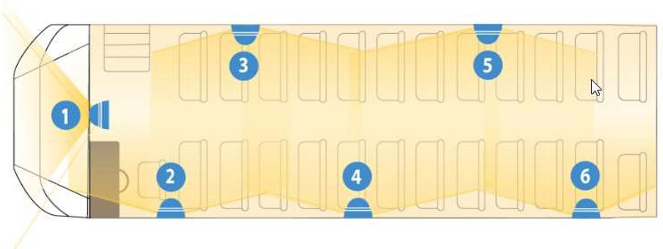
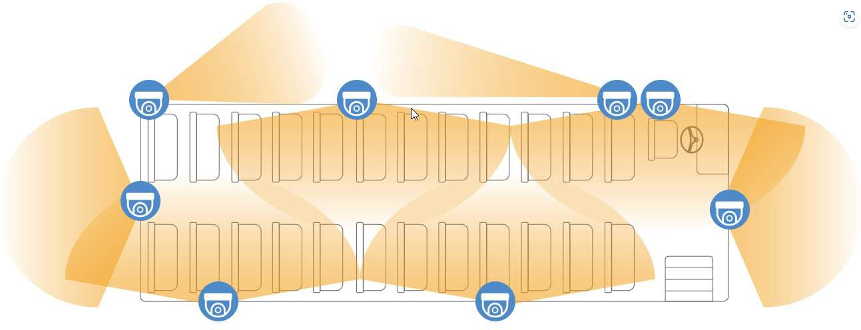
Conceptual Location of Cameras:

