
SECTOR NEW YORK ENGINEERING


SCOPE OF WORK

FOR

SECTOR NEW YORK – RENEW GALLEY STAFF LOCKER ROOMS
PROJECT #: SECNYHAB01

AT

U.S. COAST GUARD
SECTOR NEW YORK
216 COAST GUARD DRIVE
STATEN ISLAND, NY 10305
TABLE OF CONTENTS

DIVISION 1 – GENERAL REQUIREMENTS

01 10 00 SUMMARY OF WORK

SECTION 01 11 00

SUMMARY OF WORK

PART 1 GENERAL

1.1 WORK COVERED BY CONTRACT DOCUMENTS

1.1.1 Project Description & Identification

The work for this project is defined by the contract documents and consists of the following:

- In general, this project consists of repairs and renovations to the male and female staff locker rooms to address interior and exterior deficiencies, improve functionality, and restore aesthetic quality. The work will include, but is not limited to floor tile replacement, vanity and sink fixture replacements, toilet and urinal replacements, bathroom stall replacements, wall painting and patching, and locker replacement.

This project shall be referred to as Project #: SECNYHAB01 – Renew Galley Staff Locker Rooms.

1.1.2 Location

The work is located at:
Coast Guard Sector New York
216 Coast Guard Drive
Staten Island, NY 10305

1.3 requests for information

Prior to submission of bid, project questions shall be submitted in writing as a Request for Information (RFI) to the Contracting Officer (KO). After contract award and during construction, if site conditions differ significantly from these plans and specs, contractor shall submit an RFI to the KO in writing detailing the issue and recommend a solution for government review/approval.

1.4 Site visit

Contractors are highly encouraged to make a site visit to determine existing conditions and verify project elements prior to bidding. The site visit will be held on May 11th at 9:30 am.

1.5 PERIOD OF PERFORMANCE

All work shall be completed within thirty (30) days of the contract award date. Work shall be performed between Monday-Friday 0700-1530. Any work that needs to be done outside these times shall be brought to the attention of the Contracting Officer’s Representative (COR) 48 hours in advance for approval. All work dates must be confirmed 24-48 hours in advance with the COR. All contractor employees must carry a REAL ID on them at all times while working on Sector New York property.

1.6 POINTS OF CONTACT

Contracting Officer’s Representative
Sector New York Engineering
311 Battery Rd.
Staten Island, NY 10305
LTjg Claire Sullivan
Email: Claire.V.Sullivan@uscg.mil

summary of work

The contractor shall provide all labor, necessary permits, materials, equipment, and supervision necessary to complete the following scope of work:

TOILET AND URINAL REPLACEMENT

Remove and dispose of existing toilets and urinals. The male locker room has 2 toilets and 2 urinals. The female locker room has 3 toilets. The contractor shall confirm all measurements prior to ordering any material.

Install new commercial toilets and urinals according to the manufacturer’s instructions.
  - Ensure there are no leaks. Apply silicone caulk around the base of the toilets and the perimeter of the urinals where they meet the wall.
  - All plumbing work must be done by a licensed plumber. Ensure all work meets current plumbing codes and standards.

The contractor shall submit the tile, shower floor, and all fixture specifications for review prior to ordering any materials.

- BATHROROM STALLS REPLACEMENT

Remove and dispose of existing stalls/partitions in both locker rooms. The male locker room has two stalls and one urinal divider, and the female locker room has three stalls. The contractor shall confirm all measurements prior to ordering any material.
  - Install new high-density polyethylene (HDPE) bathroom stalls.
  - Ensure all work meets current codes and standards.
  - The contractor shall submit the bathroom stall specifications for review and approval prior to ordering any material.

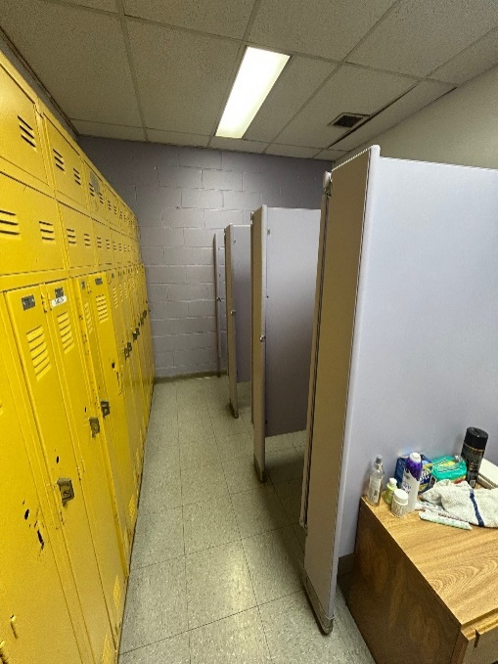

Figure 1.7.1.1 Female Locker Room Stalls.

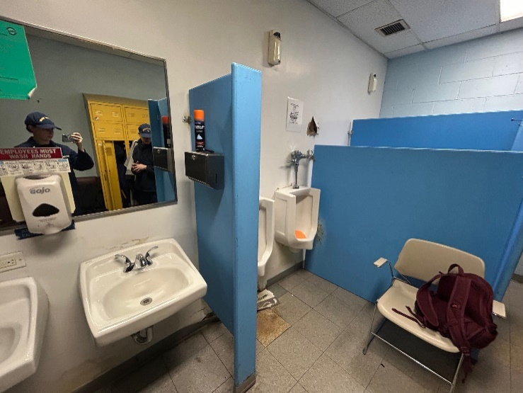

Figure 1.7.1.2. Male Locker Room Stalls.

BATHROOM SINKS AND COUNTER REPLACEMENT

Remove and dispose of existing sinks and vanities in both the male and female locker rooms. The male locker room has 2 single sinks and the female locker room has 3 single sinks.

Install new industrial solid surface counters in both locker rooms. Each counter shall have 2 sinks. The new counter in the female locker room shall be installed where the two single sinks closest to the bathroom stalls are, leaving extra room where the third sink was. The contractor shall confirm all measurements prior to ordering any material.

The contractor shall submit all vanity and fixture specifications for review prior to ordering any material.
  - All plumbing work must be done by a licensed plumber. Ensure proper plumbing connections for sinks.
  - Ensure all work meets current plumbing codes and standards.

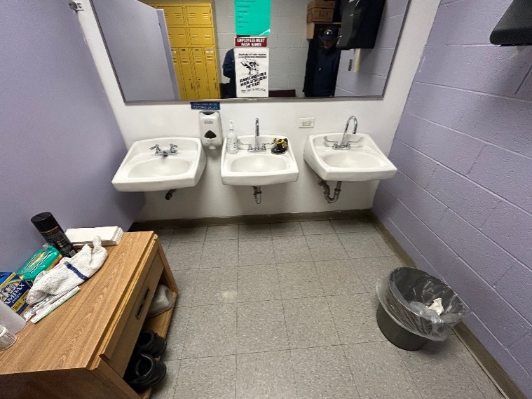

Figure 1.7.2.1. Female Locker Room Sinks.

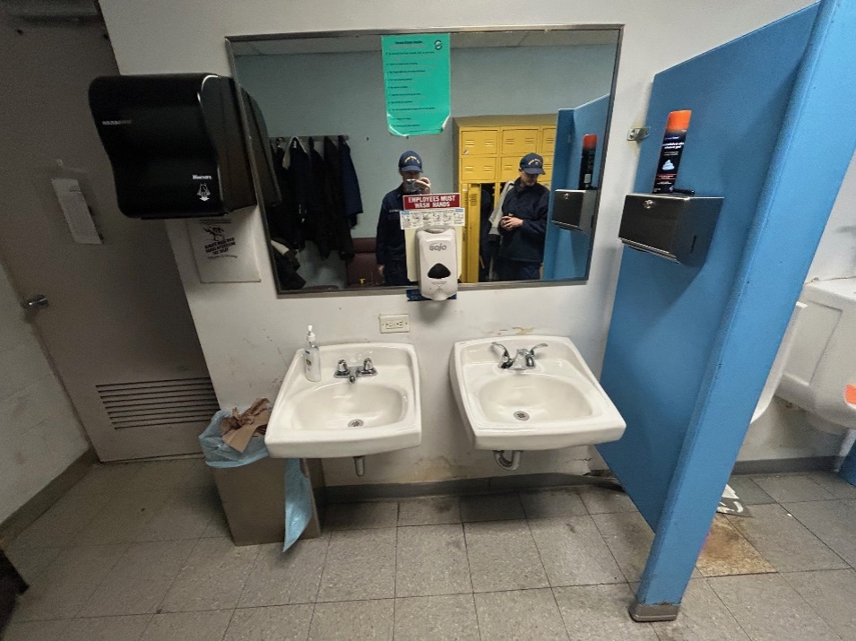

Figure 1.7.2.2. Male Locker Room Sinks.

wall PAINTING AND PATCHING

Patch small sections of damaged drywall.
  - Paint all walls, trims, and doors in both locker rooms. Paint colors will be determined by the COR.
  - Ensure areas are clean and sanded prior to applying primer and paint. Apply a minimum of two coats of paint.
  - Ensure all surfaces and furniture are protected.

The contractor shall submit the paint specifications for review and approval prior to ordering any material.

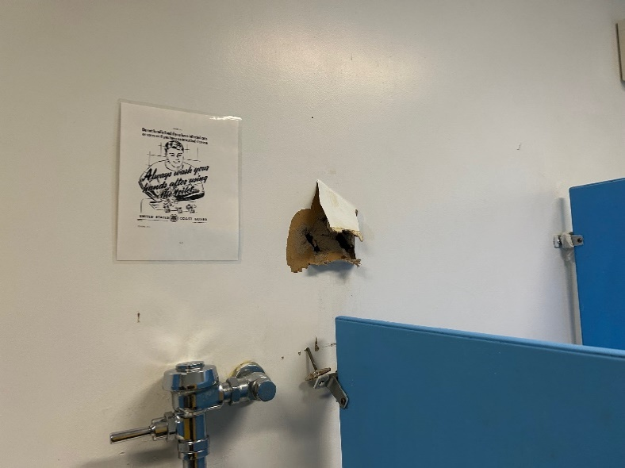

Figure 1.7.3.1. Wall Patching.

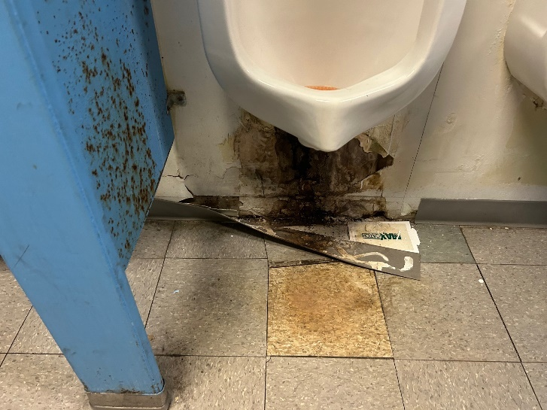

Figure 1.7.3.2. Additional Wall Patching.

locker replacement

Remove and dispose of existing lockers in both locker rooms. There are 8 full lockers (approximately 72”H x 15”W x 24”D)in the male locker room and 8 full lockers (approximately 72”H x 15”W x 24”D) in the female locker room. The contractor shall install 10 new lockers in each locker room. The new lockers shall be approximately 72”H x 15”W x 24”D. The contractor shall confirm all measurements prior to ordering any materials.

Prepare ensure the lockers are level, stable, and permanently affixed to the ground and wall.
  - Ensure all work meets current codes and standards.

The contractor shall submit the locker specifications for review prior to ordering any materials.

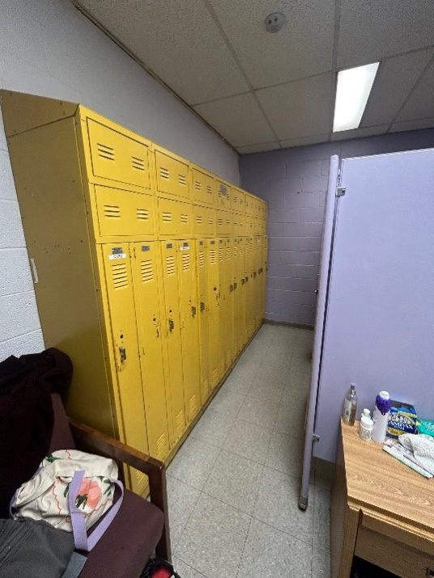

Figure 1.7.4.1. Female Lockers.

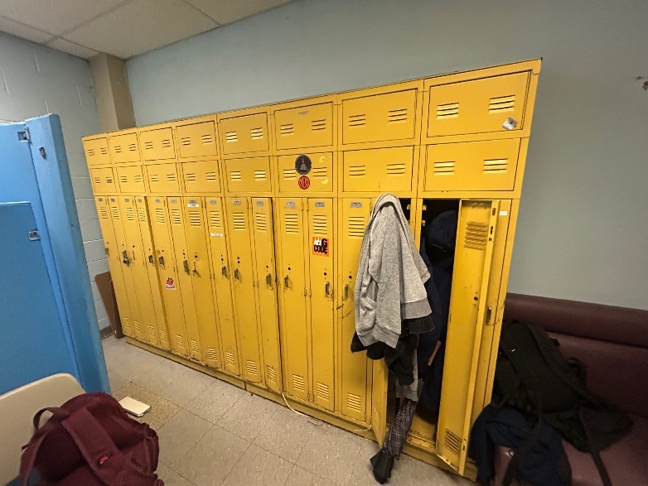

Figure 1.7.4.2. Male Lockers.

- BENCH INSTALLATION
  - Install benches in each locker room. The bench in the male locker room shall be approximately 17”H x 72”W x 10”D. The bench in the female locker room shall be approximately 17”H x 54”W x 10”D. Bench surfaces shall be hardwood laminate, and the legs shall be stainless steel. The contractor shall confirm all measurements and that benches will fit prior to ordering materials.
  - The benches shall be securely anchored to the floor.

The contractor shall submit the bench specifications for review prior to ordering any materials.

- FLOOR TILE AND BASEBOARD REPLACEMENT
  - Remove and dispose of existing floor tiles in both locker rooms. There are approximately 170 sq.ft. of floor tiles in each locker room. The contractor shall replace tiles with similar size and color linoleum tiles. The new tiles shall be industrial linoleum with a thickness of 2.5 mm or greater. The contractor shall confirm all measurements prior to ordering any material.
  - Prepare floor surfaces for new tile installation, ensuring surfaces are clean, level and waterproofed.
  - Remove and dispose of all existing baseboards in both locker rooms. There are approximately 50 ft of baseboards in each locker room. Install new 4” rubber baseboard with a cove base, similar in color to the existing baseboards.
  - Ensure all work meets current codes and standards.
  - The contractor shall submit the tile specifications to the COR for review and approval prior to ordering any material.

CONTRACTOR RESPONSIBILITIES

- The Contractor shall:
  - Verify all dimensions and conditions on-site prior to commencing work.
  - Coordinate with the COR to minimize disruptions to building operations.
  - Protect existing finishes, fixtures, and furnishings during the course of work.
  - Remove all debris and construction waste from the site daily and dispose of in accordance with local and federal regulations.
  - Provide submittals for all materials and finishes for COR approval prior to installation.
  - The Contractor shall comply with all applicable safety regulations and building codes.

-- End of Section --

