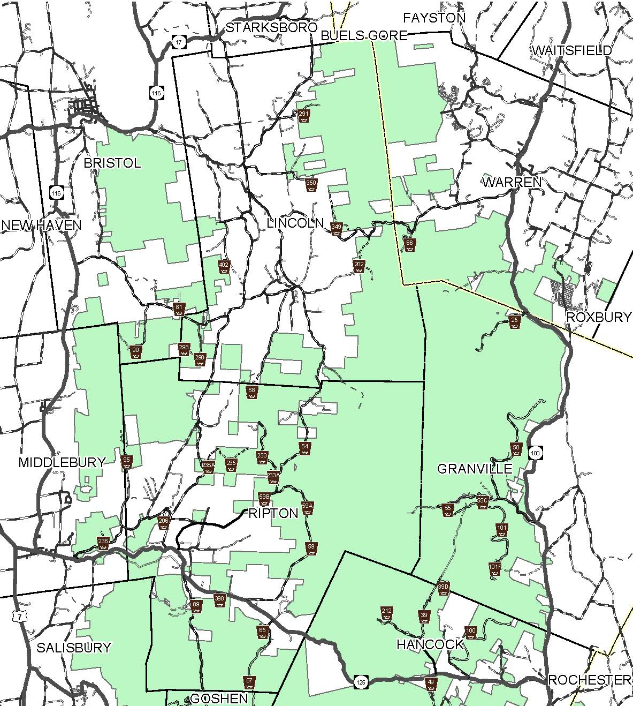
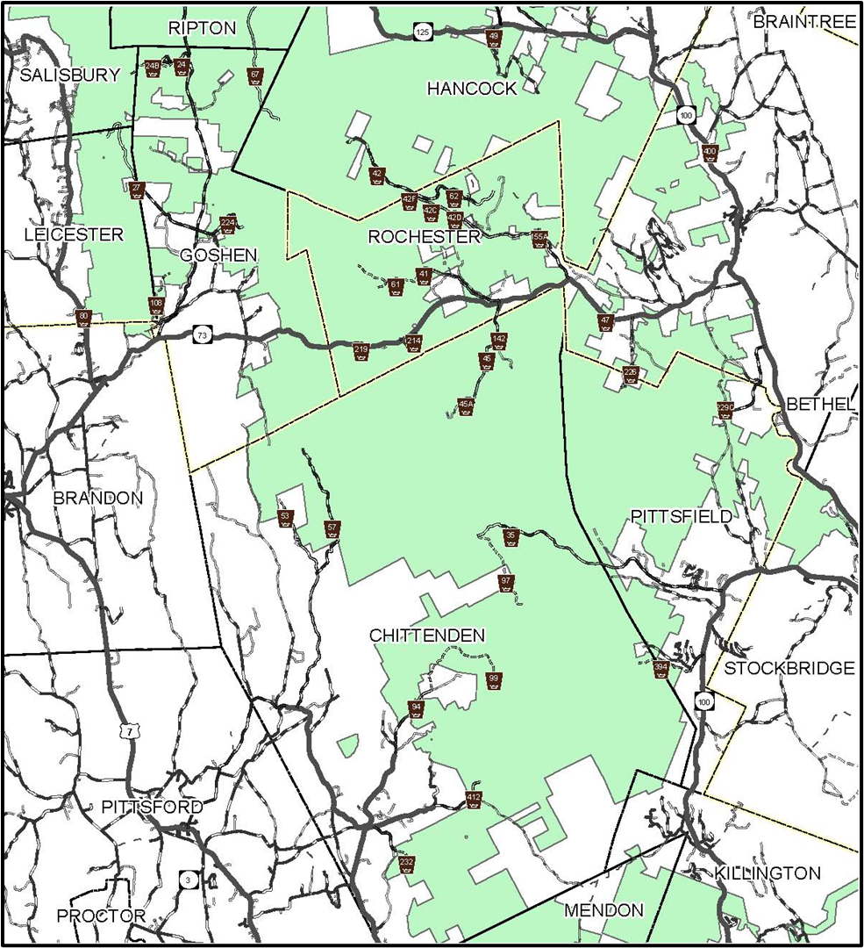
North Half Site Location Map 1 of 2
North Half Site Location Map 2 of 2
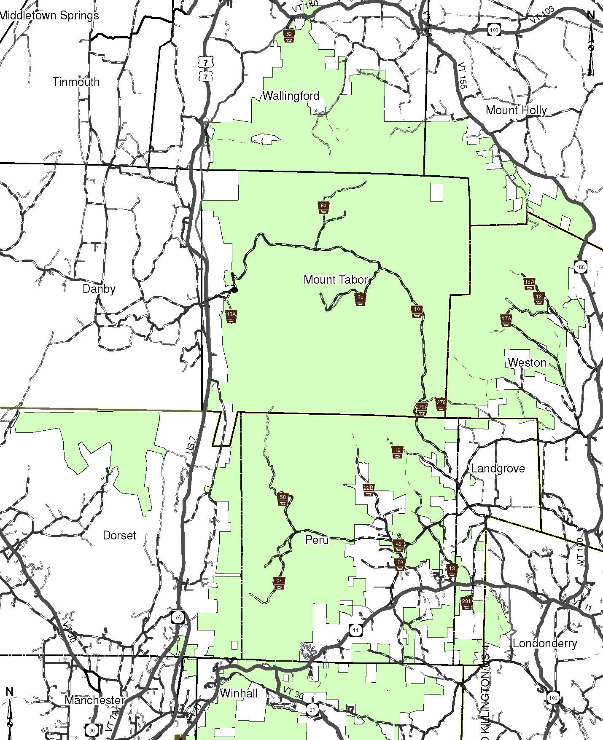
South Half Site Location Map 1 of 3
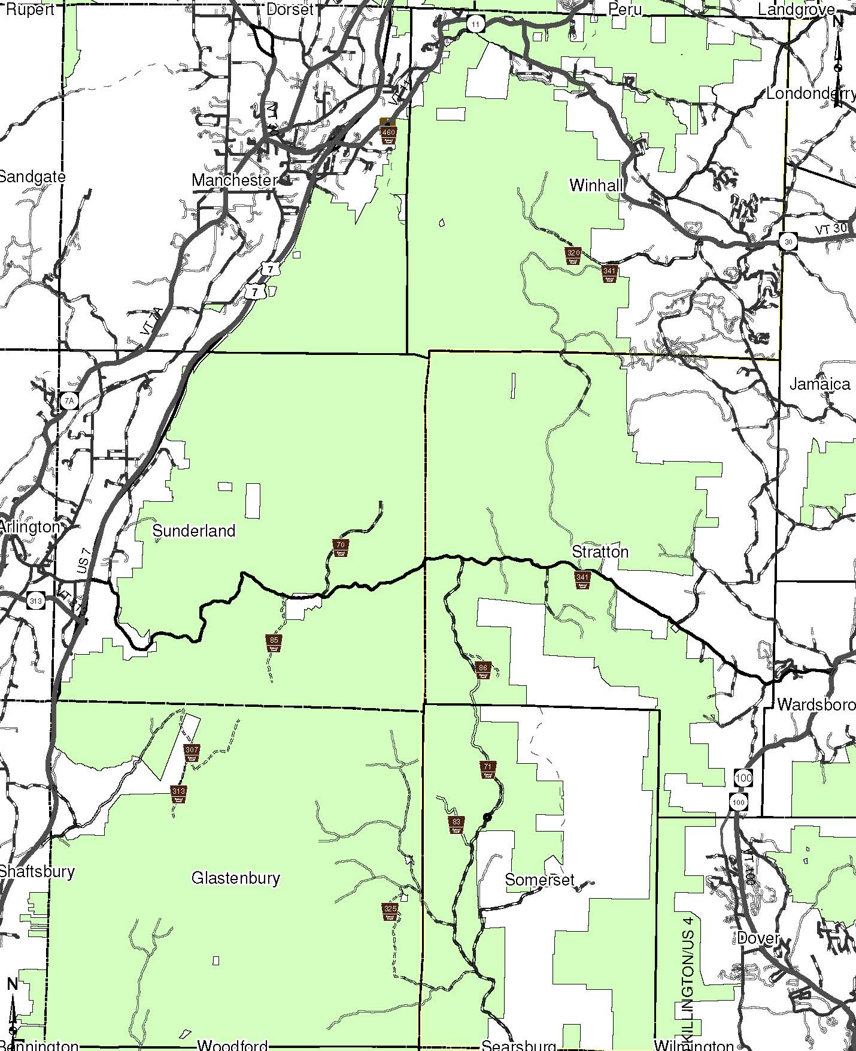
South Half Site Location Map 2 of 3
South Half Site Location Map 3 of 3
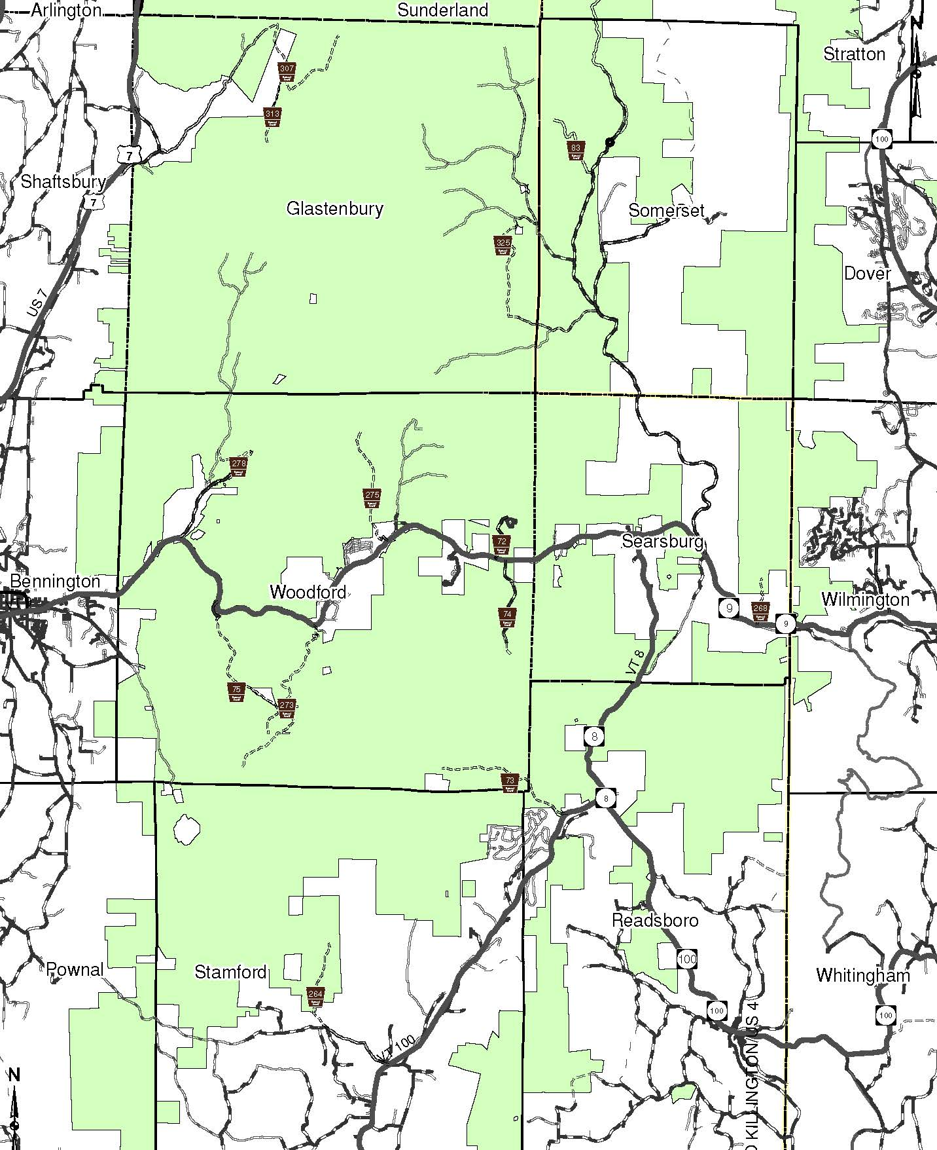
South Half Site Location Map 3 of 3

