

DEPARTMENT OF HOMELAND SECURITY
UNITED STATES COAST GUARD

1801, 1805, 1806, 1808, 1809, 1817
Lighthouse Place, Santa Barbara, CA 93109

Scope of Work
FOR

Santa Barbara Housing Units; Shower/tub replacement

Dated: 12/2/2025

Base Los Angeles Long Beach | Initial | Date
TBD
Contracting Officer (KO)
TBD
Contracting Officers Representative (COR)
LT Harrison G. Stanley
BASE FACILITY ENGINEER

GENERAL REQUIREMENTS

PART 1 GENERAL:

- BACKROUND: The existing tubs and shower bases have experienced progressive cracking, primarily originating around the drain locations. Investigation indicates that the original installations lacked adequate structural support beneath the drain areas, allowing movement and flexing under normal use. This inadequate support resulted in stress fractures and compromised the long-term integrity of the units. As part of this replacement project, the goal is to eliminate these deficiencies by ensuring that all new tubs and shower pans receive full and continuous support across the entire base and especially around the drain assemblies. Proper substrate preparation and reinforcement will be required to prevent movement, reduce stress on the fixtures, and mitigate cracking from recurring in the future.
- PROJECT SUMMARY: This project involves the corrective removal and replacement of 6 failing bathtub and shower pan assemblies that have developed cracks near the drain area due to improper installation. As part of this effort, all replacement tub and shower pan assemblies, surrounding materials and installation methods shall be standardized across all six units to ensure consistency, durability, and long-term maintenance efficiency. All housing units that require repair are currently occupied. For bid purposes, please provide a breakdown of price. The work for the restrooms includes, but is not limited to the following:
- SCOPE OF WORK: The Contractor shall provide all labor, materials, equipment, supervision, and incidentals necessary to complete the removal and replacement of tub and shower pan units and associated systems. Work must comply with current building codes, manufacturer installation requirements, industry best practices, and project standardization requirements. All six replacements must utilize the same approved tub/pan model, surround materials, waterproofing system, hardware, and installation methodology unless otherwise directed.
PROJECT REQUIREMENTS:
  - Pre-Work Requirements
            - Conduct an initial site visit and verify all measurements.
            - Submit a single standardized materials package for approval.
            - Provide a work schedule coordinated approved by the Facilities Engineer (FE).
            - Implement protective measures suitable for occupied units.

  - Demolition
            - Remove existing tubs, shower pans, wall surrounds, tile, backer board, and any compromised materials.
            - Disconnect and remove all drain assemblies, overflow systems, and associated hardware.
            - Maintain protection for surrounding finishes and occupied areas.

  - Inspection and Repair
    - Subfloor and Structural Elements
      - Inspect for water damage, rot, or structural failure.
      - Repair or replace subflooring as needed.
      - Verify level conditions suitable for standardized installation.

    - Wall Assemblies
      - Inspect for water damage, mold, or improper framing.
      - Replace or correct misaligned framing to ensure all six units have the same installation geometry.

    - Plumbing
      - Verify drain alignment and supply line integrity.
      - Ensure drain locations match the standardized tub/pan models.
      - Replace or adjust components as needed.

  - Installation of Standardized Tub/Shower Units
            - Install the same approved tub or shower pan model in all six units.
            - Install units in accordance with manufacturer specification and building codes.
            - Use consistent bedding leveling material.
            - Ensure uniform attachment, alignment, and support systems.
            - Install standardized drain, overflow, and gasket assemblies.
            - Perform leak testing at each unit.

  - Finishes and Restoration
            - Install standardized fixtures, trim and hardware.
            - Restore any disturbed finishes to match existing conditions.
            - Clean, inspect and ensure consistency across all locations.
            - Leave all units ready for immediate use.
- QUALITY CONTROL AND TESTING
  - Perform uniform leak tests.
  - Verify all six installations meet the same alignment, support and finish standards.
  - Correct any deficiencies before acceptance

- LOCATION: Project site is located at, US Coast Guard Santa Barbara Housing, 1801, 1805, 1806, 1808, 1809, 1817 Lighthouse Place, Santa Barbara, CA 93109.
- SITE INVESTIGATION: Investigate the site per FAR 52.236-3 to ascertain the general and local conditions, which can affect the work or its cost. Contact: Ruijin Garcia, at Ruijin.g.garcia@uscg.mil to arrange site access. Vendors must have DUNS and be registered at System for Award Management (SAM.gov) prior to being awarded a government Purchase Order.
- CONTRACTOR SECURITY REQUIREMENTS: For this Coast Guard facility, the Contractor shall provide a list of all on-site personnel, including sub-contractors and suppliers, to the Contracting Officers Representative (COR) 5 days prior to commencing work for clearance. The contractor shall update this list when changes occur. Contractor personnel not listed may be denied access to the Coast Guard facility. Contractor personnel will be restricted to designated working areas. Any personnel violating this policy may lose access to the Coast Guard facility. Contractor personnel shall always have photo identification while working on Coast Guard facilities.
Contractor and delivery personnel may be required to present personal photo identification to gain access to a Coast Guard installation. If identification does not indicate United States citizenship, Coast Guard Security will require proof of the legal right to work in the United States. Contractors and delivery personnel also may be subjected to immigration status and outstanding criminal warrants check.
Contractors shall provide the COR with 24 hours of advance notice of every delivery to the site (e.g., concrete, lumber, parts, etc.) and provide the company name, delivery person, and phone number of the firm(s) making deliveries. All vehicle access to government property requires vehicle registration and proof of liability insurance. Otherwise access to the Coast Guard facility may be denied.
- CONTINUITY OF FACILITIES OPERATION: Perform all on-site work between the hours of 7:30 AM and 3:30 PM, Monday through Friday (Federal Holidays excluded), unless otherwise approved by the COR or the Facility Engineer (FE). Notify the COR 3 business days in advance of any shutdowns. Contractor is required to coordinate Lock Out/Tag Out Processes and Procedures with the COR.
- NOTIFICATION OF START AND COMPLETION OF WORK: The Contractor shall notify the COR in writing (or email) five (5) business days in advance of the date they intend to commence work, and three (3) business days prior to the date that work will be ready for final inspection. All notifications must be approved by the COR, in writing, prior to commencing or completing work.
- RECYCLING AND DISPOSAL OF REFUSE: Refuse, excess, or waste materials resulting from construction operations shall become the property of the Contractor and shall be recycled and/or disposed of off Government property. All disposals shall be done in accordance with federal, state, and local laws and regulations.
- SAFETY: During the execution of this contract, the Contractor shall conform to the rules and regulations as set forth by OSHA Safety and Health Standards, 29 CFR Part 1926 - Safety and Health Regulations for Construction and California Code of Regulations, Title 8, Div. 1, Ch 4, Subchapter 4 Construction Safety Orders, and Army Corps of Engineers EM385-1-1. When the standards differ, the more restrictive standard shall apply. The contractor shall provide barriers, temporary fencing, ventilation, trench covers, etc. wherever work could cause injury to workers, visitors, Coast Guard personnel, or dependents. The contractor shall maintain safe access to all occupied portions of the residence outside of the work area, perform daily cleanup of work areas, secure all materials and tools when not in use, and coordinate work timelines to minimize occupant disruption. Return work sites to original condition after completion of work by cleaning and removing all construction material. An Accident Prevention/Safety Plan shall be submitted by the Contractor prior to any commencement of work.

- SUPPLIES AND SERVICES: All products must meet the requirements of the Buy American and Buy America Acts as amended in DFARS 225 and the FAR 25.103.
- TEMPORARY FACILITIES:
  - STORAGE: The location for exterior stock piling or lay down area of materials will be available on the premises with a location determined by the COR and Facility Engineer depending on size. The Contractor shall be responsible for protecting materials stockpiled against weather, damage, theft, and other risks of loss. The Coast Guard assumes no responsibility for material or equipment left in the storage area.
  - WATER AND ELECTRICITY: Water and 120V electricity are available at no cost to the Contractor. Cost of these utility connections and disconnections shall be the responsibility of the Contractor. Personnel using extension cords to bring power from another location for construction, maintenance, remodeling, etc., shall employ portable ground fault circuit interrupters (GFCIs), even if connecting to building wiring. Use of portable generators and compressors is authorized at contractor expense to operate portable equipment.
- FINAL ACCEPTANCE: Work will be accepted upon:
- Full functional performance of all six units.
- Visual and structural consistency across all replacements.
- No leaks, cracks, deficiencies, or installation variances.
- Completion of punch list items.
- DELIVERABLES
  - Standardized materials submittal package.
  - Work Schedule
  - Daily Progress Logs
  - Final Inspection and testing records
  - Warranty Documentation

- All bids submitted shall include breakdown of cost for labor and materials.

Unsupported drain fixture support

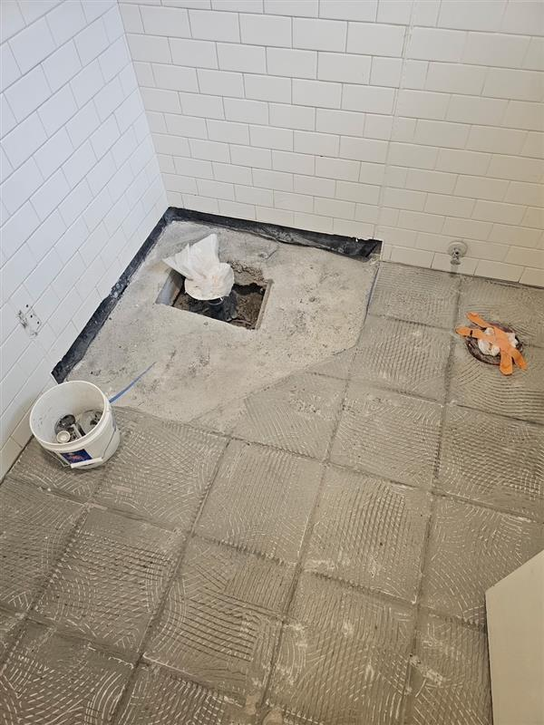

1805

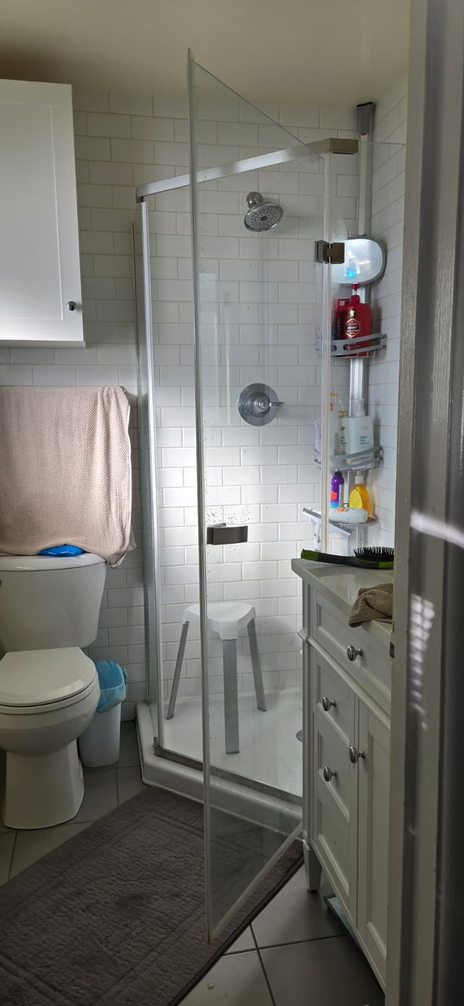
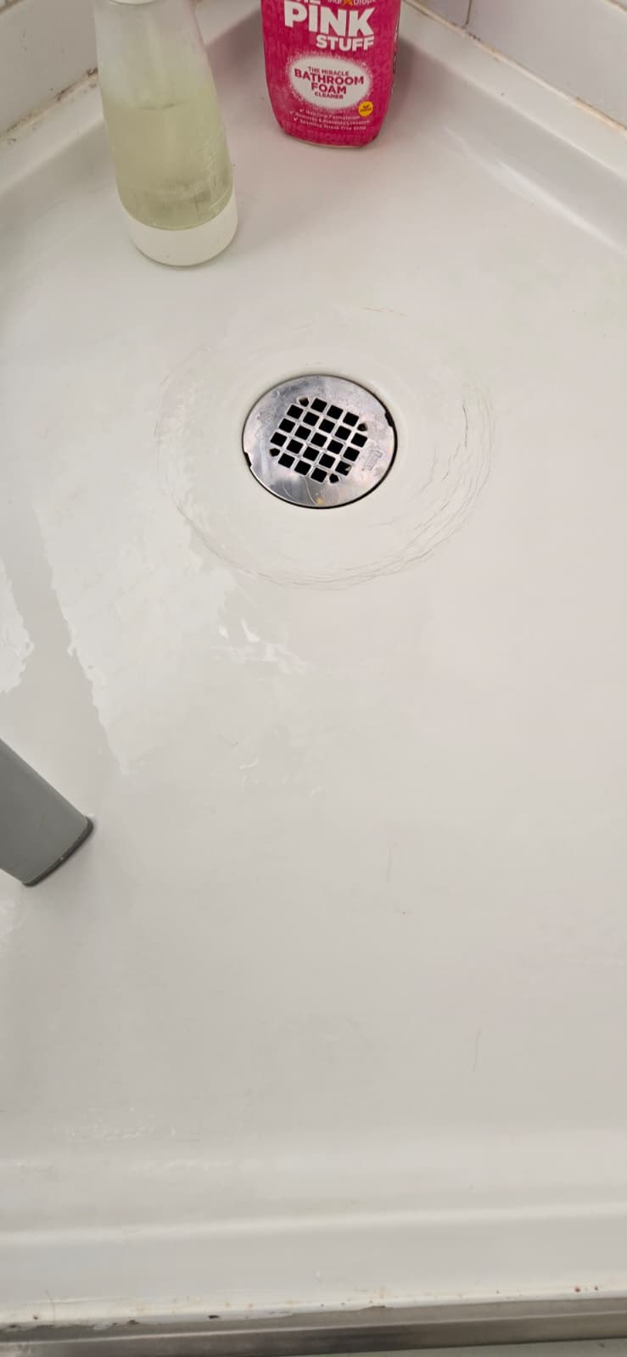
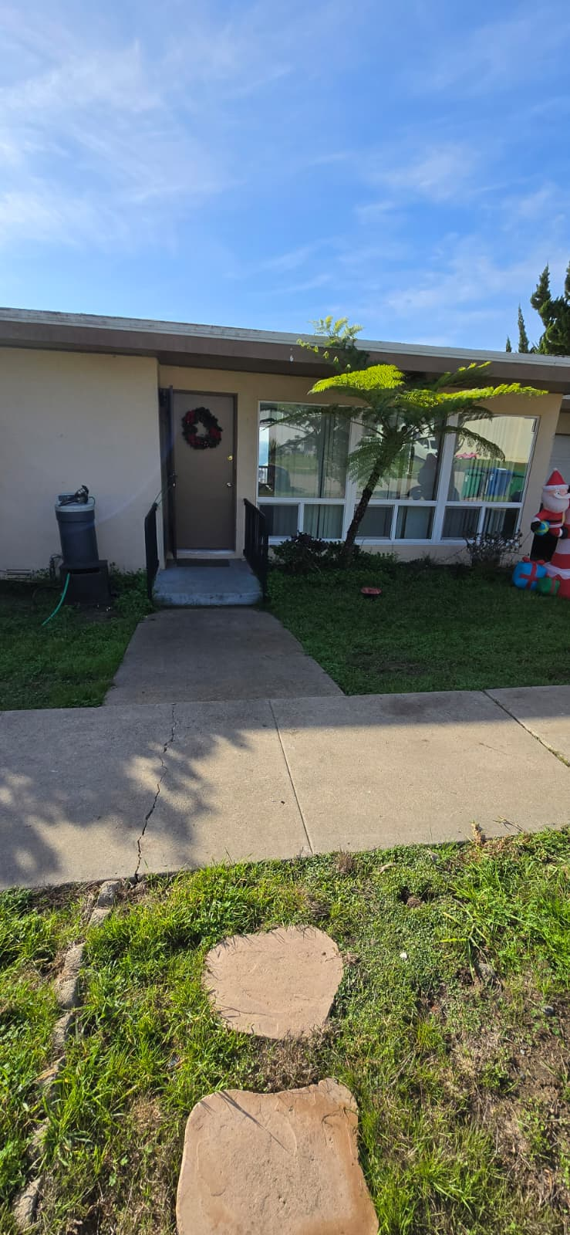

1801

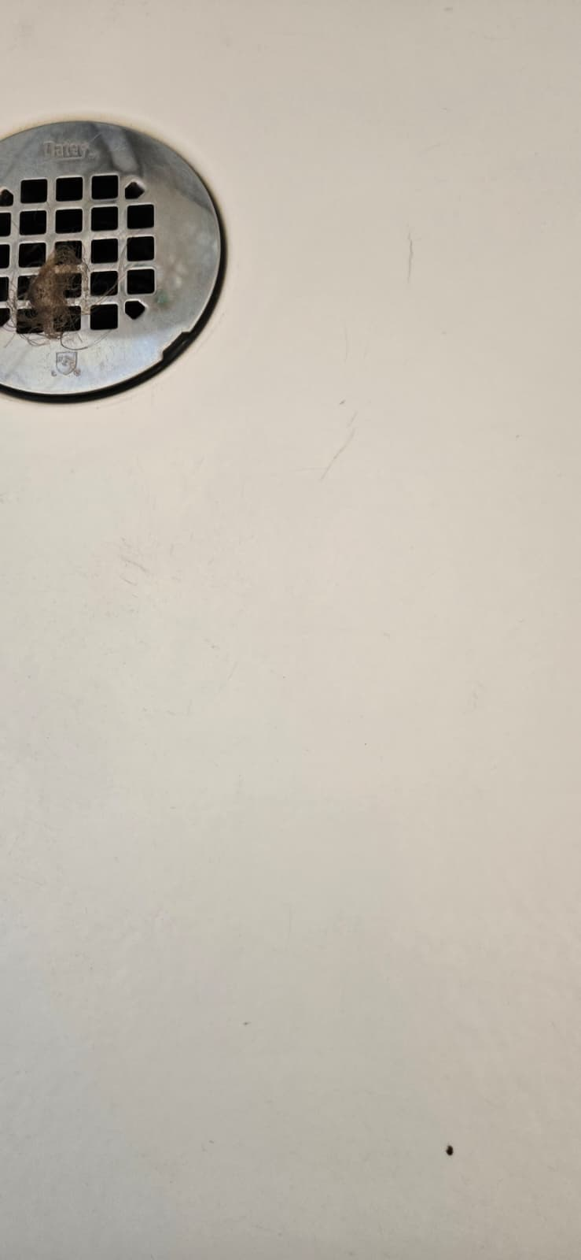
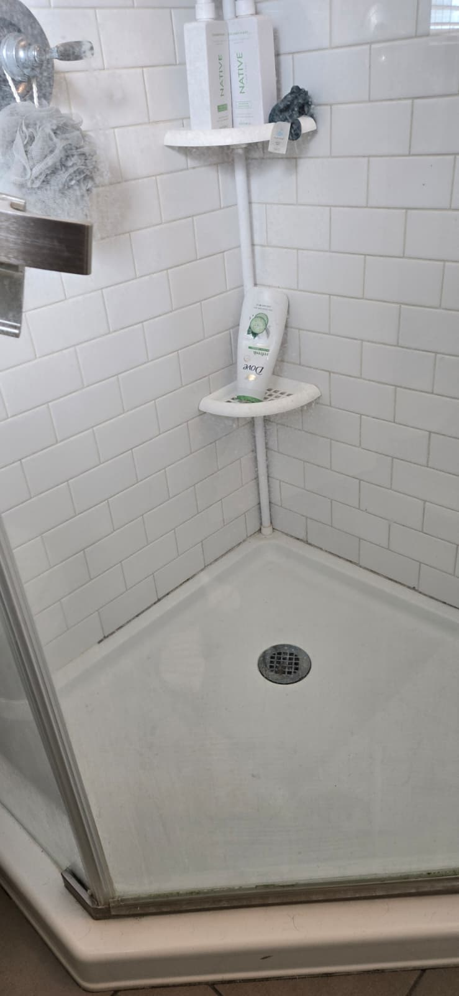
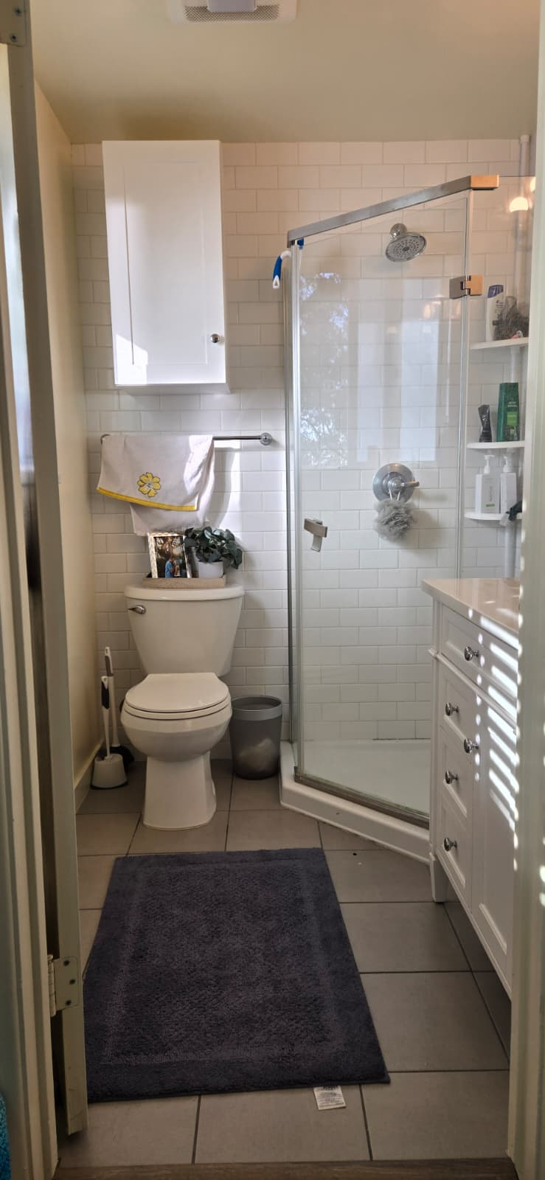
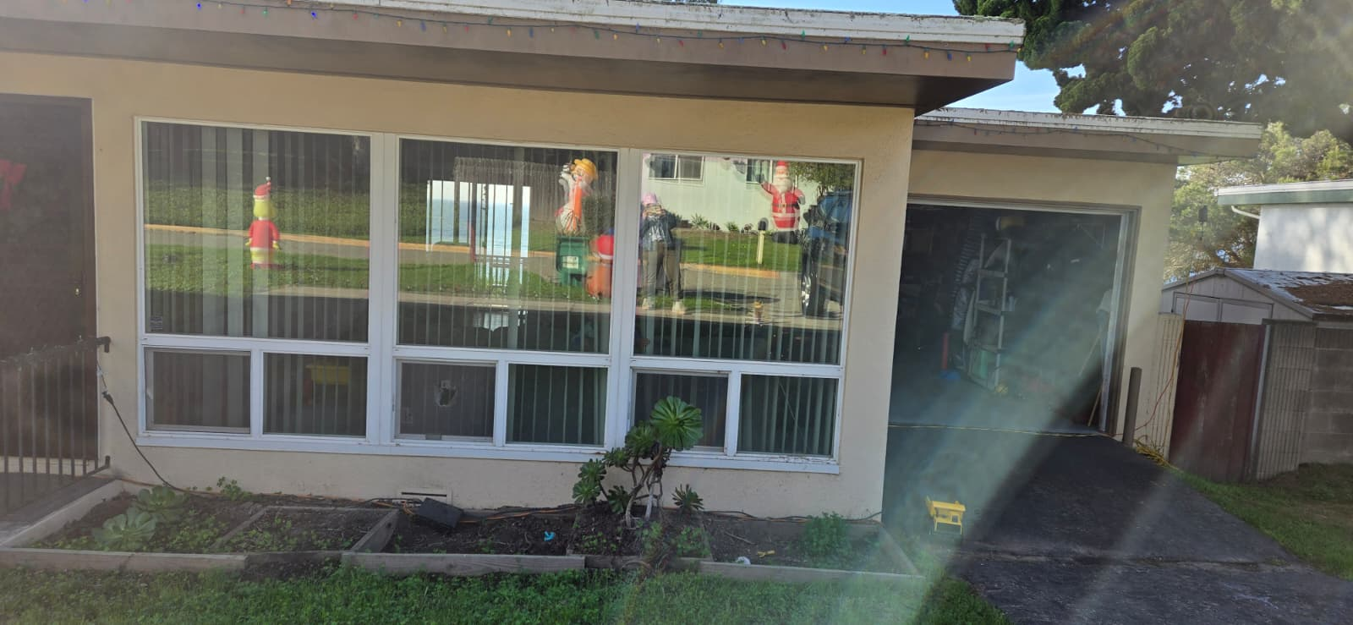

1817

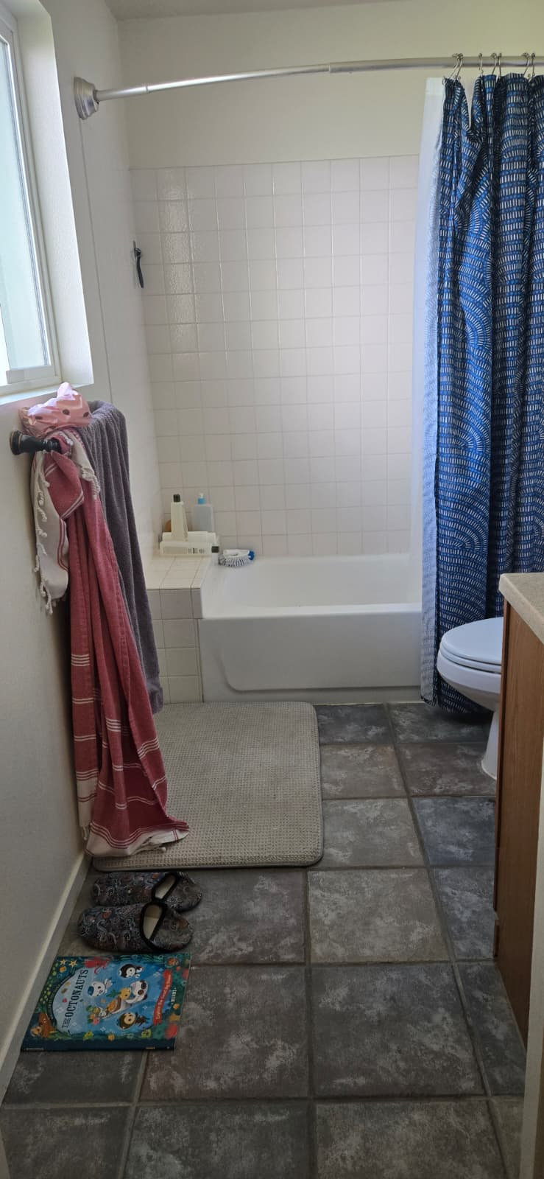
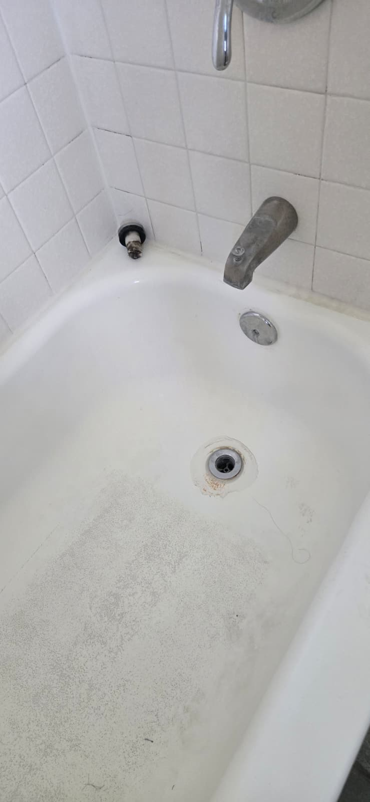

1809

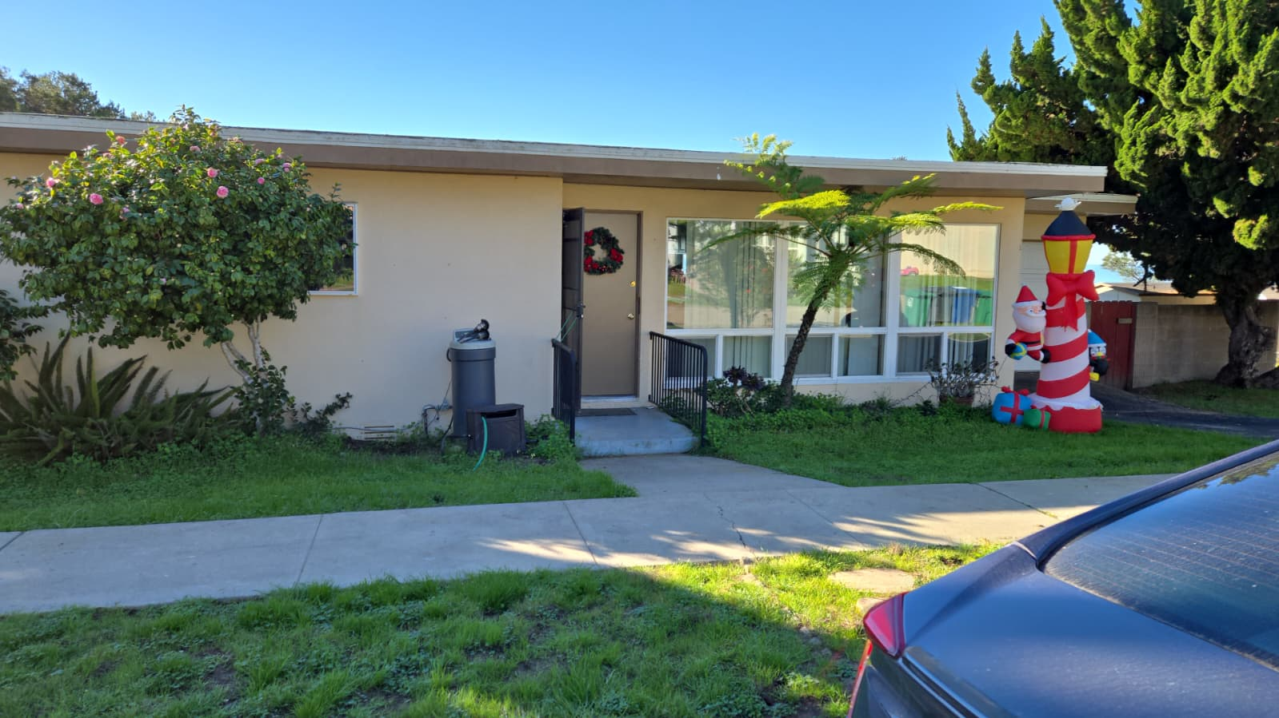

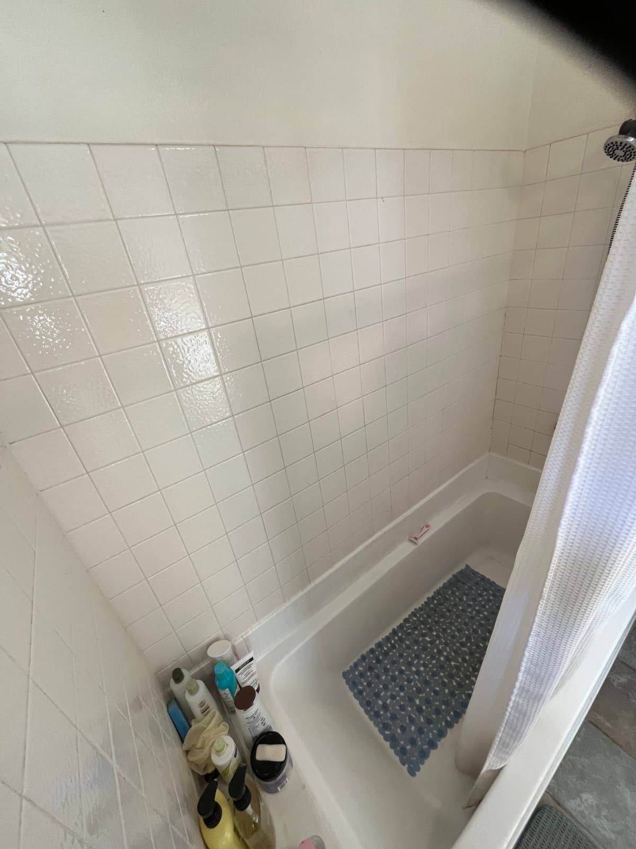
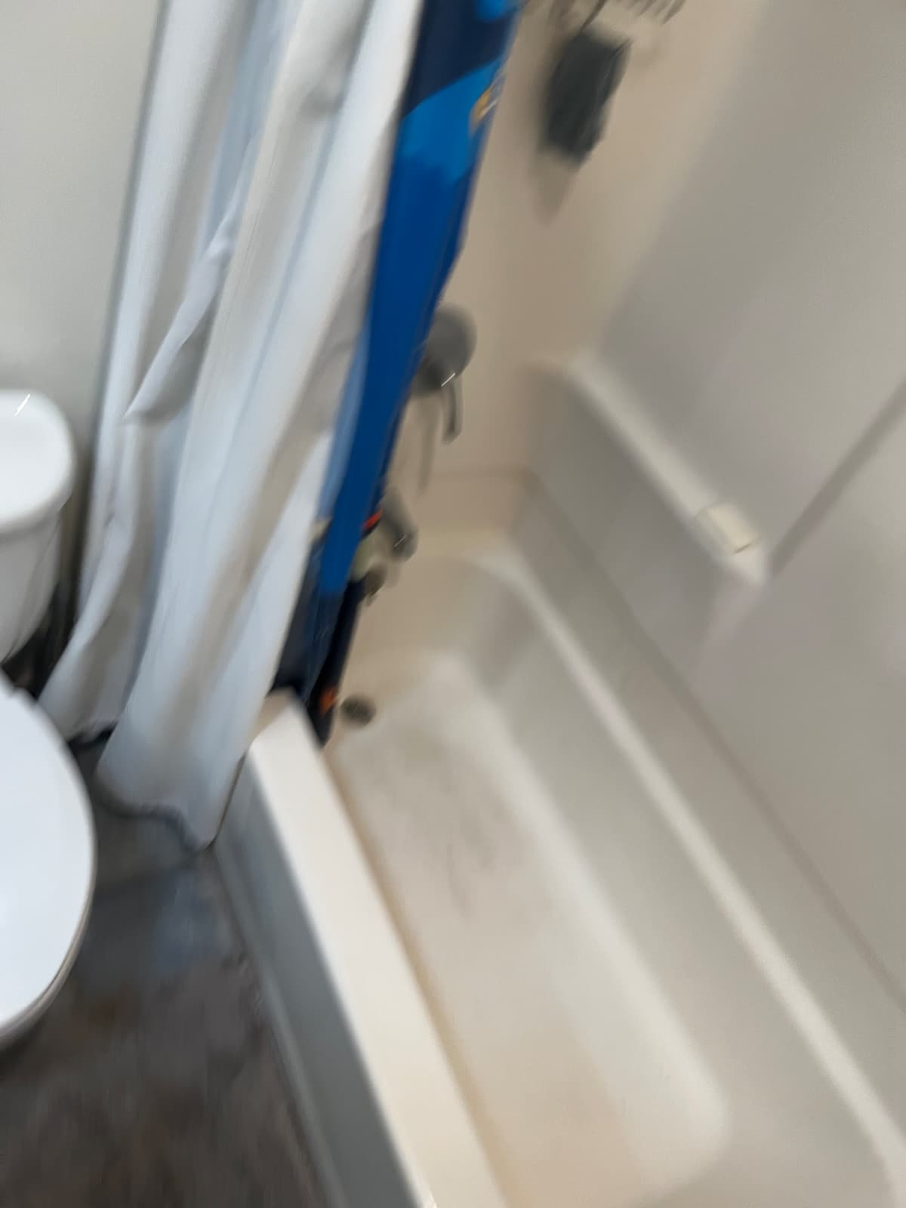

1808

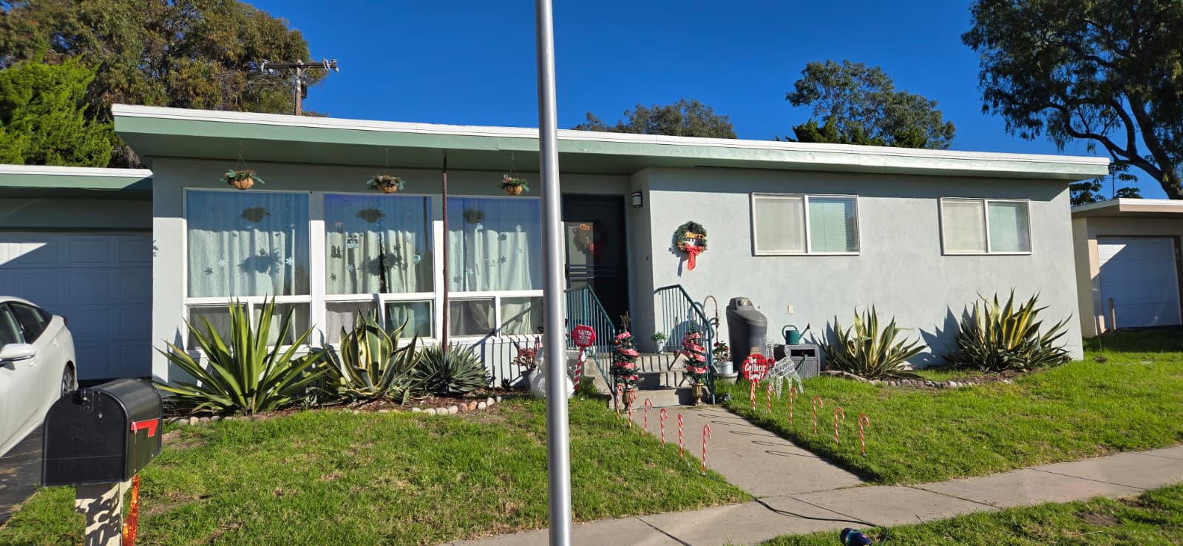
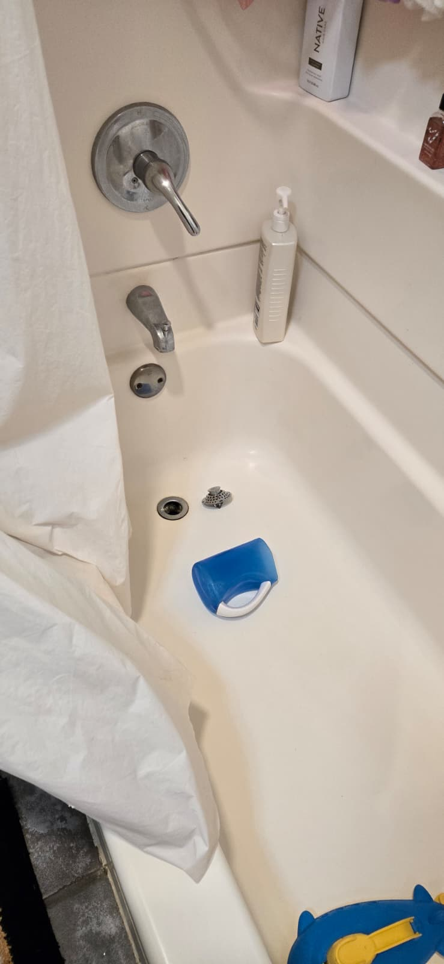
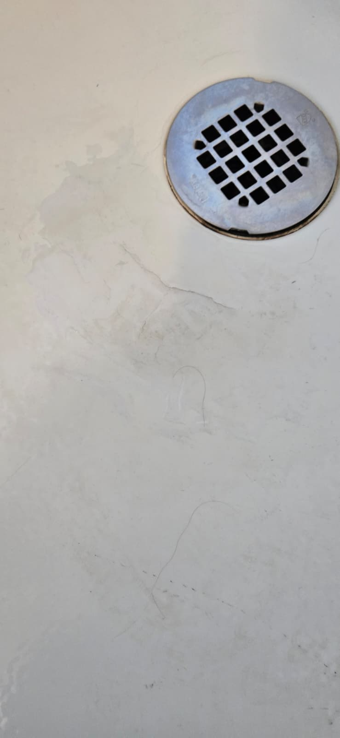

1806
