The pay.gov homepage is https://www.pay.gov
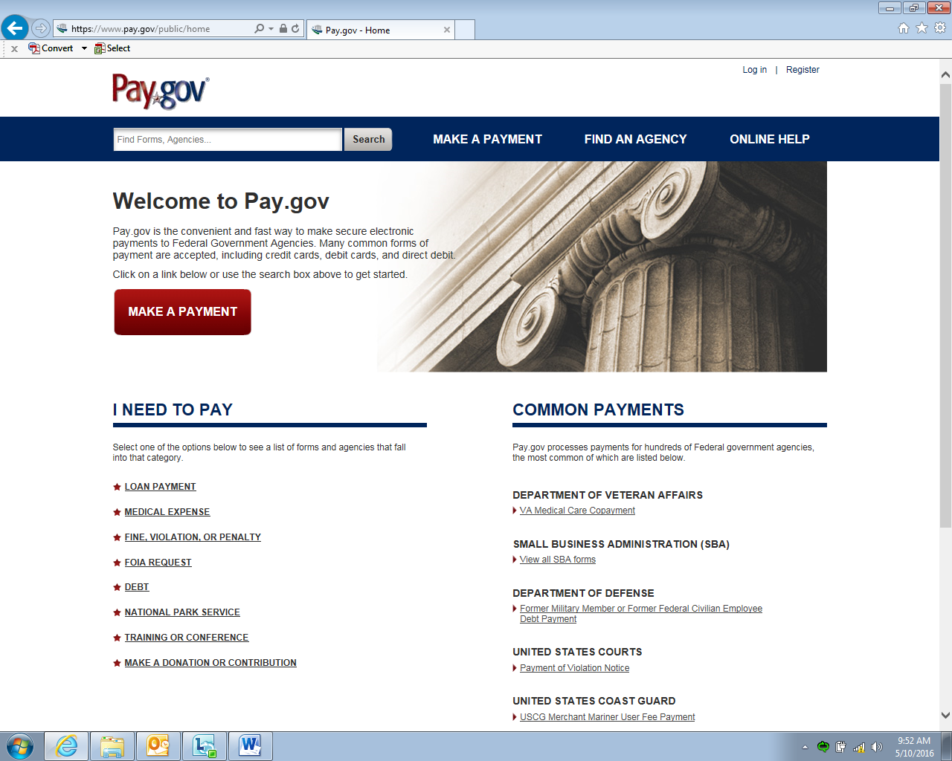

From the homepage, type “VA SAC” in the Search field and click “Search”
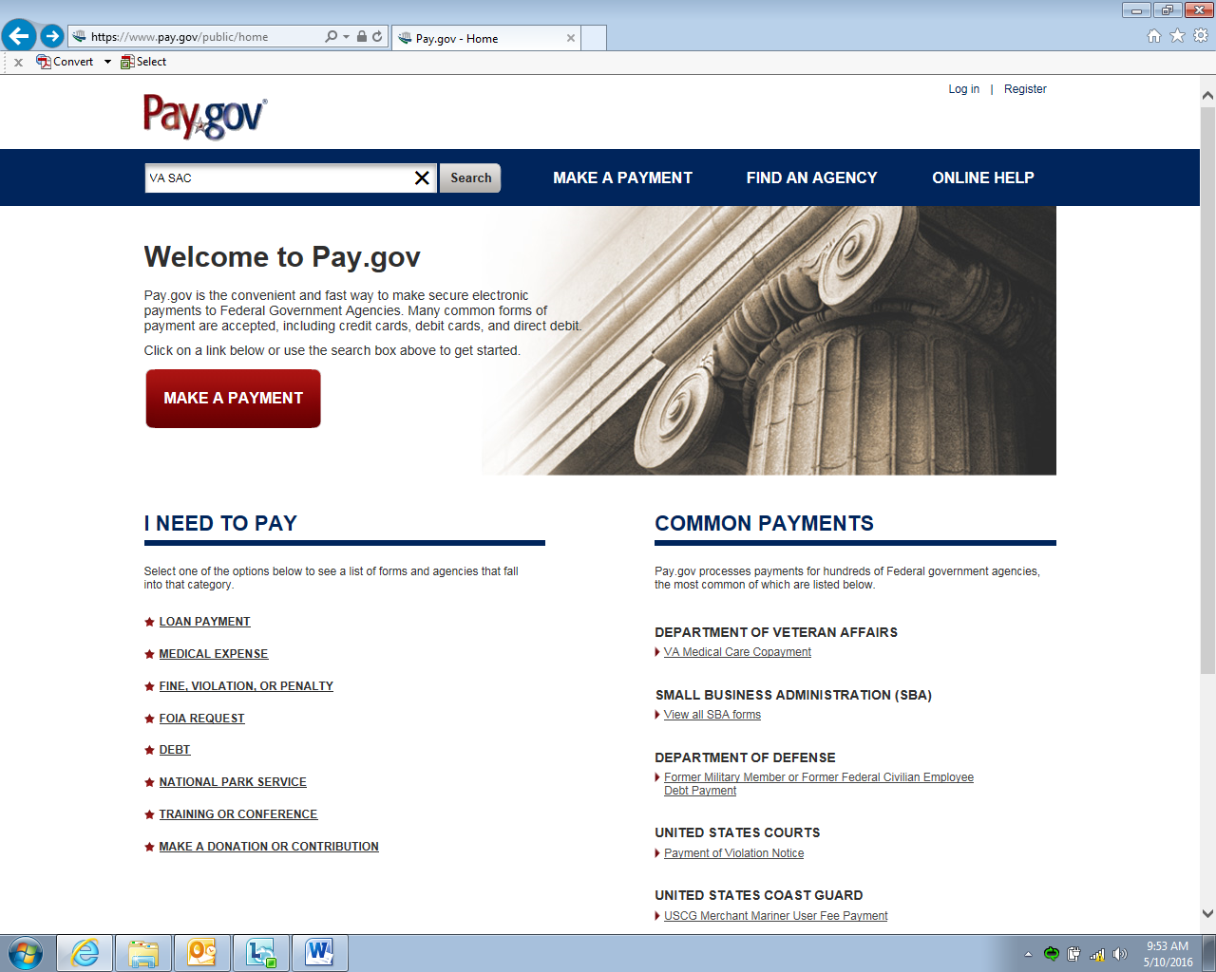

When the Search Results appear, the “SAC Contract Fee Remittance Form” will be at the top of the page, click “Continue to the Form”
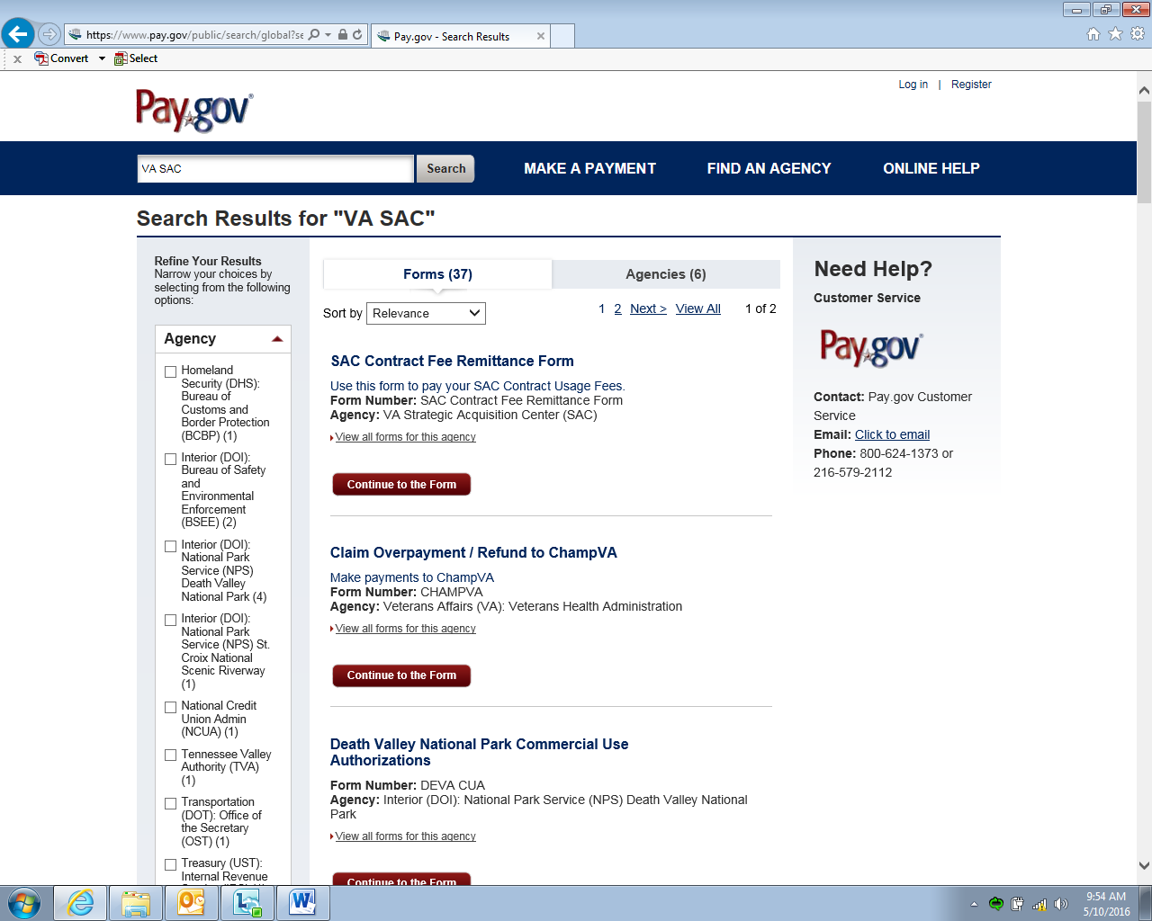

Once you click on “Continue to the Form,” the “Before You Begin” page will appear. If you are ready to make a remittance payment, click “Continue to the Form”
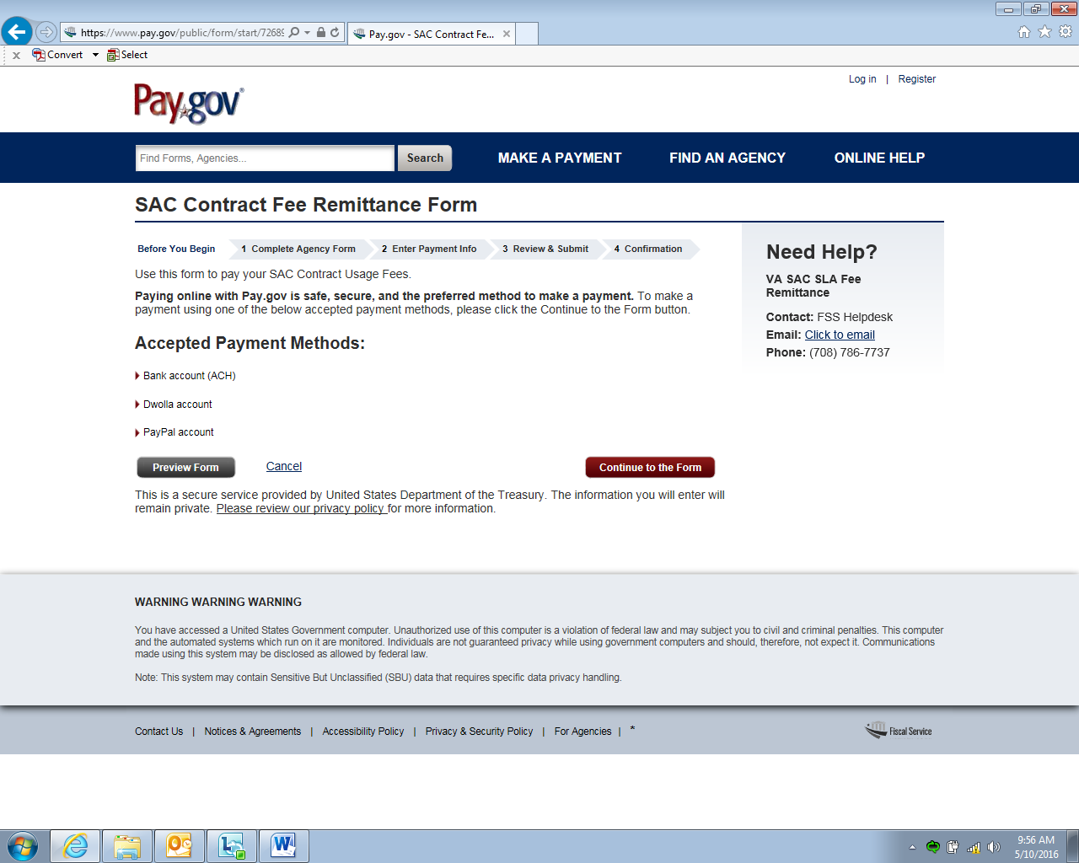

Step one of the 4-step process is “Complete Agency Form.” The steps are identified at the top of the page. To complete the agency form, perform the following:
- Select the “SAC Contract Number” from the dropdown (if your contract is not listed, contact your CO or CS)
- Enter the “Task or Delivery Order Number” if applicable (if not applicable leave blank)
- “Company Name” automatically populates based on SAC Contract Number.
- Enter the “Company Contact” (request name and phone number)
- Chose the appropriate “Sales Quarter” that is being reported from the dropdown
- Enter the total quarterly sales for the Sales Quarter in the “Quarterly Sales in Dollars” field (do not enter the “$” symbol)
- If the contract is in support of and falls under the MSPV program, click the “Yes” bubble under “MSPV Sale.”
- If MSPV Sale is “Yes,” the “MSPV IFF/SLA” and “Total Payment Amount” will automatically populate
- Click on the checkbox if you are including a .pdf of the Quarterly Report. Once all information has been added and you are sure it is correct, click “Continue” to begin Entering Payment Info.
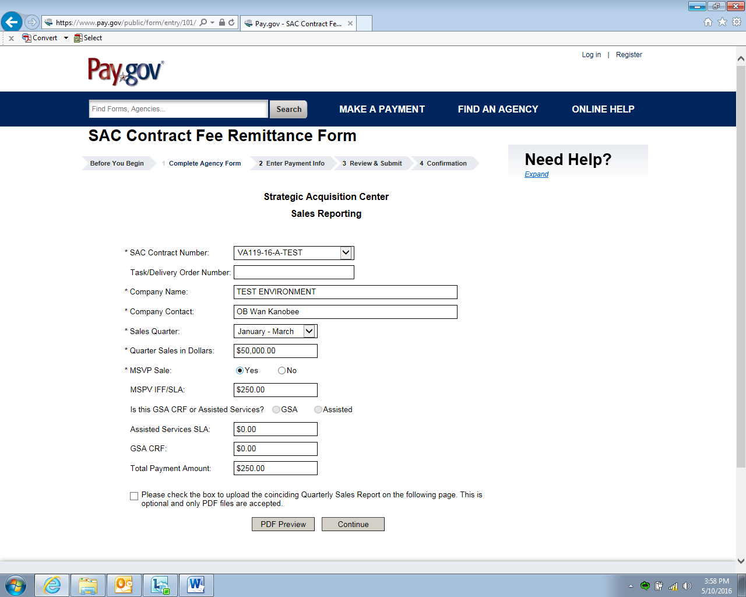
1
2
3
4
5
6
7
9
8
**These instructions show a MSPV Sale transaction – instructions are provided below for non-MSPV Sale transactions.

For the remittance of fee for non-MSPV Sale transactions, perform the following:
- Select the “SAC Contract Number” from the dropdown (if your contract is not listed, contact your CO or CS)
- Enter the “Task or Delivery Order Number” if applicable (if not applicable leave blank)
- “Company Name” automatically populates based on SAC Contract Number
- Enter the “Company Contact” (request name and phone number)
- Chose the appropriate “Sales Quarter” that is being reported from the dropdown
- Enter the total quarterly sales for the Sales Quarter in the “Quarterly Sales in Dollars” field (do not enter the “$” symbol)
- Since the contract is not in support of does not fall under the MSPV program, click the “No” bubble under “MSPV Sale.”
- If remittance is for a contract action off of a GSA FSS, click the “GSA” bubble under “Is this GSA CRF or Assisted Services?” If remittance is not for a contract action off of a GSA FSS, click the “Assisted” bubble. If the “GSA” bubble is filled, the “GSA CRF” and “Total Payment Amount” will auto-populate. If the “Assisted” bubble is filled, the “Assisted Services SLA” and “Total Payment Amount” will auto-populate.
- Click on the checkbox if you are including a .pdf of the Quarterly Report. Once all information has been added and you are sure it is correct, click “Continue” to begin Entering Payment Info.
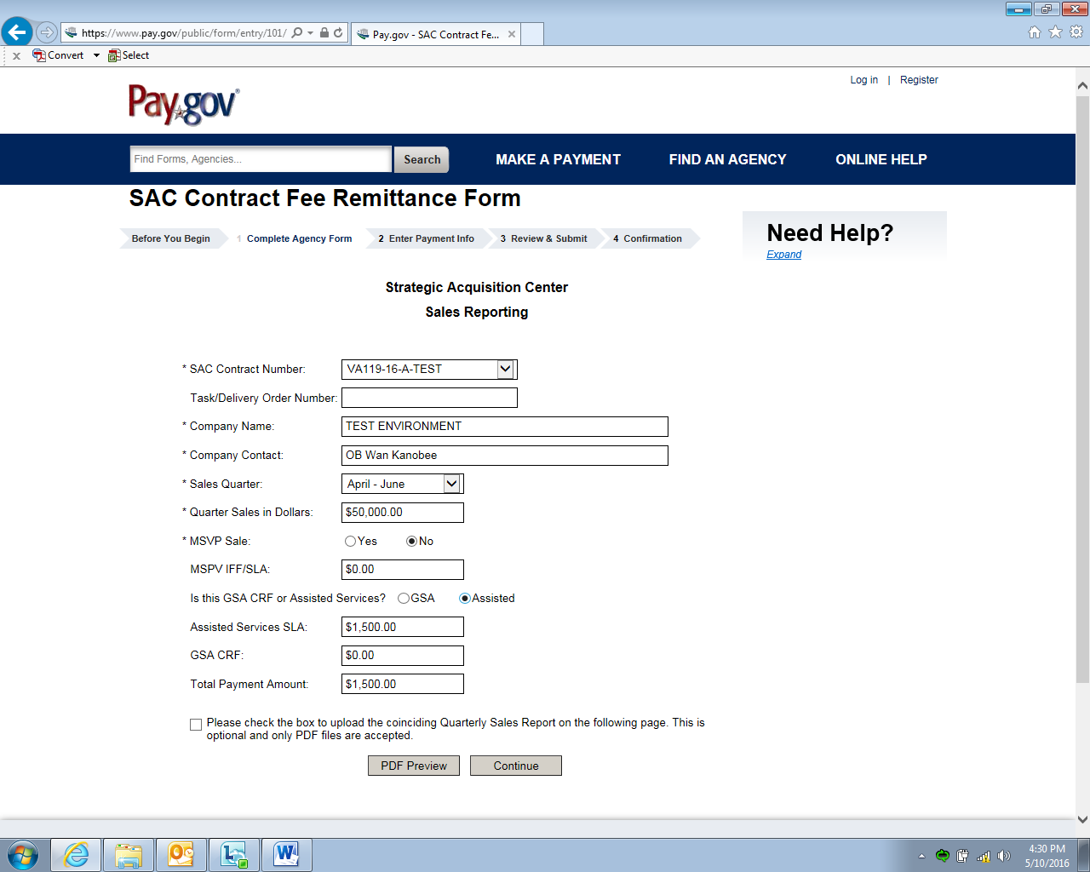
1
2
3
4
5
6
7
9
8
NOTE 1: GSA CRF is applicable to SAC BPAs issued against a GSA FSS. This is not to be confused with the VA FSS.
NOTE 2: Assisted Services SLA is applicable to SAC open-market contract vehicles.

Step two of the 4-step process is “Enter Payment Info.” The SAC currently only accepts payment via Auto Clearing House (ACH). ACH allows the use of bank routing and account numbers in order to transfer funds electronically from one back to another. Pay.gov ACH payment allows the use of either personal or business checking or savings accounts. The SAC does not accept payment via credit card or third parties (i.e. paypal). The payment amount and payment date are automatically populated from the information submitted in Step one.
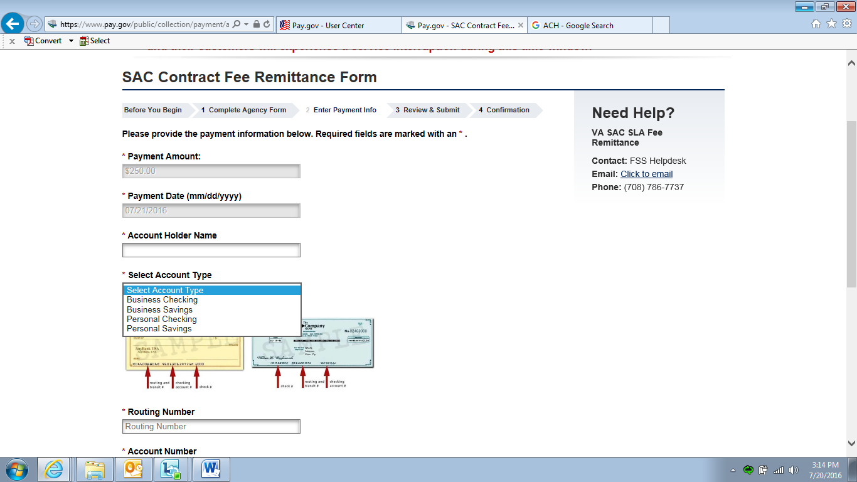
Step two instructions are continued below.

Step two continued. Enter the following information:
Account Holder Name Select the Account Type from the drop-down menu
Routing Number Account Number

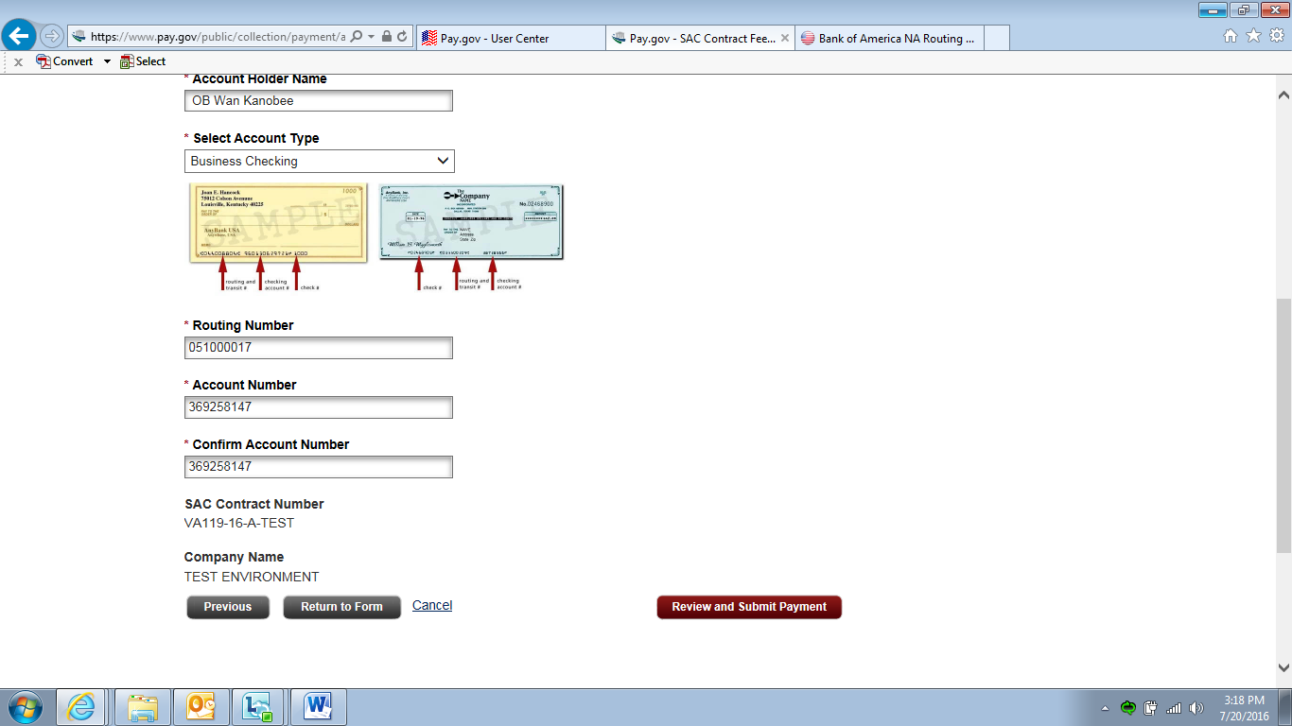

Once you have confirmed the Account Number, click “Review and Submit Payment.”

Step three of the 4-step process is “Review and Submit.” Please carefully review all of the information that you provided to ensure that it is correct. If you would like to receive an email confirmation of the transaction ensure to click “I would like to receive an email confirmation of this transaction.” and complete the email address accordingly. IT IS HIGHLY RECOMMENDED THAT YOU REQUEST FOR AN EMAIL RECEIPT.
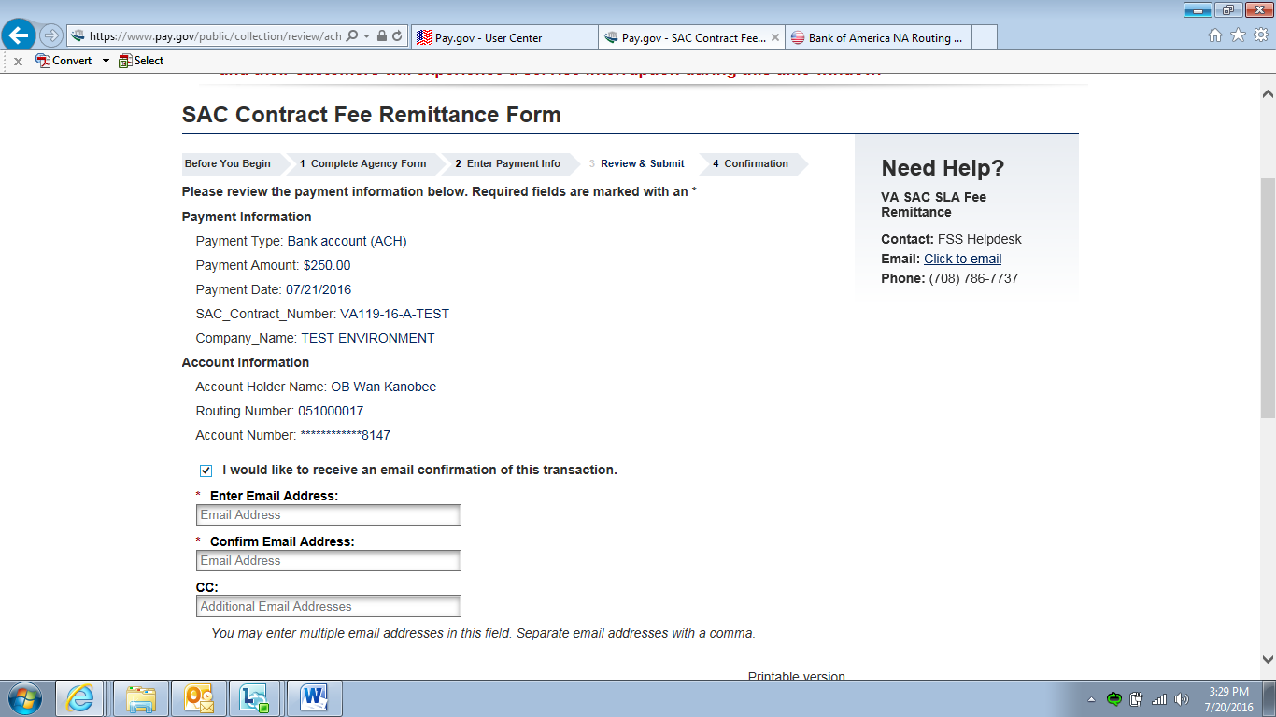
Step three instructions are continued below.

Step three continued. Once you have validated that all of your information is correct and indicated if you would like to receive an email confirmation, you may review the “Authorization and Disclosure Statement” and if you agree, click on “I agree to the Pay.gov authorization and disclosure statement.”

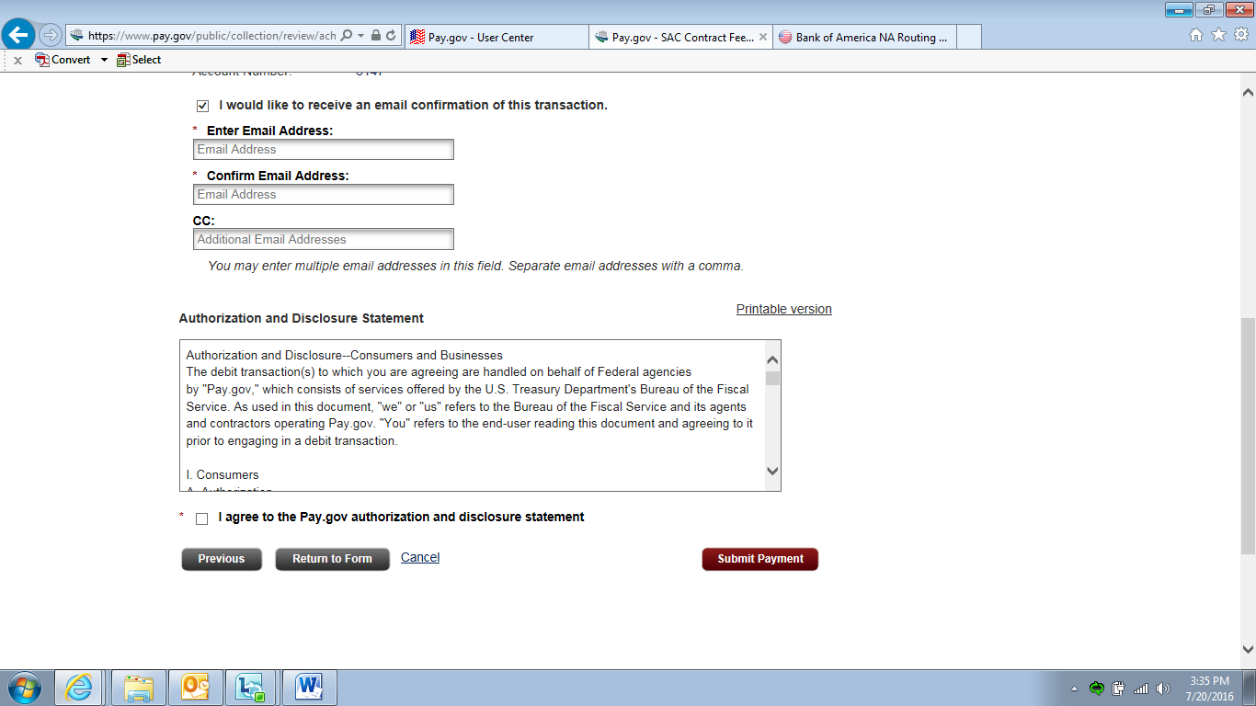
Once you have agreed to the authorization and disclosure statement, click on “Submit Payment” to complete the transaction.
Step four of the 4-step process is “Confirmation,” from which you will see a confirmation of your payment authorization.
This constitutes the end of the written instructions; however, if you have any questions throughout the payment remittance process please contact your Contracting Specialist or Contracting Officer as identified in your contract.

