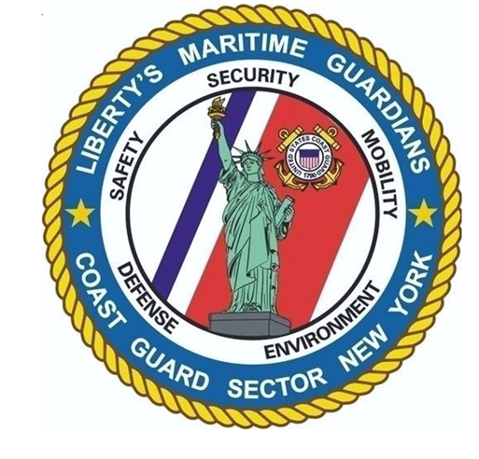
SECTOR NEW YORK ENGINEERING


SCOPE OF WORK

FOR

REPLACE ELECTRICAL CONDUCTORS PROVIDING
POWER TO PIER SHORE TIE RECEPTACLES AND LIGHTING
PROJECT #: SECNYHABHOOK02

AT

U.S. COAST GUARD
AIDS TO NAVIGATION TEAM SAUGERTIES
20 CRISPIN ROAD
HIGHLANDS, NY 07732
TABLE OF CONTENTS

DIVISION 1 – GENERAL REQUIREMENTS

01 10 00 SUMMARY OF WORK

DIVISION 26 – ELECTRICAL

26 05 19 LOW-VOLTAGE ELECTRICAL POWER CONDUCTORS AND CABLES

ENCLOSURES

Enclosure (1) – Historical Electrical Drawings

SECTION 01 11 00

SUMMARY OF WORK

PART 1 GENERAL

1.1 WORK COVERED BY CONTRACT DOCUMENTS

1.1.1 Project Description & Identification

The work for this project is defined by the contract documents and consists of the following:

- In general, this project consists of all work, including labor, equipment and materials necessary to run all new electrical conductors to provide power to cutter and boat shore tie connections as well as pier lighting at Station Sandy Hook.

This project shall be referred to as Project #: SECNYHABHOOK02 – STA Sandy Hook – Replace Pier Electrical Conductors

The existing conductors have been spliced too many times since original installation and have resulted in repeated failures with the shore-tie and pier lighting systems.
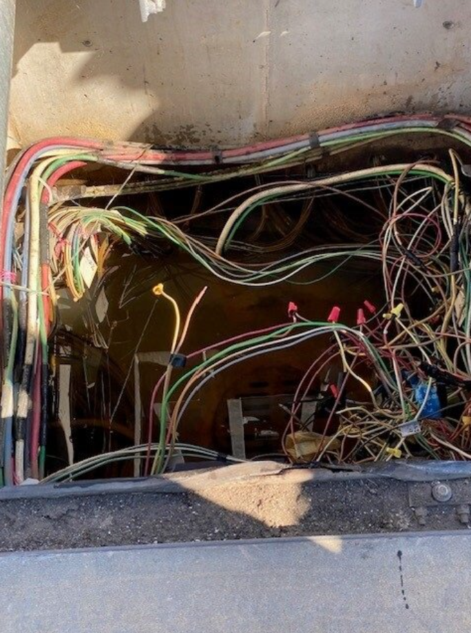
Figure 1 – Condition of Existing Electrical Conductors in Electrical Pull Box

1.1.2 Location

The work is located at:
Coast Guard Station Sandy Hook
20 Crispin Road
Highlands, NJ 07732

1.3 requests for information

Prior to submission of bid, project questions shall be submitted in writing as a Request for Information (RFI) to the Contracting Officer (KO). After contract award and during construction, if site conditions differ significantly from these plans and specs, contractor shall submit an RFI to the KO in writing detailing the issue and recommend a solution for government review/approval.

1.4 Site visit

Although not required contractors are welcome and encouraged to make a site visit to determine existing conditions and verify project elements during bidding. To make a site visit please contact the Contracting Officer’s Representative to schedule access to the site.

1.5 POINTS OF CONTACT

Contracting Officer’s Representative
Sector New York Engineering
311 Battery Rd.
Staten Island, NY 10305
LTjg Claire Sullivan
Email: Claire.V.Sullivan@uscg.mil
Phone: (206) 827-5327

PART 2 PRODUCTS

Not used.

PART 3 EXECUTION

Not used.

-- End of Section --
SECTION 26 05 19

LOW-VOLTAGE ELECTRICAL POWER CONDUCTORS AND CABLES
(REPLACE ELECTRICAL FEEDER CONDUTORS TO USCG CUTTER SHORE-TIE RECEPTACLES AND PIER LIGHTING)

PART 1 GENERAL

1.1 summary

- Scope: Replace existing low-voltage feeder conductors serving:
  - Coast Guard cutter and small boat shore tie receptacles.
  - Pier/Site lighting distribution.

- Provide new submersible/wet-location-rated conductors and ancillary materials from the nearest electrical panel located in the Boat Maintenance Facility building to the respective downstream equipment.

- Conductors shall be suitable for continuous operation in wet locations and during submersions (e.g. tidal/splash zones, flooded pull boxes, conduits below mean water line).

- Size conductors to meet existing loads and code requirements; verify loads and feeder lengths in the field.

- Coordinate outages with Station Sandy Hook personnel to maintain pier operations as required. Temporary power may be provided as the contractor chooses.

1.2 REFERENCES

- NFPA 70 (NEC), including Article 555 (Marinas, Boatyards, Piers, Docks).
- NFPA 70E, Electrical Safety in the Workplace.
- OSHA 29 CFR 1910 & 1926.
- UL: 44 (Thermoset-Insulated Wires), 83 (Thermoplastic-Insulated Wires), 1309 (Marine Shipboard Cable), 486A/B (Wire Connectors), 514 (Conduit Fittings), 6/50 (RMC/EMT), 651 (PVC), 651A (RTRC/Fiberglass).
- IEEE 1580 (Marine Cable) and IEEE 45 (Recommended Practice for Shipboard Electrical Installations) – as applicable to cable construction.
- UFC 4-152-01, Piers and Wharves (design practices for over-water environments).
- Coast Guard Electrical Shore Ties Configuration Standard Technical Order (CSTO) (Rev. B) SILC-CSTO-36-11-21-27-11-04.

1.3 administrative requirements

- Pre-work survey: Trace feeders end-to-end; identify all terminations, pull/splice locations, and raceway segments exposed to water.
- Coordination: Coordinate with local coast guard personnel to develop an outage plan or temporary power plan.

1.4 SUBMITTALS

- Product Data:
  - Feeder cable cut sheets showing UL listing for wet-location and submersible service, 90 °C wet rating, tinned copper, insulation and jacket materials, voltage rating, and sunlight/UV resistance.
  - Cable glands/sealing fittings rated IP68/NEMA 6P; watertight splices/heat-shrink kits.
- Calculations (stamped by a licensed PE):
  - Conductor sizing based on verified existing loads, conductor length, ambient conditions, installation conditions, and NEC ampacity tables (adjustment/correction factors).
2. Voltage-drop (≤3 % feeder; ≤5 % feeder+branch total).
3. Conduit fill and cable pulling tension/bend-radius checks.
4. Equipment grounding conductor (EGC) sizing and fault-current availability vs. OCPD interrupting rating.
- Shop Drawings: Feeder routing, pull/splice points, enclosure details, sealing plans, and identification scheme.
- Closeout: Test reports, as-built redlines and CAD/PDF, O&M data, labels, and updated arc-flash/one-line where affected.

1.5 QUALITY ASSURANCE

- Installer: Licensed electrical contractor in the State of New Jersey. Minimum 5 years marine/pier electrical experience.

1.6 delivery, storage, and handling

- Protect cable reels from salt spray and UV; store off ground and under cover while waiting installation.
- Protect factory end-seals until final termination. Protect insulation from damage.

1.7 safety and environmental

- Lockout and tag-out per NFPA 70E. Energized work only with written justification and Coast Guard approval.

1.8 Warranty

- Minimum 1-year workmanship and materials.

PART 2 PRODUCTS

submersible/wet-location feeder cable

- Basis of Design:
  - Conductors: Tinned copper, Class B strand.
  - Insulation: EPR (RHH/RHW-2) or equivalent 90 °C wet, XLPE acceptable where listed for continuous wet/submerged service.
  - Jacket: CPE/CSPE/Neoprene heavy-duty, UV/sunlight, oil, and abrasion resistant; black.
  - Listing: UL listed for wet locations and submersion; comply with UL 1309/IEEE 1580 Type P or a UL-listed submersible pier/marina cable specifically designated “suitable for submersion.”
  - Voltage: Match existing systems.
  - Identification: Permanent print legend; color code per NEC (phases: brown/orange/yellow or black/red/blue as standard; neutral white/gray; EGC green).
  - Accessories: Matching factory-rated IP68/NEMA 6P cable glands, watertight heat-shrink splice kits with adhesive liner, sealing boots, end-seals.

2.2 Supports and hardware

- Use existing raceway and struts for cable management/organization. If new is required it shall comply with:
  - 316 stainless steel strut, clamps and fasteners; non-metallic where appropriate to reduce galvanic corrosion.
  - Dielectric separators between dissimilar metals.

2.3 grounding and bonding

- Ground and Bond in accordance with NEC Article 555 for marina bonding requirements.
- Cutter and small boat grounding shall be in accordance with requirements outlined in Coast Guard Electrical Shore Tie CSTO and grounding for cutters/boats shall supersede NEC requirements where there is a conflict.

PART 3 EXECUTION

3.1 EXAMINATION & PREPARATION

Do not begin the project until site conditions have been thoroughly examined.

- Field verify source equipment, feeder routes, conduit condition, box conditions.
- Inspect existing raceways and wire hooks. Provide new where existing is not suitable.
- Inspect ground box/access boxes. Replace rubber gasket as necessary to reduce water inflow.

3.2 preparation

- Develop and submit load verification: measure/confirm connected loads for shore-tie system and pier lighting.
- Conductor Sizing:
  - Select using NEC tables for the installed condition with adjustment/correction (ambient, conduit fill, grouping).
  - Limit voltage drop to ≤3 % per feeder at peak load; upsize if necessary.
- Size conductors per NEC 250; verify available fault current and over current protection device ampere interrupting capacity (AIC) rating.
- Coordinate outage windows; deploy temporary power to critical pier loads if required.

3.3 installation

- Pull new feeders in continuous runs between equipment and designated pull points; no splices in conduits unless within rated watertight splice enclosures.
- Use approved pulling lubricant; do not exceed manufacturer’s tension or bend-radius limits.
- Provide drip loops and sealing to minimize water migration.
- Terminations: Clean, crimp with calibrated tools, apply antioxidant, and torque to manufacturer values; use submersible-rated glands at entries to submersible/occasionally submerged enclosures.
- Test all lighting and shore-tie receptacles to ensure proper installation.

-- End of Section --

