NYC Taxi Trip Duration
Dashboard Report
NYC Taxi Trip Duration Dataset | EDA + Feature Engineering Dashboard
ROWS  729,322  Trip records | COLUMNS  13  Original fields | TARGET  Trip Duration  Regression | AVG DURATION  15.87 min  Raw target mean | DATE RANGE  Jan-Jun 2016  Pickup dates

This report explains the NYC Taxi Trip Duration dashboard in simple business language. It focuses on trip duration, pickup time patterns, distance, location, passengers, vendors, feature engineering, leakage awareness, and model-building readiness.
Model building has not been completed in this report. The next stage is to train and compare regression models using leakage-safe features.

1. Project Introduction
The project studies historical NYC taxi trip records with pickup and dropoff locations, pickup and dropoff times, passenger count, vendor details, and trip duration. The main purpose is to understand patterns that affect trip duration and prepare the data for future machine learning.
This project is suitable for regression analysis because the target column is numerical and represents the time taken to complete a taxi trip.

2. Dataset Overview
Item | Value
Dataset name | nyc_taxi_trip_duration.csv
Rows | 729,322
Original columns | 13
Duplicate rows | 0
Missing values | 0
Pickup date range | 01 Jan 2016 to 30 Jun 2016
Dropoff date range | 01 Jan 2016 to 01 Jul 2016
Target column | trip_duration
Problem type | Regression
Project scope | EDA, feature engineering, dashboard, leakage awareness
Model building status | Not done yet; starts next
Main data areas: pickup time, dropoff time, passenger count, pickup location, dropoff location, vendor, store-and-forward flag, and trip duration.

3. Business Objective
The business objective is to understand how trip duration changes with pickup time, distance, passenger count, vendor, and location patterns.
The dashboard supports early business analysis before model building so important trip-duration patterns can be reviewed before training a prediction model.

4. Target Column Explanation
Target column | Meaning
trip_duration | Actual taxi trip duration in seconds.
trip_duration_minutes | Dashboard-readable version of the target in minutes.
trip_duration_log | Recommended transformed target for model building because the duration distribution is skewed.
The target column is trip_duration because it directly represents the total time taken by a taxi trip.
The problem type is regression because trip_duration is a continuous numerical value.

5. Dashboard Purpose
The dashboard is designed to explain the dataset visually before model building. It helps reviewers quickly understand trip duration, time patterns, distance, location behavior, feature creation, feature impact, data quality, and leakage-risk columns.

Dashboard filters used
The sidebar filters allow users to filter by vendor ID, pickup month, weekday, time slot, passenger count, pickup hour, trip duration range, and trip distance range. These filters make it easier to analyze a specific trip group without changing the original dataset.

6. Explanation of Each Dashboard Tab
Tab | What it shows | Simple purpose
Summary | Trip duration distribution, vendor share, passenger count, time slot trips | Gives a quick trip overview.
Time Heatmap | Average duration by pickup day and hour, trips by hour, duration by hour | Shows when trips are longer or more frequent.
Trip & Distance | Distance vs duration, vendor duration, passenger count duration, rush hour duration | Explains the relationship between distance, time, and trip duration.
Location Map | Pickup and dropoff concentration using sampled trips | Shows where trips start and end geographically.
Feature Creation | Created datetime, distance, airport, interaction, encoding, scaling, and leakage-safe features | Explains how raw columns were converted into useful features.
Feature Impact | Correlation, time impact, distance impact, airport impact, model readiness checklist | Shows early feature relevance before model building.
Data Quality | Missing values, duplicates, summary statistics, correlation, leakage check | Checks dataset health and unsafe columns.
Insights | Short conclusions and project direction | Summarizes findings for review.

7. Dashboard Screenshots and Simple Interpretations
The screenshots below follow the dashboard flow and help explain the main visual findings.
Figure 1: Summary Tab - Trip Duration Distribution and Vendor Share
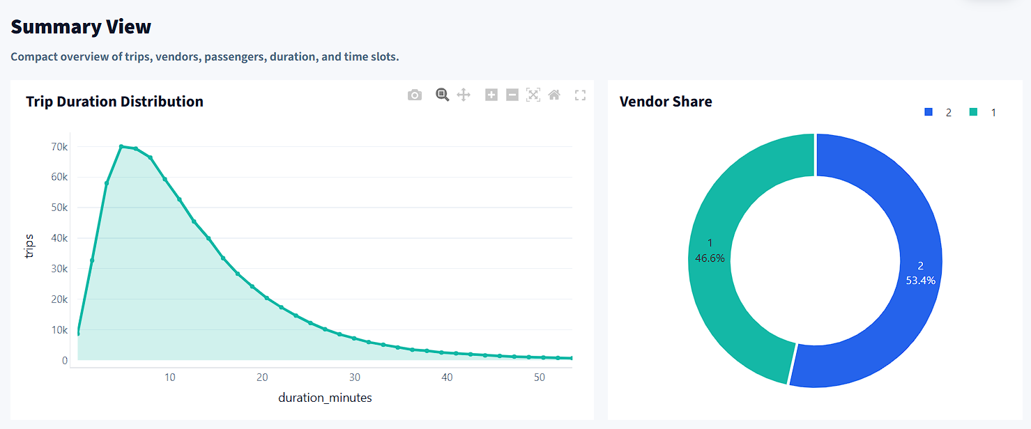

Interpretation: Most trips are short to medium length, and vendor share helps compare trip records across providers.
Figure 2: Summary Tab - Passenger Count and Time Slot Distribution
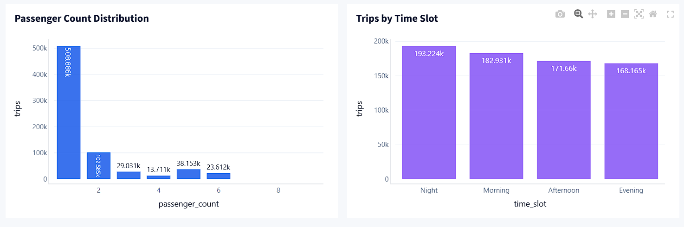

Interpretation: Most taxi trips involve small passenger counts, and trips are distributed across morning, afternoon, evening, and night slots.
Figure 3: Time Heatmap Tab - Average Duration by Day and Hour
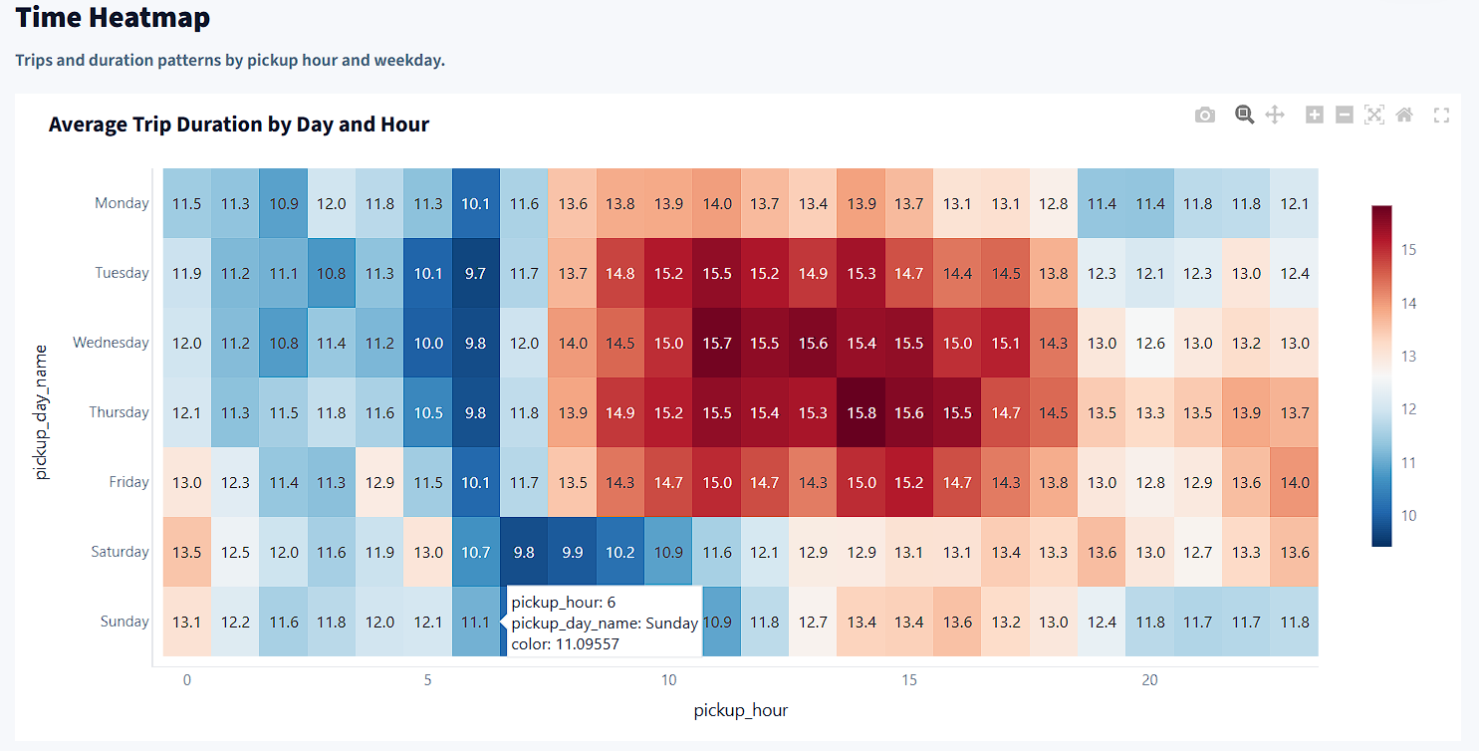

Interpretation: Pickup hour and weekday patterns help identify when trips are usually longer.
Figure 4: Time Heatmap Tab - Trips and Average Duration by Hour
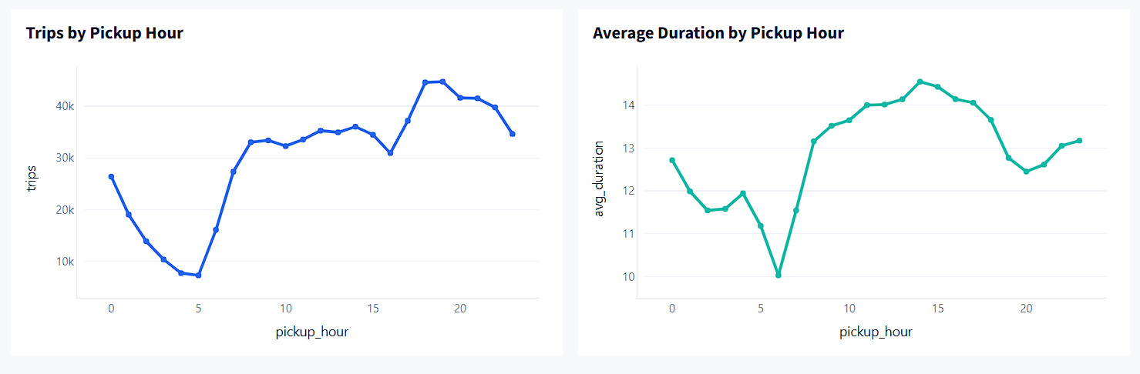

Interpretation: Hourly trip volume and average duration show whether demand and travel time change during the day.
Figure 5: Trip & Distance Tab - Distance vs Duration
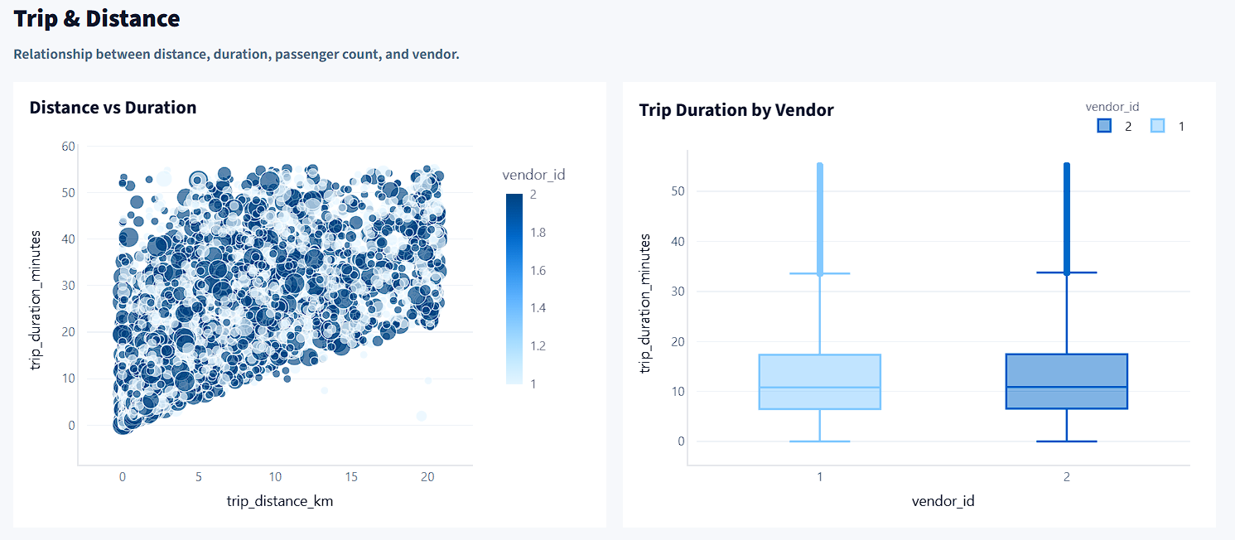

Interpretation: Longer distances usually increase trip duration, making distance one of the most important engineered features.
Figure 6: Trip & Distance Tab - Vendor, Passenger, and Rush Hour Analysis
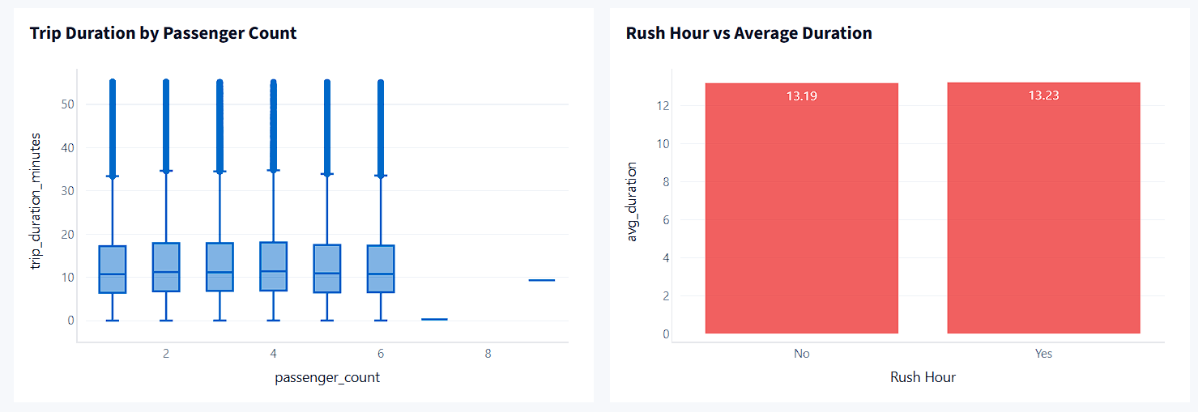

Interpretation: Vendor and passenger count give comparison views, while rush-hour duration checks traffic-related effects.
Figure 7: Location Map Tab - Pickup and Dropoff Locations
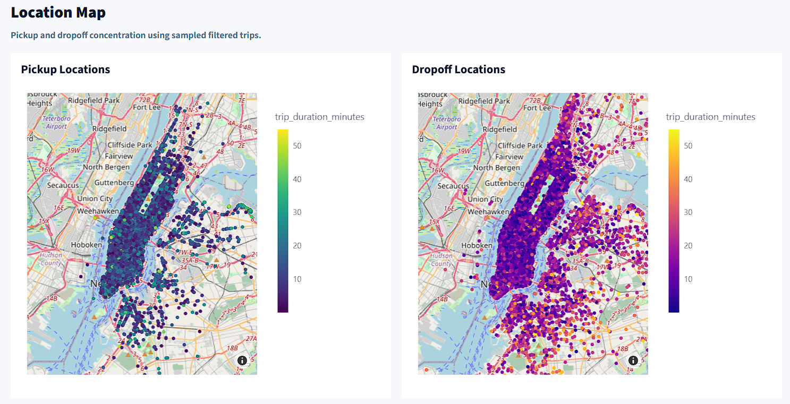

Interpretation: Pickup and dropoff points are concentrated in major NYC travel zones, so location-based features are useful.
Figure 8: Feature Creation Tab - Created Features
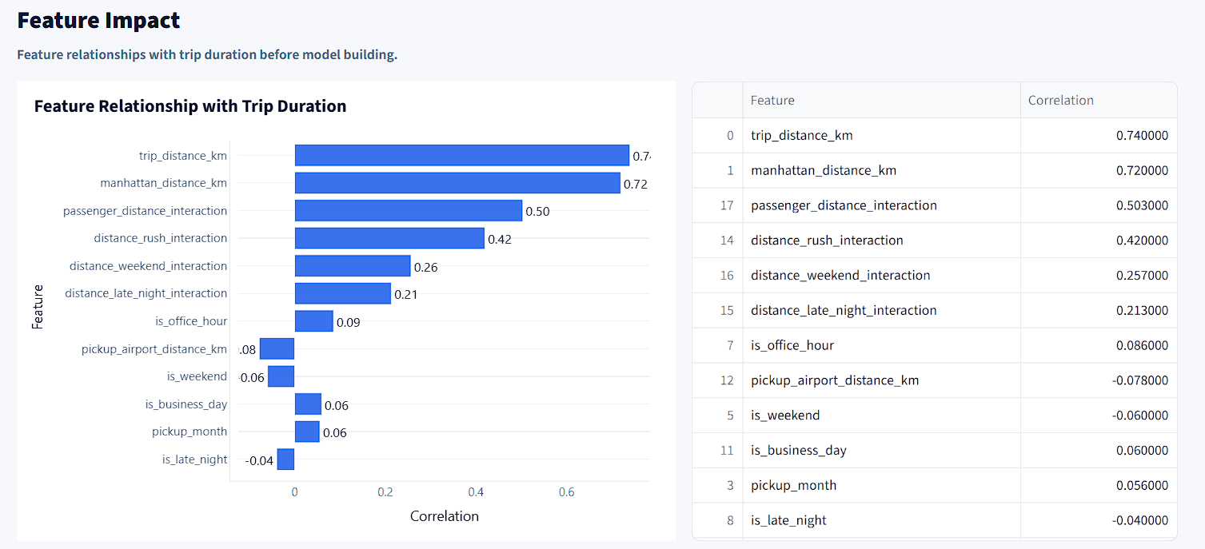

Interpretation: Datetime, distance, airport, interaction, encoding, and scaling features prepare the dataset for future model building.
Figure 9: Feature Impact Tab - Feature Relationship with Trip Duration
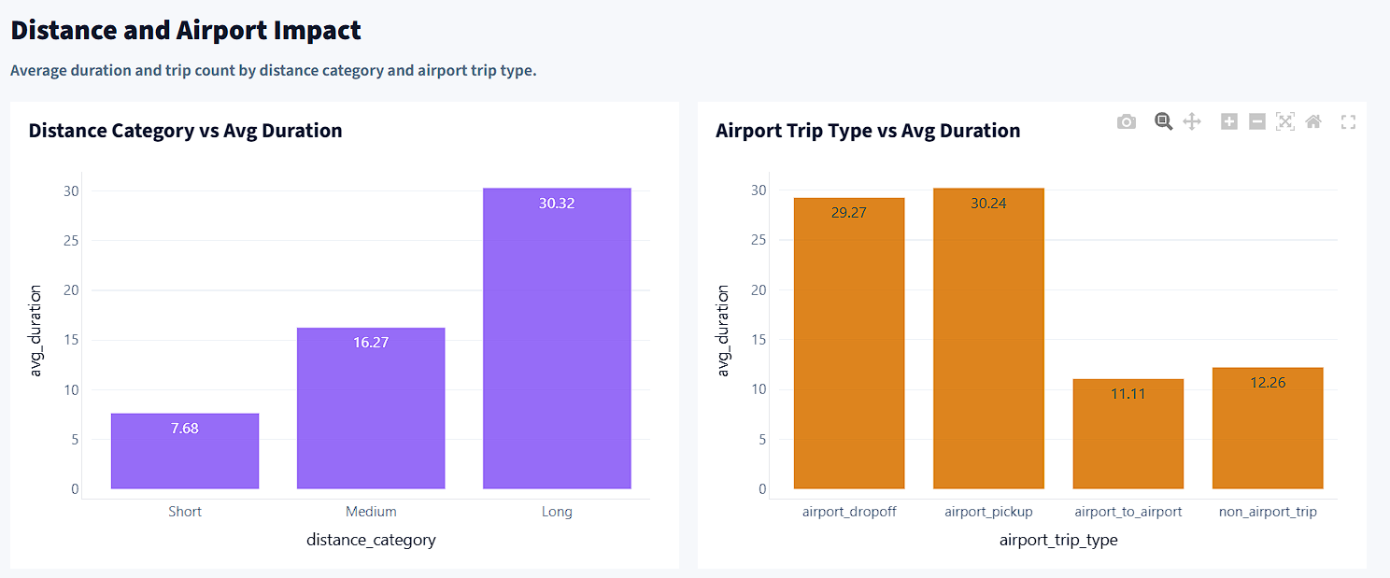

Interpretation: Distance-related features usually show stronger relationship with trip duration than simple passenger-count features.
Figure 10: Feature Impact Tab - Time, Distance, and Airport Impact
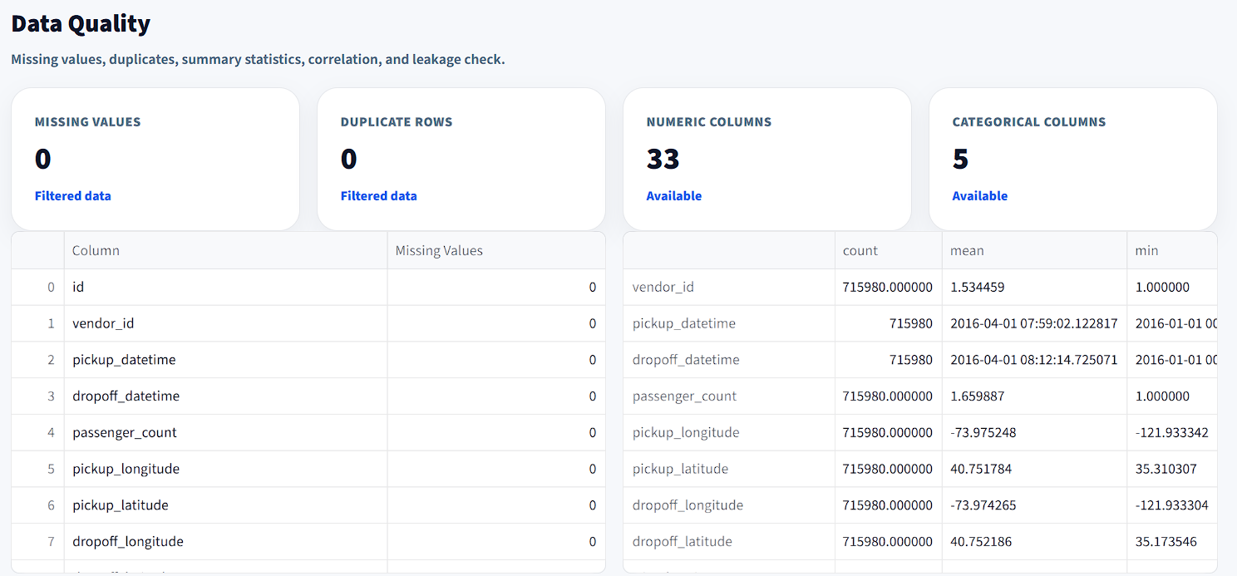

Interpretation: Time-based flags, distance categories, and airport trip type help explain duration differences.
Figure 11: Data Quality Tab - Missing Values, Summary Statistics, and Correlation

Interpretation: The dataset has no missing values in the original file, but outliers and correlation patterns still need review.
Figure 12: Data Quality Tab - Leakage Detection

Interpretation: Dropoff time and target-derived duration or speed columns must be removed before model training.

8. Feature Engineering Explanation
Feature engineering means creating useful new columns from existing data so the dashboard and future model can better understand taxi trip behavior.
Feature group | Examples | Meaning
Datetime features | pickup_hour, pickup_dayofweek, pickup_month | Captures when the trip started.
Calendar flags | is_weekend, is_business_day, is_month_start, is_month_end | Checks whether calendar timing affects trip behavior.
Peak-hour features | is_rush_hour, is_morning_peak, is_evening_peak, is_late_night | Captures traffic-related time periods.
Time grouping | time_slot | Groups trips into morning, afternoon, evening, and night.
Distance features | trip_distance_km, manhattan_distance_km | Measures straight-line and grid-style trip distance.
Location difference features | lat_diff, lon_diff, direction_angle | Captures direction and movement between pickup and dropoff points.
Airport features | is_pickup_near_airport, is_dropoff_near_airport, airport_trip_type | Identifies airport-related trips.
Interaction features | distance_rush_interaction, passenger_distance_interaction | Combines distance with time or passenger behavior.
Encoding | encoded categorical columns | Converts categories into model-readable format.
Scaling | StandardScaler, MinMaxScaler, RobustScaler | Prepares numerical features for regression algorithms.

9. Time-Series / Date-Based Feature Explanation
This dataset has pickup and dropoff datetimes, so time-based analysis is useful. The dashboard uses pickup datetime features to show how trip duration and trip volume change by hour, weekday, month, and time slot.
Feature | Simple explanation
pickup_hour | Shows hour-level trip patterns.
pickup_dayofweek / pickup_day_name | Checks which weekdays have more trips or longer trips.
pickup_month | Shows monthly trip patterns within the available date range.
is_weekend | Separates weekend trips from weekday trips.
is_rush_hour | Flags trips during morning and evening peak travel periods.
is_late_night | Captures late-night trip behavior.
time_slot | Groups hours into readable time periods.
lag/rolling features | Not included yet; they can be tested later only with a proper time-based modeling setup.

10. Feature Impact Explanation
Feature impact was checked before model building using simple numerical correlation and group-wise average trip duration. This is only pre-model feature relevance, not final model importance.
Distance-related features are expected to have the strongest relationship with trip duration. Time-based features such as rush hour, late night, and weekend flags help explain travel-time variation, but final model-based importance should be checked after training.
Passenger count may be useful, but it is usually weaker by itself compared with distance, time, and location features.

11. Leakage Notes
Data leakage happens when a model sees information that would not be available before or during prediction. This can create fake high model performance.
Column / feature | Why it is risky | Recommended action
dropoff_datetime | Trip end time is not available before trip completion. | Drop before ML.
trip_duration | Original target column. | Use only as target, not input.
trip_duration_log | Final transformed target, not an input feature. | Use only as target.
trip_duration_minutes / trip_duration_hours | Directly created from target duration. | Remove from input features.
average_speed_kmh | Uses trip duration to calculate speed. | Remove before ML.
speed_category | Created from speed, which uses trip duration. | Remove before ML.
duration_category | Created from target duration. | Use only for EDA, not ML.
trip_duration_capped / trip_duration_zscore | Created from target outlier treatment. | Use only for target handling or EDA.
Safe model training should use features available before trip completion, such as pickup datetime features, pickup and dropoff coordinates, distance features, passenger count, vendor ID, store-and-forward flag, airport features, and interaction features.

12. Business Insights
- Trip duration is highly skewed, so log transformation is useful before model building.
- Most cleaned trips are short to medium duration, with a cleaned average duration of 13.94 min.
- Distance is one of the most important business drivers of trip duration.
- Pickup hour and rush-hour flags help capture traffic-related patterns.
- Passenger count alone does not strongly explain trip duration.
- Airport-related pickup and dropoff features are useful because airport trips may have different distance and duration behavior.
- Outliers need to be reviewed because extremely long trips can distort model training.

13. Limitations
- The dataset covers January 2016 to June 2016, so it may not represent current NYC taxi behavior.
- External causes such as weather, traffic incidents, road closures, holidays, and real-time congestion are not included.
- Latitude and longitude are useful, but raw coordinates may need clustering or zone-based features for stronger modeling.
- Correlation does not prove final model importance.
- Leakage-risk columns can make a future model look better than it really is if not removed.

14. Recommendations Before Model Building
- Drop dropoff_datetime and all target-derived features before training the final model.
- Use trip_duration_log as the modeling target if the target remains highly skewed.
- Remove or cap extreme duration and distance outliers carefully.
- Use pickup datetime, distance, location, airport, vendor, passenger, and interaction features as safe inputs.
- Apply encoding and scaling only after train-test split to avoid test-data leakage.
- Compare baseline regression models before using stronger models.
- Evaluate using MAE, RMSE, R², and residual analysis.
- Check final model feature importance using model-based methods and SHAP or permutation importance after training.

15. Next Step: Model Building
The next step is to build a regression model to predict trip_duration or trip_duration_log using only leakage-safe features. Suggested models include Linear Regression, Ridge Regression, Lasso Regression, Decision Tree Regressor, Random Forest Regressor, Gradient Boosting Regressor, and XGBoost/LightGBM if available.
The final model should prioritize low prediction error and should be checked using MAE, RMSE, R², residual plots, and feature importance.

16. Final Scope Statement
This report completes the dashboard explanation for the EDA and feature engineering stage. It is suitable for review before model building because it explains the dataset, target, dashboard tabs, visual findings, feature engineering, leakage risks, business insights, limitations, and next steps.
EDA + Feature Engineering | Model building not included

