


Research Summary Study Patient Information Leaflet
Digital recordings of heart sounds in babies during the Newborn Infant Physical Examination: The babyPHONO study

We will be inviting new parents and their baby to take part in our research study after they are born. This leaflet is to help inform future parents about the possibility of being asked to take part in this research which is taking place in babies under 3 months of age at Jessop Wing. This leaflet provides a short summary, if you would like further information please get in touch via the details on the back of this leaflet.
If the research is ongoing after your baby is born you will be given time and further information to decide whether or not you want your child to take part. Participation is completely voluntary.

Why are we doing this research?
All babies are offered a ‘newborn infant physical examination’ which is sometimes called the ‘baby check’. This leaflet explains some research we are doing to see if we can make it better at finding problems with the heart.
Less than 1 in 100 babies have a problem with the structure of the heart. If we find this early, we may be able to treat it more effectively. We want to see if we can record the heart sounds of babies, to help find problems with the heart.
We are hoping to recruit at least 200 babies from Jessop Wing to take part in this research. If this study is successful, we hope that it will lead to further studies that in the future help us detect heart problems in babies more effectively.

Who are we asking to take part in this research?
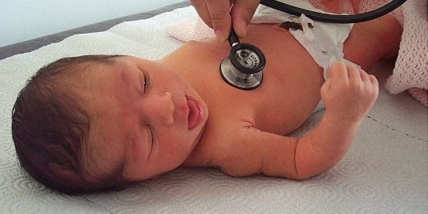
Carers of newborn babies, born at full term (more than 37 weeks gestation) who will be offered the baby check to take part.
Carers of babies younger than 3 months who are scheduled for an ultrasound of their heart (echocardiogram) will also be asked to take part.

Do you have to take part in this research?
No, taking part is your decision, and not taking part will not affect the care of you or your baby.

What will happen to you and your baby if you take part in this research?
This research aims to record the heart sounds of babies using a digital stethoscope. This is to find out whether we can use artificial intelligence to help detect heart problems from the recordings.
If you decide to take part, you will be asked to sign a consent form. A midwife, nurse or doctor will take the recording of the heart sounds using a digital stethoscope. They will do this during the full newborn physical examination, or before or after a heart scan if your baby is scheduled to have one. You will then be asked to complete a very short 6 question survey after it has finished. If your baby has a heart scan then one year later a doctor will phone you and ask you some short questions, which should take less than 15 minutes. These are to check if your baby has ever been diagnosed with a problem with their heart.
In this research study, the recording of the heart sounds will not change what happens to your baby. They will still receive the same care and any necessary scans or treatment that they would if they were not in the research study. Most babies do not need any scans or treatment.

What are the risks of this research?
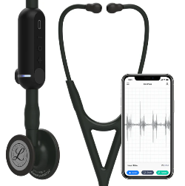
The digital stethoscope is very similar to a normal stethoscope, and does not pose any risk to your baby. Taking part in this research may mean the baby check takes around 2 to 5 minutes longer. Filling in the questionnaire afterwards and taking the phone call in a year will take a small amount of your time.
There is a risk that clinicians accidentally enter personal information into the digital stethoscope application. The information within this application will be reviewed weekly, and any personally identifiable data will be deleted by the research team to guard against this risk.

What is the benefit in taking part in this research?
Taking part in the research will not directly benefit you or your baby. However, we hope that this research will help babies born in the future by helping doctors identify problems with the heart earlier in life.

How will we use information about you and your baby?
We will need to use information from you and your baby for this research project. We will give you further information about what happens to the data from the study if you are happy to take part, after your baby has been born.

What if I have other questions about the research?
If you have any questions about the study, you can get in touch by using the e-mail address or telephone number on the back of this leaflet. Alternatively, you can ask questions to the researcher who comes to ask you to sign the consent form.

What if I have a complaint about the research?
If you are unhappy and wish to make a complaint, please contact Dr Alys Griffiths (alys.griffiths@sheffield.ac.uk) in the first instance. If you feel your complaint has not been handled in a satisfactory way you can contact Professor Heather Mortiboys (h.mortiboys@sheffield.ac.uk) or 0114 222 2290. If the complaint relates to how your personal data has been handled, you can find information about how to raise a complaint in the University’s Privacy Notice: https://www.sheffield.ac.uk/govern/data-protection/privacy/general.
If you wish to make a report of a concern or incident relating to potential exploitation, abuse or harm resulting from your involvement in this project, please contact the Designated Safeguarding Contact Dr Haris Stavroulakis (t.stavroulakis@sheffield.ac.uk). If you remain concerned, please contact the Research Ethics & Integrity Manager Lindsay Unwin (l.v.unwin@sheffield.ac.uk).

Has this research been approved by an ethics committee?
The research has been reviewed by the <Research Ethics Committee>. The reference number for the research is: 358145. Thank you for considering this research.

For further information about this research study, please contact:
E-mail: sth.babyphono@nhs.net Study phone number: +447729849599

This research study is taking place at:
Jessops Wing Hospital
Tree Root Walk, Broomhall, Sheffield, S10 2SF

This research study is sponsored by:
The University of Sheffield
Western Bank, Sheffield, S10 2TN

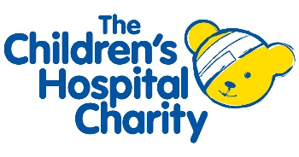
This research study is funded by:
Sheffield Children’s Hospital Charity
4 Marlborough Rd, Sheffield, S10 1DB

