**For further information about this research study**, please contact:

E-mail: [Neil.lawrence1@nhs.net](mailto:Neil.lawrence1@nhs.net) Study phone number: +447729849599

**What if I have a complaint about the research?**

If you are unhappy and wish to make a complaint, please contact Dr Alys Griffiths (alys.griffiths@sheffield.ac.uk) in the first instance. If you feel your complaint has not been handled in a satisfactory way you can contact Professor Heather Mortiboys (h.mortiboys@sheffield.ac.uk) or 0114 222 2290. If the complaint relates to how your personal data has been handled, you can find information about how to raise a complaint in the University’s Privacy Notice: https://www.sheffield.ac.uk/govern/data-protection/privacy/general.

If you wish to make a report of a concern or incident relating to potential exploitation, abuse or harm resulting from your involvement in this project, please contact the Designated Safeguarding Contact Dr Haris Stavroulakis (t.stavroulakis@sheffield.ac.uk). If you remain concerned, please contact the Research Ethics & Integrity Manager Lindsay Unwin ([l.v.unwin@sheffield.ac.uk](mailto:l.v.unwin@sheffield.ac.uk)).

Has this research been approved by an ethics committee?

The research has been reviewed by the <Research Ethics Committee>. The reference number for the research is: <research number>.

**This research study is taking place at:**

Jessops Wing Hospital

Tree Root Walk, Broomhall, Sheffield, S10 2SF

**This research study is sponsored by:**

The University of Sheffield

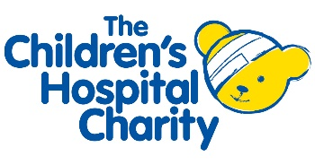Western Bank, Sheffield, S10 2TN

**This research study is funded by:**

Sheffield Children’s Hospital Charity

4 Marlborough Rd, Sheffield, S10 1DB



**Research Study:**

**Digital recordings of heart sounds in babies during the Newborn Infant Physical Examination - the babyPHONO study**

**Why are we doing this research?**

All babies are offered a ‘newborn infant physical examination’ which is sometimes called the ‘baby check’. This leaflet explains some research we are doing to see if we can make it more effective at finding problems with the heart.

Less than 1 in 100 babies have a problem with the structure of the heart. If we find this early, we may be able to treat it more effectively. We want to see if we can record the heart sounds of babies, to help detect problems with the heart.

**Why have I been offered to take part in this research?**

You have been invited to this research because you have a newborn baby, born at full term (more than 37 weeks gestation) who will be offered the baby check. All similar newborn babies are being invited to this research in this hospital on the days it is taking place.

**Do I have to take part in this research?**

No, taking part is your decision, and not taking part will not affect the care of you or your baby.

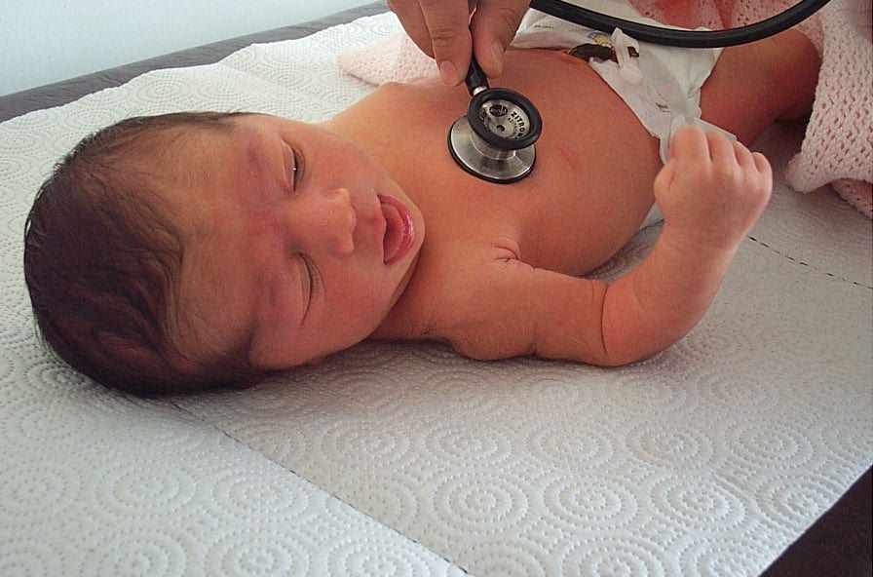

**What will happen to me and my baby if I take part in this research?**

This research study is looking to record the heart sounds of babies using a digital stethoscope. This is to find out whether we can use artificial intelligence to help detect heart murmurs from the recordings.

If you decide to take part, you will be asked to sign the consent form. The person examining your baby will take the recording of the heart sounds using a digital stethoscope. They will do this during the full newborn physical examination. You will then be asked to complete a very short 6 question survey after it has finished. One year later, a doctor will phone you and ask you some short questions, that will take less than 15 minutes. These are to check if your baby has ever been diagnosed with a problem with their heart.

In this research study, the recording of the heart sounds will not change what happens to your baby. They will still receive the same care and any necessary scans or treatment that they would if they were not in the research study. The majority of babies do not need any scans or treatment.

**What are the risks of this research?**

The digital stethoscope is very similar to a normal stethoscope, and does not pose any risk to your baby. Taking part in this research may mean the baby check takes around 2 to 5 minutes longer. Filling in the questionnaire afterwards and taking the phone call in a year will take a small amount of your time.

**What is the benefit in taking part in this research?**

Taking part in the research will not directly benefit your or your baby. However, we hope that this research will help babies born in the future.

**What will happen to the data from me and my baby?**

The recorded heart sounds and information about how old your baby is, along with any future diagnosis of heart problems will be anonymised. This information will then be freely available in an internet database for anyone to access in the future. This will allow other researchers to test the data on computer programs designed to use artificial intelligence to help detect problems with the heart.

Individual data about the ethnicity of your baby and individual responses to surveys and phone calls will be stored securely in the hospital. This data will be counted up and summarised along with other patient data, but the individual data will not be available to anyone outside of the study research team.

**What if I want myself or my baby to stop taking part in the research?**

You can withdraw your baby from the study at any time. To withdraw you can use the telephone number or e-mail address on the back of this leaflet to tell us. If you do withdraw from the research, we will speak to you about would you like us to do with any information we have already collected about you or your baby.

**What if I have other questions about the research?**

If you have any questions about the study, you can get in touch by using the e-mail address or telephone number on the back of this leaflet. Alternatively, you can ask questions to the doctor who comes to ask you to sign the consent form.

Thank you for considering this research.