NHS Blood bottle label printing instructions:

Any ‘ICE’ blood bottle label printer can be used as a normal printer. You just need to use a word document, and adjust the margins of the page appropriately to match the size of the sticker.
See the second page of this document for an example that works at a SY trust.
At this particular hospital, the LP 2824 Plus ICE label printer is used – you need to find your printer’s model number and google the sticker label size.
This label printer uses 60mm labels that are 100mm long. You therefore want to create a document that is 60mm wide and 100mm long. You then want to add margins of 5mm to each edge to ensure it prints.
Open a new word document and search for ‘page setup’
This will give you a new dialogue.
Go to the ‘paper’ tab, and set width to 60mm and Height to 100mm.
Go to the ‘margins’ tab of the same dialogue, and set all margins to 0.5cm (top, bottom, left and right)
The resulting setup will then show you how much space you have for printing
Within that word document, you can then copy and paste the following design:

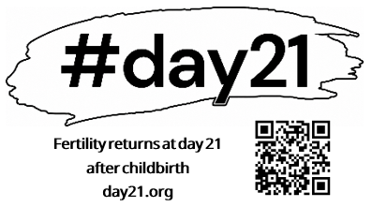

Page 2 of this document is set to the settings required for the LP 2824 Plus ICE label printer, so if this is the same printer for you, you can simply print page 2 of this document.

PLEASE NOTE: Word will likely throw you some errors when you print, asking you if you are sure you want to print in relation to margins and paper size. Simply override these errors and force it to print. After printing , check the QR code works from the actual label using your own phone.
If you are struggling with this process, please get in touch for some help or support: postnatalcontraception@gmail.com

