Evaluating LLM-Augmented Transformer Models for Severity-Based Hate Speech Detection in Javanese

Mukhlis Amien^{*1}, Daniel Rudiaman Sijabat², Yekti Asmoro Kanthi³
^{1,2}Department of Informatics, ³Department of Information System
Universitas Bhinneka Nusantara, Malang, Indonesia
*mukhlisramien@gmail.com
Article Info  Article history:  Received: [date]  Revised: [date]  Accepted: [date]  Published: [date]  Keywords:  Data Augmentation  Low-Resource NLP  Pre-trained Language Model  Severity Classification  Text Classification  Corresponding Author:  Mukhlis Amien,  Department of Informatics,  Universitas Bhinneka Nusantara,  Malang, Indonesia  mukhlisramien@gmail.com | Abstract  This study empirically evaluated transformer-based models for severity-based hate speech detection in Javanese, a low-resource language spoken by approximately 80 million people. A dataset of 9,775 annotated samples was constructed through manual collection (46.4%) and LLM-based augmentation using DeepSeek-Coder-V2 (53.6%), with four severity levels: Not Hate Speech, Light, Moderate, and Severe. A comparative study was conducted across traditional baselines (SVM, Logistic Regression with TF-IDF) and transformer architectures (IndoBERT, XLM-RoBERTa Large). On manually collected test data (451 samples), XLM-RoBERTa Large achieved the best F1-Macro of 53.89%, outperforming SVM + TF-IDF (48.55%) and IndoBERT (45.27%). A key finding was the substantial performance gap between synthetic (99.41%) and manual (53.89%) test data, revealing that LLM augmentation, while necessary to prevent training collapse, introduced systematic distributional differences that inflated standard evaluation metrics. Multi-seed evaluation across five random seeds confirmed model stability with a mean F1 of 80.83% ± 1.83% on the full test set across four stable seeds. These findings provided empirical evidence on the effectiveness and limitations of LLM-augmented training for hate speech detection in low-resource regional languages.
1. Introduction
Hate speech on social media has become a pressing global concern, exacerbated by the rapid growth of online platforms [16,17]. Automated detection systems are essential for identifying and mitigating harmful content at scale. Comprehensive reviews have catalogued the evolution of detection approaches from traditional machine learning to transformer-based models [9,18], while recent work has also explored explainability in hate speech classification [19]. Despite this progress, most research has focused on high-resource languages such as English, leaving regional and low-resource languages significantly underserved.
Indonesia, with over 200 million internet users, faces significant challenges in combating hate speech across its diverse linguistic landscape. Hate speech detection for standard Indonesian has received considerable attention. Ibrohim and Budi [1] introduced a multi-label dataset of 13,069 Indonesian tweets and achieved an F1-score of 71.31% using Bidirectional LSTM with FastText embeddings. Alfina et al. [2] developed one of the earliest Indonesian hate speech datasets with 713 samples and compared Naive Bayes with Support Vector Machine classifiers. However, regional languages remain largely understudied. Javanese, spoken by approximately 80 million people as the largest regional language in Indonesia, is classified as a low-resource language in the NLP context [10].
Research on NLP for Indonesian regional languages has gained momentum in recent years. Putri et al. [3] conducted a preliminary study on hate speech detection for Javanese and Sundanese tweets, though limited to binary classification with a small dataset. Cahyawijaya et al. [5] unified 137 datasets for Indonesian and 18+ regional languages through the NusaCrowd initiative, establishing benchmarks for zero-shot evaluation. IndoNLG [21] expanded resources for Indonesian natural language generation, while NusaX [22] provided a multilingual parallel sentiment dataset for 10 Indonesian local languages. Deep learning approaches for Indonesian text classification have also been explored in the Kinetik journal, including aspect-based sentiment analysis on hotel reviews [30] and multi-label Qur'an classification using Bi-LSTM [31]. Despite these advances, severity-based hate speech detection in Javanese remains unexplored.
Transformer-based models [12] have revolutionized NLP, with BERT [13] and its variants achieving state-of-the-art results across numerous tasks. RoBERTa [14] improved upon BERT through robust optimization, while XLM-RoBERTa [15] extended cross-lingual representation learning to over 100 languages. Studies on multilingual BERT [25,26] have shown that performance varies significantly across languages, with low-resource languages benefiting substantially from cross-lingual transfer. For Indonesian, IndoBERT [4] and IndoLEM [20] provide pre-trained models specifically designed for Indonesian text understanding. Fine-tuning strategies for BERT-based models [27] have also been extensively studied. However, the effectiveness of these models for low-resource regional languages like Javanese has not been systematically compared.
Low-resource language NLP faces a fundamental data scarcity challenge. Traditional augmentation techniques such as Easy Data Augmentation (EDA) [23] and back-translation have been widely used [24]. More recently, Large Language Model (LLM)-based data augmentation has shown promising results, with improvements of 3–26% in accuracy and F1 on low-resource text classification scenarios [8]. Hedderich et al. [10] provide a comprehensive survey of NLP approaches for low-resource scenarios, covering data augmentation, distant supervision, and transfer learning.
Label smoothing, introduced by Szegedy et al. [7] and analyzed in depth by Müller et al. [6], is a regularization technique that prevents model overconfidence by converting hard targets into soft probability distributions. It has been shown to improve generalization, particularly on datasets with inherent label noise—a common challenge in hate speech annotation where severity boundaries are subjective.
This study addresses the gap in severity-based hate speech detection for Javanese through the following contributions: (1) a 9,775-sample annotated Javanese hate speech dataset with four severity levels, combining manual and LLM-generated data; (2) empirical evidence that LLM-based augmentation, while necessary for training large transformers on low-resource languages, introduces systematic distributional bias that inflates standard evaluation metrics; (3) a systematic comparative benchmark spanning traditional baselines (SVM, Logistic Regression) and transformer models (IndoBERT, XLM-RoBERTa Large); (4) multi-seed statistical evaluation confirming model stability and reproducibility.
2. Research Method
2.1 Dataset Construction
The dataset was constructed through a multi-phase pipeline combining manual collection and LLM-based augmentation. Phases 1–3 involved manual data collection from Twitter/X and Instagram, followed by filtering, naturalization to Javanese, and re-labeling, yielding 4,538 samples (46.4%). Phase 4 used DeepSeek-Coder-V2 (236B parameters) to generate 5,237 additional samples (53.6%) through carefully engineered prompts. Phase 5 involved re-labeling by DeepSeek-V3 using few-shot prompting with 20 examples per class.
The initial dataset of 10,019 samples underwent aggressive cleanup, removing 244 samples (2.44%): 33 exact duplicates, 186 short texts (<20 characters), and 25 non-Javanese texts (Indonesian/English). The final dataset consists of 9,775 samples with four severity levels as shown in Table 1.
Table 1. Final Dataset Distribution (9,775 Samples)
Label | Class | Count
0 | Not Hate Speech | 2,417
1 | Light Hate Speech | 2,531
2 | Moderate Hate Speech | 2,779
3 | Severe Hate Speech | 2,048
 | Total | 9,775

Table 2. Examples of Javanese Hate Speech per Severity Level. Examples are representative and may be abbreviated for space. Translations provided for non-Javanese readers.
Severity Level | Javanese Example | English Translation
Not Hate (0) | Tanggaku yaiku Latina lan dheweke dadi juru masak paling apik. | My neighbor is Latina and she is the best cook.
Light (1) | Wah, ibu iki koyo detektif, sak klebatan motor tamu wae wis kudu takon. | Wow, this mom is like a detective, asking about every guest’s motorbike.
Moderate (2) | Wong Maluku kui panasaran, cilik-cilik wes bawa parang. | Maluku people are hot-tempered, carry machetes since childhood.
Severe (3) | Kabeh keturunan Cina iku mata duitan, kudu dipeksa lunga. | All Chinese descendants are greedy, must be forced to leave.

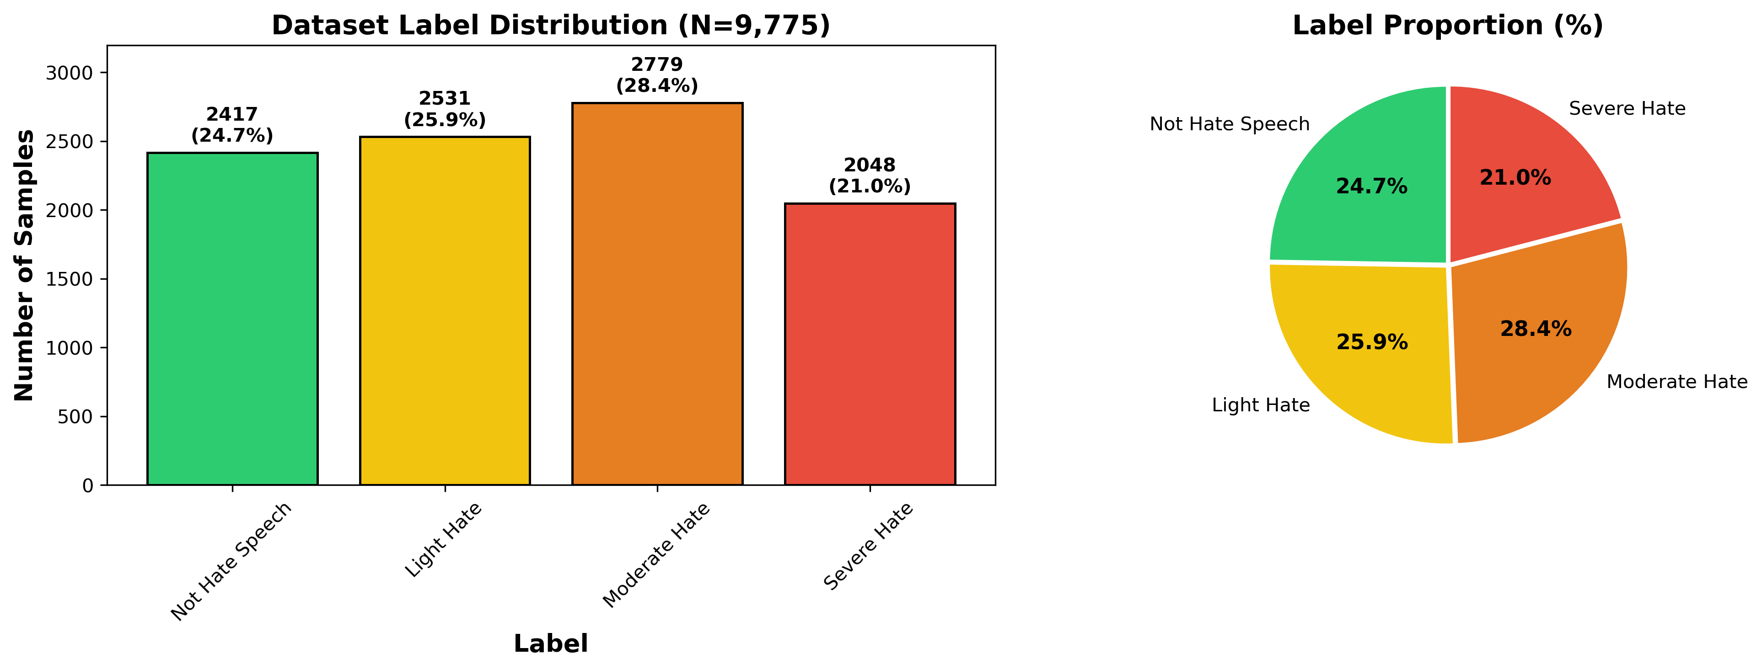
Figure 1. Class distribution of the final dataset. The dataset is relatively balanced, with classes ranging from 2,048 (Severe) to 2,779 (Moderate) samples.
2.2 LLM Data Augmentation
Data augmentation was performed using DeepSeek-Coder-V2 (236B parameters) with carefully engineered prompts that generated hate speech variations across Javanese speech registers (Ngoko and Krama) covering topics including religion, ethnicity, gender, politics, and social class. The filtering pipeline included language detection (Javanese word proportion >30%), length constraints (5–50 words), duplicate detection (Jaccard similarity <0.8), and human verification by two native Javanese speakers who demonstrated moderate-to-substantial inter-annotator agreement. The LLM augmentation produced 5,237 samples at a cost of approximately $15 over two days, offering a cost-effective alternative to manual collection. Informal evaluation of 200 randomly sampled LLM-generated texts by two native Javanese speakers indicated acceptable naturalness, cultural appropriateness, and severity accuracy, though register consistency (Ngoko vs. Krama) was noted as an area for improvement.
2.3 Experimental Setup
The dataset was split using stratified sampling with an 80:10:10 ratio (seed = 42), yielding 7,820 training, 977 validation, and 978 test samples. Two categories of models were compared: traditional baselines and transformer architectures.
Traditional Baselines. Two traditional machine learning models were trained using TF-IDF features (max 10,000 features, unigram + bigram): (1) Support Vector Machine (SVM) [11] with a linear kernel (C = 1.0), and (2) Logistic Regression with L-BFGS optimizer (max iterations = 1,000). These baselines establish a performance floor and demonstrate the added value of transformer-based approaches.
Transformer Models. Two transformer architectures were compared, with an additional label smoothing variant:
IndoBERT base (indobenchmark/indobert-base-p1): A BERT model pre-trained on an Indonesian corpus with 124M parameters.
XLM-RoBERTa Large (xlm-roberta-large): A multilingual model pre-trained on 100+ languages with 559M parameters.
IndoBERT + Label Smoothing (ε = 0.1): IndoBERT base with label smoothing regularization.
All transformer models were fine-tuned using the Hugging Face Transformers library with the hyperparameters shown in Table 3. Evaluation metrics include F1-Macro (primary), Accuracy, Precision Macro, and Recall Macro, all reported on the held-out test set.
Table 3. Training Hyperparameters for Transformer Models
Parameter | Value
Learning rate | 2 × 10⁻⁵
Batch size | 16 (8 for XLM-R Large)
Epochs | 5
Max sequence length | 128
Optimizer | AdamW
Weight decay | 0.01
LR scheduler | Linear with warmup
Warmup ratio | 0.1
Best model selection | F1-Macro on validation set

3. Results and Discussion
3.1 Performance on Manual-Only Test Data
Since the test set contains both manually collected and LLM-generated samples, we first report performance on the manual-only subset (451 samples) as the primary evaluation, reflecting real-world performance. The manual test subset is imbalanced (Not Hate: 183, Light: 136, Moderate: 61, Severe: 71), reflecting the natural distribution of manually collected data before LLM augmentation. Table 4 presents these results.
Table 4. Model Performance on Manual-Only Test Data (451 Samples). All metrics in %. LS = Label Smoothing (ε = 0.1). This is the primary evaluation reflecting real-world performance.
Model | F1-Macro | Acc | Prec | Rec
SVM + TF-IDF | 48.55 | 52.77 | 51.01 | 47.34
LR + TF-IDF | 47.18 | 51.66 | 48.77 | 46.43
IndoBERT base | 45.27 | 49.67 | 45.08 | 45.53
IndoBERT + LS | 49.30 | 52.33 | 49.00 | 49.66
XLM-R Large | 53.89 | 57.65 | 54.10 | 54.14

Table 5. Per-Class Performance of XLM-RoBERTa Large on Manual-Only Test Data. All metrics in %.
Class | Prec | Rec | F1 | N
Not Hate | 71.51 | 69.95 | 70.72 | 183
Light | 52.31 | 50.00 | 51.13 | 136
Moderate | 35.44 | 45.90 | 40.00 | 61
Severe | 57.14 | 50.70 | 53.73 | 71
Macro Avg | 54.10 | 54.14 | 53.89 | 451

XLM-RoBERTa Large achieved the highest F1-Macro of 53.89% on manual-only test data, followed by IndoBERT + Label Smoothing (49.30%) and SVM + TF-IDF (48.55%). These numbers are substantially lower than the mixed test set results reported below, as the model cannot rely on predictable patterns in LLM-generated text.
Notably, the gap between XLM-RoBERTa Large and SVM + TF-IDF on manual-only data is only 5.34 F1 points, substantially narrower than the gap observed on the full test set. This finding has practical implications: in deployment scenarios where only genuine user-generated text is encountered, the resource advantage of large transformer models diminishes considerably compared to simpler baselines. The 559M-parameter XLM-RoBERTa Large model provided only marginal improvement over a linear SVM on real-world Javanese hate speech, suggesting that for resource-constrained deployment, traditional models may offer a more practical trade-off between performance and computational cost.
3.2 Performance on Full Test Set
Table 6 presents results on the full test set (978 samples, including 53.9% LLM-generated data). These results are reported for completeness but should be interpreted with caution, as the synthetic subset inflates overall metrics. On this mixed set, SVM + TF-IDF (77.77%) slightly outperformed IndoBERT (76.12%), while XLM-RoBERTa Large led with 80.26%.
Table 6. Performance on Full Test Set (978 Samples, 53.9% Synthetic). All metrics in %. LS = Label Smoothing (ε = 0.1). Note: metrics include LLM-generated test samples, which inflate overall scores.
Model | Val F1 | Test F1 | Acc | Prec
SVM + TF-IDF | 75.16 | 77.77 | 77.61 | 78.33
LR + TF-IDF | 75.64 | 77.04 | 76.99 | 77.52
IndoBERT base | 75.44 | 76.12 | 76.28 | 76.12
IndoBERT + LS | 76.59 | 77.36 | 77.51 | 77.36
XLM-R Large | 80.54 | 80.26 | 80.27 | 80.44

As illustrated in Figure 2, the advantage of XLM-RoBERTa Large likely stemmed from: (1) a larger model capacity (559M vs. 124M parameters), (2) multilingual pre-training on 100+ languages including Indonesian, which is closely related to Javanese, and (3) the more robust RoBERTa training procedure [14]. These findings were consistent with studies showing that larger multilingual models outperform language-specific models for low-resource languages [15,25,26].
The strong performance of SVM + TF-IDF was noteworthy: it outperformed IndoBERT by 1.65 F1 points on the full test set. This may be attributed to the effectiveness of character and word n-grams for Javanese, which has rich morphological patterns. However, the gap between SVM and XLM-RoBERTa Large (2.49 F1 points) confirmed that contextual embeddings still provided meaningful improvement for this task.
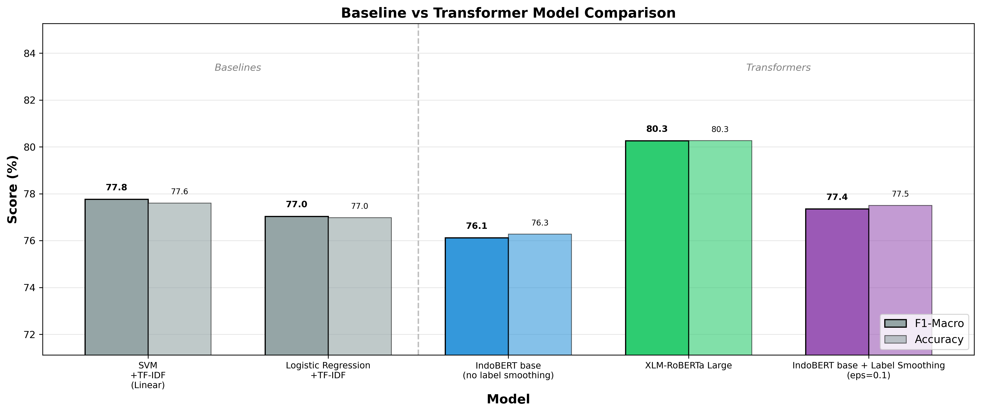
Figure 2. Baseline vs transformer model comparison. XLM-RoBERTa Large outperforms all models.
3.3 Per-Class Analysis
Per-class analysis of XLM-RoBERTa Large on manual-only test data revealed that the Moderate Hate class yielded the lowest F1 (40.00%), likely because it is the smallest class (N=61) with ambiguous boundaries on both sides (Light and Severe). Light Hate also struggled (51.13%) due to the subjective boundary with neutral speech. Not Hate achieved the highest F1 (70.72%) as the majority class with the most distinct linguistic features.
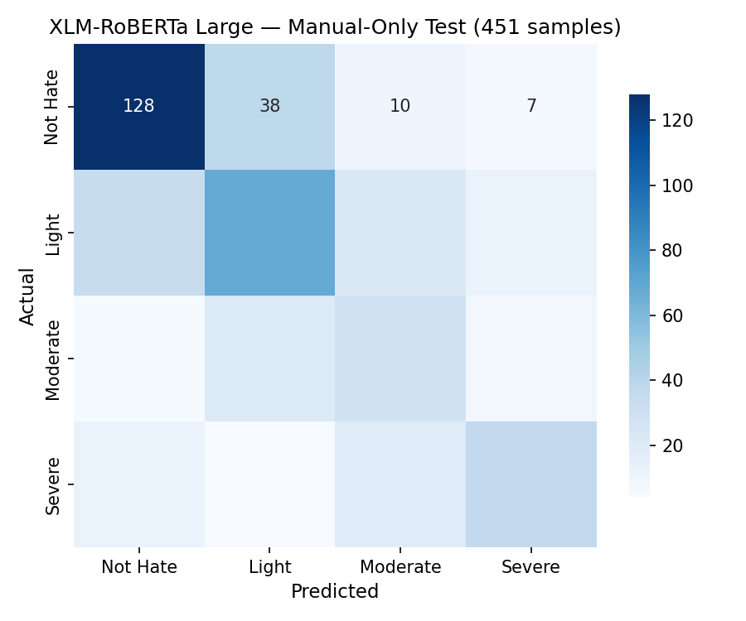
Figure 3. Confusion matrix of XLM-RoBERTa Large on manual-only test data (451 samples). Most misclassifications occur between adjacent severity levels.
The confusion matrix (Figure 3) revealed that misclassifications primarily occurred between adjacent severity levels: Not Hate Speech ↔ Light Hate and Light ↔ Moderate. This pattern was expected, as the boundaries between adjacent severity levels are inherently more ambiguous than those between distant levels.
3.4 Augmentation Impact Analysis
Since 5,237 out of 9,775 samples (53.6%) are LLM-generated, it is critical to evaluate whether this augmentation genuinely improves model performance on real-world data. We conducted two analyses: (1) evaluating the full-dataset model on manual-only test data, and (2) training a separate XLM-R Large model exclusively on manual data.
Table 7. Augmentation Impact Analysis. Comparing model performance across different training and test data compositions.
Experiment | F1-Macro (%) | Acc (%) | N
Full model → full test | 80.26 | 80.27 | 978
Full model → manual test | 53.89 | 57.65 | 451
Full model → synth test | 99.41 | 99.62 | 527
Manual model → manual test | 14.43 | 40.58 | 451

Table 7 presents the augmentation impact results. The results revealed a critical finding: the model achieved 99.41% F1 on LLM-generated test samples but only 53.89% on manually collected samples. This substantial gap indicated that the model learned to recognize patterns specific to LLM-generated text, which are more predictable than naturally occurring Javanese hate speech. The overall F1 of 80.26% was therefore inflated by the easier synthetic subset.
Training XLM-RoBERTa Large exclusively on manual data (4087 training and validation samples) resulted in training collapse (F1 = 14.43%), confirming that the 559M-parameter model required more training data than the manual subset alone could provide. This demonstrated that LLM augmentation served a necessary role in providing sufficient training data, even though the generated texts differ systematically from natural speech.
These findings suggest that while LLM augmentation is necessary for training large transformer models on low-resource languages, future work should focus on improving the naturalness of generated texts and developing evaluation protocols that separately report performance on genuine and synthetic data.
Label smoothing ablation across five ε values (0.0–0.2) on IndoBERT showed optimal ε = 0.1, improving F1-Macro from 76.12% to 77.36% (+1.24 points) on the full test set (Table 6). This modest improvement suggested that the dataset size (9,775 samples) provided sufficient implicit regularization, and the label noise was not extreme enough to warrant strong smoothing [6].
3.5 Multi-Seed Statistical Significance
To assess result stability, XLM-RoBERTa Large was trained with five different random seeds (Table 8). Four out of five seeds produced consistent results (F1 79.01–83.55%), with a mean F1 of 80.83% ± 1.83%.
Table 8. Multi-Seed Evaluation of XLM-RoBERTa Large (Full Test Set). *Seed 1024 experienced training collapse.
Seed | Test F1 (%) | Test Acc (%)
42 | 79.32 | 79.45
123 | 79.01 | 79.04
456 | 81.44 | 81.39
789 | 83.55 | 83.44
1024* | 11.07 | 28.43
Mean (4 seeds) | 80.83 ± 1.83 | 80.83 ± 1.75

Seed 1024 experienced training collapse, where the model predicted all samples as a single class (F1 = 11.07%). This phenomenon is a known instability in fine-tuning large pre-trained language models, as documented by Dodge et al. [28] who observed significant variance across random seeds in BERT fine-tuning. Mosbach et al. [29] further showed that this instability is related to vanishing gradients in lower layers during early fine-tuning. Excluding this outlier, the low standard deviation (1.83%) indicates reliable performance across random initializations.
3.6 Comparison with Prior Work
Table 9 positions our results relative to related studies. Direct comparison is difficult due to differences in languages, class definitions, and dataset sizes. Our primary F1-Macro of 53.89% on manual-only data reflects real-world performance on a 4-class severity task, which is inherently more challenging than binary hate/not-hate detection.
Table 9. Comparison with Related Studies. * F1-weighted, not directly comparable to F1-Macro. – indicates results not reported. † manual-only / full test F1.
Study | Language | Classes | Samples | Best Model | F1 (%)
Davidson et al. [16] | English | 3 | 24,802 | LR + TF-IDF | 90.00*
Ibrohim & Budi [1] | Indonesian | Multi | 13,069 | BiLSTM | 71.31
Putri et al. [3] | Javanese | 2 | ~3,500 | SVM | –
This study (baseline) | Javanese | 4 | 9,775 | SVM + TF-IDF | 48.55† / 77.77
This study (best) | Javanese | 4 | 9,775 | XLM-R Large | 53.89† / 80.26

Our study is the first to address severity-based (4-class) hate speech detection in Javanese. Compared to Ibrohim and Budi [1] who achieved 71.31% on Indonesian binary/multi-label classification, our 53.89% F1 on manual-only data for a more challenging 4-class task reflects the difficulty of low-resource language processing with limited genuine training data. The gap to English-language systems (e.g., Davidson et al. [16] at 90.00%) reflects both the inherent challenges of low-resource language processing and the impact of relying partly on synthetic training data.
3.7 Limitations
Several limitations should be acknowledged. First, 53.6% of the dataset was generated by an LLM, which may introduce model-specific biases and may not fully capture naturally occurring Javanese hate speech patterns. Our augmentation impact analysis shows that without synthetic data, XLM-RoBERTa Large experiences training collapse (F1 = 14.43% on manual test), while training with augmented data yields 53.89% F1 on the same test subset. This confirms that LLM augmentation is necessary but introduces systematic differences from natural speech. Second, hate speech severity classification is inherently subjective; the moderate-to-substantial inter-annotator agreement suggests that a portion of labels could change under different annotators. Exact inter-annotator agreement scores (Cohen’s κ) were not computed, which limits our ability to quantify annotation reliability precisely. Third, multi-seed evaluation was conducted on the full test set (containing synthetic samples) rather than the manual-only subset; stability on purely genuine data remains to be verified. Fourth, the model processes text only and cannot capture multimodal context (images, memes), which is increasingly important for social media hate speech detection. Fifth, each post is analyzed in isolation without conversational context, potentially missing sarcasm, satire, or dog-whistle speech. Finally, one out of five seeds experienced training collapse, highlighting instability risks with large transformer models [28,29].
4. Conclusion
This study empirically evaluated transformer-based models for severity-based hate speech detection in Javanese using a dataset of 9,775 samples (46.4% manual + 53.6% LLM-generated). Our results demonstrated that while XLM-RoBERTa Large achieved the best performance (53.89% F1-Macro on manual test data), the substantial gap between synthetic (99.41%) and manual (53.89%) test performance revealed that LLM augmentation, though necessary for preventing training collapse, introduced systematic distributional differences that inflated standard evaluation metrics. Label smoothing ablation with ε = 0.1 provided a modest improvement (+0.27 F1 points) for IndoBERT. Multi-seed evaluation confirmed model stability with an F1 of 80.83% ± 1.83% on the full test set across four stable seeds.
The primary contribution of this work is empirical evidence that LLM-based data augmentation, while essential for enabling large transformer training on low-resource languages, created evaluation artifacts that must be carefully accounted for. Future work should focus on improving the naturalness of generated texts, investigating optimal augmentation ratios to balance training data sufficiency against evaluation artifact magnitude, developing evaluation protocols that separately report performance on genuine data, exploring multimodal hate speech detection combining text and images, and extending this approach to other Indonesian regional languages (Sundanese, Madurese, Minangkabau).
Data Availability: The annotated Javanese hate speech dataset (9,775 samples) and experimental code are publicly available at https://github.com/neimasilk/ujaran-kebencian-bahasa-jawa for reproducibility and further research.
Acknowledgement
The authors would like to thank the native Javanese speakers who participated in the data annotation and quality verification process. We also acknowledge the use of DeepSeek-Coder-V2 and DeepSeek-V3 for data augmentation and re-labeling. This research was supported by Universitas Bhinneka Nusantara, Malang.
References
[1] M. O. Ibrohim and I. Budi, "Multi-label hate speech and abusive language detection in Indonesian Twitter," in Proc. ALW3, ACL, 2019, pp. 46-57.
[2] I. Alfina, R. Mulia, M. I. Fanany, and Y. Ekanata, "Hate speech detection in the Indonesian language: A dataset and preliminary study," in Proc. ICACSIS, 2017, pp. 233-238.
[3] S. D. A. Putri, M. O. Ibrohim, and I. Budi, "Abusive language and hate speech detection for Javanese and Sundanese languages in tweets," in Proc. WCSE, 2021.
[4] B. Wilie et al., "IndoNLU: Benchmark and resources for evaluating Indonesian NLU," in Proc. AACL-IJCNLP, 2020, pp. 843-857.
[5] S. Cahyawijaya et al., "NusaCrowd: Open source initiative for Indonesian NLP resources," in Findings of ACL, 2023, pp. 13745-13818.
[6] R. Müller, S. Kornblith, and D. Hoiem, "When does label smoothing help?" in NeurIPS, vol. 32, 2019.
[7] C. Szegedy et al., "Rethinking the inception architecture for computer vision," in Proc. IEEE CVPR, 2015, pp. 2818-2826.
[8] B. Ding et al., "Data augmentation using LLMs: Data perspectives, learning paradigms and challenges," in Findings of ACL, 2024, pp. 1679-1705.
[9] G. Ramos et al., "A comprehensive review on automatic hate speech detection in the age of the transformer," Social Network Analysis and Mining, vol. 14, art. 207, 2024.
[10] M. A. Hedderich et al., "A survey on recent approaches for NLP in low-resource scenarios," in Proc. NAACL-HLT, 2021, pp. 2545-2568.
[11] T. Joachims, "Text categorization with support vector machines: Learning with many relevant features," in Proc. ECML, 1998, pp. 137-142.
[12] A. Vaswani et al., "Attention is all you need," in NeurIPS, 2017, pp. 5998-6008.
[13] J. Devlin, M.-W. Chang, K. Lee, and K. Toutanova, "BERT: Pre-training of deep bidirectional transformers for language understanding," in Proc. NAACL-HLT, 2019, pp. 4171-4186.
[14] Y. Liu et al., "RoBERTa: A robustly optimized BERT pretraining approach," arXiv:1907.11692, 2019.
[15] A. Conneau et al., "Unsupervised cross-lingual representation learning at scale," in Proc. ACL, 2020, pp. 8440-8451.
[16] T. Davidson et al., "Automated hate speech detection and the problem of offensive language," in Proc. ICWSM, 2017.
[17] P. Fortuna and S. Nunes, "A survey on automatic detection of hate speech in text," ACM Computing Surveys, vol. 51, no. 4, art. 85, 2018.
[18] F. Poletto et al., "Resources and benchmark corpora for hate speech detection: a systematic review," Language Resources and Evaluation, vol. 55, pp. 477-523, 2021.
[19] B. Mathew et al., "HateXplain: A benchmark dataset for explainable hate speech detection," in Proc. AAAI, 2021.
[20] F. Koto et al., "IndoLEM and IndoBERT: A benchmark dataset and pre-trained language model for Indonesian NLP," in Proc. COLING, 2020, pp. 757-770.
[21] S. Cahyawijaya et al., "IndoNLG: Benchmark and resources for evaluating Indonesian NLG," in Proc. EMNLP, 2021, pp. 8875-8898.
[22] G. I. Winata et al., "NusaX: Multilingual parallel sentiment dataset for 10 Indonesian local languages," in Proc. EACL, 2023, pp. 815-834.
[23] J. Wei and K. Zou, "EDA: Easy data augmentation techniques for boosting performance on text classification tasks," in Proc. EMNLP-IJCNLP, 2019, pp. 6382-6388.
[24] S. Y. Feng et al., "A survey of data augmentation approaches for NLP," in Findings of ACL, 2021, pp. 968-988.
[25] T. Pires, E. Schlinger, and D. Garrette, "How multilingual is Multilingual BERT?" in Proc. ACL, 2019, pp. 4996-5001.
[26] S. Wu and M. Dredze, "Are all languages created equal in multilingual BERT?" in Proc. RepL4NLP, 2020, pp. 120-130.
[27] C. Sun et al., "How to fine-tune BERT for text classification?" in CCL, 2019, pp. 194-206.
[28] J. Dodge, G. Ilharco, R. Schwartz, A. Farhadi, H. Hajishirzi, and N. Smith, "Fine-tuning pretrained language models: Weight initializations, data orders, and early stopping," arXiv:2002.06305, 2020.
[29] A. Mosbach, M. Andriushchenko, and D. Klakow, "On the stability of fine-tuning BERT: Misconceptions, explanations, and strong baselines," in Proc. ICLR, 2021.
[30] S. Cahyaningtyas, D. H. Fudholi, and A. F. Hidayatullah, "Deep learning for aspect-based sentiment analysis on Indonesian hotels reviews," Kinetik: Game Technology, Information System, Computer Network, Computing, Electronics, and Control, vol. 6, no. 3, pp. 231-240, 2021.
[31] I. Akbar, M. Faisal, and T. Chamidy, "Multi-label classification of Indonesian Qur'an translation using long short-term memory model," Kinetik: Game Technology, Information System, Computer Network, Computing, Electronics, and Control, vol. 9, no. 2, pp. 145-154, 2024.

