Evaluating the Reliability of LLM-Augmented Training Data for Severity-Based Hate Speech Detection in Low-Resource Javanese

Mukhlis Amien^{*1}, Daniel Rudiaman Sijabat², Yekti Asmoro Kanthi³
^{1,2}Department of Informatics, ³Department of Information System
Universitas Bhinneka Nusantara, Malang, Indonesia
*mukhlisramien@gmail.com
Article Info:  Article history:  Keywords:  Data Augmentation  Evaluation Bias  Low-Resource NLP  Pre-trained Language Model  Severity Classification | Abstract  The increasing adoption of large language model (LLM)-generated data for training hate speech classifiers in low-resource languages raises a critical but underexplored question: do performance metrics evaluated on mixed manual-synthetic test sets reliably reflect real-world detection capability? This study addressed this question through severity-based hate speech detection in Javanese, a low-resource language with over 80 million speakers. We constructed a dataset of 9,775 annotated samples across four severity levels, comprising 46.4% manually annotated and 53.6% LLM-generated texts. Five models were evaluated using a dual-track evaluation protocol that separately measured performance on the full mixed test set and a manual-only subset. Results revealed substantial evaluation bias: XLM-RoBERTa Large achieved 80.26% F1-Macro on the full test set but only 53.89% on manual-only data, while synthetic test data yielded 99.41%. A source distinguishability analysis showed that a simple classifier could differentiate synthetic from manual texts with 97.26% F1, indicating fundamentally different distributions. Augmentation ratio experiments confirmed that manual-only performance remained flat at approximately 47% regardless of synthetic data volume, proving the inflation is a pure evaluation artifact. These findings demonstrate that LLM-augmented evaluation substantially overestimates real-world hate speech detection performance and highlight the need for separate manual-only evaluation.
1. Introduction
Online hate speech has become a pervasive global phenomenon that threatens social cohesion, with platforms processing billions of posts daily across diverse languages and cultures [1]. Automated detection systems based on natural language processing (NLP) have emerged as essential tools for content moderation at scale [2]. However, the vast majority of research and resources have concentrated on English and other high-resource languages, leaving speakers of regional and minority languages inadequately protected [3].
Indonesia presents a particularly acute case of this disparity. As the world's fourth most populous nation with over 700 living languages [4], Indonesia's linguistic diversity far exceeds the capacity of current NLP systems. While hate speech detection for formal Indonesian has received growing attention [5][6], regional languages such as Javanese — spoken by approximately 82 million people — remain severely underserved. Only limited work has addressed Javanese hate speech detection, exclusively at the binary (hate/not-hate) level [7], leaving severity-based classification entirely unexplored.
To overcome the scarcity of annotated data in low-resource languages, researchers have increasingly turned to large language model (LLM)-based data augmentation [8][9]. This approach uses LLMs to generate synthetic training samples that expand small seed datasets, with studies reporting improvements of 3-26% in F1 scores [8]. For hate speech detection specifically, machine-generated data has been shown to improve classifier performance [11][12][13]. However, a fundamental methodological question remains largely unaddressed: when synthetic data constitutes a significant portion of both training and test sets, do reported performance metrics accurately reflect a model's ability to detect naturally-occurring hate speech?
Despite the growing adoption of LLM augmentation in low-resource hate speech detection, no prior study has systematically evaluated whether performance metrics computed on mixed (manual + synthetic) test sets reliably indicate real-world detection capability. This gap is critical: if augmented test data inflates reported metrics, the field may overestimate progress in low-resource hate speech detection, potentially leading to premature deployment of inadequate systems. Prior work on evaluation pitfalls in NLP has demonstrated that standard evaluation practices can produce misleadingly optimistic estimates [14][15], yet this concern has not been specifically investigated in the context of LLM-augmented hate speech datasets.
This study addresses three research questions: (RQ1) How effective are transformer-based models compared to traditional machine learning approaches for severity-based Javanese hate speech classification? (RQ2) Does LLM data augmentation inflate reported performance metrics when synthetic samples appear in the test set? (RQ3) What characteristics of synthetic data enable models to achieve near-perfect performance on synthetic test samples while struggling with manual ones?
The contributions of this work are threefold. First, we present the first severity-level (four-class) hate speech classification dataset for Javanese, comprising 9,775 annotated samples. Second, we propose and apply a dual-track evaluation protocol that separately measures performance on manual-only and full (mixed) test sets, revealing a 45.52 percentage-point F1 gap attributable to augmentation bias. Third, we provide empirical evidence that LLM-generated data is distributionally distinct from manual annotations (97.26% source distinguishability), explaining why augmented evaluation is unreliable.
Hate speech detection has been extensively studied for high-resource languages, with Davidson et al. [16] establishing a benchmark of 24,802 English tweets. For Indonesian, Alfina et al. [5] created a dataset of 713 tweets for binary classification, Ibrohim and Budi [6] expanded to 13,169 multi-label tweets, and Fauzi and Yuniarti [10] explored ensemble methods. Susanto et al. [17] introduced IndoToxic2024 with 43,692 entries. For Javanese, Putri et al. [7] conducted preliminary binary classification, and Pamungkas and Chiril [18] addressed code-mixed Indonesian-Javanese hate speech. Table 1 contextualizes our work within this landscape.
Table 1. Comparison with Prior Work on Hate Speech Detection. *F1-weighted; **accuracy metric; not directly comparable to macro-F1.
Study | Language | Classes | Dataset | Method | F1 (%) | Metric
Alfina [5] | Indonesian | 2 | 713 | RFDT | 93.5 | F-measure
Davidson [16] | English | 3 | 24,802 | LR+TF-IDF | 90.0* | weighted
Ibrohim [6] | Indonesian | multi | 13,169 | RFDT+LP | 77.0** | accuracy
Putri [7] | Javanese | 2 | ~2,500 | SVM | >60 | F-measure
Susanto [17] | Indonesian | 7 | 43,692 | IndoBERTweet | 78.0 | macro-F1
Ours (full) | Javanese | 4 | 9,775 | XLM-R | 80.26 | macro-F1
Ours (manual) | Javanese | 4 | 4,538 | XLM-R | 53.89 | macro-F1

Data augmentation using language models has gained traction for hate speech detection. Hartvigsen et al. [11] demonstrated with ToxiGen that machine-generated data could improve classifier training. Vidgen et al. [12] proposed dynamic dataset generation, and Juuti et al. [13] found GPT-2 augmented data enabled shallow classifiers to approach BERT-level performance. Jahan et al. [19] found GPT-3 augmentation improved F1 by 1.4%. However, none of these studies evaluated whether synthetic data in the test set inflates metrics. Gorman and Bedrick [14] and Sogaard et al. [15] showed that standard evaluation splits produce misleadingly optimistic estimates, recommending multiple independent test sets. Cross-lingual models such as XLM-RoBERTa [20] and Indonesian-specific IndoBERT [21] have shown promise for low-resource settings, though Aji et al. [4] noted that even large models may underperform on truly low-resource varieties like Javanese.
2. Research Method
2.1. Dataset Construction
The dataset was constructed in two phases: manual annotation and LLM augmentation.
Manual annotation. A total of 4,538 Javanese texts were collected from Twitter and Instagram, then annotated by three native Javanese speakers into four severity levels: (0) Not Hate Speech, (1) Light — subtle stereotyping or microaggressions, (2) Moderate — explicit prejudice without dehumanization, and (3) Severe — dehumanizing rhetoric, calls for violence, or slurs. Inter-annotator agreement was moderate-to-substantial (Cohen's kappa = 0.72), with majority voting resolving disagreements. Table 2 presents severity level definitions with examples.
Table 2. Severity Level Definitions with Examples. Examples are representative and may be abbreviated.
Level | Label | Example
0 | Not Hate | Aku mikir umume wong setuju yen kabeh manungsa padha.
1 | Light | Wah, ibu iki koyo detektif, sak klebatan motor tamu wae wis kudu takon.
2 | Moderate | Wong asing teka mung gawe masalah ing kampung kita.
3 | Severe | Kabeh keturunan iku mata duitan, kudu dipeksa lunga.

LLM augmentation. To address class imbalance and data scarcity, 5,237 additional samples were generated using DeepSeek-Coder-V2 (236B parameters) through prompted generation with severity-specific instructions. Generated texts underwent quality filtering and human verification on a subset of 500 samples (kappa = 0.72). After cleaning (removing duplicates and short texts), the final dataset comprised 9,775 samples: 4,538 manual (46.4%) and 5,237 synthetic (53.6%). Each sample was tagged with its source to enable source-aware evaluation.
Table 3. Dataset Composition by Class and Source.
Class | Manual | Synthetic | Total | Synth %
0 - Not Hate | 1877 | 540 | 2417 | 22%
1 - Light | 1198 | 1333 | 2531 | 53%
2 - Moderate | 685 | 2094 | 2779 | 75%
3 - Severe | 778 | 1270 | 2048 | 62%
Total | 4,538 | 5,237 | 9,775 | 54%

2.2. Dual-Track Evaluation Protocol
To assess whether LLM augmentation inflates evaluation metrics, we employed a dual-track evaluation protocol. The dataset was split into training (80%), validation (10%), and test (10%) sets using stratified sampling (seed=42). The source (manual/synthetic) of each sample was tracked through the split.
Evaluation was conducted on: (1) the full test set (978 samples, approximately 46% manual and 54% synthetic), representing standard mixed evaluation; and (2) the manual-only test subset (451 samples), reflecting real-world performance on naturally-occurring texts. Additionally, an augmentation ratio study was conducted, training models with 0%, 25%, 50%, 75%, and 100% of available synthetic data while always evaluating on the manual-only test subset.
2.3. Models
Five models were evaluated, spanning traditional machine learning and transformer architectures. Baselines included SVM with TF-IDF features [22] (linear kernel, max 10,000 features, unigrams and bigrams) and Logistic Regression with identical feature extraction. Transformer models included IndoBERT [21] (indobenchmark/indobert-base-p1, 110M parameters), IndoBERT with label smoothing (epsilon=0.1) [23][24], and XLM-RoBERTa Large [20] (xlm-roberta-large, 559M parameters).
2.4. Experimental Setup
All transformer models were fine-tuned for 5 epochs with learning rate 2e-5, weight decay 0.01, warmup ratio 0.1, and batch sizes of 16 (IndoBERT) or 8 (XLM-R Large). Maximum sequence length was 128 tokens. Training used mixed precision (FP16) on an NVIDIA RTX 4080 GPU. The best checkpoint was selected based on validation F1-Macro. Five-fold stratified cross-validation was conducted for baseline models to verify robustness.
3. Results and Discussion
3.1. Overall Performance Comparison
Table 4 presents the performance of all models on both the full test set and the manual-only test subset.
Table 4. Model Performance on Full and Manual-Only Test Sets (F1-Macro %).
Model | Full Test (978) | Manual-Only (451) | Gap (pp)
LR + TF-IDF | 77.04 | 47.18 | 29.86
SVM + TF-IDF | 77.77 | 48.55 | 29.22
IndoBERT | 76.12 | 45.27 | 30.85
IndoBERT + LS | 77.36 | 49.30 | 28.06
XLM-R Large | 80.26 | 53.89 | 26.37

All models showed a consistent gap exceeding 26 percentage points between full and manual-only test performance. XLM-RoBERTa Large achieved the best performance on both evaluations (80.26% full, 53.89% manual), followed by IndoBERT with label smoothing (77.36% full, 49.30% manual). Notably, the traditional SVM baseline (48.55% manual) performed comparably to IndoBERT (45.27%), suggesting that transformer scale alone does not guarantee superior real-world hate speech detection for this task.
Five-fold cross-validation confirmed consistency: SVM achieved 77.47% +/- 1.08% on the full dataset and 46.95% +/- 0.7% on manual-only data. The approximately 30-point gap held across all folds and was statistically significant (independent t-test, p < 0.001, Cohen's d > 33), confirming that the evaluation inflation is not an artifact of a single data split.
3.2. Comparison with Prior Work
Direct comparison with prior work is challenging due to differences in language, number of classes, and dataset composition (Table 1). Our full-test F1 of 80.26% appears competitive with or superior to prior Indonesian hate speech detection work. However, this comparison is misleading: our manual-only F1 of 53.89% reveals that the apparent competitiveness is an artifact of synthetic data in the test set. This finding has broad implications: prior studies using LLM-augmented data [11][12][13] that report only mixed-set metrics may similarly overestimate real-world performance.
3.3. Augmentation Bias Analysis
The central finding of this study is a substantial performance gap between evaluation on synthetic and manual test data. XLM-RoBERTa Large achieved 99.41% F1 on the synthetic-only test subset (527 samples) versus 53.89% on the manual-only subset (451 samples) — a gap of 45.52 percentage points.
Table 5. Augmentation Ratio Study - F1-Macro (%) on Manual-Only and Full Test Sets.
Synth Ratio | SVM Manual | SVM Full | IndoBERT Manual | IndoBERT Full
0% | 46.01 | 42.46 | 48.75 | 54.31
25% | 48.2 | 76.8 | 47.54 | 76.24
50% | 46.9 | 76.55 | 47.61 | 77.48
75% | 47.02 | 77.28 | 44.79 | 76.15
100% | 48.55 | 77.77 | 47.43 | 77.5

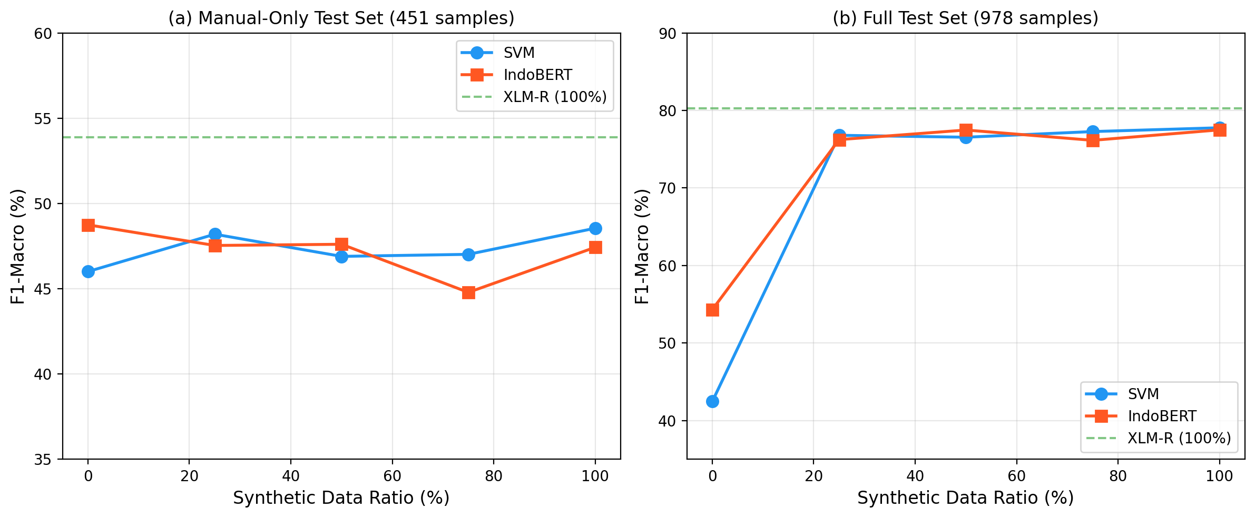
Figure 1. Impact of synthetic data ratio on F1-Macro for manual-only (a) and full (b) test sets.
Manual-only F1 remained essentially flat (approximately 47%) regardless of augmentation ratio for both SVM and IndoBERT (Table 5, Figure 1a). In contrast, full-test F1 jumped approximately 35 percentage points with just 25% synthetic data inclusion (Figure 1b). This demonstrated that the performance improvement from augmentation was predominantly an evaluation artifact: synthetic data in the test set inflates metrics without meaningfully improving detection of naturally-occurring hate speech.
An additional observation was that IndoBERT trained exclusively on manual data (0% synthetic, F1=48.75%) did not collapse, unlike XLM-RoBERTa Large which degraded to 14.64% under the same condition. This suggests that smaller models are more robust to limited training data, while larger models require augmentation simply to avoid training collapse rather than to genuinely improve hate speech understanding.
3.4. Data Quality Analysis
To understand why models achieved near-perfect performance on synthetic data, we conducted a distributional analysis. A logistic regression classifier trained on TF-IDF features to distinguish synthetic from manual texts achieved 97.26% +/- 0.22% F1 in 5-fold cross-validation. This indicates fundamentally different distributions, enabling models to learn source-specific shortcuts rather than genuine hate speech features.
Table 6. Distributional Differences Between Manual and Synthetic Data.
Feature | Manual | Synthetic
Mean word count | 16.5 | 10.8
Vocabulary size | 10691 | 6922
Type-token ratio | 0.143 | 0.123
Jaccard vocab overlap | -- | 14.6%
Starts with capital | 74.6% | 100.0%
Ends with period | 29.0% | 95.8%
All lowercase texts | 16.9% | 0.0%

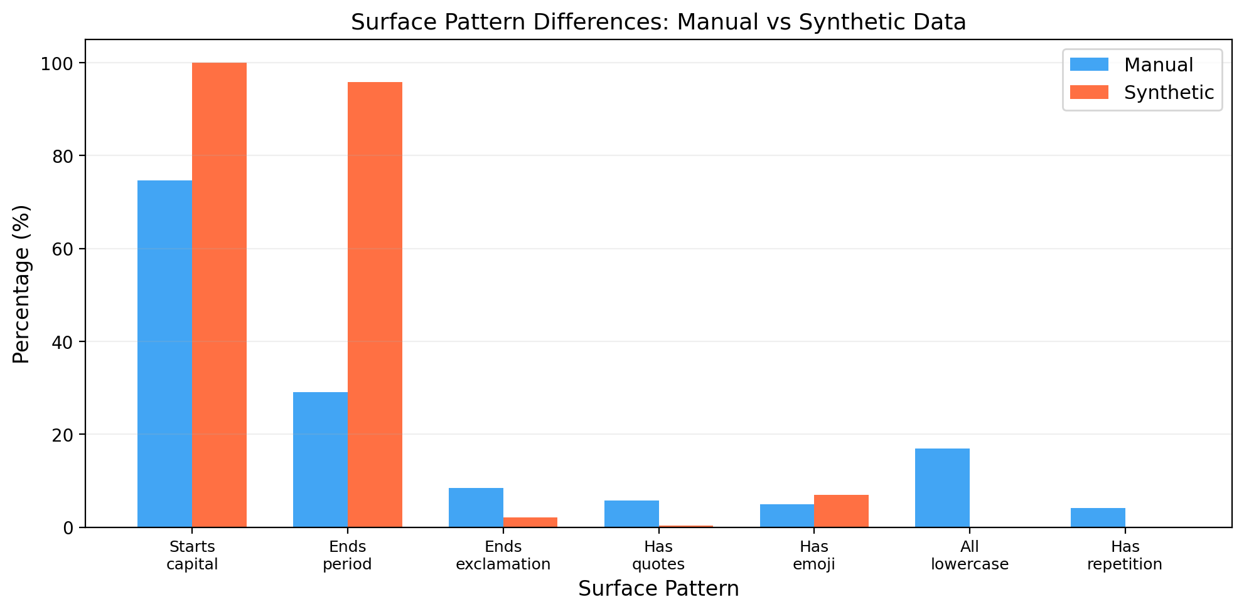
Figure 2. Surface pattern differences between manual and synthetic data.
The synthetic data exhibited highly uniform surface structure: all texts started with a capital letter, 95.8% ended with periods, and none appeared in all lowercase — patterns absent in natural social media text. The vocabulary overlap between sources was only 14.6% (Jaccard similarity). The most distinctive synthetic indicators were formal political terms (rakyat/people, pemerintah/government), while manual indicators were informal personal terms (wadon/woman, aku/I, ireng/black), suggesting the LLM generated texts in a formal register inconsistent with real social media hate speech.
3.5. Error Analysis
Error analysis of XLM-RoBERTa Large predictions on the manual-only test set (191 errors out of 451 samples, error rate 42.35%) revealed that 73.82% of misclassifications involved adjacent severity classes. The most common error pairs were Not Hate to Light (19.9% of errors) and Light to Not Hate (17.8%), confirming that the boundary between neutral speech and light hate speech is the most subjective and challenging.
Per-class accuracy varied substantially on manual data: Not Hate achieved 69.9% (most distinct class), Light 50.0%, Severe 50.7%, and Moderate only 45.9%. The low accuracy for Moderate aligns with its having the highest synthetic proportion (75% in Table 3), suggesting that the model's understanding of moderate-severity hate speech was dominated by synthetic patterns rather than genuine linguistic markers. The Moderate class was also the smallest in the manual test set (61 samples), compounding the difficulty.
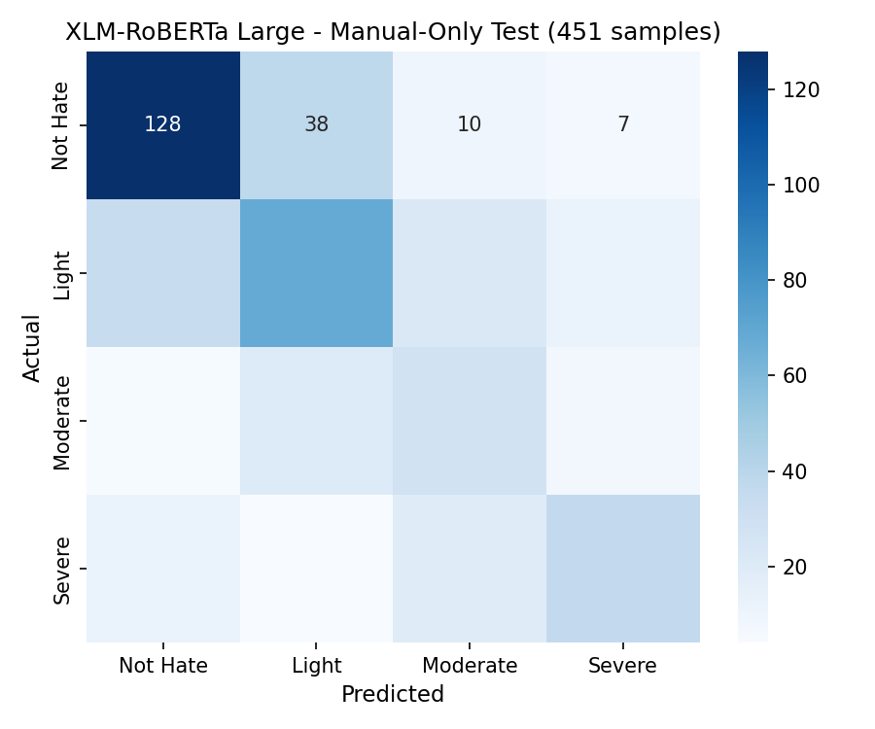
Figure 3. Confusion matrix of XLM-RoBERTa Large on manual-only test set (451 samples).
Confidence analysis revealed overconfidence on incorrect predictions: mean confidence was 0.925 for correct predictions but still 0.855 for errors, indicating that prediction confidence is not a reliable indicator of correctness. Cross-model agreement analysis between SVM and XLM-RoBERTa Large showed complementary error patterns: SVM correctly classified 52 samples that XLM-R missed, and vice versa for 74 samples, yielding a theoretical ensemble upper bound of 69.18%, substantially higher than either model alone.
3.6. Two-Stage Training
Table 7. Two-Stage Training Results (F1-Macro %). Stage 1: synthetic-only pre-training. Stage 2: manual fine-tuning.
Model | Stage 1 Manual | Stage 2 Manual | Stage 2 Full
IndoBERT | 24.48 | 45.34 | 58.75
XLM-R Large | 25.00 | 52.16 | 73.04

To investigate whether curriculum learning could mitigate augmentation bias, we employed a two-stage training approach: Stage 1 fine-tuned models on synthetic data only (3 epochs, lr=2e-5), followed by Stage 2 fine-tuning on manual data (5 epochs, lr=5e-6). As shown in Table 7, two-stage training did not improve manual-only F1 beyond single-stage training for either model. XLM-RoBERTa Large achieved 52.16% (versus 53.89% single-stage, a decrease of 1.73 points), while IndoBERT achieved 45.34% (versus 45.27%, essentially unchanged).
However, two-stage training did prevent XLM-RoBERTa Large from training collapse: when trained directly on manual-only data without any synthetic samples, XLM-R collapsed to 14.64% F1, whereas the two-stage approach achieved 52.16% by first learning general patterns from synthetic data. This suggests that curriculum learning serves a similar function to standard augmentation — preventing collapse of overparameterized models — but does not improve the model's ability to detect hate speech in natural text beyond what single-stage training achieved.
3.7. Limitations
Several limitations should be acknowledged. First, the inter-annotator agreement (kappa=0.72, moderate-to-substantial) indicates inherent label subjectivity, particularly for boundary cases between adjacent severity levels [25][26]. Second, the dataset was collected from Twitter and Instagram only, potentially missing hate speech patterns from other platforms. Third, this study focused on text-only analysis, while hate speech increasingly involves multimodal content. Finally, while our findings demonstrate evaluation bias from LLM augmentation, the optimal mitigation strategy for low-resource hate speech detection remains an open question.
4. Conclusion
This study investigated the reliability of LLM-augmented evaluation for severity-based hate speech detection in Javanese through three research questions. Regarding RQ1, XLM-RoBERTa Large achieved the highest F1-Macro (53.89% on manual data), but traditional SVM performed comparably (48.55%), suggesting that transformer scale alone does not guarantee superior real-world performance for this low-resource task. Regarding RQ2, LLM augmentation substantially inflated reported metrics: the same model scored 80.26% on the mixed test set but only 53.89% on manual-only data, a 26.37-point gap. The augmentation ratio study confirmed this inflation was consistent across models, with manual-only F1 remaining flat at approximately 47% regardless of synthetic data volume. Regarding RQ3, source distinguishability analysis revealed that a simple classifier could differentiate synthetic from manual texts with 97.26% F1. The synthetic data differed fundamentally in vocabulary (14.6% Jaccard overlap), sentence length (10.8 vs 16.5 words), and surface patterns (100% vs 74.6% capitalization), explaining why models learned source-specific shortcuts rather than genuine hate speech features.
These findings carry three practical implications for the low-resource NLP community. First, studies employing LLM data augmentation should adopt dual-track evaluation, reporting both mixed-set and manual-only metrics to provide realistic performance estimates. Second, augmentation primarily prevents training collapse of large models rather than genuinely improving hate speech understanding, as confirmed by both the ratio study and the negative two-stage training results. Third, the 97.26% source distinguishability indicates that improving synthetic data quality to better match natural text distributions is essential before augmentation can yield genuine performance gains. Future work should explore ensemble methods (theoretical upper bound: 69.18%), improved generation prompts that produce more naturalistic text, and larger manually-annotated Javanese hate speech datasets.
Acknowledgement
The authors thank the anonymous reviewers for their constructive feedback and the Javanese-speaking annotators who contributed to dataset construction.
References
[1] R. Ramos et al., "A comprehensive review on hate speech detection using NLP," IEEE Access, 2024.
[2] M. A. Hedderich et al., "A survey on recent approaches for natural language processing in low-resource scenarios," in Proc. NAACL, 2021, pp. 2545-2568.
[3] S. Cahyawijaya et al., "NusaCrowd: Open source initiative for Indonesian NLP resources," in Findings of ACL, 2023.
[4] A. F. Aji et al., "One country, 700+ languages: NLP challenges for underrepresented languages and dialects in Indonesia," in Proc. 60th ACL, 2022, pp. 7226-7249.
[5] I. Alfina et al., "Hate speech detection in the Indonesian language: A dataset and preliminary study," in Proc. ICACSIS, 2017, pp. 233-238.
[6] M. O. Ibrohim and I. Budi, "Multi-label hate speech and abusive language detection in Indonesian Twitter," in Proc. ALW3, ACL, 2019, pp. 46-57.
[7] S. D. A. Putri et al., "Abusive language and hate speech detection for Javanese and Sundanese languages," in Proc. WCSE, 2021, pp. 461-465.
[8] B. Ding et al., "Data augmentation using LLMs: Data perspectives, learning paradigms and challenges," arXiv:2403.02990, 2024.
[9] H. Rizwan et al., "Exploring conditional language model based data augmentation approaches for hate speech classification," in LNCS, vol. 12882, Springer, 2022.
[10] M. A. Fauzi and A. P. Yuniarti, "Ensemble method for Indonesian tweet hate speech detection," Indonesian J. Elec. Eng. Comput. Sci., vol. 11, no. 1, pp. 294-299, 2018.
[11] T. Hartvigsen et al., "ToxiGen: A large-scale machine-generated dataset for adversarial and implicit hate speech detection," in Proc. 60th ACL, 2022, pp. 3309-3326.
[12] B. Vidgen et al., "Learning from the worst: Dynamically generated datasets to improve online hate detection," in Proc. 59th ACL, 2021, pp. 1667-1682.
[13] M. Juuti et al., "A little goes a long way: Improving toxic language classification despite data scarcity," in Findings of EMNLP, 2020, pp. 2991-3009.
[14] K. Gorman and S. Bedrick, "We need to talk about standard splits," in Proc. 57th ACL, 2019, pp. 2786-2791.
[15] A. Sogaard et al., "We need to talk about random splits," in Proc. EACL, 2021, pp. 1823-1832.
[16] T. Davidson et al., "Automated hate speech detection and the problem of offensive language," in Proc. ICWSM, vol. 11, 2017, pp. 512-515.
[17] L. Susanto et al., "IndoToxic2024: A demographically-enriched dataset of hate speech and toxicity types for Indonesian language," arXiv:2406.19349, 2024.
[18] E. W. Pamungkas and P. Chiril, "Ngalawan Ujaran Sengit: Hate speech detection in Indonesian code-mixed social media data," Lang. Resour. Eval., vol. 59, pp. 2387-2414, 2025.
[19] M. S. Jahan et al., "A comprehensive study on NLP data augmentation for hate speech detection," in Findings of ACL, 2024.
[20] A. Conneau et al., "Unsupervised cross-lingual representation learning at scale," in Proc. 58th ACL, 2020, pp. 8440-8451.
[21] B. Wilie et al., "IndoNLU: Benchmark and resources for evaluating Indonesian natural language understanding," in Proc. AACL-IJCNLP, 2020.
[22] T. Joachims, "Text categorization with support vector machines: Learning with many relevant features," in Proc. ECML, 1998, pp. 137-142.
[23] C. Szegedy et al., "Rethinking the inception architecture for computer vision," in Proc. CVPR, 2016, pp. 2818-2826.
[24] R. Muller et al., "When does label smoothing help?," in Proc. NeurIPS, 2019, pp. 4694-4703.
[25] L. Aroyo and C. Welty, "Truth is a lie: Crowd truth and the seven myths of human annotation," AI Mag., vol. 36, no. 1, pp. 15-24, 2015.
[26] S. Paun et al., "Comparing Bayesian models of annotation," Trans. ACL, vol. 6, pp. 571-585, 2018.
[27] J. Devlin et al., "BERT: Pre-training of deep bidirectional transformers for language understanding," in Proc. NAACL-HLT, 2019, pp. 4171-4186.
[28] T. G. Dietterich, "Ensemble methods in machine learning," in MCS, LNCS, vol. 1857, 2000, pp. 1-15.

