Temples Without Villages: Candi and the Hidden Settlement Geography of Volcanic Java
Mukhlis Amien¹
Go Frendi Gunawan¹
¹Lab Data Sains, Universitas Bhinneka Nusantara, Malang, Indonesia
Corresponding author: Mukhlis Amien (amien@ubhinus.ac.id)
ORCID: 0000-0002-1848-167X
Keywords: Java, candi, volcanic taphonomy, settlement geography, inscriptions, Hindu-Buddhist archaeology, Insulindia, buried landscapes
Judul (Bahasa Indonesia): Candi Tanpa Desa: Candi dan Geografi Permukiman yang Tersembunyi di Jawa Vulkanik
Kata kunci: Jawa, candi, tafonomi vulkanik, geografi permukiman, prasasti, arkeologi Hindu-Buddha, Nusantara, lanskap terkubur

Introduction: What Survives and What is Lost
The scholarly understanding of pre-modern Java rests on what the island’s volcanic landscape has permitted to survive. Lombard’s magisterial portrait of the “Javanese crossroads” drew upon inscriptions, temple complexes, and literary texts–all products of elite patronage, all rendered in durable media (Lombard 1990). His three-volume synthesis demonstrated how Java functioned as a crossroads of Indian, Chinese, Islamic, and European cultural currents. Yet Lombard himself was aware that this portrait was drawn almost entirely from the records of courts and religious institutions–the very sources most likely to survive in durable media. The villages, markets, workshops, and domestic spaces that constituted the lived experience of the vast majority of Javanese–built in wood, bamboo, and thatch–have left almost no archaeological trace.
Lombard’s third volume, Les réseaux, traced the commercial and cultural networks that converged on Java, but beneath these layers of Indian, Chinese, and Islamic influence he repeatedly acknowledged a deeper stratum: the monde du village, the Austronesian substrate of rice cultivation, ancestor worship, and communal organisation that persisted through every successive wave of external contact (Lombard 1990: vol. 3, esp. chaps 9–10). Yet this foundational layer is almost entirely absent from the documentary record that Lombard himself relied upon. The very sources that made his synthesis possible–court inscriptions, temple reliefs, Chinese trade records–are products of the elite networks, not of the villages. The volcanic landscape of Java offers a material explanation for this silence.
This evidential asymmetry is not accidental. Java hosts 34 active volcanoes that have been burying the landscape at measurable rates for millennia. When Wolters described the “localization” of Indic culture in Southeast Asia–the creative process by which imported cultural elements were absorbed and transformed by local societies–he worked primarily from inscriptions and temples (Wolters 1999). His framework of localisation implied an active indigenous substrate that selected, adapted, and reinterpreted external influences. But the material evidence of that substrate–the domestic architecture, the organic-media records, the vernacular religious practices–has been systematically subtracted from the evidential base by the very geological processes that made Java’s soils so productive.
Miksic has noted the paradox directly: Java’s archaeological record is simultaneously one of the richest in Southeast Asia in monumental terms and one of the most incomplete in settlement terms (Miksic 2004: 234–256). De Casparis, mapping the distribution of inscriptions across Java, observed that they clustered in areas associated with court activity–the Kedu plain, the Prambanan basin, the Brantas valley–while the volcanic highlands remained “comparatively inscription-free” (de Casparis 1975). This clustering has traditionally been interpreted as reflecting the distribution of political power. But it may equally reflect the distribution of a particular genre of evidence: administrative texts produced by and for court institutions, in zones where volcanic burial was least severe.
This paper proposes that surviving candi can serve as witnesses–not merely to the religious life of Hindu-Buddhist Java, but to the geography of an entire buried settlement landscape. By analysing where temples were built, where inscriptions were composed, and where these two categories of evidence diverge, we extract spatial information about past communities that no surface survey can now recover. The argument proceeds in three stages: first, we establish the taphonomic mechanism by which volcanic sedimentation has erased the settlement record; second, we demonstrate that candi and inscriptions occupy systematically different spatial zones; and third, we show that the 929 CE political collapse provides a natural experiment confirming this spatial structure.

The Volcanic Landscape as Taphonomic Agent
Java lies on the Sunda Arc, where the Indo-Australian plate subducts beneath the Eurasian plate, producing one of the densest volcanic concentrations on Earth. The island hosts 34 of Indonesia’s 127 active volcanoes, erupting on average once every 1–2 years (Global Volcanism Program 2023; Whitten et al. 1996). Throughout this paper, volcano locations follow the canonical 30-peak inventory of active and recently active Java volcanoes (Smithsonian GVP-derived), replacing the partial inventories used in earlier project work. Merapi alone has produced more than 60 eruptions in the last millennium (Newhall et al. 2000: 9–50).
The archaeological consequence is progressive burial. Unlike the catastrophic single-event burial at Pompeii or Akrotiri, Java’s temples and settlements were buried by cumulative deposition–repeated small to moderate events (lahars, tephra falls, pyroclastic surges) accumulating over centuries (Lavigne and Thouret 2003: 45–69). Measured sedimentation rates range from 2.4 mm/yr on distal slopes to 6.2 mm/yr on proximal flanks. At these rates, a structure abandoned at ground level would be covered by 2.4–6.2 metres within a millennium–rendering it invisible to surface survey.
Colonial-era archaeologists documented the consequences directly. The Oudheidkundig Verslag reports of 1912–1929 record numerous instances of archaeological structures found at depth: temples near Kelud under 2 m of lahar deposit, Trowulan structures at 3.5–4.3 m, a Viṣṇu statue at Prambanan at 9.14 m below the modern surface (Oudheidkundig Verslag 1912–1929; see also van Bemmelen 1949). The discovery of Candi Sambisari in 1966 at 6.5 m depth, and Candi Kimpulan in 2009 at 2.5 m, confirmed that significant Hindu-Buddhist structures can be completely concealed within centuries of abandonment (Putra and Setyastuti 2019: 377–402).
This taphonomic process is not random. It preferentially erases evidence from the zones closest to volcanoes: the very areas that, in Mohr’s analysis, supported the highest population densities due to the exceptional fertility of volcanic soils (Mohr 1938). The irony is precise: the geological process that made Java agriculturally productive has simultaneously buried the archaeological evidence of the civilisations that productivity sustained.

Sacred Geography: Mountains, Temples, and the Western Flank

Candi as Settlement Witnesses
Hindu-Buddhist candi–monumental structures of andesite and brick–resist volcanic burial and tropical weathering far better than organic-material settlements. Of the 142 candi for which coordinates were compiled from published surveys, heritage registries, and standard catalogues (Dumarçay 1993; Soekmono 1995), most are visible at the surface today, and others were rediscovered through excavation–Sambisari in 1966 and Kimpulan in 2009, each buried for centuries before its discovery. They are, in Schiffer’s terminology, products of differential formation processes: what survives is what resists (Schiffer 1987).
But candi were never isolated monuments. Soekmono’s study of candi function emphasised their role within settlement complexes–surrounded by villages, irrigated fields, markets, and craft production areas. De Groot’s spatial analysis of Central Javanese candi demonstrated that temples were oriented toward and clustered near major volcanoes, particularly Merapi and Penanggungan (de Groot 2009). A quantitative test of this co-location strengthens the claim: of 108 non-temple archaeological sites in East Java, 81 per cent lie within 10 km of the nearest candi, with a mean distance of 6.8 km. Candi and settlements are spatially co-located–confirming that temples genuinely mark the centres of broader settlement complexes.

Western Flanks: Between Landscape and Cosmology
Analysis of the bearing from each candi to its nearest active volcano reveals a striking pattern (Figure 1). The mean bearing is 298° (west-northwest), with nearly half of all candi (47.9 per cent) on western flanks; the eastern quadrant contains under 10 per cent.
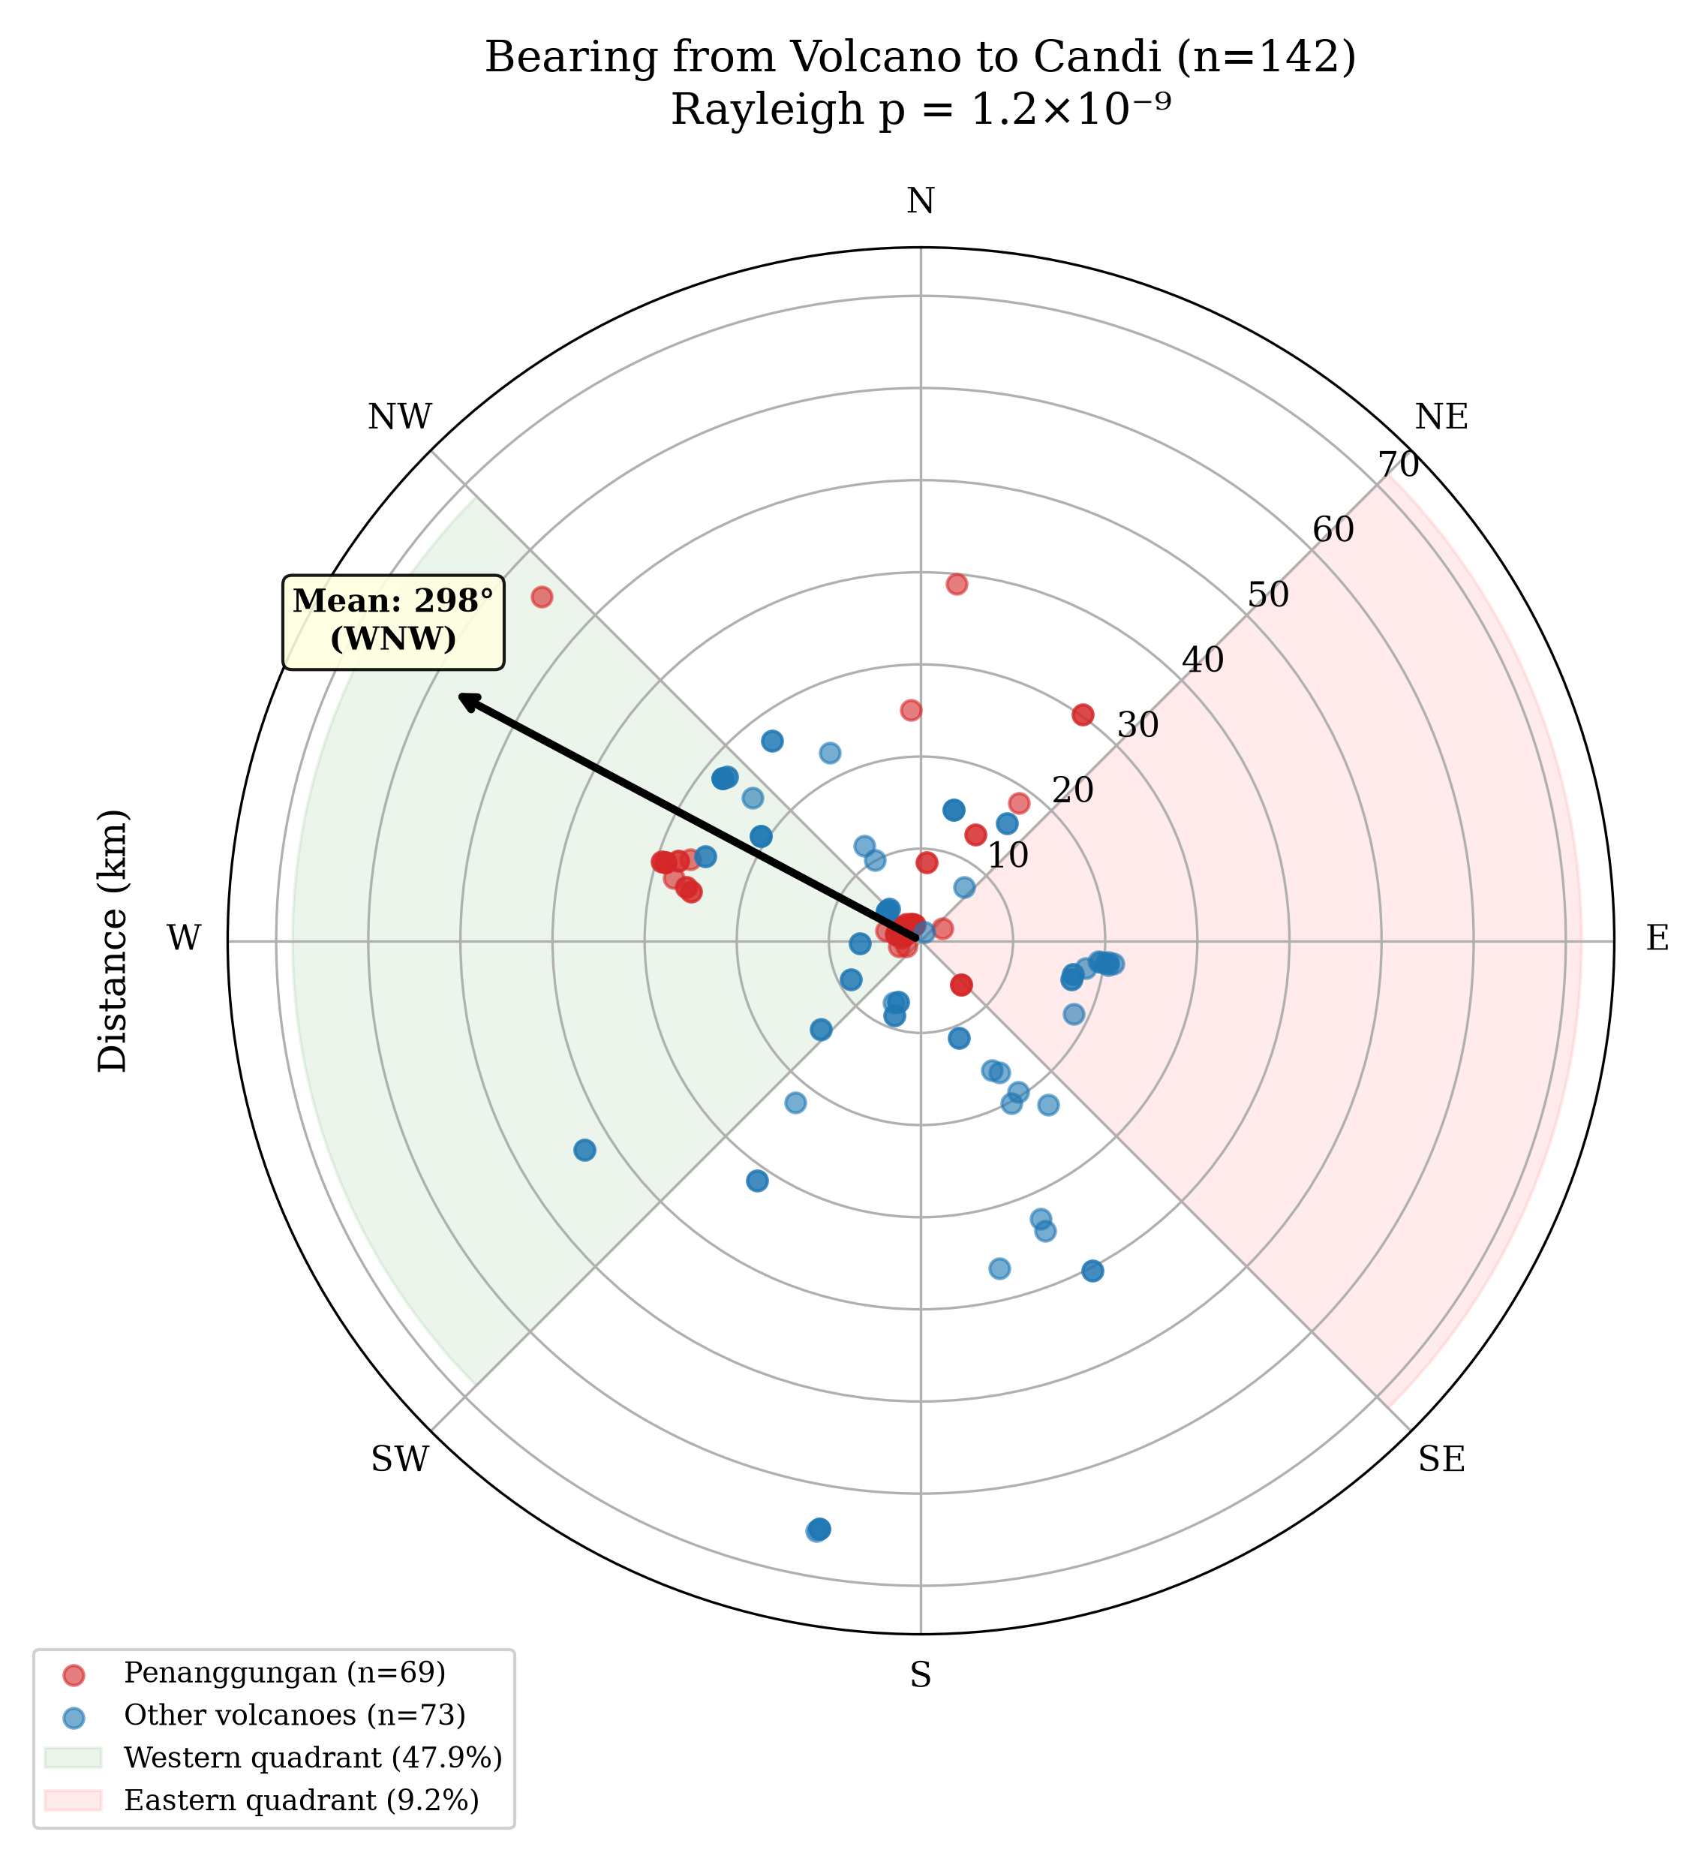
Polar plot of candi bearings from nearest volcanic peak. The western clustering (mean 298°) is consistent with positioning downwind of prevailing dry-season winds.
This western concentration has both practical and cosmological dimensions. Java’s dry season is dominated by the southeast monsoon, whose winds drift eruption plumes west-northwest; the western flanks are therefore the downwind side of dry-season eruptions and receive the heaviest tephra load. For agricultural communities this ashfall is an asset–the continuously renewed fertile soils that Mohr associated with the island’s densest populations.
But the pattern also resonates with Javanese sacred geography. In the Śaiva-siddhānta tradition that shaped Javanese temple architecture, mountains are identified with the cosmic Mount Meru, axis of the universe and abode of the gods (Kinney et al. 2003). De Groot argued that the spatial organisation of Central Javanese candi reflects a deliberate sacred landscape in which temples were positioned to maintain visual and ritual connections with volcanic peaks. The western orientation may thus carry additional significance: in Hindu-Javanese cosmology, the west (paścima) is associated with Varunạ, the waters, and the setting sun–an appropriate direction for funerary and ancestral candi.
De Groot’s analysis of Central Javanese candi demonstrated that temples were not merely placed near volcanoes but positioned to maintain specific visual relationships with volcanic peaks–what she termed “intervisibility” between sacred structure and mountain summit (de Groot 2009: chaps 5–6). Kinney, Klokke, and Kieven have shown that the iconographic programs of East Javanese temples encode directional cosmology: relief narratives progress in specific sequences around the building, calibrated to the cardinal orientation of the entrance (Kinney et al. 2003: 42–68). The convergence of cosmological prescription (how temples face) and landscape pragmatism (where temples stand) suggests that the builders operated within a tradition that integrated religious knowledge with empirical observation of volcanic hazard–a tradition whose depth we can measure spatially even if its textual record has been lost.
The proximity pattern is equally revealing (Figure 2). Zone A (within 10 km of a volcanic peak) contains 45.1 per cent (64 of 142) of all candi–an overrepresentation of 19.1$×$ relative to land area. Penanggungan alone hosts 73 candi, 63 per cent on its western flank. But the pattern is not dependent on this single mountain: after excluding Penanggungan entirely, the remaining 69 candi across Java still show significant western clustering.
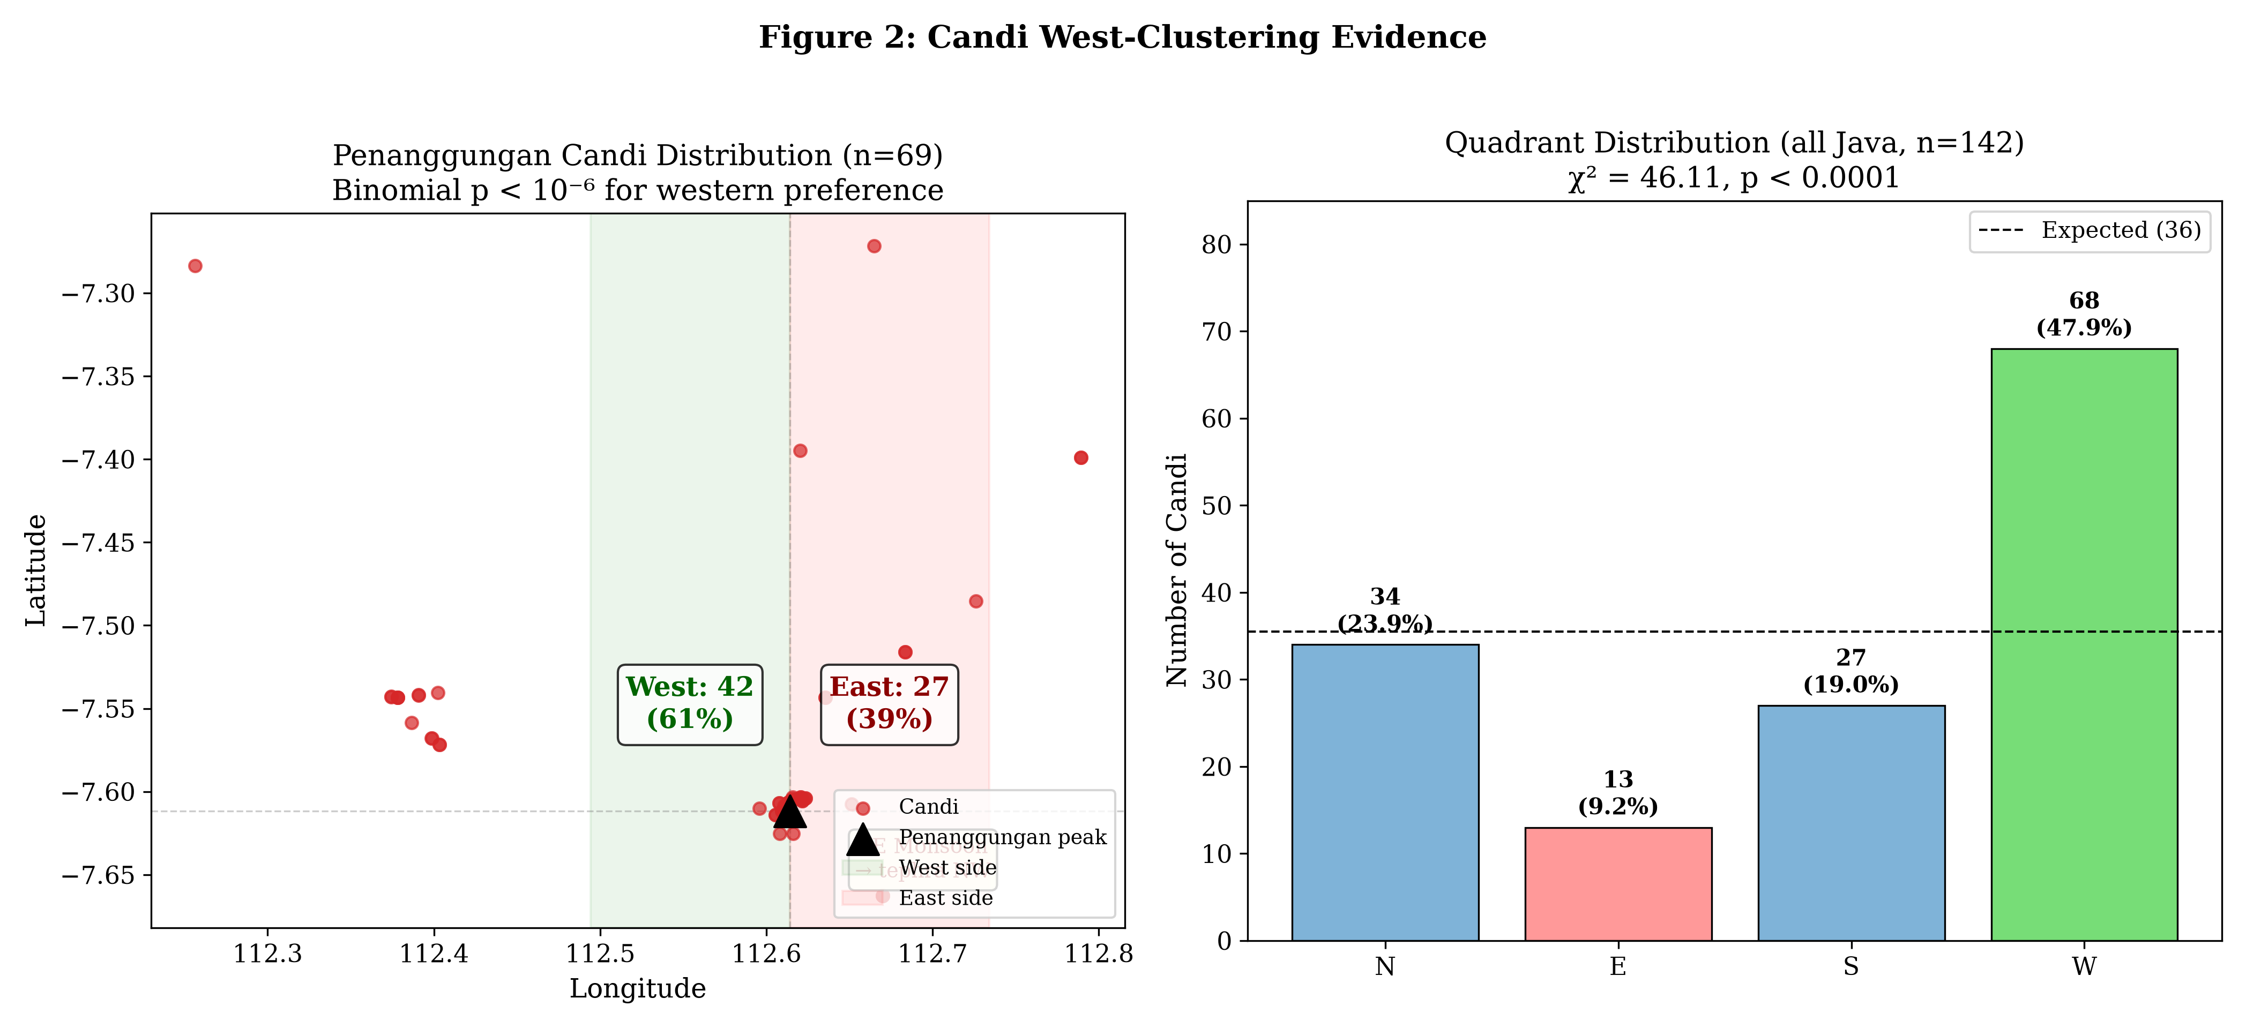
Distribution of 73 candi on Mount Penanggungan, showing the western-flank concentration. The pattern persists across Java after this mountain is excluded.

Orientation Follows Canon, Siting Follows Landscape
A critical distinction emerges when we examine not where candi were placed but how they were oriented. Of the 20 candi for which entrance orientations are recorded in published surveys–only 14 per cent of the full dataset, reflecting the incomplete state of architectural documentation–85 per cent face the equinox direction (east or west), consistent with religious prescription in the Śilpaśāstra architectural tradition. Only 35 per cent face toward the nearest volcano–indistinguishable from random expectation.
The builders of Java’s temples thus operated according to two distinct logics simultaneously: a textual canon governing how temples should face, and an empirical understanding of volcanic geography governing where they should stand. This dual intentionality is what makes the candi distribution informative. It is not random scatter but a deliberate spatial record of where communities chose to build, shaped by both religious knowledge and landscape experience.

The Inscription Contrast: Two Geographies of Power

Sacred and Administrative Space
If candi proximity to volcanoes merely reflected general settlement geography, we would expect inscriptions–which record administrative activity across the inhabited landscape–to show a similar spatial distribution. We georeferenced 182 inscriptions from the DHARMA epigraphic database (DHARMA project 2024), of which the 175 located on Java and Bali form the analysis set, re-derived against the canonical 30-volcano inventory.
The contrast is stark. Inscriptions are on average 6.1 km farther from volcanoes than candi. While 45.1 per cent of candi lie in Zone A (within 10 km of a volcano), only 13.1 per cent of inscriptions do. Inscriptions instead cluster in what we term the “court zone” (15–30 km from volcanoes), on the fertile alluvial plains where the Kedu, Prambanan, and Brantas polities established their administrative centres.
This spatial divergence is not a statistical artefact. It reflects a fundamental distinction between two modes of cultural production. Candi are architectural, devotional, and landscape-embedded–expressions of the relationship between communities and their sacred mountains. Inscriptions are textual, administrative, and court-produced–records of sima (tax-free) land grants, royal genealogies, and boundary demarcations in Sanskrit formulaic prose (de Casparis 1975: 15–42). These two genres of evidence were produced by different institutions, for different purposes, in systematically different locations.
This has consequences for archaeological inference. Scholars have routinely used inscription counts as proxies for population density, political complexity, or the reach of “Indianization” (Coedès 1968). But if inscriptions are a court technology concentrated in a specific geographic zone, then inscription-based estimates systematically overrepresent the Sanskritized court world and underrepresent the indigenous volcanic-slope world where most of Java’s population likely lived.

The 929 CE Discontinuity
The political migration from Central to East Java in 929 CE provides a before-after observation that illuminates this spatial structure. The causes of the Mataram collapse remain debated–Merapi eruptions, political conflict, economic reorganisation–but the consequences for the inscriptional record are well documented (Christie 2001: 25–55; see also Hall 2011).
Before 929 CE, 58 per cent of dated and georeferenced inscriptions ($n=100$) are located in the court zone, and 91 per cent of those court-zone inscriptions are Sanskrit-dominant. After 929, 48 per cent ($n=31$) appear in the periphery ($>$30 km from volcanoes), and 87 per cent of those are mixed or indigenous-rich in vocabulary.
This shift has traditionally been interpreted as “de-Indianization” or “Javanization”–a civilisation-wide retreat from Indic cultural forms (Kulke 1990; Pollock 2006). But the spatial data suggest a more precise interpretation: what changed at 929 CE was not Javanese culture but the geography of textual production. The court system that had generated Sanskrit inscriptions in the 15–30 km zone collapsed. Epigraphic activity migrated to the periphery, where indigenous vocabulary had always been the norm.
If this interpretation is correct, the “de-Indianization” narrative may describe a change in who was writing inscriptions and where, rather than a transformation of Javanese cultural identity. In Wolters’ terms, the indigenous substrate was never absent–it was merely invisible within the court zone’s inscriptional genre. The 929 CE collapse removed the Sanskrit overlay and revealed the underlying cultural landscape.
Christie’s influential analysis of demographic trends in early Java reinforces this interpretation from a different angle. Her “states without cities” argument held that early Javanese polities were not urban in any conventional sense: political power was exercised through dispersed control of wet-rice agricultural production, not through concentrated urban populations (Christie 1991: 23–40). If the population was dispersed across the agrarian landscape rather than concentrated in administrative centres, then inscription-based estimates of settlement density–which are anchored to court locations–systematically misrepresent where people actually lived. The Two Javas model provides the spatial correlate to Christie’s demographic argument: the court zone produced the texts, but the volcano zone housed the villages.

Liangan: A Window into the Buried Landscape
The discovery of Liangan in 2008 provides the most direct illustration of the model’s plausibility. Located 5.5 km from Mount Sindoro on its western flank–Zone A, western quadrant–the site was found not by archaeologists but by sand miners, who exposed a complete Mataram-era settlement beneath 4–6 m of pyroclastic deposits (Abbas 2016).
What Liangan preserved is precisely what our analysis predicts should exist but cannot be detected by surface survey: wooden houses with post-hole foundations, carbonised rice grains (tropical japonica), an iron-smelting workshop with slag and tuyères, Tang Dynasty ceramics indicating long-distance trade networks, and the complete domestic infrastructure of a Hindu-Buddhist-era village. The site yielded both a Hindu temple (Candi Liangan) and the village that surrounded it–the combination that our model posits for every known candi but that volcanic burial has rendered invisible elsewhere.
The closest analogue is Cerén in El Salvador, the Central American village sealed by a single eruption c. 600 CE that preserved sleeping mats, stored food, and agricultural tools (Sheets 2002). Both sites demonstrate that volcanic burial can preserve the vernacular layer of pre-modern life that normally leaves no archaeological trace. But where Cerén resulted from a single catastrophic event, Liangan was buried by cumulative deposition over centuries–the process that characterises Java’s volcanic taphonomy more broadly.
Liangan is not an anomaly but a proof of possibility. If the spatial patterns identified in this paper are correct, similar sites lie beneath the volcanic deposits of East Java’s western flanks, awaiting discovery–or destruction by unmonitored mineral extraction.

Heritage Implications: What is Being Lost
The practical urgency of these findings lies in the ongoing destruction of potential archaeological sites by sand and gravel mining on volcanic slopes. Liangan was discovered by miners. But for every site exposed and reported, others are likely destroyed without documentation. The western flanks of East Java’s volcanoes–where our model predicts the highest concentration of buried sites–are precisely the zones targeted for mineral extraction due to the abundance of volcanic aggregate.
Indonesia’s rescue archaeology capacity is minimal by international standards: approximately 70 excavations per year, compared to Japan’s 8,300 (Takata and Yanase 2022). The mechanisms by which buried sites become known elsewhere–developer-funded excavation, systematic geophysical survey, ground-penetrating radar reconnaissance (Conyers 2004)–have not been deployed at scale in Indonesian volcanic zones.
The spatial model developed here identifies ten priority areas for geophysical survey, derived from the intersection of candi clustering, terrain suitability, and sedimentation rate estimates. These coordinates are available to authorised heritage bodies (BPCB, Balai Arkeologi) upon request. The most productive survey depths–2 to 9 m, based on colonial-era burial data and the Liangan precedent–are within the range of electrical resistivity tomography and ground-penetrating radar.
What is at stake is not merely archaeological curiosity but the recovery of a monde insulindien that Lombard intuited but could not yet document: the vernacular landscape of pre-modern Java, hidden beneath the volcanic soils that sustained it.
The current evidential gap has institutional as well as geological roots. As Bloembergen and Eickhoff have documented, the colonial Oudheidkundige Dienst constructed its archaeological priorities around monumental Hindu-Buddhist remains–candi, inscriptions, relief panels–that served the colonial narrative of a pre-Islamic “golden age” (Bloembergen and Eickhoff 2020: chaps 2–4). Vernacular sites–villages, workshops, agricultural infrastructure–were neither sought nor recorded. This institutional bias persists in postcolonial heritage management, where the Balai Pelestarian Cagar Budaya (BPCB) focuses on registered monuments rather than systematic landscape survey. The geological erasure of the volcanic-slope settlement record has thus been compounded by an institutional erasure that privileges the monumental over the domestic.

Discussion: The Buried Crossroads
The convergence of these evidence lines–candi clustering on western volcanic flanks, the inscription-architecture divergence, documented burial depths of 2–9 m, the Liangan discovery, and the survey-intensity control–points toward a single conclusion: pre-modern Java was far more extensively settled in volcanic zones than the surviving record indicates.
A potential objection is that the archaeological gap near volcanoes reflects differential survey effort rather than genuine burial. We tested this using robustness regression controlling for three survey-intensity proxies (road distance, proximity to heritage offices, university proximity). After controlling for all three, volcanic proximity still explains additional variance in site counts. The deficit is real, not a survey artefact.
What this means is that the monumental record we possess–the candi, the inscriptions, the literary texts–represents only the fraction of Javanese civilisation that happened to be encoded in durable media and located at distances or depths where survival was possible. The vernacular layer–the houses, the markets, the workshops, the rice granaries–has been systematically subtracted from the evidential base. Lombard’s “Javanese crossroads” is therefore not merely a crossroads of cultures but a buried crossroads, whose full spatial extent remains to be excavated.
The 71 per cent temple bias in East Java’s archaeological database–where candi account for the vast majority of known sites, while settlements represent barely 1 per cent–further illustrates the distortion. This is not a reflection of past reality but of what survives: stone resists, wood does not. The spatial patterns identified here suggest where the missing settlements might be found.

Limitations
The Penanggungan concentration (51 per cent of all candi) limits spatial generalisability, though the pattern survives its exclusion. All evidence remains indirect–no subsurface geophysical validation has yet been conducted. The temporal range of the candi proxy (c. 8th–15th century) does not extend to the pre-Hindu or Islamic periods. The geocoding of inscriptions carries a mean uncertainty of $±$5 km for some entries, which may blur zone boundaries. Finally, the argument rests on the assumption that candi and their associated settlements were co-located–an assumption supported by the candi-settlement proximity test but not yet confirmed by excavation. Crucially, the model generates testable predictions: ground-penetrating radar and electrical resistivity survey of ten western-flank sites at 2–9 m depth should yield buried settlement remains. If systematic geophysical survey finds nothing at predicted locations, the model would be refuted–a condition that distinguishes this framework from unfalsifiable post-hoc narrative.

Conclusion
The temples of Java stand as markers of a civilisation far larger than what survives on the surface. By reading their spatial distribution–not as a catalogue of monuments but as a map of past communities–we can begin to reconstruct the settlement geography that volcanic sedimentation has erased.
Two distinct landscapes of cultural production emerge from this analysis: a sacred landscape on volcanic slopes, where communities built temples in dialogue with the mountain cosmology that structured their religious life; and an administrative landscape on the alluvial plains, where courts generated the inscriptional record from which historians have reconstructed “Javanese civilisation.” The 929 CE Mataram collapse, by removing the court system that had generated Sanskrit-heavy inscriptions, revealed an indigenous cultural substrate that had been present throughout–hidden not by its own absence but by the genre conventions of court epigraphy.
This is not merely a methodological contribution. It is a reframing of how we understand the archaeological record of the monde insulindien’s most volcanically active island. The silence in the record is not evidence of absence; it is evidence of burial. And the temples, paradoxically, are both survivors of that process and guides to what lies beneath.

Acknowledgements
AI tools (Claude, Anthropic, versions 4 and 5) were used between February and August 2026 for spatial geocoding, statistical computation assistance, and editorial refinement of the manuscript. All statistical analyses were independently verified using standard libraries (SciPy, GeoPandas). Research design, hypothesis formation, data interpretation, and all conclusions are the authors’ work. Figures are programmatic plots (matplotlib) of author-compiled data; no AI-generated imagery was used. Code and data are available at the project repository.

References
Abbas, N. (ed.) (2016) Liangan: Mozaik Peradaban Mataram Kuno di Lereng Sindoro. Yogyakarta: Kepel Press/Balai Arkeologi Yogyakarta.
Bloembergen, M., and Eickhoff, M. (2020) The Politics of Heritage in Indonesia: A Cultural History. Cambridge: Cambridge University Press.
de Casparis, J.G. (1975) Indonesian Palaeography: A History of Writing in Indonesia from the Beginnings to c. A.D. 1500. Leiden: E.J. Brill.
Christie, J.W. (1991) ‘States without Cities: Demographic Trends in Early Java.’ Indonesia 52: 23–40.
Christie, J.W. (2001) ‘Revisiting early Mataram.’ In Klokke, M.J. and van Kooij, K.R. (eds) Fruits of Inspiration: Studies in Honour of Prof. J.G. de Casparis. Groningen: Egbert Forsten, 25–55.
Coedès, G. (1968) The Indianized States of Southeast Asia. Translated by Susan Brown Cowing. Honolulu: University of Hawai’i Press.
Conyers, L.B. (2004) Ground-Penetrating Radar for Archaeology. Walnut Creek: AltaMira Press.
de Groot, V.M.Y. (2009) Candi, Space and Landscape: A Study on the Distribution, Orientation and Spatial Organization of Central Javanese Temple Remains. PhD diss., Leiden University.
DHARMA project (2024) The Domestication of “Hindu” Asceticism and the Religious Making of South and Southeast Asia: Epigraphic Database. CNRS/ERC. https://dharma.hypotheses.org/
Dumarçay, J. (1993) The Temples of Java. Oxford: Oxford University Press.
Global Volcanism Program (2023) Volcanoes of the World. V. 5.1.1. Smithsonian Institution. https://volcano.si.edu/
Hall, K.R. (2011) A History of Early Southeast Asia: Maritime Trade and Societal Development, 100–1500. Lanham: Rowman & Littlefield.
Kinney, A.R., Klokke, M.J., and Kieven, L. (2003) Worshipping Śiva and Buddha: The Temple Art of East Java. Honolulu: University of Hawai’i Press.
Kulke, H. (1990) ‘Indian Colonies, Indianization or Cultural Convergence? Reflections on the Changing Image of India’s Role in South-East Asia.’ In Becker, H. and Ptak, R. (eds) Unterwegs nach Indien. Munich: Museum für Völkerkunde.
Lavigne, F., and Thouret, J.-C. (2003) ‘Sediment Transportation and Deposition by Rain-Triggered Lahars at Merapi Volcano, Central Java, Indonesia.’ Geomorphology 49(1–2): 45–69.
Lombard, D. (1990) Le carrefour javanais: essai d’histoire globale. 3 vols. Paris: Éditions de l’École des hautes études en sciences sociales.
Miksic, J.N. (2004) ‘The Classical Cultures of Indonesia.’ In Glover, I. and Bellwood, P. (eds) Southeast Asia: From Prehistory to History. London: RoutledgeCurzon, 234–256.
Mohr, E.C.J. (1938) ‘The Relation between Soil and Population Density in the Netherlands East Indies.’ In Comptes Rendus du Congrès International de Géographie. Amsterdam.
Newhall, C.G., Bronto, S., Alloway, B., Banks, N.G., Bahar, I., del Marmol, M.A., Hadisantono, R.D., Holcomb, R.T., McGeehin, J., Miksic, J.N., Rubin, M., Sayudi, S.D., Sukhyar, R., Andreastuti, S., Tilling, R.I., Torley, R., Trimble, D. and Wirakusumah, A.D. (2000) ‘10,000 Years of Explosive Eruptions of Merapi Volcano, Central Java: Archaeological and Modern Implications.’ Journal of Volcanology and Geothermal Research 100(1–4): 9–50.
Oudheidkundig Verslag (1912–1929) Batavia: Oudheidkundige Dienst in Nederlandsch-Indië.
Pollock, S. (2006) The Language of the Gods in the World of Men: Sanskrit, Culture, and Power in Premodern India. Berkeley: University of California Press.
Putra, P.B., and Setyastuti, A. (2019) ‘Le complexe cultuel de Kimpulan, site enfoui sous les cendres du Merapi (Yogyakarta, Java central).’ Bulletin de l’École française d’Extrême-Orient 105: 377–402.
Schiffer, M.B. (1987) Formation Processes of the Archaeological Record. Albuquerque: University of New Mexico Press.
Sheets, P.D. (ed.) (2002) Before the Volcano Erupted: The Ancient Cerén Village in Central America. Austin: University of Texas Press.
Soekmono, R. (1995) The Javanese Candi: Function and Meaning. Leiden: Brill.
Takata, H., and Yanase, T. (2022) ‘Production, Preservation and Dissemination of Archaeological Data in Japan.’ Internet Archaeology 58.
van Bemmelen, R.W. (1949) The Geology of Indonesia. Vol. 1A. The Hague: Government Printing Office.
Whitten, T., Soeriaatmadja, R.E., and Afiff, S.A. (1996) The Ecology of Java and Bali. Singapore: Periplus Editions.
Wolters, O.W. (1999) History, Culture, and Region in Southeast Asian Perspectives. Rev. ed. Ithaca: Cornell University Southeast Asia Program.

On the persistence of village structures beneath successive “réseaux.”
Monte Carlo simulation ($p<0.0001$, 10,000 permutations) confirms that the observed candi-settlement proximity cannot be explained by chance clustering.
Rayleigh test for circular non-uniformity: $p=1.2×{10}^{−9}$.
Excluding Penanggungan: $p=0.0009$, confirming that the pattern is island-wide.
Binomial test: $p=4.9×{10}^{−14}$. The small $n$ reflects documentation gaps rather than selection; all candi with published orientations were included.
Mann-Whitney $U$ test: $p=2.8×{10}^{−7}$.
Percentages re-derived 2026-08-13 on the canonical 30-volcano inventory (E105 canonical-30 re-run); the earlier partial-inventory run gave 57/91/53/89 per cent.
On the Indianization debate and its critiques.
On colonial archaeological priorities and their postcolonial persistence.
Quasi-Poisson GLM on the canonical 30-volcano Java inventory: volcanic proximity $β=−0.831$, likelihood-ratio $p=2.9×{10}^{−7}$ (dispersion-adjusted quasi-likelihood). The signal strengthens relative to the earlier 7-volcano run ($β=−0.477$, $p=0.0015$).
Of 391 known archaeological sites in East Java, 277 (70.8%) are temples or temple fragments; with statues and inscriptions, monuments account for 73.1%. Only 5 (1.3%) are identified settlements.

