Uncoded basic vocabulary in six Sulawesi word lists: What the absence of a cognate-set assignment in the Austronesian Basic Vocabulary Database does and does not show
Mukhlis Amien
Universitas Bhinneka Nusantara
Go Frendi Gunawan
Universitas Bhinneka Nusantara
In the Austronesian Basic Vocabulary Database (ABVD), part of every Sulawesi word list carries no cognate-set assignment, often read as substrate. We ask what the absence of a cognate-set number shows, using 1,357 forms of six ABVD lists from four Sulawesi subgroups, 438 of them (32.3 percent) uncoded. A classifier given the written form and the meaning ranks uncoded above coded forms (area under the curve 0.73) but barely improves on calling every form coded. Uncoded forms are about one character longer, more often carry a written glottal mark and more often denote actions. Makasar has more uncoded meanings than Bugis and Sa'dan Toraja (34.8 against 23.4 and 19.0 percent), and few of them resemble its relatives' forms; 70.9 percent of Tolaki's uncoded forms have a look-alike of the same meaning elsewhere in Bungku-Tolaki (10.5 percent by chance). Coding status is not origin: a set number is not a finding of inheritance, nor its absence one of non-Austronesian descent.
Keywords: Sulawesi languages, Austronesian Basic Vocabulary Database, cognate coding, Makasar, Tolaki, substrate, classification

Introduction.
In the basic vocabulary of many Austronesian languages some forms cannot be assigned to a higher-level proto-form: either they have cognates only in a few close relatives, and so reconstruct at most to a low-level proto-language, or no cognate is known at all. Such residues have long attracted a particular reading. For three Philippine Negrito languages, Reid (1994) counted forms with no known cognate anywhere at 17 to 29 percent of a 539-item list and, after weighing lost inherited forms, radical sound change and coinage, preferred a non-Austronesian substratum as their source. For Sulawesi the reading has been attached above all to Makasar. Lexicostatistical counts have long shown Makasar, with Konjo and Selayar, as the most divergent part of the South Sulawesi group (Mills 1975:491; Sirk 1989:71); whether a substratum lies behind the divergence has been raised and left open (Bulbeck 1992); and Bulbeck, Pasqua, and Di Lello (2000:103), citing a retention figure of 38 percent from Proto-Malayo-Polynesian, describe the remaining 62 percent of the basic vocabulary as open to investigation as borrowing from pre-Austronesian, possibly Toalean, languages.
The Austronesian Basic Vocabulary Database (ABVD; Greenhill, Blust, and Gray 2008), in its Cross-Linguistic Data Formats (CLDF) version (Forkel et al. 2018), records for every form of a 210-meaning list whether its editors have grouped it with forms in other lists under a cognate-set number. The forms left without a number are the operational residue of the comparative method as it has been applied within one database. As computational work on Austronesian lexical data has grown (Gray, Drummond, and Greenhill 2009; List 2012; Forkel et al. 2018), that residue is easy to extract and tempting to interpret. This paper asks what it is. For six ABVD word lists from Sulawesi we ask three things: what the absence of a cognate-set number means in the two lists where the question matters most, Makasar and Tolaki; whether uncoded forms can be told apart from coded ones by their written shape and their meaning; and what, measurably, distinguishes them.
Sulawesi is a suitable place to ask. Blust (2013:82) lists eleven linguistic microgroups for the island and notes some evidence for a larger Celebic grouping; Sneddon (1993:2) counts nine microgroups and adds Banggai as a group of one. A Celebic supergroup was proposed by van den Berg (1996) and developed by Mead (2003), in whose version it comprises Tomini-Tolitoli, Kaili-Pamona, Saluan-Banggai, Bungku-Tolaki, Muna-Buton and Wotu-Wolio but not South Sulawesi, with some branches called tentative. Our six lists represent four of these groups: South Sulawesi (Bugis, Makasar, Sa'dan Toraja), Muna-Buton (Muna), Wotu-Wolio (Wolio) and Bungku-Tolaki (Tolaki). Three of the four fall inside the proposed Celebic supergroup, a point we return to when similarity across lists is discussed.
Two terms are used throughout. A form is coded when it carries at least one cognate-set number in the ABVD snapshot we used, and uncoded when it carries none. By the profile of the uncoded forms we mean the set of measurable properties of their written shape and of their meaning that distinguish them, in these lists, from the coded forms. The profile is part orthographic and part semantic, and a statistical classifier is used to assess how far it separates the two classes; it is not a phonological fingerprint, because the inputs are written forms, not phonemic transcriptions, and because some of the inputs describe the meaning.
The paper makes no claim about the origin of any form. Where an etymological judgment would be needed, none of the authors can supply it, and the paper says so. What stands in its place is a set of mechanical comparisons with explicit controls for chance: a classifier assessed on forms and on whole lists it has not seen; a look-alike screen whose sensitivity is measured on forms the database itself has coded; a permutation test whose decision rule was written before it was run. Each can be repeated from ABVD with the released scripts and files, and the limits of each are stated with its result. Section 2 describes the data, the label, the inputs and the tests; section 3 gives the results in eight short parts; section 4 discusses what they do and do not show; section 5 concludes.

Data and methods.

Data.
The data are six word lists of the ABVD, in the lexibank/abvd CLDF release at repository state 917c5a5 (7 October 2025; license CC BY 4.0): Muna (ABVD list 27; 219 forms; compiled from van den Berg), Bugis (48; 242 forms; Soppeng dialect, recopied from Zainuddin Taha with additions from Fachruddin Ambo Enre and Mills 1975), Makasar (166; 217 forms; Abd. Rajab), Wolio (192; 254 forms; J. C. Anceaux), Sa'dan Toraja (226; 216 forms; ABVD's list "Tae' (S. Toraja)", entered by Blust from van der Veen's dictionary of 1940) and Tolaki (674; 209 forms; Omar Abdullah Pidani; Konawe dialect). We use the spelling Makasar and the name Sa'dan Toraja in the text; the released files keep ABVD's identifiers so that every row can be traced.
ABVD's meaning list has 210 items. The six lists cover between 200 and 210 of them, and a meaning can have more than one form in a list: 117 of the 1,357 rows are a second or third form for their meaning. Every count in this paper is therefore a count of forms, with one exception noted in section 2.6, where the Makasar comparison is made by meaning. The 210-item list is ABVD's own, and we do not call it a Swadesh list. For the computation of the inputs described in section 2.3, bracketed additions by the compiler, leading and trailing punctuation and stray spaces were removed from the written form; the released files give the form exactly as ABVD records it.

The label.
A form counts as coded if its Cognacy field in the snapshot holds at least one cognate-set number, and as uncoded if the field is empty. By this definition 919 forms (67.7 percent) are coded and 438 (32.3 percent) are uncoded. This is the only label used in the paper. An earlier version of this study used two label sets and a step that was meant to recover inherited forms by comparison with reconstructions; the step compared no forms with any reconstruction and has been removed, as has a filter for loanwords that matched five unrelated words.
Two points about this label matter for everything that follows. First, a cognate-set number records that ABVD's editors grouped a form with other forms. It is not a finding of inheritance. ABVD flags loans only occasionally; eleven forms in these six lists carry its loan flag (Muna 2, Bugis 1, Makasar 1, Wolio 2, Tolaki 5, none in the Sa'dan Toraja list), and five of the eleven also carry a cognate-set number. The clearest case is Tolaki kila 'lightning', flagged by ABVD as a loan from Malay, which sits in the same set as the Proto-Malayo-Polynesian entry. Sets also differ greatly in breadth: the median coded form in the Bugis list belongs to a set attested in 284 lists, the median coded Muna form to a set attested in 54, and 35.7 percent of Muna's coded forms belong to sets of five lists or fewer. Second, how much of a list is coded depends on what else happens to be in the database. Of the 185 coded Muna forms, 44 are coded only because the same form recurs in ABVD's second Muna list (Wuna, list 147, which shares Muna's Glottolog code); counted as uncoded they would raise Muna's uncoded share from 15.5 to 35.6 percent. The five Tolaki dialect lists in ABVD are not cross-coded with the Tolaki list in this way (no form). The label is thus not the same kind of thing in every list, and "uncoded" is not an upper bound on anything: a form of non-Austronesian or borrowed origin can carry a set number, and an inherited form can lack one.

Inputs of the classifier.
Twenty-five inputs are computed for every form, seventeen from the written form and eight from the meaning. We name them by what the code computes rather than by what the measurement might be taken to mean. From the written form: length in characters (hyphens, spaces and glottal marks included); the number and the share of vowel letters; whether the form ends in a vowel letter; whether it contains a written glottal mark (ʔ or an apostrophe); whether it contains ŋ or the digraph ng, or one of the letter pairs mb, nd, nj, mp, nk, nc, nt; whether it contains a hyphen or the same block of two or three letters twice in a row; the number of consonant-letter clusters; whether it begins with one of the strings ma, me, mo, pa, ka, ta, na, po or aŋ; and eight indicators for the first letter (a, b, k, m, p, s, t, other). The code's own names for some of these inputs ("nasal cluster", "reduplication", "prefix-like") say more than the inputs measure: of the 394 forms that begin with one of the nine strings, 88 have four letters or fewer (for instance mata, tau), and of the 142 forms flagged for a hyphen or a repeated block, 93 contain a hyphen (89 of them with no repeated block), almost all of them in the Bugis and Sa'dan Toraja lists, where the hyphen appears to mark a boundary set by the compiler. We therefore speak of an onset string, of a nasal input and of a hyphen-or-repetition input, and we test stricter versions of each in section 3.5.
From the meaning: one indicator for membership in a core set of 174 of the 210 meanings, and seven indicators for broad semantic domains (action, body, nature, quality, number, grammatical word, other). The core set and the domains are groupings made by the authors for this study; they are not taken from Concepticon or from the World Loanword Database, and the core set is not the Swadesh 100-item list. The classifier has no input that identifies the source list, although some form inputs carry information about it (Section 3.5). An earlier version used such an input, an integer that numbered the six lists; it was the strongest input of that model and has been removed. Table 5 lists the inputs that matter with their observed values.

The classifier.
The main classifier is gradient-boosted decision trees (XGBoost; Chen and Guestrin 2016) with 300 trees of depth four and a learning rate of 0.05, trained without class weighting to separate uncoded from coded forms; the score it gives a form is its estimated probability of belonging to the uncoded class, so a higher score means a form that looks more like the uncoded forms. A random forest (Breiman 2001) and a logistic regression, both from scikit-learn (Pedregosa et al. 2011) and both with the two classes weighted equally, were run on the same inputs to see whether the ranking depends on the choice of method; the equal weighting is why their recall is higher and their accuracy lower in table 3. The size of each input's contribution to the predictions is summarized by SHAP (Shapley additive explanations) values (Lundberg and Lee 2017): each prediction is attributed to the inputs, and the mean of the absolute attributions over all forms is an input's average contribution, shown in figure 1. Software: Python 3.11, scikit-learn 1.8.0, xgboost 3.0.3, shap 0.50.0.

How the classifier is assessed.
A classifier that is scored on the forms it was trained on will look better than it is. We therefore report two kinds of out-of-sample assessment. In cross-validation the 1,357 forms are divided at random into five parts of equal uncoded share; a model trained on four parts scores the fifth; this is done for every part, and the whole procedure is repeated ten times with different divisions, giving fifty test sets. In the held-out-list assessment the model is trained on five lists and scores the sixth, once for each list. The second assessment is what "generalizes across Sulawesi languages" means concretely: a model that has never seen a Tolaki form is asked to rank the Tolaki forms.
The main measure is the area under the receiver operating characteristic curve (AUC): the probability that a randomly chosen uncoded form receives a higher score than a randomly chosen coded form. A value of 0.5 is chance and 1.0 is perfect ranking. Verbal scales for the AUC exist (for instance Nahm 2022, table 4, which calls 0.7 to 0.8 "fair" and 0.6 to 0.7 "poor"), but they are conventions without an empirical basis (White et al. 2023:2), and we report the numbers rather than the labels. We also report accuracy, the share of forms placed in the right class at a score threshold of 0.5, together with the accuracy of the trivial rule that calls every form coded (0.677), and the precision, recall and F1 score of the uncoded class. Two further baselines matter: a model given only the identity of the source list reaches an AUC of 0.680, and a model given only the eight meaning inputs reaches 0.646.
Variation is reported as the standard deviation of the AUC over the ten repetition means and over the fifty test sets; these are measures of the stability of the procedure, not confidence intervals. A bootstrap over forms of the pooled out-of-sample scores (which average the ten repetitions and so run slightly higher, 0.737 [0.709, 0.766] for the full model) gives an interval of about plus or minus 0.03; it leaves out the variation of training. For the held-out-list assessment we also give, for each list, the accuracy of the majority answer for that list, since a classifier can be worse than that answer.

The three checks and the spelling tests.
Three further analyses ask what the label means. (a) Makasar against Proto-Malayo-Polynesian. For each meaning that has an entry in ABVD's Proto-Malayo-Polynesian (PMP) list and a form in the Makasar list (201 meanings), the Makasar form is placed in one of three classes: it shares a cognate-set number with the PMP entry; it is coded but in another set; or it is uncoded. The same is done for Bugis, Sa'dan Toraja, Wolio, Muna and Tolaki. The unit here is the meaning, not the form. (b) Tolaki against its subgroup. Each Tolaki form is compared with the forms of the same meaning in ABVD's Proto-Bungku-Tolaki list (780) and in 42 other Bungku-Tolaki lists (41 of them contributed by one compiler, D. Mead; 13 languages by Glottolog code). The comparison is a look-alike screen: a normalized edit distance (Levenshtein 1966) between the written forms after bracketed material, hyphens, apostrophes and the glottal mark have been removed, computed so that up to three leading characters may be ignored on either side, with a match counted at a distance of 0.34 or less (a stricter run uses 0.25). The chance rate is the same comparison made against the forms of other meanings. The screen's sensitivity is measured on forms that ABVD itself places in a cognate set; because ABVD's coders and the screen both work from surface resemblance, that sensitivity is an upper bound on what the screen would find among cognates the coders missed. The same screen is applied to the uncoded Makasar forms, against the PMP entry and against the Bugis and Sa'dan Toraja forms of the same meaning. A look-alike is not a cognate judgment, and a distance of zero does not mean that two forms are identical. (c) Similarity across lists. For every meaning, the uncoded forms of different lists are paired; the statistic is the mean normalized distance over all such pairs, compared with its distribution when the meaning labels of the uncoded forms are shuffled within each list (10,000 permutations); the number of look-alike pairs at the 0.34 threshold is counted beside it. Numerals are excluded from the primary set because decimal compounds are transparent across the lists. The coded forms, paired in the same way, serve as a positive control. The decision rules for the three-class count, the look-alike screens, this test and the spelling tests below were written down before the runs, on the same day and by the same analyst; none was registered externally.
The spelling tests ask how far the classifier depends on orthographic convention. The written glottal mark was re-coded in six ways (as q, as k, left unwritten, as a geminate of the following consonant, apostrophe unified to ʔ, and the input removed), the digraphs ng and ny and the Muna digraphs gh, bh and dh were converted to single symbols, and the two size inputs (length and vowel count) were removed, each time re-running the cross-validation and the held-out-list assessment. Figure 2 shows how the parts of the study fit together.
FIGURE 2. THE WORKFLOW OF THE STUDY: DATA, LABEL, INPUTS, CLASSIFIER, AND THE THREE CHECKS ON WHAT "UNCODED" MEANS
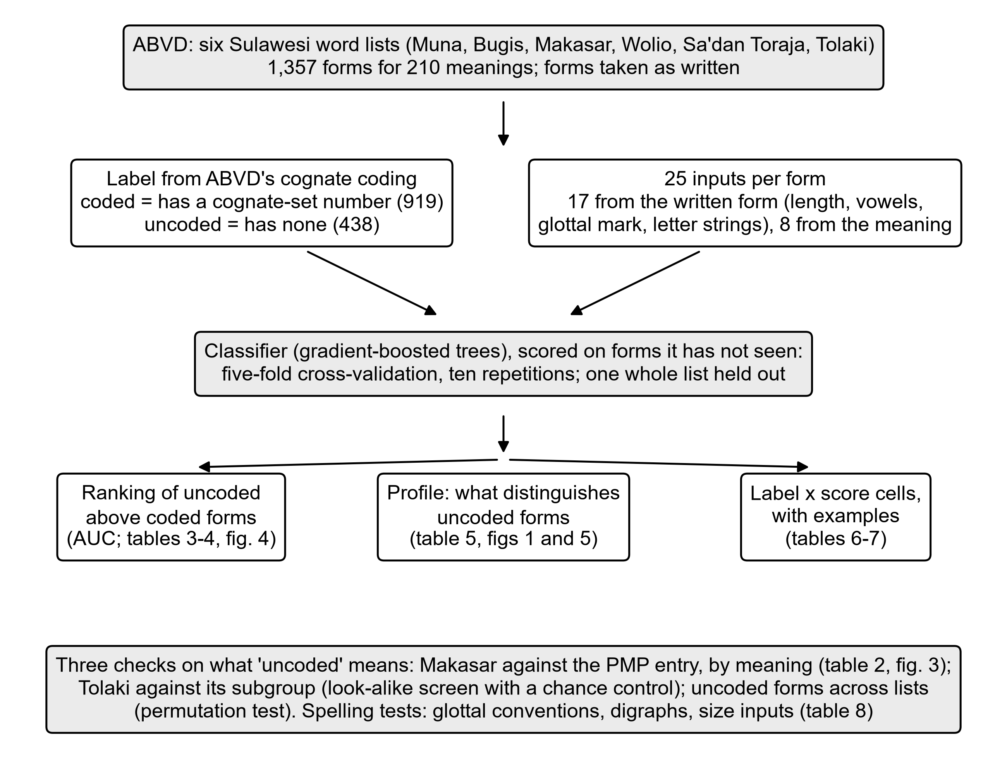
[Figure 2: preview for reading; the journal receives the separate TIFF file]

Results.

How many forms are uncoded.
Table 1 gives the label by list. The uncoded share runs from 15.5 percent in the Muna list to 64.1 percent in the Tolaki list; over the six lists it is 32.3 percent. The lower end of the range rests on one circumstance of the database: the 44 Muna forms coded only through ABVD's second Muna list (Section 2.2). The classifier does not rest on them. With those 44 forms relabeled as uncoded, the cross-validated AUC moves from 0.727 to 0.741 for the full model and from 0.672 to 0.699 for the form-only model.
TABLE 1. THE LABEL BY LIST: FORMS WITH AND WITHOUT A COGNATE-SET NUMBER IN THE ABVD SNAPSHOT
List | Forms | Coded (n) | Coded (%) | Uncoded (n) | Uncoded (%)
Muna | 219 | 185 | 84.5 | 34 | 15.5
Bugis | 242 | 180 | 74.4 | 62 | 25.6
Makasar | 217 | 137 | 63.1 | 80 | 36.9
Wolio | 254 | 171 | 67.3 | 83 | 32.7
Sa'dan Toraja | 216 | 171 | 79.2 | 45 | 20.8
Tolaki | 209 | 75 | 35.9 | 134 | 64.1
All six lists | 1,357 | 919 | 67.7 | 438 | 32.3
Note. Of the 185 coded Muna forms, 44 belong only to sets whose other members are in ABVD's second Muna list (Wuna, list 147); counted as uncoded they would put Muna at 35.6 percent. The five Tolaki dialect lists are not cross-coded with the Tolaki list in this way.

Makasar.
Table 2 gives, for each list, the share of meanings whose form is in the same cognate set as the PMP entry, coded in another set, or uncoded. For Makasar the three shares are 39.3, 25.9 and 34.8 percent of 201 meanings; for Bugis 48.3, 28.4 and 23.4; for Sa'dan Toraja 48.0, 33.0 and 19.0. The first class, a form in the PMP entry's set as ABVD codes it, is a lower bound on the share that ABVD would count as retained from PMP, not retention itself, because an uncoded meaning cannot be in the set whatever its origin; if every uncoded Makasar meaning turned out to belong there, the share would be 74.1 percent. With ABVD's doubtful assignments counted, the first class is 42.8 percent.
TABLE 2. MEANINGS WITH A PROTO-MALAYO-POLYNESIAN ENTRY, BY THE CODING OF THE LIST'S FORM
List | Meanings with a PMP entry | In the PMP entry's set, % [95% CI] (n) | Coded in another set, % [95% CI] (n) | No cognate set, % [95% CI] (n)
Makasar | 201 | 39.3 [32.8, 46.2] (79) | 25.9 [20.3, 32.3] (52) | 34.8 [28.6, 41.6] (70)
Bugis | 201 | 48.3 [41.4, 55.1] (97) | 28.4 [22.6, 34.9] (57) | 23.4 [18.1, 29.7] (47)
Sa'dan Toraja | 200 | 48.0 [41.2, 54.9] (96) | 33.0 [26.9, 39.8] (66) | 19.0 [14.2, 25.0] (38)
Wolio | 197 | 42.6 [35.9, 49.6] (84) | 33.0 [26.8, 39.8] (65) | 24.4 [18.9, 30.8] (48)
Muna | 201 | 35.8 [29.5, 42.7] (72) | 49.8 [42.9, 56.6] (100) | 14.4 [10.2, 20.0] (29)
Tolaki | 191 | 26.2 [20.5, 32.8] (50) | 9.9 [6.5, 15.0] (19) | 63.9 [56.9, 70.4] (122)
Note. Wilson 95 percent intervals; the unit is the meaning. The column "In the PMP entry's set" is a lower bound on the share ABVD would count as retained, since an uncoded meaning cannot share a set with the PMP entry. Figure 3 draws the same shares.

FIGURE 3. MEANINGS WITH A PROTO-MALAYO-POLYNESIAN ENTRY, BY THE CODING OF THE LIST'S FORM (THE SHARES OF TABLE 2)
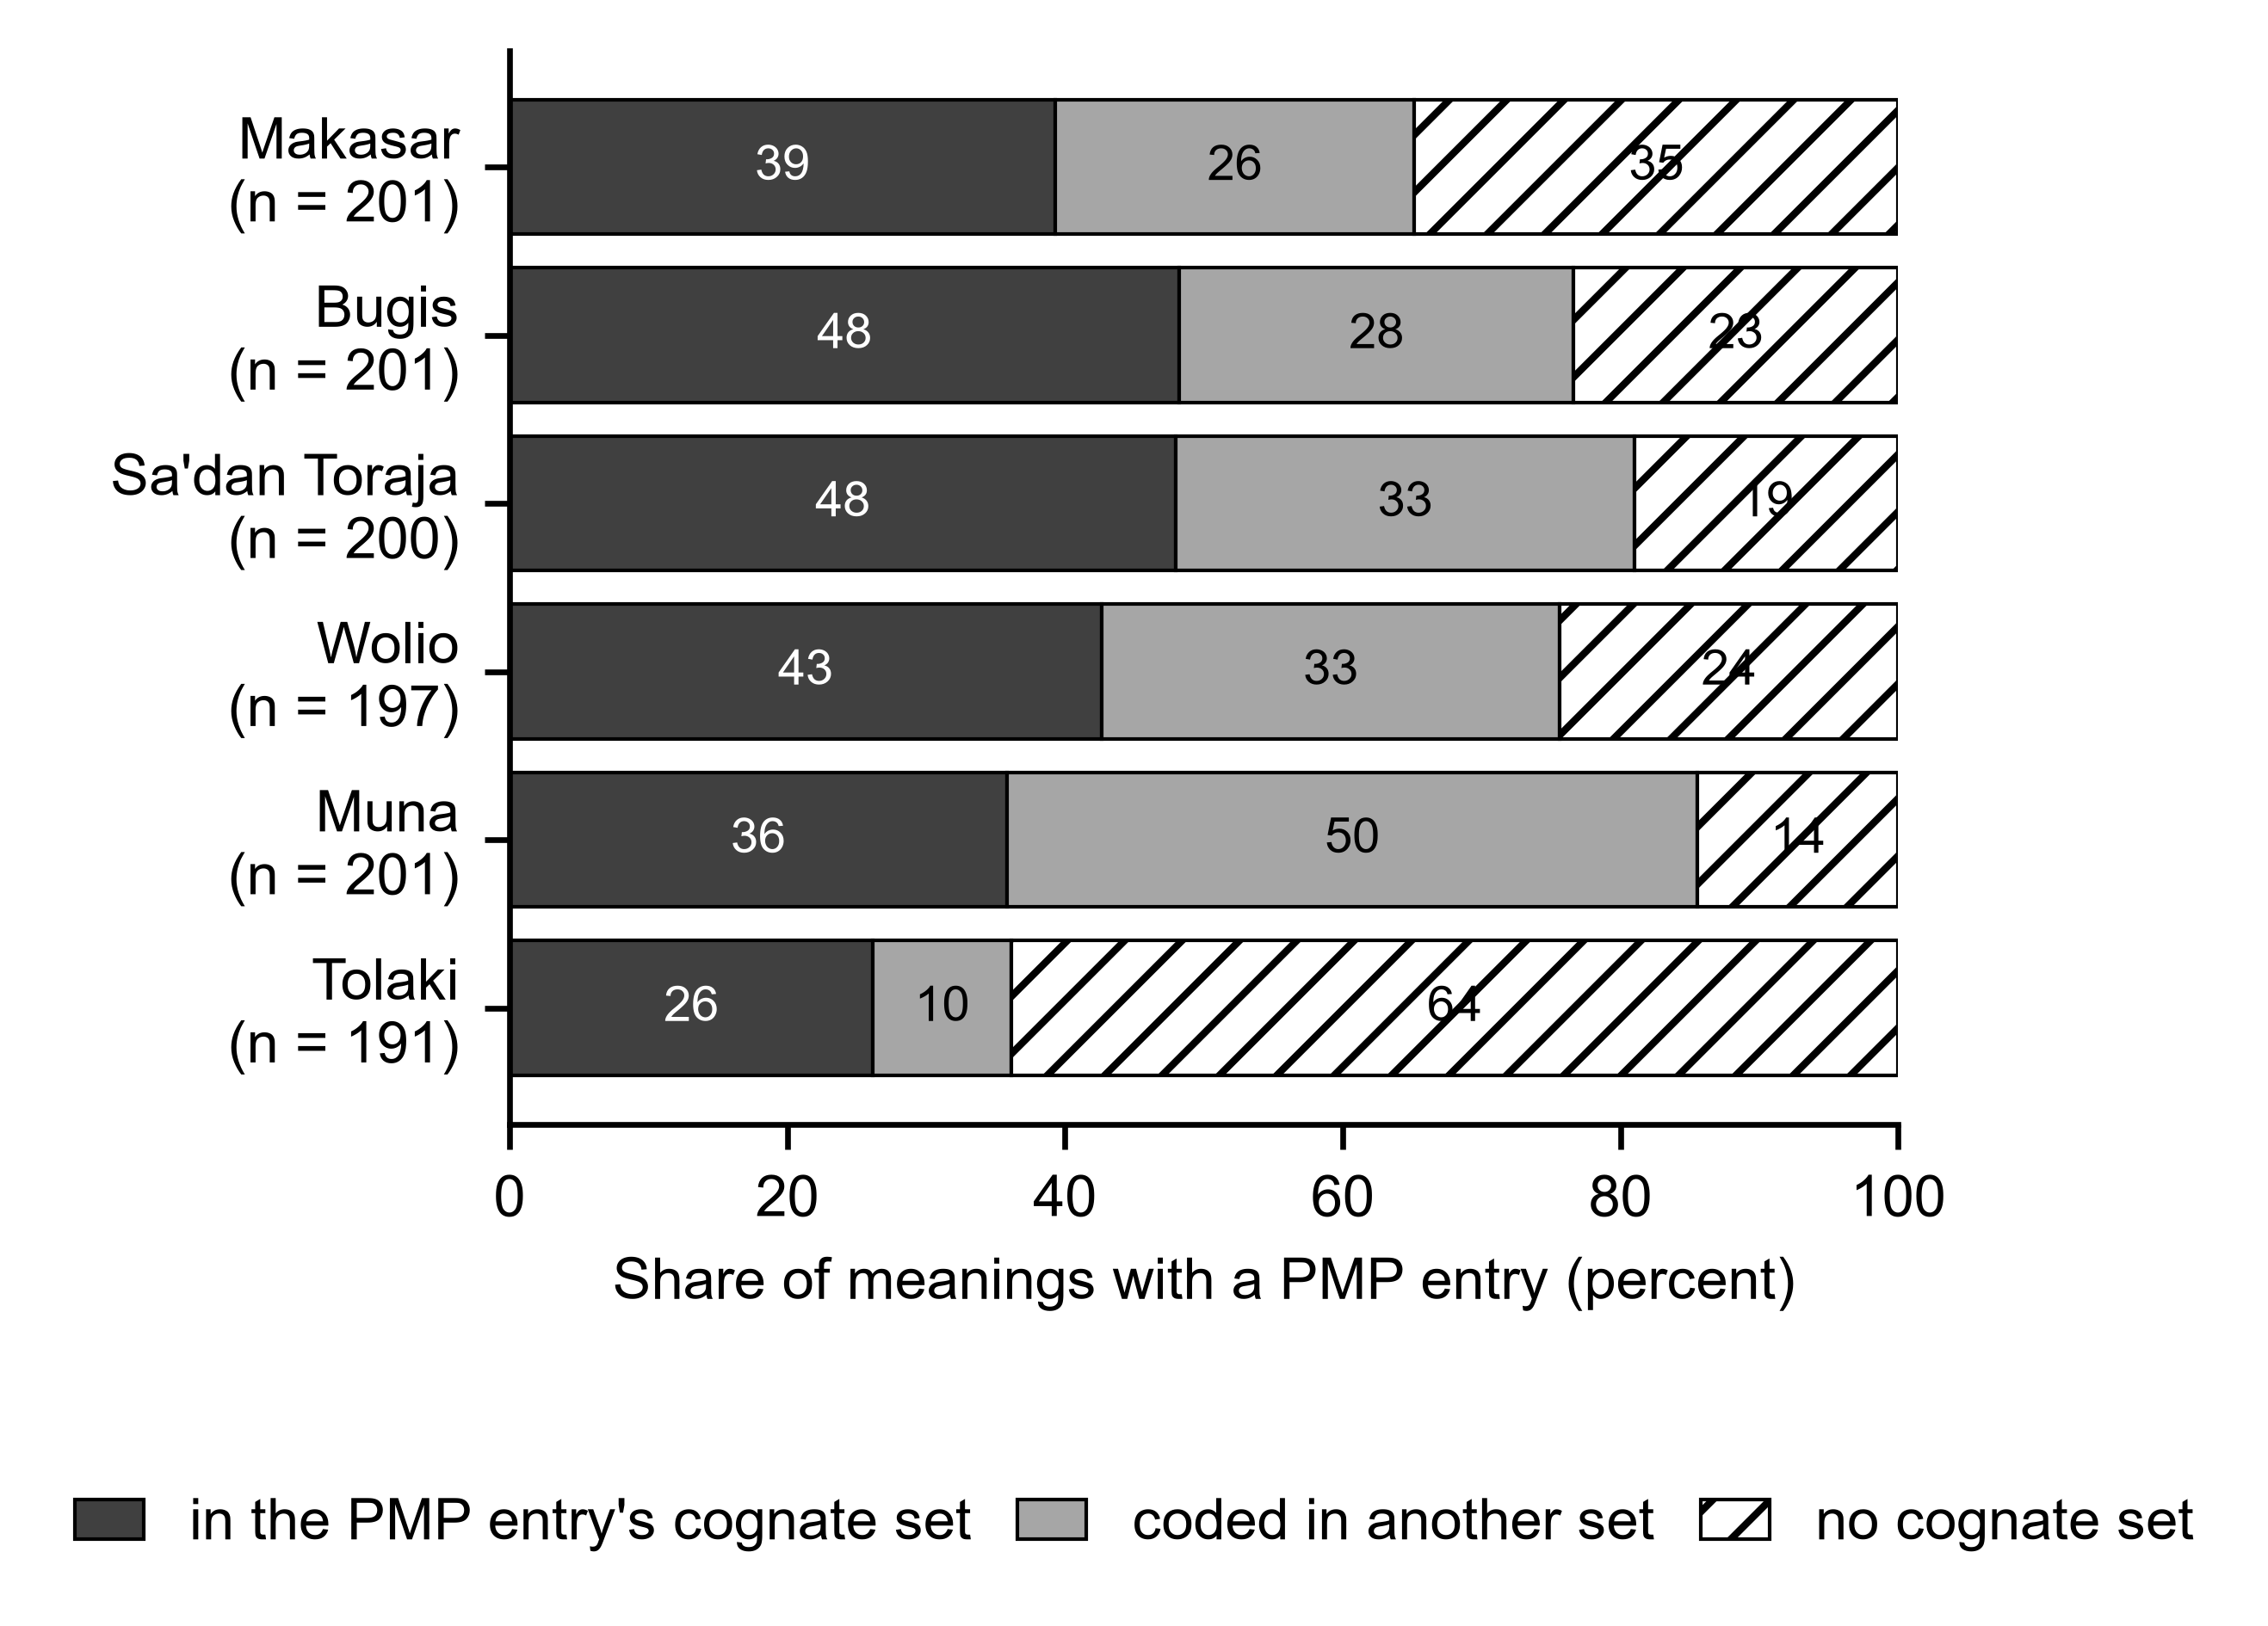
[Figure 3: preview for reading; the journal receives the separate TIFF file]

What distinguishes Makasar from its two relatives in these data is one fact. On the meanings shared with each relative, Makasar has more uncoded meanings than Bugis (exact McNemar test, p = 0.006) and than Sa'dan Toraja (p = 0.0001; both unadjusted). Its lower share in the PMP set and its smaller share of cognate sets held in common with each relative (41.4 and 39.2 percent of the meanings present in both lists, against 53.1 percent between Bugis and Sa'dan Toraja) are the same fact counted again: on the meanings coded in both lists, Makasar is in the PMP set for 70 of 110 meanings against Bugis's 69, and for 70 of 115 against Sa'dan Toraja's 71. Those conditional figures decide nothing about the uncoded forms, because they would be the same whether the uncoded forms are cognates that have not been coded or words that have replaced the inherited ones.
The look-alike screen says a little more. Of 75 uncoded Makasar forms whose meaning has a PMP entry, two resemble the PMP form (about one is expected by chance); the screen finds 38 percent of the Makasar forms that ABVD itself places in the PMP entry's set, and that figure is an upper bound for cognates the coders missed. Of 80 uncoded Makasar forms, 10 (12.5 percent) resemble the Bugis or the Sa'dan Toraja form of the same meaning, against 3.8 percent expected by chance and against 90 of 136 (66 percent) among the coded Makasar forms. The screen therefore does not support the reading that Makasar's uncoded forms are, for the most part, cognates that have simply not been coded; it leaves open what they are. For 28 of the 70 uncoded Makasar meanings the Bugis form is in the PMP set, and for 25 of 69 the Sa'dan Toraja form is; these meanings are listed in the released files for anyone able to judge them.
How does this fit the published figure? The 38 percent cited by Bulbeck, Pasqua, and Di Lello (2000:103) comes from Bellwood (1997:115), who reports Blust's lexicostatistical comparison of 62 Austronesian languages with a 200-item reconstructed PMP list: Western Malayo-Polynesian languages retain 41 percent on average, Malay 59, Minangkabau 50, Tagalog 46, Makasar 38, Sundanese 35 and Yogyakarta Javanese 30. Our 39.3 percent is a count of the same kind, in the same tradition (ABVD's PMP list is Blust's), on a different Makasar word list; that the two agree is not independent confirmation of either, and in its source the figure is not presented as low. A more independent comparison is Sirk's (1989:71) lexicostatistical table, made with other word lists and another judge: Makasar shares 45 percent with Bugis and 42 with Sa'dan, while Bugis and Sa'dan share 60. ABVD's cognate coding gives 41.4, 39.2 and 53.1 percent for the same pairs, the same order, with somewhat smaller gaps. The data are thus compatible with the lexical divergence of Makasar reported in that literature; they do not establish it, and they say nothing about its cause, whether substratum, borrowing or innovation. The 62 percent that Bulbeck, Pasqua, and Di Lello call open to investigation is the complement of a retention count: it contains forms with cognates outside the PMP set as well as forms with none, and so cannot be set against the uncoded share of table 1.

Tolaki.
The Tolaki list has a cognate-set number for 75 of its 209 forms (35.9 percent), by far the lowest share of the six. An earlier version of this paper called this under-documentation. That is the wrong word: the list is not short of data. It fills 200 of the 210 meanings, and of its 86 uncoded forms whose meaning is also covered by ABVD's five Tolaki dialect lists, 88.4 percent recur in those lists. What is sparse is the cognate coding of the whole subgroup. ABVD's Proto-Bungku-Tolaki list is coded for 35.6 percent of its forms, and the 42 other Bungku-Tolaki lists for between 29.9 and 59.6 percent (median 45.0). The unit matters here: the share by form falls with the length of a list (Spearman's rho = −0.55), presumably because longer lists carry more synonyms. Counted by meaning, with the first form of each meaning and on the meanings the lists share, the Tolaki list is coded for 38.3 percent, the five dialect lists for 36.1 to 40.6 percent, and the 42 comparison lists for a median of 46.7 percent, five of them at or below the Tolaki figure. The six Tolaki lists sit on the lower side of a thinly coded subgroup, by a moderate margin, among lists almost all of which come from one compiler.
The look-alike screen shows where the uncoded Tolaki forms have counterparts. Of the 134 uncoded forms, 70.9 percent have a look-alike of the same meaning in the Proto-Bungku-Tolaki list or in one of the 42 other lists, against 10.5 percent expected by chance; at the strict threshold the figures are 63.4 against 3.0 percent. For the coded Tolaki forms the same screen finds a look-alike for 95.9 percent (chance 14.6). Most uncoded forms of this list, then, have a similar-looking form of the same meaning elsewhere in the subgroup. Of the 34 uncoded forms that match an entry of the Proto-Bungku-Tolaki list, seven match an entry that ABVD does assign to a cognate set; these seven are the clearest candidates for coding gaps in the plain sense, although the match is the screen's, not a cognate judgment. Twelve of the 128 uncoded forms whose meaning has a PMP entry resemble that entry by the screen (about two are expected by chance; nine remain at the strict threshold; one of the twelve is loan-flagged); the screen finds 48 percent of the Tolaki forms that ABVD itself places in the PMP set, so that figure too is an upper bound. For the remaining forms the study cannot decide between a coding gap, a chance resemblance and a loan.
A look-alike within the subgroup says nothing about origin. One example makes the point: a word borrowed from a non-Austronesian language by the speakers of a low-level proto-language can be inherited by all its daughters and recur across the subgroup exactly as an inherited Austronesian word does. The screen also compares spellings, not sound correspondences, across lists that are largely one compiler's, and ABVD's own note places the Tolaki list in the Konawe dialect, which is also one of the five dialect lists; the twelve PMP look-alikes are listed in the released files, and none of them should be taken as an etymology before a specialist has looked at it.

Can uncoded forms be told apart?
Table 3 gives the cross-validated performance of the three classifiers on the two input sets, and table 4 the held-out-list results. With the written form and the meaning as inputs, XGBoost ranks uncoded above coded forms with an AUC of 0.727 (random forest 0.727, logistic regression 0.700); with the written form alone, 0.672 (0.683, 0.671). The standard deviation over the ten repetition means is 0.007 and over the fifty test sets 0.027; the bootstrap interval around the pooled score is about plus or minus 0.03.
TABLE 3. CROSS-VALIDATED PERFORMANCE OF THREE CLASSIFIERS ON TWO INPUT SETS
Inputs | Classifier | AUC | Accuracy | Always coded | Precision | Recall | F1
form + meaning (25) | XGBoost | 0.727 | 0.719 | 0.677 | 0.597 | 0.404 | 0.480
form + meaning (25) | Random Forest | 0.727 | 0.663 | 0.677 | 0.483 | 0.622 | 0.543
form + meaning (25) | Logistic regression | 0.700 | 0.648 | 0.677 | 0.468 | 0.657 | 0.546
form only (17) | XGBoost | 0.672 | 0.696 | 0.677 | 0.560 | 0.304 | 0.391
form only (17) | Random Forest | 0.683 | 0.646 | 0.677 | 0.463 | 0.581 | 0.514
form only (17) | Logistic regression | 0.671 | 0.629 | 0.677 | 0.445 | 0.601 | 0.511
Note. Five folds, ten repetitions, fifty test sets. Precision, recall and F1 are those of the uncoded class. "Always coded" is the accuracy of calling every form coded.
Standard deviation of the AUC over the ten repetition means / over the fifty test sets: form + meaning (25), XGBoost: 0.007 / 0.027; form + meaning (25), Random Forest: 0.004 / 0.026; form + meaning (25), Logistic regression: 0.004 / 0.027; form only (17), XGBoost: 0.008 / 0.029; form only (17), Random Forest: 0.006 / 0.026; form only (17), Logistic regression: 0.004 / 0.031.

As a yes/no classifier the model is close to that trivial rule: at a threshold of 0.5 its accuracy is 0.719 against 0.677, and it finds 40 percent of the uncoded forms (recall 0.404) with a precision of 0.597 (F1 0.480). The earlier version of this paper reported an F1 of 0.82, which was the score of the coded class.
TABLE 4. ONE LIST HELD OUT: A MODEL TRAINED ON FIVE LISTS SCORES THE SIXTH
Held-out list | n | Uncoded | AUC (F+M) | Acc. (F+M) | AUC (F) | Acc. (F) | Majority
Muna | 219 | 34 | 0.614 | 0.580 | 0.573 | 0.740 | 0.845
Bugis | 242 | 62 | 0.706 | 0.690 | 0.659 | 0.707 | 0.744
Makasar | 217 | 80 | 0.711 | 0.668 | 0.655 | 0.664 | 0.631
Wolio | 254 | 83 | 0.667 | 0.650 | 0.597 | 0.622 | 0.673
Sa'dan Toraja | 216 | 45 | 0.697 | 0.759 | 0.604 | 0.736 | 0.792
Tolaki | 209 | 134 | 0.809 | 0.498 | 0.760 | 0.426 | 0.641
Mean (standard deviation) over the six lists |  |  | 0.701 (0.059) |  | 0.641 (0.061)
Note. F+M = form and meaning inputs (25); F = form inputs only (17); Majority = accuracy of the majority answer for that list. Figure 4 plots the two AUC columns.

FIGURE 4. AUC FOR A HELD-OUT LIST, BY INPUT SET, WITH THE CHANCE LINE AT 0.5 (THE AUC COLUMNS OF TABLE 4)
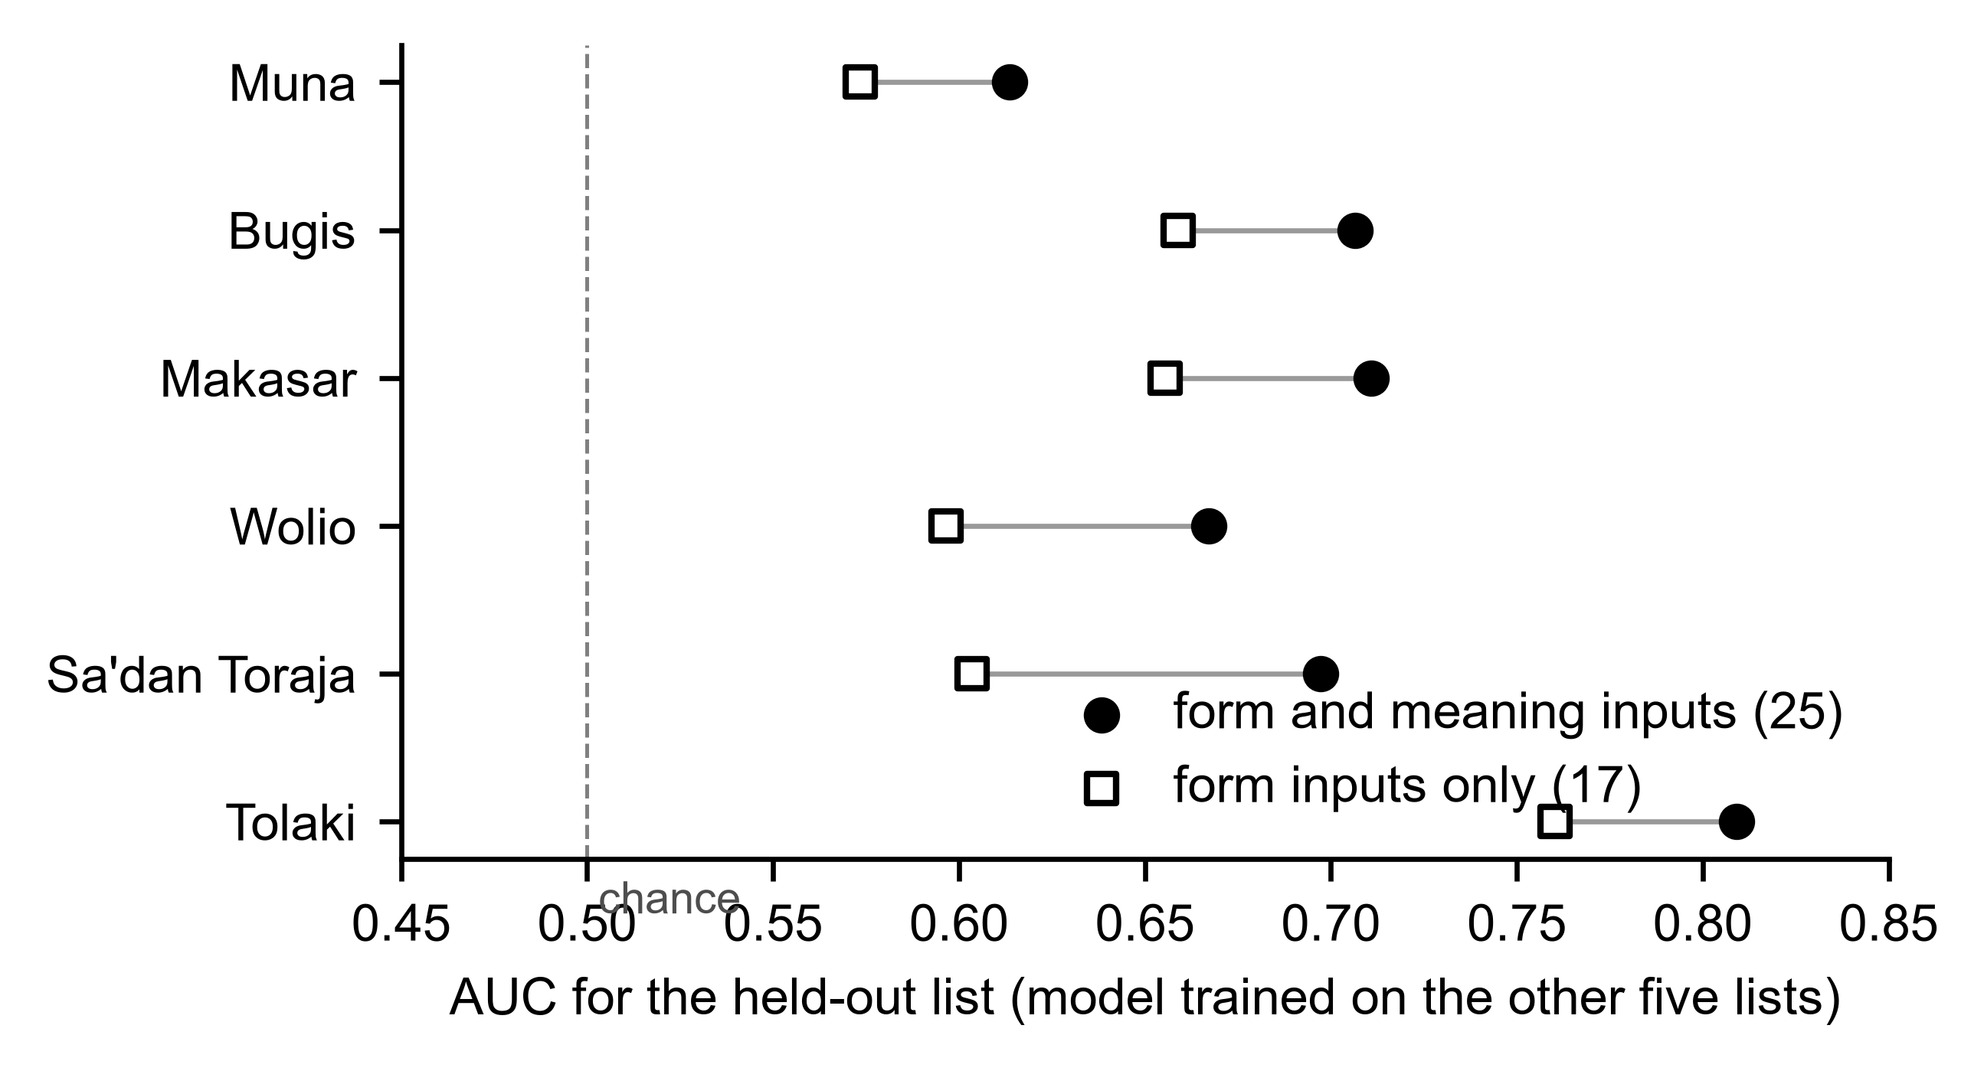
[Figure 4: preview for reading; the journal receives the separate TIFF file]

For a list the model has not seen, the AUC runs from 0.614 (Muna) to 0.809 (Tolaki), mean 0.701, and from 0.573 to 0.760, mean 0.641, with the form inputs alone. The ranking carries over to an unseen list; the classification does not. At a threshold of 0.5 the accuracy for the held-out list is below the majority answer for five of the six lists with either input set (Makasar is the exception). Without the Tolaki list, whose uncoded share is the largest, the cross-validated AUC of the full model is 0.701 (a difference of −0.025). Within each list, out of sample, the full model's AUC is 0.653 (Muna), 0.739 (Bugis), 0.751 (Makasar), 0.664 (Wolio), 0.668 (Sa'dan Toraja) and 0.854 (Tolaki), so the pooled figure is not mainly produced by differences between lists. Pooled over the six lists, the form-only model does no better than a model told only which list a form comes from (0.672 against 0.680); inside a held-out list its ranking is still above chance (AUC 0.573 to 0.760).

What distinguishes them.
Table 5 gives, for each input that matters, its mean or share among uncoded and among coded forms, the number of lists in which the difference has the same sign as the pooled difference, and a within-list effect with a 95 percent interval: a stratified mean difference for counts, a Mantel-Haenszel odds ratio of being uncoded for indicators. These properties are correlated with one another and are one bundle, not ten separate findings.
TABLE 5. THE PROFILE: UNCODED AGAINST CODED FORMS, WITHIN LISTS
Property | Uncoded | Coded | Same sign (of 6) | Effect type | Effect [95% CI] | At equal letter count §
Length in characters (hyphens, spaces and glottal marks included) | 6.10 | 5.20 | 6 | mean difference † | +1.09 [0.87, 1.32] | —
Number of vowel letters | 2.88 | 2.54 | 6 | mean difference † | +0.39 [0.30, 0.49] | —
Consonant-letter clusters | 0.48 | 0.32 | 6 | mean difference † | +0.21 [0.14, 0.28] | 1.51 [1.09, 2.09]
Glottal stop written (ʔ or ') | 23.5% | 11.6% | 5 | odds ratio ‡ | 2.67 [1.88, 3.79] | 2.60 [1.79, 3.76]
Begins with ma, me, mo, pa, ka, ta, na, po or aŋ | 37.0% | 25.2% | 6 | odds ratio ‡ | 1.57 [1.20, 2.04] | 1.09 [0.80, 1.48]
Contains ŋ or ng, or mb, nd, nj, mp, nk, nc, nt | 30.4% | 23.7% | 6 | odds ratio ‡ | 1.55 [1.18, 2.04] | 0.95 [0.70, 1.30]
Hyphen or repeated letter sequence | 11.9% | 9.8% | 5 | odds ratio ‡ | 1.68 [1.12, 2.51] | —
Ends in a vowel | 78.5% | 79.2% | 3 | odds ratio ‡ | 0.66 [0.47, 0.93] | —
Meaning: action | 40.4% | 23.4% | 6 | odds ratio ‡ | 2.46 [1.89, 3.20] | 2.22 [1.67, 2.95]
Meaning in the "core" set (174 of 210) | 83.6% | 83.2% | 3 | odds ratio ‡ | 1.04 [0.76, 1.43] | —
† Stratified mean difference (uncoded minus coded), equal list weights.
‡ Mantel-Haenszel odds ratio of being uncoded, stratified by list. CI = confidence interval.
§ Mantel-Haenszel odds ratio of being uncoded with the number of letters also held fixed (strata: list by letter count); for consonant-letter clusters the indicator "one or more clusters" is used.

Three properties stand. Uncoded forms are longer: 6.10 against 5.20 characters, a within-list difference of +1.09 [0.87, 1.32] characters, or +0.93 [0.72, 1.13] counting letters only; the vowel count measures the same thing. They more often carry a written glottal mark: 23.5 against 11.6 percent, odds ratio 2.67 [1.88, 3.79]. The contrast is present in each of the lists that write the mark: Bugis 2.04, Makasar 2.01, Sa'dan Toraja 2.40; in the Tolaki list all 29 marked forms are uncoded and no coded form carries a mark, which pulls the pooled figure up (without Tolaki, 2.11). And they more often have an action meaning: 40.4 against 23.4 percent, odds ratio 2.46 [1.89, 3.20]. With the number of letters held fixed (strata of list by letter count), the glottal mark gives 2.60 [1.79, 3.76] (2.19 [1.50, 3.22] without Tolaki) and the action meaning 2.22 [1.67, 2.95]; consonant-letter clusters give 1.51 [1.09, 2.09], but they overlap with the nasal-plus-stop pairs and with glottal mark plus consonant, and with the glottal mark also held fixed the figure is 1.38 [0.98, 1.93].
Several properties reported in the earlier version of this paper do not stand as stated. The onset-string input (the strings the code calls prefix-like) is more frequent among uncoded forms, 37.0 against 25.2 percent (odds ratio 1.57 [1.20, 2.04]), not less, as we had written. But it is not separable from length: with the number of letters held fixed the odds ratio is 1.09 [0.80, 1.48], and with the number of letters after the matched string held fixed it is 2.51 [1.85, 3.40]. Two ways of equalizing length give two answers, so the data neither show fewer onset strings nor establish more; a length criterion alone ("six letters or more") gives an odds ratio of 2.56 [1.98, 3.32]. The nasal input behaves in the same way: 30.4 against 23.7 percent as coded (1.55 [1.18, 2.04]), 21.0 against 12.7 percent for a strict nasal-plus-stop definition (2.05 [1.47, 2.84]), and 0.95 [0.70, 1.30] or 1.24 [0.84, 1.81] with letters held fixed. The hyphen-or-repetition input gives about the same estimate under every definition (1.68 [1.12, 2.51] as coded; 1.61 [0.87, 2.98] for a repeated block alone; 1.57 [0.94, 2.63] for a hyphen alone), and the intervals of the two halves include one; we do not treat it as a separate property, and the data do not show that uncoded and coded forms do not differ in it. "Ends in a vowel" is the glottal mark counted a second time: in the three South Sulawesi lists, the only lists with consonant-final forms, uncoded forms are 23.8 percent of the vowel-final forms, 25.9 percent of the forms ending in another consonant and 39.3 percent of the forms ending in a glottal mark; with the glottal-final forms set aside the odds ratio is 0.91 [0.58, 1.44]. The core-set indicator does not differ (1.04 [0.76, 1.43]).
Figure 1 ranks the inputs by their mean absolute contribution to the predictions of the full model. The six largest are the glottal mark (0.279), length (0.276), the action meaning (0.269), the vowel count (0.266), the vowel share (0.210) and consonant-letter clusters (0.198). The figure describes the classifier, not the vocabulary: for "ends in a vowel" the model's direction is the reverse of the within-list association. Two circumstances could produce that: all 285 consonant-final forms are in the three South Sulawesi lists, so the input also tells the model which list a form comes from, and the input overlaps with the glottal input. Which of the two accounts for the sign was not tested. Statements about the vocabulary in this paper rest on table 5, not on figure 1.
FIGURE 1. MEAN ABSOLUTE CONTRIBUTION OF EACH INPUT TO THE PREDICTIONS OF THE FULL MODEL (SHAP VALUES), WITH THE DIRECTION OF EACH INPUT'S EFFECT ON THE SCORE
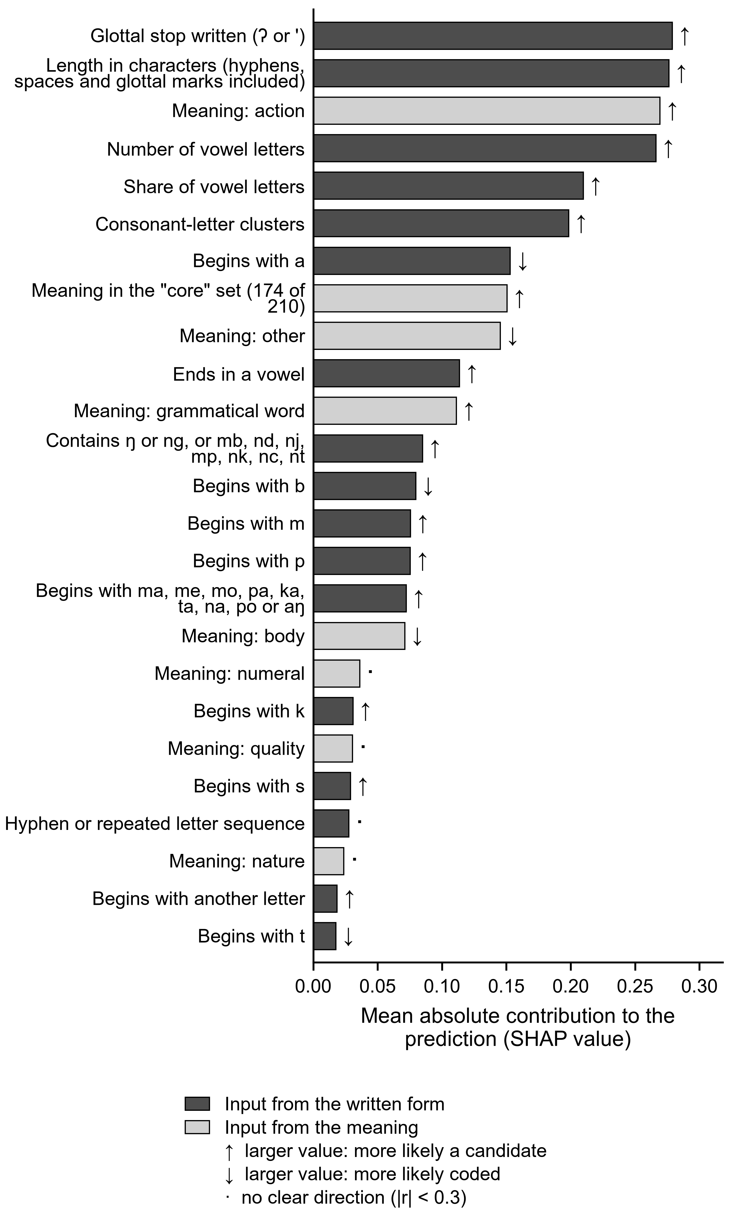
[Figure 1: preview for reading; the journal receives the separate TIFF file]

The action meanings need a comment, because their forms are also longer (5.95 against 5.31 characters, in five of six lists) and are cited differently from list to list: 91.9 percent of the Muna action forms begin with a, as do 81.7 percent of the Makasar ones, while 61.7 percent of the Tolaki action forms begin with one of the nine onset strings. One reading of the whole bundle is that uncoded forms are more often morphologically complex citation forms, verbs with their affixes. We state it as a reading. No form was segmented in this study, the only segmentation marked by compilers in the data (the hyphen in the Bugis and Sa'dan Toraja lists, which appears to mark a morpheme boundary) gives a mixed result (uncoded forms are 34.4 percent of hyphenated Bugis forms against 22.5 percent of the rest, and 20.0 against 20.9 percent in Sa'dan Toraja), and a rival reading fits the same numbers: affixed citation forms may simply be harder to code, so that the profile would be a profile of coding difficulty rather than of the words. A third reading, that some lists write glottalization where others do not, is taken up in section 3.6.
Table 6 crosses the label with the model's out-of-sample score at a threshold of 0.5. Of the 438 uncoded forms, 172 score 0.5 or more ("uncoded, profile") and 266 below it; of the 919 coded forms, 105 score 0.5 or more and 814 below. The agreement between label and score beyond chance is Cohen's kappa = 0.31 (Cohen 1960; 0 is chance-level agreement, 1 complete agreement). An earlier version of this paper reported a kappa of 0.61 and a set of 266 forms "confirmed by both methods"; that agreement was computed on the forms the model had been trained on and is withdrawn. Table 7 gives two examples for each cell, printed as ABVD records them with their set number, the PMP entry of the meaning and the nearest same-meaning form in another Sulawesi list by the screen. They are the forms the classifier scores most extremely, so they illustrate its inputs by construction; none has been assessed etymologically, and the nearest look-alike is a spelling match, not a cognate. The full table of 92 example rows (73 forms, coded and uncoded) and the scores of all 1,357 forms are in the released files.
TABLE 6. THE LABEL CROSSED WITH THE OUT-OF-SAMPLE SCORE OF THE FULL MODEL, BY LIST
List | n | Uncoded, profile | Uncoded, no profile | Coded, profile | Coded, no profile | Kappa
Muna | 219 | 5 | 29 | 9 | 176 | 0.13
Bugis | 242 | 27 | 35 | 23 | 157 | 0.33
Makasar | 217 | 31 | 49 | 19 | 118 | 0.27
Wolio | 254 | 32 | 51 | 31 | 140 | 0.22
Sa'dan Toraja | 216 | 15 | 30 | 19 | 152 | 0.24
Tolaki | 209 | 62 | 72 | 4 | 71 | 0.34
All six lists | 1,357 | 172 | 266 | 105 | 814 | 0.31
Note. "Profile" = score of 0.5 or more; the scores are out of sample (five-fold cross-validation, ten repetitions) and averaged over the ten repetitions, which is why the cells imply an accuracy (0.727) slightly above the per-repetition accuracy of table 3 (0.719). Kappa is Cohen's.

TABLE 7. EXAMPLES FOR THE FOUR CELLS OF TABLE 6, AS RECORDED IN ABVD
Cell | List | Meaning | Form (ABVD) | Set | PMP (ABVD) | Score | Nearest look-alike (list)
uncoded & no profile | Makasar | road/path | agaŋ | — | *zalan | 0.02 | daleŋ (Bantik)
uncoded & no profile | Sa'dan Toraja | mouth | sadaŋ | — | *baqbaq | 0.04 | baba (Banggai (W.dialect))
uncoded & profile | Tolaki | to cry | umi'ia | — | *taŋis | 0.96 | miʔia (Kodeoha)
uncoded & profile | Tolaki | to see | ki'ii | — | *kita | 0.95 | moŋkii (Mori Bawah (Bahano))
coded & no profile | Tolaki | thatch/roof | ato | 1 | *qatep | 0.01 | ghato (Muna (Katobu-Tongkuno Dialect))
coded & no profile | Muna | father | ama | 1 | *t-ama | 0.01 | tama (Banggai (W.dialect))
coded & profile | Wolio | red | male'i | 1 | *ma-iʀaq | 0.92 | mo-lei (Uma (Kantewu dialect))
coded & profile | Wolio | near | marampi | 25 | *ma-azani | 0.87 | motampi (Kumbewaha)
Note. Forms are given as ABVD records them and have not been assessed etymologically. "Set" is ABVD's cognate-set number; "PMP (ABVD)" is the Proto-Malayo-Polynesian entry for the meaning; the nearest look-alike is a spelling match by the screen of section 2.6, which ignores up to three leading characters, so a distance of 0.0 does not mean identity.

In the earlier version five meanings ('One Hundred', 'Fifty', 'Twenty', 'to stand' and 'to hit') appeared as consensus candidates in four or more lists. 'Fifty' and 'Twenty' appear to be decimal compounds whose parts recur across the lists (Makasar limampulo, Sa'dan Toraja limaŋpulo, Tolaki limambulo, Wolio lima pulu); they are uncoded in four lists and coded in Bugis. The 'One Hundred' forms are not uniform across the lists and do not belong with them. 'To stand' and 'to hit' were on that version's own list of inherited meanings, and its consensus had been computed on a label that ignored the list. Out of sample, no meaning is "uncoded, profile" in four or more lists.

Does the result depend on spelling?
The classifier sees only what the compilers wrote. A glottal stop written as q or k, or not written at all, is invisible to it, and the lists differ in how they write it: 36 percent of the Makasar forms carry ʔ, 22 percent of the Sa'dan Toraja forms (47 with ʔ, one with an apostrophe), 21 percent of the Bugis forms, 14 percent of the Tolaki forms (29, all with an apostrophe, which the compiler's note says stands for a glottal stop), four Wolio forms (two uncoded, two coded) and no Muna form. Whether these differences are differences of notation or of phonology we cannot say; a language without a phonemic glottal stop has nothing to write, and the question is one for specialists. In the Tolaki list every form written with an apostrophe is uncoded. Figure 5 gives the share of marked forms among uncoded and among coded forms for each list.
FIGURE 5. FORMS WITH A WRITTEN GLOTTAL MARK, UNCODED AGAINST CODED, BY LIST (NUMBERS OF UNCODED AND CODED FORMS IN PARENTHESES)
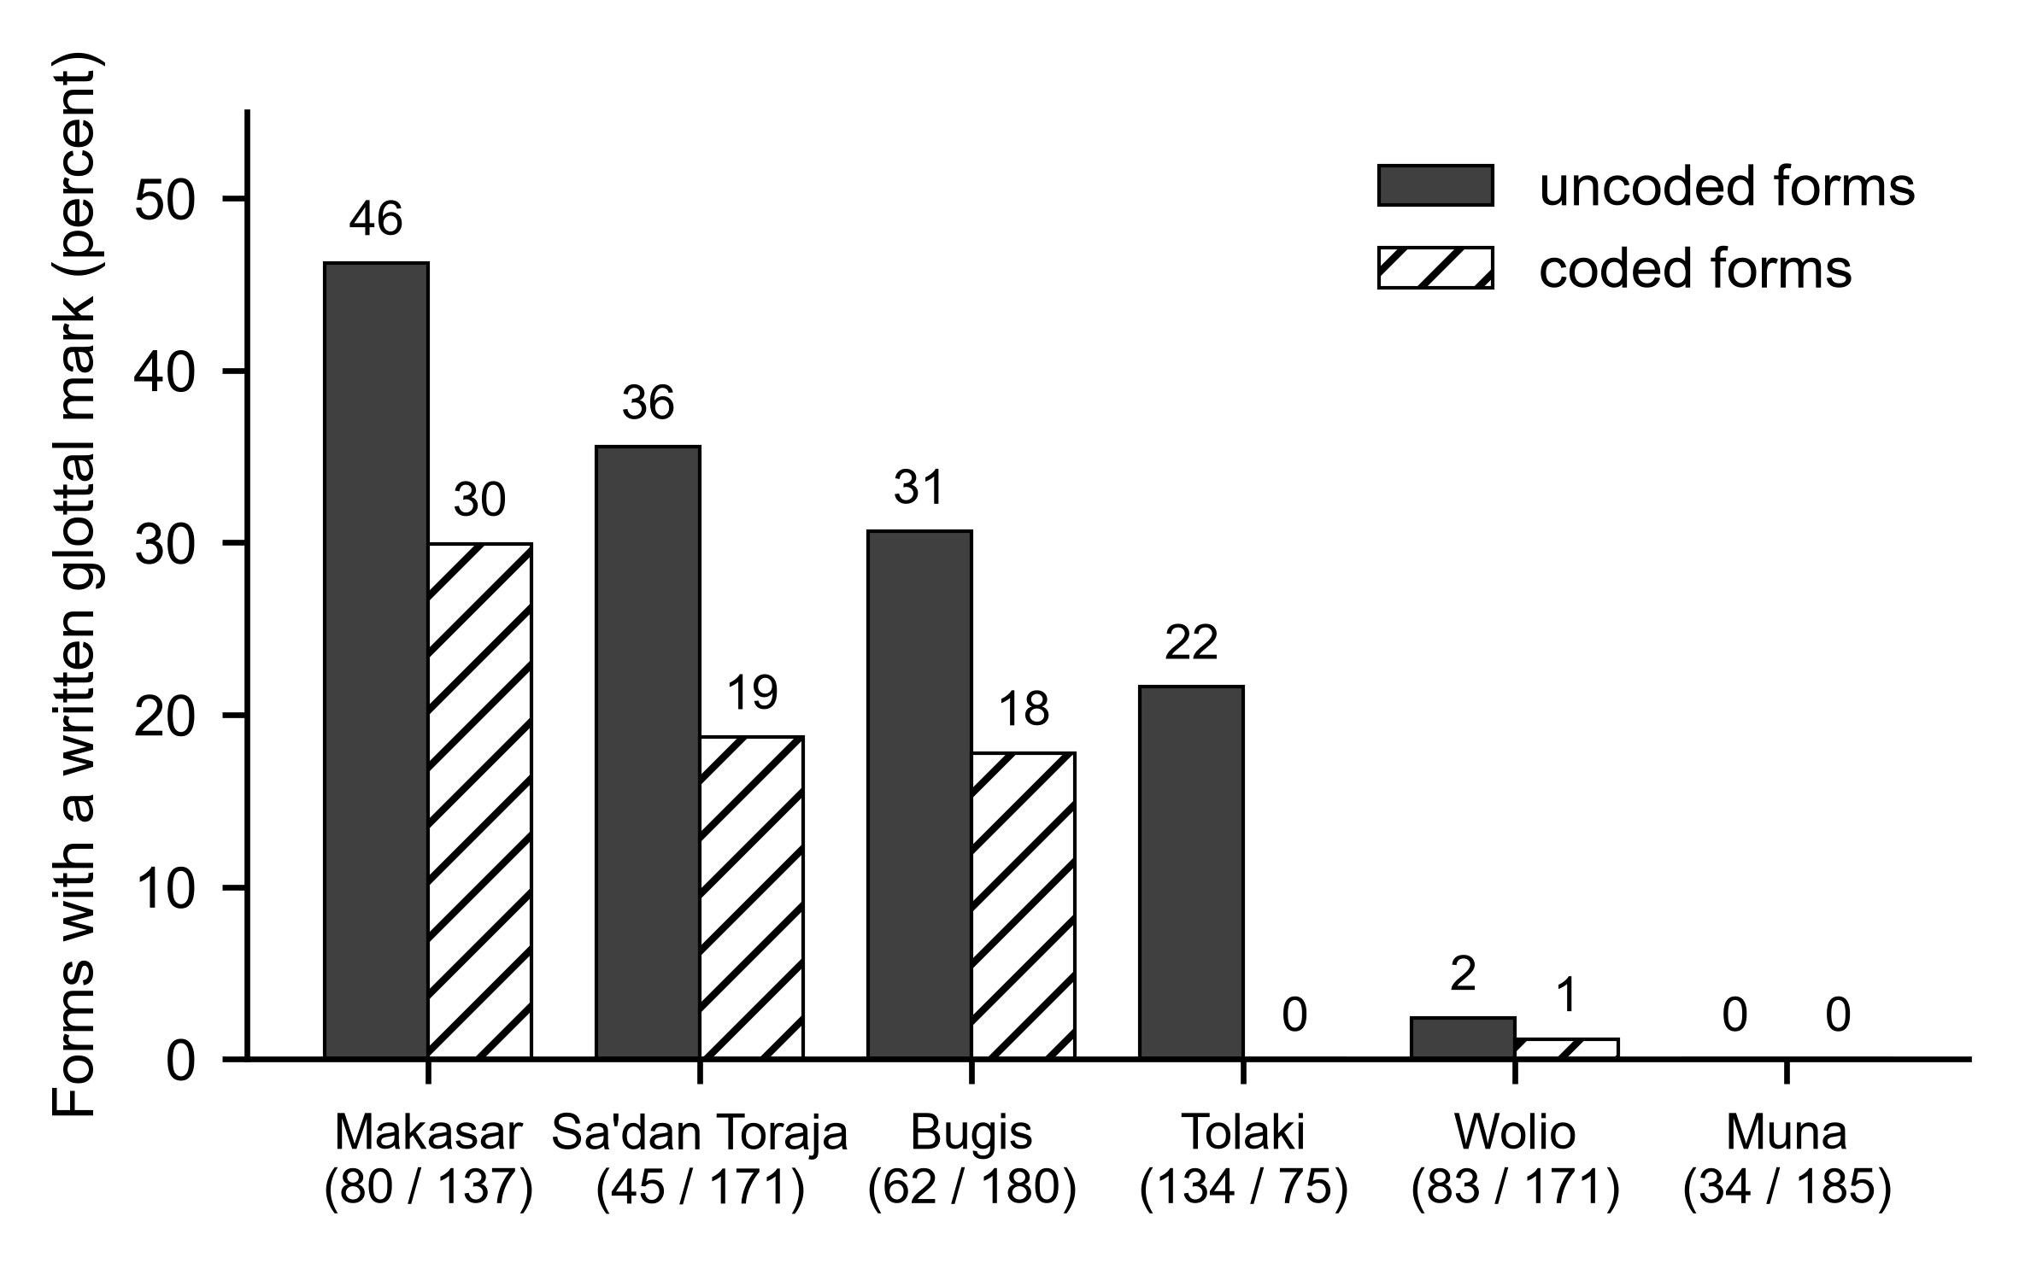
[Figure 5: preview for reading; the journal receives the separate TIFF file]

Eleven Sa'dan Toraja forms end in k beside 45 that end in a glottal mark, in one and the same source; since ABVD's PMP entries for two of those eleven meanings themselves end in k (*manuk 'bird', *tasik 'sea'), we do not treat that k as a way of writing the glottal stop. Glottal mark followed by a consonant occurs in 35 forms (Makasar 26, Sa'dan Toraja 7, Bugis 2) and is also counted by the cluster input.
Table 8 gives the AUC under each re-coding of the glottal mark. Writing the mark as q, which for the classifier is the same as removing the input, costs 0.016 of cross-validated AUC and 0.020 for the held-out lists; writing it as k costs about the same in cross-validation and 0.024 for the held-out lists (a k also feeds the first-letter and nk inputs); leaving the mark unwritten costs 0.006; leaving it unwritten but doubling a following consonant, so that a pre-glottalized consonant becomes a geminate, costs 0.007; unifying the apostrophe to ʔ changes no input. The AUC stays at or above 0.710 in every variant (held-out lists down to 0.677). By the rule written before the run (a loss between 0.010 and 0.020 counts as partial dependence), the result depends partly on how the glottal stop is written: nearly the same result, not the same result. No noise estimate exists for these differences, so their size relative to chance variation is not known.
TABLE 8. THE AUC OF THE FULL MODEL UNDER SIX WRITINGS OF THE GLOTTAL STOP
Convention | Forms changed | AUC, cross-validated | Δ | AUC, held-out list (mean) | Δ
As in the sources (ʔ or apostrophe) | 0 | 0.727 | 0.000 | 0.701 | 0.000
Mark written as q | 210 | 0.710 | −0.016 | 0.681 | −0.019
Mark written as k | 210 | 0.710 | −0.016 | 0.677 | −0.024
Mark left unwritten | 210 | 0.720 | −0.006 | 0.699 | −0.001
Pre-glottalised consonant written as a geminate | 210 | 0.720 | −0.007 | 0.696 | −0.005
Apostrophe written as ʔ (changes no input) | 32 | 0.727 | 0.000 | 0.701 | 0.000
Glottal input removed | 0 | 0.710 | −0.016 | 0.681 | −0.019
Note. Δ is the change from the first row. Rows 2 and 7 are the same change for the classifier; row 3 differs slightly because a k also feeds other inputs; row 5 removes the mark and doubles a following consonant; row 6 changes no input.

Digraphs matter little. The conversion of ng and ny in all lists and of gh, bh and dh in Muna to single symbols changes 75 forms (Muna 54, Tolaki 20, Sa'dan Toraja 1; ny occurs in no form, gh in no Wolio form) and leaves the AUC unchanged (−0.0003 with form and meaning inputs, +0.003 with the form alone; both below the 0.010 of the rule). The two Muna forms with dh, akaradhaa 'to work' and idho 'green', are both coded and were both converted; the earlier version of this paper omitted dh from the list, and no loanword was removed from the classifier's data. Word size, on the other hand, is one of the things the classifier uses: removing the length input alone changes nothing, because the vowel count carries the same information, but removing both size inputs costs 0.014 of AUC with form and meaning inputs and 0.023 with the form alone. The earlier version's statement that the result does not depend on form length is withdrawn, as is its statement that the profile is not an orthographic artifact: the glottal-mark result above is exactly a dependence on orthography, of modest size.

Are uncoded forms similar across lists?
The earlier version of this paper reported a clustering analysis and a test with p = 0.569 as evidence that the uncoded forms share no word families across the lists. The test compared a mean over twenty meanings with single draws of mostly coded vocabulary and did not test that hypothesis; the clustering's "optimal" number of clusters was the edge of the range searched. Both are withdrawn and replaced by the permutation test of section 2.6.
Among the uncoded forms without numerals (411 forms, 440 same-meaning pairs across lists), the mean distance between same-meaning forms is 0.836, against 0.869 when meanings are shuffled (permutation standard deviation 0.006; none of 10,000 permutations reached the observed value). Four pairs are look-alikes at the 0.34 threshold, against 0.52 expected (p = 0.0016). The positive control shows what a shared layer looks like in the same measure: among the coded forms (1,793 pairs) the mean distance is 0.578 against 0.856, with 472 look-alike pairs against 8.5 expected. The excess among uncoded forms is about one eighth of the excess among coded forms on the distance measure and about one thirtieth on look-alike pairs (comparing the excesses over expectation per pair). The four pairs are Bugis ma-kunru and Wolio makundu 'dull', Wolio tawa and Tolaki tawa 'leaf', Muna notente and Wolio tente 'to swell', and Bugis ma-tanəʔ and Wolio matamo 'heavy'; all four involve Wolio, none lies within South Sulawesi, and two begin with ma- on both sides. Several of the meanings that pull the statistic down most are quality terms whose uncoded forms begin with ma-, mo- or me- in several lists ('heavy' in all four of its forms, 'dull' in three of four, 'near' in three of three), so part of the small excess may be a shared affix rather than shared roots. Removing any single meaning changes the mean distance by at most 0.003. Pairs inside South Sulawesi (83) show an excess of 0.046 and the other pairs (357) one of 0.030; the difference between the two is about one combined standard deviation and is not distinguishable from zero. Among the "uncoded, profile" forms without numerals (159 forms, 68 pairs) there are too few pairs to tell.
Shared vocabulary that ABVD's editors have recognized carries a cognate-set number and is by definition in the coded class, which this test does not examine; a shared layer beyond Proto-Malayo-Polynesian, if there were one, would sit there to the extent that the editors recognized it. Three of the four subgroups represented fall inside the proposed Celebic supergroup, so the four are not four independent witnesses. The paper therefore makes no claim about a shared pre-Austronesian layer, positive or negative, and it does not describe the uncoded forms as independent innovations either: the data show a small excess of similarity among uncoded forms of the same meaning, of a size far below that of the coded vocabulary, and nothing more. More than twenty p-values were computed in this and the preceding sections; of these, only the primary permutation test had its decision rule written before the run (Section 2.6).

Sixteen further lists.
An earlier version applied the model to sixteen further ABVD lists (eight from Sulawesi, six from western Indonesia, two from eastern Indonesia) and reported a geographic pattern. That application used two inputs computed at the level of the list, and the per-list rates it reported depended on them. Without any list-level input, the model ranks the uncoded forms of those sixteen lists against their own ABVD label with a mean AUC of 0.638 (range 0.427 to 0.795; 0.60 or more in ten of the sixteen). The mean score of the Sulawesi lists is higher than that of the western lists (0.308 against 0.229, p = 0.023), but among coded forms alone the difference is not detectable (0.242 against 0.208, p = 0.37), and we make no geographic claim.

Discussion.
What the profile is. The measured content of section 3.5 is a correlated bundle: uncoded forms in these six lists are about one character longer, more often carry a written glottal mark where the source writes one, and more often denote actions; the glottal mark and the action meaning hold at equal length, and the onset-string and nasal inputs do not separate from length. Everything beyond that is interpretation. The reading that the uncoded forms are morphologically complex citation forms is plausible, but it was not tested, and the rival reading that affixed forms are harder to code fits the same numbers. Loanwords are commonly adapted to the phonology of the borrowing language (Blust 2012:556, on Palauan); an uncoded form that looks like the coded vocabulary is therefore not thereby inherited, and deserves a specialist's attention as much as one that does not.
What the classifier is for. It is a ranking aid, not a detector of substrate vocabulary. Its AUC of 0.73 means that an uncoded form outranks a coded form about three times in four; its accuracy as a yes/no classifier is close to the trivial rule, and for a list it has not seen it is below the majority answer. The ranking does carry over to unseen lists, with an AUC of 0.70 on average. Whether that ranking helps a specialist has not been tested; the forms it puts first are long, more often glottal-marked and more often action words (Table 5), and the score carries no etymological information.
Makasar. The study adds to the discussion of Makasar's divergence a decomposition on a public database (in the PMP set, coded elsewhere, uncoded, with intervals) and a screen of the uncoded forms: Makasar has more uncoded meanings than Bugis and Sa'dan Toraja by 11 to 16 points, and only a small fraction of those forms resemble the PMP entry or the relatives' forms by a screen whose sensitivity even on coded forms is at most 38 percent. The counts are compatible with the lexical divergence reported by Mills (1975), Sirk (1989) and Bulbeck, Pasqua, and Di Lello (2000); they do not prove it, since a spelling screen is not a cognate judgment, and they say nothing about its cause. What would decide the matter is a specialist's judgment of the 70 uncoded Makasar meanings against their Bugis and Sa'dan Toraja forms; the list is released for that purpose.
Tolaki. The word under-documentation is withdrawn. The Tolaki list is well filled; it sits on the lower side of a thinly coded subgroup, and most of its uncoded forms have look-alikes elsewhere in Bungku-Tolaki. Seven of them match a coded Proto-Bungku-Tolaki entry by the screen, and twelve resemble the PMP entry. None of this bears on origin, for the reason given in section 3.3.
Similarity across lists. Among uncoded forms, same-meaning forms are slightly more alike across lists than different-meaning forms. The excess is small, part of it may be shared affixation, and the coded class, where recognized shared vocabulary lives, was not examined. The paper has no cross-language claim.
Limitations. The inputs are written forms, not phonemic transcriptions, and the lists differ in notation; the glottal mark is written routinely in four lists, in four forms of a fifth and not at all in the sixth, and whether that is notation or phonology is not known to us. No form was morphologically segmented, so the morphological reading of the profile is untested. The label is the state of cognate coding in one snapshot of one database; "coded" mixes inherited forms, small local sets and flagged loans, the coding rate differs between lists and subgroups, and one language has two lists that code each other. The properties of the profile are correlated, the intervals treat forms as independent although meanings recur across the six lists, and ten properties were tested without adjustment. Six lists from one island were used. The look-alike screen compares spellings, its 42 Bungku-Tolaki comparison lists represent 13 languages from two contributors, and its sensitivity is an upper bound. The three-class count, the look-alike screens, the permutation test and the spelling tests had their decision rules written before they were run, on the same day and by the same analyst and without external registration; the further counts of section 3.5 and the per-list figures were made after the results were known. Form inputs carry information about the source list even though no list-level input is used. And no single form has been assessed by a specialist in these languages.

Conclusion.
Four things can be said. First, the uncoded forms of six Sulawesi ABVD lists can be ranked against the coded forms from their written shape and their meaning, with an AUC of about 0.73, but not reliably classified; the ranking carries over to a list the model has not seen. Second, the properties that distinguish them are a correlated bundle of length, a written glottal mark and an action meaning; the morphological reading of that bundle is untested. Third, for Makasar and for Tolaki the absence of a cognate-set number means different things, and in neither list does the absence of a number by itself indicate non-Austronesian origin: Makasar's uncoded forms are numerous and mostly unlike their relatives' forms by a mechanical screen; Tolaki's mostly have look-alikes elsewhere in its subgroup. A cognate-set number, equally, is not a finding of inheritance. Fourth, among uncoded forms the similarity across lists is small, and the test does not reach the class where a shared layer would be found. Three directions follow: morphological segmentation before any property is computed; cognate coding at the level of the subgroup, which would show how many of Tolaki's uncoded forms belong to sets with forms in related lists; and specialist inspection of the released lists, which is the only step that can establish etymologies. Conversion of the written forms to a phonetic transcription (Anderson et al. 2018) could reduce the dependence on notation that section 3.6 measured.
DATA AND CODE AVAILABILITY
The data files described below are deposited at Zenodo (https://doi.org/10.5281/zenodo.23202245; license CC BY 4.0): one row for each of the 1,357 forms (ABVD identifiers, the form as recorded, cognate-set numbers and loan flag, the label, the out-of-sample scores of the full model, of a variant with the list-identity input that section 2.3 withdrew, and of the held-out-list model, the cell of table 6, and the nearest same-meaning look-alike in other Sulawesi lists and, for Tolaki, in Bungku-Tolaki lists); the 438 uncoded forms as a subset; the 70 uncoded Makasar meanings with the Bugis and Sa'dan Toraja forms and the PMP entry; the twelve Tolaki look-alikes of PMP entries; and the 92 example rows from which table 7 was drawn. The source data are ABVD (Greenhill, Blust, and Gray 2008), lexibank/abvd at repository state 917c5a5, CC BY 4.0. The analysis scripts, the pre-stated decision rules and the result files are in the public project repository (https://github.com/neimasilk/volcarch-repo, folders experiments/E227 to E231; MIT license).
DECLARATION ON THE USE OF ARTIFICIAL INTELLIGENCE
This study was carried out with artificial intelligence (AI) assistance (Claude, Anthropic) at every stage: the scripts for feature extraction, classification, the look-alike screen and the permutation test; the re-derivation of every number of an earlier version of this paper from the raw files, which found the errors acknowledged in the text; the analyses added for the revision; the tables; the locating and reading of the sources cited; and the drafting of the text. The authors set the questions and the rules of the study, approved the design choices and the withdrawal of the earlier claims, reviewed the text, and take responsibility for every statement. No statement in this paper rests on an etymological judgment, by an AI system or by the authors; the remark on the decimal numerals in section 3.5 is an observation about transparent compounds. The authors are not specialists in the languages discussed; the methods of section 2 are their substitute for judgments they cannot make, and the limits of that substitute are stated where each result is given.
ACKNOWLEDGMENTS
We thank the two anonymous reviewers of Oceanic Linguistics, whose questions prompted part of the re-derivation reported here, and the editors for their patience. We thank the compilers of the ABVD word lists and the ABVD team for making the data available under an open license.
REFERENCES
Anderson, Cormac, Tiago Tresoldi, Thiago Costa Chacon, Anne-Maria Fehn, Mary Walworth, Robert Forkel and Johann-Mattis List. 2018. A cross-linguistic database of phonetic transcription systems. Yearbook of the Poznan Linguistic Meeting 4(1). 21–53. https://doi.org/10.2478/yplm-2018-0002.
Bellwood, Peter. 1997. Prehistory of the Indo-Malaysian archipelago. Revised. Honolulu: University of Hawai’i Press.
Berg, René van den. 1996. The demise of focus and the spread of conjugated verbs in Sulawesi. In Hein Steinhauer (ed.), Papers in Austronesian linguistics no. 3 (Pacific Linguistics A-84), 89–114. Canberra: Pacific Linguistics, The Australian National University.
Blust, Robert. 2012. The Proto-Malayo-Polynesian multiplicative ligature *ŋa: A reply to Reid. Oceanic Linguistics 51(2). 538–566. https://doi.org/10.1353/ol.2012.0016.
Blust, Robert. 2013. The Austronesian languages. Revised edition. Canberra: Asia-Pacific Linguistics.
Breiman, Leo. 2001. Random forests. Machine Learning 45(1). 5–32. https://doi.org/10.1023/A:1010933404324.
Bulbeck, David, Monique Pasqua and Adrian Di Lello. 2000. Culture history of the Toalean of South Sulawesi, Indonesia. Asian Perspectives 39(1–2). 71–108. https://doi.org/10.1353/asi.2000.0004.
Bulbeck, F. David. 1992. A tale of two kingdoms: The historical archaeology of Gowa and Tallok, South Sulawesi, Indonesia. Canberra: The Australian National University PhD thesis.
Chen, Tianqi and Carlos Guestrin. 2016. XGBoost: A scalable tree boosting system. In Proceedings of the 22nd ACM SIGKDD international conference on knowledge discovery and data mining, 785–794. https://doi.org/10.1145/2939672.2939785.
Cohen, Jacob. 1960. A coefficient of agreement for nominal scales. Educational and Psychological Measurement 20(1). 37–46. https://doi.org/10.1177/001316446002000104.
Forkel, Robert, Johann-Mattis List, Simon J. Greenhill, Christoph Rzymski, Sebastian Bank, Michael Cysouw, Harald Hammarström, Martin Haspelmath, Gereon A. Kaiping and Russell D. Gray. 2018. Cross-Linguistic Data Formats, advancing data sharing and re-use in comparative linguistics. Scientific Data 5. 180205. https://doi.org/10.1038/sdata.2018.205.
Gray, Russell D., Alexei J. Drummond and Simon J. Greenhill. 2009. Language phylogenies reveal expansion pulses and pauses in Pacific settlement. Science 323(5913). 479–483. https://doi.org/10.1126/science.1166858.
Greenhill, Simon J., Robert Blust and Russell D. Gray. 2008. The Austronesian Basic Vocabulary Database: From bioinformatics to lexomics. Evolutionary Bioinformatics 4. 271–283. https://doi.org/10.4137/EBO.S893.
Levenshtein, Vladimir I. 1966. Binary codes capable of correcting deletions, insertions, and reversals. Soviet Physics Doklady 10(8). 707–710.
List, Johann-Mattis. 2012. LexStat: Automatic detection of cognates in multilingual wordlists. In Proceedings of the EACL 2012 joint workshop of LINGVIS and UNCLH, 117–125. Avignon, France: Association for Computational Linguistics.
Lundberg, Scott M. and Su-In Lee. 2017. A unified approach to interpreting model predictions. In Advances in neural information processing systems 30, 4765–4774.
Mead, David. 2003. Evidence for a Celebic supergroup. In John Lynch (ed.), Issues in Austronesian historical phonology (Pacific Linguistics 550), 115–141. Canberra: Pacific Linguistics, The Australian National University. https://doi.org/10.15144/PL-550.115.
Mills, Roger Frederick. 1975. Proto South Sulawesi and Proto Austronesian phonology. Ann Arbor: University of Michigan PhD thesis.
Nahm, Francis Sahngun. 2022. Receiver operating characteristic curve: Overview and practical use for clinicians. Korean Journal of Anesthesiology 75(1). 25–36. https://doi.org/10.4097/kja.21209.
Pedregosa, Fabian, Gaël Varoquaux, Alexandre Gramfort, Vincent Michel, Bertrand Thirion, Olivier Grisel, Mathieu Blondel, et al. 2011. Scikit-learn: Machine learning in Python. Journal of Machine Learning Research 12. 2825–2830.
Reid, Lawrence A. 1994. Possible non-Austronesian lexical elements in Philippine Negrito languages. Oceanic Linguistics 33(1). 37–72. https://doi.org/10.2307/3623000.
Sirk, Ülo. 1989. On the evidential basis for the South Sulawesi language group. In James N. Sneddon (ed.), Studies in Sulawesi linguistics, part 1 (NUSA: Linguistic Studies of Indonesian and Other Languages in Indonesia), vol. 31, 55–82. Jakarta: Universitas Katolik Indonesia Atma Jaya.
Sneddon, J. N. 1993. The drift towards final open syllables in Sulawesi languages. Oceanic Linguistics 32(1). 1–44. https://doi.org/10.2307/3623095.
White, Nicole, Rex Parsons, Gary Collins and Adrian Barnett. 2023. Evidence of questionable research practices in clinical prediction models. BMC Medicine 21. 339. https://doi.org/10.1186/s12916-023-03048-6.

. Articles typically include a note of thanks to those who read earlier versions of the article (including anonymous reviewers). These notes go at the beginning after the first section header. For this style sheet, I would like to thank John Lynch in particular who provided me with the OL specs and answered many of my questions. Abbreviations differing from the Leipzig Glossing Rules can also be placed in the introductory footnote (see section 8.3). Glosses in this style sheet follow the Leipzig glossing rules with the following exceptions: lv, locative voice; m, metathesized; pv, patient voice; and sub, subordinator.
. A handy trick to avoid MS Word underlining all the target language text as being misspelled is to change the language for the top line of an example to a language for which you do not have spell-checker installed. I use Indonesian for this purpose.
. The way the online submission system works means that images may move around and overlap with other elements of the document after conversion to PDF.
. Asterisks are not used as table note callout as they are used frequently in linguistics to mark ungrammatical examples or reconstructions.
. This is an example footnote. The number in the note itself is followed by a period and a tab-stop. The number is also not superscript.

