Multi-Site Calibration of Volcanic Sedimentation Rates and Implications for Archaeological Visibility in Java, Indonesia
Mukhlis Amien^{1,*}
¹Lab Data Sains, Universitas Bhinneka Nusantara, Indonesia
*Correspondence: amien@ubhinus.ac.id
ORCID: https://orcid.org/0000-0000-0000-0000
Abstract
Active volcanism in Indonesia has historically been viewed as a catalyst for catastrophic site preservation, yet cumulative, non-catastrophic volcanic sedimentation presents a more pervasive taphonomic challenge by systematically burying the material record of early Javanese polities. This paper presents a new empirical calibration framework for estimating archaeological burial depths using four independent empirical calibration points across two distinct volcanic systems: the Kelud system (Dwarapala Singosari, A.D. ~1268) and the Merapi system (Candi Sambisari, Kedulan, and Kimpulan, 9th century A.D.). Despite differences in eruption frequency and local topography, we identify a remarkably consistent mean sedimentation rate of $4.4±1.2$ mm/yr over a 1,200-year horizon. We apply this rate to the “absence” of early archaeological evidence in Java, demonstrating that remains from the Kanjuruhan period (A.D. ~760) likely lie beneath 4.0–7.8 meters of overburden—exceeding the detection limits of standard surface surveys and conventional ground-penetrating radar. Spatial analysis of 666 known sites in East Java confirms that the observable record is dominated by survey history and survivorship bias toward monumental stone architecture. Our findings suggest that the apparent chronological primacy of non-volcanic regions, such as Kutai in Kalimantan, may partly reflect differential preservation conditions rather than genuine historical precedence. This framework provides a quantitative baseline for prioritizing future subsurface investigations in volcanic island arcs.
Keywords: volcanic taphonomy, sedimentation rates, archaeological visibility, East Java, multi-site calibration, survey bias, Indonesia, geoarchaeology

Introduction
The Indonesian archipelago sits at the confluence of three major tectonic plates, producing one of Earth’s densest concentrations of active volcanoes alongside a deep record of human habitation stretching back to Homo erectus. Java alone hosts 45 active volcanoes across approximately 129,000 km², yielding a volcanic density unmatched by any comparably sized landmass (Bemmelen 1949). Hindu-Buddhist kingdoms flourished on the island from at least the 4th century A.D., yet the material evidence of early Javanese polities remains strikingly sparse compared to contemporaneous societies in mainland Southeast Asia. The kingdom of Kutai in Kalimantan—a region devoid of active volcanism—is conventionally regarded as Indonesia’s oldest polity (A.D. ~400), its Yupa inscriptions found near the modern ground surface (Vogel 1918; Coedès 1968). This paper argues that such apparent chronological primacy may partly reflect differential preservation conditions rather than genuine historical precedence.
Volcanic eruptions are widely recognized as agents of catastrophic archaeological preservation: Pompeii, Akrotiri, and Cerén demonstrate how single events can seal entire settlements in extraordinary detail (Sigurdsson et al. 1985; Doumas 1983; Sheets 1992). Far less attention has been paid to the inverse process: the cumulative taphonomic effect of repeated, non-catastrophic eruptions that gradually bury surface-level remains beneath meters of overburden over centuries. In volcanically active regions, this ongoing sedimentation systematically removes the material record from the observable archaeological landscape—not through destruction, but through concealment (Torrence and Grattan 2002; Grattan 2006). Figure 1 provides striking photographic evidence of this process at the Dwarapala guardian statues of Candi Singosari, East Java.
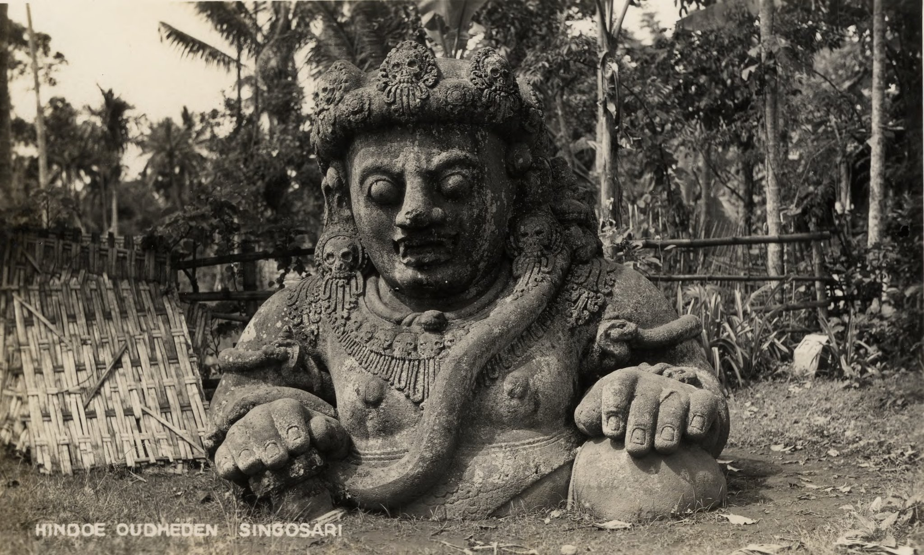  (a) | 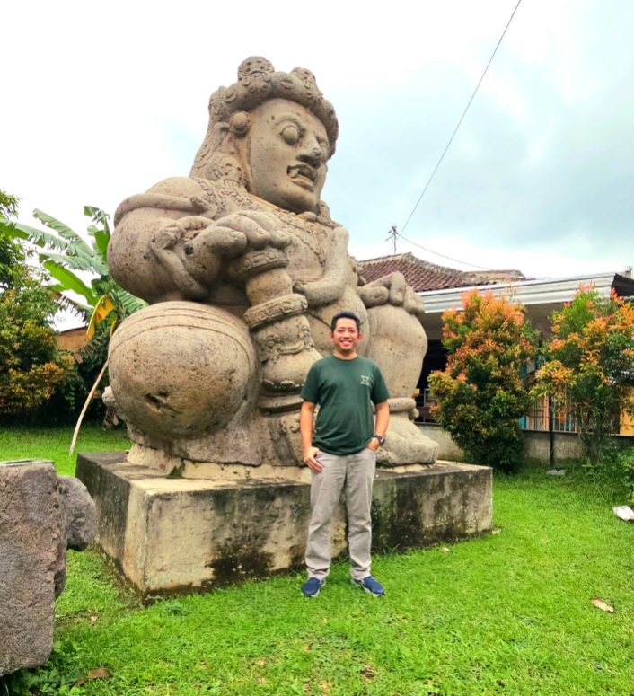  (b)
Direct photographic evidence of cumulative volcanic sedimentation at Candi Singosari. (a) Colonial-era photograph (c. 1860) from the Leiden University Library archives, captioned Hindoe Oudheden—Singosari, showing the Dwarapala guardian statue partially buried beneath volcanic sediment approximately six centuries after its construction (A.D. ~1268). Only the head, shoulders, and hands remain visible above the accumulated overburden. (b) The same statue today, fully excavated and displayed at its original seated height of 370 cm. At the calibrated sedimentation rate of 3.5 mm/yr derived from this site (Section 3.2), approximately 185 cm of volcanic overburden accumulated between construction and the statue’s rediscovery in A.D. 1803.
The distinction is consequential. Catastrophic preservation creates spectacular but spatially localized windows into the past. Cumulative burial, by contrast, operates at landscape scale, affecting entire volcanic basins and potentially rendering whole centuries of habitation invisible to conventional surface survey. In Java, where no point on the island lies more than approximately 27 km from the nearest active volcano, the cumulative process is not a localized anomaly but an island-wide taphonomic regime.
Geoarchaeological approaches to understanding post-depositional site formation have a well-established methodological tradition (French 2003), and the problem of surface visibility in archaeological survey has been recognized for decades (Wandsnider and Camilli 1992). However, these perspectives have rarely been applied systematically to volcanic landscapes in island Southeast Asia, where the dominant research tradition has focused on monumental stone architecture—precisely the class of evidence most resistant to burial (Groot 2009). The result is a circular observational bias: we find stone temples because they protrude through sediment; we interpret their distribution as reflecting settlement patterns; and we overlook the wooden settlements that constituted the overwhelming majority of historical habitation.
This paper presents an empirical approach to quantifying the cumulative burial problem. We exploit four independent archaeological sites—each with known construction dates and measured burial depths—as calibration points spanning two distinct volcanic systems: the Kelud system in East Java (Dwarapala Singosari, A.D. ~1268) and the Merapi system in Central Java (Candi Sambisari, Kedulan, and Kimpulan, 9th century A.D.). These yield cumulative volcanic sedimentation rates that are remarkably consistent across sites separated by hundreds of kilometers, suggesting that mm/yr-scale burial is a systematic phenomenon across volcanic Java. Kelud alone has produced 37 confirmed eruptions since A.D. 1000 (Global Volcanism Program 2024), and the Merapi system is among the world’s most persistently active stratovolcanoes (Gertisser et al. 2012).
We apply the calibrated rates to project expected burial depths for remains of successive historical periods, demonstrating that Kanjuruhan-era (A.D. ~760) sites in the Malang basin likely lie beneath 4.0–7.8 m of overburden—exceeding the effective range of both surface survey and standard ground-penetrating radar (Putra and Setyastuti 2019). We further examine the spatial distribution of 666 known archaeological sites in East Java, showing that the observable record is dominated by survey history and survivorship bias rather than genuine settlement patterns. The paper concludes by identifying priority zones for future subsurface investigation where high terrain suitability coincides with deep predicted burial, offering a quantitative framework for directing archaeological fieldwork in volcanic island arcs.

Background

Java as a volcanic burial zone
Java hosts 45 active volcanoes across approximately 129,000 km²—a volcanic density of 0.35 per 1,000 km², the highest of any major Indonesian island and approximately six times that of Sumatra (0.06/1,000 km²) (Bemmelen 1949). The average spacing between volcanic centers is ~54 km, meaning that no point on Java is more than approximately 27 km from the nearest active volcano. Since tephra from VEI 3–4 eruptions can deposit measurable ash at 50–100+ km from the source (Newhall and Self 1982), the entire island lies within the depositional range of at least one—and often multiple—volcanic centers.
This density has a fundamental implication for archaeological preservation: Java is not an island where some sites happen to be near volcanoes—it is an island where volcanic sedimentation is an inescapable, island-wide taphonomic process. The relevant question is not whether burial occurs at any given location, but how deep—a function of proximity to active vents, eruption frequency, prevailing wind patterns, and local topography.
East Java province alone encompasses seven major active centers: Kelud, Semeru, Arjuno-Welirang, Bromo, Lamongan, Raung, and Ijen. The Brantas River basin—which hosted the Singosari (A.D. 1222–1293) and Majapahit (A.D. 1293–~1500) kingdoms—sits in the depositional path of Kelud (35 km east), Arjuno-Welirang (25 km north), and Semeru (60 km southeast). Kelud alone has produced 37 confirmed eruptions since A.D. 1000 (Global Volcanism Program 2024; Maeno et al. 2019).
In Central Java, Mount Merapi—one of the world’s most active stratovolcanoes—has buried a cluster of 9th-century Hindu-Buddhist temples to depths of 3–7 m (Lavigne and Thouret 2000; Thouret et al. 2000). These buried temples (Sambisari, Kedulan, Kimpulan) were discovered accidentally during modern construction and mining activities, not through systematic archaeological survey.

The observable archaeological record in East Java
Our compilation of known archaeological sites in East Java (Section 3.1) identified 666 unique entries, of which only 391 (59%) have usable spatial coordinates. The dataset is dominated by stone monuments (candi) from the Singosari and Majapahit periods (13th–15th centuries A.D.) (Kinney, Klokke, and Kieven 2003). Earlier periods are poorly represented: pre-10th century sites constitute less than 5% of the geocoded total.
This temporal distribution is consistent with two complementary explanations: (a) archaeological survey has historically concentrated on the Singosari-Majapahit heartland around Blitar, Malang, and Mojokerto; and (b) older sites are more deeply buried, having accumulated more overburden, making them less likely to be discovered by surface methods.

Volcanic taphonomy
Taphonomy—the study of post-mortem processes affecting the archaeological and fossil records—has a well-established literature in sedimentary and fluvial contexts (Schiffer 1987). Volcanic taphonomy is comparatively understudied outside of catastrophic preservation events (Pompeii, Akrotiri/Santorini, Cerén in El Salvador) (Sigurdsson et al. 1985; Doumas 1983; Sheets 1992). These high-profile cases involved rapid burial by single eruptions, preserving sites in extraordinary detail.
The process we describe is fundamentally different: cumulative volcanic taphonomy, where repeated small-to-moderate eruptions over centuries gradually bury sites layer by layer. This produces the same end result—sites invisible from the surface—but through a slower, less dramatic mechanism. The key distinction is that cumulative burial is spatially pervasive (affecting entire volcanic basins, not just eruption-proximal zones) and temporally continuous (ongoing, not one-time events).

The Kutai comparison
The oldest known kingdom in the Indonesian archipelago is Kutai Martadipura (A.D. ~400), located in East Kalimantan—a region with zero active volcanoes across 544,000 km² (Vogel 1918). Its Yupa inscriptions were found near the present ground surface.
The contrast is stark: Java has 45 active volcanoes in 129,000 km²; Kalimantan has zero in 544,000 km². At the mean Javanese sedimentation rate of 4.4 mm/yr, a Kutai-era (A.D. ~400) inscription in the Malang basin would now lie beneath 4–10 m of volcanic overburden—invisible to any surface survey. The same inscription in Kalimantan sits exactly where it was placed 1,600 years ago, because there is no volcanic sedimentation to bury it.
Kutai’s apparent chronological primacy over Javanese polities of similar or greater antiquity may therefore reflect differential preservation conditions rather than genuine temporal precedence (Coedès 1968; Miksic 2004). The “oldest kingdom” may be the most visible one—a consequence of volcanic density asymmetry between islands.

Data and Methods

Archaeological site dataset
We compiled a database of known archaeological sites in East Java province from three complementary sources. First, we queried the OpenStreetMap Overpass API for all features tagged with historic=* within the Jawa Timur administrative boundary (bounding box: 6.5–9.0°S, 111.0–115.0°E), yielding 281 geolocated features. Second, we queried the Wikidata SPARQL endpoint for entities with coordinate property P625 within the same bounding box, recovering 16 precisely located sites. Third, we scraped the Indonesian-language Wikipedia article “Daftar candi di Indonesia” for 369 additional entries.
To increase spatial coverage, we geocoded the 369 coordinate-less entries using the OpenStreetMap Nominatim API with progressive query refinement. Of 369 queries, 94 returned valid coordinates within the study area (25.5% success rate). After spatial deduplication within a 100 m radius, the final dataset contains 666 unique site entries, of which 391 have usable coordinates (58.7% geocoding rate). Within the East Java analytical bounds, 383 geocoded sites were used for spatial analysis.
Limitation: The dataset is heavily biased toward stone monuments (candi) that survived volcanic burial due to their monumental scale. Wooden settlements, which likely constituted the vast majority of historical habitation, are systematically absent—precisely the pattern predicted by the taphonomic bias hypothesis. We note that Indonesia currently lacks a comprehensive, centralized digital archaeological site registry; the dataset assembled here represents the most complete compilation achievable from publicly available sources, but systematic undercounting is likely.

The Dwarapala calibration
The primary empirical anchor for our burial depth framework is the pair of Dwarapala guardian statues at Candi Singosari, Malang Regency, East Java.
Known parameters:
- Construction date: A.D. ~1268 (reign of Kertanegara, Singosari Kingdom)
- Discovery date: A.D. 1803, by Nicolaus Engelhard
- Physical dimensions: 370 cm seated height, ~40 tonnes, monolithic andesite
- Condition at discovery: “separuh tubuh terpendam” (half the body buried)
- Estimated burial depth: ~185 cm
- Elapsed time: 1803 $−$ 1268 $=$ 535 years
Calculated sedimentation rate:
$$R=\frac{185 \text{cm}}{535 \text{yr}}=0.35 \text{cm/yr}=3.5 \text{mm/yr}$$
Cross-validation: Gunung Kelud erupted approximately 20 times between 1268 and A.D. 1803. Documented VEI 3–4 eruptions deposit 2–20 cm of ash at Malang distance (~35 km). Twenty eruptions at an average of ~5 cm per event would account for ~100 cm of the 185 cm total burial. The remainder (~85 cm) is attributable to secondary remobilization (lahars, reworked tephra), contributions from Semeru and Arjuno-Welirang, and non-volcanic aggradation (Global Volcanism Program 2024; Maeno et al. 2019). We note that the rates reported here represent total landscape aggradation in volcanic terrain, not pure primary tephra accumulation; for archaeological burial, however, the total rate is the operationally relevant metric regardless of depositional source.
Figure 2 illustrates the Dwarapala burial timeline from construction to present.
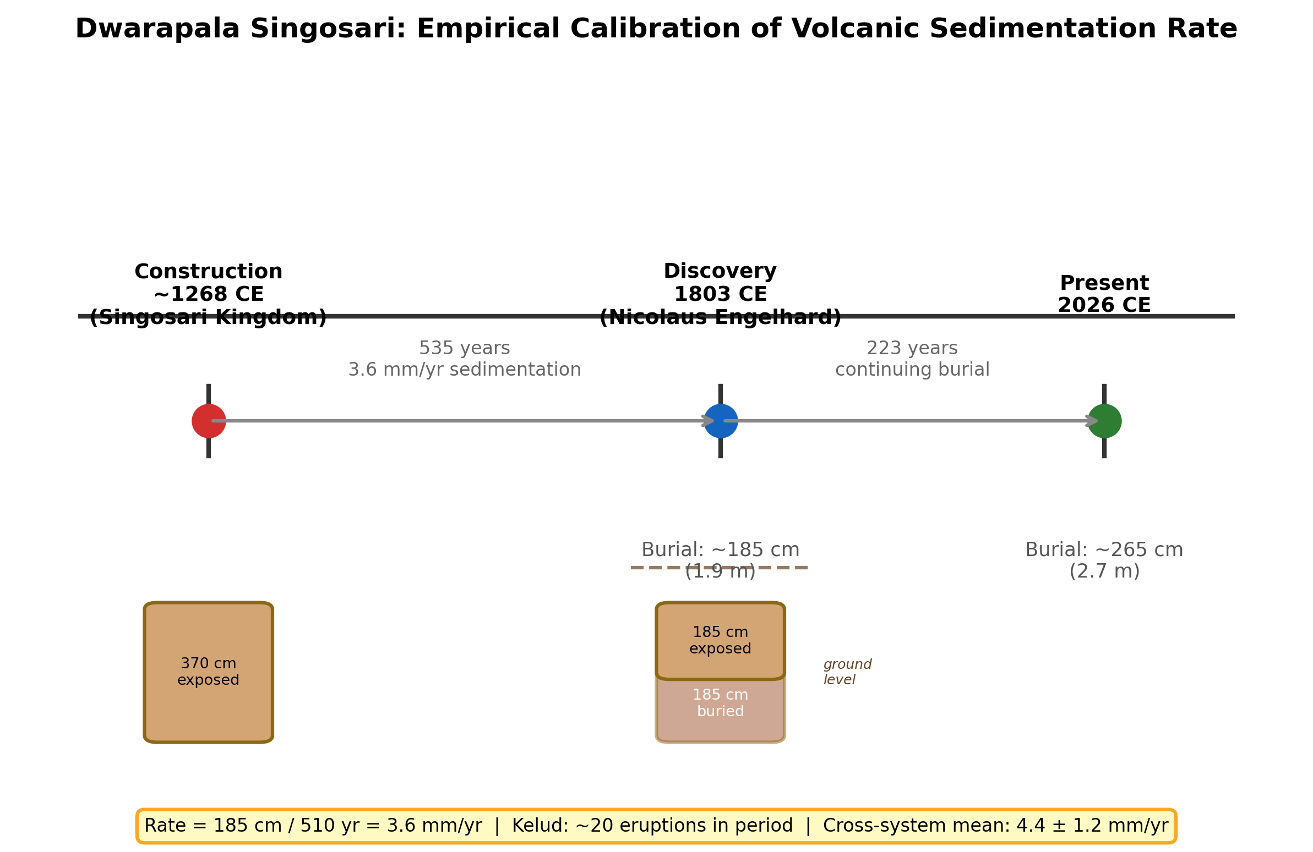
Dwarapala Singosari burial timeline. The statues were constructed A.D. ~1268 at full height (370 cm) and discovered in A.D. 1803 with approximately half (185 cm) buried by volcanic sedimentation, yielding a cumulative rate of 3.5 mm/yr. The cross-system mean from four calibration points is $4.4±1.2$ mm/yr.

Secondary calibration points
To assess whether the Dwarapala rate is a local anomaly or representative of a Java-wide phenomenon, we compiled three additional calibration points from Central Java’s Merapi volcanic system (Table [tab:calibration]).
Across all four sites, the computed rates span 2.4–6.2 mm/yr. Taking the midpoint of each site’s range (Dwarapala: 3.5; Sambisari: 5.1; Kedulan: 5.8; Kimpulan: 3.5 mm/yr) yields a mean of $4.4±1.2$ mm/yr (1$σ$, $n=4$). The full observed range of 2.4–6.2 mm/yr is used for all subsequent projections. The consistency across two independent volcanic systems—Kelud in East Java and Merapi in Central Java—suggests that mm/yr-scale burial of archaeological sites is systematic and Java-wide, not a local anomaly (Figure 3).
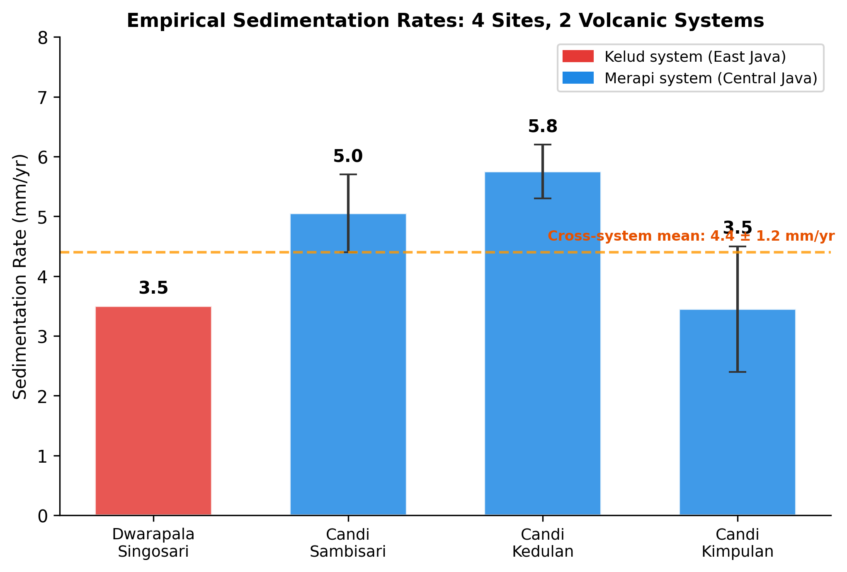
Empirical sedimentation rates from four archaeological sites across two volcanic systems. Error bars show the range from reported depth uncertainty. The cross-system mean is $4.4±1.2$ mm/yr.

Burial depth projection model
Using the empirically-derived rate range, we estimate expected overburden depth by era:
$$D(\text{era})=R×(T_{\text{present}}−T_{\text{era}})$$
where $R$ ranges from 2.4 to 6.2 mm/yr and $T_{\text{present}}=2026$. This linear model is a first-order approximation; actual deposition is episodic, with eruption clusters interspersed by quiescent periods and subject to compaction. The wide rate range (2.4–6.2 mm/yr) partially captures this variability. Results are presented in Figure 4.
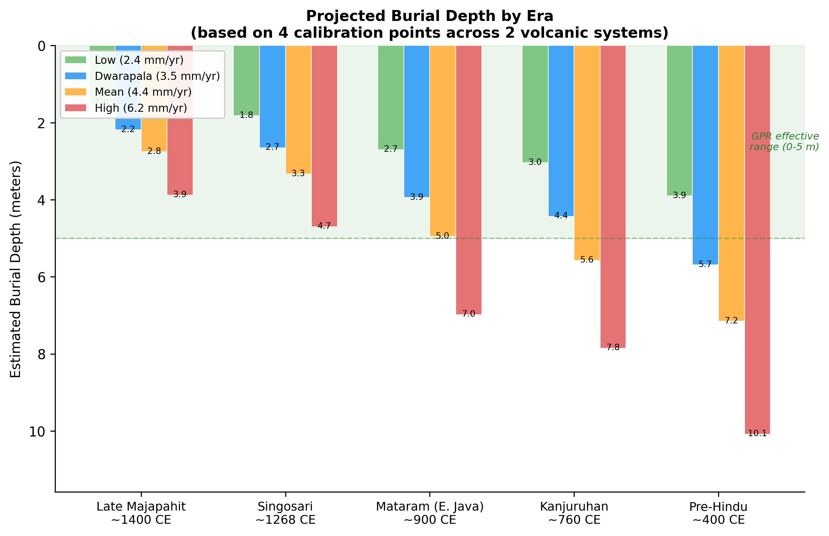
Projected burial depth by historical era using four empirically-derived sedimentation rates. The green band indicates the effective range of ground-penetrating radar in volcanic sediment (0–5 m). Kanjuruhan-era and earlier remains may exceed GPR detection limits.

Spatial analysis methods
E004—Raw site density vs volcanic proximity. We computed the minimum great-circle distance from each geocoded site to the nearest of seven reference volcanoes. Sites were binned into seven distance bands (0–25, 25–50, 50–75, 75–100, 100–150, 150–200, and 200+ km). Site density was expressed as sites per 1,000 km². Spearman’s rank correlation between distance band midpoint and site density tests whether sites are found preferentially near or far from volcanoes.
E005—Terrain-controlled analysis. To separate the effect of terrain suitability from volcanic proximity, we constructed a terrain suitability index combining four DEM-derived features: slope ($<$15° preferred), elevation (100–800 m a.s.l.), topographic wetness index (TWI $>$ median), and river proximity ($<$5 km). Each feature was scored 0–1 and equally weighted. The study area was divided into a 25 km $×$ 25 km grid (187 cells). For each cell, we computed the residual between observed and terrain-predicted site count. Spearman correlation between residual density and distance to nearest volcano tests the taphonomic bias hypothesis after controlling for terrain preference.

Results

The Dwarapala calibration (RQ1)
The Dwarapala sedimentation calculation yields a rate of 3.5 mm/year (Section 3.2). This rate is internally consistent with documented Kelud eruption histories, which account for approximately 100 of the 185 cm total burial through direct tephra deposition alone. The remaining 85 cm is attributable to secondary remobilization and contributions from other volcanic systems.
The secondary calibration points yield rates of 2.4–6.2 mm/yr across the Merapi system, consistently higher than the Dwarapala rate (3.5 mm/yr) from the Kelud system. This difference is physically plausible: Merapi erupts more frequently than Kelud, and the Central Java sites are closer to their volcanic source. The cross-system mean of $4.4±1.2$ mm/yr suggests that ongoing volcanic burial is a Java-wide phenomenon with quantifiable, consistent rates.

Burial depth projections (RQ3)
Key projections for the Malang basin using the full rate range:
These depths exceed standard archaeological surface survey capabilities (0–1 m) and approach or exceed the effective range of ground-penetrating radar (2–5 m in volcanic sediment) (Conyers 2004; Goodman and Piro 2013). Detection of Kanjuruhan-era or earlier remains will likely require deep GPR, borehole coring, or fortuitous exposure through modern construction.

Cautionary analysis: why distribution data cannot test H1
We conducted two spatial analyses to examine whether the distribution of known sites reflects taphonomic bias. In E004, analysis of 383 geocoded sites revealed a strong negative correlation between site density and distance from the nearest active volcano (Spearman’s $ρ=−0.955$, $p=0.0008$, $n=7$ distance bands; Table 1, Figure 5). Known sites cluster near volcanoes—the opposite of what a naive reading of the taphonomic bias hypothesis would predict.
Site density by distance to nearest active volcano.
Distance Band (km) | Sites | Area (km²) | Density (/1,000 km²)
0–25 | 147 | 11,343 | 12.96
25–50 | 136 | 18,034 | 7.54
50–75 | 37 | 18,528 | 2.00
75–100 | 22 | 16,373 | 1.34
100–150 | 41 | 28,523 | 1.44
150–200 | 0 | 25,507 | 0.00
200+ | 0 | 73,740 | 0.00
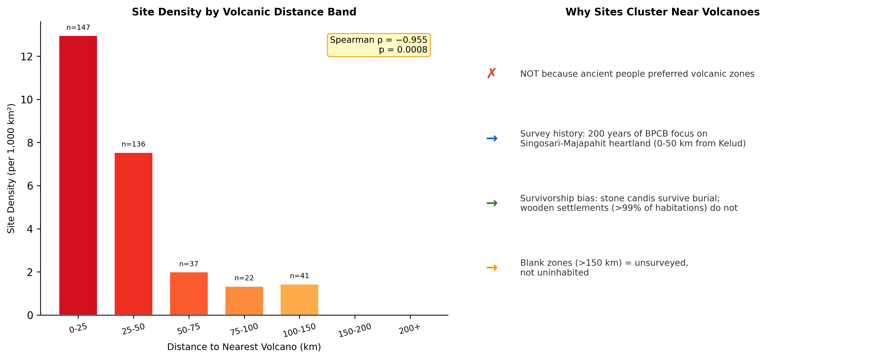
Left: Site density by volcanic distance band showing strong near-volcano clustering ($ρ=−0.955$). Right: Interpretive framework explaining why this pattern reflects survey history, not settlement preference.
In E005, a terrain-controlled analysis using a composite terrain suitability index (slope, elevation, TWI, river proximity) across 187 grid cells of 25 km $×$ 25 km yielded Spearman’s $ρ=−0.358$ ($p<0.0001$). Terrain suitability explains part of the clustering, but the remaining signal reflects survey intensity concentrated on the Singosari-Majapahit heartland. Repeating both analyses after geocoding 94 additional sites (E006; increasing from 297 to 391 geocoded entries) produced negligible change: E004 $ρ$ shifted from $−0.991$ to $−0.955$; E005 $ρ$ from $−0.364$ to $−0.358$. The pattern is robust.
Critically, these results do not test the taphonomic bias hypothesis. The fundamental limitation is circular: the sites in our dataset are those that survived burial and were discovered by archaeologists. Both processes systematically favor low-burial-depth locations:
- Survivorship bias: Stone temples dominate the dataset because they are large enough to protrude through meters of sediment. Wooden and bamboo structures—$>$99% of historical habitation—leave no surface trace after burial.
- Survey bias: Indonesian archaeological survey has concentrated on regions of known historical kingdoms for over two centuries. “Blank” areas on the archaeological map are blank because they are unsurveyed, not uninhabited.
- Discovery mechanism bias: Most deeply buried temples were found accidentally during modern construction (Sambisari: farmer’s plow, 1966; Kimpulan: university excavation, 2009; Liangan: sand mining, 2008) (Putra and Setyastuti 2019; Abbas 2016).
The taphonomic bias hypothesis therefore cannot be confirmed or denied from distribution data alone. It remains a hypothesis requiring subsurface investigation to test. This is itself a contribution: the “archaeological absence” of pre-Majapahit evidence in volcanic zones cannot be interpreted as evidence of cultural absence.

Discussion

Multi-point calibration as the core contribution
The central finding is not a statistical test of H1 but an empirical calibration: four independent archaeological sites across two volcanic systems yield cumulative sedimentation rates of 2.4–6.2 mm/yr (mean $4.4±1.2$ mm/yr). This consistency across sites separated by hundreds of kilometers and sourced from different volcanic centers establishes that ongoing burial is a systematic feature of volcanic Java.
The Dwarapala rate (3.5 mm/yr) sits at the lower end. Merapi-system sites show higher rates (mean ~4.8 mm/yr), consistent with Merapi’s higher eruption frequency. This variation is itself informative: burial rates are site-specific and depend on distance from volcanic vents, topographic position, and local hydrology. A spatially-resolved burial depth model must account for this heterogeneity.
Preliminary independent validation from geotechnical borehole literature supports these rates. A screening of published geotechnical reports identifies six additional buried archaeological sites not included in our calibration set: Candi Liangan (3.6 mm/yr; Merapi-Sindoro system, a non-temple settlement), Candi Pendem (3.3 mm/yr), Candi Morangan (3.2 mm/yr), Candi Kadisoka (2.7 mm/yr), Candi Ijo (1.4 mm/yr), and Pleret palace complex (2.3 mm/yr; a non-temple palatial site). The mean rate across these six independent sites is 2.8 mm/yr, converging with the Dwarapala rate (3.5 mm/yr) and falling within the calibration range reported here. Notably, Liangan represents a third volcanic system (Sindoro) and a non-monumental site type, while Pleret is a post-Majapahit palatial complex—both extending the applicability of the framework beyond temple architecture and beyond the Kelud-Merapi pair. A full analysis incorporating these and additional sites from the geotechnical literature is in preparation.

The informative “negative” result
Our spatial analysis shows known sites clustering near volcanoes. We argue this is itself evidence for the hypothesis: the observable record maps where we have looked (Majapahit-Singosari heartland, 0–50 km from Kelud/Arjuno) rather than where sites exist. Stone monuments that dominate the dataset are precisely those large enough to resist burial—the kind that would survive in high-deposition zones (Verhagen and Whitley 2012).
The negligible change upon adding 29% more sites (E006) confirms the pattern is saturated: the observable record has reached a ceiling imposed by survey history, not by genuine settlement distributions.

Falsifiability
While the taphonomic bias hypothesis cannot be tested with surface distribution data alone (Section 4.3), it is falsifiable through subsurface investigation. Specifically, the hypothesis predicts that systematic subsurface survey in high-suitability volcanic zones (Zone B in our terrain model) should reveal buried archaeological features at the projected depths. If a comprehensive subsurface survey program—employing deep GPR, borehole coring, or systematic excavation—were conducted across multiple high-suitability locations in the Malang basin and found no buried remains at the predicted depths, this would constitute strong evidence against the hypothesis. The absence of buried sites in zones where the model predicts their presence would suggest that the observed site distribution genuinely reflects past settlement patterns rather than differential preservation.

Practical implications for fieldwork
The burial depth projections have direct operational implications:
- GPR applicability: Ground-penetrating radar is effective to ~2–5 m in volcanic ash. Late Majapahit-era remains (1.5–3.9 m) are detectable; Kanjuruhan-era remains (3.0–7.9 m) may exceed GPR range (Conyers 2004).
- Priority zones: Areas with high terrain suitability AND high expected burial depth are where settlement remains are most likely preserved yet invisible.
- Discovery mechanism: Accidental discoveries during construction illustrate that deeply buried sites exist but systematic subsurface survey has never been conducted.

The Kutai comparison (H2)
As a thought experiment: at 4.4 mm/yr, a Kutai-era (A.D. ~400) artifact in the Malang basin would now lie beneath ~7 m of overburden. The same artifact in Kalimantan (zero volcanism) sits at the original ground surface. We do not claim that Javanese polities necessarily predate Kutai, only that the differential preservation conditions between volcanic and non-volcanic islands must be considered before interpreting surface-based chronologies as reflecting genuine temporal precedence (Coedès 1968).

Limitations
- Calibration sample size: Four points, while spanning two volcanic systems, remain a small sample. Rates carry uncertainty from imprecise construction dates and variable depth measurements.
- Rate constancy: We treat sedimentation as temporally uniform, smoothing over episodic large eruptions. The Dwarapala rate is a cumulative average over ~535 years.
- Depth measurement uncertainty: Published depths vary across sources (e.g., Sambisari: “5 m” to “6.5 m”). We report ranges rather than point estimates.
- Spatial extrapolation: Rates derive from two specific volcanic basins. Extrapolation to other Java regions requires additional calibration.
- Site type bias: All four calibration sites are monumental stone temples. Non-monumental sites (wooden settlements, earthworks) may experience different effective burial rates due to differences in surface expression, compaction, and post-depositional disturbance. Preliminary evidence from Liangan (a non-temple settlement) and Pleret (a palatial complex) suggests comparable rates, but systematic validation across site types remains a priority.
- Survey bias unquantified: We argue that survey history dominates distribution data but cannot quantify this without systematic coverage maps.

Future work
Three follow-up studies are planned: (1) a machine learning settlement suitability model independently tested against volcanic burial zones (Paper 2; an interactive dashboard exploring model predictions is available at https://volcarch-dashboard.streamlit.app); (2) a spatially-resolved burial depth model calibrated against all four anchor points (Paper 3); and (3) targeted GPR survey at 5–10 locations in high-suitability, high-burial-depth zones to test for subsurface anomalies.

Conclusions
We have presented a quantitative framework for estimating volcanic taphonomic bias in the Indonesian archaeological record. Four empirical calibration points from two independent volcanic systems yield cumulative sedimentation rates of 2.4–6.2 mm/yr (mean $4.4±1.2$ mm/yr), suggesting that multi-meter burial is a systematic, Java-wide phenomenon.
The spatial distribution of known sites in East Java cannot test the taphonomic bias hypothesis because the observable record is dominated by survey history and survivorship bias. This is itself a contribution: the “archaeological absence” of pre-Majapahit evidence in volcanic zones cannot be interpreted as evidence of cultural absence.
Our projections indicate that Kanjuruhan-era (A.D. ~760) remains in the Malang basin lie beneath 3.0–7.9 m of overburden, and pre-Hindu (A.D. ~400) remains beneath 3.9–10.1 m. These depths exceed conventional survey capabilities and approach the limits of ground-penetrating radar. Future investigation in volcanic Java should incorporate subsurface detection methods in zones identified as having both high settlement suitability and high expected burial depth.

Data Availability
The archaeological site dataset, DEM derivatives, and analysis scripts are available at https://github.com/neimasilk/volcarch-repo. Raw DEM data from Copernicus GLO-30 are publicly available at https://dataspace.copernicus.eu/. An interactive dashboard for exploring settlement suitability model predictions is available at https://volcarch-dashboard.streamlit.app. All analysis scripts (E001–E006) are available in the project repository under experiments/.

Acknowledgments
The author thanks the Global Volcanism Program (Smithsonian Institution) for open eruption data, and the OpenStreetMap and Wikidata communities for structured geospatial data. AI-assisted tools (Claude, Anthropic) were used as a writing companion during manuscript preparation for code development assistance and data analysis scripting; the AI tools did not contribute to research design, hypothesis formulation, or scientific interpretation, and all results were independently verified by the author. This research received no specific grant from any public, commercial, or not-for-profit sector.
Abbas, Novida. 2016. “A Reinterpretation of the Buried Hindu-Buddhist Remains of Liangan, Central Java.” Amerta 34 (1): 27–42.
Bemmelen, R. W. van. 1949. The Geology of Indonesia. Vol. 1A. The Hague: Government Printing Office.
Coedès, George. 1968. The Indianized States of Southeast Asia. Honolulu: University of Hawai’i Press.
Conyers, Lawrence B. 2004. Ground-Penetrating Radar for Archaeology. Walnut Creek: AltaMira Press.
Doumas, Christos G. 1983. Thera: Pompeii of the Ancient Aegean. London: Thames; Hudson.
French, Charles. 2003. Geoarchaeology in Action: Studies in Soil Micromorphology and Landscape Evolution. London: Routledge. https://doi.org/10.4324/9780203166888.
Gertisser, Ralf, Sylvain J. Charbonnier, Jörg Keller, and Christoph M. Vidal. 2012. “The Geological Evolution of Merapi Volcano, Central Java, Indonesia.” Bulletin of Volcanology 74 (5): 1213–33. https://doi.org/10.1007/s00445-012-0591-3.
Global Volcanism Program. 2024. “Volcanoes of the World, v. 5.2.2.” Smithsonian Institution. https://volcano.si.edu/.
Goodman, Dean, and Salvatore Piro. 2013. GPR Remote Sensing in Archaeology. Berlin: Springer. https://doi.org/10.1007/978-3-642-31857-3.
Grattan, John. 2006. “Aspects of Armageddon: An Exploration of the Role of Volcanic Eruptions in Human History and Civilization.” Quaternary International 151 (1): 10–18. https://doi.org/10.1016/j.quaint.2006.01.019.
Groot, Véronique M. Y. de. 2009. “Candi, Space and Landscape: A Study on the Distribution, Orientation and Spatial Organization of Central Javanese Temple Remains.” PhD thesis, Leiden University.
Kinney, Ann R., Marijke J. Klokke, and Lydia Kieven. 2003. Worshipping Siva and Buddha: The Temple Art of East Java. Honolulu: University of Hawai’i Press.
Lavigne, Franck, and Jean-Claude Thouret. 2000. “Lahars at Merapi Volcano, Central Java: An Overview.” Journal of Volcanology and Geothermal Research 100 (1–4): 423–56. https://doi.org/10.1016/S0377-0273(00)00150-5.
Maeno, Fukashi, Setsuya Nakada, Mitsuhiro Yoshimoto, Taketo Shimano, Natsumi Hokanishi, Asnawir Zaennudin, and Masato Iguchi. 2019. “A Sequence of a Plinian Eruption Preceded by Dome Destruction at Kelud Volcano, Indonesia, on February 13, 2014, Revealed from Tephra Fallout and Pyroclastic Density Current Deposits.” Journal of Volcanology and Geothermal Research 382: 24–41. https://doi.org/10.1016/j.jvolgeores.2017.03.002.
Miksic, John N. 2004. “From Megaliths to Tombstones: The Transition from Prehistory to History in Western Indonesia.” Indonesia and the Malay World 32 (93): 191–210. https://doi.org/10.1080/1363981042000320125.
Newhall, Christopher G., and Stephen Self. 1982. “The Volcanic Explosivity Index (VEI): An Estimate of Explosive Magnitude for Historical Volcanism.” Journal of Geophysical Research: Oceans 87 (C2): 1231–38. https://doi.org/10.1029/JC087iC02p01231.
Putra, Prishardoyo Bagyo, and Ayu Setyastuti. 2019. “Le Complexe Cultuel de Kimpulan, Site Enfoui Sous Les Cendres Du Merapi (Yogyakarta, Java Central).” Bulletin de l’École Française d’Extrême-Orient 105: 377–402. https://doi.org/10.3406/befeo.2019.6297.
Schiffer, Michael Brian. 1987. Formation Processes of the Archaeological Record. Albuquerque: University of New Mexico Press.
Sheets, Payson D. 1992. The Cerén Site: A Prehistoric Village Buried by Volcanic Ash in Central America. Fort Worth: Harcourt Brace Jovanovich.
Sigurdsson, Haraldur, Steven Carey, Winifred Cornell, and Tullio Pescatore. 1985. “The Eruption of Vesuvius in A.D. 79.” National Geographic Research 1 (3): 332–87.
Thouret, Jean-Claude, Franck Lavigne, Karim Kelfoun, and Sutikno Bronto. 2000. “Toward a Revised Hazard Assessment at Merapi Volcano, Central Java.” Journal of Volcanology and Geothermal Research 100 (1–4): 479–502. https://doi.org/10.1016/S0377-0273(00)00152-9.
Torrence, Robin, and John Grattan. 2002. Natural Disasters and Cultural Change. London: Routledge. https://doi.org/10.4324/9780203165768.
Verhagen, Philip, and Thomas G. Whitley. 2012. “Integrating Archaeological Theory and Predictive Modeling: A Live Report from the Scene.” Journal of Archaeological Method and Theory 19 (1): 49–100. https://doi.org/10.1007/s10816-011-9102-7.
Vogel, J. Ph. 1918. “The Yupa Inscriptions of King Mulavarman from Koetei (East Borneo).” Bijdragen Tot de Taal-, Land- En Volkenkunde 74: 167–232.
Wandsnider, LuAnn, and Eileen L. Camilli. 1992. “The Character of Surface Archaeological Deposits and Its Influence on Survey Accuracy.” Journal of Field Archaeology 19 (2): 169–88. https://doi.org/10.2307/530400.

