DSN AI Bootcamp 2026 Project Participation – Data Analytics Track
Answer & Submission Sheet
Participant Name | ṅѧṃєʟєśś™
Dashboard tool used | Microsoft Excel
.
Part A - Data Cleaning Review
Identify at least three meaningful data-quality issues you found. For each issue, explain what you found, what you did, and why your action was appropriate.
Data-quality issue | What you found | What you did | Why this action was appropriate
Duplicate transactions | 12 rows were exact copies of other rows, with the same Transaction_ID and every field identical, adding ₦1,130,900 to revenue. | Removed the duplicates (432 → 420 rows). | The same transaction was being counted twice. Since every field matched, keeping one copy loses nothing, and Transaction_ID is unique again.
Misstated Reported Revenue | 22 rows disagreed with Units × Price × (1 − Discount), by exact 10% or 20% steps. | Recalculated revenue for every row and used it for all analysis, keeping the reported column for comparison. | The formula matches the other 398 rows exactly, so the 22 exceptions are errors in the field.
Missing costs | 31 rows had no Cost_Per_Unit_NGN, mostly in Abuja (20 of 80). The original dashboard treated them as zero cost, so their full revenue counted as profit. | Left them blank and calculated profit only where cost exists. Added a Cost_Missing flag and Revenue_Costed, and calculated margin as profit ÷ costed revenue. | A missing cost isn't a zero cost, and inventing values would add assumptions. Matching the margin's numerator and denominator avoids penalising markets with more blanks. The exclusion is stated on the dashboard.
Inconsistent labels (State and Category) | "Lagos " and "LAGOS" (5 rows) and "Accessories ", "accessories" and "Accessory" (4 rows). Pivots split these into separate groups. | Standardised spelling, case and spacing. | These are one entity written differently, so correcting them changes no values. It restored Lagos's true total of ₦13,692,700.
Which data-quality issue had the greatest impact on your analysis?
Missing costs. 31 of the 420 transactions (7.4%) had no Cost_Per_Unit_NGN, covering ₦2,747,625 of revenue, and 20 of them were in Abuja. This issue had the widest reach, because every profit and margin figure (by market, category, discount tier and sales rep) depended on how the blanks were treated. It also changed a conclusion: with blanks treated as zero cost, Abuja looked like a top performer, and it is actually the weakest market on recorded profit.
It was also the hardest to resolve. Unlike duplicates or spelling errors, it has no single obvious fix, because the true cost is unknown. Treating blanks as zero, dropping the rows and estimating the costs each give different answers, so the decision had to be justified and not just applied.
Explain how correcting that issue changed or affected the analysis.
The original approach treated each blank cost as zero, so the full revenue of those 31 sales counted as profit (a 100% margin on ₦2,747,625). I treated a blank as unknown. Profit is calculated only on transactions with a recorded cost, and margin is profit divided by the revenue of those same transactions (₦43,932,100). I did not estimate the missing costs, because that would add an assumption the data doesn't support.

Measure | Blanks as zero cost | Corrected (final)
Total profit | ₦16,547,425 | ₦13,799,800
Overall margin | 35.45% | 31.41%
Abuja profit | ₦3,208,300 (3rd of 5) | ₦1,143,375 (5th)
Abuja margin | 48.00% (highest) | 24.75% (lowest)
Margin: Electronics / Home / Accessories | 34.45% / 33.20% / 49.76% | 30.70% / 28.14% / 46.80%
Excluding the rows wasn't enough on its own. Dividing the remaining profit by all revenue would have understated Abuja's margin (17.11%), because its revenue included the uncosted sales. Using costed revenue as the denominator compares like with like.
The correction reversed the Abuja finding and changed every margin on the dashboard, which is why the original dashboard's profit figures couldn't be relied on. Abuja's corrected margin rests on 75% of its transactions, so it is the least certain figure. The conclusion that Abuja is not the most profitable market holds regardless, because even if all 20 missing costs were zero, its profit would reach only ₦3,208,300, below Lagos's ₦4,579,900. The exclusion is stated on the dashboard, so management can see its size.
Part B - Dashboard Audit
For each management claim, state your verdict, provide the corrected result where applicable, and explain the evidence supporting your conclusion.
1. Abuja is the most profitable market.
Verdict
Incorrect
Corrected answer / result
Abuja has the lowest recorded profit of the five markets (₦1,143,375, 24.75% margin). Lagos is the most profitable market, with ₦4,579,900 profit and a 33.45% margin.
Explanation / evidence
Abuja appeared strong in the original dashboard (₦3,218,285) because 20 of its 80 transactions had no recorded cost and were treated as zero cost, so their full revenue counted as profit. Those transactions cover ₦2,064,925 of revenue, so Abuja's recorded profit rests on only ₦4,619,275 of its ₦6,684,200 revenue. I didn't assume values for the missing costs. Even in the most generous case, where all 20 had cost nothing, Abuja's profit could reach at most ₦3,208,300. That is still below Lagos's ₦4,579,900, and Lagos has no missing costs. Abuja therefore cannot be the most profitable market, whatever the missing costs were.
2. Electronics is the strongest-performing product category and should receive more budget.
Verdict
Misleading
Corrected answer / result
Electronics is the largest category (₦29,346,500 revenue, 62.9% of the total; ₦8,520,600 profit). Its margin (30.70%) is below Accessories (46.80%), and it has the highest return rate (11.86%, against 7.46% for Home and 4.59% for Accessories).
Explanation / evidence
The claim is true on scale, but the conclusion doesn't follow. Size alone doesn't show that extra budget would be well spent, since Electronics earns less per naira of revenue than Accessories and has the highest returns. The dataset has no spend or return-on-budget data, so the budget recommendation can't be tested. Accessories is small (₦4.13M revenue), so I don't claim it should get the budget instead.
3. Higher discounting is improving profitability.
Verdict
Incorrect
Corrected answer / result
Profit margin falls at every discount level: 35.70% (0%), 33.03% (5%), 28.57% (10%), 27.54% (15%), 19.33% (20%), 15.01% (25%).
Explanation / evidence
A discount lowers the selling price but not the cost, so margin must shrink. A smartphone costing ₦112,000 and priced at ₦165,000 earns a 32.1% margin at full price but only 9.5% at 25% off. The trend is visible within the 0–15% tiers alone (387 of 420 transactions). The 20% and 25% tiers have only 13 and 20 transactions (fewer once sales without a recorded cost are excluded), so I treat them as supporting evidence only.
4. The Online channel has the lowest return rate.
Verdict
Incorrect
Corrected answer / result
In-store has the lowest return rate (6.44%), followed by Online (9.70%) and WhatsApp (11.90%). The overall rate is 8.57%.
Explanation / evidence
Online sits in the middle. The original dashboard's own table also showed In-store lowest (6.3%) with Online at 10.9%, and its chart axis was labelled in the millions, which hid that.
5. August is the strongest sales month.
Verdict
Incorrect
Corrected answer / result
August is the weakest sales month and May is the strongest.
Explanation / evidence
Across the eight months, revenue ranges from ₦3.17M (August) up to ₦7.01M (May), and August is below every other month. The claim also contradicts the original dashboard's own figures, where August (₦3.21M) was lowest and May (₦7.56M) highest.
6. Lagos is underperforming compared with other markets.
Verdict
Incorrect
Corrected answer / result
Lagos is the best-performing market: ₦13,692,700 revenue (29.3% of total), ₦4,579,900 profit, a 33.45% margin and a 5.65% return rate, below the 8.57% average.
Explanation / evidence
Lagos leads on revenue, profit and margin, and none of its transactions has a missing cost. The original dashboard fragmented it across three spellings ("Lagos", "Lagos " with a trailing space, "LAGOS"), so it looked like several markets, two of them nearly empty. Standardising the labels restored the true total.
7. The reported revenue field can be used directly for decision-making.
Verdict
Incorrect
Corrected answer / result
The reported revenue field CANNOT be used directly for decision-making. This is because, upon recalculation, revenue (Units × Unit Price × (1 − Discount)) is ₦46,679,725, against ₦46,369,970 in the reported field, a net difference of −₦309,755.
Explanation / evidence
22 of 420 transactions disagree. 15 are understated (₦377,280 in total) and 7 are overstated (₦67,525), a gross error of ₦444,805. The net figure looks small only because the errors partly cancel, so individual rows and segments are more wrong than the total suggests. For example, transaction 100002 should be 5 × ₦165,000 × 0.95 = ₦783,750, but the field says ₦627,000. The other 398 rows match the formula exactly, and the exceptions are off by exact 10% or 20% steps, which marks them as errors in the field.
8. The dashboard is sufficiently reliable for management to act on without further data cleaning.
Verdict
Incorrect
Corrected answer / result
The dashboard is NOT sufficiently reliable for management to act on without further data cleaning, as revenue, profit and return rate were all overstated on the original dashboard.
Explanation / evidence
Four data problems distorted the original figures. 12 duplicate transactions added ₦1,130,900 to revenue, and 22 misstated revenue rows moved it by a net −₦309,755. State labels were split across spellings, and blank costs were treated as zero cost, which inflated profit. Of the seven specific claims audited, six were incorrect and one misleading, including all four statements in the dashboard’s own management summary (three incorrect, one misleading). These errors change real decisions, such as which market to back and where to spend the budget.
Part C - Corrected Dashboard
Insert a clear snapshot of your corrected dashboard below. The dashboard may be created in Power BI or Excel.
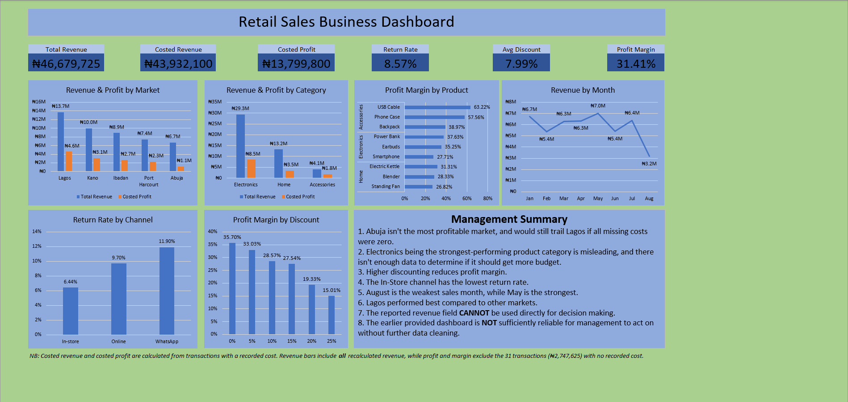
Part D - Final Analysis Questions
1. Which conclusion in the original dashboard was the most misleading, and why?
Answer
Abuja is the most profitable market.
Explanation / evidence
20 of Abuja's 80 transactions had no recorded cost, and the original dashboard counted them as zero cost, so ₦2,064,925 of revenue became pure profit. Abuja showed ₦3,218,285 of profit, against ₦1,143,375 on recorded costs, which is the lowest of the five markets. Lagos leads at ₦4,579,900, and Abuja also has the highest return rate (17.5% against 8.57% overall). Nothing on the dashboard flagged the blank costs, so the figures looked authoritative, and a manager would back the market with the weakest recorded profit.
2. What changed most materially after you cleaned and corrected the data?
Answer
The profit and margin picture, driven by treating blank costs as unknown instead of zero.
Explanation / evidence
Revenue moved from ₦47,500,870 to ₦46,679,725 (−₦821,145, or 1.76%), made up of −₦1,130,900 for duplicates and +₦309,755 for corrected revenue rows. Profit was affected far more. Removing ₦2,747,625 of revenue that had been counted as pure profit cut the overall margin from 35.45% to 31.41%. Abuja's profit fell 64% (₦3,208,300 to ₦1,143,375), and it went from the highest margin (48.00%) to the lowest (24.75%).
3. If management had acted on the original dashboard, what decision could have created the greatest business risk?
Answer
Increasing discounts, based on the claim that higher discounting improves profitability.
Explanation / evidence
The dashboard showed no profit-by-discount evidence, and the data shows the opposite. Margin falls from 35.70% (no discount) to 15.01% (25% off), because a discount cuts the price and not the cost. At 20% and 25% off, margins (19.33% and 15.01%) are roughly half the no-discount margin or less. On costed sales, discounts cost ₦3,341,400, equal to 24% of costed profit.

4. Based on your corrected analysis, what is the most important driver of business performance in this dataset?
Answer
Product mix, meaning which products are sold and in what proportions, is the most important driver of performance. Discount depth is second and is the main lever management controls.
Explanation / evidence
A sale’s margin depends only on its product and its discount, because each product has a fixed price and cost: the product sets a built-in margin and the discount reduces it. Margin ranges from 26.82% to 63.22% across products and from 15.01% to 35.70% across discount tiers, against narrower ranges across states (24.75%–33.45%) and sales reps (29.29%–32.53%). The largest product, smartphones, makes up 41.6% of costed revenue at a 27.71% margin, below the 31.41% average, while USB cables and phone cases earn 63.22% and 57.56% on only 3.2% of costed revenue. Discounting erodes margin further, from 35.70% with no discount to 15.01% at 25% off, and discounts cost ₦3,341,400 on costed sales (24% of profit). The data cannot show whether discounts win extra customers.
5. What three actions should management take next based on the evidence from your corrected dashboard?
Answer
Management should (1) control discounting above 15%, (2) rebalance the product mix and fix Electronics returns before adding budget, and (3) fix data controls and recover the missing costs, starting with Abuja.
Explanation / evidence
Action 1, discounting. Discounts cost ₦3,341,400, equal to 24% of profit on costed sales. Margin falls from 35.70% (no discount) to 27.54% at 15%, then to 19.33% at 20% and 15.01% at 25%, so the steepest drop comes above 15%. The 15% threshold is a suggested review point, not a proven optimum.
Action 2, product mix and returns. Smartphones are 41.6% of costed revenue at 27.71%, while Accessories earn 46.80% against 30.70% for Electronics. Electronics also has the highest return rate (11.86%, against 7.46% for Home and 4.59% for Accessories). Profit is not reduced for returns, so if returned sales were refunded, Electronics’ true profitability is lower than shown. Test shifting emphasis toward higher-margin products and investigate returns before extra budget goes in. The data can’t show how demand would respond.
Action 3, data controls. 31 transactions (₦2,747,625) had no cost, 20 of them in Abuja, plus 12 duplicates, 22 misstated revenue rows and inconsistent labels. The original dashboard overstated revenue by 1.76% and made Abuja look profitable. Recovering Abuja's costs would settle the one market whose profitability remains uncertain (25% of its transactions unmeasured, return rate 17.5%).

