Hospital Middleware API
Development Planning Documentation
Agnos back-end assignment
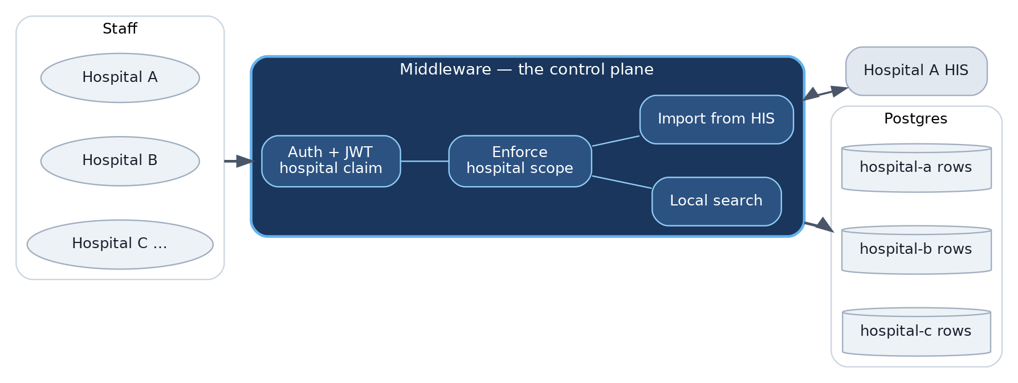
System overview — staff authenticate, the middleware scopes every query by hospital.
Go 1.24 · Gin · PostgreSQL 16 · Nginx · Docker Compose · golang-migrate
# | Deliverable | Section
1 | Project Structure | Section 1
2 | API Spec | Section 2
3 | ER Diagram | Section 3

Staff never reach HIS or Postgres directly. One API, one database — every row is tagged by hospital, and each staff member sees only their own hospital's data, taken from the JWT and never from a request field.

1. Project Structure

1.1 Runtime topology
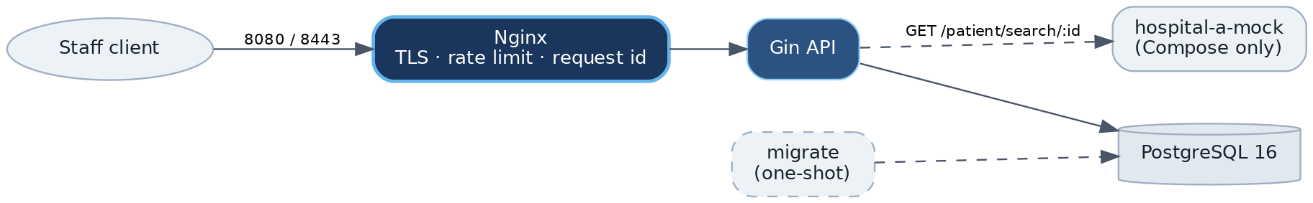
Docker Compose runs nginx + api + postgres + migrate + hospital-a-mock. Only Nginx is published.

1.2 Repository layout
Each feature is a bounded context with the same four layers. Adding a hospital, a domain, or another HIS adapter means dropping in a parallel package and wiring it in cmd/api + httpapi.
cmd/
api/main.go # composition root - config -> DB -> HIS client -> services -> router
mockhis/main.go # local Hospital A stub
internal/
staff/ # bounded context
domain/ # aggregate, VOs, Repository port
application/ # use cases: Create, Login
infrastructure/postgres/ # SQL adapter
transport/http/ # Gin handler + DTOs
patient/ # bounded context
domain/ # aggregate, Gender/LookupID/SearchCriteria VOs, ports
application/ # use cases: LookupFromHIS, Search
infrastructure/
postgres/ # SQL adapter
hospitalA/ # HIS anti-corruption layer
# hospitalB/ <- same pattern for another upstream
transport/http/
# <next-context>/ <- e.g. appointments: same 4 layers
shared/ # shared kernel: apperr, hospital.Code, httpkit envelope
httpapi/ # route registration + health - no business logic
middleware/ # recovery, request id, logger, timeout, JWT, rate limit
config/ platform/ # env validation, DB pool, slog, JWT
migrations/ # versioned SQL (.up.sql / .down.sql)
nginx/ # proxy config + TLS certs
docs/
planning/ # this document
openapi/ # openapi.yaml (served at /openapi/openapi.yaml)
postman/ # collection + environment
docker-compose.yml Dockerfile Makefile .env.example

1.3 Layering (per bounded context)
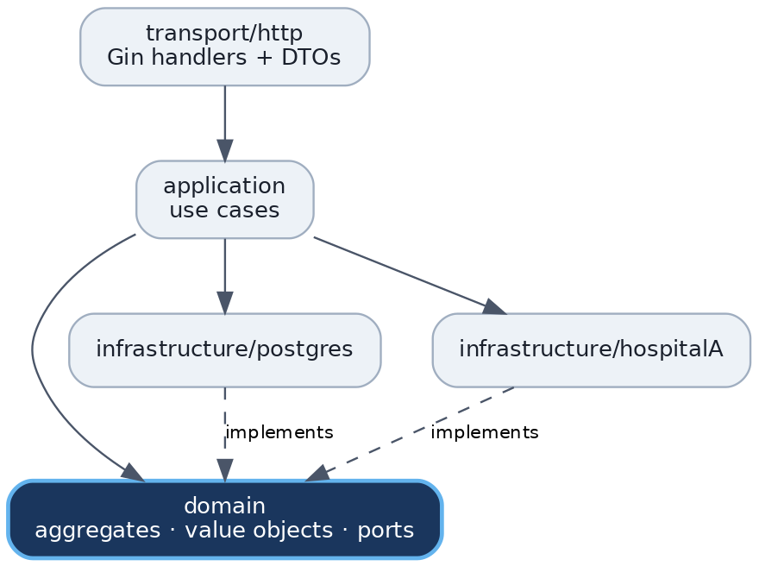
Dependencies point inward. domain declares the ports; infrastructure implements them, so tests inject fakes.
Layer | May do | Must not do
transport/http | Bind/validate, call service, map errors to HTTP | SQL, HIS calls, business rules
application | Auth rules, hospital scope, upsert orchestration | Import Gin; touch DB drivers directly
infrastructure/postgres | Parameterized SQL for owned tables | Call HIS; import handlers
infrastructure/hospitalA | HTTP to HIS, decode into domain types | Leak wire shapes outward
domain | Aggregates, value objects, ports | Import Gin, SQL drivers, wire types

1.4 Bounded contexts
Concern | Package | Key rule
Staff create / login | internal/staff | UNIQUE (username, hospital)
Patient search | internal/patient | Always filter by JWT hospital
HIS lookup | patient/infrastructure/hospitalA | Called only from patient/application
Auth | internal/middleware | JWT claims: sub, hospital

2. API Spec

2.1 Endpoint map
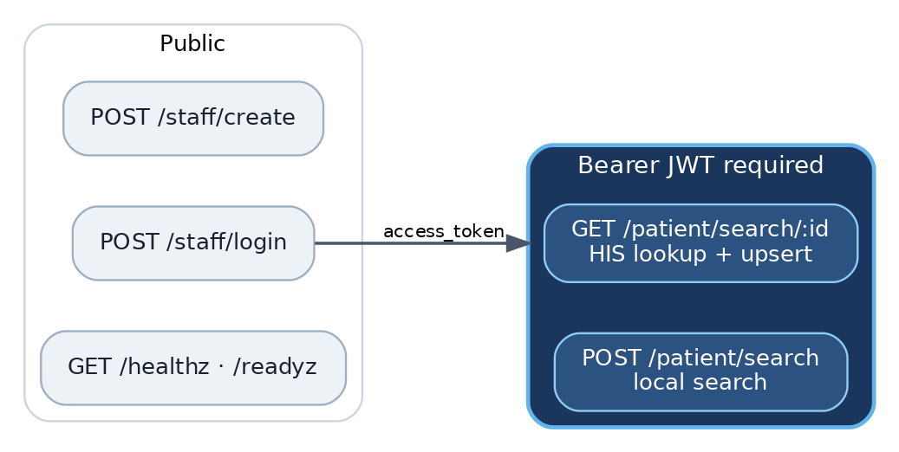
Login issues the access token; the whole /patient group requires it.
Method | Path | Auth | Purpose
POST | /staff/create | — | Create staff bound to one hospital
POST | /staff/login | — | Issue access token
GET | /patient/search/:id | JWT | Fetch from HIS, upsert locally, return
POST | /patient/search | JWT | Search local records, hospital-scoped
GET | /healthz | — | Liveness
GET | /readyz | — | Readiness (pings Postgres)

Base URL (local): http://localhost:8080 / https://localhost:8443. Live spec at /openapi/openapi.yaml, Swagger UI at /docs/swagger.

2.2 Response envelopes
{ "data": { } } // single
{ "data": [ ], "meta": { "count": 12 } } // collection
{ "error": { "code": "INVALID_INPUT", "message": "..." } } // error
message never contains SQL, stack traces, upstream URLs, or PII.
Code | HTTP | Use
INVALID_INPUT | 400 | Validation failure; empty search filters
UNAUTHORIZED | 401 | Bad credentials or token
FORBIDDEN | 403 | Authenticated but not allowed
NOT_FOUND | 404 | Missing resource; HIS 404
CONFLICT | 409 | Duplicate (username, hospital)
PAYLOAD_TOO_LARGE | 413 | Body over 1 MB
RATE_LIMITED | 429 | Edge or app limit
INTERNAL_ERROR | 500 | Unexpected
BAD_GATEWAY | 502 | HIS failure, timeout, decode error

2.3 POST /staff/create
{ "username": "alice", "password": "at-least-12-chars", "hospital": "hospital-a" }
201 created (no password hash) · 400 · 409. Password ≥ 12 chars, bcrypt-hashed; hospital normalized lowercase; unique per (username, hospital).

2.4 POST /staff/login
// request
{ "username": "alice", "password": "at-least-12-chars", "hospital": "hospital-a" }
// 200 response
{ "data": { "access_token": "<jwt>", "token_type": "Bearer", "expires_in": 3600 } }
JWT (HS256) claims: sub, hospital, iat, exp. No refresh token — out of scope. Unknown user, wrong hospital, and wrong password all return the same 401 with comparable timing, so accounts cannot be enumerated.

2.5 GET /patient/search/:id — HIS lookup
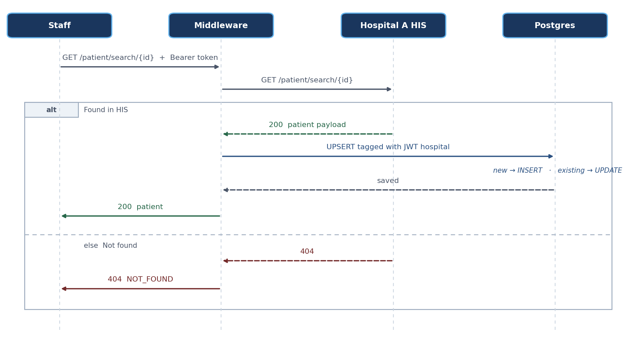
Lookup by national or passport ID: fetch from HIS, upsert under the caller's hospital, return.
id = national ID or passport ID (alphanumeric, ≤ 64). Responses: 200 · 401 · 404 · 502 (HIS 5xx, timeout, or undecodable body). Upstream bodies are logged, never forwarded.

2.6 POST /patient/search — local search
All fields optional, at least one required. Never calls HIS.
{
"national_id": "", "passport_id": "",
"first_name": "", "middle_name": "", "last_name": "",
"date_of_birth": "1990-01-15",
"phone_number": "", "email": "",
"limit": 50, "offset": 0
}
200 { "data": [...], "meta": { "count": N } } · 400 if no filters · 401.
- POST, not GET — filters carry PII; query strings land in access logs, proxies, and browser history.
- limit default 50, max 200; offset default 0.
- A hospital field in the body is ignored for authorization.
- Patient responses set Cache-Control: no-store.

2.7 Two distinct patient flows
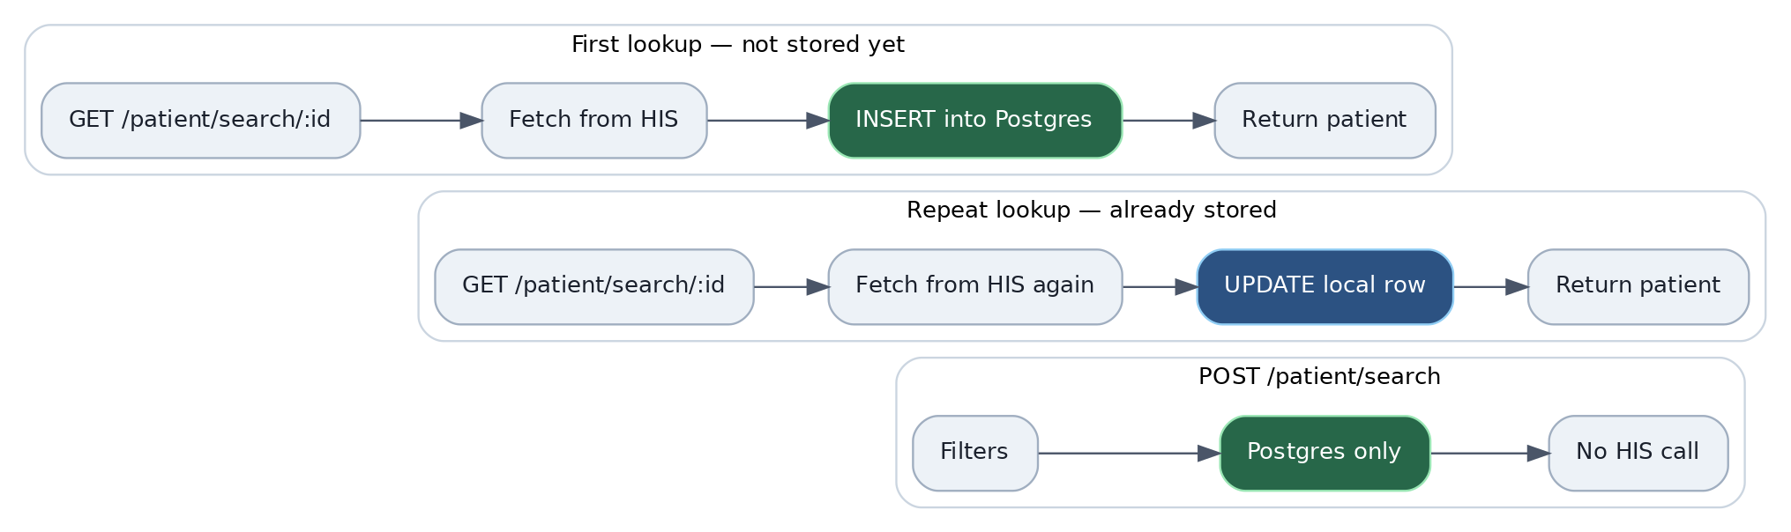
Import always refreshes from HIS and upserts; local search reads Postgres only.

2.8 Hospital isolation
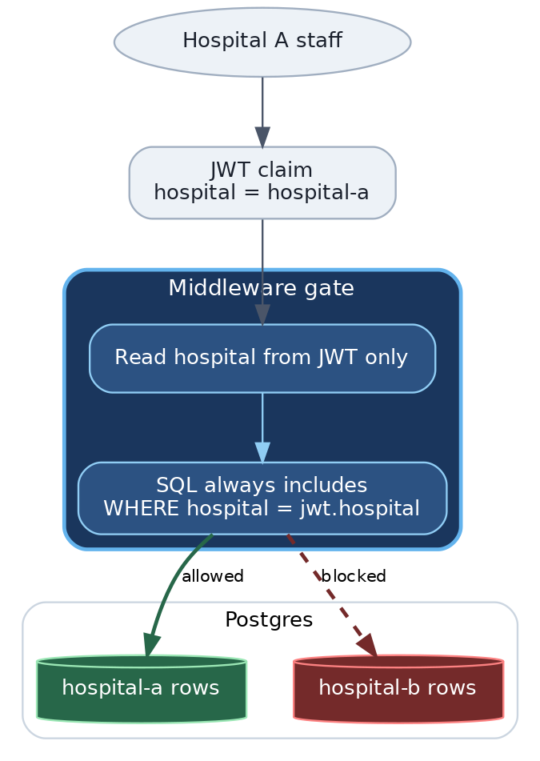
The hospital comes from the JWT and is appended to every query. Cross-hospital reads are unreachable through the API.

2.9 External: Hospital A HIS
GET https://hospital-a.api.co.th/patient/search/{id} returns Thai/English names, date_of_birth, patient_hn, national_id, passport_id, phone_number, email, gender (M/F). Configurable via HOSPITAL_A_BASE_URL and HOSPITAL_A_TIMEOUT; in Compose it points at cmd/mockhis so demos run offline.
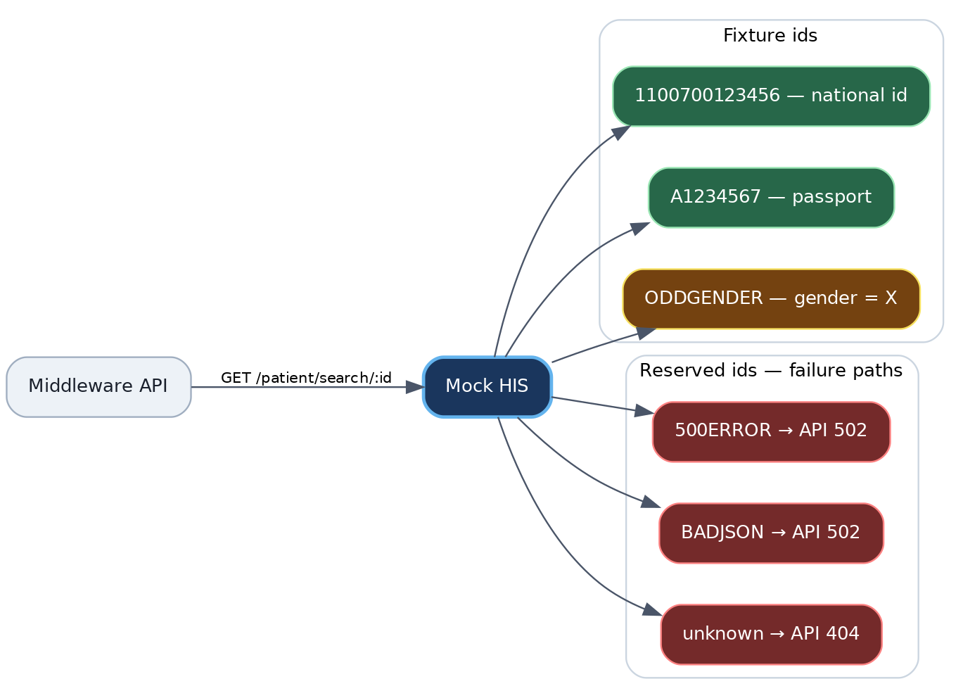
Mock HIS fixtures and reserved failure ids — every error path is demonstrable offline.

2.10 Rate limiting
Layer | Scope | Baseline
Nginx | Per-IP edge | 10 r/s, burst 20
App | Per-IP on /staff/login | 10 / 15 min
App | Per-(username, hospital) on login | 10 / 15 min
App | Per-staff_id on /patient/* | 60 / min

App limiters are in-memory — single instance only. Multiple replicas would need a shared store (Redis); a deliberate scope boundary for this assignment.

3. ER Diagram
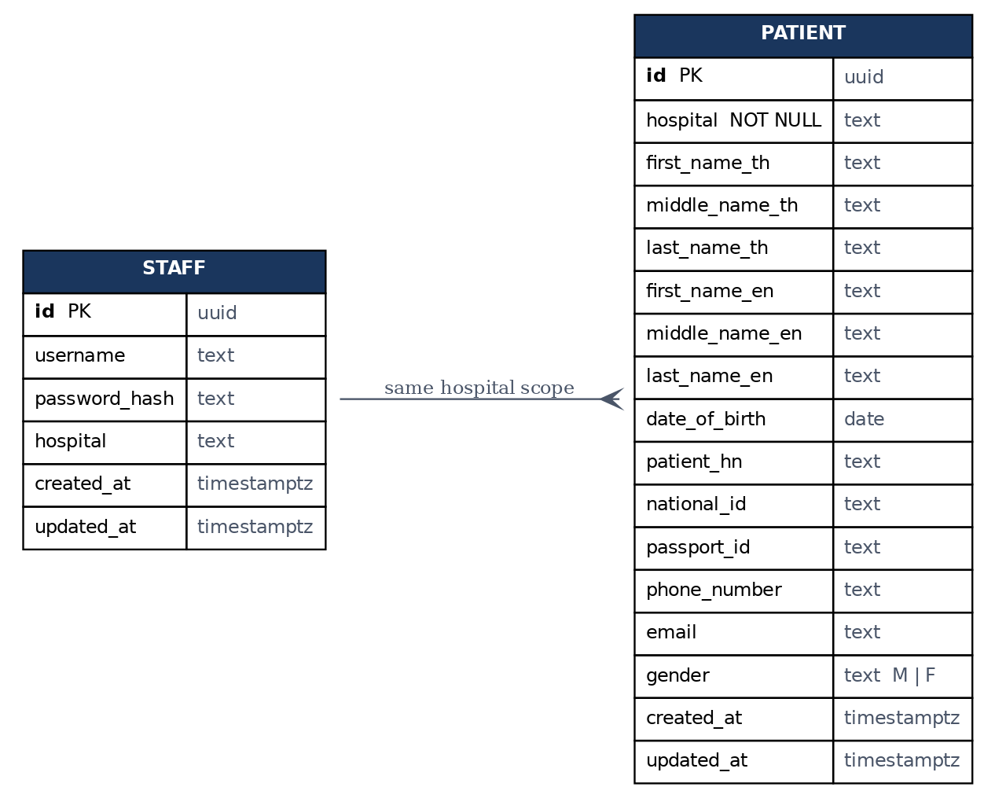
Both tables carry a hospital code; authorization matches patient.hospital to the JWT claim.
Staff and Patient are not an FK parent/child pair. Timestamps are TIMESTAMPTZ (UTC); date_of_birth is DATE.

3.1 staff
Column | Type | Notes
id | UUID PK | gen_random_uuid()
username | TEXT
password_hash | TEXT | bcrypt
hospital | TEXT | lowercase code, e.g. hospital-a
created_at / updated_at | TIMESTAMPTZ | UTC

UNIQUE (username, hospital) — the same username may exist at different hospitals; one staff row maps to exactly one hospital.

3.2 patients
Mirrors the Hospital A HIS field set, plus the required hospital scoping key.
Column | Type | Notes
id | UUID PK
hospital | TEXT NOT NULL | scoping key
first/middle/last_name_th | TEXT | nullable
first/middle/last_name_en | TEXT | nullable
date_of_birth | DATE | YYYY-MM-DD in JSON
patient_hn | TEXT
national_id / passport_id | TEXT | nullable
phone_number / email | TEXT
gender | TEXT | CHECK M | F | NULL
created_at / updated_at | TIMESTAMPTZ | UTC

3.3 Upsert identity
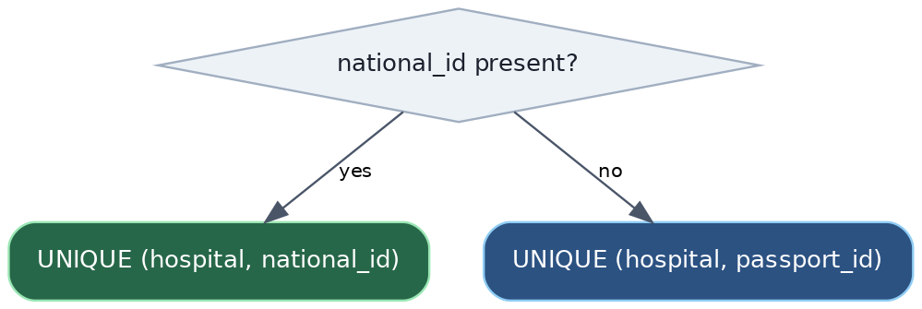
Two partial unique indexes decide the upsert key.
Uniqueness is always per hospital — the same national or passport ID may exist at two different hospitals.

3.4 Search indexes
Every filter that matters at scale has a supporting index, all prefixed by hospital:
(hospital, national_id) (hospital, lower(first_name_en))
(hospital, passport_id) (hospital, lower(last_name_en))
(hospital, last_name_en) (hospital, lower(email))
(hospital, date_of_birth) (hospital, phone_number)

4. Testing
Scope | Approach
Domain / value objects | Table-driven unit tests
Application | Fake Repository / HISClient ports
Transport | httptest against the Gin router
Repositories | Parameterized SQL against Postgres

Every behavior ships with a positive and a negative case: valid vs. duplicate staff, correct vs. wrong-hospital login, HIS hit vs. 404/500/bad JSON, in-scope vs. cross-hospital search.
gofmt -w . && go vet ./... && go test ./... -race -cover && govulncheck ./...

5. Design decisions
- Staff and patients are separate bounded contexts — each owns its logic and SQL.
- Two patient flows — HIS import by ID vs. local search; search never calls HIS.
- Search uses POST — PII filters stay out of URLs and logs.
- One access token, no refresh; expiry configurable.
- Patients unique per hospital — the same ID can exist at two hospitals.
- Migrations are an explicit step, not run on app boot.
- Rate limits at the edge and in the app — in-memory, single-instance scope.

6. Running it
cp .env.example .env
make up
curl http://localhost:8080/healthz
Port | Service
8080 | Nginx → API
8443 | Nginx HTTPS (self-signed)
5432 | Postgres

Postman walkthrough (create staff → login → HIS import → local search, plus negatives) lives in docs/postman/.

