Visualization using seaborn



[1]: **import numpy as np**

**import pandas as pd**

**import matplotlib.pyplot as plt**

**import seaborn as sns**



[2]: data1 = pd.read_csv("datasets/iris.csv")

data2 = pd.read_csv("datasets/tips.csv")



[3]: data1.head()

|  |  |  |  |  |  |  |  |  |
| --- | --- | --- | --- | --- | --- | --- | --- | --- |
| [3]: | Sepal Length | Sepal Width | | Petal | Length Petal Width | | | iris \ |
| 0 | 5.1 |  | 3.5 |  |  | 1.4 | 0.2 | Iris-setosa |
| 1 | 4.9 |  | 3.0 |  |  | 1.4 | 0.2 | Iris-setosa |
| 2 | 4.7 |  | 3.2 |  |  | 1.3 | 0.2 | Iris-setosa |
| 3 | 4.6 |  | 3.1 |  |  | 1.5 | 0.2 | Iris-setosa |
| 4 | 5.0 |  | 3.6 |  |  | 1.4 | 0.2 | Iris-setosa |
|  | species no |  |  |  |  |  |  |  |
| 0 | 1 |  |  |  |  |  |  |  |
| 1 | 1 |  |  |  |  |  |  |  |
| 2 | 1 |  |  |  |  |  |  |  |
| 3 | 1 |  |  |  |  |  |  |  |
| 4 | 1 |  |  |  |  |  |  |  |
| [4]: data2.head() | |  |  |  |  |  |  |  |
| [4]: | total_bill | tip | sex smoker | | day | time | size |  |
| 0 | 16.99 | 1.01 | Female | No | Sun | Dinner | 2 |  |
| 1 | 10.34 | 1.66 | Male | No | Sun | Dinner | 3 |  |
| 2 | 21.01 | 3.50 | Male | No | Sun | Dinner | 3 |  |
| 3 | 23.68 | 3.31 | Male | No | Sun | Dinner | 2 |  |
| 4 | 24.59 | 3.61 | Female | No | Sun | Dinner | 4 |  |



[5]: *# 1. swarm plot* *2. strip plot |categorical scatter plot*



[6]: sns.stripplot(data= data2,x="day",y="total_bill",color="red",size=5)

plt.show()

1

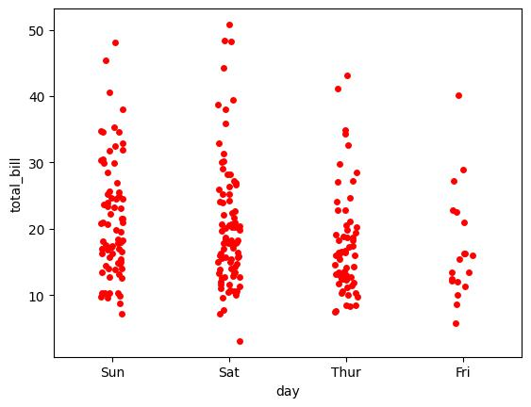

[7]: sns.

↪catplot(data=data2,kind="strip",x="smoker",y="total_bill",color="orange",size=5)

plt.show()

C:\Users\Admin\AppData\Local\Programs\Python\Python311\Lib\site-packages\seaborn\axisgrid.py:118: UserWarning: The figure layout has changed to tight

self._figure.tight_layout(*args, **kwargs)

2

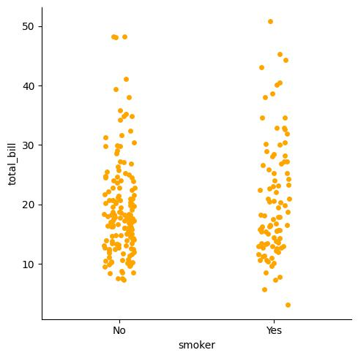

[8]: *# swarm plot*

* *swarmplot is same as strip plot but it also shows*
* *the distriution of the data that how data is distubeted .*



[9]: sns.swarmplot(data=data2,x="day",y="total_bill",hue="sex")

plt.show()

3

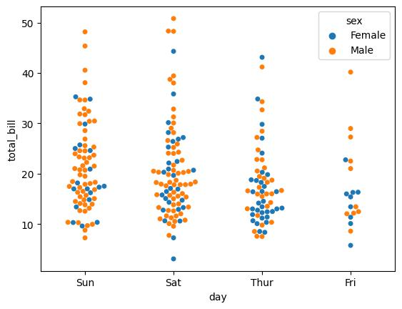

[10]: *# categorical distribution plot*



[11]: *# box plot*



[12]: *# box plot is a stranderdized way of displaying the distribution of data. bases*␣ ↪*on five number summary.*

* *it can also tell your outliers and what there values are .*
* *box plots can also tell you if ypur data is symmetrical ,*
* *how tightly your data is grouped and if and how yor data is skewed .*



[13]: sns.boxplot(data=data2,y="total_bill")

[13]: <Axes: ylabel='total_bill'>

4

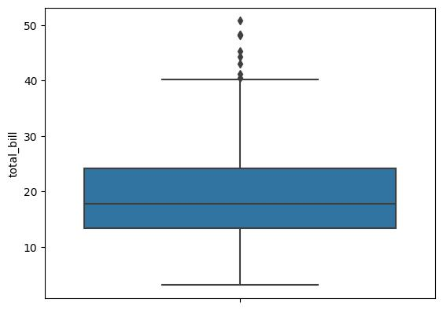

[14]: sns.boxplot(data=data2,x="day",y="total_bill")

plt.show()

5

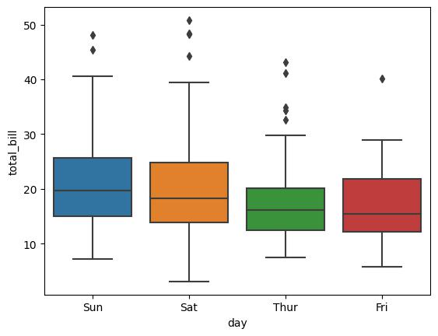

|  |  |  |  |  |  |  |  |  |
| --- | --- | --- | --- | --- | --- | --- | --- | --- |
| [15]: data1.head() | |  |  |  |  |  |  |  |
| [15]: | Sepal Length | Sepal Width | | Petal | Length Petal Width | | | iris \ |
| 0 | 5.1 |  | 3.5 |  |  | 1.4 | 0.2 | Iris-setosa |
| 1 | 4.9 |  | 3.0 |  |  | 1.4 | 0.2 | Iris-setosa |
| 2 | 4.7 |  | 3.2 |  |  | 1.3 | 0.2 | Iris-setosa |
| 3 | 4.6 |  | 3.1 |  |  | 1.5 | 0.2 | Iris-setosa |
| 4 | 5.0 |  | 3.6 |  |  | 1.4 | 0.2 | Iris-setosa |
|  | species no |  |  |  |  |  |  |  |
| 0 | 1 |  |  |  |  |  |  |  |
| 1 | 1 |  |  |  |  |  |  |  |
| 2 | 1 |  |  |  |  |  |  |  |
| 3 | 1 |  |  |  |  |  |  |  |
| 4 | 1 |  |  |  |  |  |  |  |
| [16]: data2.head() | |  |  |  |  |  |  |  |
| [16]: | total_bill | tip | sex smoker | | day | time | size |  |
| 0 | 16.99 | 1.01 | Female | No | Sun | Dinner | 2 |  |
| 1 | 10.34 | 1.66 | Male | No | Sun | Dinner | 3 |  |



6

|  |  |  |  |  |  |  |  |
| --- | --- | --- | --- | --- | --- | --- | --- |
| 2 | 21.01 | 3.50 | Male | No | Sun | Dinner | 3 |
| 3 | 23.68 | 3.31 | Male | No | Sun | Dinner | 2 |
| 4 | 24.59 | 3.61 | Female | No | Sun | Dinner | 4 |



[17]: *# viloin plot*



[18]: sns.violinplot(data=data2,x="sex",y="total_bill")

[18]: <Axes: xlabel='sex', ylabel='total_bill'>

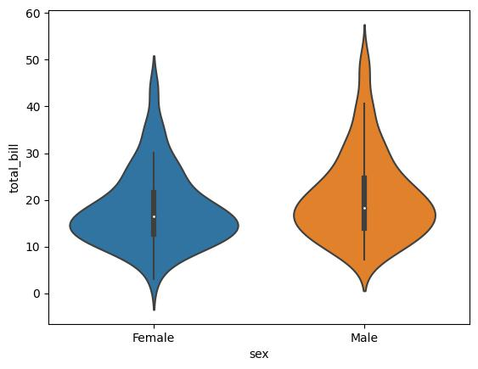

[19]: *# barplot*



[27]: sns.barplot(data=data2,x="day",y="total_bill",estimator="sum")

[27]: <Axes: xlabel='day', ylabel='total_bill'>

7

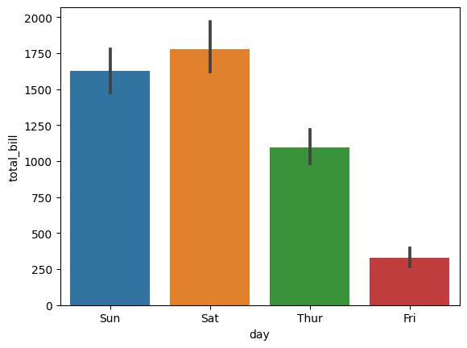

[26]: data2[data2["day"]=="Sun"]["total_bill"].mean()

[26]: 21.41



[30]: sns.

↪barplot(data=data2,x="day",y="total_bill",estimator="sum",hue="smoker",errorbar=**None**,edgeco

[30]: <Axes: xlabel='day', ylabel='total_bill'>

8

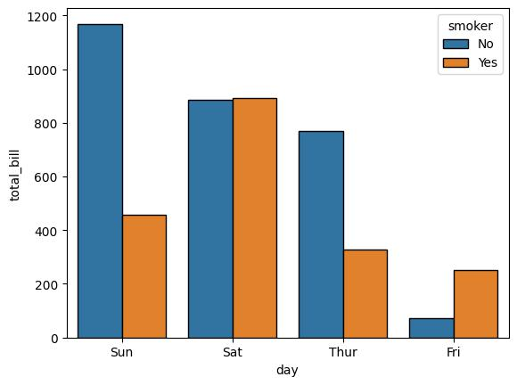

[31]: *# countplot*



[39]: sns.countplot(data=data2,x="sex",edgecolor="black",hue="smoker")

[39]: <Axes: xlabel='sex', ylabel='count'>

9

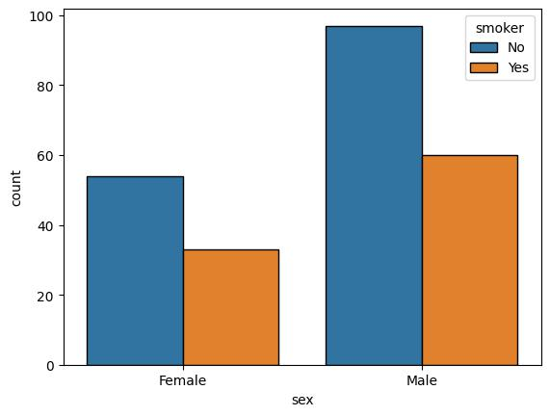

|  |  |  |  |  |  |  |  |  |  |
| --- | --- | --- | --- | --- | --- | --- | --- | --- | --- |
| [40]: data2 | |  |  |  |  |  |  |  |  |
| [40]: | total_bill | tip |  | sex smoker | |  | day | time | size |
| 0 | 16.99 | 1.01 |  | Female | No |  | Sun | Dinner | 2 |
| 1 | 10.34 | 1.66 |  | Male | No |  | Sun | Dinner | 3 |
| 2 | 21.01 | 3.50 |  | Male | No |  | Sun | Dinner | 3 |
| 3 | 23.68 | 3.31 |  | Male | No |  | Sun | Dinner | 2 |
| 4 | 24.59 | 3.61 |  | Female | No |  | Sun | Dinner | 4 |
| .. | … | … | … | … | … | … | … |  |  |
| 239 | 29.03 | 5.92 |  | Male | No |  | Sat | Dinner | 3 |
| 240 | 27.18 | 2.00 |  | Female | Yes |  | Sat | Dinner | 2 |
| 241 | 22.67 | 2.00 |  | Male | Yes |  | Sat | Dinner | 2 |
| 242 | 17.82 | 1.75 |  | Male | No |  | Sat | Dinner | 2 |
| 243 | 18.78 | 3.00 |  | Female | No |  | Thur | Dinner | 2 |

[244 rows x 7 columns]



[45]: temp = data2[data2["day"]=="Sun"]



[53]: temp["total_bill"].values

10

[53]: array([16.99, 10.34, 21.01, 23.68, 24.59, 25.29, 8.77, 26.88, 15.04,

14.78, 10.27, 35.26, 15.42, 18.43, 14.83, 21.58, 10.33, 16.29,

16.97, 17.46, 13.94, 9.68, 30.4 , 18.29, 22.23, 32.4 , 28.55,

18.04, 12.54, 10.29, 34.81, 9.94, 25.56, 19.49, 38.07, 23.95,

25.71, 17.31, 29.93, 14.07, 13.13, 17.26, 24.55, 19.77, 29.85,

48.17, 25. , 13.39, 16.49, 21.5 , 12.66, 16.21, 13.81, 17.51,

24.52, 20.76, 31.71, 7.25, 31.85, 16.82, 32.9 , 17.89, 14.48,

9.6 , 34.63, 34.65, 23.33, 45.35, 23.17, 40.55, 20.69, 20.9 ,

30.46, 18.15, 23.1 , 15.69])



[55]: data2

|  |  |  |  |  |  |  |  |  |  |
| --- | --- | --- | --- | --- | --- | --- | --- | --- | --- |
| [55]: | total_bill | tip |  | sex smoker | |  | day | time | size |
| 0 | 16.99 | 1.01 |  | Female | No |  | Sun | Dinner | 2 |
| 1 | 10.34 | 1.66 |  | Male | No |  | Sun | Dinner | 3 |
| 2 | 21.01 | 3.50 |  | Male | No |  | Sun | Dinner | 3 |
| 3 | 23.68 | 3.31 |  | Male | No |  | Sun | Dinner | 2 |
| 4 | 24.59 | 3.61 |  | Female | No |  | Sun | Dinner | 4 |
| .. | … | … | … | … | … | … | … |  |  |
| 239 | 29.03 | 5.92 |  | Male | No |  | Sat | Dinner | 3 |
| 240 | 27.18 | 2.00 |  | Female | Yes |  | Sat | Dinner | 2 |
| 241 | 22.67 | 2.00 |  | Male | Yes |  | Sat | Dinner | 2 |
| 242 | 17.82 | 1.75 |  | Male | No |  | Sat | Dinner | 2 |
| 243 | 18.78 | 3.00 |  | Female | No |  | Thur | Dinner | 2 |

[244 rows x 7 columns]



[58]: data2[(data2["sex"]=="Male") & (data2["smoker"]=="No")]

|  |  |  |  |  |  |  |  |
| --- | --- | --- | --- | --- | --- | --- | --- |
| [58]: | total_bill | tip | sex | smoker | day | time | size |
| 1 | 10.34 | 1.66 | Male | No | Sun | Dinner | 3 |
| 2 | 21.01 | 3.50 | Male | No | Sun | Dinner | 3 |
| 3 | 23.68 | 3.31 | Male | No | Sun | Dinner | 2 |
| 5 | 25.29 | 4.71 | Male | No | Sun | Dinner | 4 |
| 6 | 8.77 | 2.00 | Male | No | Sun | Dinner | 2 |
| .. | … | … … | … | … | … … |  |  |
| 232 | 11.61 | 3.39 | Male | No | Sat | Dinner | 2 |
| 233 | 10.77 | 1.47 | Male | No | Sat | Dinner | 2 |
| 235 | 10.07 | 1.25 | Male | No | Sat | Dinner | 2 |
| 239 | 29.03 | 5.92 | Male | No | Sat | Dinner | 3 |
| 242 | 17.82 | 1.75 | Male | No | Sat | Dinner | 2 |

[97 rows x 7 columns]



[59]: data2["sex"]

11

[59]: 0 Female

* Male
* Male
* Male
* Female

…

1. Male
2. Female
3. Male
4. Male
5. Female

Name: sex, Length: 244, dtype: object



[60]: data2.sex

[60]: 0 Female

* Male
* Male
* Male
* Female

…

1. Male
2. Female
3. Male
4. Male
5. Female

Name: sex, Length: 244, dtype: object



[61]: data2.day

[61]: 0 Sun

* Sun
* Sun
* Sun
* Sun

…

1. Sat
2. Sat
3. Sat
4. Sat
5. Thur

Name: day, Length: 244, dtype: object



[70]: data2[(data2.sex=="Female") & (data2.smoker=="Yes") & (data2.time=="Dinner") &␣ ↪(data2.total_bill>=20)]

12

|  |  |  |  |  |  |  |  |
| --- | --- | --- | --- | --- | --- | --- | --- |
| [70]: | total_bill | tip | sex smoker | | day | time | size |
| 72 | 26.86 | 3.14 | Female | Yes | Sat | Dinner | 2 |
| 73 | 25.28 | 5.00 | Female | Yes | Sat | Dinner | 2 |
| 102 | 44.30 | 2.50 | Female | Yes | Sat | Dinner | 3 |
| 103 | 22.42 | 3.48 | Female | Yes | Sat | Dinner | 2 |
| 186 | 20.90 | 3.50 | Female | Yes | Sun | Dinner | 3 |
| 214 | 28.17 | 6.50 | Female | Yes | Sat | Dinner | 3 |
| 219 | 30.14 | 3.09 | Female | Yes | Sat | Dinner | 4 |
| 229 | 22.12 | 2.88 | Female | Yes | Sat | Dinner | 2 |
| 240 | 27.18 | 2.00 | Female | Yes | Sat | Dinner | 2 |



[65]: print(int(**True**))

1



[66]: print(**True** + 1)

2



[67]: print(int(**True**) + 1)

2



[71]: *# Regression plot*



[76]: exp = [2,3,4,5,6]

salary = [2000,3000,4000,5000,6000]

sns.regplot(x=exp,y=salary)

[76]: <Axes: >

13

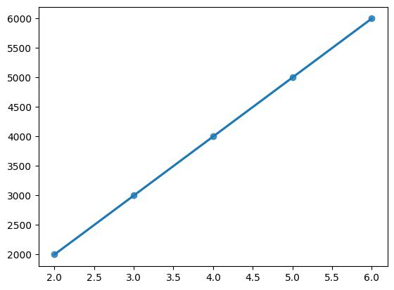

|  |  |  |  |  |  |  |  |  |  |
| --- | --- | --- | --- | --- | --- | --- | --- | --- | --- |
| [74]: data2 | |  |  |  |  |  |  |  |  |
| [74]: | total_bill | tip |  | sex smoker | |  | day | time | size |
| 0 | 16.99 | 1.01 |  | Female | No |  | Sun | Dinner | 2 |
| 1 | 10.34 | 1.66 |  | Male | No |  | Sun | Dinner | 3 |
| 2 | 21.01 | 3.50 |  | Male | No |  | Sun | Dinner | 3 |
| 3 | 23.68 | 3.31 |  | Male | No |  | Sun | Dinner | 2 |
| 4 | 24.59 | 3.61 |  | Female | No |  | Sun | Dinner | 4 |
| .. | … | … | … | … | … | … | … |  |  |
| 239 | 29.03 | 5.92 |  | Male | No |  | Sat | Dinner | 3 |
| 240 | 27.18 | 2.00 |  | Female | Yes |  | Sat | Dinner | 2 |
| 241 | 22.67 | 2.00 |  | Male | Yes |  | Sat | Dinner | 2 |
| 242 | 17.82 | 1.75 |  | Male | No |  | Sat | Dinner | 2 |
| 243 | 18.78 | 3.00 |  | Female | No |  | Thur | Dinner | 2 |

[244 rows x 7 columns]



[75]: sns.regplot(data=data2,x="total_bill",y="tip")

[75]: <Axes: xlabel='total_bill', ylabel='tip'>

14

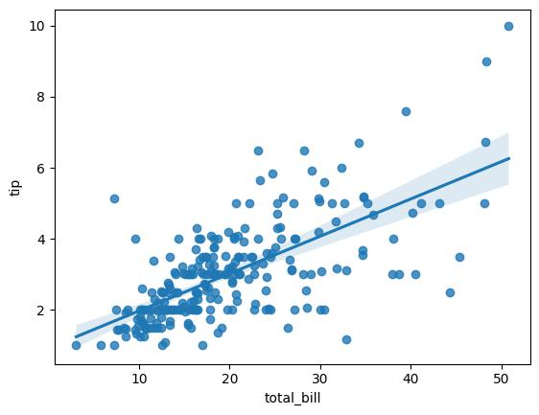

[78]: sns.lmplot(data=data2,x="total_bill",y="tip")

C:\Users\Admin\AppData\Local\Programs\Python\Python311\Lib\site-packages\seaborn\axisgrid.py:118: UserWarning: The figure layout has changed to tight

self._figure.tight_layout(*args, **kwargs)

[78]: <seaborn.axisgrid.FacetGrid at 0x1e9bcdb61d0>

15

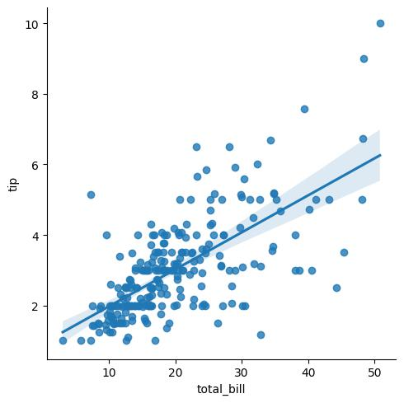

[80]: *# 6.Jointplot -> is a stylish way to plot graphs .*



[83]: sns.jointplot(data=data2,x="total_bill",y="tip",hue="sex",kind="hist")

[83]: <seaborn.axisgrid.JointGrid at 0x1e9beaa81d0>

16

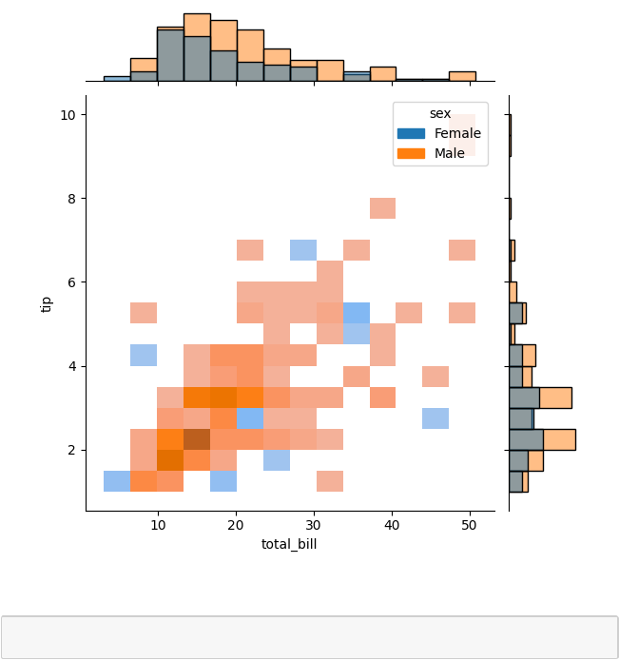

[90]: g = sns.JointGrid(data=data2,x="total_bill",y="tip")

g.plot(sns.scatterplot,sns.histplot)

[90]: <seaborn.axisgrid.JointGrid at 0x1e9c0568950>

17

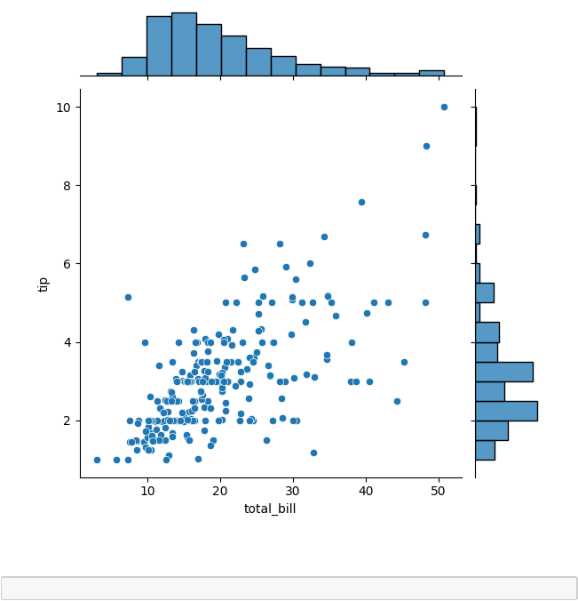

|  |  |  |  |  |  |  |  |  |  |
| --- | --- | --- | --- | --- | --- | --- | --- | --- | --- |
| [91]: data2 | |  |  |  |  |  |  |  |  |
| [91]: | total_bill | tip |  | sex smoker | |  | day | time | size |
| 0 | 16.99 | 1.01 |  | Female | No |  | Sun | Dinner | 2 |
| 1 | 10.34 | 1.66 |  | Male | No |  | Sun | Dinner | 3 |
| 2 | 21.01 | 3.50 |  | Male | No |  | Sun | Dinner | 3 |
| 3 | 23.68 | 3.31 |  | Male | No |  | Sun | Dinner | 2 |
| 4 | 24.59 | 3.61 |  | Female | No |  | Sun | Dinner | 4 |
| .. | … | … | … | … | … | … | … |  |  |
| 239 | 29.03 | 5.92 |  | Male | No |  | Sat | Dinner | 3 |
| 240 | 27.18 | 2.00 |  | Female | Yes |  | Sat | Dinner | 2 |
| 241 | 22.67 | 2.00 |  | Male | Yes |  | Sat | Dinner | 2 |
| 242 | 17.82 | 1.75 |  | Male | No |  | Sat | Dinner | 2 |

18

243 18.78 3.00 Female No Thur Dinner 2

[244 rows x 7 columns]



[99]: gap = pd.read_csv("datasets/gapminder.csv")



|  |  |  |  |  |  |  |  |
| --- | --- | --- | --- | --- | --- | --- | --- |
| [100]: gap |  |  |  |  |  |  |  |
| [100]: | country continent | | year | life_exp | hdi_index | co2_consump | gdp \ |
| 0 | Afghanistan | Asia | 1998 | 53.3 | 0.344 | 0.0522 | NaN |
| 1 | Afghanistan | Asia | 1999 | 54.7 | 0.348 | 0.0402 | NaN |
| 2 | Afghanistan | Asia | 2000 | 54.7 | 0.350 | 0.0370 | NaN |
| 3 | Afghanistan | Asia | 2001 | 54.8 | 0.353 | 0.0376 | NaN |
| 4 | Afghanistan | Asia | 2002 | 55.5 | 0.384 | 0.0471 | 333.0 |
| … | … | … … | … | … | … | … |  |
| 3670 | Zimbabwe | Africa | 2014 | 58.0 | 0.547 | 0.8810 | 1440.0 |
| 3671 | Zimbabwe | Africa | 2015 | 58.6 | 0.553 | 0.8810 | 1450.0 |
| 3672 | Zimbabwe | Africa | 2016 | 59.2 | 0.558 | 0.7710 | 1430.0 |
| 3673 | Zimbabwe | Africa | 2017 | 59.9 | 0.563 | 0.8450 | 1480.0 |
| 3674 | Zimbabwe | Africa | 2018 | 60.6 | 0.569 | 0.8500 | 1510.0 |

services

* 24.4
* 24.6
* 24.7
* 24.7
* 25.6

……

367025.4

367125.7

367226.1

367326.6

367427.2

[3675 rows x 8 columns]



[109]: temp = gap.pivot_table(index="country",columns="year",values="life_exp"). ↪head(10)



|  |  |  |  |  |  |  |  |  |  |  |  |
| --- | --- | --- | --- | --- | --- | --- | --- | --- | --- | --- | --- |
| [110]: temp |  |  |  |  |  |  |  |  |  |  |  |
| [110]: year | 1998 | 1999 | 2000 | 2001 | 2002 | 2003 | 2004 | 2005 | 2006 | 2007 | … \ |
| country |  |  |  |  |  |  |  |  |  |  | … |
| Afghanistan | 53.3 | 54.7 | 54.7 | 54.8 | 55.5 | 56.5 | 57.1 | 57.6 | 58.0 | 58.5 | … |
| Albania | 74.8 | 75.1 | 75.4 | 76.0 | 75.9 | 75.6 | 75.8 | 76.2 | 76.9 | 77.5 | … |
| Algeria | 70.2 | 70.7 | 71.0 | 71.3 | 71.8 | 72.0 | 72.6 | 72.9 | 73.3 | 73.6 | … |
| Angola | 50.6 | 51.9 | 52.8 | 53.4 | 54.5 | 55.1 | 55.5 | 56.4 | 57.0 | 58.0 | … |

19

|  |  |  |  |  |  |  |  |  |  |  |  |
| --- | --- | --- | --- | --- | --- | --- | --- | --- | --- | --- | --- |
| Argentina | 73.7 | 73.8 | 74.2 | 74.3 | 74.3 | 74.4 | 74.9 | 75.3 | 75.4 | 75.3 | … |
| Armenia | 71.6 | 71.9 | 72.4 | 72.5 | 72.7 | 72.8 | 73.0 | 73.0 | 73.1 | 73.5 | … |
| Australia | 79.1 | 79.4 | 79.7 | 80.1 | 80.3 | 80.6 | 80.9 | 81.2 | 81.5 | 81.5 | … |
| Austria | 77.9 | 78.2 | 78.5 | 78.9 | 79.0 | 79.1 | 79.5 | 79.8 | 80.1 | 80.3 | … |
| Azerbaijan | 66.0 | 66.2 | 66.5 | 67.1 | 67.2 | 67.1 | 67.2 | 67.3 | 67.7 | 68.2 | … |
| Bahamas | 71.4 | 70.8 | 71.3 | 71.3 | 71.9 | 72.4 | 72.4 | 73.2 | 73.0 | 73.6 | … |
| year | 2009 | 2010 | 2011 | 2012 | 2013 | 2014 | 2015 | 2016 | 2017 | 2018 |  |
| country |  |  |  |  |  |  |  |  |  |  |  |
| Afghanistan | 59.9 | 60.5 | 61.0 | 61.4 | 61.9 | 61.9 | 61.9 | 62.0 | 62.9 | 62.7 |  |
| Albania | 78.0 | 78.1 | 78.1 | 78.2 | 78.3 | 78.2 | 78.1 | 78.2 | 78.3 | 78.4 |  |
| Algeria | 74.2 | 74.5 | 74.7 | 74.9 | 75.1 | 75.3 | 75.4 | 75.7 | 75.9 | 76.0 |  |
| Angola | 59.5 | 60.2 | 60.8 | 61.4 | 62.1 | 63.0 | 63.5 | 63.9 | 64.2 | 64.6 |  |
| Argentina | 75.8 | 75.9 | 76.0 | 76.2 | 76.3 | 76.5 | 76.5 | 76.2 | 76.3 | 76.5 |  |
| Armenia | 73.6 | 73.9 | 74.2 | 74.6 | 75.1 | 75.2 | 75.1 | 75.3 | 75.5 | 75.6 |  |
| Australia | 81.9 | 82.1 | 82.3 | 82.6 | 82.7 | 82.7 | 82.7 | 83.0 | 83.0 | 82.9 |  |
| Austria | 80.5 | 80.8 | 81.0 | 81.2 | 81.3 | 81.5 | 81.6 | 81.8 | 82.0 | 82.1 |  |
| Azerbaijan | 68.8 | 69.0 | 69.2 | 69.5 | 69.7 | 69.9 | 70.2 | 70.3 | 70.4 | 70.8 |  |
| Bahamas | 73.2 | 73.2 | 73.2 | 73.3 | 73.5 | 73.6 | 73.3 | 73.7 | 73.8 | 73.8 |  |

[10 rows x 21 columns]



[115]: plt.figure(figsize=(15,8))

sns.heatmap(data=temp,annot=**True**,linewidth=0.1,cmap="winter")

[115]: <Axes: xlabel='year', ylabel='country'>

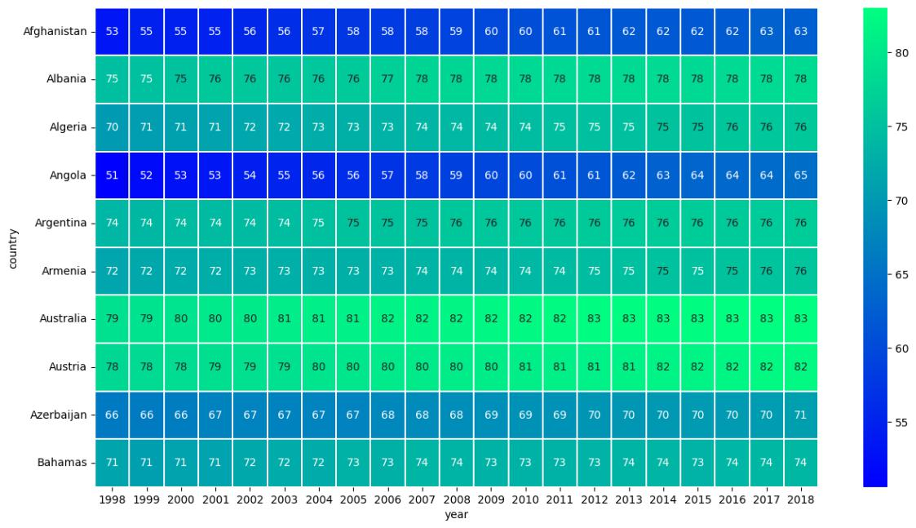

20

[ ]: 

21