Milestone-4 File I/O Integration
Nejla Yber
Grand Canyon University
CST-239 Programming in Java II
Kenia Madrazo
14/07/2026

Screenshot1 Program Startup
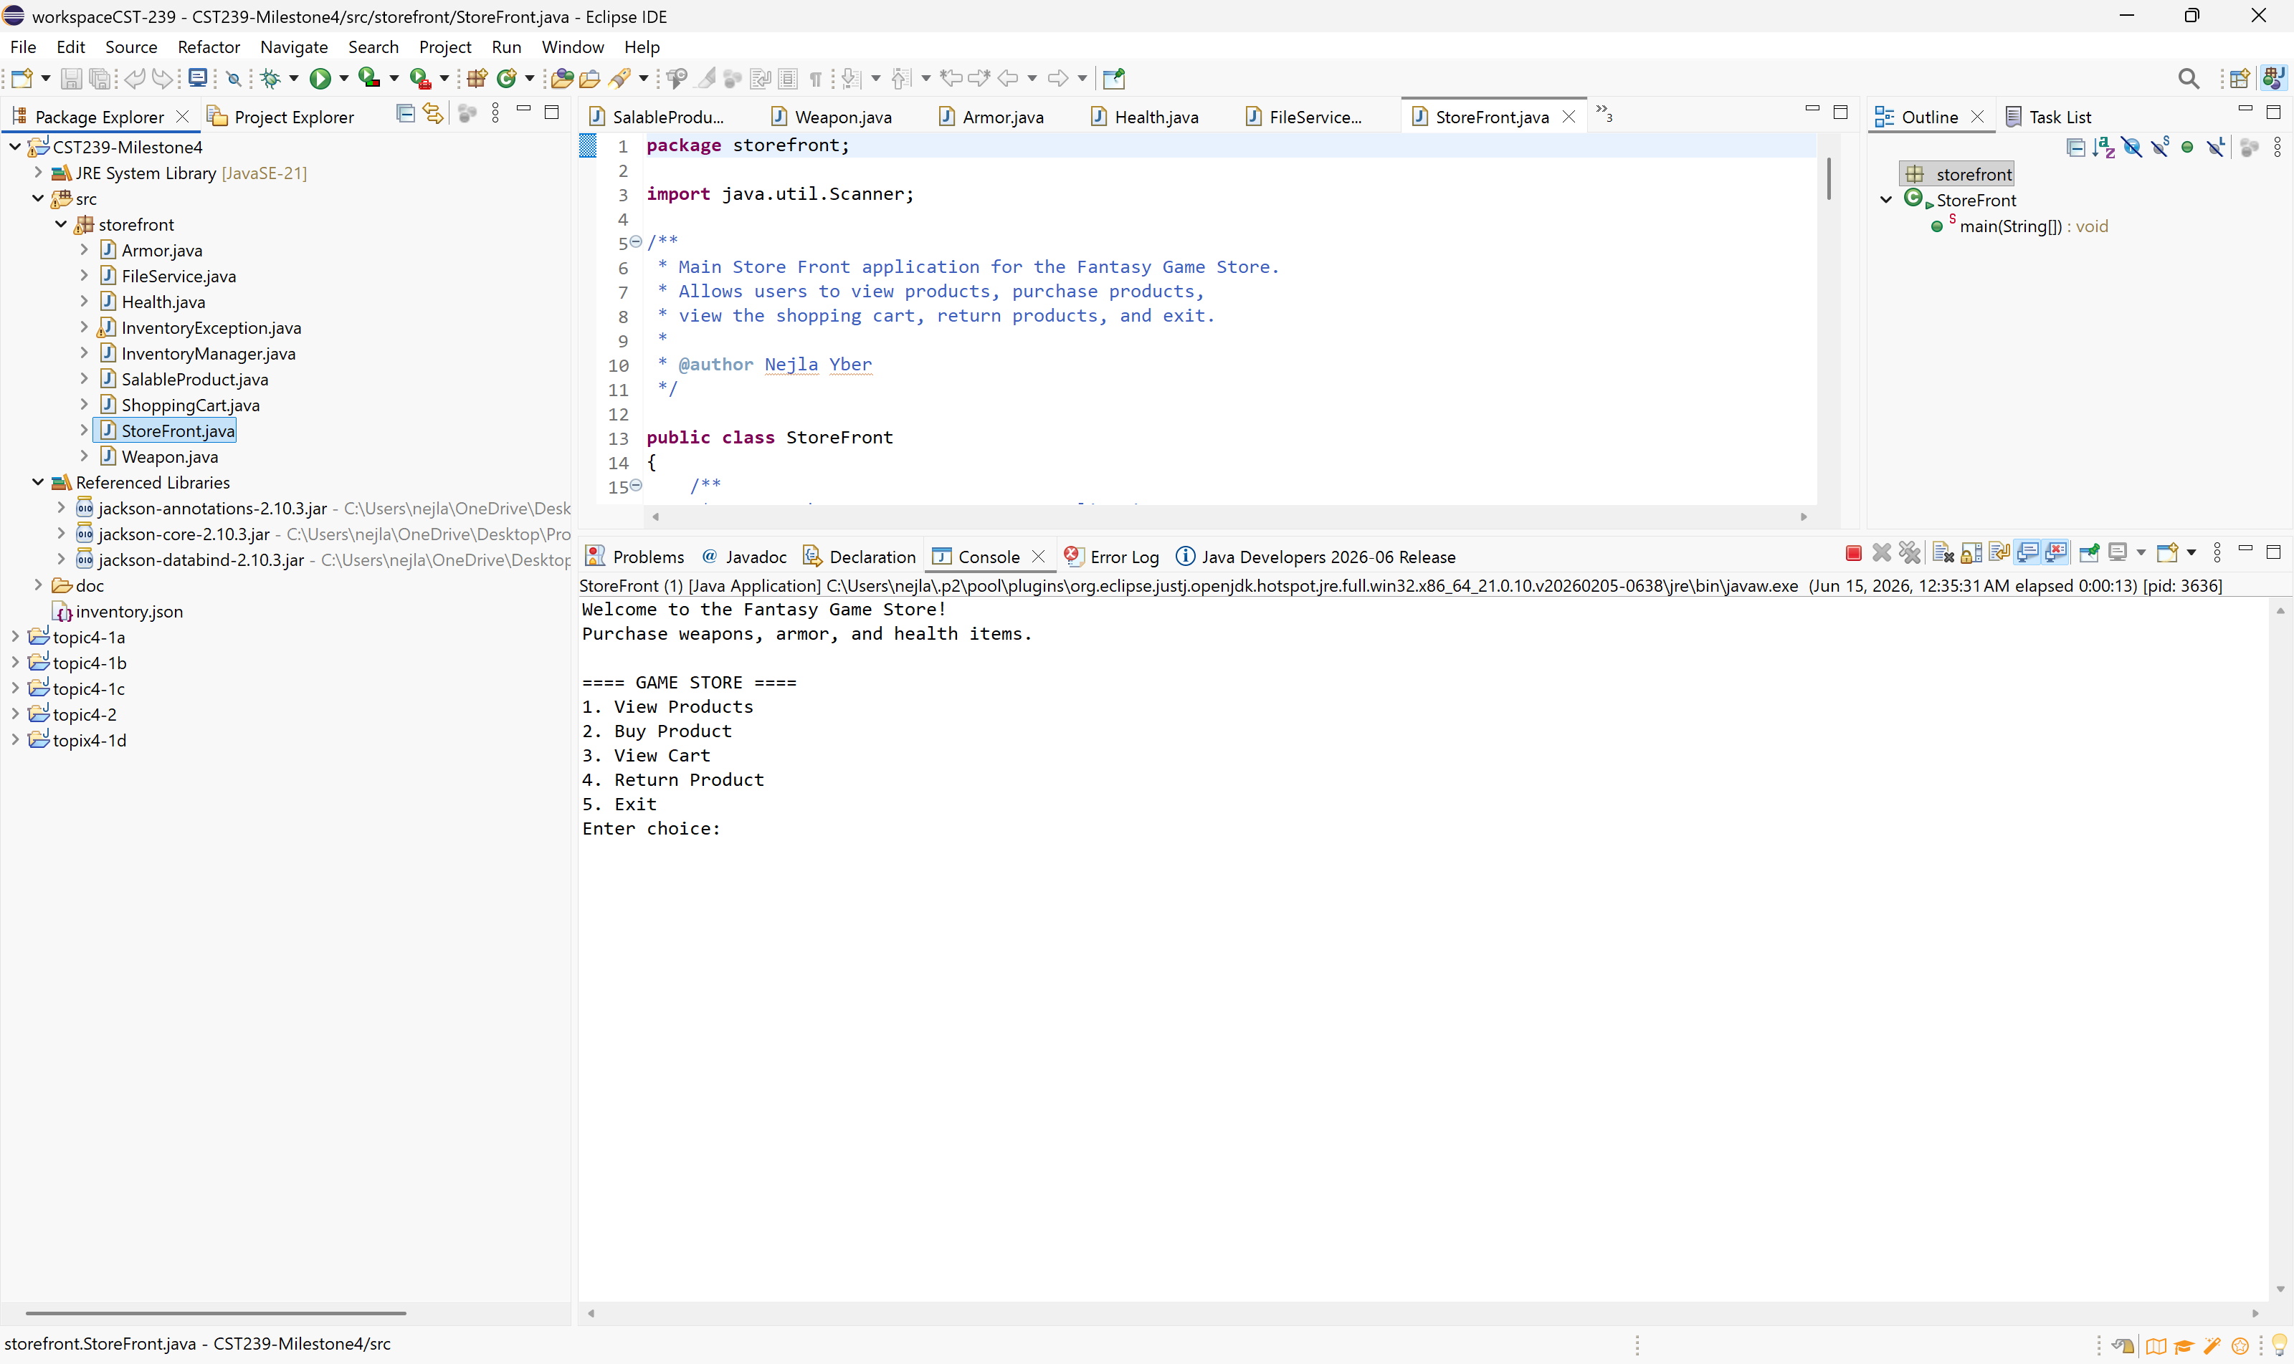
Screenshot2 View Product
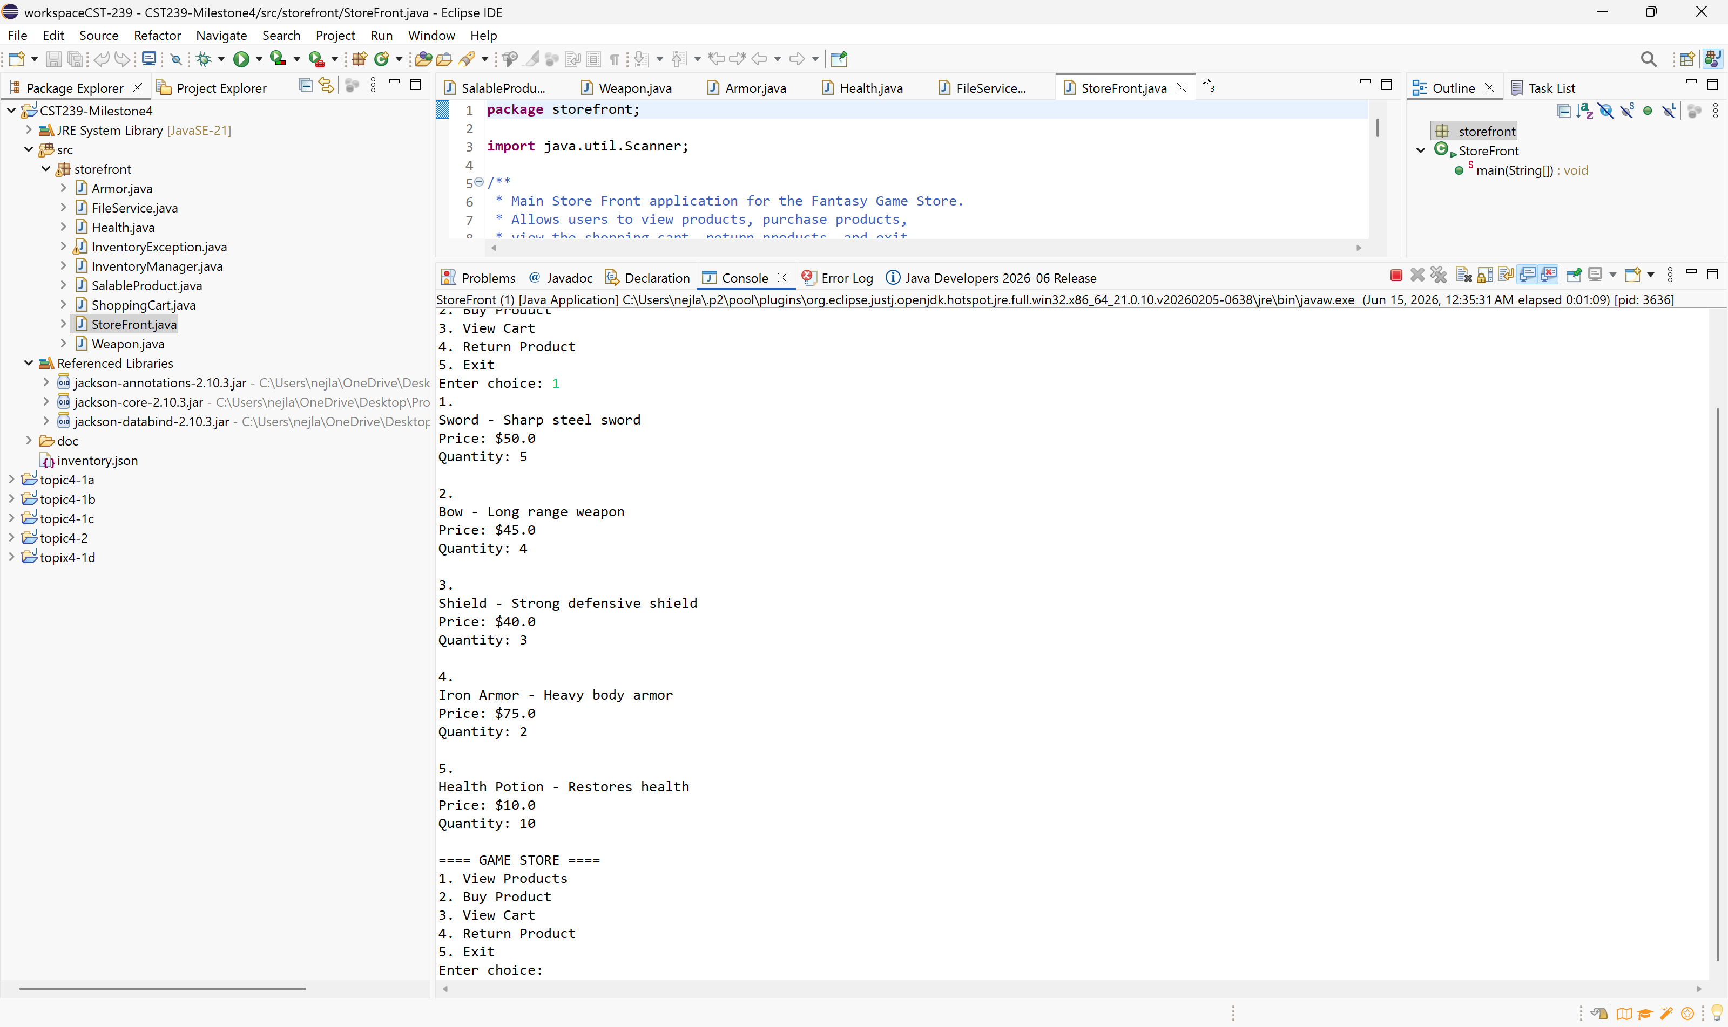

Screenshot3 Buy Product
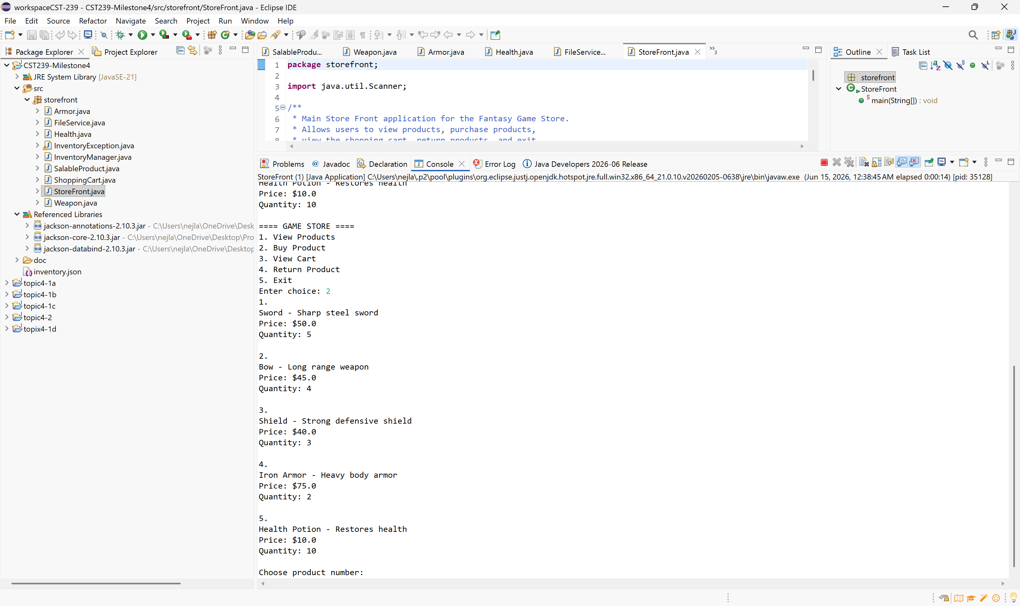
Screenshot4 ViewCart
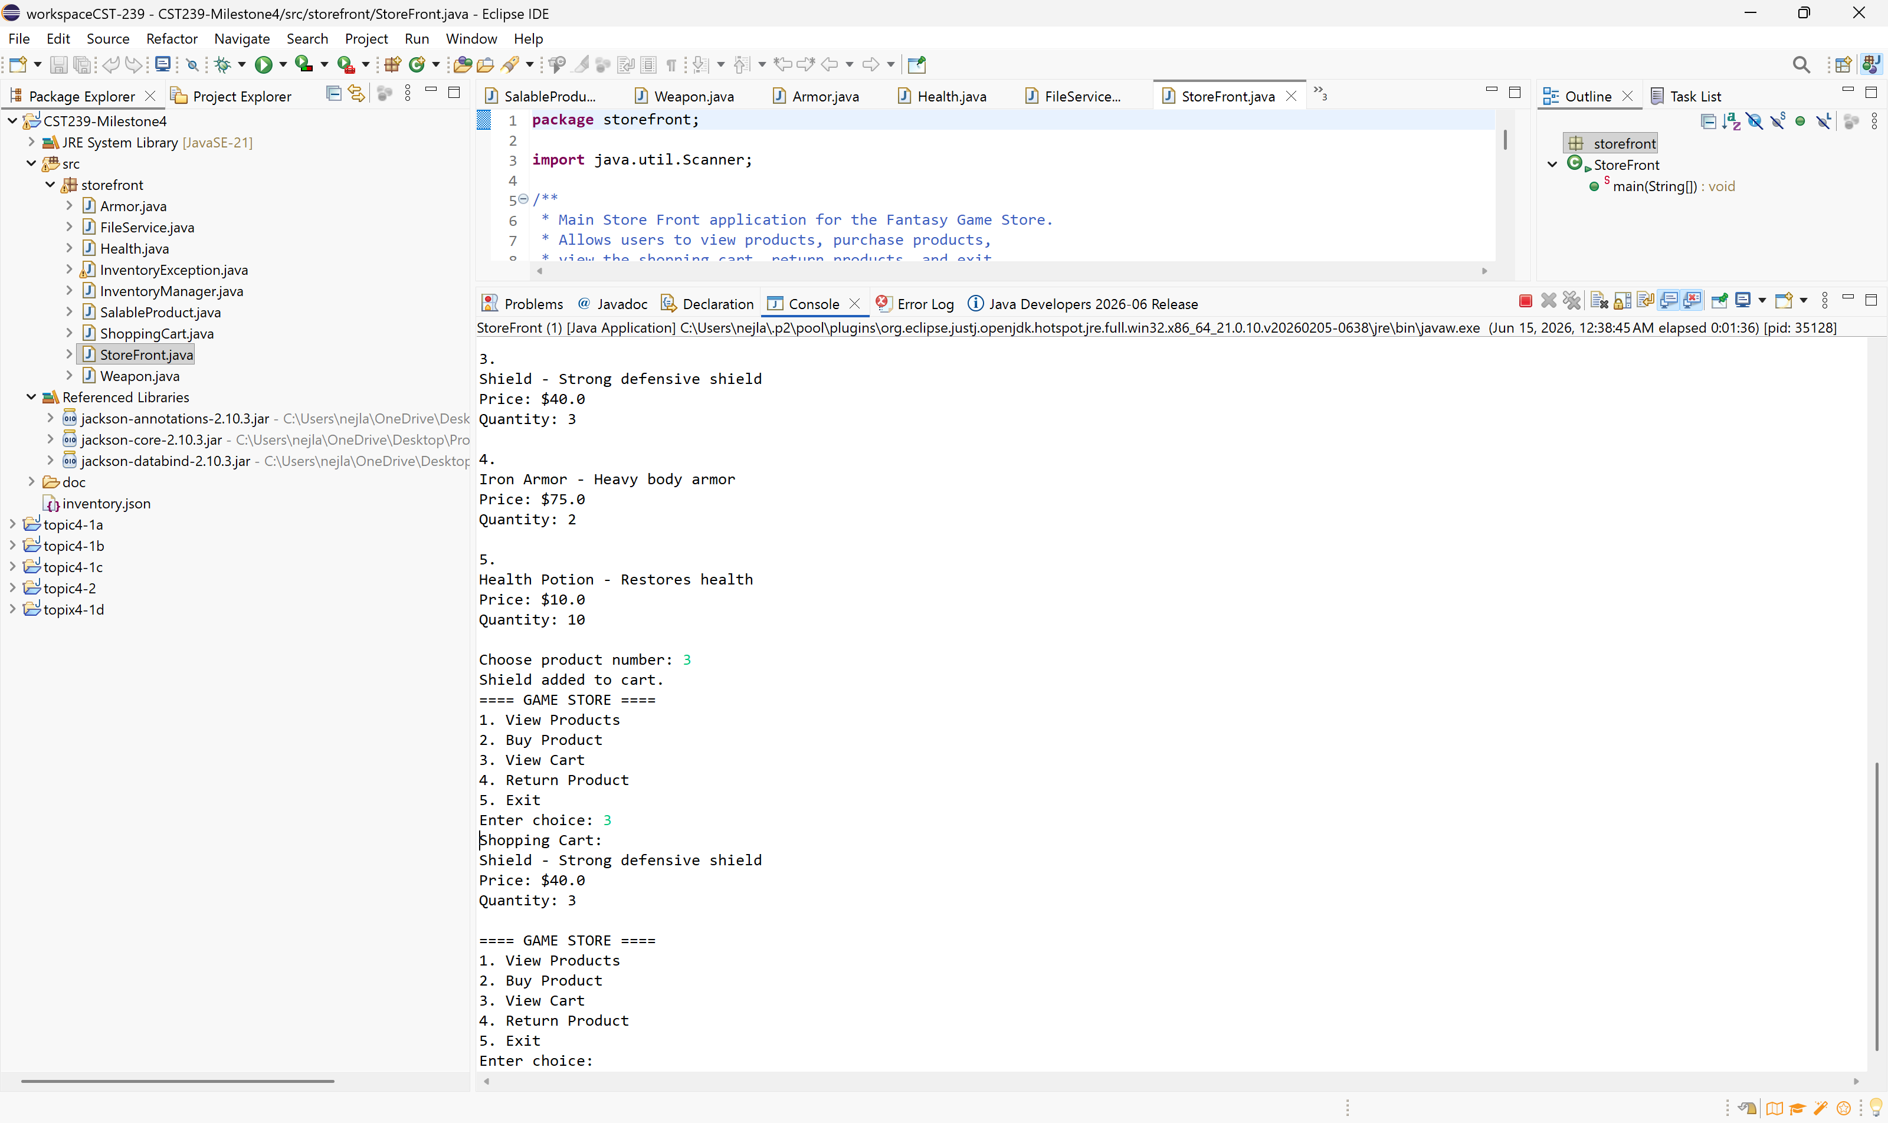

Screenshot5 ReturnProduct
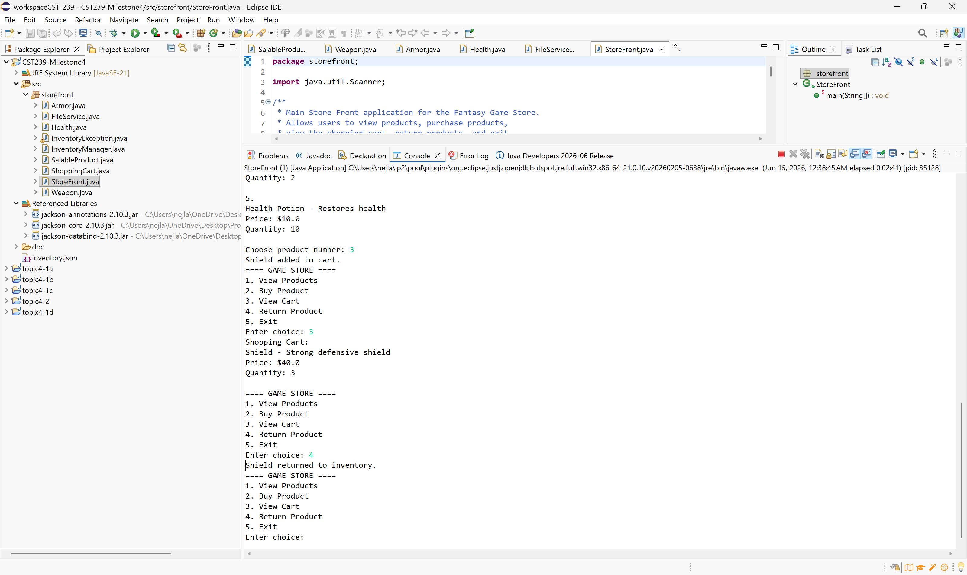
Screenshot6 goodby
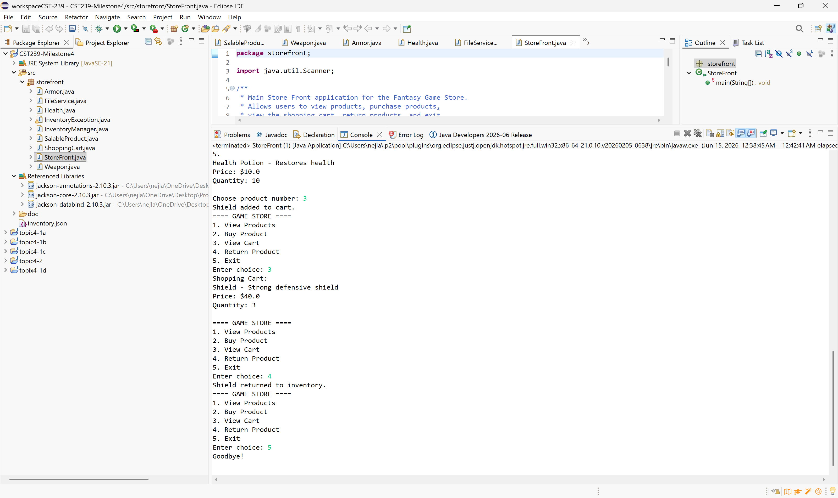

Screenshot storefrontflowchart
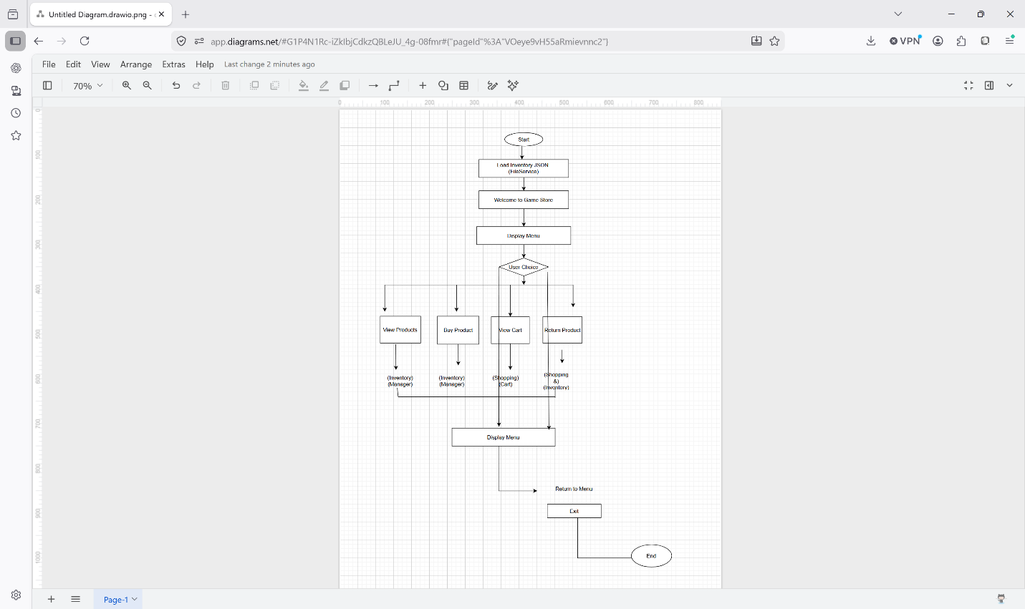
Screenshot storefront UML
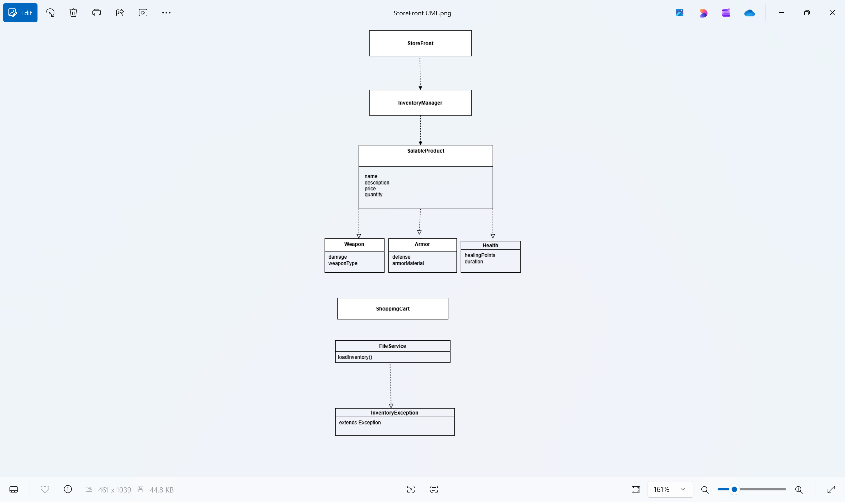

Screenshot 1: video

Screenshot 2: video

Screenshot GitHub

