

**CEN 308 SOFTWARE ENGINEERING**

PROJECT DOCUMENTATION

Movie Streaming Platform

Prepared by:

**Ajdin Polic**

**Nejra Jerlagic**

Proposed to:

**Nermina Durmić, Assist. Prof. Dr.**

**Aldin Kovačević, Teaching Assistant**

Date of submission

24.06.2022.

Table of Contents

1. Introduction 3

1.1. About the Project 3

1.2. Project Functionalities and Screenshots 3

2. Project Structure 6

2.1. Technologies 6

2.3. Architectural Pattern 6

3. Testing 6

4. Conclusion 8

# 1. Introduction

This document represents the basic template of the documentation that you need to submit along with your project. Your documentation *should contain* *all the content* that is mentioned here. However, if you want to add additional sections to the document, rearrange it or redesign it, you are welcome to do so, as long as you keep all of the content that is required here.

There will not be a separate LMS submission for the documentation. Instead, you will add this documentation file to your *project repository on GitHub* once you are done.

As a final note, before submitting your final project version, go over the [project requirements](https://docs.google.com/document/d/1IFsQ4zHoXjq4f_xMKOwe13WdXSAMbZzWY7Rj5tk1nhs/edit?usp=sharing) one more time and make sure that your project was done in accordance with them. You may delete these three paragraphs in your final document.

## 1.1. About the Project

For our project we decided to make a different web application from our initial idea.   
The application we wanted to use was only applicable as a mobile application, that’s why we decided to go in a different route. Our project is based on movie streaming application. With popularity that Netflix and other famous streaming platforms have, we thought that our application can be useful and that is has a lot of potential. We made sure to use knowledge we gained from the current year and previous years to complete this project successfully.

## 1.2. Project Functionalities and Screenshots

1. The user can successfully make an account for our web application.

2. After finishing register process, user can use his login information to login to the website.

3. When user enters the application, he can choose if he wants to register or login to the website.

4. When user completes login, they will enter the application main interface, where they can see basic information about our website. On the right corner, the user can choose if he wants to go back to the home page, chose genre of the movie, chose to contact us or if they want to use a search bar to find a specific movie.

5. When user scrolls down from our home page, they can find socials connected to our website and name.  
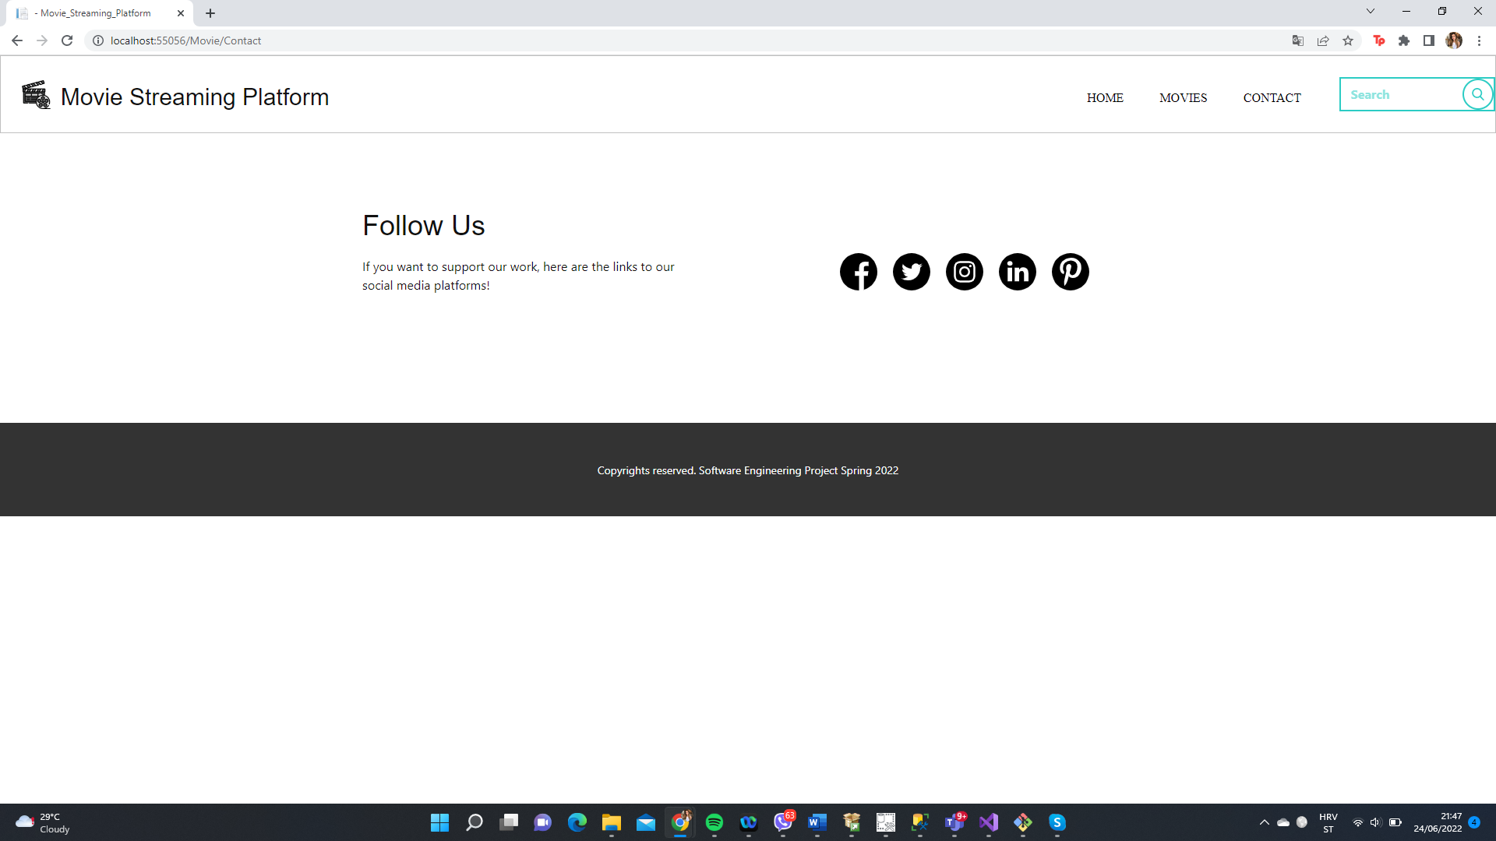

6. When user choses genre of the movie, website will pick top recommendation for them and show those movies. It provides customer with 2 options: to watch the movie on our website or to download it.

# 2. Project Structure

## 2.1. Technologies

Technologies we used for this project are:  
MSSQL  
Dotnet core   
Nicepage autogenerated frontend for frontend

2.2. Database Entities   
Datebase entities for Movies database are: Name, ReleaseDate, Category, UnitPrice, MemoryLocation (movie mp4 file), PhotoMemoryLocation (cover photo of the movie)

## 2.3. Architectural Pattern

For this application, we choose to work with MVC (Model-View-Controller) architecture. In this architecturepattern there are three parts: Model, View and Controller. Model works with data logic. View displays the information from the model to the user while controller: controls the data flow into a model object and updates the view whenever data changes. We thought that this is the best method to work with in our case, especially since this web page needs a strong backend manipulation.

# 3. Testing

Since we wanted to make sure that certain parts of the application are verified, we decided to make tests which will be run before the deadline, to make sure that everything works correctly, while having enough time to fix the issues. The platform we decided to use for testing is QASE.io which lets the user write detailed tests using Gherkin syntax. These are our test run results.

SMOKE:

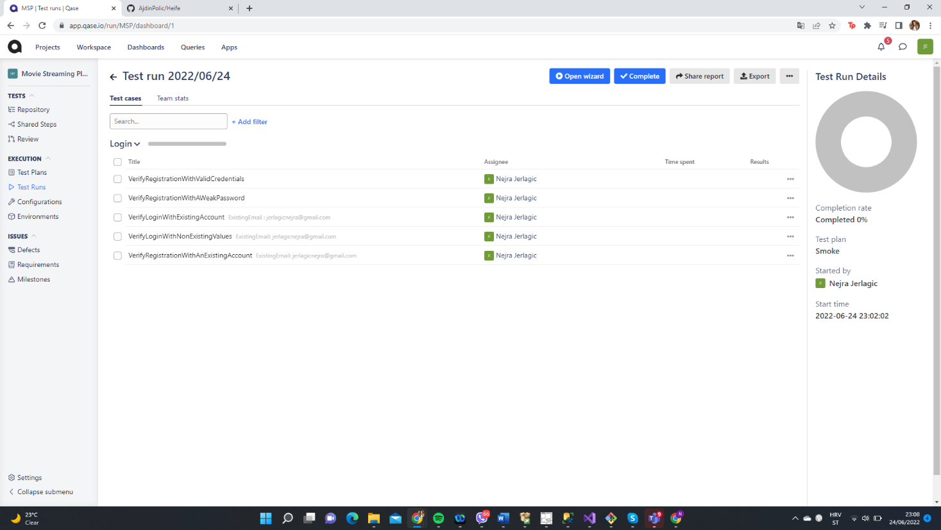

REGRESSION:

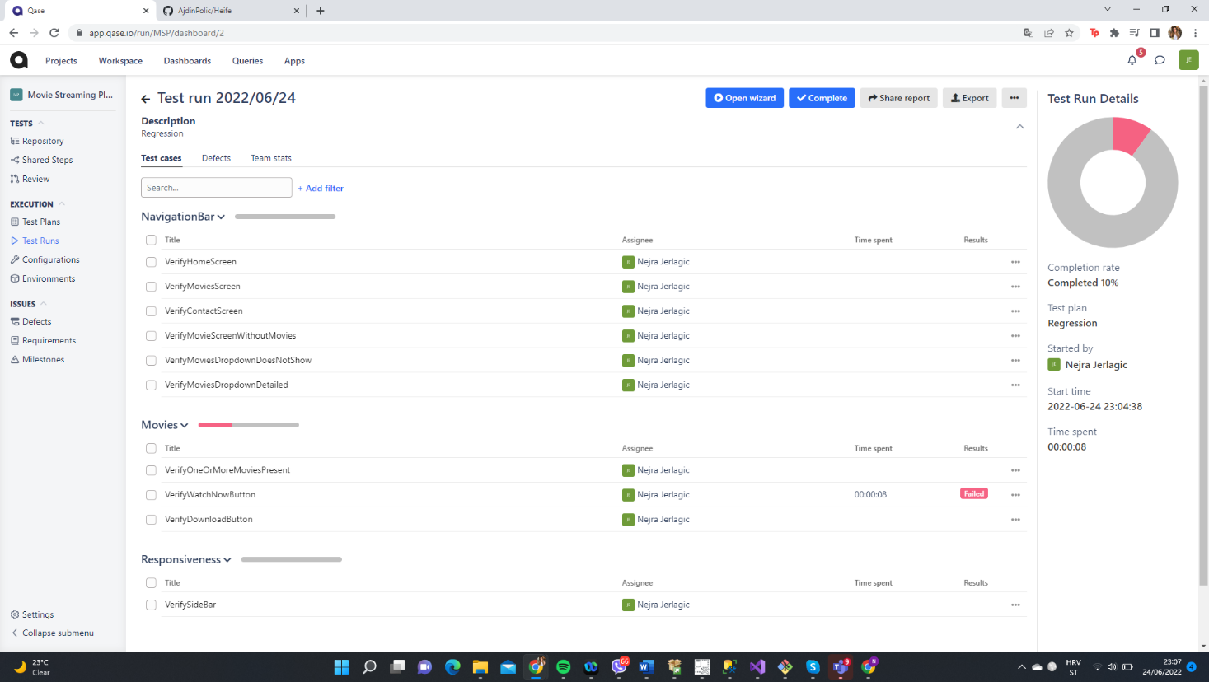

# 4. Conclusion

We are satisfied with functionally of our application and how smooth is the process. We are happy with how our application gives feedback to the user in many cases. Our web application has its place in the current market. The tests went smoothly, and we didn’t have many issues during the project.

Most challenging part was defiantly trying to find best way to use all knowledge we gained so far.

We had wonderful time working together on this project and I hope you’ll enjoy with our product and work we did.