Table of Contents
1. Purpose of the Document 2
2. Sample Project Files 2
3. Initialize new GIT repository 2
3.1. Git init – Initialize GIT Repository 2
3.2. Hidden .git directory – Important metadata about configuration 2
4. GIT Hub cloud Repository 2
4.1. Create New Repository 2
4.2. Git remote add origin - Link local repository to GITHub cloud repository 3
4.3. Git push – Push local repository to GITHub cloud repository 3
4.4. Git clone – pull codes from GITHub cloud repository to local repository 3
5. Basic GIT commands 4
5.1. Git add . – Add current directory to staging area 4
5.2. Git commit – commit files of staging area 4
5.3. Git status – tells current branch name and status of project files 4
5.4. Git add <file> – adds the file to the staging area 4
5.5. Git commit <file> – commits the file from the staging area 5
5.6. Git status --short – status of each path in short format 6
5.7. Git diff – Differential information between local directory and staged 6
5.8. Git diff –staged – Differential information between staged and committed files 6
5.9. Git diff –staged –no-renames – Turn of rename detection 7
5.10. Git commit -a – commits all the files bypassing staging area 7
5.11. Git log – high level overview of previous commits 7
5.12. Git log -1 – Top 1 (Latest) commit history 8
5.13. Git log --oneline – High level overview of history of commit 8
5.14. Git log –stat – detailed overview of previous commits 8
5.15. Git log –patch – Granular level information of previous commits 9
5.16. Git rm <filename> – Remove and delete the file from tracking 9
5.17. Git rm –cached <filename> – Remove file from tracking without deleting 9
5.18. Git mv <oldfilename> <newfilename> – Rename file 10
6. GIT Branches 11
6.1. Git checkout -b <branchname> – Creates the new branch and move pointer 11
6.2. Git stash – Creates the working directory and avoid overwriting 11
6.3. Git merge <branchname>– Merge the branch with master branch 12
6.4. Git reset --mixed <hash>– Resets the commit to specific hash 13

Purpose of the Document
The purpose of document to learn and execute basic GIT commands.

Sample Project Files

C02X11L7HTD7:git nandakumarekanathan$ ls
Controllers Views
GIT.csproj appsettings.Development.json
Models appsettings.json
Program.cs bin
Properties obj
Startup.cs wwwroot
C02X11L7HTD7:git nandakumarekanathan$

Initialize new GIT repository

Git init – Initialize GIT Repository

C02X11L7HTD7:git nandakumarekanathan$ git init
Initialized empty Git repository in /Users/nandakumarekanathan/Documents/nlabs/SCM/GIT/.git/
C02X11L7HTD7:git nandakumarekanathan$
C02X11L7HTD7:git nandakumarekanathan$

Hidden .git directory – Important metadata about configuration

C02X11L7HTD7:.git nandakumarekanathan$ ls
FETCH_HEAD config hooks objects
HEAD description info refs
C02X11L7HTD7:.git nandakumarekanathan$

GIT Hub cloud Repository

Public cloud repository: https://github.com/nekanathan?tab=repositories

Create New Repository
https://github.com/nekanathan/GIT-Learning.git

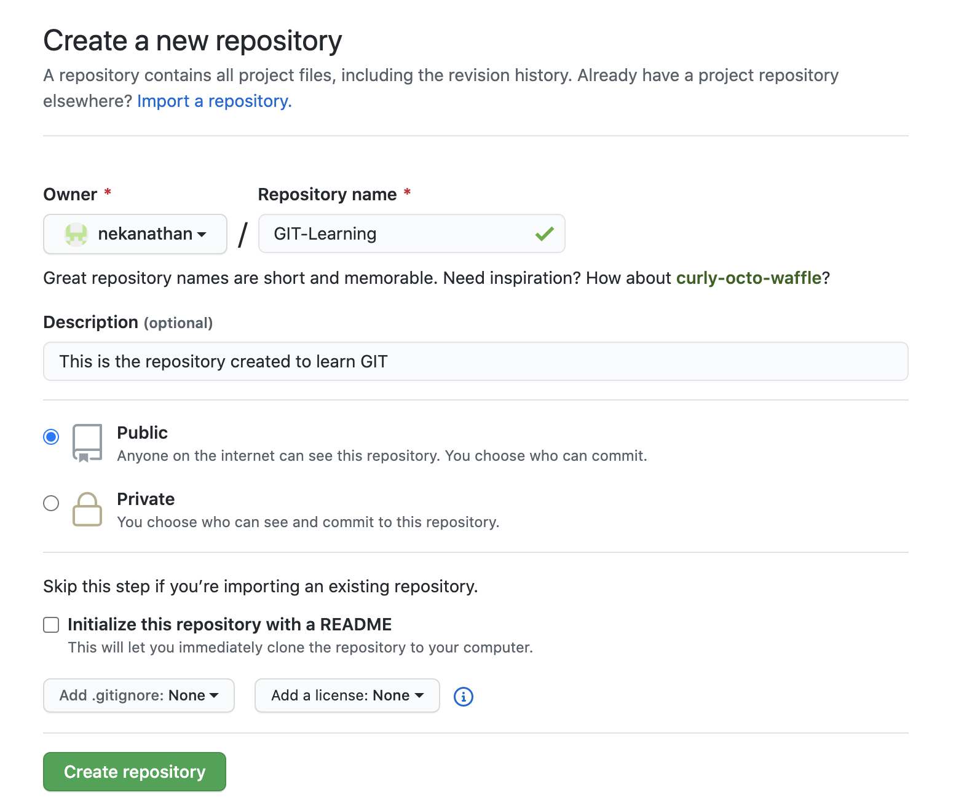

Git remote add origin - Link local repository to GITHub cloud repository

02X11L7HTD7:git nandakumarekanathan$ git remote add origin https://github.com/nekanathan/GIT-Learning.git
C02X11L7HTD7:git nandakumarekanathan$

Git push – Push local repository to GITHub cloud repository

C02X11L7HTD7:git nandakumarekanathan$ git push -u origin master
Username for 'https://github.com': nekanathan
Password for 'https://nekanathan@github.com':
Enumerating objects: 123, done.
Counting objects: 100% (123/123), done.
Delta compression using up to 8 threads
Compressing objects: 100% (104/104), done.
Writing objects: 100% (123/123), 756.56 KiB | 4.30 MiB/s, done.
Total 123 (delta 17), reused 0 (delta 0), pack-reused 0
remote: Resolving deltas: 100% (17/17), done.
To https://github.com/nekanathan/GIT-Learning.git
* [new branch] master -> master
Branch 'master' set up to track remote branch 'master' from 'origin'.
C02X11L7HTD7:git nandakumarekanathan$

Git clone – pull codes from GITHub cloud repository to local repository

C02X11L7HTD7:git nandakumarekanathan$ mkdir clone
C02X11L7HTD7:git nandakumarekanathan$ cd clone
C02X11L7HTD7:clone nandakumarekanathan$ git clone https://github.com/nekanathan/GIT-Learning.git
Cloning into 'GIT-Learning'...
remote: Enumerating objects: 131, done.
remote: Counting objects: 100% (131/131), done.
remote: Compressing objects: 100% (91/91), done.
remote: Total 131 (delta 22), reused 129 (delta 20), pack-reused 0
Receiving objects: 100% (131/131), 757.31 KiB | 1.87 MiB/s, done.
Resolving deltas: 100% (22/22), done.
C02X11L7HTD7:clone nandakumarekanathan$

Basic GIT commands

Git add . – Add current directory to staging area
C02X11L7HTD7:git nandakumarekanathan$ git add .

Git commit – commit files of staging area

C02X11L7HTD7:git nandakumarekanathan$ git commit -m "first commit"
[master (root-commit) c5aaa72] first commit
100 files changed, 64743 insertions(+)
create mode 100644 .vscode/launch.json
create mode 100644 .vscode/tasks.json
create mode 100644 Controllers/HomeController.cs
create mode 100644 GIT.csproj
create mode 100644 Models/ErrorViewModel.cs
create mode 100644 Program.cs
create mode 100644 Properties/launchSettings.json
create mode 100644 README.md
create mode 100644 Startup.cs
create mode 100644 Views/Home/Index.cshtml
create mode 100644 Views/Home/Privacy.cshtml
create mode 100644 Views/Shared/Error.cshtml
create mode 100644 Views/Shared/_Layout.cshtml

Git status – tells current branch name and status of project files

C02X11L7HTD7:git nandakumarekanathan$ git status
On branch master
Your branch is up to date with 'origin/master'.

nothing to commit, working tree clean
C02X11L7HTD7:git nandakumarekanathan$

C02X11L7HTD7:git nandakumarekanathan$ git status
On branch master
Your branch is up to date with 'origin/master'.

Untracked files:
(use "git add <file>..." to include in what will be committed)
Newfile.cs

nothing added to commit but untracked files present (use "git add" to track)

Git add <file> – adds the file to the staging area

C02X11L7HTD7:git nandakumarekanathan$ git add Newfile.cs
C02X11L7HTD7:git nandakumarekanathan$ git status
On branch master
Your branch is up to date with 'origin/master'.

Changes to be committed:
(use "git restore --staged <file>..." to unstage)
new file: Newfile.cs

C02X11L7HTD7:git nandakumarekanathan$

Git commit <file> – commits the file from the staging area

C02X11L7HTD7:git nandakumarekanathan$ git status
On branch master
Your branch is up to date with 'origin/master'.

Changes to be committed:
(use "git restore --staged <file>..." to unstage)
new file: Newfile.cs

Changes not staged for commit:
(use "git add <file>..." to update what will be committed)
(use "git restore <file>..." to discard changes in working directory)
modified: Program.cs

C02X11L7HTD7:git nandakumarekanathan$ git add Program.cs
C02X11L7HTD7:git nandakumarekanathan$ git status
On branch master
Your branch is up to date with 'origin/master'.

Changes to be committed:
(use "git restore --staged <file>..." to unstage)
new file: Newfile.cs
modified: Program.cs

C02X11L7HTD7:git nandakumarekanathan$
C02X11L7HTD7:git nandakumarekanathan$ git status
On branch master
Your branch is up to date with 'origin/master'.

Changes to be committed:
(use "git restore --staged <file>..." to unstage)
new file: Newfile.cs
modified: Program.cs

Changes not staged for commit:
(use "git add <file>..." to update what will be committed)
(use "git restore <file>..." to discard changes in working directory)
modified: Program.cs

C02X11L7HTD7:git nandakumarekanathan$ git add Program.cs
C02X11L7HTD7:git nandakumarekanathan$ git status
On branch master
Your branch is up to date with 'origin/master'.

Changes to be committed:
(use "git restore --staged <file>..." to unstage)
new file: Newfile.cs
modified: Program.cs

C02X11L7HTD7:git nandakumarekanathan$

Git status --short – status of each path in short format

M = modified A = added
C02X11L7HTD7:git nandakumarekanathan$ git status --short
A Newfile.cs
M Program.cs

Git diff – Differential information between local directory and staged

C02X11L7HTD7:git nandakumarekanathan$ git diff
C02X11L7HTD7:git nandakumarekanathan$ git diff
diff --git a/SameFile.cs b/SameFile.cs
index d597bb7..1e6ad40 100644
--- a/SameFile.cs
+++ b/SameFile.cs
@@ -9,7 +9,7 @@ using Microsoft.Extensions.Logging;

namespace GIT
{
- public class Program
+ public class SameFile
{

public static void Main(string[] args)
C02X11L7HTD7:git nandakumarekanathan$

Git diff –staged – Differential information between staged and committed files

C02X11L7HTD7:git nandakumarekanathan$ git diff --staged
diff --git a/Newfile.cs b/Newfile.cs
new file mode 100644
index 0000000..3dffec8
--- /dev/null
+++ b/Newfile.cs
@@ -0,0 +1 @@
+using System;
\ No newline at end of file
diff --git a/Program.cs b/Program.cs
index eb11095..c8268f7 100644
--- a/Program.cs
+++ b/Program.cs
diff --git a/Program.cs b/Program.cs
index eb11095..c8268f7 100644
--- a/Program.cs
+++ b/Program.cs
@@ -11,6 +11,7 @@ namespace GIT
{
public class Program
{
+ ^M
public static void Main(string[] args)
{
CreateHostBuilder(args).Build().Run();
diff --git a/SameFile.cs b/SameFile.cs
new file mode 100644
index 0000000..d597bb7
C02X11L7HTD7:git nandakumarekanathan$

Git diff –staged –no-renames – Turn of rename detection

Git shows similarity index as 100% with renamed file with same contents between Stage and commit. To avoid this we can use this command to avoid notification message about similarity index.

Git commit -a – commits all the files bypassing staging area

C02X11L7HTD7:git nandakumarekanathan$ git commit -a -m "Second commit"
[master 374d3ef] Second commit
3 files changed, 29 insertions(+)
create mode 100644 Newfile.cs
create mode 100644 SameFile.cs
C02X11L7HTD7:git nandakumarekanathan$ git status
On branch master
Your branch is ahead of 'origin/master' by 1 commit.
(use "git push" to publish your local commits)

nothing to commit, working tree clean
C02X11L7HTD7:git nandakumarekanathan$

Git log – high level overview of previous commits

C02X11L7HTD7:git nandakumarekanathan$ git log
commit 374d3ef20f03791ed1cc1ebd0b10a47431255243 (HEAD -> master, origin/master)
Author: nandakumar <nandaeknath@gmail.com>
Date: Sat Jul 25 13:51:42 2020 +0100

Second commit

commit c5aaa723857eeccb51424c051e2e226ccb9f77d0
Author: nandakumar <nandaeknath@gmail.com>
Date: Sat Jul 25 12:51:51 2020 +0100

first commit
C02X11L7HTD7:git nandakumarekanathan$

Git log -1 – Top 1 (Latest) commit history

C02X11L7HTD7:git nandakumarekanathan$ git log -1
commit 374d3ef20f03791ed1cc1ebd0b10a47431255243 (HEAD -> master, origin/master)
Author: nandakumar <nandaeknath@gmail.com>
Date: Sat Jul 25 13:51:42 2020 +0100

Second commit
C02X11L7HTD7:git nandakumarekanathan$

Git log --oneline – High level overview of history of commit

C02X11L7HTD7:git nandakumarekanathan$ git log --oneline
374d3ef (HEAD -> master, origin/master) Second commit
c5aaa72 first commit
C02X11L7HTD7:git nandakumarekanathan$

Git log –stat – detailed overview of previous commits

C02X11L7HTD7:git nandakumarekanathan$ git log --stat
commit 374d3ef20f03791ed1cc1ebd0b10a47431255243 (HEAD -> master, origin/master)
Author: nandakumar <nandaeknath@gmail.com>
Date: Sat Jul 25 13:51:42 2020 +0100

Second commit

Newfile.cs | 1 +
Program.cs | 1 +
SameFile.cs | 27 +++++++++++++++++++++++++++
3 files changed, 29 insertions(+)

commit c5aaa723857eeccb51424c051e2e226ccb9f77d0
Author: nandakumar <nandaeknath@gmail.com>
Date: Sat Jul 25 12:51:51 2020 +0100

first commit

.vscode/launch.json | 36 +
.vscode/tasks.json | 42 +
Controllers/HomeController.cs | 37 +
GIT.csproj | 7 +
Models/ErrorViewModel.cs | 11 +

Git log –patch – Granular level information of previous commits

C02X11L7HTD7:git nandakumarekanathan$ git log --patch
commit 374d3ef20f03791ed1cc1ebd0b10a47431255243 (HEAD -> master, origin/master)
Author: nandakumar <nandaeknath@gmail.com>
Date: Sat Jul 25 13:51:42 2020 +0100

Second commit

diff --git a/Newfile.cs b/Newfile.cs
new file mode 100644
index 0000000..3dffec8
--- /dev/null
+++ b/Newfile.cs
@@ -0,0 +1 @@
+using System;
\ No newline at end of file
diff --git a/Program.cs b/Program.cs
index eb11095..c8268f7 100644
--- a/Program.cs
+++ b/Program.cs

Git rm <filename> – Remove and delete the file from tracking

C02X11L7HTD7:git nandakumarekanathan$ ls
Controllers Startup.cs
GIT.csproj Views
Models appsettings.Development.json
Newfile.cs appsettings.json
Program.cs bin
Properties obj
README.md wwwroot
SameFile.cs
C02X11L7HTD7:git nandakumarekanathan$ git rm SameFile.cs
rm 'SameFile.cs'
C02X11L7HTD7:git nandakumarekanathan$ git status
On branch master
Your branch is up to date with 'origin/master'.

Changes to be committed:
(use "git restore --staged <file>..." to unstage)
deleted: SameFile.cs

C02X11L7HTD7:git nandakumarekanathan$

Git rm –cached <filename> – Remove file from tracking without deleting

C02X11L7HTD7:git nandakumarekanathan$ git rm --cached SameFile2.cs
rm 'SameFile2.cs'
C02X11L7HTD7:git nandakumarekanathan$ git status
On branch master
Your branch is ahead of 'origin/master' by 1 commit.
(use "git push" to publish your local commits)

Changes to be committed:
(use "git restore --staged <file>..." to unstage)
deleted: SameFile2.cs

Untracked files:
(use "git add <file>..." to include in what will be committed)
SameFile2.cs

C02X11L7HTD7:git nandakumarekanathan$ ls
Controllers Startup.cs
GIT.csproj Views
Models appsettings.Development.json
Newfile.cs appsettings.json
Program.cs bin
Properties obj
README.md wwwroot
SameFile2.cs
C02X11L7HTD7:git nandakumarekanathan$

Git mv <oldfilename> <newfilename> – Rename file

C02X11L7HTD7:git nandakumarekanathan$ git mv README.md README
C02X11L7HTD7:git nandakumarekanathan$ ls
Controllers Startup.cs
GIT.csproj Views
Models appsettings.Development.json
Newfile.cs appsettings.json
Program.cs bin
Properties obj
README wwwroot
SameFile2.cs
C02X11L7HTD7:git nandakumarekanathan$
C02X11L7HTD7:git nandakumarekanathan$ git status
On branch master
Your branch is ahead of 'origin/master' by 1 commit.
(use "git push" to publish your local commits)

Changes to be committed:
(use "git restore --staged <file>..." to unstage)
renamed: README.md -> README
deleted: SameFile2.cs

Untracked files:
(use "git add <file>..." to include in what will be committed)
SameFile2.cs

C02X11L7HTD7:git nandakumarekanathan$

GIT Branches

Git checkout -b <branchname> – Creates the new branch and move pointer

02X11L7HTD7:git nandakumarekanathan$ git checkout -b new_branch
Switched to a new branch 'new_branch'
C02X11L7HTD7:git nandakumarekanathan$ git status
On branch new_branch
Changes to be committed:
(use "git restore --staged <file>..." to unstage)
renamed: README.md -> README
deleted: SameFile2.cs

Untracked files:
(use "git add <file>..." to include in what will be committed)
SameFile2.cs

C02X11L7HTD7:git nandakumarekanathan$ git commit -m "new branch commit"
[new_branch 975bf46] new branch commit
2 files changed, 1 deletion(-)
rename README.md => README (100%)
delete mode 100644 SameFile2.cs
C02X11L7HTD7:git nandakumarekanathan$

Git stash – Creates the working directory and avoid overwriting

nothing added to commit but untracked files present (use "git add" to track)
C02X11L7HTD7:git nandakumarekanathan$ git checkout master
error: The following untracked working tree files would be overwritten by checkout:
SameFile2.cs
Please move or remove them before you switch branches.
Aborting
C02X11L7HTD7:git nandakumarekanathan$ git add .
C02X11L7HTD7:git nandakumarekanathan$ git stash
Saved working directory and index state WIP on new_branch: 975bf46 new branch commit
C02X11L7HTD7:git nandakumarekanathan$ git status
On branch new_branch
nothing to commit, working tree clean
C02X11L7HTD7:git nandakumarekanathan$ git stash list
stash@{0}: WIP on new_branch: 975bf46 new branch commit
C02X11L7HTD7:git nandakumarekanathan$ git stash show
SameFile2.cs | 1 +
1 file changed, 1 insertion(+)
C02X11L7HTD7:git nandakumarekanathan$
C02X11L7HTD7:git nandakumarekanathan$ git checkout master
Switched to branch 'master'
Your branch is ahead of 'origin/master' by 1 commit.
(use "git push" to publish your local commits)
C02X11L7HTD7:git nandakumarekanathan$ ls
Controllers Startup.cs
GIT.csproj Views
Models appsettings.Development.json
Newfile.cs appsettings.json
Program.cs bin
Properties obj
README.md wwwroot
SameFile2.cs
C02X11L7HTD7:git nandakumarekanathan$
C02X11L7HTD7:git nandakumarekanathan$ git add .
C02X11L7HTD7:git nandakumarekanathan$ git status
On branch master
Your branch is ahead of 'origin/master' by 1 commit.
(use "git push" to publish your local commits)

Changes to be committed:
(use "git restore --staged <file>..." to unstage)
modified: SameFile2.cs
new file: SameFile3.cs

C02X11L7HTD7:git nandakumarekanathan$ git commit -m "4th commit"
[master c801627] 4th commit
2 files changed, 3 insertions(+), 1 deletion(-)
create mode 100644 SameFile3.cs
C02X11L7HTD7:git nandakumarekanathan$ git status
On branch master
Your branch is ahead of 'origin/master' by 2 commits.
(use "git push" to publish your local commits)

Git merge <branchname>– Merge the branch with master branch

02X11L7HTD7:git nandakumarekanathan$ git merge new_branch
Already up to date.
C02X11L7HTD7:git nandakumarekanathan$ git checkout master
Already on 'master'
Your branch is ahead of 'origin/master' by 4 commits.
(use "git push" to publish your local commits)
C02X11L7HTD7:git nandakumarekanathan$ git checkout new_branch
Switched to branch 'new_branch'
C02X11L7HTD7:git nandakumarekanathan$ git status
On branch new_branch
Changes not staged for commit:
(use "git add <file>..." to update what will be committed)
(use "git restore <file>..." to discard changes in working directory)
modified: Program.cs

no changes added to commit (use "git add" and/or "git commit -a")
C02X11L7HTD7:git nandakumarekanathan$ git commit -a -m "changed program.cs"
[new_branch 49cb15f] changed program.cs
1 file changed, 1 insertion(+)
C02X11L7HTD7:git nandakumarekanathan$ git merge new_branch
Already up to date.
C02X11L7HTD7:git nandakumarekanathan$ git checkout master
Switched to branch 'master'
Your branch is ahead of 'origin/master' by 4 commits.
(use "git push" to publish your local commits)
C02X11L7HTD7:git nandakumarekanathan$ git merge new_branch
Merge made by the 'recursive' strategy.
Program.cs | 1 +
1 file changed, 1 insertion(+)
C02X11L7HTD7:git nandakumarekanathan$ git status
On branch master
Your branch is ahead of 'origin/master' by 6 commits.
(use "git push" to publish your local commits)

nothing to commit, working tree clean
C02X11L7HTD7:git nandakumarekanathan$ ls
Controllers Startup.cs
GIT.csproj Views
Models appsettings.Development.json
Newfile.cs appsettings.json
Program.cs bin
Properties obj
README wwwroot
SameFile3.cs
C02X11L7HTD7:git nandakumarekanathan$

Git reset --mixed <hash>– Resets the commit to specific hash

C02X11L7HTD7:git nandakumarekanathan$ git log --oneline
0bd57db (HEAD -> master) Merge branch 'new_branch'
49cb15f (new_branch) changed program.cs
189bf66 7 commit
c801627 4th commit
975bf46 new branch commit
f78b7f7 Third commit
374d3ef (origin/master) Second commit
c5aaa72 first commit
C02X11L7HTD7:git nandakumarekanathan$ git reset --mixed 374d3ef
Unstaged changes after reset:
M Program.cs
D README.md
D SameFile.cs
C02X11L7HTD7:git nandakumarekanathan$ git status
On branch master
Your branch is up to date with 'origin/master'.

Changes not staged for commit:
(use "git add/rm <file>..." to update what will be committed)
(use "git restore <file>..." to discard changes in working directory)
modified: Program.cs
deleted: README.md
deleted: SameFile.cs

Untracked files:
(use "git add <file>..." to include in what will be committed)
README
SameFile3.cs

no changes added to commit (use "git add" and/or "git commit -a")
C02X11L7HTD7:git nandakumarekanathan$ git add .
C02X11L7HTD7:git nandakumarekanathan$ git status
On branch master
Your branch is up to date with 'origin/master'.

Changes to be committed:
(use "git restore --staged <file>..." to unstage)
modified: Program.cs
renamed: README.md -> README
deleted: SameFile.cs
new file: SameFile3.cs

C02X11L7HTD7:git nandakumarekanathan$ git commit -m "last commit"
[master 0452573] last commit
4 files changed, 2 insertions(+), 27 deletions(-)
rename README.md => README (100%)
delete mode 100644 SameFile.cs
create mode 100644 SameFile3.cs
C02X11L7HTD7:git nandakumarekanathan$ git status
On branch master
Your branch is ahead of 'origin/master' by 1 commit.
(use "git push" to publish your local commits)

nothing to commit, working tree clean
C02X11L7HTD7:git nandakumarekanathan$

