**Chat Away**

Project Statement

Matthew Hutchinson – Project Manager

Chris MacEachern – Analyst/Developer

Nimna Ekanayaka – Analyst/Developer

CIS-2261

January 18th, 2016

# Approval

**Client:**

Gerald Caissy, Instructor, Holland College

**System Name:**

Chat Away

**Prepared by:**

Matthew Hutchinson – Project Manager/Developer

Chris MacEachern – Analyst/Developer

Nimna Ekanayaka – Analyst/Developer

By signing this document, the party is stating they have reviewed and approve of the current proposal.  It is understood that any changes requested after the Project Statement has been signed must adhere to the change request standards.  The party understands that the contents of this document are confidential.

**Client:**

___________________________ ______________________

        Signature                                                   Date

**Project Manager:**

___________________________    ______________________

Signature                                                         Date

# Table of Contents

Approval 2

Table of Contents 3

Project Summary 4

Project Objective 5

Project Deliverables 6

Assumptions & Constraints 7

Project Plan 8

Project Organization Chart 9

Change Management 10

Decision Making 11

Project Status Reporting 12

Appendix A ~ Change Request/Notification Form 13

Appendix B ~ Team Contract 14

# Project Summary

**Client:**

Gerald Caissy, Instructor, Holland College

**System Name:**

Chat Away

**Project Manager:**

Matthew Hutchinson

**Start Date:**

January 11th, 2016

**End Date:**

February 19th, 2016

**Total Budget:**

$12,400.00

**Resources:**

Microsoft Office, Project, Visio.

Android Studio.

BitBucket + Source Tree.

PHPMyAdmin

XAMPP

# Project Objective

The overall objective of this project will be developing a system that will allow users to interact and socialize in a new and unique way. The project will involve the development of a mobile application called Chat Away. Chat Away will allow for users to create an account and then engage in a random chat with another user within the area. The user would also have the option of participating in group chats and sending private messages. In addition to the mobile application some additional administration features will be added that will allow for admins to generate reports, and monitor and block any chat activity. Over the course of this project implementing all of the above features will be the complete goal.

# Project Deliverables

**Analysis Deliverables:**

* Group Meetings: Meet with group members and brainstorm new ideas.
* Group Interviews: After meetings, conduct a series of interviews select absolute requirements.
* Analyze Software Resources: Review Software requirements such as Java, MySQL and PHP and install and maintain them.
* Illustrate System Design: Create UML diagrams for system activities.
* Review Company Records: Verify data consistency.

**Design and Development deliverables:**

* Database design: Create tables based on entity relationship diagrams and normalize them.
* Interface design: Design output and user interfaces.
* Application architecture: Ensure application is scalable, reliable, available, and manageable.
* Network topology: Determine if a physical or wireless network should be used.
* Implement System: Perform a data and system change over.

**Non-Deliverables:**

* System maintenance:
* System security:
* Hardware supply:

# Assumptions & Constraints

**Assumptions:**

-User will have mobile device that meets minimum system requirements

-A server that is able to handle the maximum level of traffic will be used

-Proper administration of the app will allow for a safe environment for users to socialize

-App will be developed exclusively for Android

**Constraints:**

-Some areas will have smaller number of users then others

-Less customization will be allowed for non paying users

-Resources are limited since the development team only consists of 3 people

-Less can be shown on interface since app is being developed for mobile

# Project Plan

The project plan for this application can be found in attached under the file name: ChatAwayProjectPlan.

This file will be updated regularly and tasks will be updated as needed.





# 

# Budget

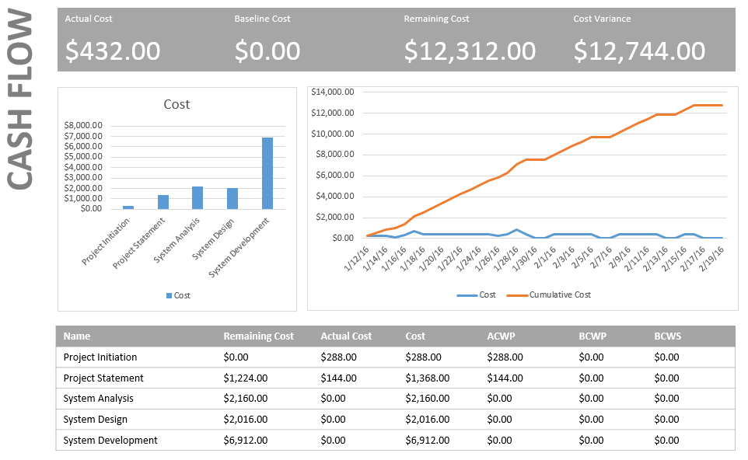

# Project Organization Chart

# Change Management

Change Management Process (CMP) is the process of introducing and approving changes to a project. Chat Away uses the CMP methodology to properly announce, log, document and distribute the changes made so that any updates can be implemented without a hassle.

In order to maintain a well-functioning system change management has a set of processes as follows.

1. Accept feedback from the client.
2. Review client feedback.
3. Accept changes if they are adequate.
4. Test the build with changes.
5. Review impact after the test run.
6. Based on impact result approve or reject the change.
7. If approved changes will be added through an update.

# Decision Making

Throughout the course of this project there will be times when a decision will need to be made in order to keep the project on track. In order to ensure that any decision will effectively benefit the project, a series of steps has been established. These steps should be followed when any decision needs to be made and will help guide the decision making process. The steps are as follows:

1. **Identify the problem** – This will be the initial step. A complete and thorough understanding of the problem will help in finding a proper solution.
2. **Determine Alternatives** – The project team should brainstorm all possible solutions to the problem that has been identified.
3. **Evaluate the alternatives** – All possible solutions should be evaluated. Some pros and cons should be determined for each solution.
4. **Choose the best alternative** – Based on evaluation of each alternative the team must choose the best solution.
5. **Implement the solution** - The work that is required for the chosen solution will be divided and assigned to the appropriate team member.
6. **Evaluate decision** - After the implementation of the solution an evaluation should be performed to determine if the solution solved the initial problem.

If the evaluation determines that the problem has not been solved then a different alternative that was determined in step 3 must be selected. The process will start again from step 4. The process of identifying the problem and determining any alternatives should not take any longer than 24 hours. The time it takes to implement a solution will vary and an estimate should be determined during step 2. This time will be an important factor in choosing the alternative solution that will be implemented.

# Project Status Reporting

Progress reports are used to communicate the progress of Chat Away system development. Progress reports will be issued every Monday to the staff for review and approval. Each progress report will contain the following.

1. Overview of the progress: All deliverables produced up to the date.
2. Overview of the budget: Attach the overview of the budget which includes the budget allocated, spent to date and amount remaining.
3. Outstanding issues and recommended actions: All issues and the recommended action for each.
4. Change request: Contains each change request issued to date.
5. Plans for next period: Tasks, activities and deliverables completed over the next period.

# Standards and Conventions

For this project we will follow the following standards and naming conventions:

* Camel Casing conventions will be followed
* File names will follow the following format ChatAway_[FileName]
* All files will have a header containing the following information
  + File Name
  + File Purpose
  + Date Created
  + Date Updated
  + Last User to Update
  + List of Dependence

# Appendix A ~ Change Request/Notification Form

|  |  |  |  |
| --- | --- | --- | --- |
| **Project Title:** | | **Change Request Number:** | |
| **Name:** | | **Date:** | |
| **Description of change:**  A brief description of the change that is being requested should be provided here. | | | |
| **Impact on time:**  The impact that the change will have on the project schedule (if any) should be provided here. | | | |
| **Impact on cost:**  The impact that the change will have on the project's budget should be provided here. | | | |
| **Resolution:**  Here you can state a recommendation or resolution of the change request that is being proposed. | | | |
| **Change Approval** | | | |
| **Name** | **Signature** | | **Date** |
|  |  | |  |
|  |  | |  |

# Appendix B ~ Team Contract

**Participation**

Each member of the group will actively participate and everyone is entitled to share their ideas.  All work to be completed will be distributed evenly amongst members to avoid overloading any single person.  Deadlines are expected to be met by everyone.

**Communication**

All members of the group are expected to attend all meetings.  If anyone is unable to attend, they are expected to notify other members of their absence.  Electronic correspondence must be answered in a timely manner to ensure communication is effective.  It is important to ask other group member for help if needed.  If a member is unable to meet a deadline, the project manager must be notified.

**Problem-Solving**

If a disagreement should arise, it is expected to be handled with respect from each other.  Everyone should be able to express their opinion openly.  If there is a disagreement between two people that cannot be decided simply, consult the rest of the group.  If the entire group is in disagreement on a matter, the project manager is to be consulted.

**Meeting Guidelines**

Each member of the group is expected to be present at all meetings, be punctual, and participate actively in meetings.  Prior to meetings, any preparation for the meeting to be productive should be completed.  Everyone in the group is responsible to keep each other on task.