12/05/2023

I created the domain entities. They represents the business model.
From there .NET propose some tools to generate and manage the creation of the Database and related tables.

Libraries installed on API layer
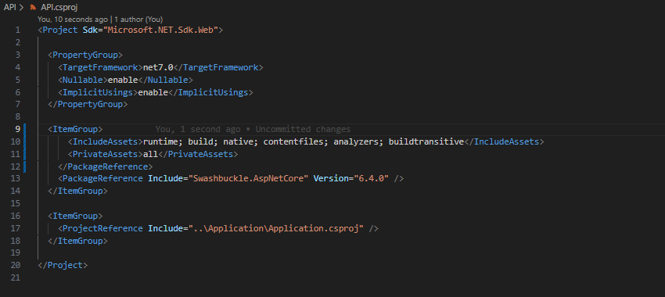
Libraries installed on the « Application » layer just after creation

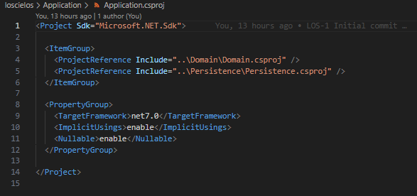
I use Nugget package manager, a tool provided by Microsoft on VS Code and Vstudio to install libraries (shortcut on VS Code iss Ctrl-Shift-P)

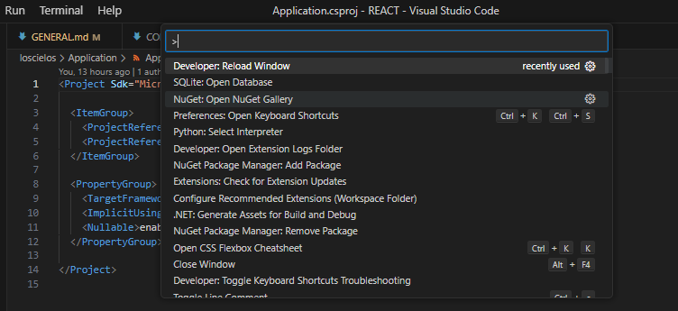

By searching « Microsoft entity Framework core we got a list of libraries

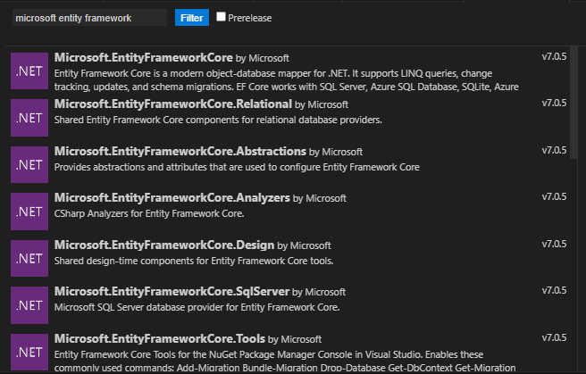

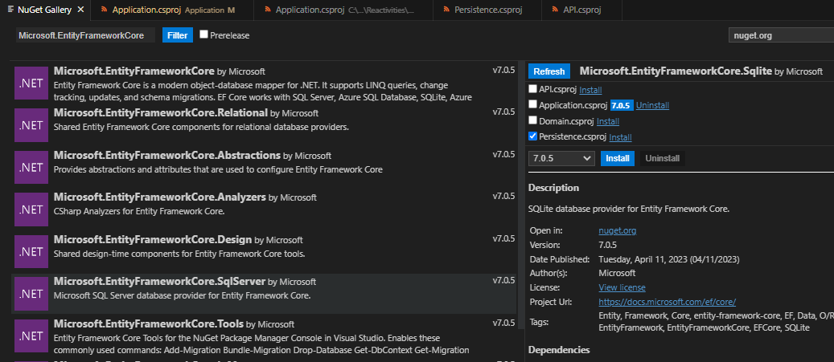

I select Microsoft.EntityFrameworkCore and Microsoft.EntityFrameworkCore.Design that i install in API layer and Microsoft.EntityFrameworkCore.Sqlite in Persistence layer

Now the libraries installed are as follow on API layer :

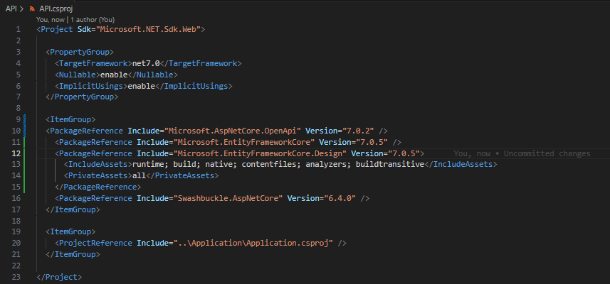

on Persistence layer :

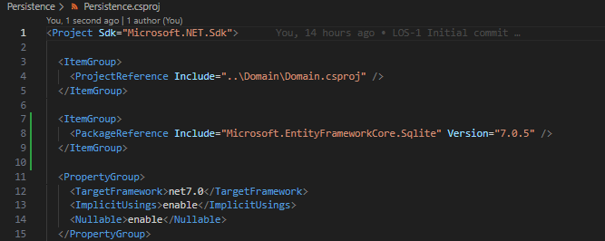
As you can see above, the Nullable tag is enabled, which means that compiler will raise warning for any reference of variables that may be null. As a very useful feature icluded since .NET 6, it is prone to various errors when using Entity Framework.
So i decided to disable it for all the layers. I will ensure myself to avoid the NullReferenceException.

CREATE DATABASE ACCESS CLASSES

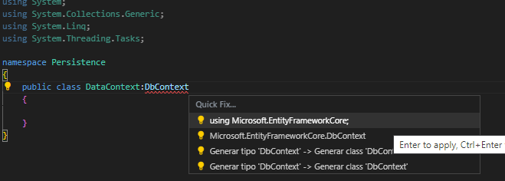
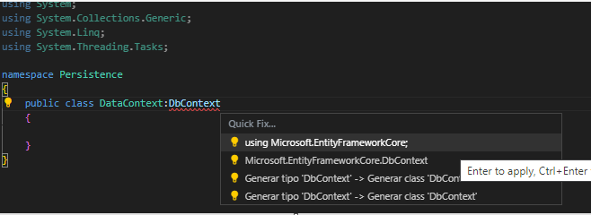
The class DataContext derived from the DbContext given by EntityFramework.
This is a layer of abstraction that will allow us to create and query the database without necesarily writing SQL queries. It use a system called ORM for Object relationship mapper that will converts our code into necessaries queries executed against the database.
This is abstraction is a big help for redondant SQL queries, centralizing the management of the database by wirting our queries in C# code and making sure it will be properly translated to any SQL langages. Without the needs to be either SQL expert or PostSQL expert or MSSQL expert we can generate high level of code.
An other benefit of this is to be able to use different database management system with low changes in the code.
By example for this particular project i used SQLite for the developement and then move to a MYSQL database for production. In the future it will be more manageable to switch to a stronger SQL server.

