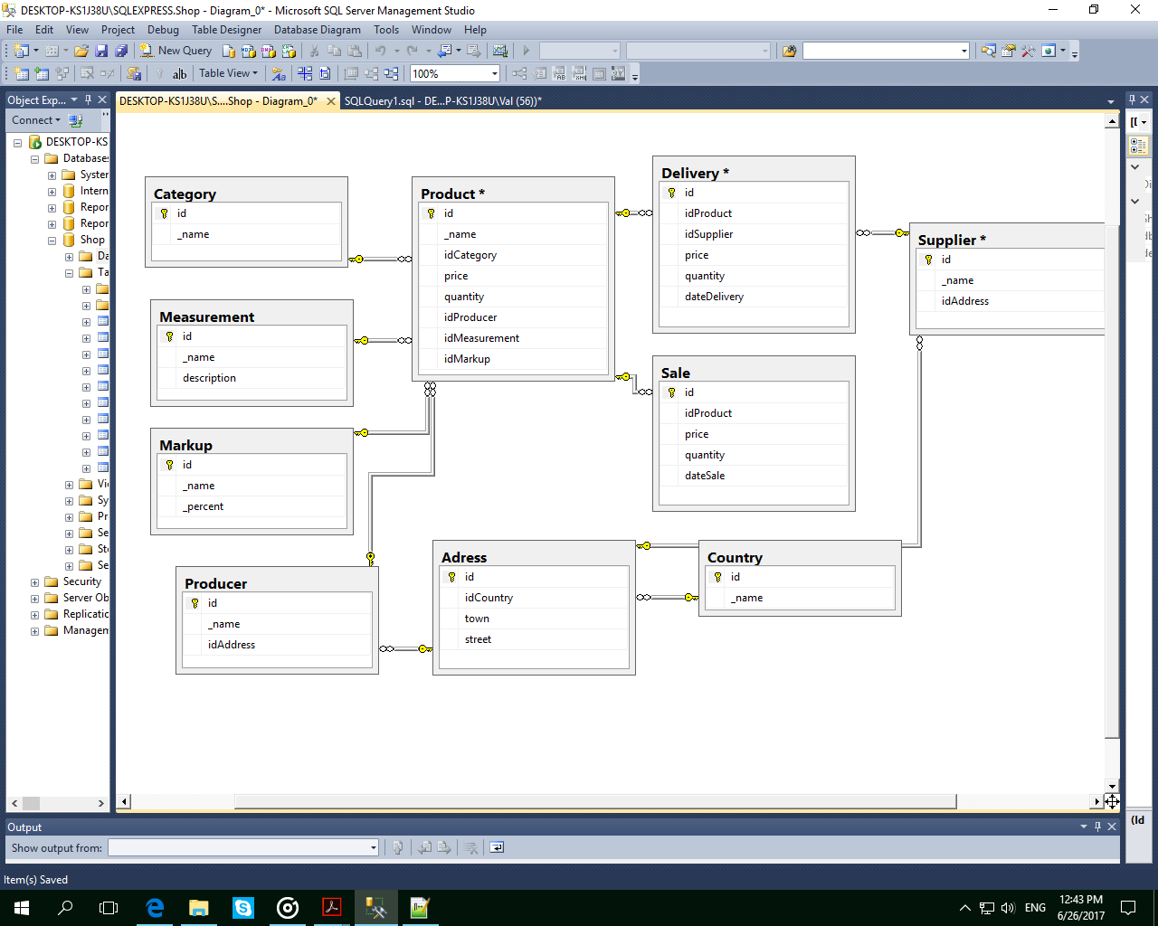

use Shop

CREATE TABLE Product

(

id int identity(1,1) primary key,

_name varchar(50) NOT NULL,

idCategory int NOT NULL,

price float NOT NULL,

quantity int NOT NULL,

idProducer int NOT NULL,

idMeasurement int NOT NULL,

idMarkup int NOT NULL

)

CREATE TABLE Adress

(

id int identity(1,1) primary key,

idCountry int NOT NULL,

town varchar(50) NOT NULL,

street varchar(50) NOT NULL

)

CREATE TABLE Country

(

id int identity(1,1) primary key,

_name varchar(50) NOT NULL

)

CREATE TABLE Sale

(

id int identity(1,1) primary key,

idProduct int NOT NULL,

price float NOT NULL,

quantity int NOT NULL,

dateSale date NOT NULL

)

CREATE TABLE Delivery

(

id int identity(1,1) primary key,

idProduct int NOT NULL,

idSupplier int NOT NULL,

price float NOT NULL,

quantity int NOT NULL,

dateDelivery date NOT NULL

)

CREATE TABLE Supplier

(

id int identity(1,1) primary key,

_name varchar(50) NOT NULL,

idAddress int NOT NULL,

)

CREATE TABLE Producer

(

id int identity(1,1) primary key,

_name varchar(50) NOT NULL,

idAddress int NOT NULL,

)

CREATE TABLE Markup

(

id int identity(1,1) primary key,

_name varchar(50) NOT NULL,

_percent int NOT NULL

)

CREATE TABLE Measurement

(

id int identity(1,1) primary key,

_name varchar(50) NOT NULL,

description varchar(50) NOT NULL

)

CREATE TABLE Category

(

id int identity(1,1) primary key,

_name varchar(50) NOT NULL

)

INSERT INTO Country Values

('Uganda'),('Ukraine'),('Russia'),('UK'),('USA'),('Poland'),('Italia'),('Israel'),('Nigeria'),('Mumbai')

INSERT INTO Adress Values

(1, 'Muri', 'Origami'), (1, 'Gor', 'Are'), (2, 'Dnipro', 'Koliya'), (2, 'ZP', 'Pobedy'), (1, 'Muri', 'Origami'),

(3, 'Moscow', 'Pushkina'), (3, 'Ufa', 'Olga'), (4, 'Oxford', 'Override'), (4, 'Redshier', 'Horad'),

(5, 'NY', 'MainStreet'), (5, 'Orlando', 'Otta'), (6, 'Varshava', 'Outer'), (6, 'Oid', 'Hello'),

(7, 'Rome', 'Kolisey'), (8, 'Menu', 'Dabash'), (9, 'Niger', 'Umba'), (10, 'Ihad', 'Lol')

INSERT INTO Producer Values

('Veselo', 1), ('Neveselo', 2), ('Aderto', 3), ('Oper', 4), ('Preterto', 5), ('Nasha', 6),

('Goleo', 7), ('Kola', 8), ('Selo', 9), ('Jor', 10), ('Opleer', 11), ('Ased', 12), ('Por', 13),

('Bermud', 14), ('Isae', 15), ('Oler', 16), ('Jocker', 17)

INSERT INTO Markup Values

('Spring', 10),('Super', 5),('Super-Super', 15),('Discount', 20),('BlackFr', 25),('SuperPuper', 50)

INSERT INTO Measurement Values

('kg','kilogram'), ('t','tonna')

INSERT INTO Category Values

('Groceries'), ('SmartPhones'), ('Parfumes'), ('Doors')

INSERT INTO Supplier Values

('Fast', 5), ('Slow', 4), ('So-so',3), ('Cheap', 2), ('Expensive', 1), ('BySheep', 6), ('ByCar', 7)

INSERT INTO Product Values

('IPhone',2,21000,50,1,1,2)

--1

SELECT *

FROM Delivery

--2

SELECT _name, quantity

FROM Product

WHERE quantity IS NULL

--3

SELECT Supplier._name as 'Supplier', Adress.street +', '+ Adress.town + ', '+ Country._name as [Street, Town, Country]

FROM (Supplier INNER JOIN Adress ON Supplier.idAddress = Adress.id)INNER JOIN Country ON Country.id = Adress.idCountry

--4

SELECT Product._name, Sale.quantity

FROM Sale INNER JOIN Product ON Sale.idProduct = Product.id

WHERE Sale.quantity > 10 AND Sale.dateSale BETWEEN '2010-06-06' AND '2010-07-30'

--5

SELECT Product._name, Sale.dateSale

FROM Sale INNER JOIN Product ON Sale.idProduct = Product.id

WHERE Sale.dateSale LIKE '2010-11-%'

--6

SELECT Product._name, Producer._name

FROM Product INNER JOIN Producer ON Product.idProducer = Producer.id

WHERE Product.idCategory = 1

--7

SELECT AVG(price) as 'AVG'

FROM Sale

WHERE dateSale BETWEEN '2010-06-20' AND '2010-11-30'

--8

SELECT Supplier._name, Adress.town, Country._name

FROM (Supplier INNER JOIN Adress ON Supplier.idAddress = Adress.id) INNER JOIN Country ON Adress.idCountry = Country.id

WHERE Country._name LIKE 'R%' AND Adress.town LIKE 'M%'

--9

SELECT Product._name, Supplier._name

FROM (Delivery INNER JOIN Supplier ON Delivery.idSupplier = Supplier.id) INNER JOIN Product ON Product.id = Delivery.idProduct

WHERE Supplier._name IN ('Fast', 'Slow')

--10

SELECT Product._name

FROM Product

WHERE _name BETWEEN 'K%' AND 'T%'

--11

SELECT Product._name as 'Name', Supplier._name as 'Supplier', Producer._name as 'Producer'

FROM ((Delivery INNER JOIN Product ON Delivery.idProduct = Product.id) INNER JOIN Supplier ON Supplier.id = Delivery.idSupplier) INNER JOIN Producer ON Producer.id = Product.idProducer

WHERE Producer._name LIKE 'K%' OR Producer._name LIKE 'P%' AND Product.idCategory <> 1

--12

SELECT Product._name as 'Product', Producer._name as 'Producer', Country._name as 'Country'

FROM (((Delivery INNER JOIN Product ON Product.id = Delivery.idProduct)INNER JOIN Producer ON Product.idProducer = Producer.id) INNER JOIN Adress ON Producer.idAddress = Adress.id) INNER JOIN Country ON Adress.idCountry = Country.id

WHERE (Country._name IN ('Ukraine', 'Russia') OR Country._name = 'USA') AND Delivery.price < 100 AND Delivery.dateDelivery BETWEEN '2010-06-01' AND '2010-11-30'

--13

SELECT Product._name as 'Product', Product.idCategory as 'Category', Sale.quantity as 'Quantity', Producer._name as 'Producer', Supplier._name as 'Supplier'

FROM (((Sale INNER JOIN Product ON Sale.idProduct = Product.id) INNER JOIN Producer ON Producer.id = Product.idProducer) INNER JOIN Delivery ON Product.id = Delivery.idProduct) INNER JOIN Supplier ON Delivery.idSupplier = Supplier.id

WHERE Product.idCategory = 1 AND Sale.quantity > 100

--14

SELECT Product._name as 'Product', Supplier._name as 'Supplier', Category._name as 'Category', Delivery.dateDelivery, Delivery.price as 'Price'

FROM ((Delivery INNER JOIN Product ON Delivery.idProduct = Product.id) INNER JOIN Category ON Category.id = Product.idCategory) INNER JOIN Supplier ON Delivery.idSupplier = Supplier.id

WHERE Supplier._name IN ('Fast','Slow','So-so')

ORDER BY Product._name

--15

SELECT Product._name as 'Product', Producer._name + ', ' + Adress.street + ', ' + Adress.town + ', ' + Country._name as 'Producer', Category._name as 'Category', Sale.dateSale, Sale.price as 'Price'

FROM ((((Sale INNER JOIN Product ON Sale.idProduct = Product.id) INNER JOIN Producer ON Product.idProducer = Producer.id) INNER JOIN Category ON Product.idCategory = Category.id) INNER JOIN Adress ON Producer.idAddress = Adress.id) INNER JOIN Country ON Adress.idCountry = Country.id

WHERE Producer._name <> 'Veselo' AND Producer._name <> 'Kola'

ORDER BY Product._name, Price DESC

