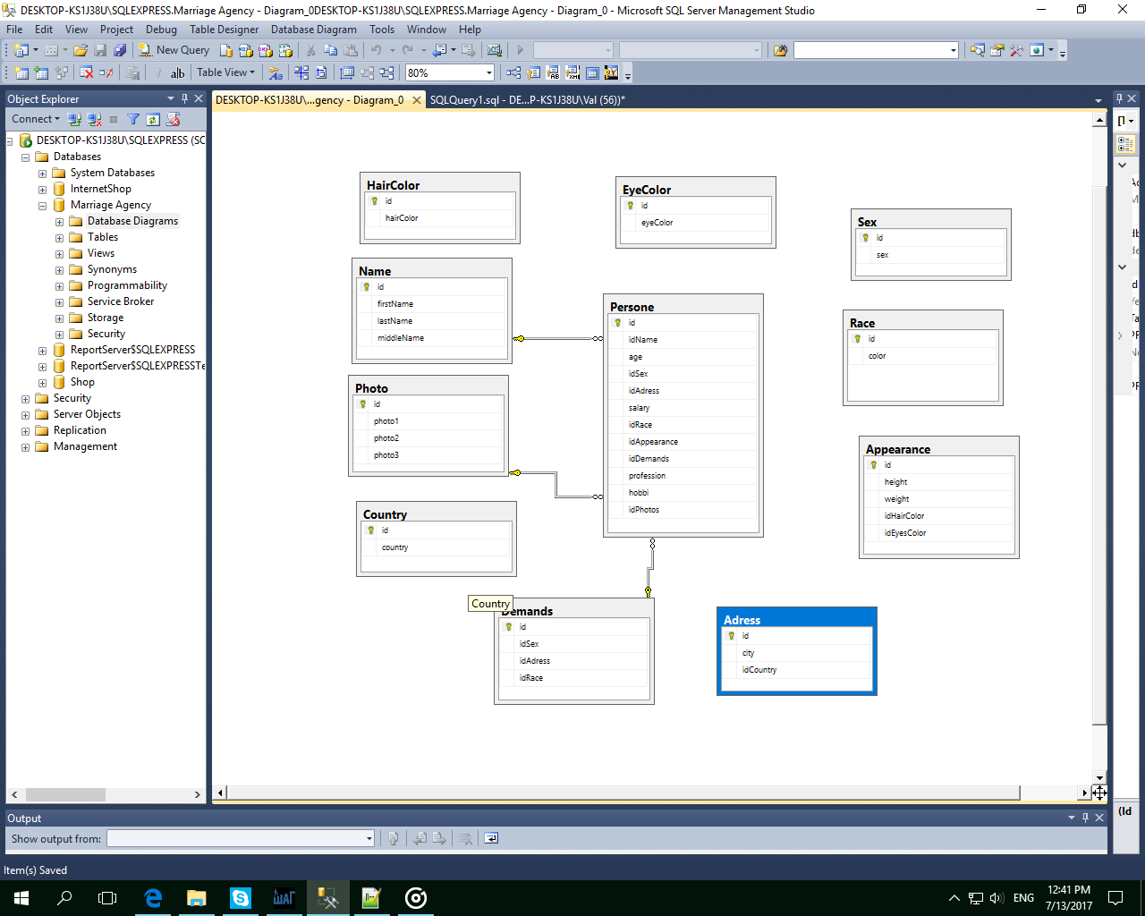

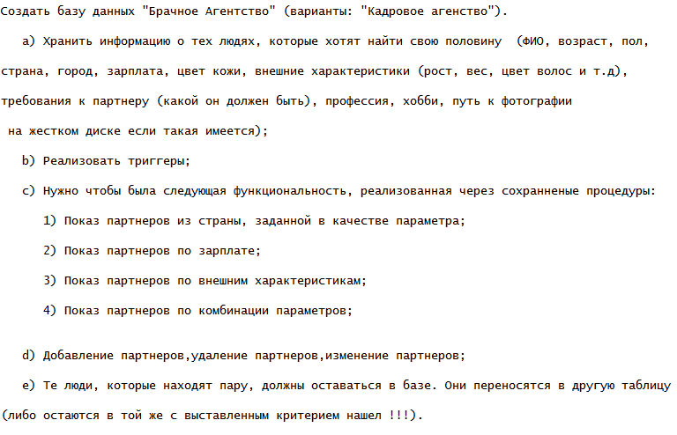

use [Marriage Agency]

Create table Name

(

id int identity(1,1) primary key,

firstName varchar (50),

lastName varchar (50),

middleName varchar (50)

)

Create table Sex

(

id int identity(1,1) primary key,

sex varchar (50)

)

Create table Adress

(

id int identity(1,1) primary key,

city varchar (50),

idCountry int

)

Create table Country

(

id int identity(1,1) primary key,

country varchar (50)

)

Create table Race

(

id int identity(1,1) primary key,

color varchar (50)

)

Create table Appearance

(

id int identity(1,1) primary key,

height int,

weight int,

idHairColor int,

idEyesColor int

)

Create table HairColor

(

id int identity(1,1) primary key,

hairColor varchar (50)

)

Create table EyeColor

(

id int identity(1,1) primary key,

eyeColor varchar (50)

)

Create table Photo

(

id int identity(1,1) primary key,

photo1 nvarchar (200),

photo2 nvarchar (200),

photo3 nvarchar (200)

)

Create table Persone

(

id int identity(1,1) primary key,

idName int,

age date,

idSex int,

idAdress int,

salary float,

idRace int,

idAppearance int,

idDemands int,

profession varchar(100),

hobbi varchar(255),

idPhotos int,

accept bit

)

Create table Demands

(

id int identity(1,1) primary key,

idSex int,

idAdress int,

idRace int

)

INSERT INTO Country VALUES

('Ukraine'), ('Russia'), ('Germany')

INSERT INTO Adress VALUES

('ZP', 1), ('DP', 1), ('Kiev', 1), ('Lvov', 1),

('Moscow', 2), ('ECB', 2), ('SPB', 2), ('Voronezh', 2),

('Berlin', 3), ('Hamburg', 3), ('Munchen', 3), ('Koln', 3)

INSERT INTO Sex VALUES

('Man'), ('Woman')

INSERT INTO Race VALUES

('Black'), ('White'), ('Latinos'), ('Yellow')

INSERT INTO EyeColor VALUES

('Blue'), ('Dark'), ('Green'), ('Brown')

INSERT INTO HairColor VALUES

('Black'), ('Rus'), ('Painted'), ('Brown')

INSERT INTO Appearance VALUES

(180, 100, 1, 1), (180, 90, 2, 2), (180, 95, 3, 3),

(175, 80, 4, 4), (175, 100, 1, 2), (170, 88, 1, 3),

(170, 70, 1, 4), (188, 86, 2, 1), (174, 82, 2, 2),

(182, 97, 2, 3), (173, 60, 2, 4), (172, 55, 3, 1),

(169, 50, 3, 2), (171, 52, 3, 3), (177, 56, 3, 4),

(168, 45, 4, 1), (171, 48, 4, 2), (173, 56, 4, 3),

(176, 50, 4, 4)

INSERT INTO Photo VALUES

('D:/photos/photo1.bmp', 'D:/photos/photo2.bmp', 'D:/photos/photo3.bmp')

INSERT INTO Name VALUES

('Sergey', 'Pupkin', 'Fabovich'),('Illia', 'Fedin', 'Humovich'), ('Anton', 'Track', 'Toolsovich'),

('Pol', 'Nepupkin', 'Gelovacovich'),('Xeon', 'Sesor', 'Nocovich'), ('Anton', 'Poloz', 'Uberovich'),

('Sergey', 'Goover', 'Demertievich'),('Koliya', 'Honest', 'Oliverovich'), ('Kirill', 'Loreal', 'Loopovich'),

('Rembo', 'Ferry', 'Holmovich'),('Koliya', 'Dust', 'Nosievich'), ('Kirill', 'Hendyman', 'Ubiitsovich'),

('Jerald', 'Violin', 'Parascovich'),('Tony', 'Goog', 'Googlovich'), ('Harry', 'Kloun', 'Rembovich'),

('Jerald', 'Reeter', 'Pavlovich'),('Dread', 'Boobs', 'Sergeevich'), ('Zoom', 'Older', 'Woogyevich'),

('John', 'Flow', 'Derecovich'),('Onil', 'Secer', 'Marcelotvich'), ('Larry', 'Reter', 'Lolitovich'),

('John', 'Over', 'Vegetablovich'),('Oleg', 'Arean', 'Jackovich'), ('Barn', 'Grill', 'Girlovnovich'),

('Irina', 'Gerta', 'Fabovna'),('Irina', 'Fert', 'Humovna'), ('Irina', 'Rack', 'Toolsovna'),

('Anna', 'Gelovach', 'Gelovachevna'),('Anna', 'Chmir', 'Nocovna'), ('Anasteysha', 'Geert', 'Uberovna'),

('Yana', 'Perdak', 'Demertivna'),('Olga', 'Dirka', 'Olievna'), ('Kerosina', 'Lorael', 'Loopovna'),

('Egeria', 'Holma', 'Holmovna'),('Katerina', 'First', 'Nosieva'), ('Katerina', 'Rock', 'Ubiitsa'),

('Yana', 'Greta', 'Parascovna'),('Parasca', 'Google', 'Googlovna'), ('Olga', 'Mazepa', 'Rembovna'),

('Anna', 'Verona', 'Pavlovna'),('Anna', 'Booblic', 'Sergeevna'), ('Anasteysha', 'Woogy', 'Woogyevna'),

('Yana', 'Accol', 'Derecovna'),('Olga', 'Second', 'Marcelotovna'), ('Kerosina', 'Foobar', 'Lolitovna'),

('Egeria', 'Ovoch', 'Vegetables'),('Katerina', 'Ogurec', 'Jackovna'), ('Liza', 'Girl', 'Girlovna')

INSERT INTO Demands VALUES

(1, 1, 1), (1, 2, 2), (1, 3, 3), (1, 4, 4), (1, 5, 1), (1, 6, 2),

(1, 7, 3), (1, 8, 4), (1, 9, 1), (1, 10, 2), (1, 11, 3), (1, 12, 4),

(1, 1, 1), (1, 2, 2), (1, 3, 3), (1, 4, 4), (1, 5, 1), (1, 6, 2),

(1, 7, 3), (1, 8, 4), (1, 9, 1), (1, 10, 2), (1, 11, 3), (1, 12, 4),

(2, 1, 1), (2, 2, 2), (2, 3, 3), (2, 4, 4), (2, 5, 1), (2, 6, 2),

(2, 7, 3), (2, 8, 4), (2, 9, 1), (2, 10, 2), (2, 11, 3), (2, 12, 4),

(2, 1, 1), (2, 2, 2), (2, 3, 3), (2, 4, 4), (2, 5, 1), (2, 6, 2),

(2, 7, 3), (2, 8, 4), (2, 9, 1), (2, 10, 2), (2, 11, 3), (2, 12, 4)

INSERT INTO Persone VALUES

(1, '1990-10-01', 2, 1, 1000, 2, 1, 1, 'Weitres', 'Sport', 1),

(2, '1991-05-04', 2, 2, 2000, 1, 11, 2, 'Weitres', 'Sport', 1),

(3, '1992-11-20', 2, 3, 3000, 3, 12, 3, 'Pilot', 'Flowers', 1),

(4, '1992-12-01', 2, 4, 4000, 4, 13, 4, 'Accountate', 'Bike', 1),

(5, '1989-02-23', 2, 5, 4500, 2, 14, 5, 'Repair', 'Dress', 1),

(6, '1989-10-29', 2, 6, 3500, 1, 15, 6, 'Ingeneer', 'Solt', 1),

(7, '1993-06-15', 2, 7, 3200, 3, 16, 7, 'Florist', 'Phones', 1),

(8, '1994-12-30', 2, 8, 1200, 4, 17, 8, 'Cuter', 'SmartPeopple', 1),

(9, '1995-08-09', 2, 9, 1800, 2, 18, 9, 'Dantist', 'Drink', 1),

(10, '1991-03-08', 2, 10, 1900, 1, 19, 10, 'Doctor', 'Party', 1),

(11, '1993-05-11', 2, 11, 2200, 3, 18, 11, 'Housekeeper', 'Honey', 1),

(12, '1990-07-21', 2, 12, 3400, 4, 17, 12, 'HomeSit', 'Cleen', 1),

(13, '1995-01-27', 2, 1, 3000, 2, 16, 13, 'Pilot', 'Cars', 1),

(14, '1996-02-07', 2, 2, 3600, 1, 15, 14, 'Putana', 'Sport', 1),

(15, '1988-04-17', 2, 3, 4100, 3, 14, 15, 'SalesPersone', 'WorkingOut', 1),

(16, '1997-04-08', 2, 4, 4400, 4, 13, 16, 'SalesPersone', 'Food', 1),

(17, '1997-10-14', 2, 5, 3600, 2, 12, 17, 'SuperIntendant', 'Sport', 1),

(18, '1992-11-30', 2, 6, 3700, 1, 11, 18, 'IT-manager', 'Flowers', 1),

(19, '1993-12-10', 2, 7, 3800, 3, 11, 19, 'Pilot', 'Olive', 1),

(20, '1989-11-23', 2, 8, 3900, 4, 12, 20, 'Florist', 'Books', 1),

(21, '1988-05-05', 2, 9, 4000, 2, 13, 21, 'HomeSit', 'Swimming', 1),

(22, '1991-08-24', 2, 10, 3100, 1, 14, 22, 'Doctor', 'Seashore', 1),

(23, '1993-09-28', 2, 11, 3200, 3, 15, 23, 'Dantist', 'Money', 1),

(24, '1995-07-27', 2, 12, 1000, 4, 16, 24, 'Weitres', 'Salary', 1),

(25, '1992-11-30', 1, 12, 5000, 1, 1, 25, 'Pilot', 'Sport', 1),

(26, '1995-10-28', 1, 11, 5200, 2, 2, 26, 'Cuter', 'Driveing', 1),

(27, '1996-08-06', 1, 10, 4400, 3, 3, 27, 'Mechanic', 'Growing', 1),

(28, '1992-08-11', 1, 9, 4700, 4, 4, 28, 'Driver', 'Zoomming', 1),

(29, '1990-10-01', 1, 8, 2000, 1, 5, 29, 'Driver', 'Jumping', 1),

(30, '1989-02-22', 1, 7, 1000, 2, 6, 30, 'Businessman', 'Swimming', 1),

(31, '1988-07-29', 1, 6, 2100, 3, 7, 31, 'Treiner', 'Flowers', 1),

(32, '1996-12-30', 1, 5, 4100, 4, 8, 32, 'Klerk', 'Boarding', 1),

(33, '1995-02-14', 1, 4, 4900, 1, 9, 33, 'OfficeManager', 'Skying', 1),

(34, '1992-10-09', 1, 3, 5200, 2, 10, 34, 'Weiter', 'Books', 1),

(35, '1994-09-25', 1, 2, 4100, 3, 10, 35, 'Accountate', 'Reading', 1),

(36, '1994-08-24', 1, 1, 4700, 4, 9, 36, 'RepairMan', 'Cleening', 1),

(37, '1996-07-23', 1, 12, 4700, 1, 8, 37, 'Plumber', 'Sweepping', 1),

(38, '1990-06-14', 1, 11, 4900, 2, 7, 38, 'Treiner', 'Jogging', 1),

(39, '1989-04-22', 1, 10, 4200, 3, 6, 39, 'Plumber', 'Riding', 1),

(40, '1988-07-15', 1, 9, 2300, 4, 5, 40, 'Ingeneer', 'Driving', 1),

(41, '1990-01-28', 1, 8, 2500, 1, 4, 41, 'Weiter', 'Flying', 1),

(42, '1997-06-18', 1, 7, 4500, 2, 3, 42, 'Sportsman', 'Smoking', 1),

(43, '1993-03-19', 1, 6, 4600, 3, 2, 43, 'Guide', 'Swimming', 1),

(44, '1990-10-01', 1, 5, 3200, 4, 1, 44, 'Doctor', 'Reading', 1),

(45, '1997-11-20', 1, 4, 1300, 1, 2, 45, 'Dantist', 'Roofer', 1),

(46, '1996-04-22', 1, 3, 4500, 2, 3, 46, 'Weitres', 'Skiing', 1),

(47, '1994-01-14', 1, 2, 2800, 3, 4, 47, 'Weitres', 'Fishing', 1),

(48, '1995-01-07', 1, 1, 2900, 4, 5, 48, 'Weitres', 'Tooth', 1)

CREATE procedure ShowPartnerByCountry

@country varchar(50)

AS

BEGIN

SELECT Name.*, Country.country

FROM ((Persone INNER JOIN Name ON Persone.idName = Name.id) INNER JOIN Adress ON Persone.idAdress = Adress.id) INNER JOIN Country ON Adress.idCountry = Country.id

WHERE Country.country = @country

END

EXECUTE ShowPartnerByCountry 'Ukraine'

CREATE procedure ShowPartnerBySalary1

@salaryBegin float,

@salaryEnd float

AS

BEGIN

SELECT Name.*, Persone.salary

FROM Persone INNER JOIN Name ON Persone.idName = Name.id

WHERE Persone.salary BETWEEN @salaryBegin AND @salaryEnd

ORDER BY Persone.salary DESC

END

EXECUTE ShowPartnerBySalary1 3200, 4500

CREATE procedure ShowPartnersByAppearance

@height int,

@weight int,

@hairColor varchar(50),

@eyeColor varchar(50)

AS

BEGIN

SELECT Name.*, Persone.age

FROM (((Persone INNER JOIN Name ON Persone.idName = Name.id) INNER JOIN Appearance ON Persone.idAppearance = Appearance.id) INNER JOIN HairColor ON Appearance.idHairColor = HairColor.id) INNER JOIN EyeColor ON Appearance.idEyesColor = EyeColor.id

WHERE Appearance.height = @height AND Appearance.weight = @weight AND HairColor.hairColor = @hairColor AND EyeColor.eyeColor = @eyeColor

END

EXECUTE ShowPartnersByAppearance 180, 90, 'Rus', 'Dark'

CREATE procedure ShowPartnersByPersonsPrefer1

@idPersone int

AS

BEGIN

DECLARE @idSex int, @idAdress int, @idRace int

SELECT @idSex = Demands.idSex, @idAdress = Demands.idAdress, @idRace = Demands.idRace

FROM Persone INNER JOIN Demands ON Persone.idDemands = Demands.id

WHERE Persone.id = @idPersone

SELECT Name.*, Persone.age

FROM (Persone INNER JOIN Name ON Persone.idName = Name.id) INNER JOIN Demands ON Persone.idDemands = Demands.id

WHERE Persone.idSex = @idSex AND Persone.idAdress = @idAdress AND Persone.idRace = @idRace

END

EXECUTE ShowPartnersByPersonsPrefer1 32

CREATE procedure AddPersoneTransacrion

@firstName varchar(50),

@lastName varchar(50),

@middleName varchar(50),

@age date,

@idSex int,

@idAdress int,

@salary float,

@idRace int,

@idAppearance int,

@idSexDemands int,

@idAdressDemands int,

@idRaceDemands int,

@profession varchar(50),

@hobbi varchar(50),

@photo1 nvarchar(50),

@photo2 nvarchar(50),

@photo3 nvarchar(50)

AS

BEGIN TRANSACTION

DECLARE @idName int, @idDemands int, @idPhoto int

BEGIN TRY

INSERT INTO Name VALUES

(@firstName, @lastName, @middleName)

SELECT @idName = SCOPE_IDENTITY()

INSERT INTO Demands VALUES

(@idSexDemands, @idAdressDemands, @idRaceDemands)

SELECT @idDemands = SCOPE_IDENTITY()

INSERT INTO Photo VALUES

(@photo1, @photo2, @photo3)

SELECT @idPhoto = SCOPE_IDENTITY()

INSERT INTO Persone VALUES

(@idName, @age, @idSex, @idAdress, @salary, @idRace, @idAppearance, @idDemands, @profession, @hobbi, @idPhoto)

COMMIT

END TRY

BEGIN CATCH

ROLLBACK

END CATCH

EXECUTE AddPersoneTransacrion 'Antonio', 'Garsia', 'Lopesovich', '1993-04-01', 1, 1, 10000, 2, 1, 2, 1, 2, 'Baker', 'Driving', 'D:/photos/photo5.bmp', 'D:/photos/photo5.bmp', 'D:/photos/photo5.bmp'

CREATE procedure DeletePersone1

@idPersone int

AS

BEGIN TRANSACTION

BEGIN TRY

DELETE

FROM Persone

WHERE Persone.id = @idPersone

DELETE

FROM Name

WHERE Name.id = @idPersone

DELETE

FROM Photo

WHERE Photo.id = @idPersone

DELETE

FROM Demands

WHERE Demands.id = @idPersone

COMMIT

END TRY

BEGIN CATCH

ROLLBACK

END CATCH

EXECUTE DeletePersone1 50

CREATE procedure UpdatePersoneTransacrion1

@idPersone int,

@firstName varchar(50),

@lastName varchar(50),

@middleName varchar(50),

@age date,

@idSex int,

@idAdress int,

@salary float,

@idRace int,

@idAppearance int,

@idSexDemands int,

@idAdressDemands int,

@idRaceDemands int,

@profession varchar(50),

@hobbi varchar(50),

@photo1 nvarchar(50),

@photo2 nvarchar(50),

@photo3 nvarchar(50)

AS

BEGIN TRANSACTION

BEGIN TRY

UPDATE Name

SET Name.firstName = @firstName, Name.lastName = @lastName, Name.middleName = @middleName

FROM Persone INNER JOIN Name ON Persone.idName = Name.id

WHERE Persone.id = @idPersone

UPDATE Demands

SET Demands.idSex = @idSexDemands, Demands.idAdress = @idAdressDemands, Demands.idRace = @idRaceDemands

FROM Persone INNER JOIN Demands ON Persone.idDemands = Demands.id

WHERE Persone.id = @idPersone

UPDATE Photo

SET Photo.photo1 = @photo1, Photo.photo2 = @photo2, Photo.photo3 = @photo3

FROM Persone INNER JOIN Photo ON Persone.idPhotos = Photo.id

WHERE Persone.id = @idPersone

UPDATE Persone

SET Persone.age = @age, Persone.idAdress = @idAdress, Persone.salary = @salary, Persone.idAppearance = @idAppearance, Persone.profession = @profession, Persone.hobbi = @hobbi

WHERE Persone.id = @idPersone

COMMIT

END TRY

BEGIN CATCH

ROLLBACK

END CATCH

EXECUTE UpdatePersoneTransacrion1 48, 'Antonio', 'Garsia', 'Lopesovich', '1993-04-01', 1, 1, 10000, 2, 1, 2, 1, 2, 'Baker', 'Driving', 'D:/photos/photo5.bmp', 'D:/photos/photo5.bmp', 'D:/photos/photo5.bmp'

CREATE procedure SweepPartnersByPersonsPrefer3

@idPersone int

AS

BEGIN

DECLARE @idSex int, @idAdress int, @idRace int, @nameRes varchar(50)

SELECT @idSex = Demands.idSex, @idAdress = Demands.idAdress, @idRace = Demands.idRace

FROM Persone INNER JOIN Demands ON Persone.idDemands = Demands.id

WHERE Persone.id = @idPersone

SELECT @nameRes = Name.firstName

FROM (Persone INNER JOIN Name ON Persone.idName = Name.id) INNER JOIN Demands ON Persone.idDemands = Demands.id

WHERE Persone.idSex = @idSex AND Persone.idAdress = @idAdress AND Persone.idRace = @idRace

if(@nameRes IS NULL)

BEGIN

UPDATE Persone

SET Persone.accept = 'false'

WHERE Persone.id = @idPersone

END

ELSE

BEGIN

UPDATE Persone

SET Persone.accept = 'true'

WHERE Persone.id = @idPersone

END

END

DECLARE @count int

SELECT @count = COUNT(Persone.id)

FROM Persone

WHILE @count > 0

BEGIN

EXECUTE SweepPartnersByPersonsPrefer3 @count

SET @count = @count - 1

if(@count = 0)

BREAK

ELSE

CONTINUE

END