**Day 2(28-05-2020)**

**Image 1:**

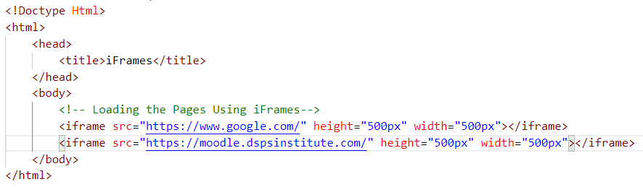

**Image 2:**

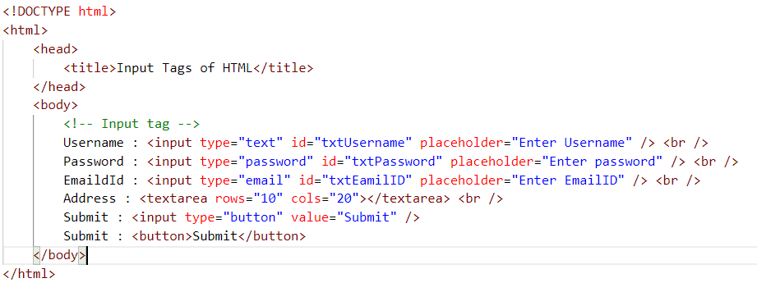

**Assignment Problem**

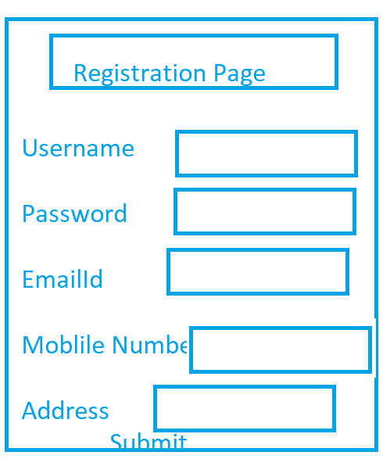

**CSS [Cascading Style Sheet]**

Css is a language that describes the styles of the HTML tags or elements.

Css will enhance the look and feel of the HTML Documents

Css will makes the things more effective

**1. Inline - Css**

The css which can affect only single element of the html document

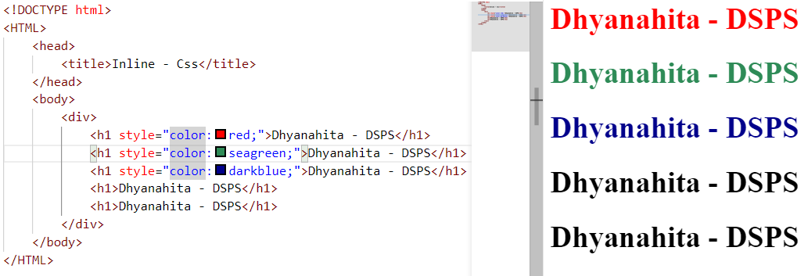

**2. Internal or Embedded Css**

The css which applies to all the html elements which are of same type

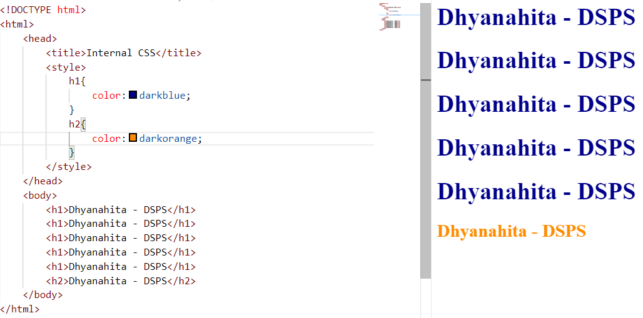

1. **Id Selector :** 
   1. Which always represents with # tag

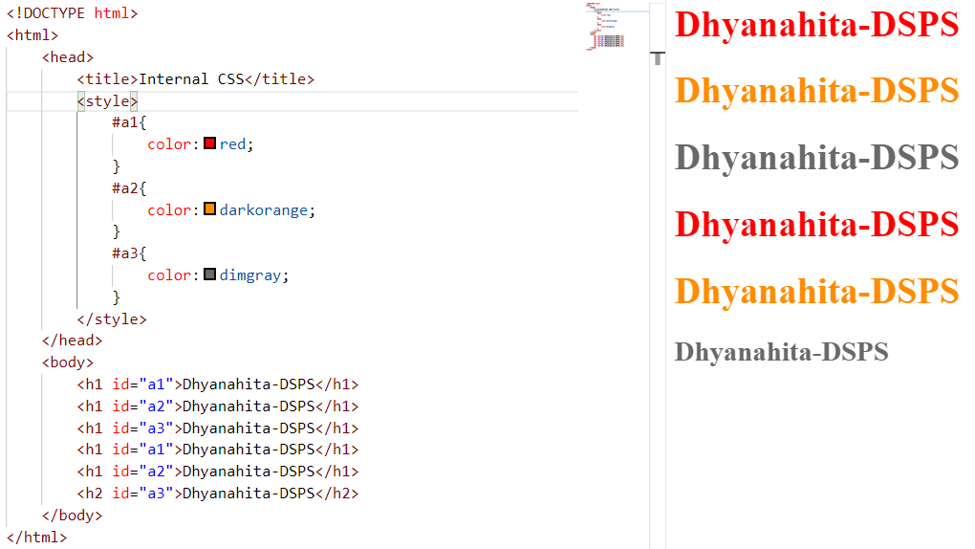

1. **Class Selector**
   1. Which represents the .(dot) followed by name of the class

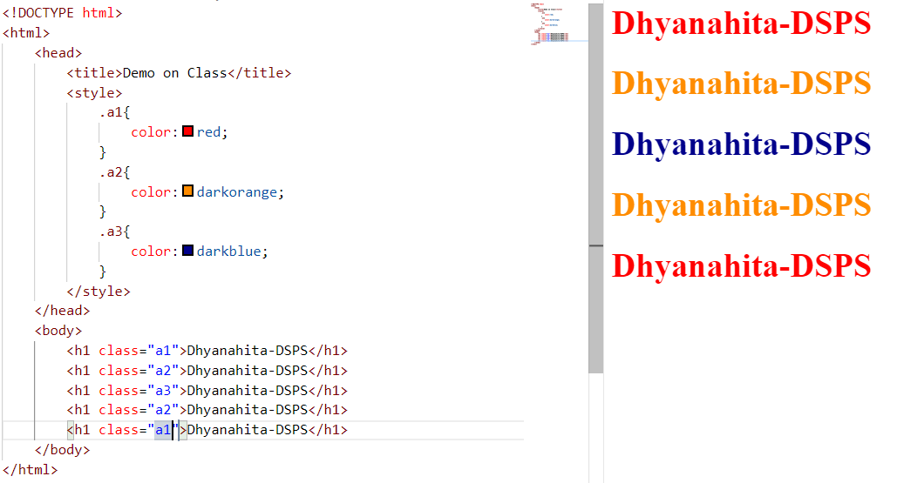

1. **External CSS**
   1. You need to Design the css document separately
   2. You have to link that to html document by using link tag on head part of the browser

Step 1: Design the CSS Doc:

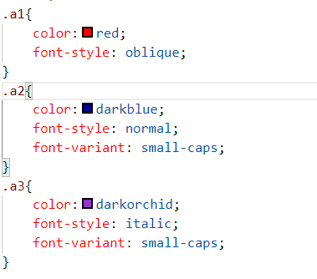

**Step 2:** Link the css document to html document

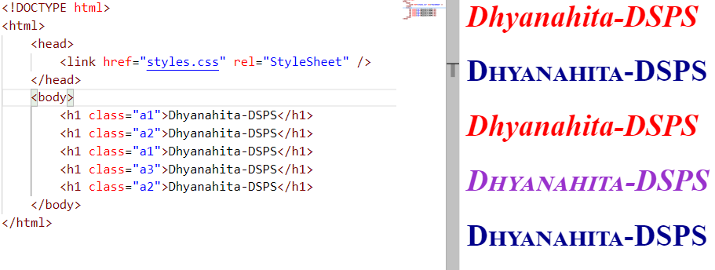

**CSS Properties**

1. **Text Properties**
   1. Color : can be represented by Name of the color, Hex code of the color and rgb color codes also
   2. Text-align

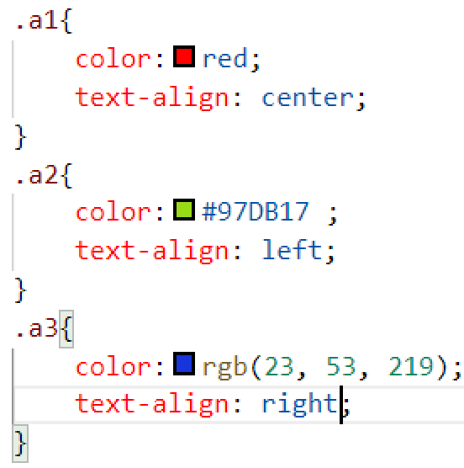

* 1. Text-transform

