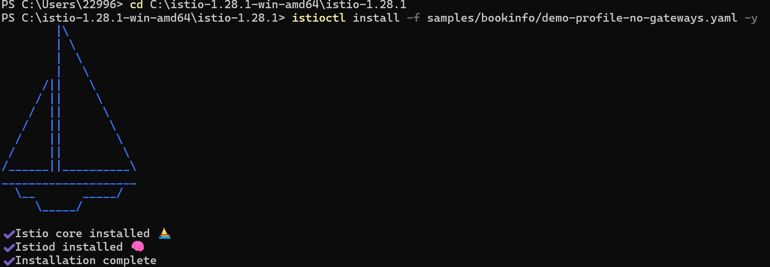
Install Istio and Gateway API CRDs
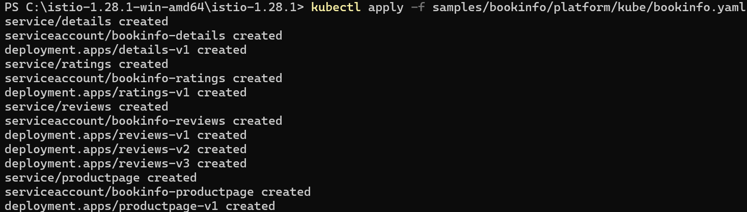
Deploy the Bookinfo sample application
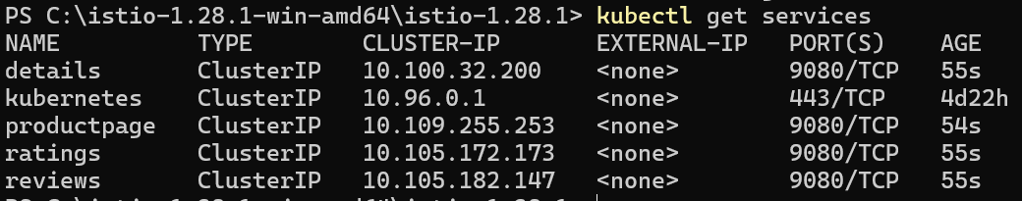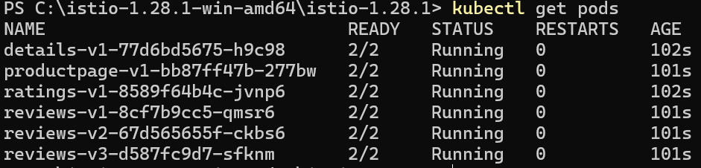
List the services and pods
Validate that the app is running inside the cluster by checking for the page title in the response
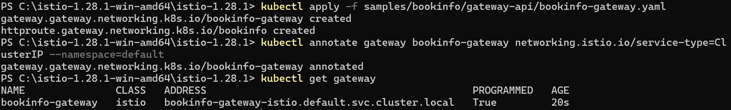
Open the application to outside traffic
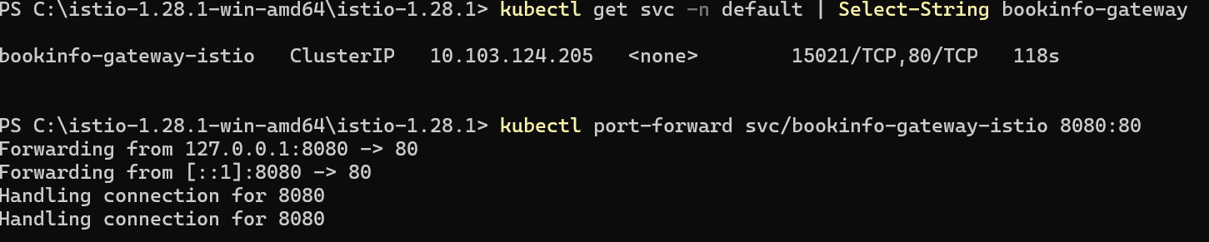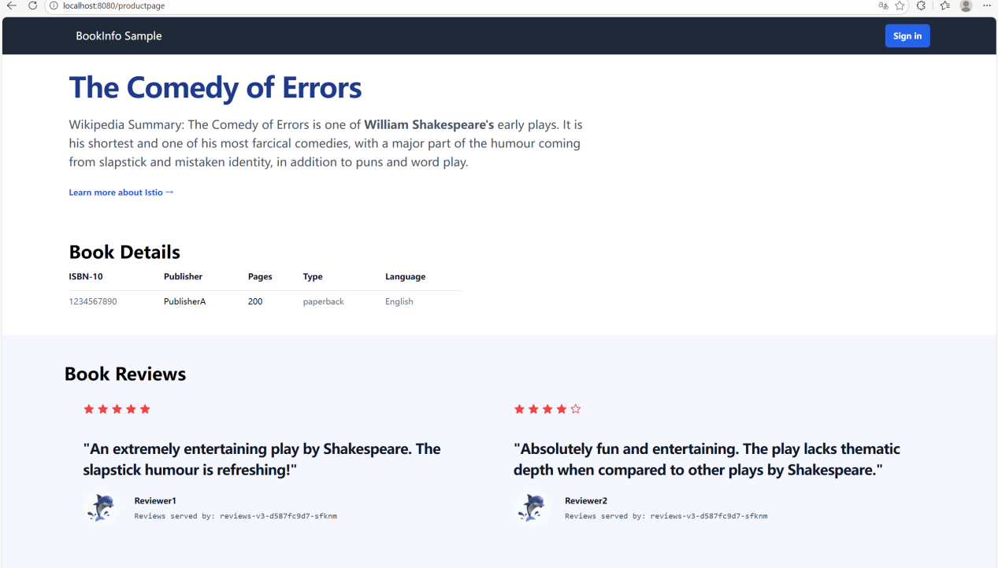
Connect to the Bookinfo productpage service through the gateway
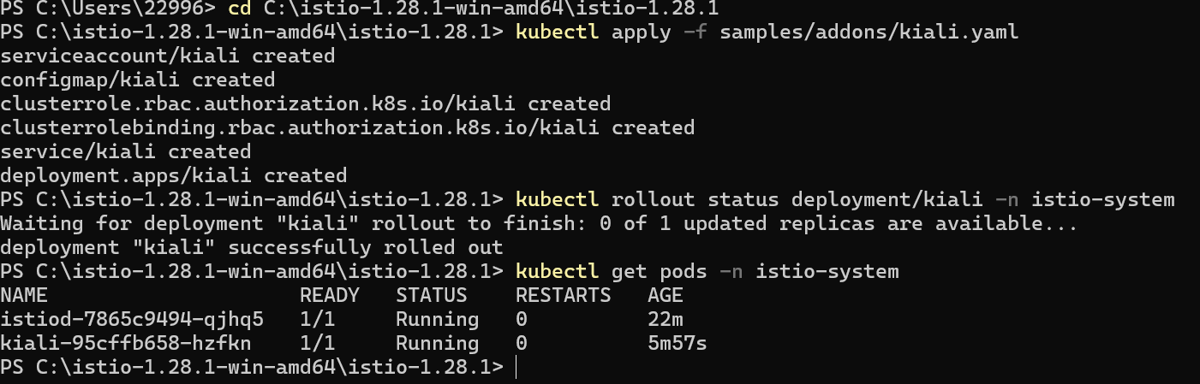
Install Kiali and the other addons and wait for them to be deployed
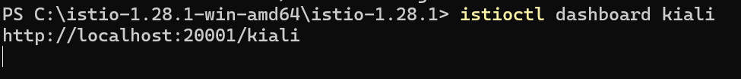
Access the Kiali dashboard
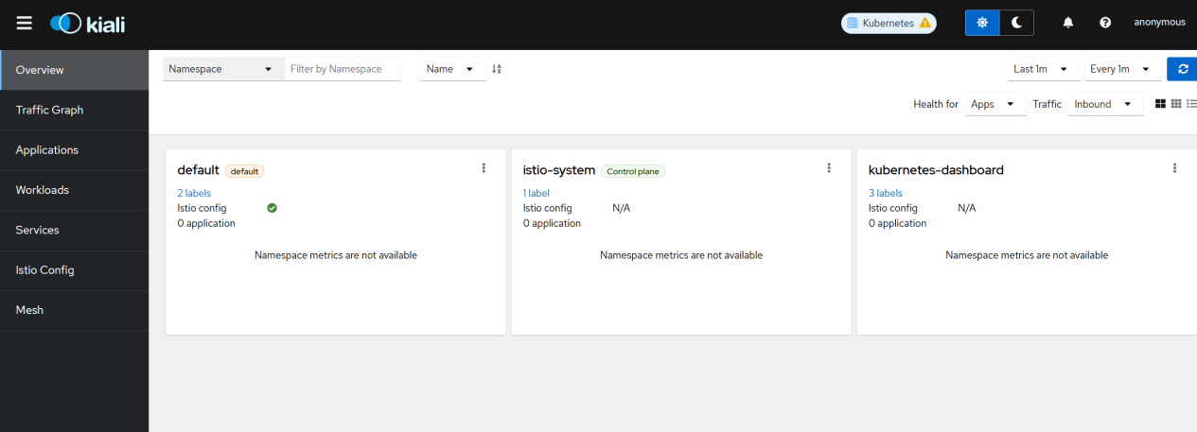
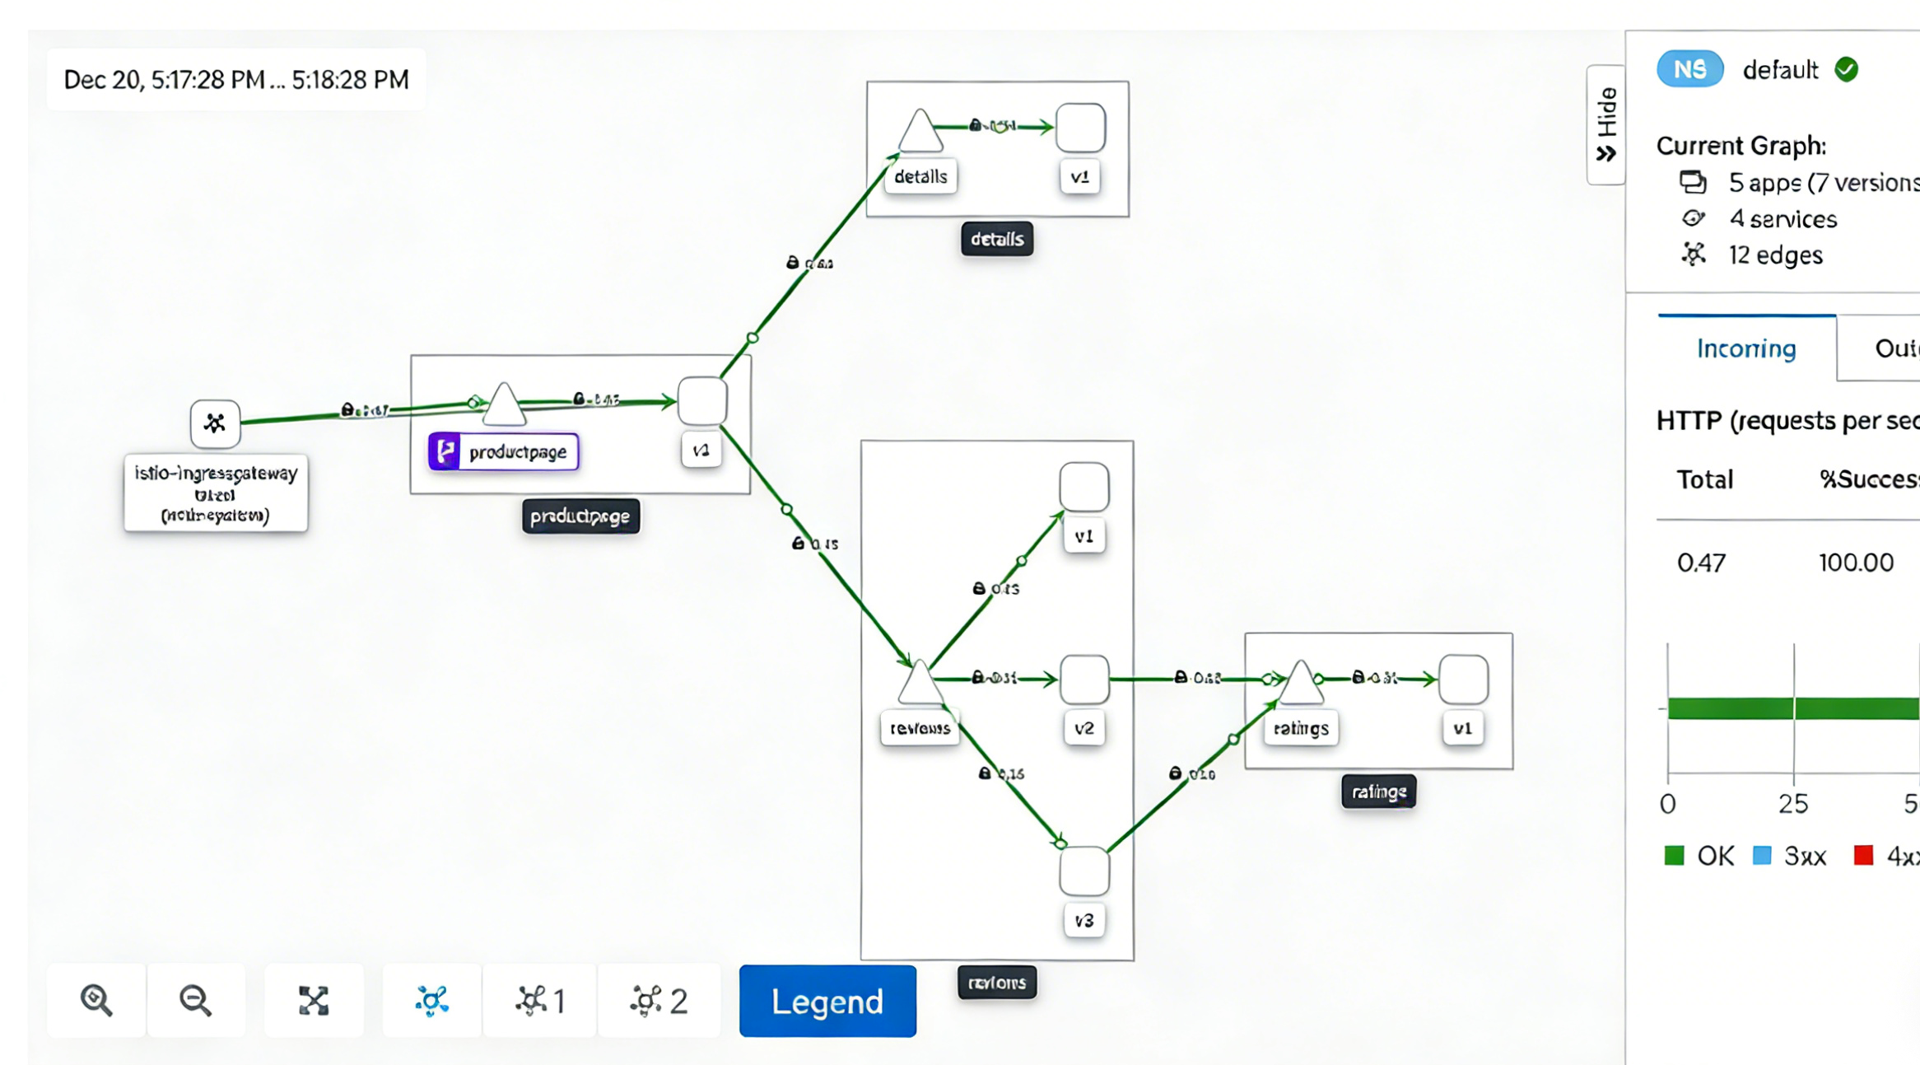
View the graph part

