Firstly,change the crt and the key as the request asked.
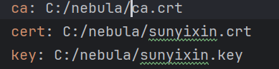
Then use the cmd to run nebula.exe(already changed the path before)
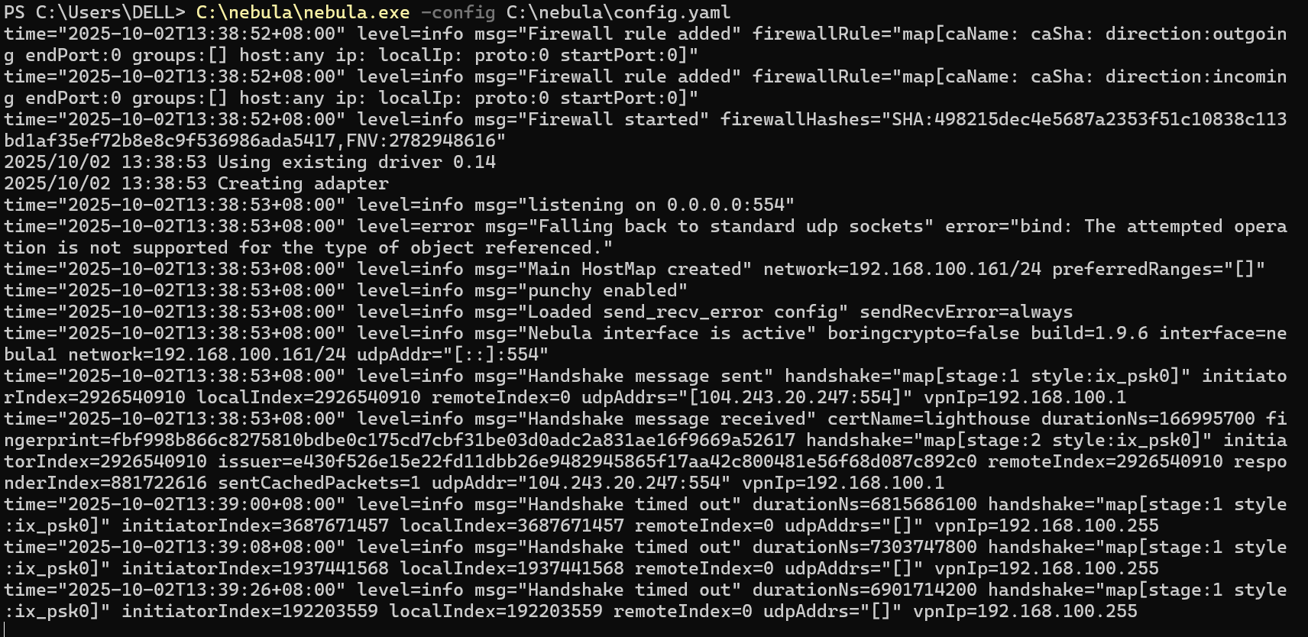
Finally test the connect to see whether the nebula works
