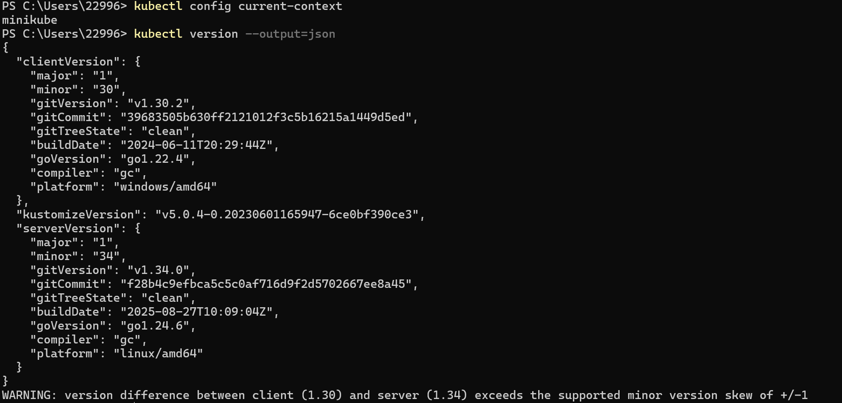
Verify my current context
Verfy the Kserve environment
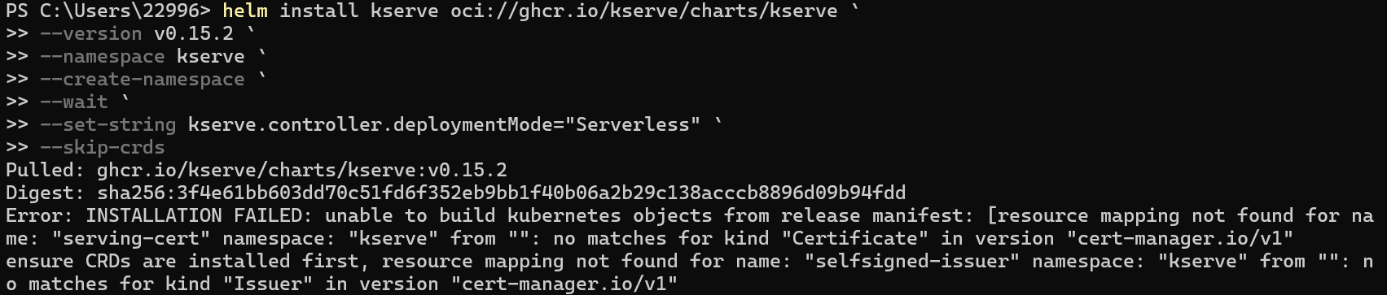
The downloads failed for the reason unknown so I have to stop here

