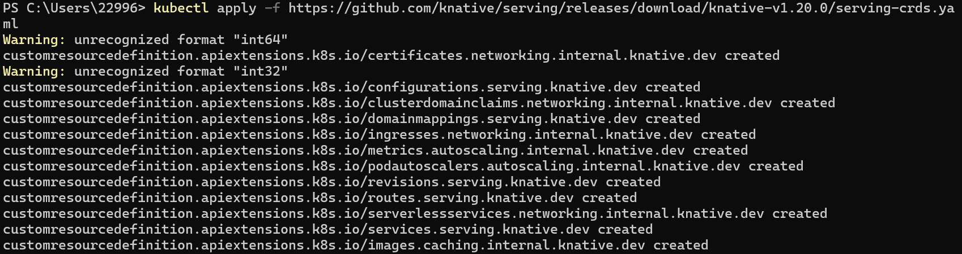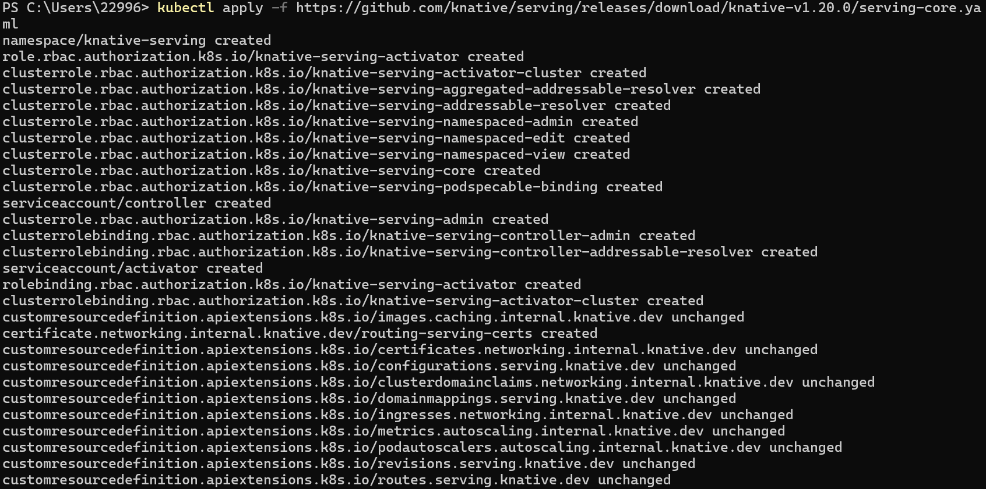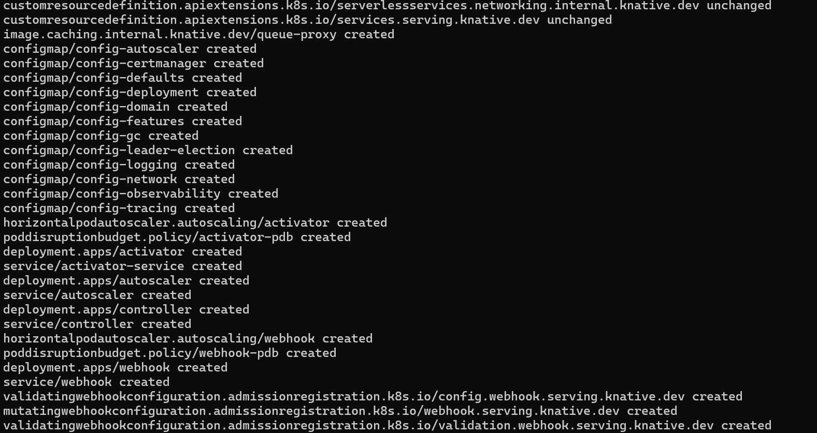
Install the Knative Serving component
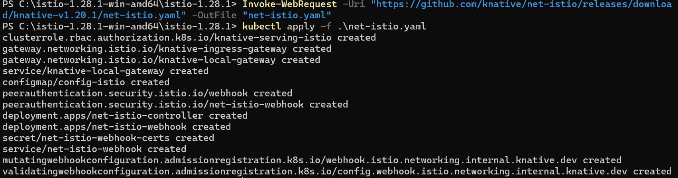
Install a networking layer
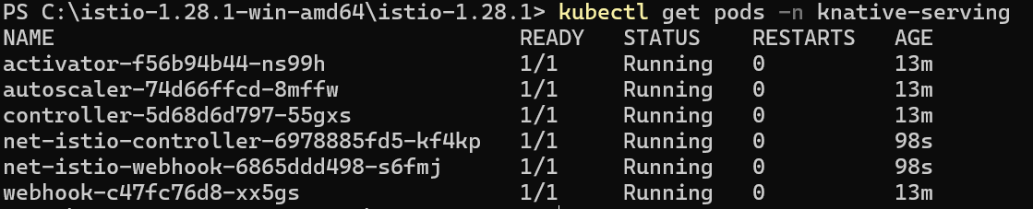
Configure DNS
Install optional Serving extensions
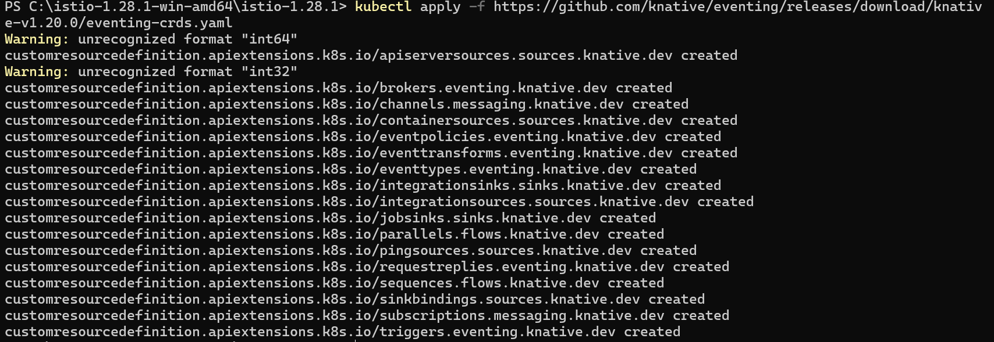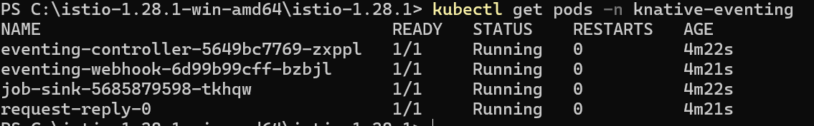
Install the Knative Eventing component
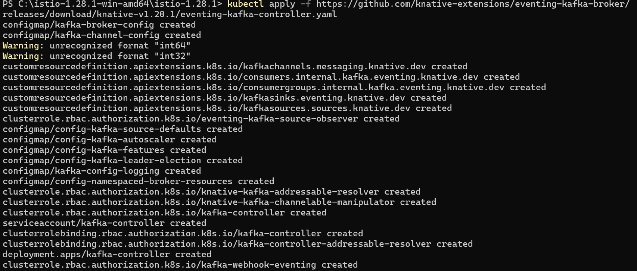
Install a default Channel (messaging) layer

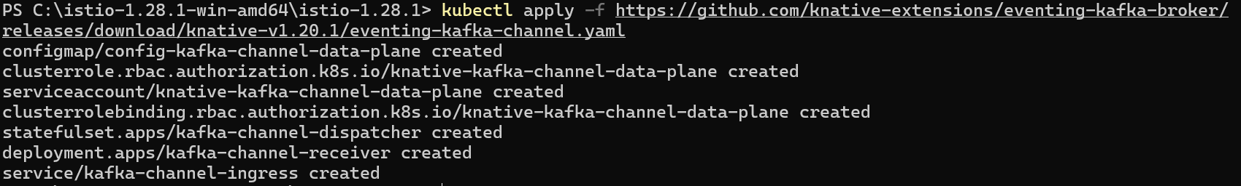
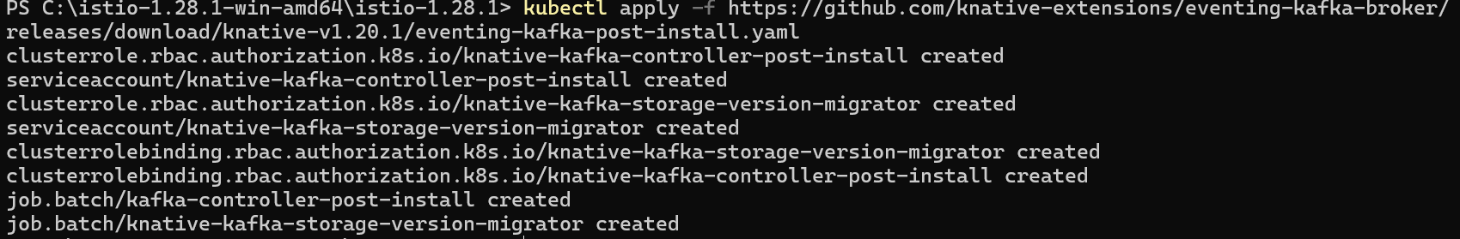
Install a Broker layer

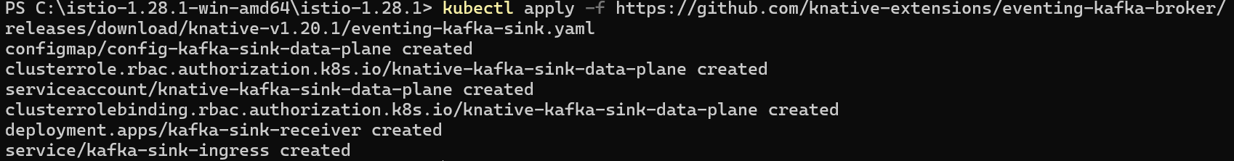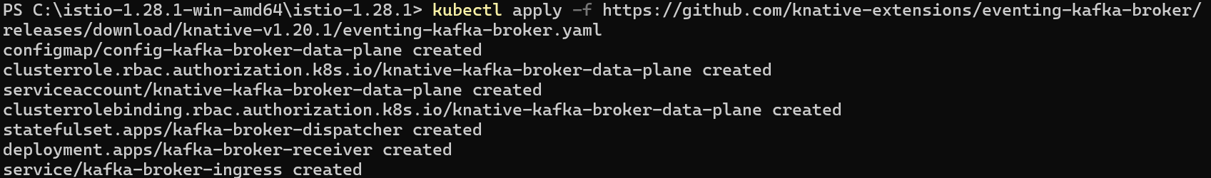
Install optional Eventing extensions
Installing the kn func CLI plugin and func CLI
Create a function project
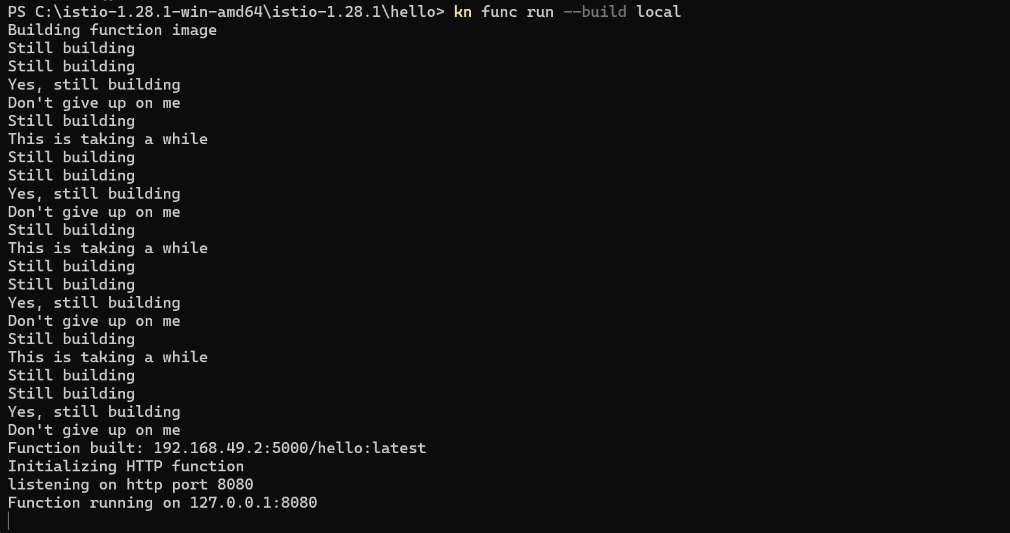
Run the function locally(registry build before locally)
Verify that the function has been successfully run
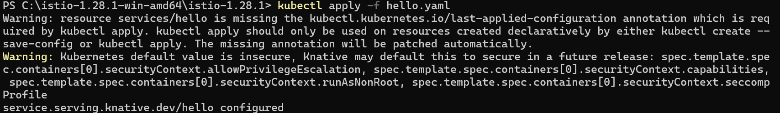
Use yaml to deploy the service
View a list of Knative Services
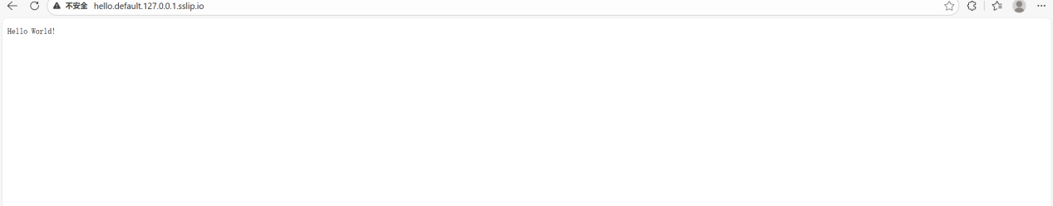
Access the Knative Service
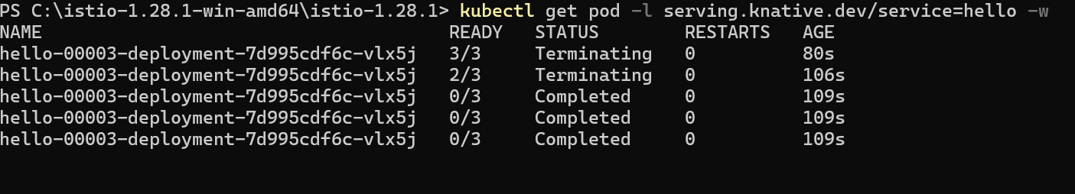
Watch the pods and see how they scale to zero after traffic stops going to the URL

Update the environment variable through yaml

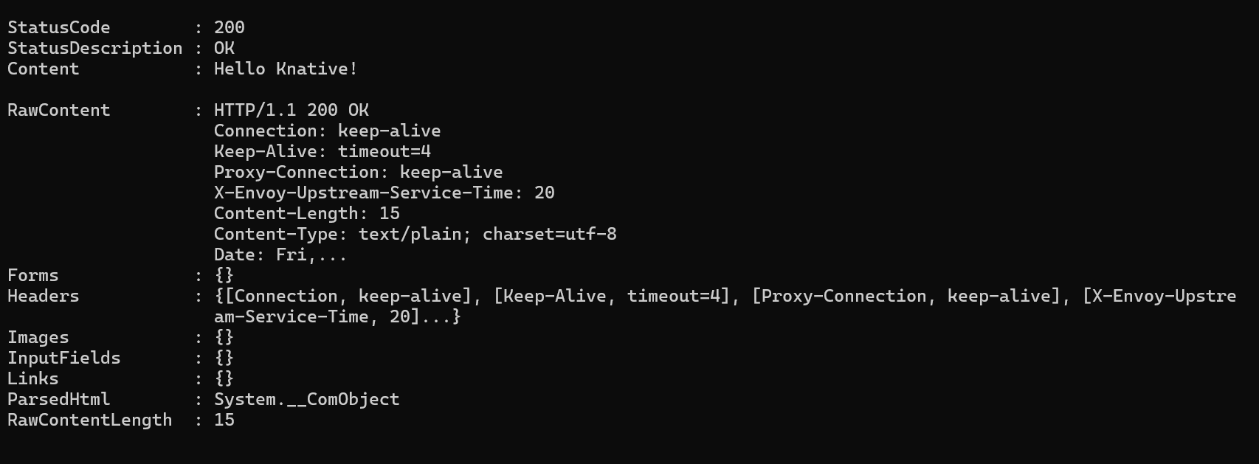
Access the Knative Service again
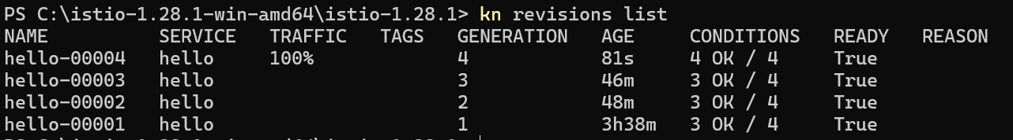
View a list of existing Revisions
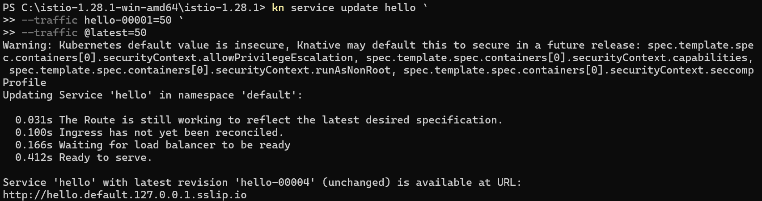
Split the traffic between the two Revisions
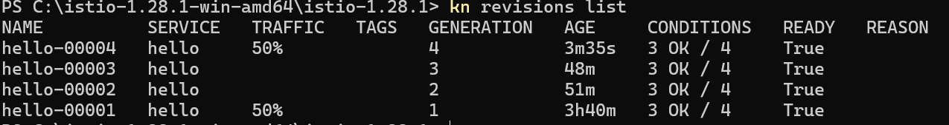
Verify the traffic split
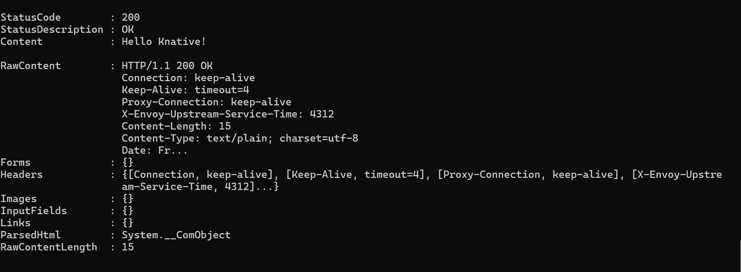
The result is 50% world 50%Knative
Verify that the Broker is installed
Create the CloudEvents Player Service
Create a SinkBinding between the service and the broker.
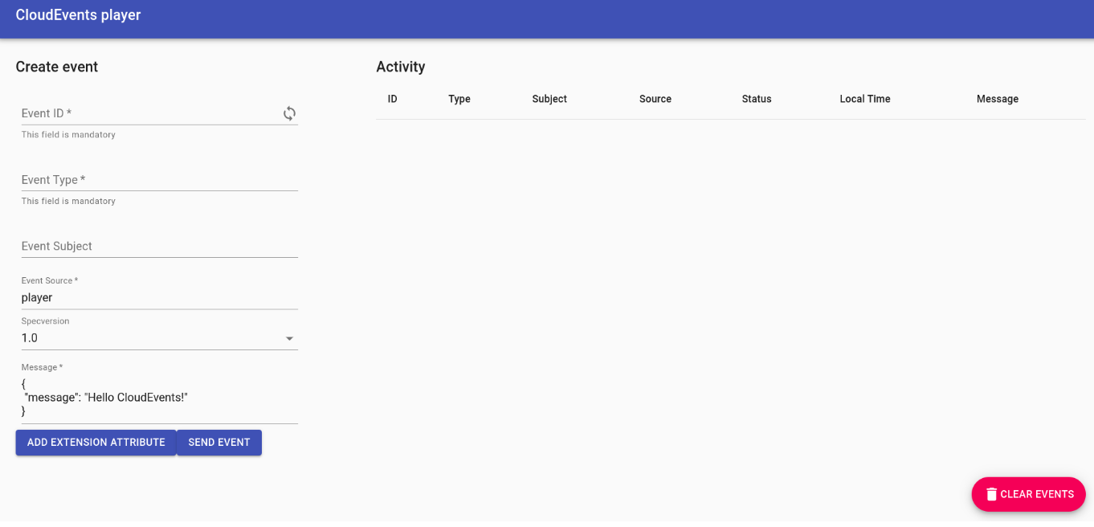
Open the Service URL in browser

