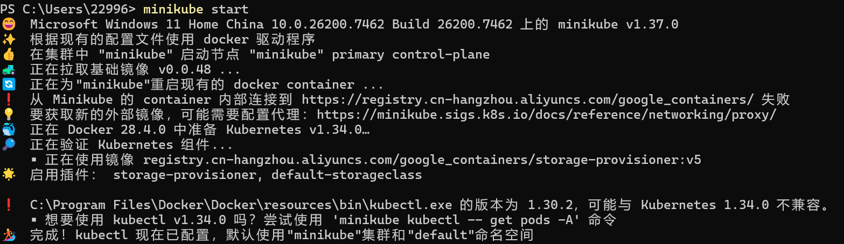

Create a minikube cluster
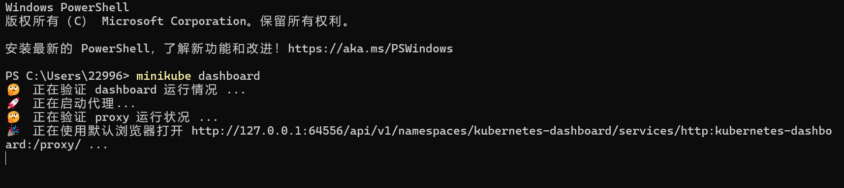
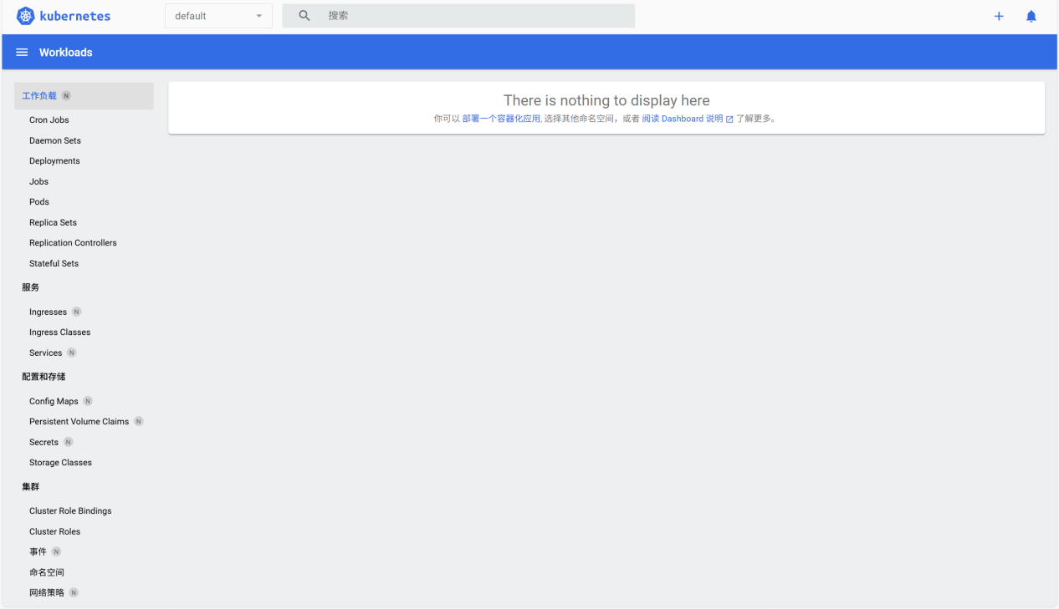

Open the Dashboard
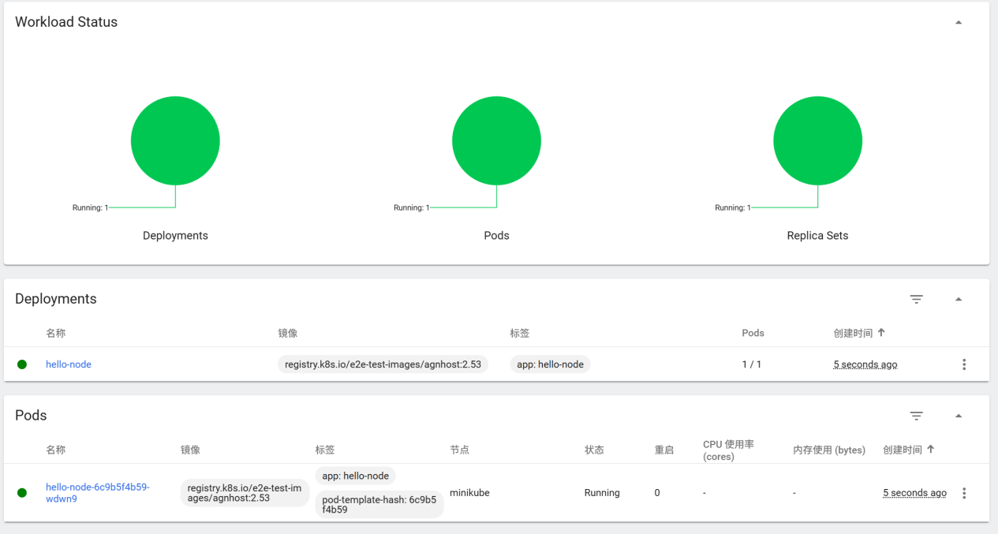
Use the kubectl create command to create a Deployment that manages a Pod

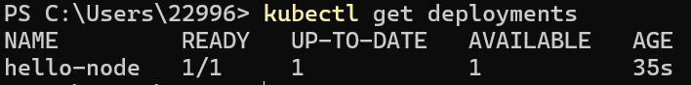
View the Deployment
View the Pod
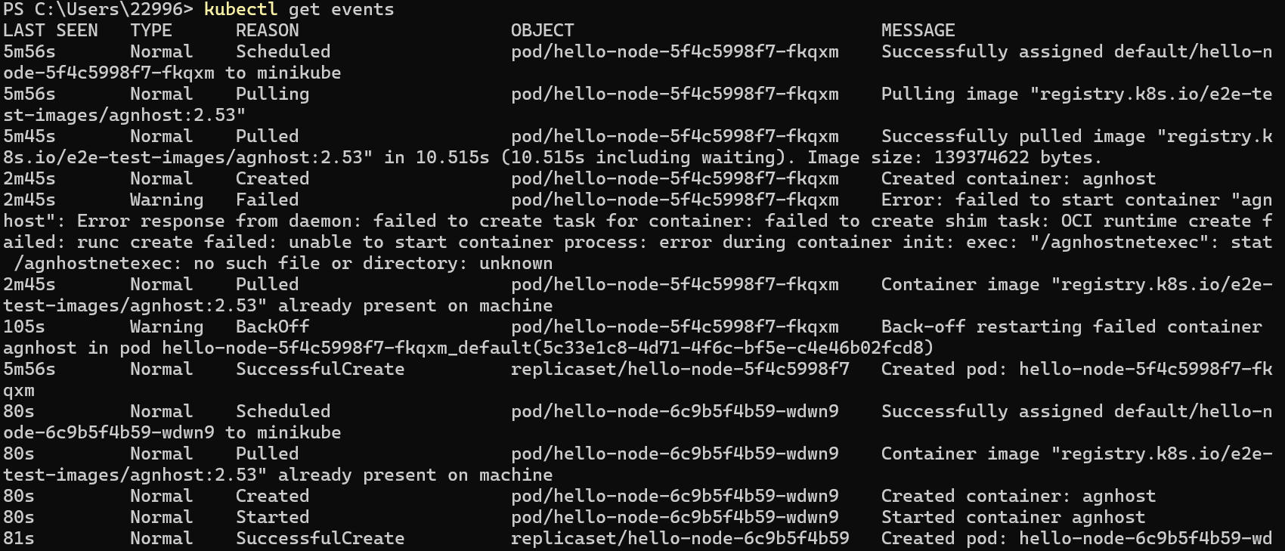
View cluster events
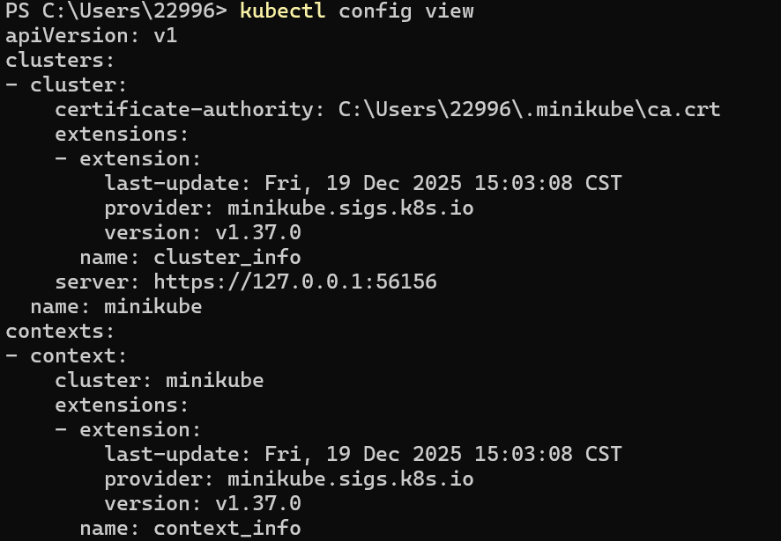
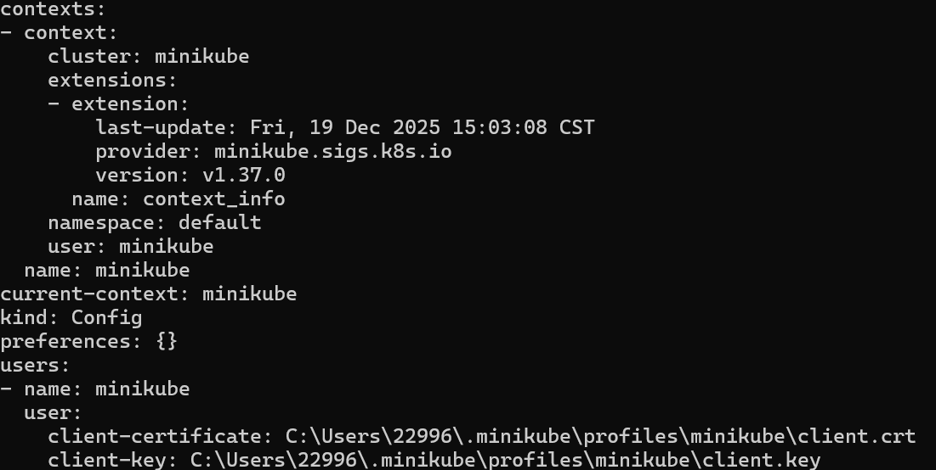
View the kubectl configuration

View application logs for a container in a pod
Expose the Pod to the public internet
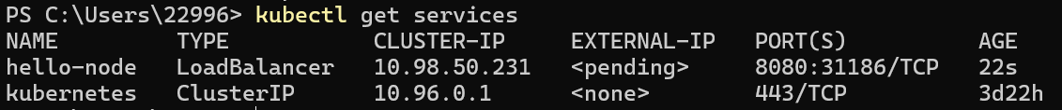
View the Service
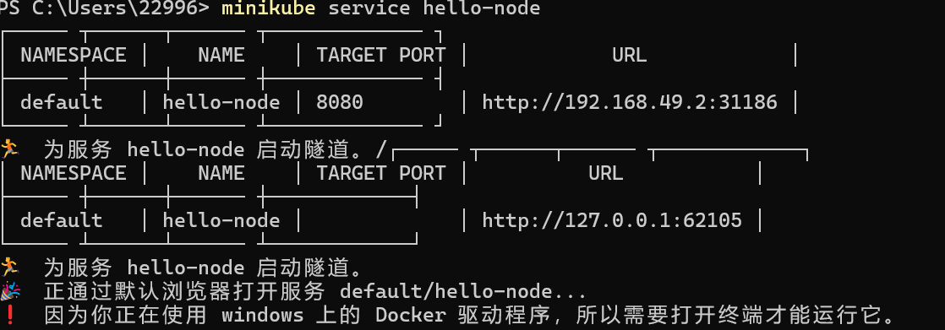

Open up a browser window that serves your app and shows the app's response
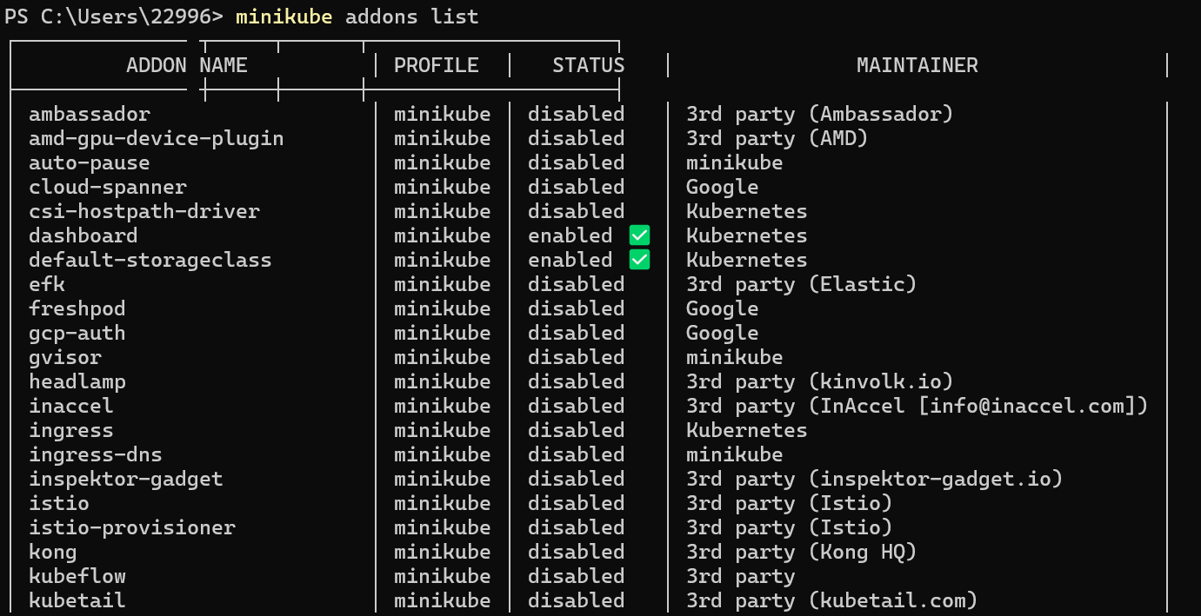
List the currently supported addons
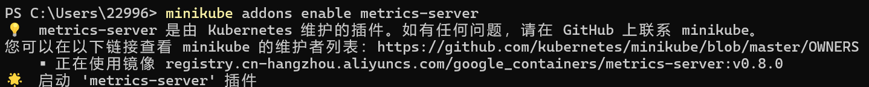
Enable an addon
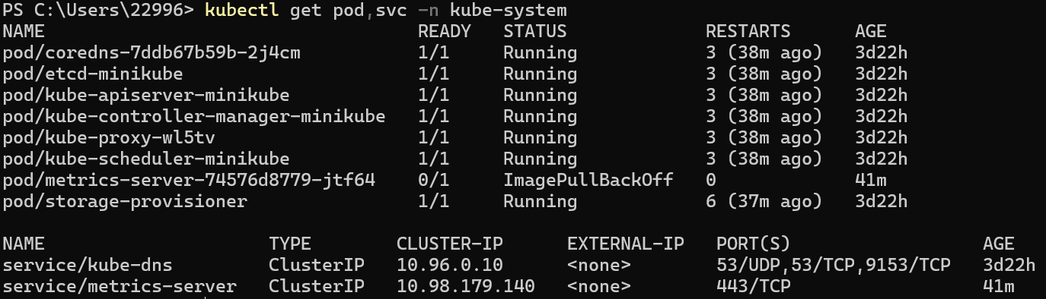
View the Pod and Service
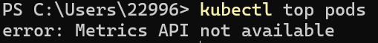
Check the output from metrics-server (after a while this became OK)
Disable metrics-server
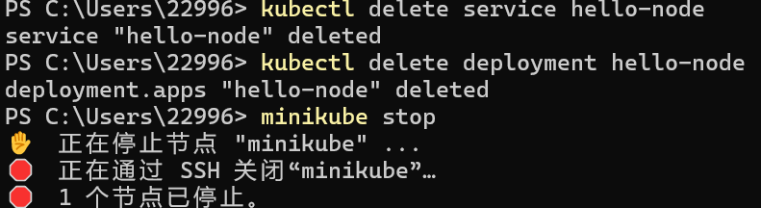
Clean up
Deploy an app
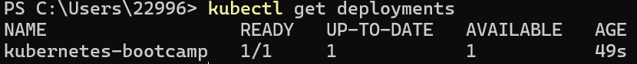
List deployments use the kubectl get deployments command
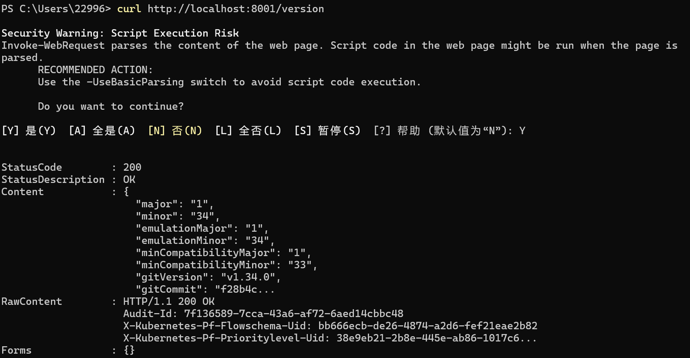
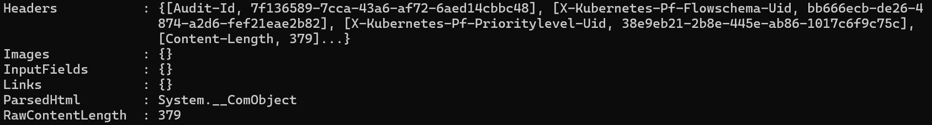
Query the version directly through the API
Get the Pod name, and store it in the environment variable

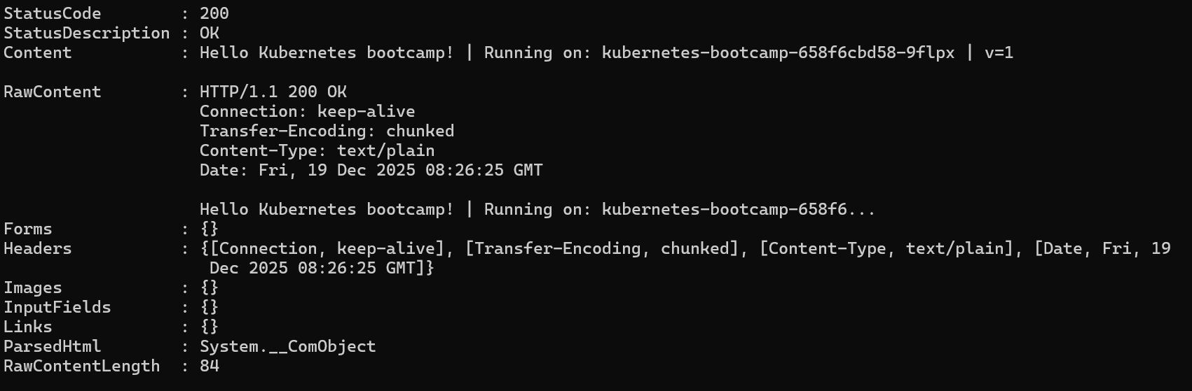
Access the Pod
Use the kubectl get command and look for existing Pods
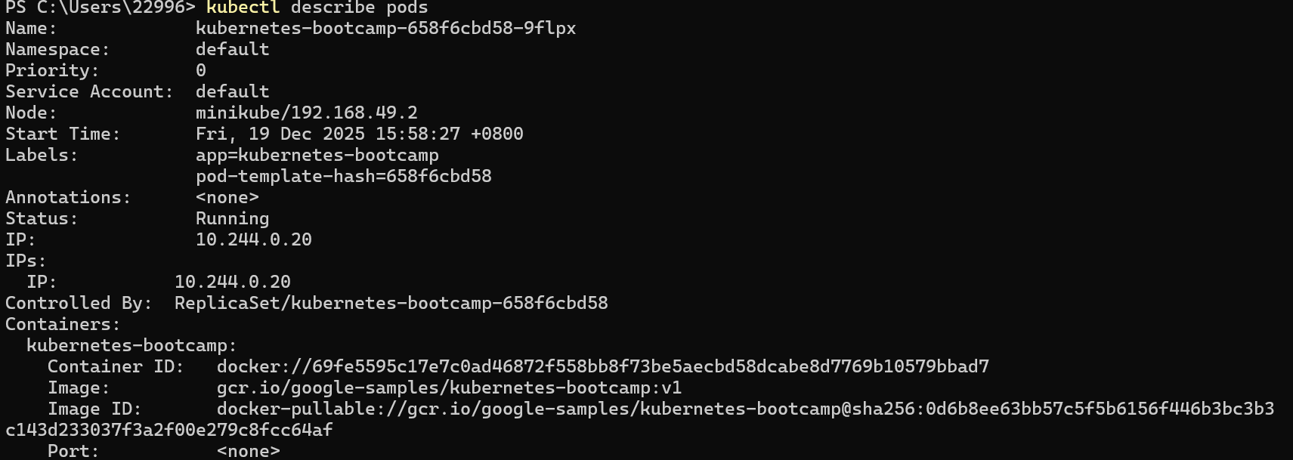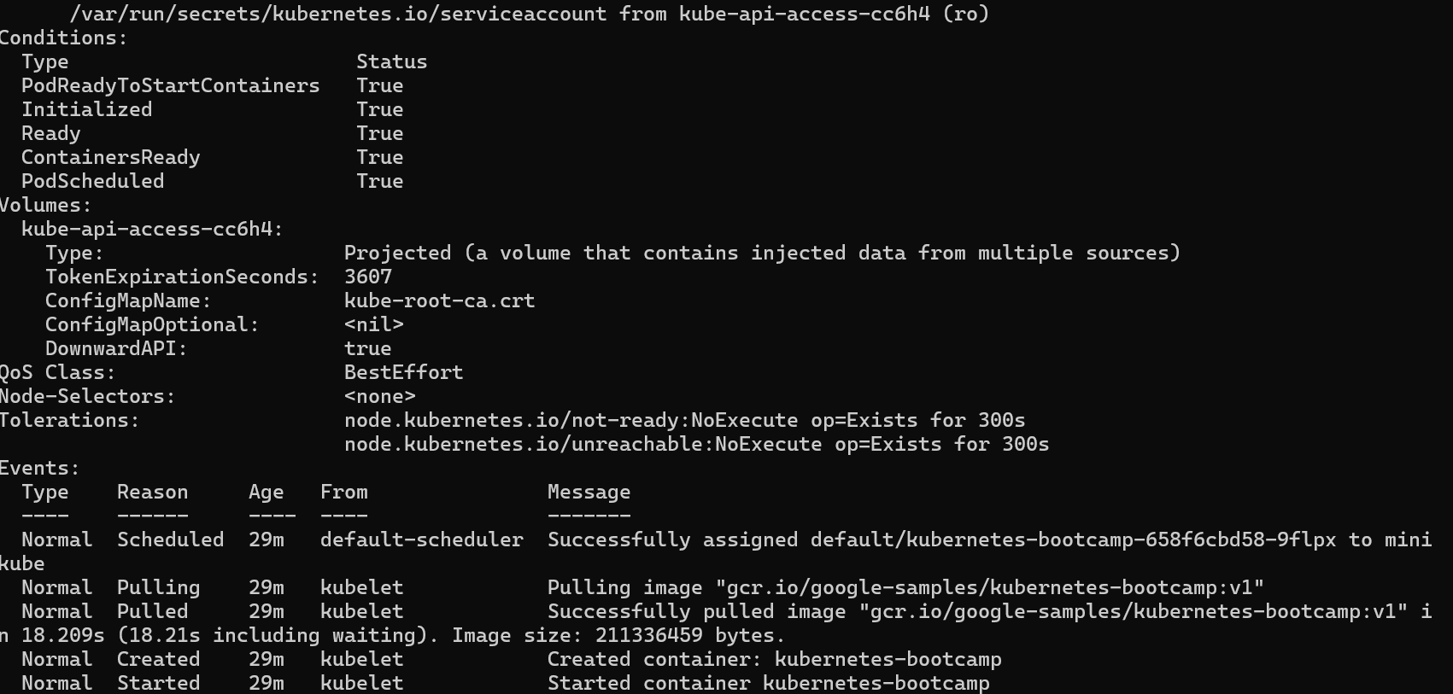
View the containers and the pods
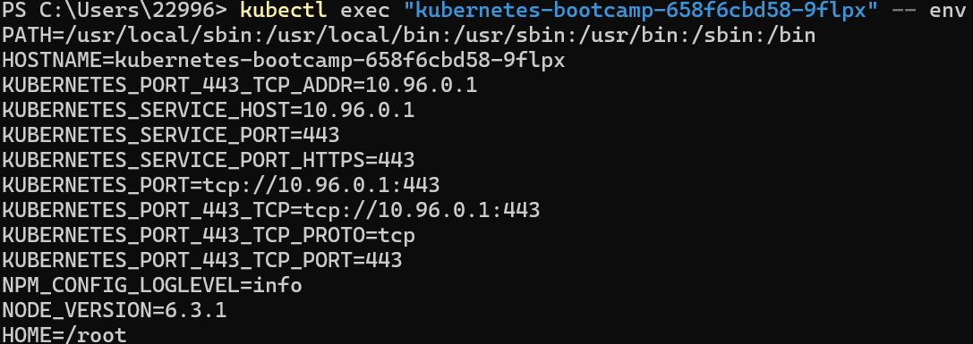
List the environment variables
Start a bash session in the Pod’s container
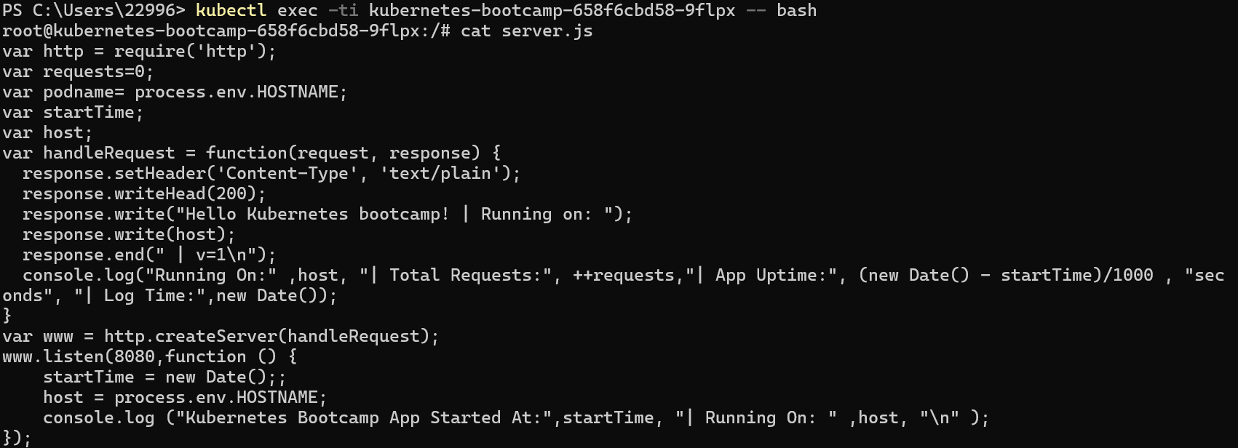
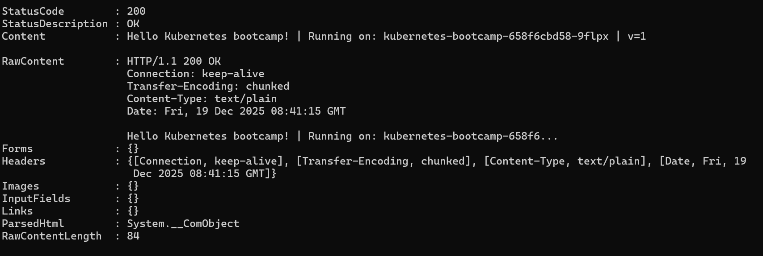
Run the NodeJS application
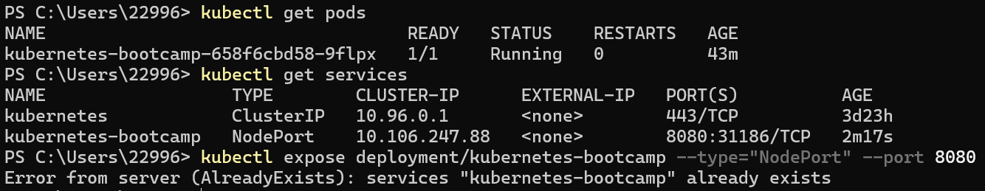
Get the pods and services and expose the deployment to the external traffic
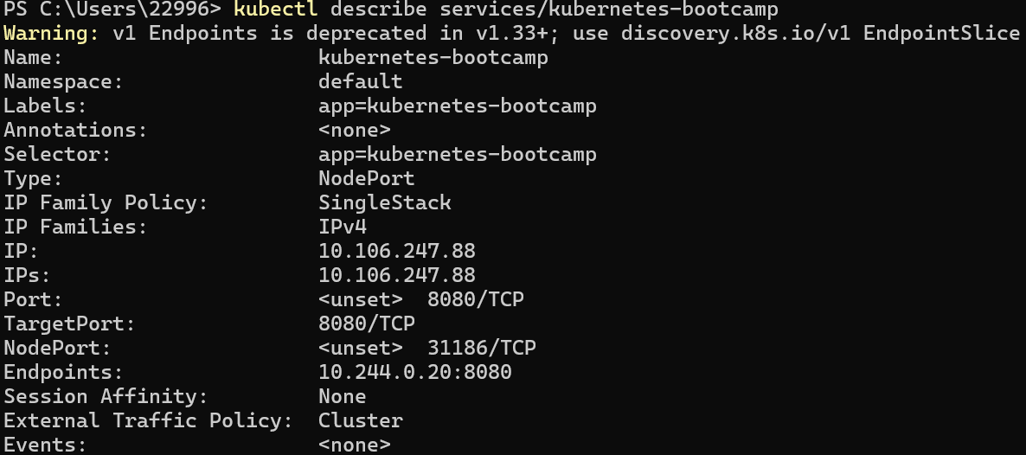
Find out what port was opened externally
Create an environment variable called NODE_PORT

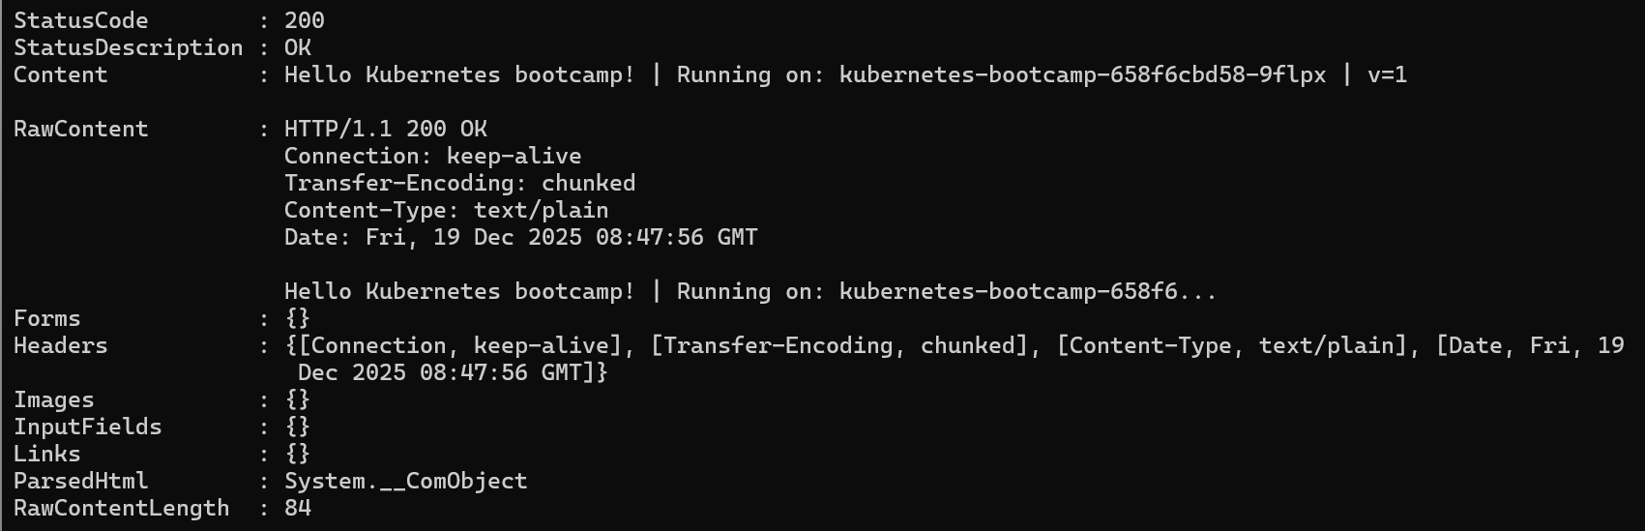
Execute the given code
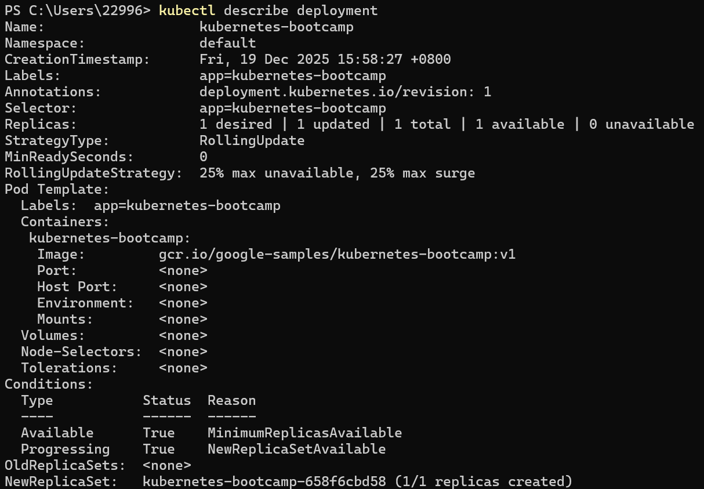
Find out the name of the label
List the pods and the services
Get the name of the Pod and store it in the POD_NAME environment variable
Apply a new label

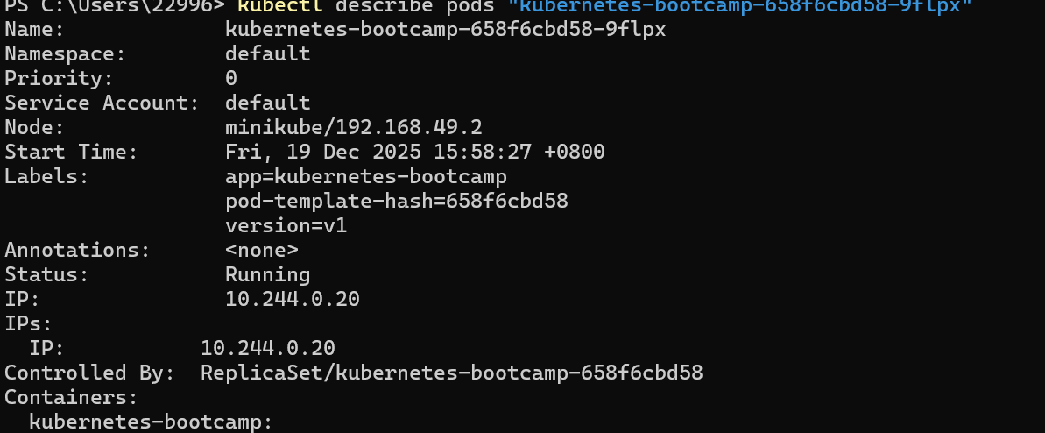
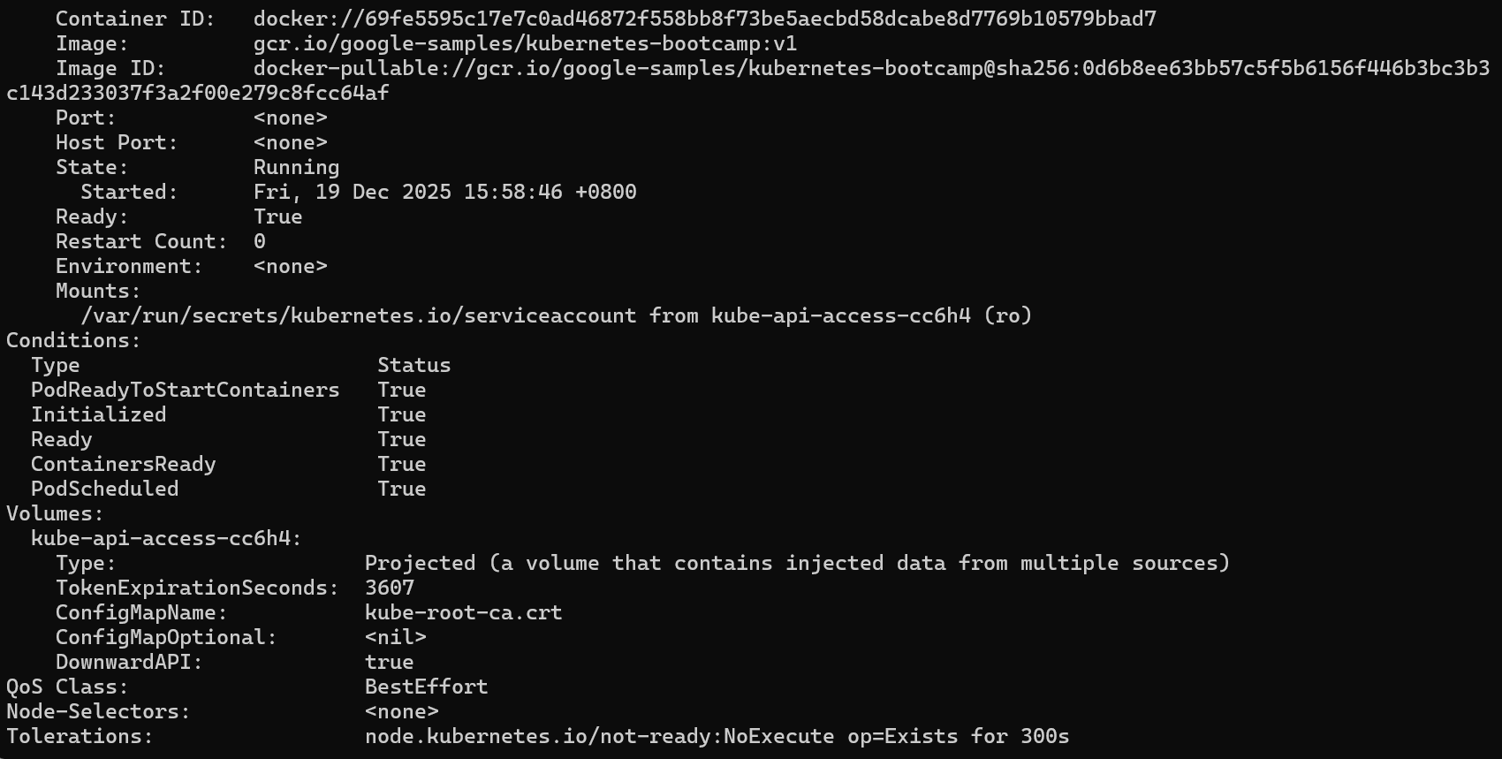
Check the new label with the describe pod command

See the Pod

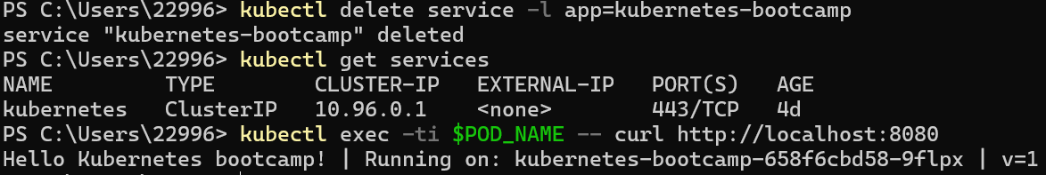
Deleting the service
Create a new Service with its type set to LoadBalancer
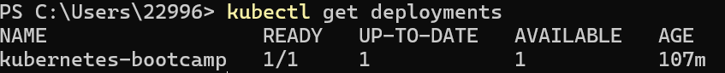
List the Deployments
See the ReplicaSet created by the Deployment
Scale the Deployment to 4 replicas
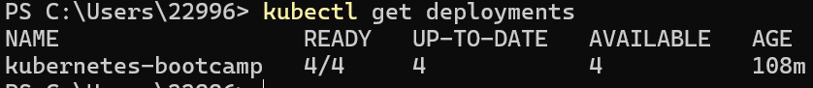
List the Deployments once again
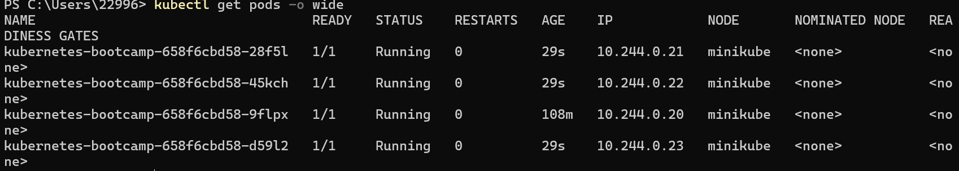
Check if the number of Pods changed
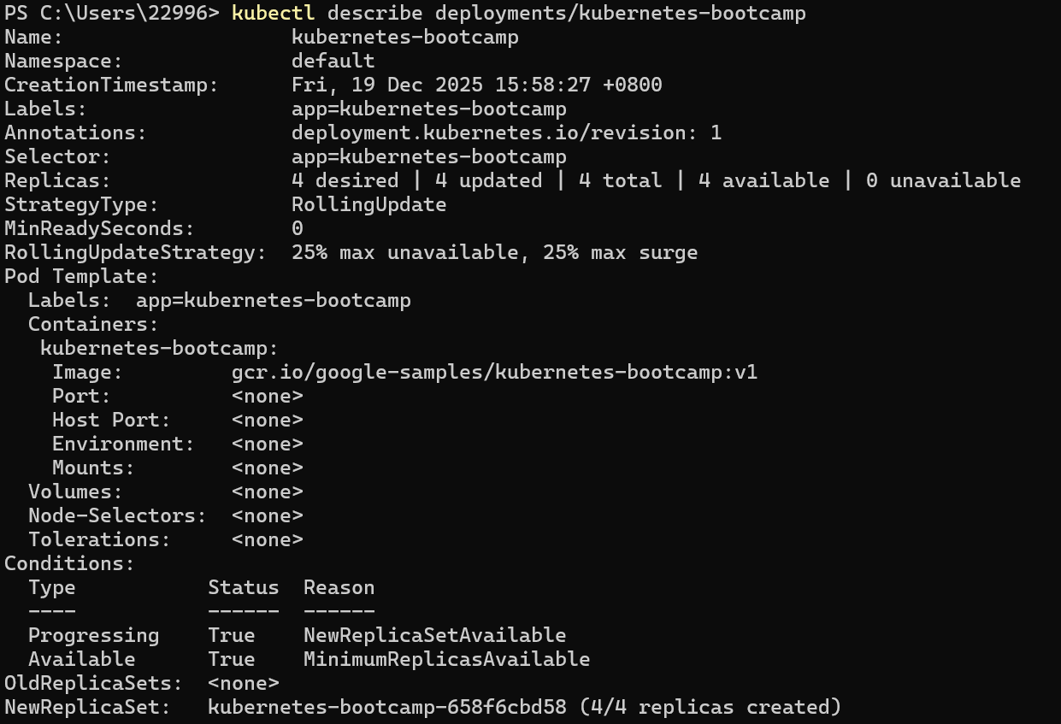
Check the change in the Deployment events log
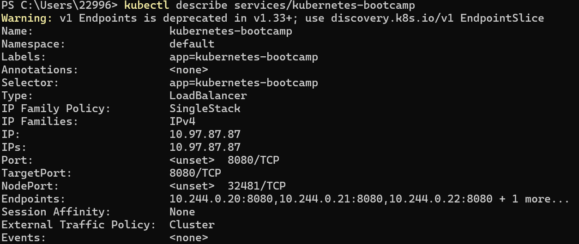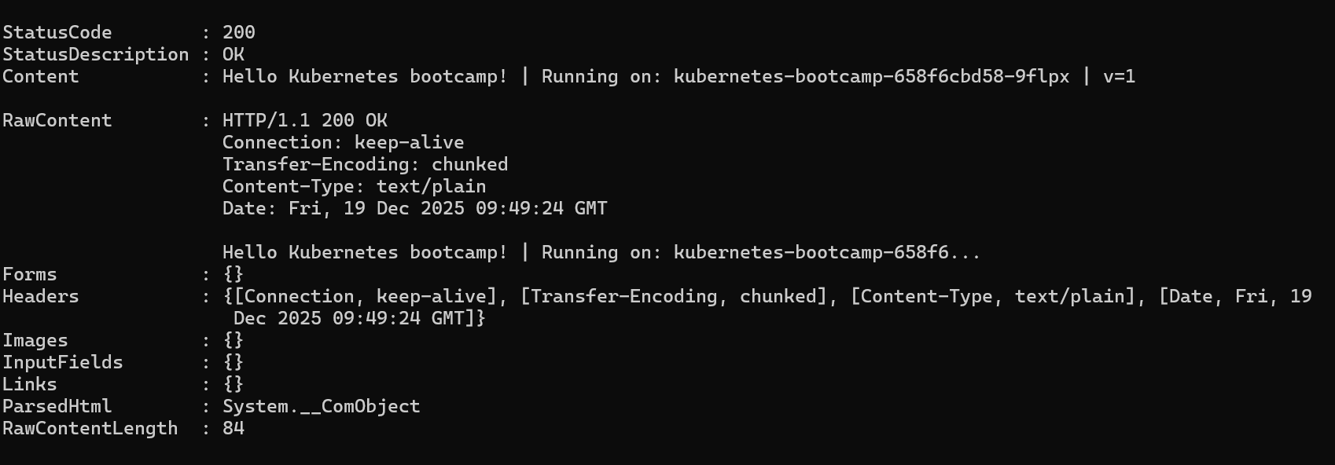
Check that the Service is load-balancing the traffic

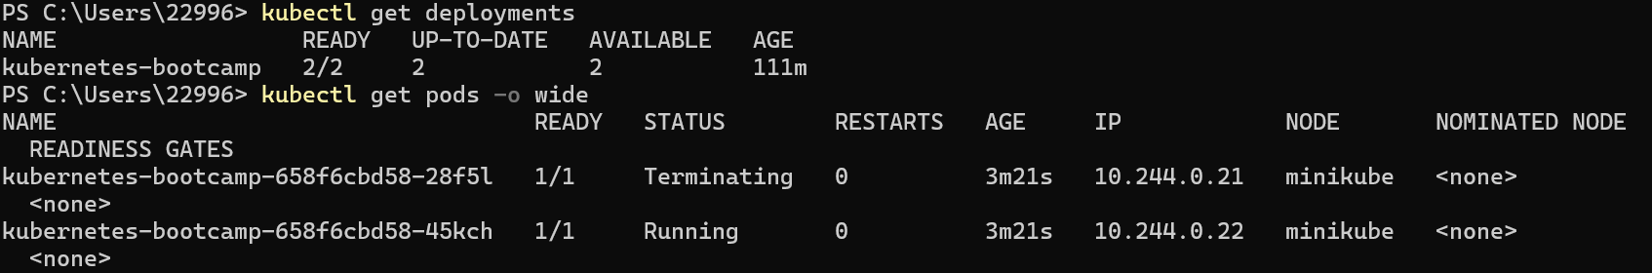
Scale down the deployment
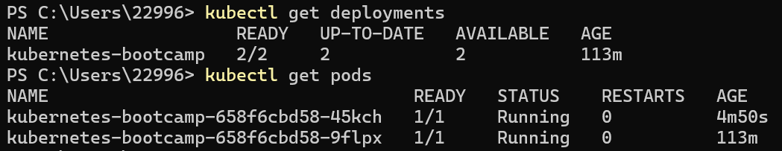
List the deployments and the pods
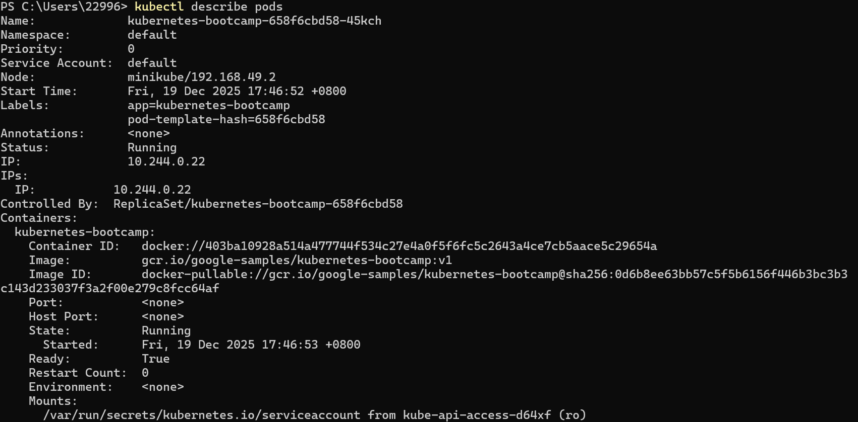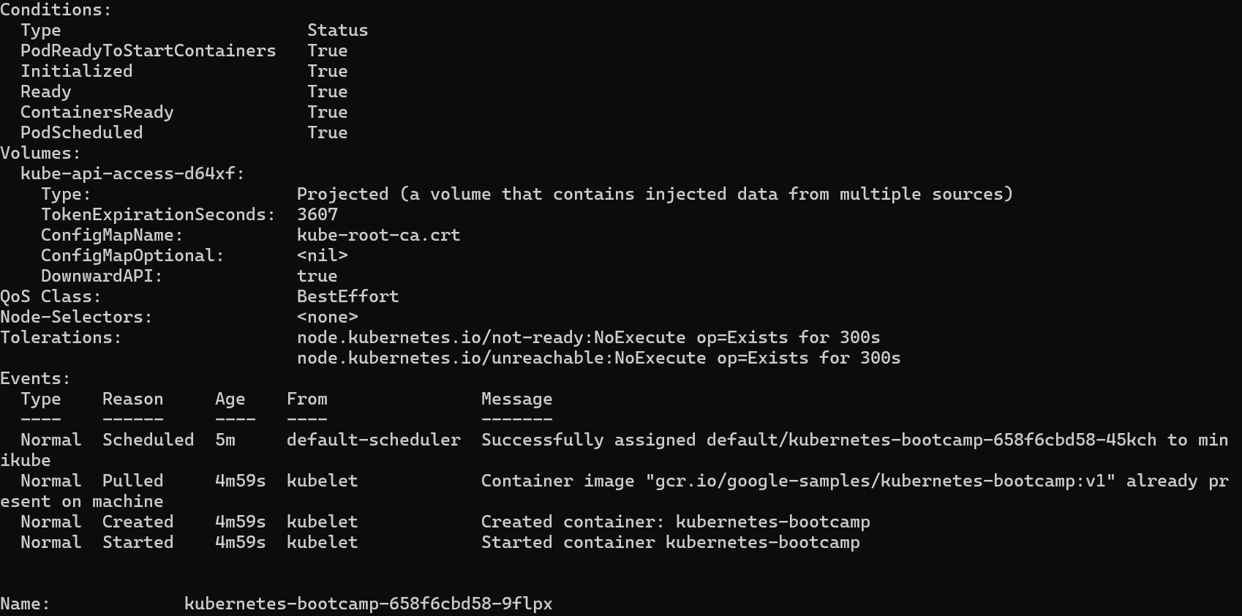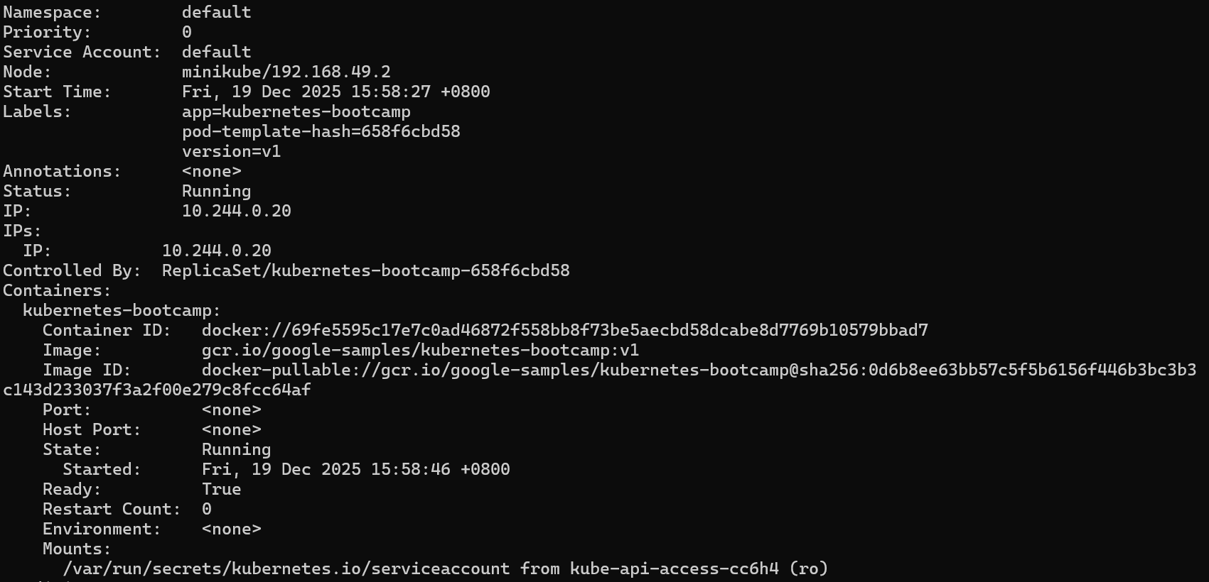
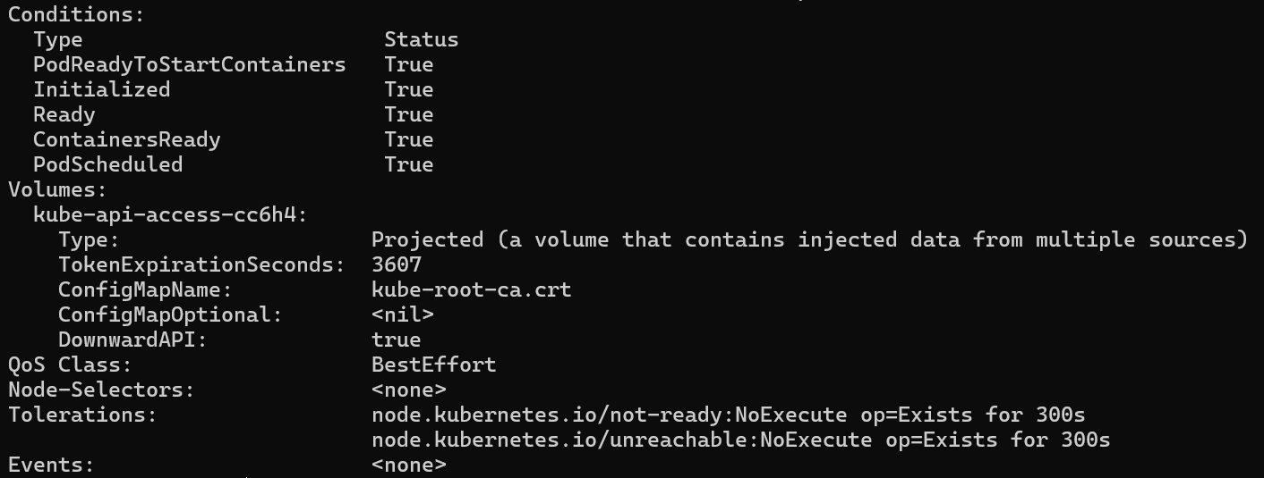
View the current image version of the app
Update the image of the application to version 2
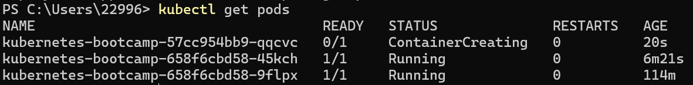
View the old one terminating
Confirm the update by running the rollout status subcommand
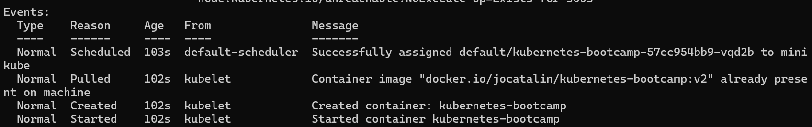
View the current image version of the app
Try to deploy an image tagged with v10
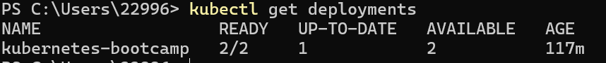
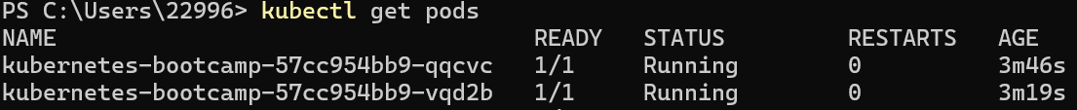
List the deployments and pods
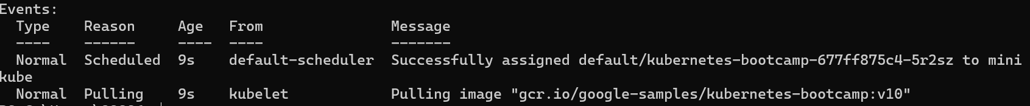
View the version of the pods
Roll back the deployment to the last working version
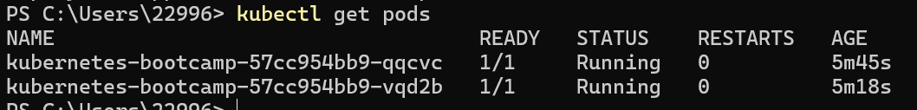
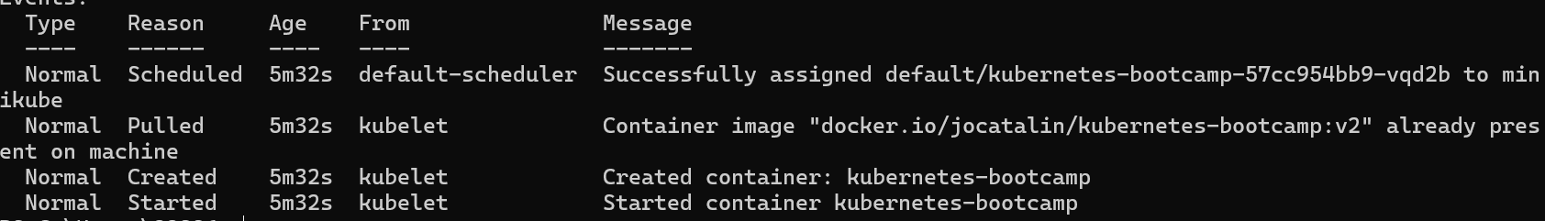
List and describe the pods
Clear up

