1.download gitea from docker.
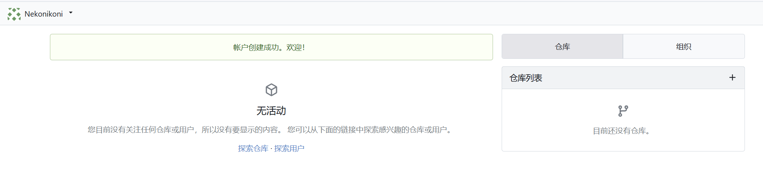
2.Check LFS and make sure it is working.
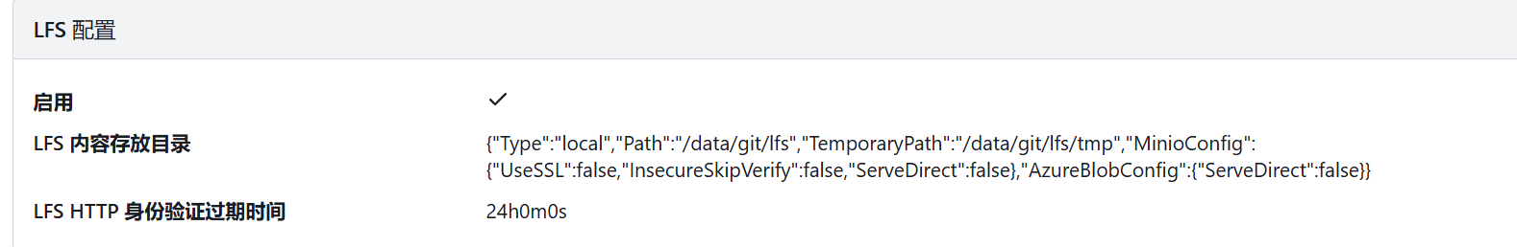
3.use CMD to add 1GB file to the repo.
