Open the terminal and run the code

The ps output and the port access to the website to see the successfully running container
Stop the container and finish the first step
Open a terminal and search for images using the docker search command
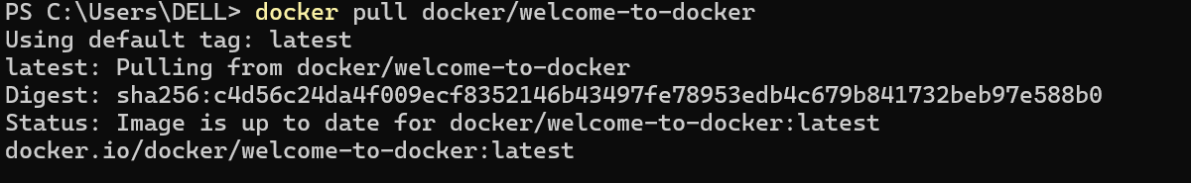
Pull the image using the docker pull command
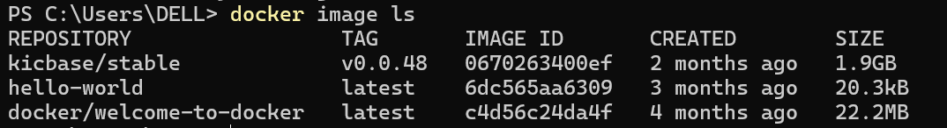
List my downloaded images
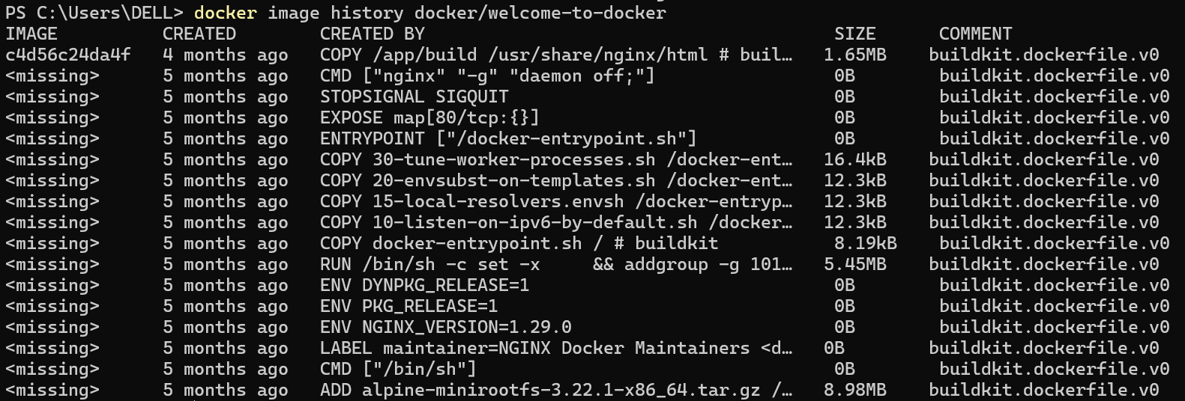
List the image's layers using the docker image history command
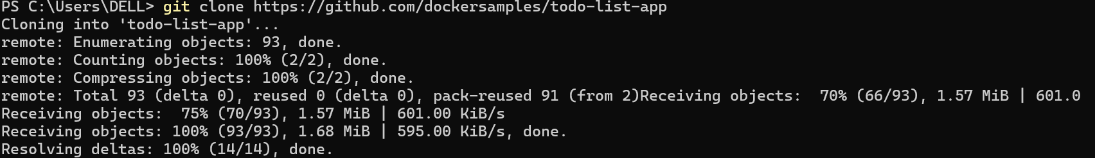
Open a terminal and clone the sample application.
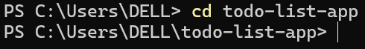
Navigate into the todo-list-app directory
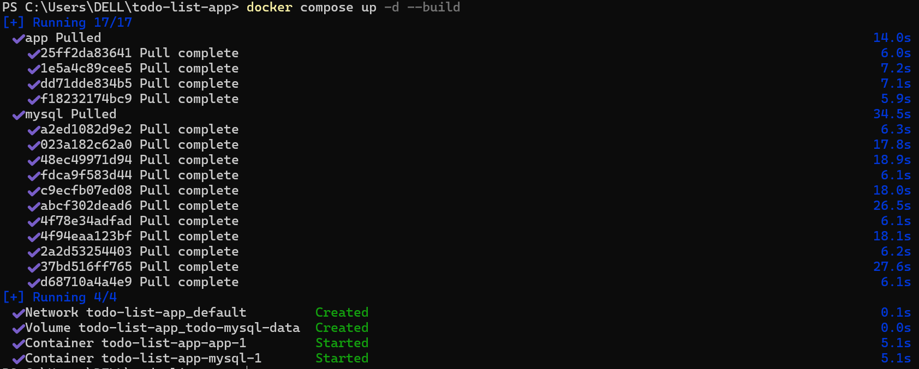
Use the docker compose up command to start the application
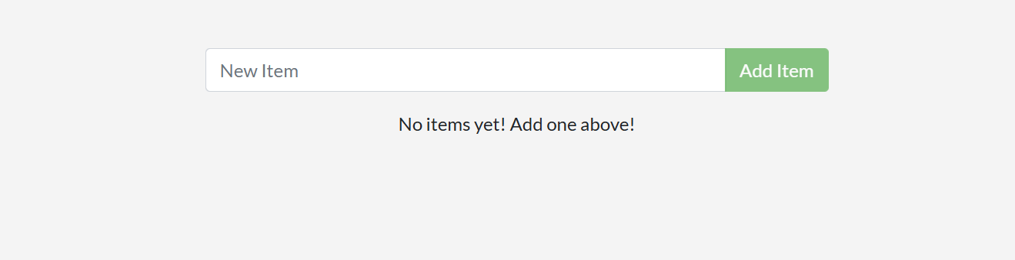

Open http://localhost:3000 in the browser to see the site
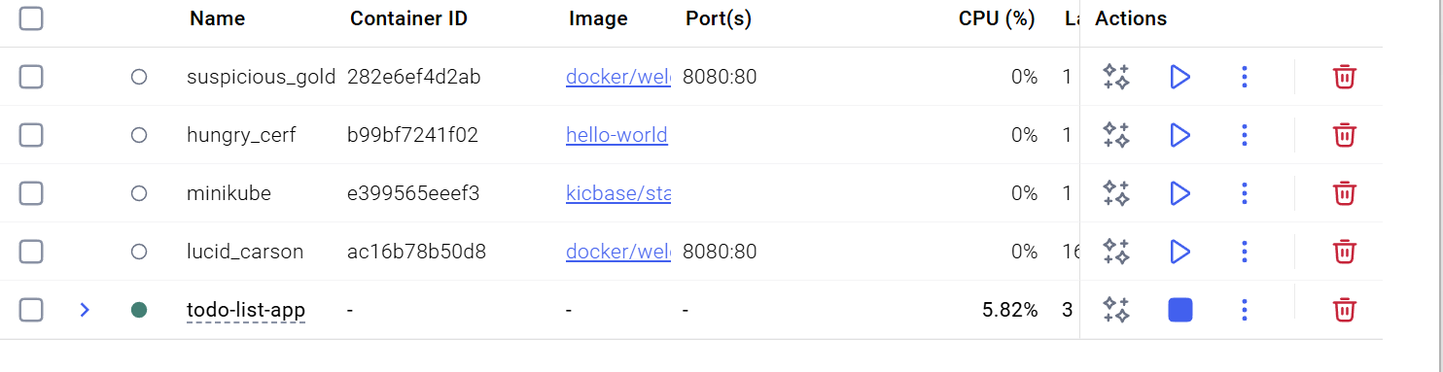
The Docker Desktop GUI
Use the docker compose down command and remove everything
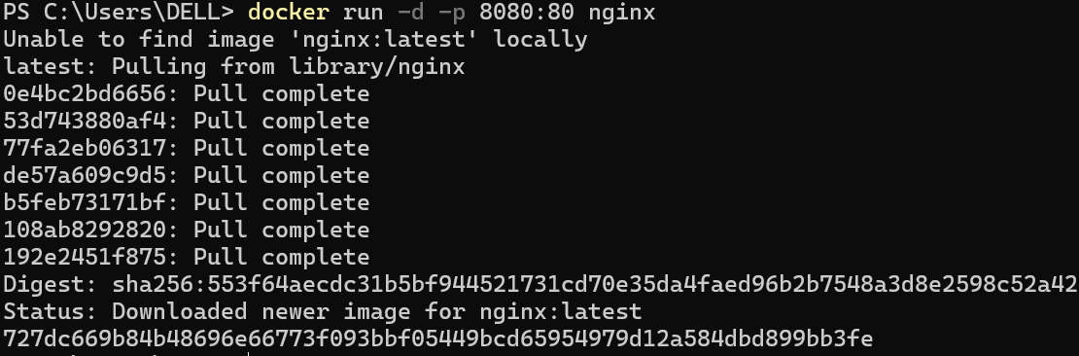
Publish the container's port 80 to host port 8080

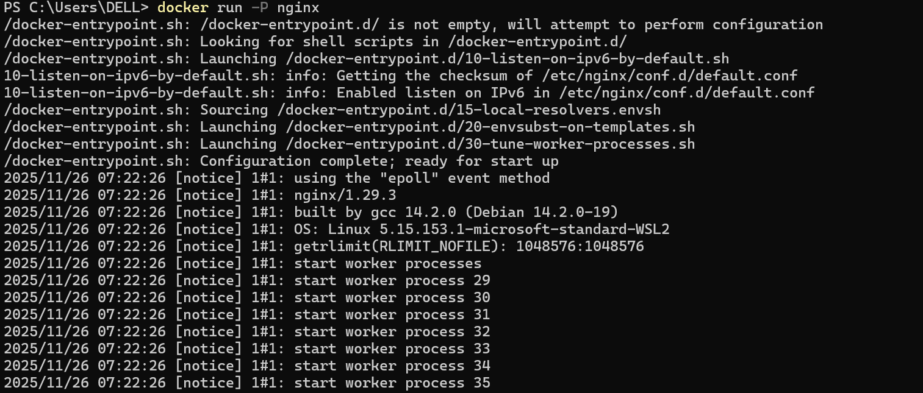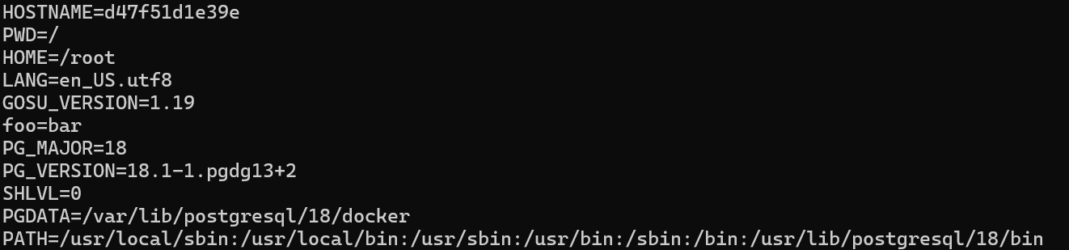
Publish all of the exposed ports configured by the image
Open two postgres and view them in the dash board
Create a new custom network
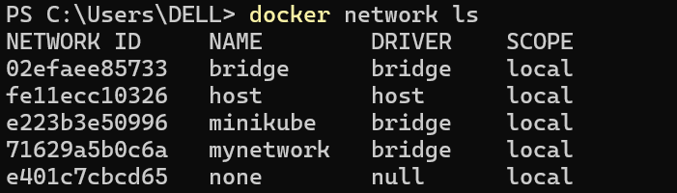
Verify the network
Connect Postgres to the custom network
Manage the resources
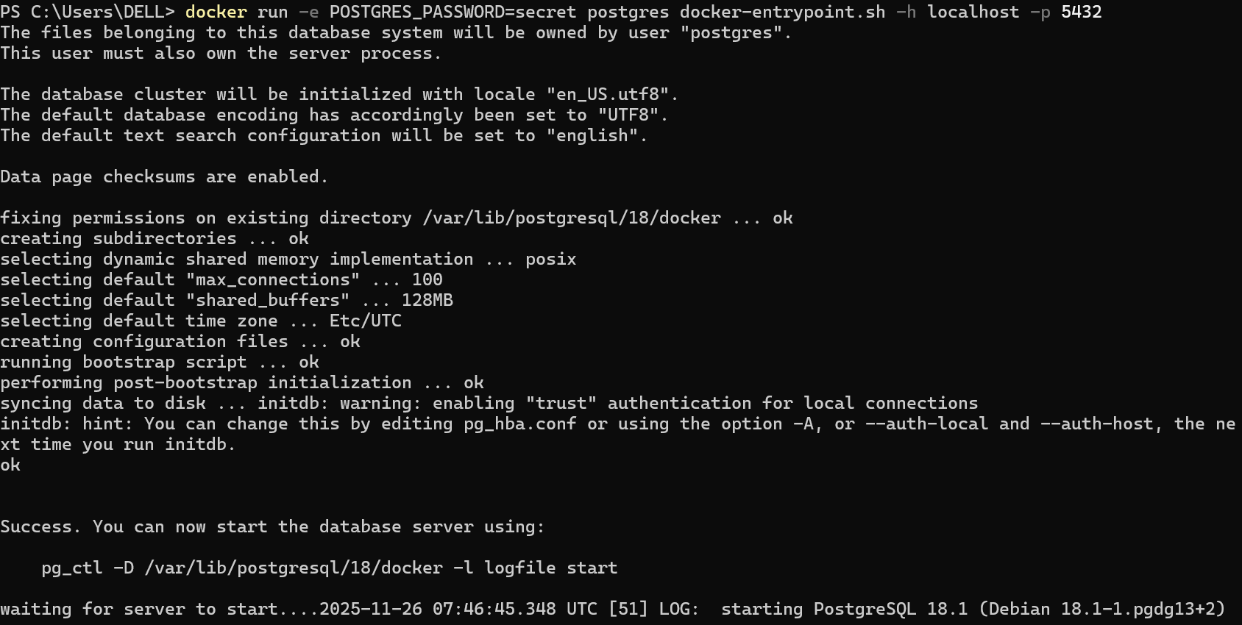
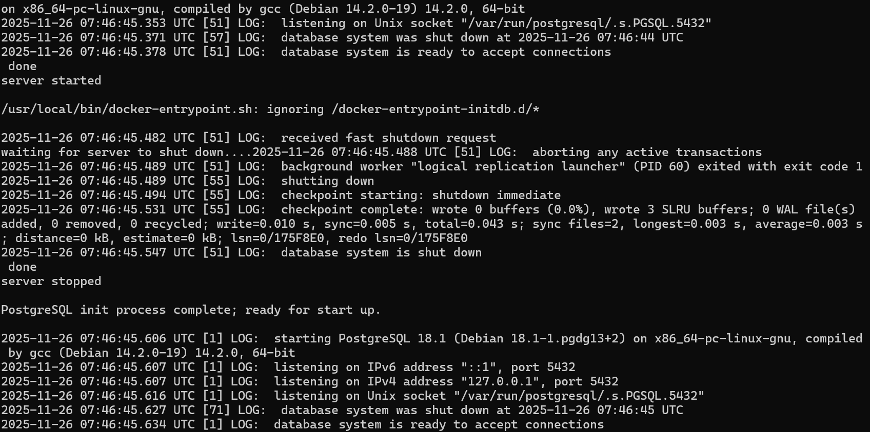
Override defaults directly using the docker run command

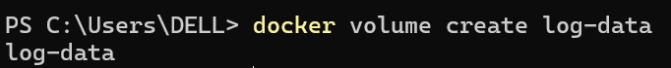
Create a volume named log-data
Starting a container
Start a container using the Postgres image
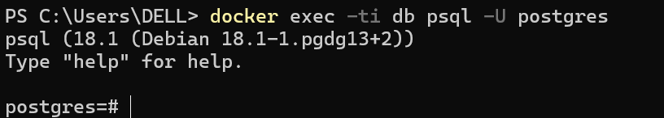
Connect to the database
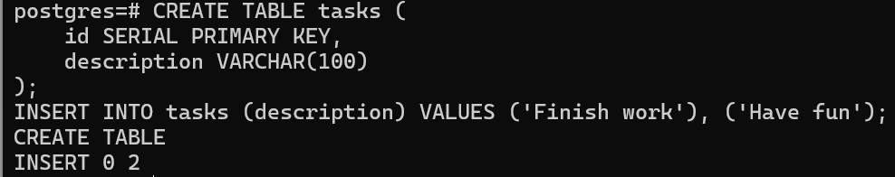
In the PostgreSQL command line，create a database table and insert two records
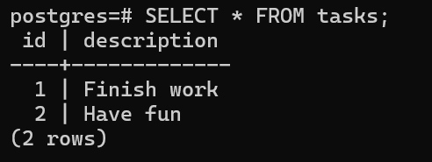
Verify the data is in the database
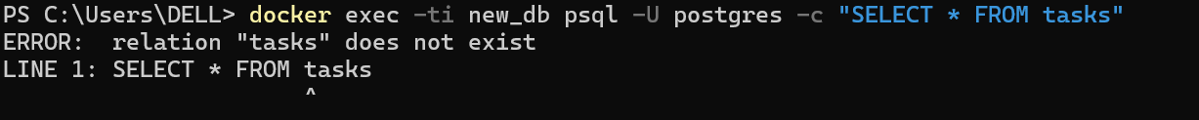
Verify the database still has the records
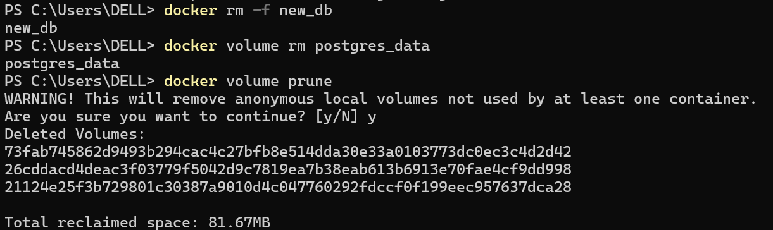
Remove the previous container
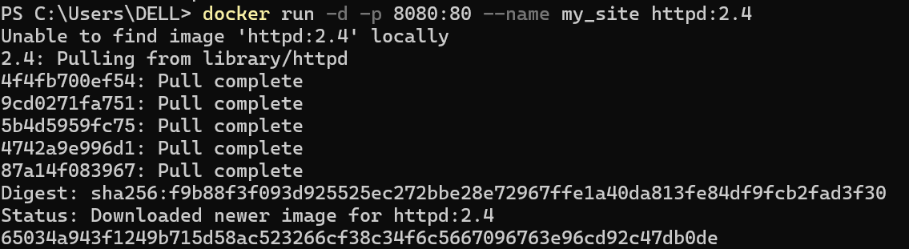
Start a container using the httpd image
Access to the localhost:8080
Navigate into the nginx directory to build the image
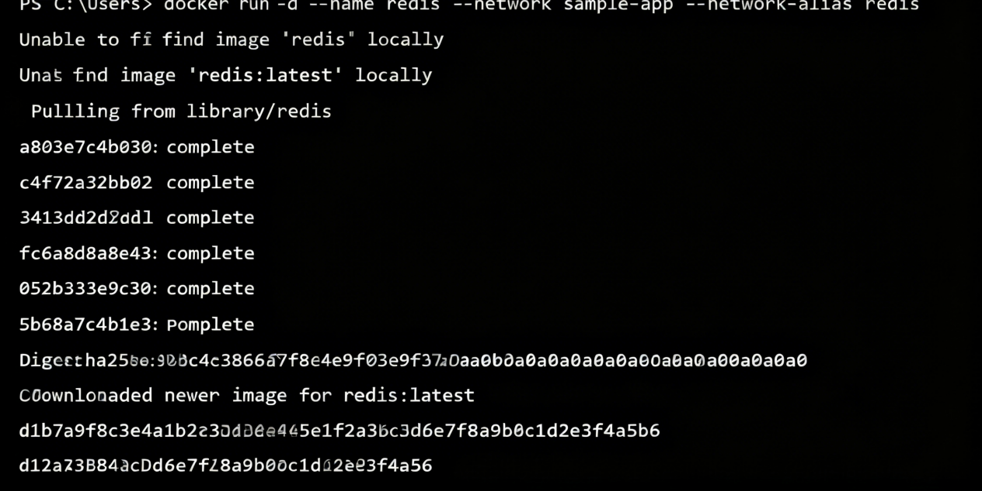

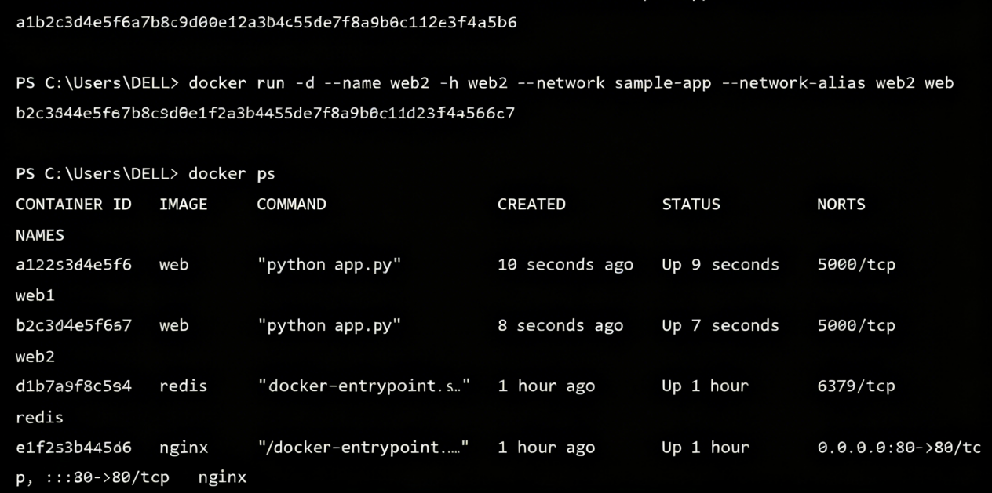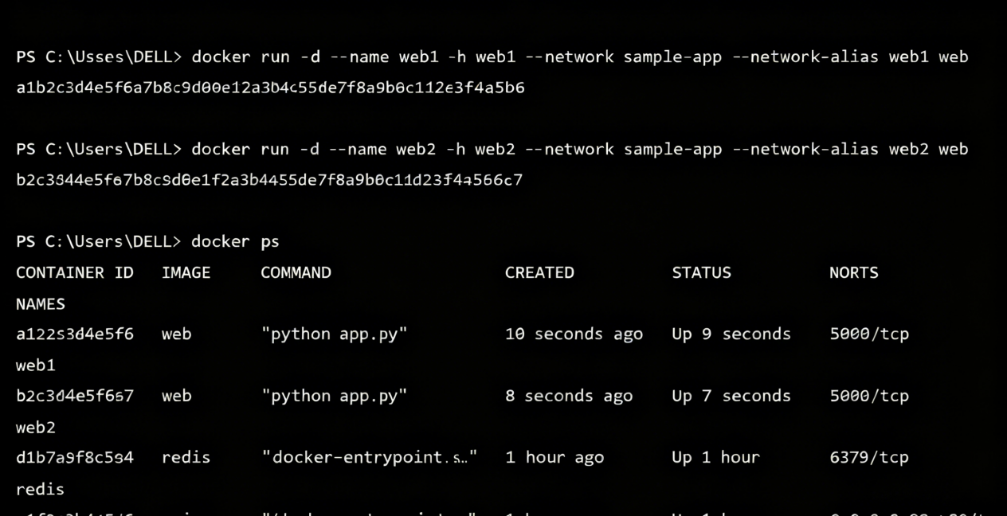
The creation and output of the two websites

