IT5512- WEB TECHNOLOGY LAB-SESSION-15
DATE: 23/11/22 FN
SIMPLE GUI APPLICATION DEVELOPMENT USING SWING

- Implement the following form using Java Swing and display the contents in another form.
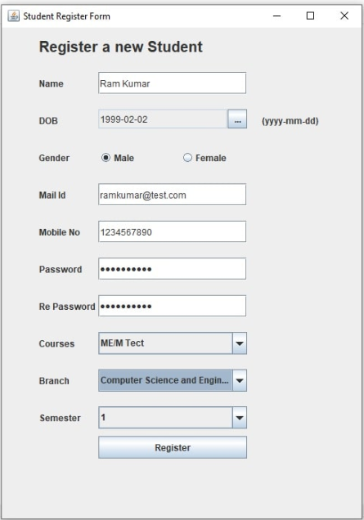

- Write a program to simulate Towers of Hanoi using Java Swing.
