IT5512- WEB TECHNOLOGY LAB-SESSION-5
DATE: 14/09/22 FN
INHERITANCE, SUPER, FINAL, ARRAYLIST

- Create a class named 'Member' having the following members: Data members
1 - Name
2 - Age
3 - Phone number
4 - Address
5 – Salary
It also has a method named 'printSalary' which prints the salary of the members.
Two classes 'Employee' and 'Manager' inherits the 'Member' class. The 'Employee' and 'Manager' classes have data members 'specialization' and 'department' respectively. Now, assign name, age, phone number, address and salary to an employee and a manager by making an object of both of these classes and print the same. (Note: Use all access specifier)
- Create a class country, state, city and village. Arrange these classes in hierarchical manner.
- Declare a class of vehicle. Derived classes are two-wheeler, three-wheeler and four-wheeler. Display the properties of each type of vehicle using member function of class.
- Write a Java program to implement the following scenario with these keywords/concepts listed below: i.) this ii.)super iii.)final iv.)Access Modifier v.) static
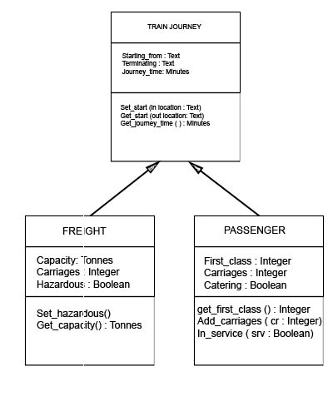
- Write a java program to store details of student and using ArrayList class methods (add,remove,addall,remove,contains,size,get) do the necessary manipulations.
- Write a method reverse that reverses the order of the elements in an ArrayList of strings. Write a method capitalizePlurals that accepts an ArrayList of strings and replaces every word ending with an "s" with its uppercased version. Write a method removePlurals that accepts an ArrayList of strings and removes every word in the list ending with an "s", case-insensitively.
- Write a program that reads a numbers from ArrayList and displays all the numbers as a list, then: a. Prints the average of the numbers. b. Prints the highest and lowest number. c. Filters out all of the even numbers (ones divisible by 2).

