IT5512- WEB TECHNOLOGY LAB-SESSION-6
DATE: 21/09/22 FN
INTERFACE, ABSTRACT, POLYMORPHISM, REGULAR EXPRESSION

- Write a Java program to implement the following specified in the picture using inheritance, interface concepts and calculate the salary of an employee. Use super keyword , access modifiers
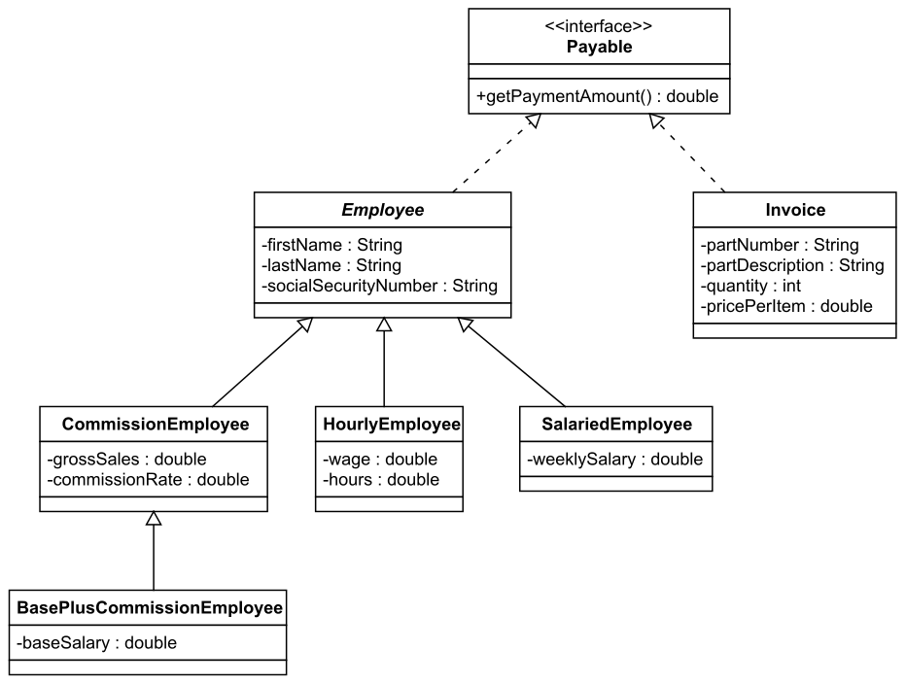
- We have to calculate the percentage of marks obtained in three subjects (each out of 100) by student A and in four subjects (each out of 100) by student B. Create an abstract class 'Marks' with an abstract method 'getPercentage'. It is inherited by two other classes 'A' and 'B' each having a method with the same name which returns the percentage of the students. The constructor of student A takes the marks in three subjects as its parameters and the marks in four subjects as its parameters for student B. Create an object for each of the two classes and print the percentage of marks for both the students.
- Write a program OnlinebookShop which sells and then add Technical Book and Non-Technical book as subclasses of the Book class which holds the details about book name, publisher, Published year, edition and price. Implement the polymorphic behavior through overriding methods. Explore the usage of Upcasting and Downcasting also.
- Write a java program for registering the details of jobseeker. The requirements are mentioned below.
i. username should always end with _job and there should be atleast minimum of characters to the left of _job.
ii. Validate the emaild provided by the user.
iii. Password should accept only characters and numbers.
5. An company requires each employee to maintain a secret code. The secret code needs to pass certain validation for getting accepted. The validation rules are given as follows:
i. The secret code should be six characters long
ii. The first three characters should be cod
iii. There should be at least one digit in code (use isDigit)
iv. The first character should always be an upper case letter (Use isUpperCase)
v. The code should contain only alphabets and digits
Return true if the above validation is passed.

