IT5512- WEB TECHNOLOGY LAB-SESSION-1
DATE: 17/08/22 FN

BASIC JAVA PROGRAMS

Instructions to set java path

To set the path of JDK, you need to follow following
steps:
- Open command prompt
- copy the path of jdk/bin directory
- write in command prompt: set path=copied_path
Command to set path:

set path=C:\Program Files\Java\jdk1.6.0_23\bin

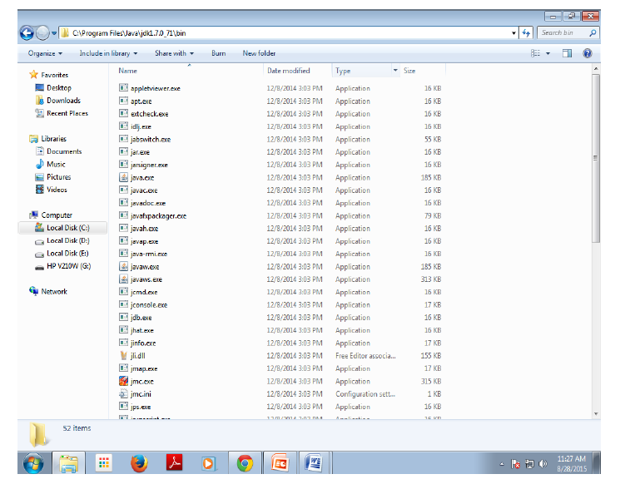
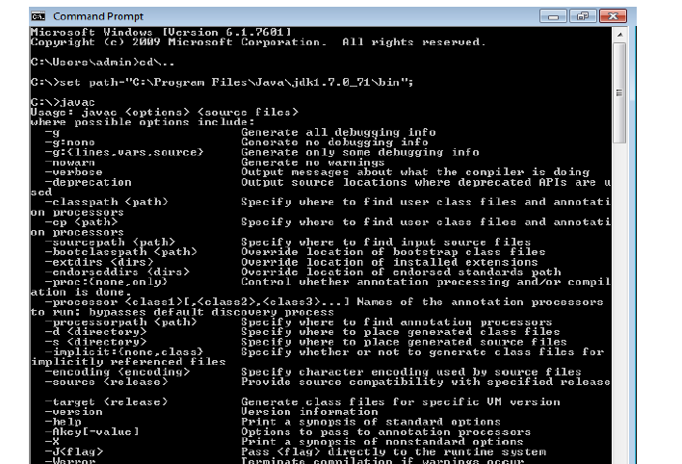

OR

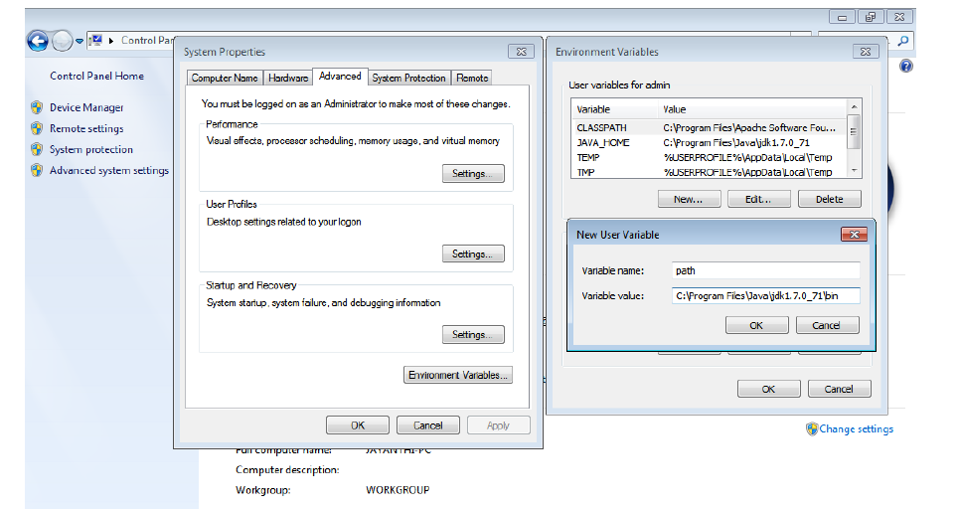

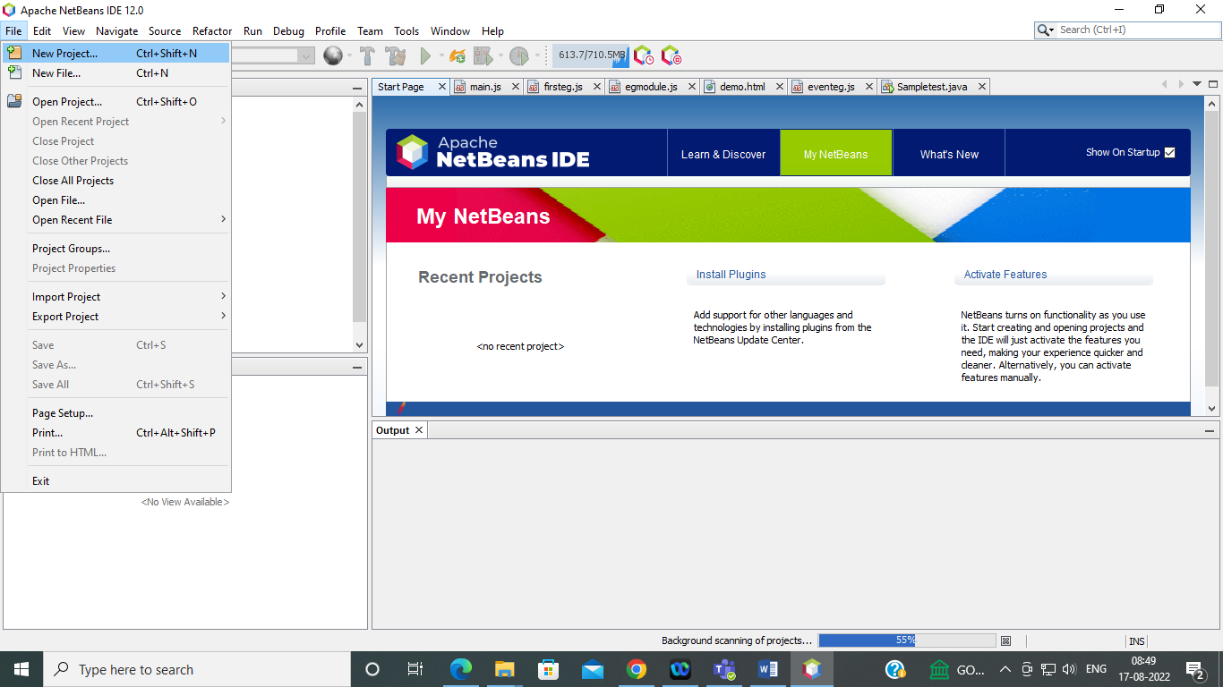

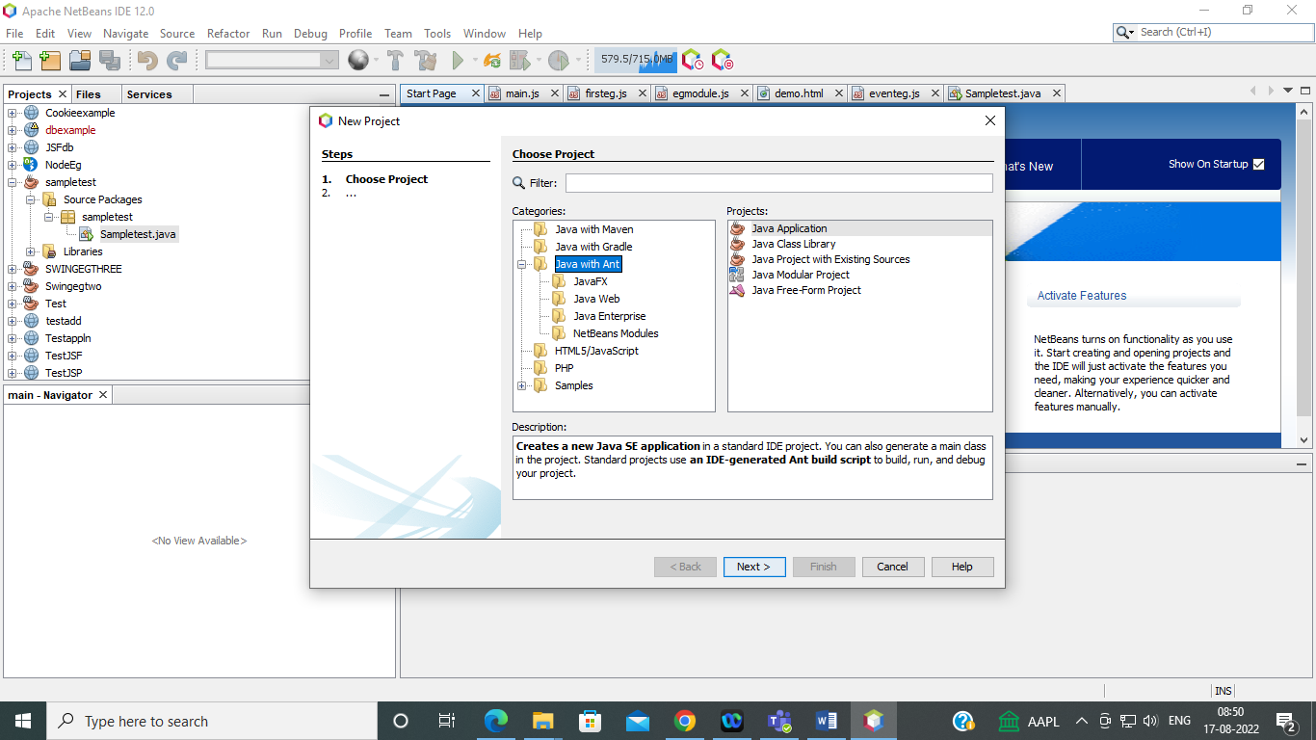
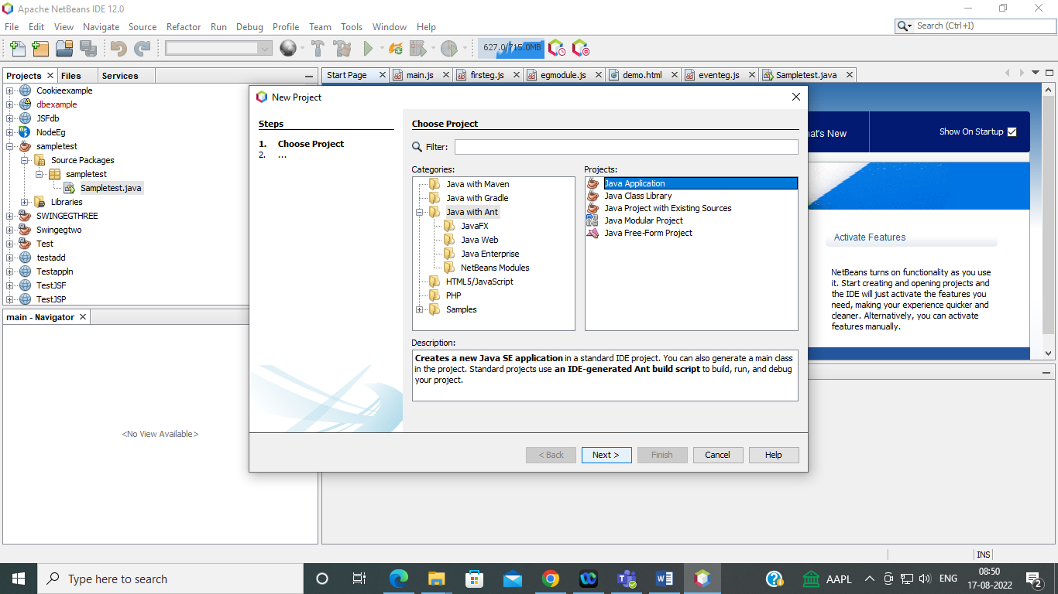
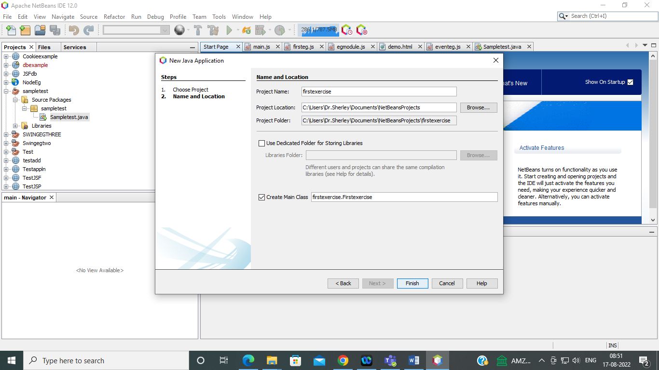
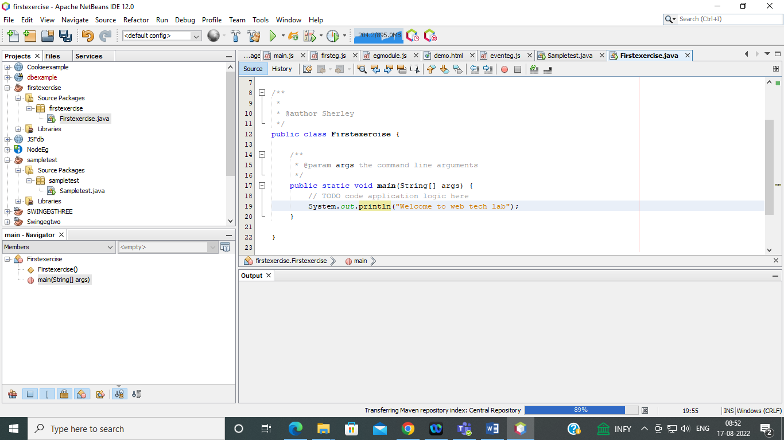
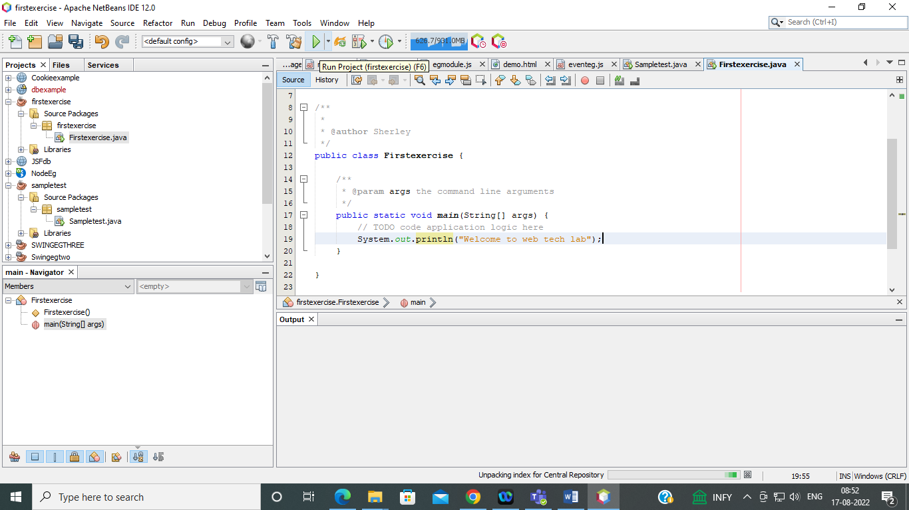
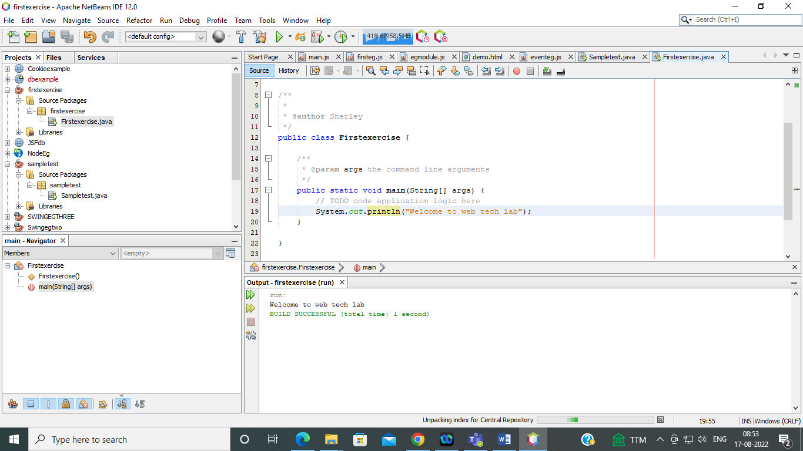

Basic programs:

class FibonacciExample1{
public static void main(String args[])
{
int n1=0,n2=1,n3,i,count=10;
System.out.print(n1+" "+n2);//printing 0 and 1
for(i=2;i<count;++i) {
n3=n1+n2;
System.out.print(" "+n3);
n1=n2;
n2=n3;
}
}}

Syntax for Declaring Class:
<AccessModifier>class<Class_Name>
class Student1{
int id;
String name;
public static void main(String args[]){
Student1 s1=new Student1();
System.out.println(s1.id);
System.out.println(s1.name);
}
}

Objects:
Objects have states and behaviors. Example: A dog has states - color, name,
breed as well as behaviors -wagging, barking, eating. An object is an instance of a
class
An object has three characteristics:
• State : represents data (value) of an object.
• Behavior : represents the behavior (functionality) of an object such as deposit,
withdraw etc.
• Identity : Object identity is typically implemented via a unique ID. The value
of the ID is not visible to the external user. But,it is used internally by the JVM
to identify each object uniquely.
Syntax:
<Class_Name>ClassObjectReference = new <Class_Name>();

How to Access Member of a Class:
You call a method of an object by naming the object followed by a period (dot), this should be followed by the name of the method and its argument list.
Syntax :

objectName.methodName(arg1, arg2, arg3).

Example
class Student2{
int rollno;
String name;
Void insertRecord(int r, String n){ //method
rollno=r;
name=n;
}
Void displayInformation(){
System.out.println(rollno+" "+name);
}//method
public static void main(String args[]){
Student2 s1=new Student2();
Student2 s2=new Student2();
s1.insertRecord(111,"Karan");
s2.insertRecord(222,"Aryan");
s1.displayInformation();
s2.displayInformation();
}
}

