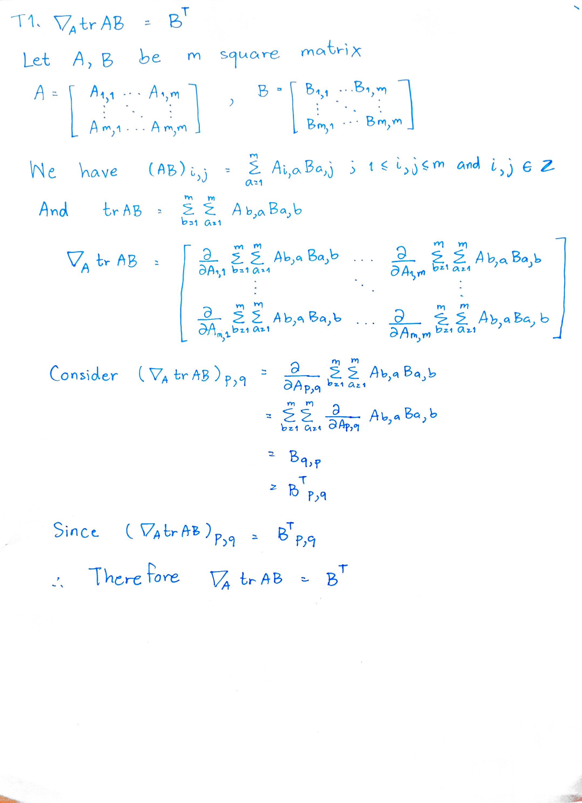
T1.

T2.
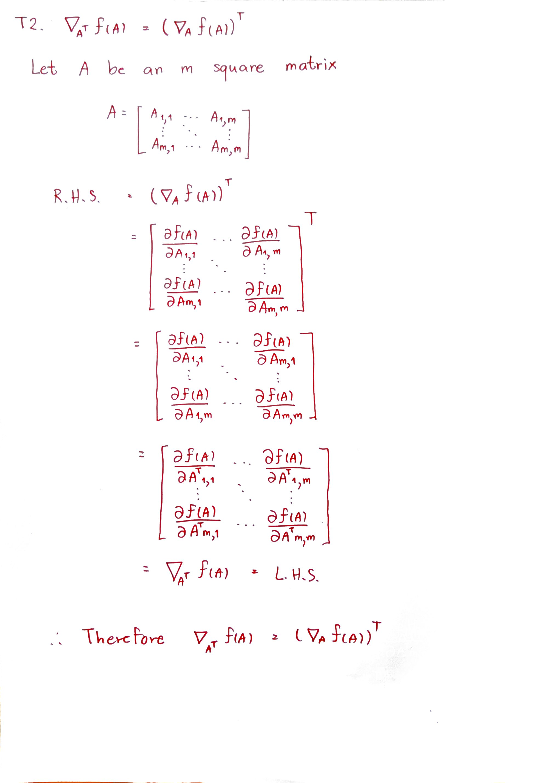

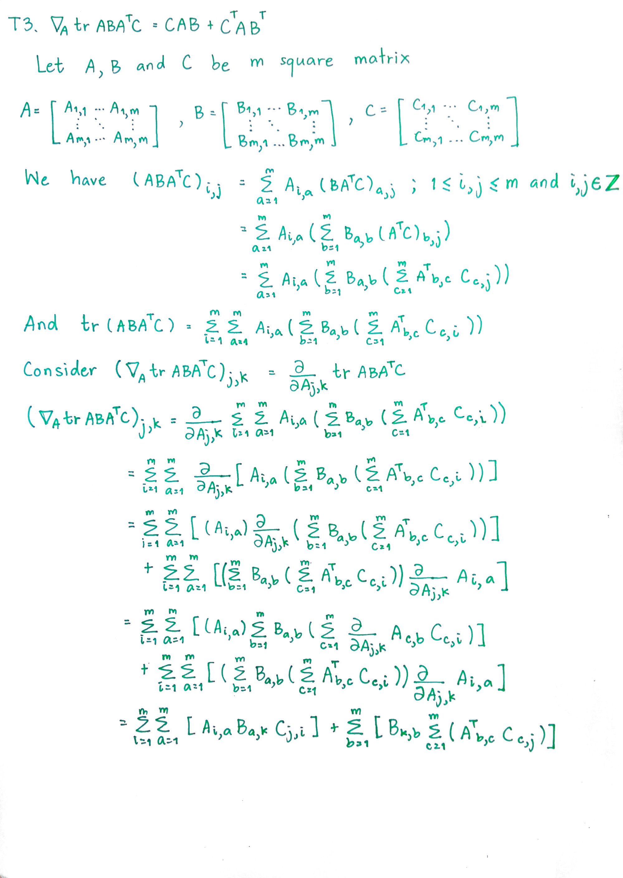
T3.

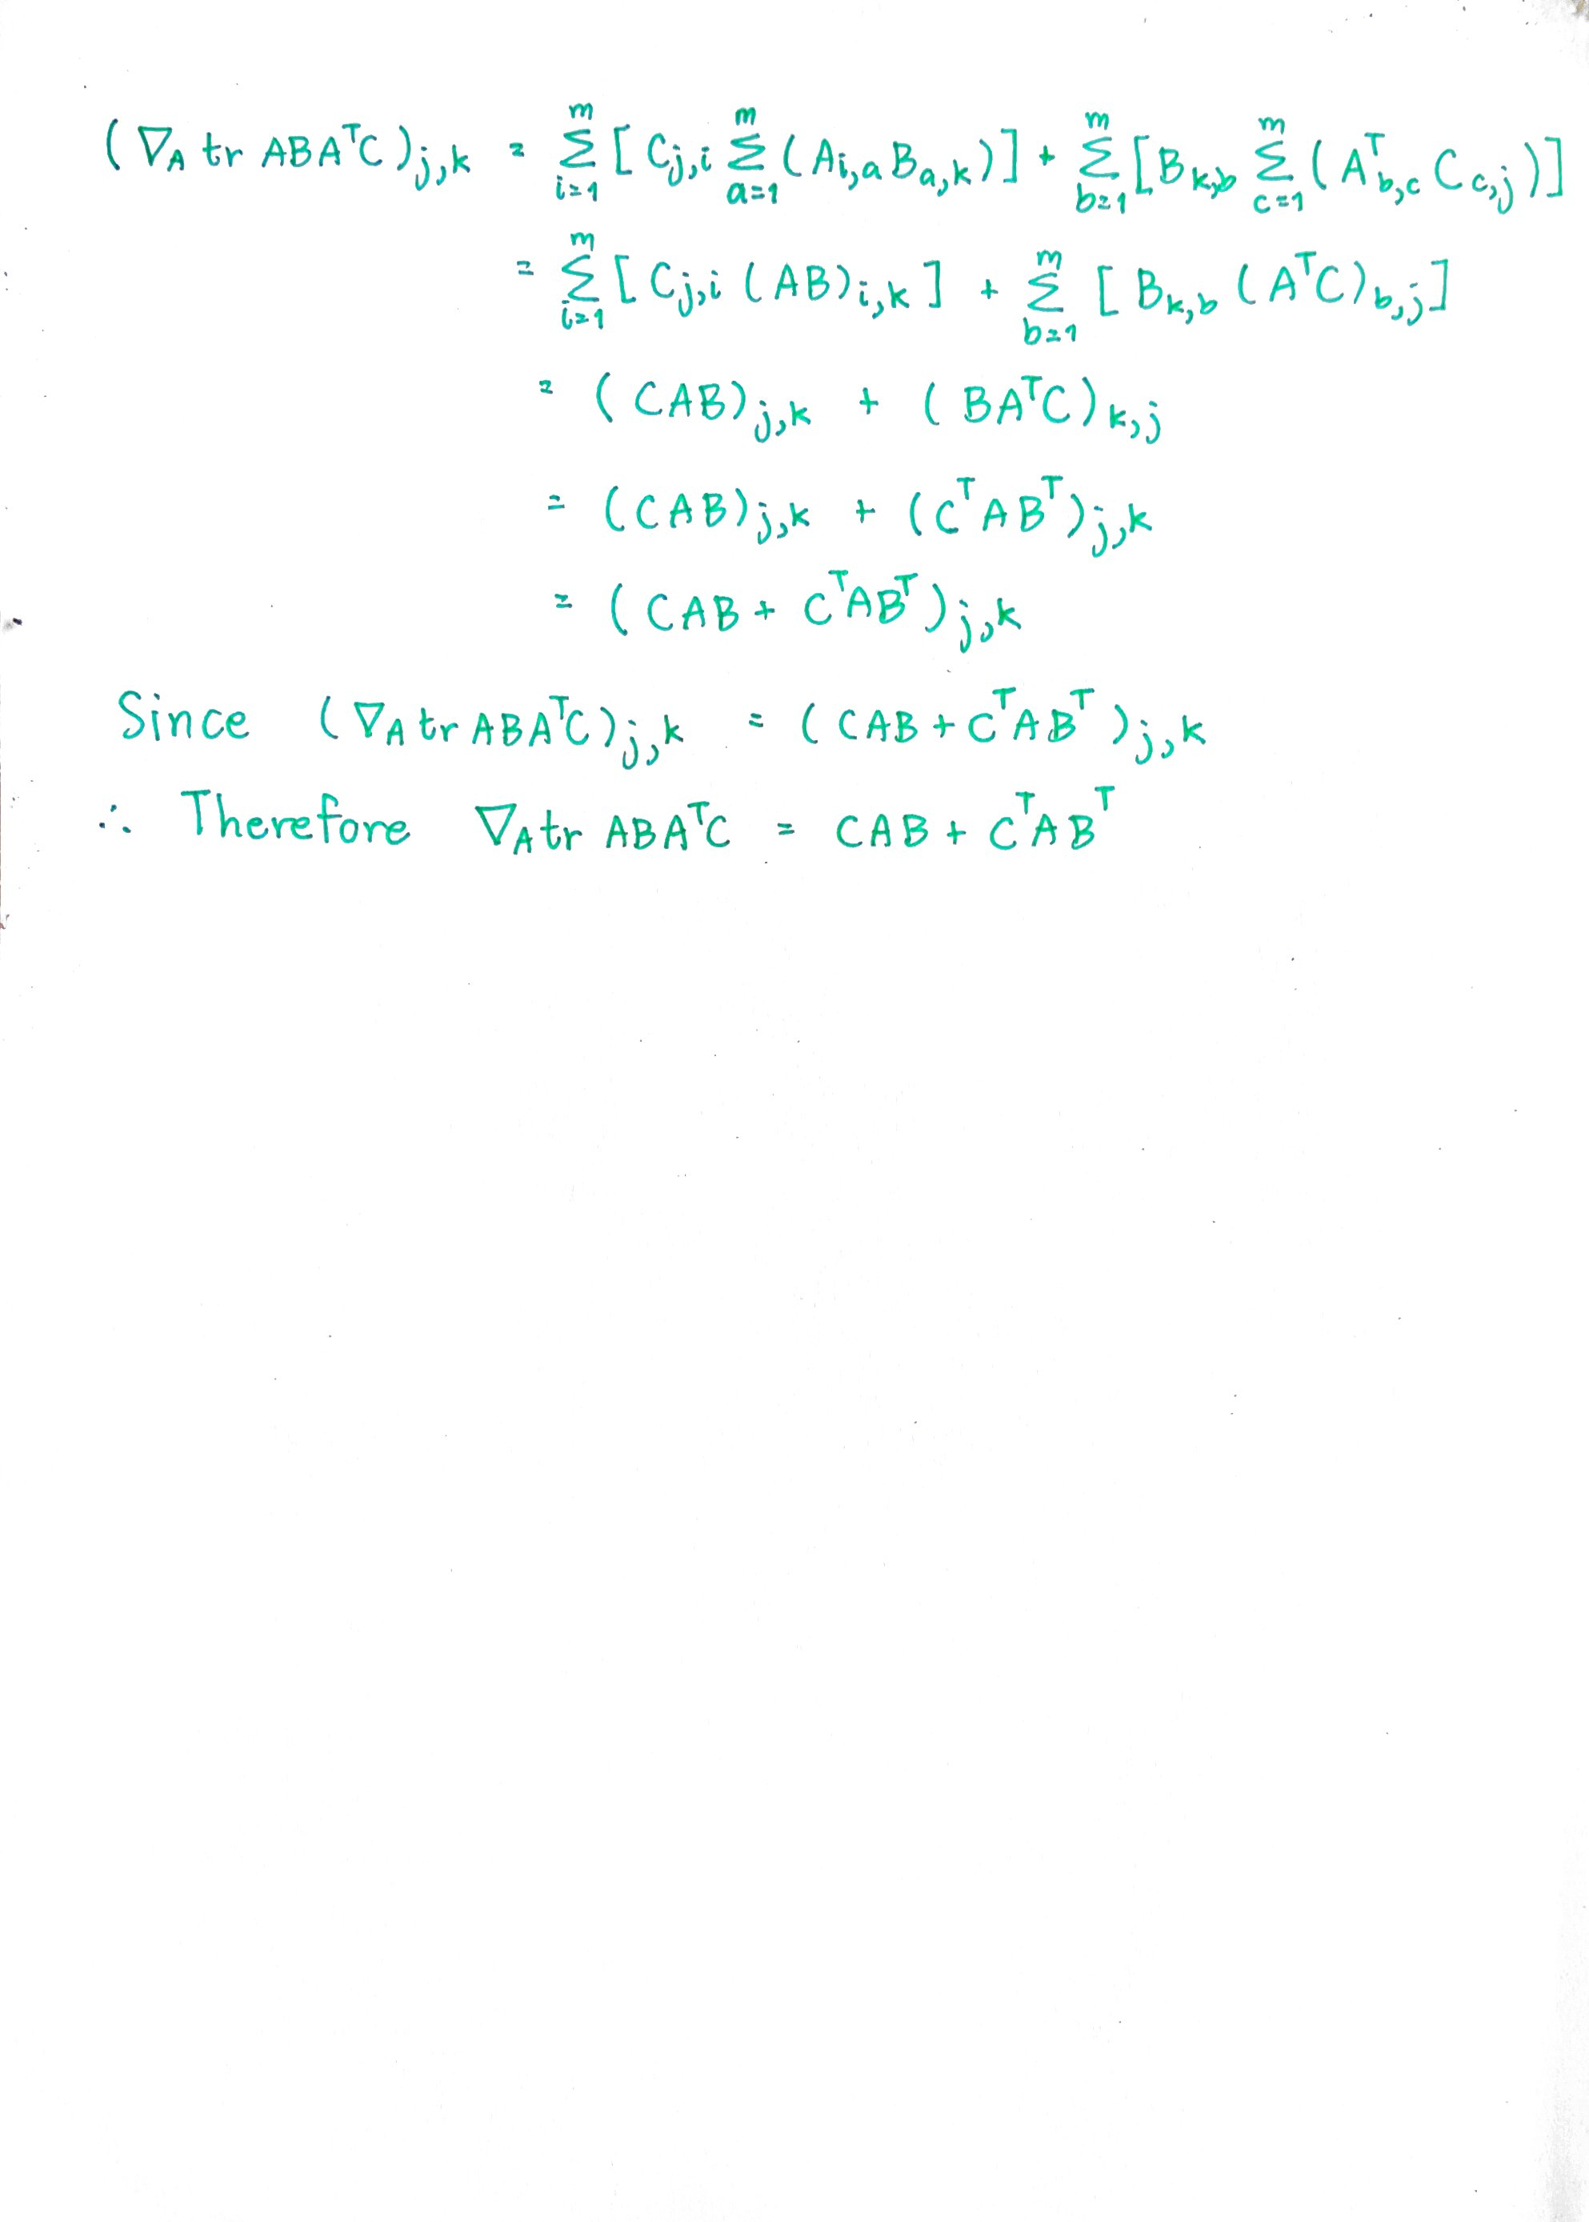

T4. If the starting points are (3, 3), (2, 2) and (-3, -3), assign and update step are as follow.
Iteration 1: points (3, 3), (8, 8), (6, 6), (7, 7) are assign to a cluster with centroid (3, 3)
points (1, 2), (2, 2) are assign to a cluster with centroid (2, 2)
points (-2, -4), (-7, -7), (-3, -3) are assign to a cluster with centroid (-3, -3)
updated centroids are (6, 6), (1.5, 2) and (-4, -4.6667)
Iteration 2: points (8, 8), (6, 6), (7, 7) are assign to a cluster with centroid (6, 6)
points (1, 2), (2, 2), (3, 3) are assign to a cluster with centroid (1.5, 2)
points (-2, -4), (-7, -7), (-3, -3) are assign to a cluster with centroid (-4, -4.6667)
updated centroids are (7, 7), (2, 2.3333) and (-4, -4.66666667)
Iteration 3: points (8, 8), (6, 6), (7, 7) are assign to a cluster with centroid (6, 6)
points (1, 2), (2, 2), (3, 3) are assign to a cluster with centroid (1.5, 2)
points (-2, -4), (-7, -7), (-3, -3) are assign to a cluster with centroid (-4, -4.6667)
updated centroids are (7, 7), (2, 2.3333) and (-4, -4.66666667)
Since iteration 2 and 3 are the same, K-Mean is finished.

T5. If the starting points are (-3, -3), (2, 2) and (-7, -7), the result after iteration 1 and 2 are the same as shown below.
Iteration 1, 2: points (-3, -3), (-2, -4) are assign to a cluster with centroid (-3, -3)
points (1, 2), (3, 3), (2, 2), (8, 8), (6, 6), (7, 7) are assign to a cluster with centroid (2, 2)
points (-7, -7) are assign to a cluster with centroid (-7, -7)
updated centroids are (6, 6), (1.5, 2) and (-4, -4.6667)
You can notice that this result is different from the result getting from T4. As the set of starting points can affect the clustering result using K-Mean Algorithm.

T6. I think the one from T4. is better. In order to measure the goodness quality of a set of starting point, we will calculate the sum of the square distance between each point and its centroid divided by total number of points of each starting points case and use it as a cost for quality comparision. Lower score mean better goodness quality. From calculation result, cost from L4. is 3.2593 and cost from L5. is 8.6481. Therefore we can conclude that the result from T4. is better.

OT1. I think 4 would be a best K for this question. Consider a a plot between K (x-axis) and
fraction of explain variance (y-axis).

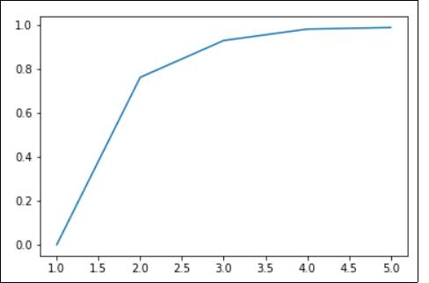
By using elbow method, we should select a value K=n in which between K=n and K=n+1 have no significant increase in fraction of explain variance. From calculation, we’ve got the following data.
K=2, fraction of explain variance = 0.7620
K=3, fraction of explain variance = 0.9299
K=4, fraction of explain variance = 0.9817
K=5, fraction of explain variance = 0.9888
You can see no significant increase in fraction of explain variance from K=4 to K=5 so we conclude that 4 would be a best K for this question and at K=4, it also have explain variance = 98.17% which mean it can explain most of our data too.
T7. Median age of the training set is 28.

T8. Mode of Embarked is S

T9. Solution is included in ipynb file



T10. Here is the result.

OT2. Solution is included in ipynb file

OT3. The weights learned from the two methods are similar.
The weight got from Gradient Descent Method is
[[ 0.77595145]
[-0.18830454]
[ 0.49096938]
[-0.00504691]
[ 0.04912014]]
The weight got from Matrix Inversion Method is
[[ 0.77654442],
[-0.18843944],
[ 0.49086711],
[-0.00505436],
[ 0.04911346]]
So we got MSE of different between two method is 7.60740723e-08 which is relatively small, therefore we conclude that they are similar.

OT4. We added Age*Sex and Embarked**2 as a feature for this model. We found a slightly accuracy drop in both training set and test set. The Kaggle result (test set) are below which its accuracy is a bit lower than T10 (0.77033). For training set, model from T9 got accuracy around(The code is also inside ipynb file)
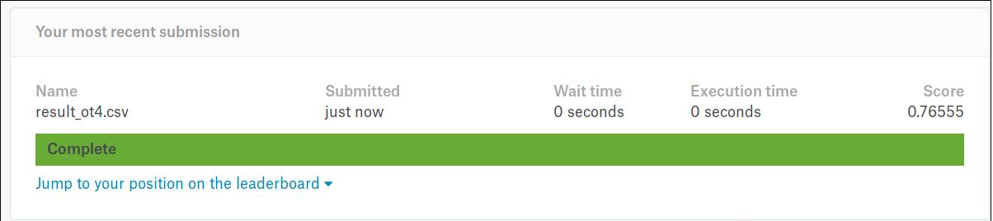

OT5. When reduce amount of feature to just Sex and Age. We only found a slightly drop in accuracy of train set (The difference of accuracy is around 1% at 3000 iterations). Since sex and age are the feature that highly corelated to prediction target, we then see model still perform a good prediction. (Code is inside ipynb file)

