Pattern Recognition
Pisit Wajanasara 5931042721

T1.
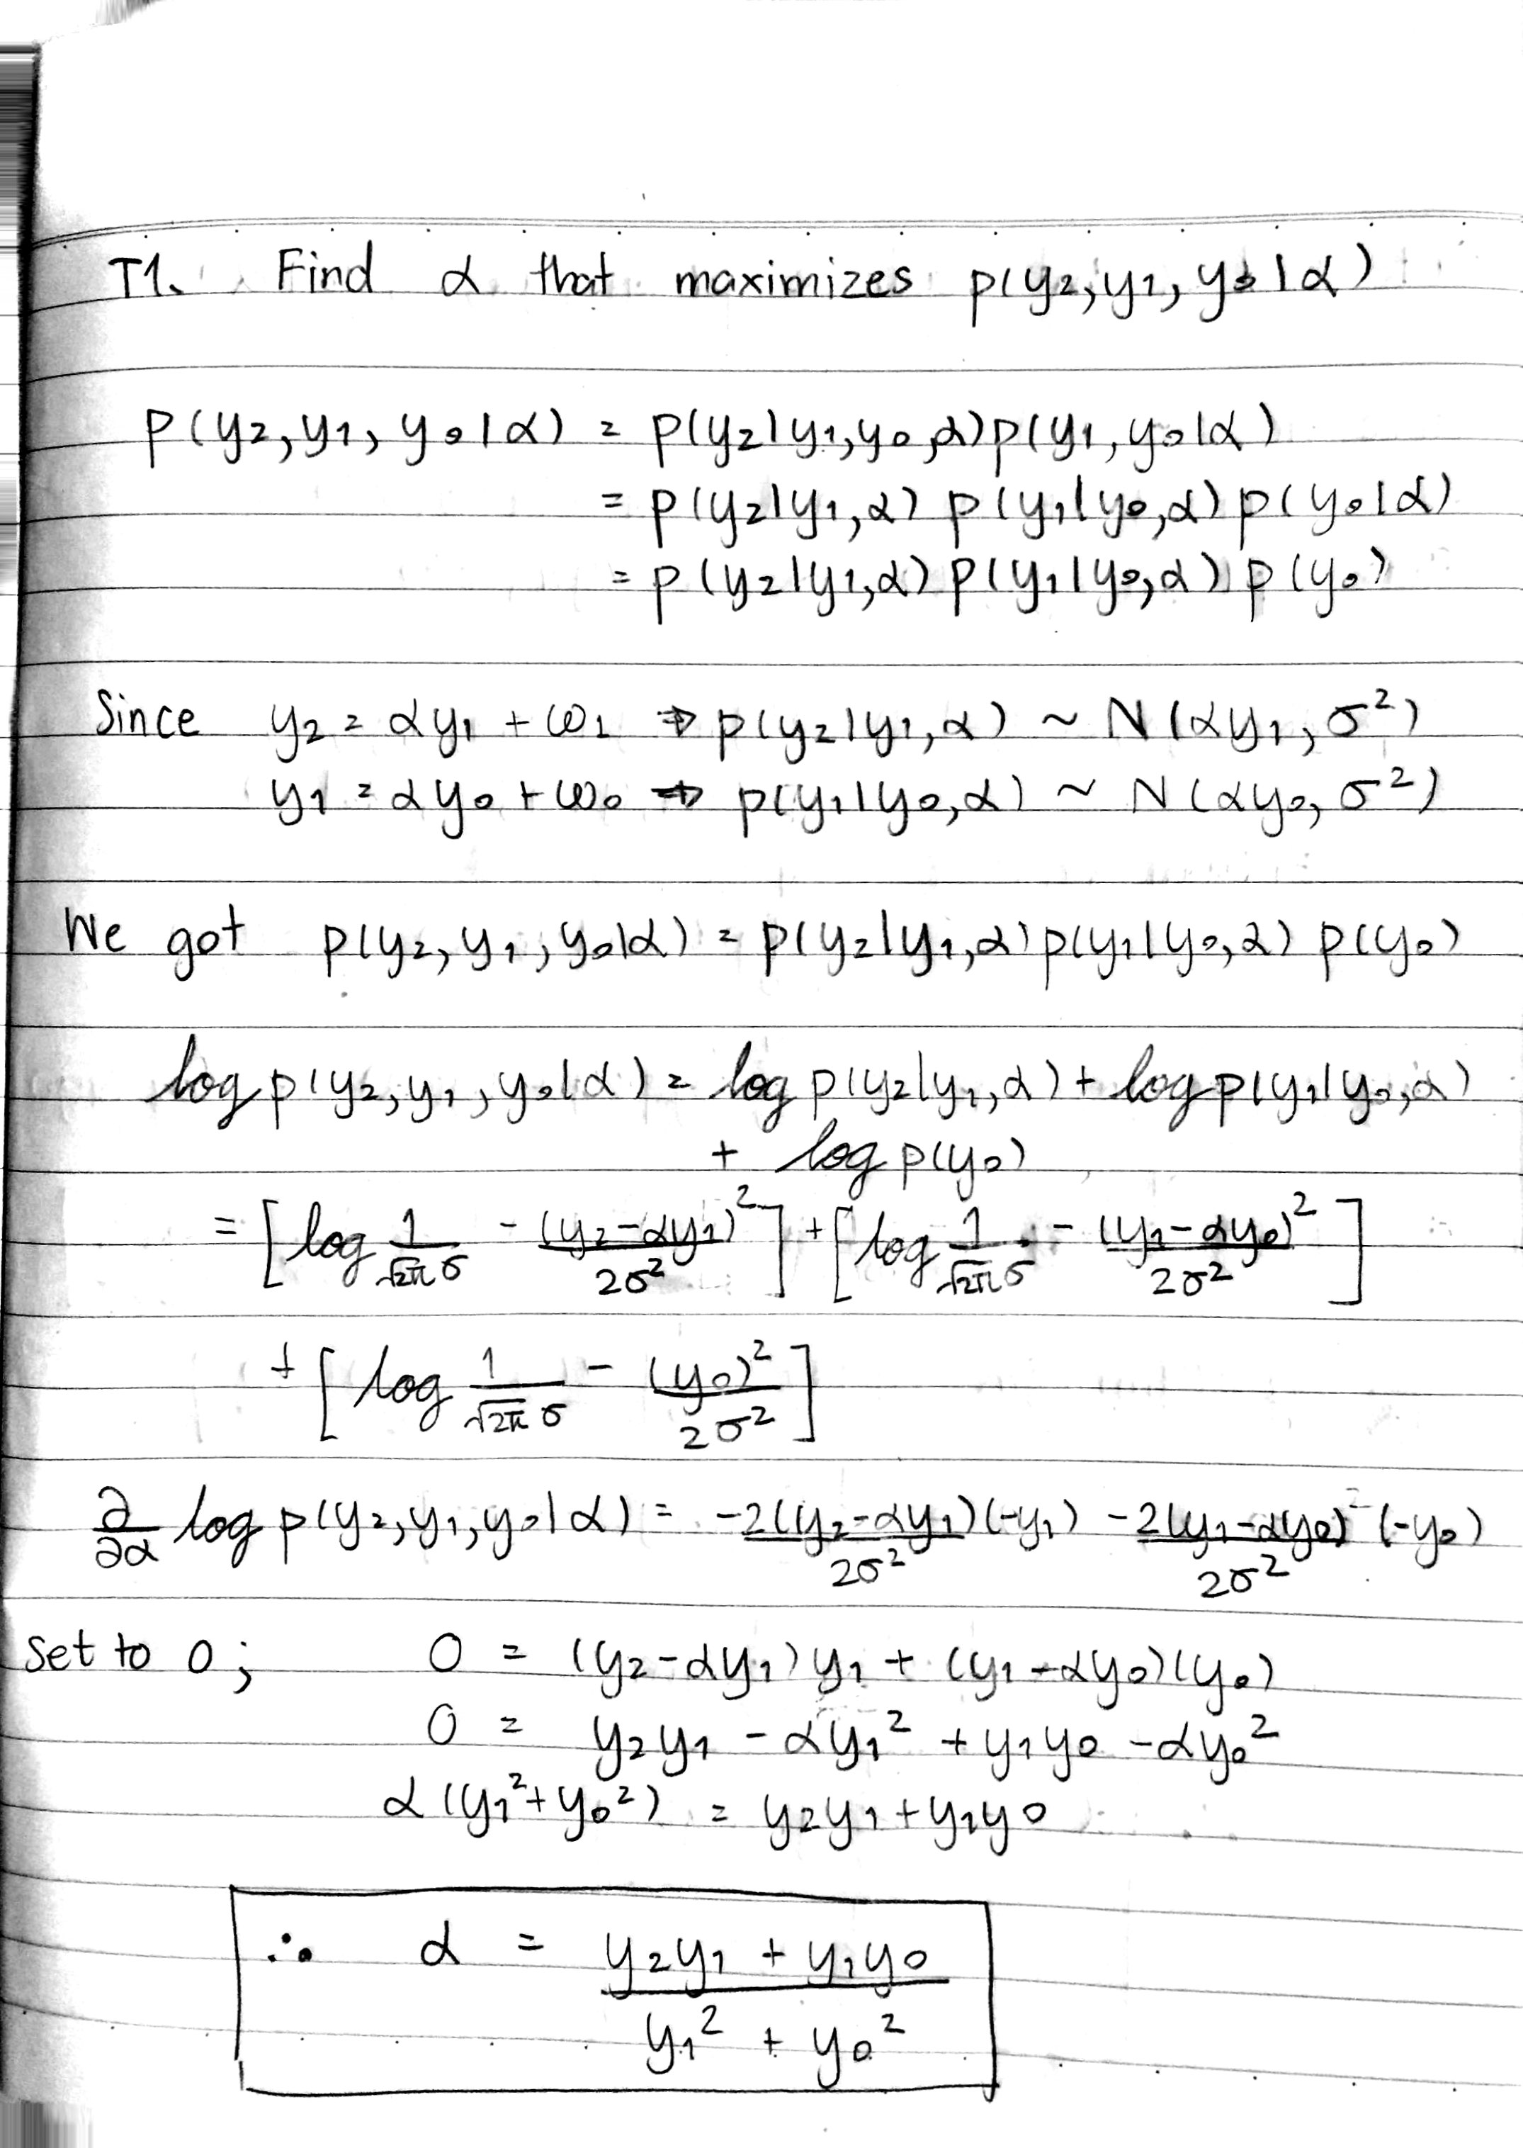
OT1.
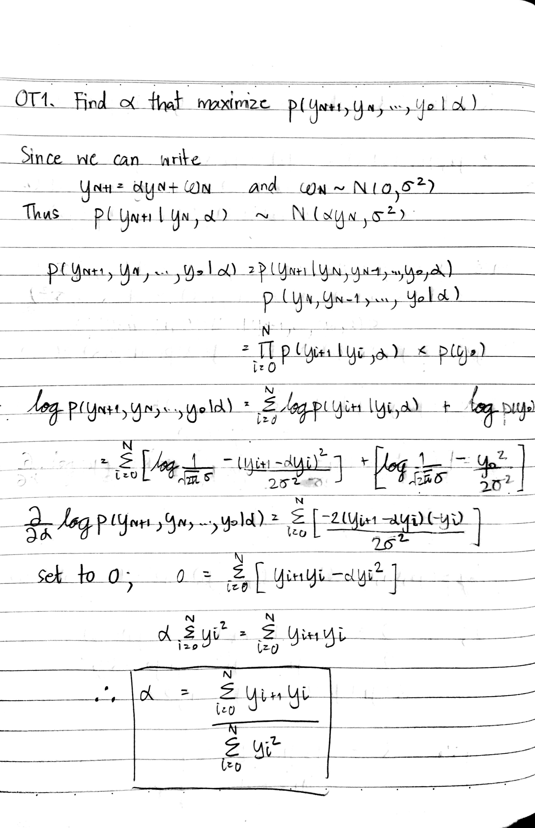
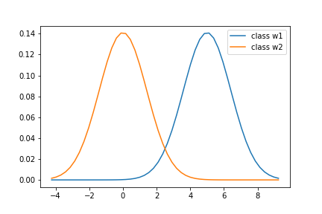
T2.
Decision boundary is 2.5

T3.

T4. From observed histogram, we can use Gaussian to estimate the histogram but not for all column, because some column have a shape that is not Gaussian like. If we use Gaussian to estimate them, they might provide bad result because of this estimation. We can use Gaussian Mixture Model to estimate the histogram because it can handle a case that histogram is not just like a one Gaussian Distribution.

T5. 859 bins have zero count. This is not a good discretization because if we have too many zero bin count this will make we hard to estimate the distribution of the histogram. Moreover, from observation, many bins that have zero count are between other bin that have non-zero count. This show that the distribution we see from histogram is difficultly determined.

T6.
    - For age, bin size = 10 is most sensible, as you can see in the histogram, this can make the estimation using Gaussian more sensible compared to bin size = 40 and 100.
    - For monthly income, bin size = 40 is most sensible. For the histogram of each bin size we can observe the same distribution shape, so we will also use other data for consideration. We know that min, max and standard deviation of the data are 1009, 19859 and 4738.803810 respectively (You may observe different number in the iPython notebook file because the data will be shuffled each time we run the code.), so bin size = 10 make the binning result too rough for discretization and bin size = 100 make the binning result too detailed with some bins that have zero amount of data.
    - For distance from home, bin size = 10 is most sensible. For other bin size(40, 100), there are many bins that has zero amount of data in it but not in the case which bin size = 10.

T7. The criteria for discretization is
    - The range of data is large (max – min > 30)
    - The data is not categorical data
    - The data is continuous
The columns that follow the criteria are DailyRate, EmployeeCount, HourlyRate, MonthlyRate, TotalWorkingYears and YearsAtCompany.

T8. We should use Gaussian distribution because most of the feature has Gaussian distribution like shape, it also make our model not too complex. The MLE for the likelihood distribution of each 33 features are its likelihood distribution that we convert the y-axis to be ratio between frequency and total number of data. That's it, it make the summation of the area under curve to be 1 and it is our MLE in this case.

T9. Prior of class “leave” is 0.16111951588502268
Prior of class “stay” is 0.8388804841149773

T10. Accuracy is 0.7770
Recall is 0.5833
Precision is 0.3784
F1 Score is 0.4590
(Result may be different in each code run)

T11. Accuracy is 0.7838
Recall is 0.5
Precision is 0.375
F1 Score is 0.4286

T12. Accuracy is 0.5068
Recall is 0.3333
Precision is 0.1231
F1 Score is 0.1798

T13. Accuracy is 0.8378
Recall is 0
Precision is 0
F1 Score is 0

T14. Compare T11 with T12
You can see that our classifier has higher accuracy than Random classifier which mean that out model done a good job at prediction accuracy. Moreover, We see that recall, precision and f1 score is all higher than random classifier baseline.
Compare T11 with T13
You can see that T13 win in accuracy test. If we see in test set, we can see that most of the employee has attrition value to 0.0 with its ratio equal to accuracy (0.8378). Although our model accuracy is less than majority rule baseline, the value of recall, precision and f1 score are also better compared to this baseline.

