Pattern Recognition
Pisit Wajanasara 5931042721

T1.
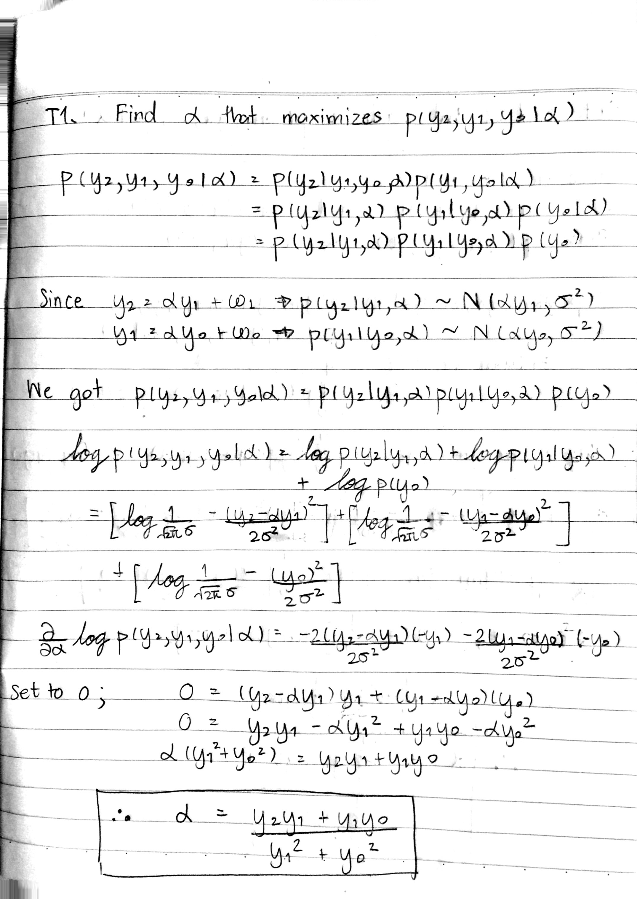
OT1.
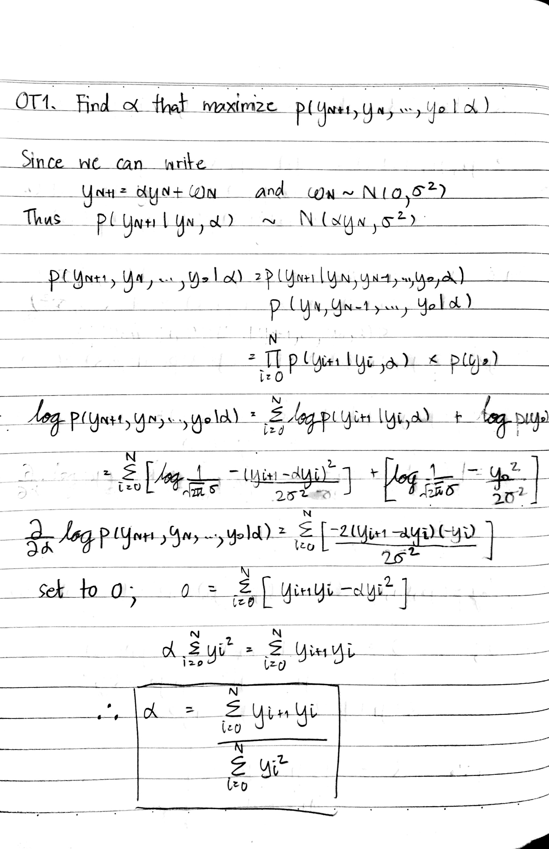
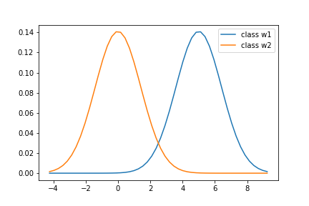
T2.
Decision boundary is 2.5

T3.
Decision boundary is 1.945
The boundary shift toward the sad cat distribution.
OT2.
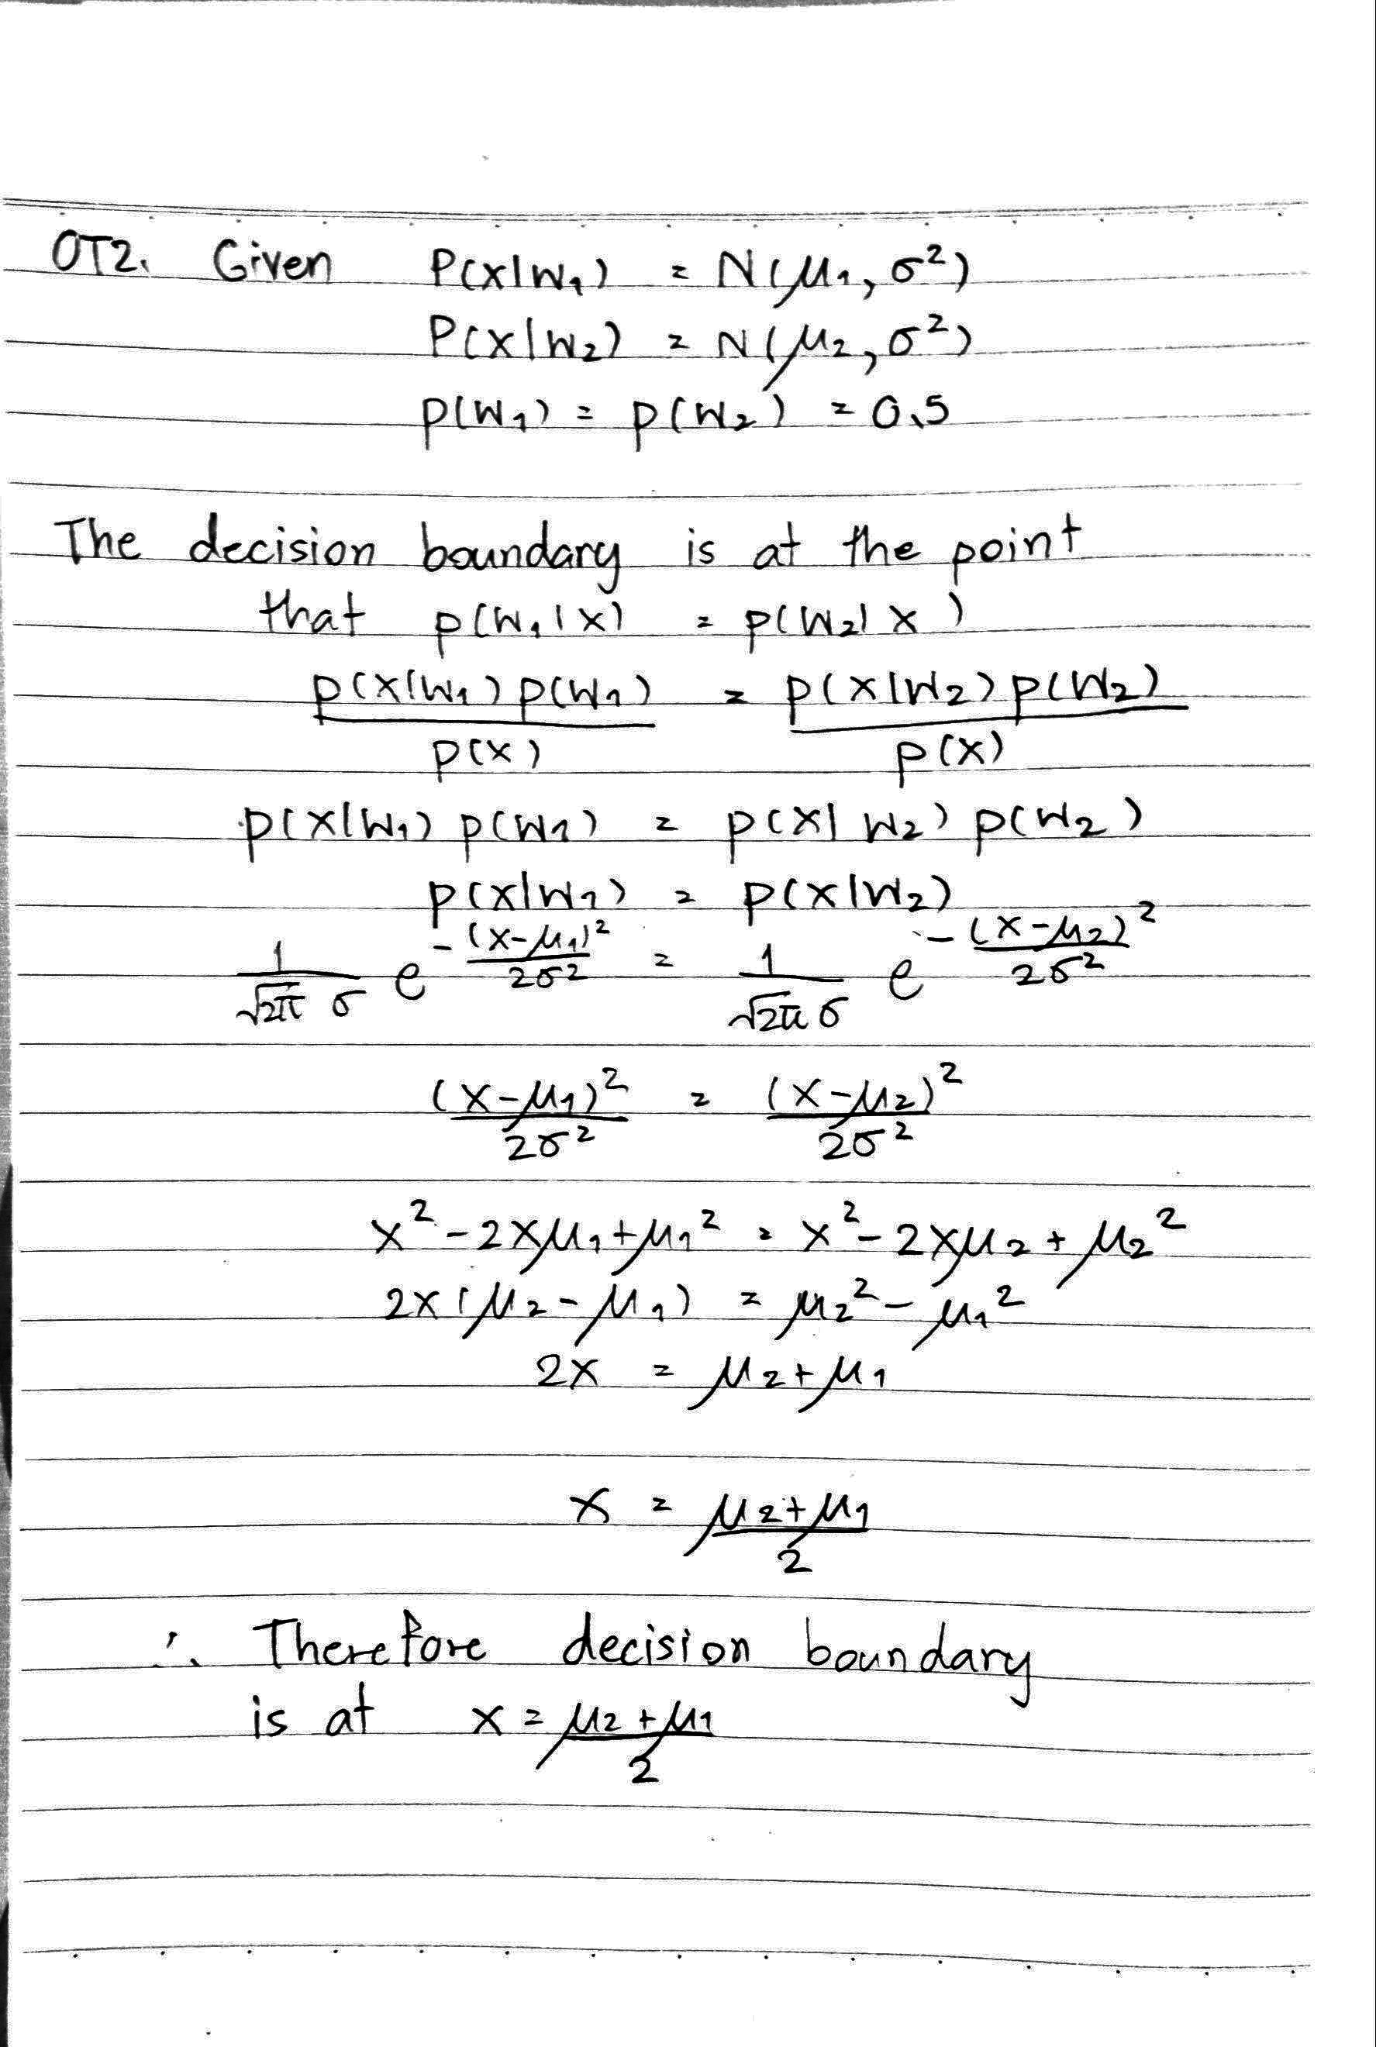
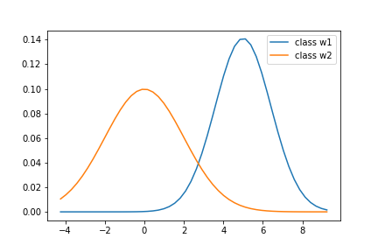
Decision boundary is 2.7355

T4. From observed histogram, we can use Gaussian to estimate the histogram but not for all column, because some column have a shape that is not Gaussian like. If we use Gaussian to estimate them, they might provide bad result because of this estimation. We can use Gaussian Mixture Model to estimate the histogram because it can handle a case that histogram is not just like a one Gaussian Distribution.

T5. 859 bins have zero count. This is not a good discretization because if we have too many zero bin count this will make we hard to estimate the distribution of the histogram. Moreover, from observation, many bins that have zero count are between other bin that have non-zero count. This show that the distribution we see from histogram is difficultly determined.

T6. (*** See histogram in ipynb file ****)
    - For age, bin size = 10 is most sensible, as you can see in the histogram, this can make the estimation using Gaussian more sensible compared to bin size = 40 and 100.
    - For monthly income, bin size = 40 is most sensible. For the histogram of each bin size we can observe the same distribution shape, so we will also use other data for consideration. We know that min, max and standard deviation of the data are 1009, 19859 and 4738.803810 respectively (You may observe different number in the iPython notebook file because the data will be shuffled each time we run the code.), so bin size = 10 make the binning result too rough for discretization and bin size = 100 make the binning result too detailed with some bins that have zero amount of data.
    - For distance from home, bin size = 10 is most sensible. For other bin size(40, 100), there are many bins that has zero amount of data in it but not in the case which bin size = 10.

T7. The criteria for discretization is
    - The range of data is large (max – min > 30)
    - The data is not categorical data
    - The data is continuous
The columns that follow the criteria are DailyRate, EmployeeCount, HourlyRate, MonthlyRate, TotalWorkingYears and YearsAtCompany.
(*** See discretized features in ipynb file ***)

T8. We should use Multinomial distribution because we use histogram to estimate the distribution of features. The MLE for the likelihood distribution of each 33 features are its histogram that we separate the class “leave” and class “stay” then convert the y-axis to be ratio between frequency and total number of data in that class. That's it, it make the summation of the area under curve to be 1 and it is our MLE in this case.

T9. Prior of class “leave” is 0.16111951588502268
Prior of class “stay” is 0.8388804841149773

T10. Accuracy is 0.7837
Recall is 0.375
Precision is 0.3461
F1 Score is 0.36
(Result may be different in each code run)

T11. Accuracy is 0.7635
Recall is 0.4167
Precision is 0.3226
F1 Score is 0.3636

T12. Accuracy is 0.4662
Recall is 0.4583
Precision is 0.1429
F1 Score is 0.2178

T13. Accuracy is 0.8378
Recall is 0
Precision is 0
F1 Score is 0

T14. Compare T10 with T12
You can see that our classifier has higher accuracy than Random classifier which mean that out model done a good job at prediction accuracy. Moreover, We see that precision and f1 score is all higher than random classifier baseline.
Compare T10 with T13
You can see that T13 win in accuracy test. If we see in test set, we can see that most of the employee has attrition value to 0.0 with its ratio equal to accuracy (0.8378). Although our model accuracy is less than majority rule baseline, the value of recall, precision and f1 score are also better compared to this baseline.

T15. Best accuracy is 0.8378 at threshold = 1.05
Best F1 score is 0.4643 at threshold = -0.55

T16.
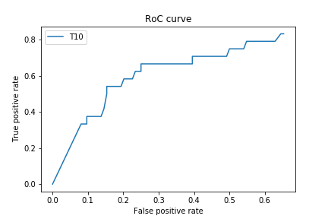

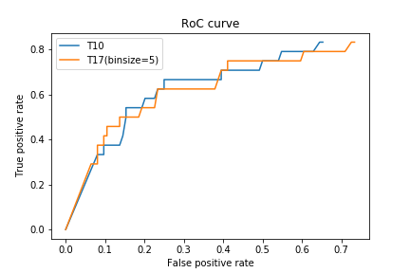
T17.

As you can see in the RoC curve above, the RoC curve is not the same if we reduce bin size to 5. From RoC curve, you can see that at the same false positive rate, some false positive rate value at binsize = 5 will get better true positive rate and some false positive rate value at binsize = 5 will get less true positive rate compared to result from T10. To tell that what bin size is better in this case, it depend on what you need based on constraints of the apply application.

OT3. Accuracy mean is 0.8318
Accuracy variance is 0.0006433

P.S. Result may be different in each run because of train and test set is differ in each run.

