  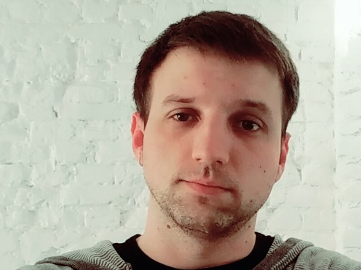
  SERGEY KOTLYAROV
  DEVELOPER
  I always try to learn something new and develop myself in areas of interest. Computer graphics, CAD, CorelDraw, 3ds and rarely raster graphics captivated my interest. Currently I am studying Java for Web and Android development. Also I've learnt the basics of HTML and CSS to structure and style webpages. I was learning Unity for a while. Now I'am open for new job opportunities and it'll be great to work for a company where I'll be able to improve my skills and learn some new technologies.
  CONTACTS
  Dneprodzerzhinsk
  Zaporozhye
  +38 093 864 21 27
  s.kotljarov@gmail.com
  sergejkotljarov
  mellivora.13
  mrcat.adr.com.ua
  EDUCATION
  2015 | WEB DEVELOPMENT COURSES
  2012 | NATIONAL MINING UNIVERSITY OF UKRAINE
  2007 | SPECIALIZATION: PROGRAMMING ENGINEERING
  2007 | OLES HONCHAR DNIPROPETROVSK NATIONAL UNIVERSITY
  2006
   | SPECIALIZATION: PROGRAMMING ENGINEERING
  WORK EXPERIENCES
  ZAPORIZHYAOBLENERGO |  | 24.03.2015
  SYSTEM ENGINEER |  | Present
  - Development and commissioning of the call center system based on Cisco BE6000 complex
  - Phone support based on Asterisk and related software
  - Support for user workstations
  - Reporting System Development call center in the form of a Java Web application
  DTEK KRYMENERGO |  | 24.07.2012
  SYSTEM ENGINEER |  | 25.07.2014
  - Supporting Network Infrastructure
  - Construction and design SCS
  - Repair of PC and office equipment
  - Develop of the converter address book
  - Support for user workstations
  - Maintain and update database equipment
  - Creating schemes of buildings and floor plans
  SKILLS
  Java/JSP/JDBC |  |  |  |  |  |  |  |  |  |  |  |  |  |  |  |  |  |  |  |  |  |  | 3Ds Max
  MySQL/SQLite |  |  |  |  |  |  |  |  |  |  |  |  |  |  |  |  |  |  |  |  |  |  | Adobe Photoshop
  HTML/CSS |  |  |  |  |  |  |  |  |  |  |  |  |  |  |  |  |  |  |  |  |  |  | Server OS
  AutoCAD/qCAD |  |  |  |  |  |  |  |  |  |  |  |  |  |  |  |  |  |  |  |  |  |  | Android dew
  Corel DRAW / Inkscape |  |  |  |  |  |  |  |  |  |  |  |  |  |  |  |  |  |  |  |  |  |  | English
  HOBBY
  Painting , Computers, puzzles, workout, cooking, bicycles, crafting.

