**PS4 Final Project Proposal**

RxRockstars

Anas Zain, Arun Kumar Soora, Bhavana Bethi, Neha Kowtharapu, Rahul

Papaganti

Department Of BioHealth Informatics, Indiana University

Health Information Standards and Terminologies

Dr. Zeyana Hamid

April 26, 2024

**Introduction**

The potential of Electronic Health Records (EHRs) to transform patient care in the context of contemporary healthcare rests on the smooth flow and integration of medical data among various systems. To do this, standardized terminology and organized data are needed to create a common understanding. As fundamental frameworks, biomedical ontologies and terminology standards guarantee uniformity, interoperability, and semantic clarity. They also provide enhanced analytics and clinical decision assistance for better patient outcomes. Simultaneously, the rapid expansion of the healthcare sector has accelerated the use of Business Process Management (BPM) techniques, which provide an organized examination and optimization of the provision of healthcare. By modeling, business process management (BPM) promotes standard operating procedures and improves stakeholder understanding, that in turn drives quality and efficiency in healthcare management. As XML files, each section must precisely represent the given use-case and be in accordance with the overall objectives of better healthcare delivery, streamlined procedures, and increased interoperability. When these different approaches are used and their products are clubbed together, it can give rise to a comprehensive and customized tool for effective healthcare administration and information sharing.

**Use Case and Terminology choices**

**Use Case E: Clinician to nurses and back**

A patient aged 65 years consulted a clinician with the chief complaints of headache and has been diagnosed with hypertension. He had no past medical or medication history. He has been a chronic smoker for 10 years and is non-alcoholic. Also, a family history of diabetes mellitus and hypertension. Physical examination was found be normal. Blood pressure was found to be 190/130 mmHg. The patient was diagnosed with hypertensive urgency and admitted in the hospital. The patient was prescribed with 0.2mg clonidine. The clinician also advised the nurse to record Blood pressure every 4 hours. All the information has been updated in electronic health records. Nurse followed the clinician notes in EHR and measured the blood pressure accordingly. All the observations should be recorded in nursing notes and update should be sent back to EHR.

**Terminologies / ontologies Choices:**

1. Chief Complaint: SNOMED CT, ICD-10-CM, LOINC

2. Diagnosis: SNOMED CT, ICD-11, LOINC, MeSH, CPT3

3. Personal History/Habits: SNOMED CT, ICD-10, LOINC, CPT

4. Family history: LOINC, SNOMED CT

5. Medication: RxNorm, SNOMED, LOINC

6. Observation: SNOMED CT

**Terminologies Selected**

|  |  |  |
| --- | --- | --- |
| **CLINICAL CONCEPT** | **CODES** | **TERMINOLOGY** |
| Headache | R51 | ICD-10 |
| Hypertensive Urgency | 443482000 | SNOMED CT |
| Hypertension | 38341003 | SNOMED CT |
| Smoking | 428071000124103 | SNOMED CT |
| Diabetes mellitus | Z83.3 | ICD-10 |
| Clonidine | 884185 | RxNorm |
| Systolic blood pressure - observation  Diastolic blood pressure – observation | 8480-6  8462-4 | LOINC |

**Terms**

**Chief Complaint - Headache:**

* Standard Terminology Used: SNOMED CT, ICD-10-CM, LOINC
* Rationale: SNOMED CT, ICD-10-CM, and LOINC were chosen for encoding the chief complaint of headache. SNOMED CT offers a comprehensive vocabulary that accurately represents clinical concepts, ensuring precise recording of symptoms like headaches (Chang & Mostafa, 2021). ICD-10-CM provides specific diagnostic codes for headaches, enhancing coding accuracy and alignment with diagnostic criteria (Fodeh et al., 2023). LOINC codes enable standardized representation of clinical observations, including headache assessments, facilitating interoperability and data exchange across healthcare systems (Watson et al., 2020).

**Diagnosis - Hypertension, Hypertensive Urgency:**

* Standard Terminology Used: SNOMED CT, ICD-11, LOINC, MeSH, CPT
* Rationale: SNOMED CT, ICD-11, LOINC, MeSH, and CPT were selected to encode diagnoses of hypertension and hypertensive urgency. SNOMED CT offers unmatched granularity and specificity, ensuring precise representation of clinical conditions like hypertension (Chang & Mostafa, 2021). ICD-11 and LOINC provide additional diagnostic coding options and standardized representation of clinical findings, enhancing interoperability and alignment with international standards (Sigmund et al., 2020). MeSH terms enrich the semantic understanding of diagnoses, while CPT codes support billing and procedural documentation, contributing to comprehensive clinical documentation and interoperability in healthcare settings.

**Personal History/Habits - Chronic Smoking:**

* Standard Terminology Used: SNOMED CT, ICD-10, LOINC, CPT
* Rationale: SNOMED CT, ICD-10, LOINC, and CPT were chosen to document personal history/habits such as chronic smoking. SNOMED CT's detailed vocabulary allows precise recording of patient habits, including smoking behaviors (Lee et al., 2014). ICD-10 codes provide standardized representation of nicotine dependence and smoking-related disorders, enhancing clinical documentation and coding accuracy. LOINC codes support standardized representation of patient history data, while CPT codes facilitate billing and reimbursement for smoking cessation counseling services, ensuring comprehensive documentation and interoperability in healthcare settings.

**Family History:**

• Standard Terminology Used: SNOMED CT, ICD-10, LOINC, CPT

• Rationale: SNOMED CT, ICD-10, LOINC, and CPT were chosen to document personal history/habits such as chronic smoking. SNOMED CT's detailed vocabulary allows precise recording of patient habits, including smoking behaviors (Lee et al., 2014). ICD-10 codes provide standardized representation of nicotine dependence and smoking-related disorders, enhancing clinical documentation and coding accuracy. LOINC codes support standardized representation of patient history data, while CPT codes facilitate billing and reimbursement for smoking cessation counseling services, ensuring comprehensive documentation and interoperability in healthcare settings.

**Medication - Clonidine:**

* Standard Terminology Used: RxNorm, SNOMED, LOINC
* Rationale: RxNorm, SNOMED, and LOINC were selected for medication coding, specifically for the drug clonidine. RxNorm is the primary drug terminology standard in the United States, ensuring standardized representation and exchange of medication data (Bodenreider et al., 2018). SNOMED CT offers detailed drug information and relationships, enhancing clinical decision support and interoperability. LOINC codes support standardized representation of medication orders and observations, facilitating seamless integration of medication data into electronic health records and interoperability across healthcare systems.

**Observation - Blood Pressure:**

* Standard Terminology Used: SNOMED-CT, LOINC
* Rationale: SNOMED CT and LOINC standards were chosen for encoding observations related to blood pressure. SNOMED CT defines concepts, including thresholds and measurement methods, ensuring comprehensive representation of blood pressure data (Chang & Mostafa, 2021). LOINC codes, such as those for systolic and diastolic blood pressure measurements, facilitate standardized representation and interoperability of clinical observations across healthcare systems, supporting accurate documentation and clinical decision-making (Watson et al., 2020).

**BPMN Steps/UML Relations**

**UML Class Model**

The UML class diagram in our case study represents an Electronic Health Record (EHR) system, detailing its structure and relationships among key entities:

**Entities and Their Functions:**

• Hospital: Identifies itself with a name and connects to multiple providers.

• Provider: Medical professionals with unique IDs, names, and specialties. They can diagnose and prescribe, linked to many patients and EHR entries.

• Patient: Individuals with IDs, names, optional age and birth dates, and medical histories. They can receive medication and have vital signs recorded.

• Medication: Drugs identified by name and code, with details on dosage and frequency, tied to patients.

• Vital Sign: Records of patient health metrics like blood pressure.

• Nurse: Healthcare staff tracking observations and administering care, associated with various observations.

• EHR: Central record keeping system with unique patient details, can be updated with new data.

• Diagnosis: Medical condition details tied to a patient within the EHR.

• Observation: Nurses' notes on patient conditions, including blood pressure readings.

**Relationships:**

• Association: Lines linking classes show relationships, like a provider's link to EHR entries.

• Multiplicity: Symbols like "1..*" denote one-to-many relationships, indicating a patient can have numerous medications or vital sign entries.

**Notes:**

• NPI: Acronym for National Provider Identifier.

• BP: Abbreviation for Blood Pressure.

• Diagnosis: Uses coding systems like ICD-10 for standardizing medical terms.

• Patient's gender and birth date are not mandatory.

The diagram visualizes the EHR system's components—patients, their care records, medications, and the healthcare professionals who manage them.

**UML Use Case Diagram**

The UML Use Case Diagram illustrates the functions within an Electronic Health Record (EHR) system and how different healthcare professionals interact with these functions:

**Actors:**

• Clinician: A doctor or similar healthcare provider who records patient information and prescribes medication.

• Nurse: A healthcare provider who records vital signs like blood pressure and has access to patient records.

• EHR: The system used to store and manage patient health information.

**Use Cases:**

• Record Patient Information: Clinicians input or update patient details in the EHR.

• Prescribe Medication: Clinicians use the EHR to prescribe drugs to patients.

• Record Blood Pressure: Nurses measure and log the patient's blood pressure in the EHR.

• View Patient Information: Nurses review patient records in the EHR.

System Boundary:

• The blue rectangle indicates that these interactions occur within the EHR system's domain.

**Relationships:**

• Solid lines show which actors can perform which actions. Both clinicians and nurses can view patient information.

• Purple arrows may suggest the order of actions or that certain actions are dependent on others, such as prescribing medication after recording patient information.

**Summary:**

The diagram depicts the roles of clinicians and nurses in using an EHR system, emphasizing the collaborative nature of patient care. Clinicians are responsible for documenting and updating patient details and managing prescriptions, while nurses focus on recording critical patient data like blood pressure and accessing patient information to provide care. All these tasks are interconnected and essential to maintaining accurate and up-to-date patient health records.

**BPMN Model Steps**

1. Patient:

The patient is the central entity in this process. They are experiencing a symptom or condition that prompts them to seek medical attention.

2. Call for Appointment:

This step initiates the process. The patient contacts the healthcare facility or their healthcare provider to schedule an appointment for evaluation and consultation (Whear et al., 2020).

3. Appointment Scheduled:

Based on the patient's request, an appointment is scheduled for further assessment and examination by a clinician (Matulis & McCoy, 2020).

4. History of HTN:

The clinician reviews the patient's medical history, with a specific focus on their history of hypertension (HTN). This historical information is crucial for understanding the patient's current condition and determining appropriate management strategies (Saklayen & Deshpande, 2016).

5. Hypertensive Urgency:

The clinician evaluates the patient's current condition and assesses whether it constitutes a hypertensive urgency. A hypertensive urgency is characterized by a sudden and severe increase in blood pressure, which can cause symptoms like headaches and requires prompt intervention to prevent potential complications (Alley & Copelin II, 2020).

6. Are Vitals Recorded? (Exclusive Gateway):

This decision point represents an exclusive gateway, which means that the process flow will follow one of the outgoing paths based on a specific condition. In this case, the condition is whether the patient's vital signs, such as blood pressure, have been recorded or not.

7. BP High? (Exclusive Gateway):

If the vitals have been recorded, this exclusive gateway evaluates whether the patient's blood pressure is high, indicating a potential hypertensive urgency. The process flow will follow the appropriate path based on this condition (Alley & Copelin II, 2020).

8. Admit to Hospital?

Depending on the severity of the hypertensive urgency and the patient's overall condition, a decision is made whether to admit the patient to the hospital for further treatment and monitoring or to manage the condition on an outpatient basis (Vidt, 2001).

9. Prescription: Clonidine (0.2mg):

If the patient is not admitted to the hospital, the clinician may prescribe Clonidine, an antihypertensive medication, to manage hypertensive urgency. Clonidine helps lower blood pressure and reduce the risk of complications (Rama Yasaei & Abdolreza Saadabadi, 2019).

10. Prescribe NSAID:

In addition to antihypertensive medication, the clinician may also prescribe a non-steroidal anti-inflammatory drug (NSAID) to address potential symptoms like headaches, which are listed as "Chief Complaints: HEADACHE" in the diagram.

11. Give Instruction to Nurses to Record BP:

The clinician provides instructions to the nurses or healthcare staff to regularly record the patient's blood pressure at specified intervals for continuous monitoring purposes (The Royal Children's Hospital Melbourne, 2017).

12. Record in the EHR's clinical notes:

The clinician documents the patient's condition, interventions, prescribed medications, and any other relevant information in the Electronic Health Record (EHR) system's clinical notes. This ensures accurate and comprehensive documentation of the patient's car (Aguirre et al., 2019).

13. EHR Update:

The EHR is updated with the latest patient information, treatment plan, and any other relevant data gathered during the episode of care (Ehrenstein et al., 2019).

14. Record BP Every 4 hours:

As per the clinician's instructions, the nurses or healthcare staff record the patient's blood pressure every 4 hours to closely monitor their condition and identify any changes or potential concerns (CDC, 2019).

15. Update Nurse Notes:

The nurses update their notes with the recorded blood pressure values and any other relevant observations or assessments related to the patient's condition and treatment (Toney-Butler & Unison-Pace, 2023).

The BPMN diagram highlights the importance of thorough assessment, decision-making based on clinical evaluations, appropriate interventions (medication or hospitalization), regular monitoring of vital signs, comprehensive documentation in the EHR system, and collaborative care involving clinicians, nurses, and other healthcare professionals.

**Conclusion**

Integrating Electronic Health Records (EHRs), standardized biomedical terminologies, and Business Process Management (BPM) techniques presents a robust framework for enhancing healthcare delivery and information management. By leveraging terminologies like SNOMED CT for diagnosis, RxNorm for medication, and ICD-10-CM for chief complaints, healthcare providers can ensure accurate representation and communication of clinical data across various systems. These standardized terminologies facilitate interoperability and support clinical decision-making and quality improvement initiatives.

Moreover, using BPM techniques, as illustrated through UML and BPMN models, streamlines healthcare processes, promotes standardized procedures, and enhances stakeholder collaboration. Through structured workflows and clear delineation of roles and responsibilities, BPM ensures efficient patient management and continuity of care. It is supported by a study conducted by Gomes et al. (2018), which underscores the crucial role of process management in the healthcare industry. The study highlights how BPM aids organizations in improving efficiency, standardizing procedures, enhancing the quality of care, promoting interoperability, facilitating decision-making, and ultimately yielding better patient outcomes.

The presented use case, involving the transfer of clinical information from a clinician to nurses and back, underscores the importance of seamless data flow and communication in healthcare settings. From scheduling appointments to prescribing medications and monitoring vital signs, each step in the process is meticulously arranged to ensure optimal patient outcomes and comprehensive documentation in the EHR system.

By combining standardized terminologies with BPM methodologies, healthcare organizations can achieve greater efficiency, interoperability, and quality of care. This integrated approach lays the foundation for a comprehensive and customized tool for effective healthcare administration and information sharing in the modern healthcare landscape.

**References**

Aguirre, R. R., Suarez, O., Fuentes, M., & Sanchez-Gonzalez, M. A. (2019). Electronic health record implementation: A review of resources and tools. *Cureus*, *11*(9). https://doi.org/10.7759/cureus.5649

Alley, W. D., & Copelin II, E. L. (2020). Hypertensive urgency. *PubMed*; *StatPearls Publishing*. https://www.ncbi.nlm.nih.gov/books/NBK513351/

Bodenreider, O., Cornet, R., & Vreeman, D. J. (2018). Recent developments in clinical terminologies — SNOMED CT, LOINC, and RXNorm. *Yearbook of Medical Informatics, 27*(01), 129–139. https://doi.org/10.1055/s-0038-1667077

CDC. (2019). *Measuring blood pressure*. Centers for disease control and prevention. https://www.cdc.gov/bloodpressure/measure.htm

Chang, E., & Mostafa, J. (2021). The use of SNOMED CT, 2013-2020: A literature review. *Journal of the American Medical Informatics Association: JAMIA, 28*(9), 2017–2026. https://doi.org/10.1093/jamia/ocab084

Ehrenstein, V., Kharrazi, H., Lehmann, H., & Taylor, C. O. (2019). Obtaining data from electronic health records. In www.ncbi.nlm.nih.gov. *Agency for Healthcare Research and Quality (US)*. https://www.ncbi.nlm.nih.gov/books/NBK551878/

Fodeh, S. J., Fenton, B. T., Wang, R., Skanderson, M., Altalib, H., Kuruvilla, D., Schindler, E. a. D., Haskell, S. G., Brandt, C., & Sico, J. J. (2023). Understanding headache classification coding within the veterans health administration using ICD-9-CM and ICD-10-CM in fiscal years 2014–2017. *PLOS ONE, 18*(1), e0279163. https://doi.org/10.1371/journal.pone.0279163

Gomes, J., Portela, F., & Santos, M. F. (2018). Introduction to BPM approach in healthcare and case study of end user interaction with EHR interface. *Procedia Computer Science*, *141*, 519–524. https://doi.org/10.1016/j.procs.2018.10.132

Lee, D., De Keizer, N., Lau, F., & Cornet, R. (2014). Literature review of SNOMED CT use. *Journal of the American Medical Informatics Association, 21*(e1), e11–e19. https://doi.org/10.1136/amiajnl-2013-001636

Matulis, J. C., & McCoy, R. (2020). Patient-centered appointment scheduling: A call for autonomy, continuity, and creativity. *Journal of General Internal Medicine*, *36*(2). https://doi.org/10.1007/s11606-020-06058-9

Rama Yasaei, & Abdolreza Saadabadi. (2019, October). Clonidine. *Nih.gov;* *StatPearls Publishing.* https://www.ncbi.nlm.nih.gov/books/NBK459124/

Saklayen, M. G., & Deshpande, N. V. (2016). Timeline of history of hypertension treatment. *Frontiers in Cardiovascular Medicine*, *3*. https://doi.org/10.3389/fcvm.2016.00003

Sigmund, C. D., Carey, R. M., Appel, L. J., Arnett, D. K., Bosworth, H. B., Cushman, W. C., Galis, Z. S., Parker, M., Hall, J. E., Harrison, D. G., McDonough, A. A., Nicastro, H. L., Oparil, S., Osborn, J. W., Raizada, M. K., Wright, J. D., & Oh, Y. S. (2020). Report of the national heart, lung, and blood institute working group on hypertension. *Hypertension*, *75*(4), 902–917. https://doi.org/10.1161/hypertensionaha.119.13887

The Royal Children's Hospital Melbourne. (2017). Clinical Guidelines (Nursing) : Observation and Continuous Monitoring. *Rch.org.au.* https://www.rch.org.au/rchcpg/hospital_clinical_guideline_index/Observation_and_Continuous_Monitoring/

Toney-Butler, T., & Unison-Pace, W. (2023, August 28). Nursing admission assessment and examination. *National Library of Medicine*; *StatPearls Publishing.* https://www.ncbi.nlm.nih.gov/books/NBK493211/

Vidt, D. G. (2001). Emergency room management of hypertensive urgencies and emergencies. *The Journal of Clinical Hypertension*, *3*(3), 158–164. https://doi.org/10.1111/j.1524-6175.2001.00449.x

Watson, K. E., Hamarneh, Y. N. A., Rabi, D. M., Daskalopoulou, S. S., & Tsuyuki, R. T. (2020). Hypertension Canada’s 2020 hypertension guidelines for pharmacists: An update. *Canadian Pharmacists Journal / Revue Des Pharmaciens Du Canada*, *154*(1), 19–25. https://doi.org/10.1177/1715163520975809

Whear, R., Thompson-Coon, J., Rogers, M., Abbott, R. A., Anderson, L., Ukoumunne, O., Matthews, J., Goodwin, V. A., Briscoe, S., Perry, M., & Stein, K. (2020). Patient-initiated appointment systems for adults with chronic conditions in secondary care. *Cochrane Database of Systematic Reviews*. https://doi.org/10.1002/14651858.cd010763.pub2

**Appendix**

**Appendix 1**

*Model 1: UML Class Model*

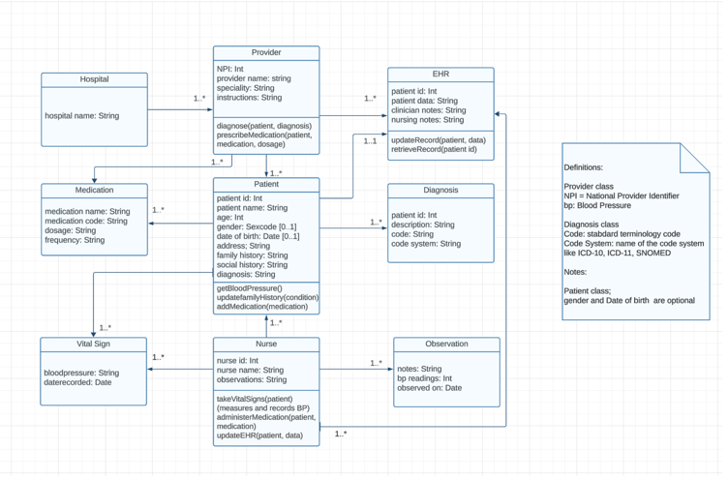

*Model 2: UML Use Case Diagram*

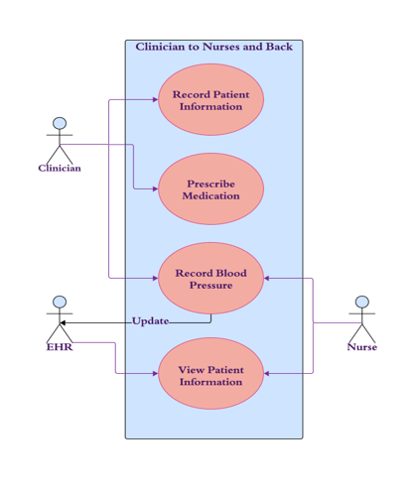

*BPMN diagram*

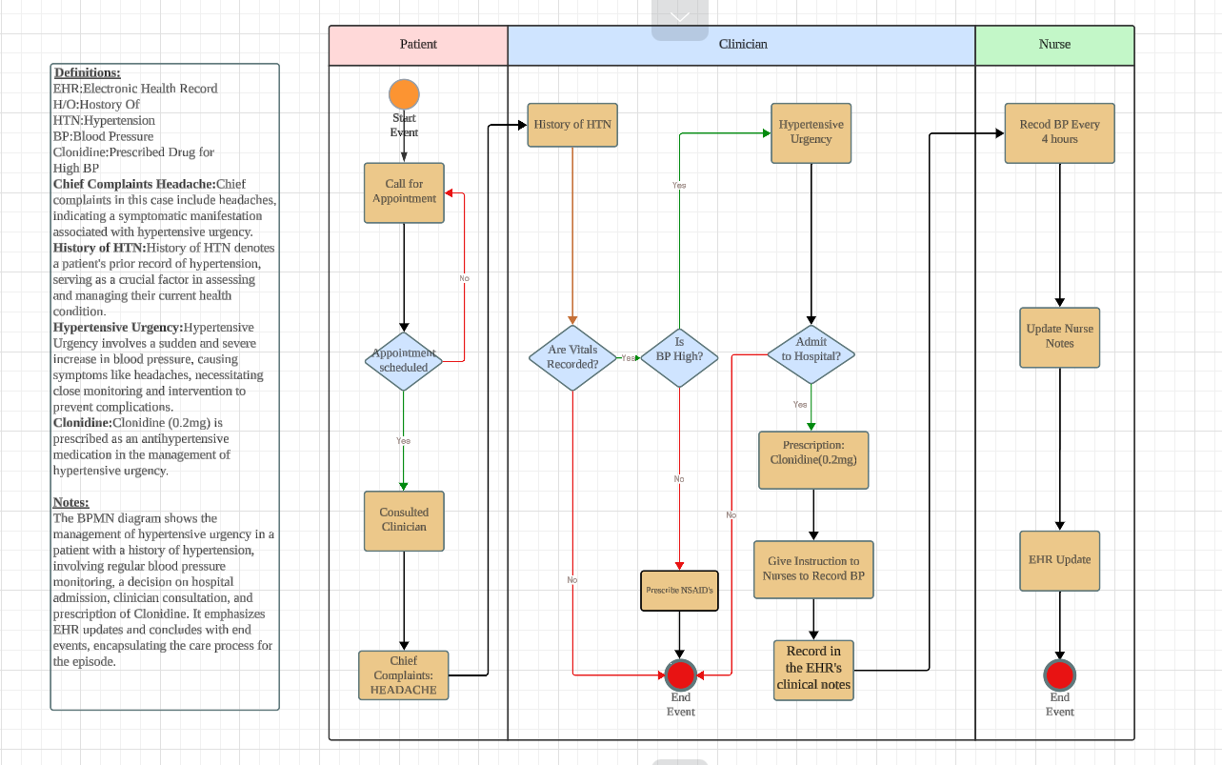

**Appendix 2**

