实验十

1 实验目的：掌握面向对象编程中继承、派生的用法。

2 实验题目：

（1）编写一个集合类，要求类的每个对象可以保存0~100个不同的整数，并使用友元函数实现如下功能：
①从集合中加入一个整数
②从集合中去掉一个整数
③判断一个整数是否在集合中
④求两个集合的并集，结果是一个集合
⑤求两个集合的交集，结果是一个集合

（2）下面是一个形状类Shape，编写Shape的派生类：圆类Circle、三角形类Triangle和矩形类Rectangle，并重定义基类的成员函数使之返回正确的结果（show函数要输出对象的基本信息），然后编写程序进行测试。
class Shape
{public:
double area()
{return 0;};
double girth()
{return 0;};
void show()
{cout<<”Shape Object”<<endl;};
private:
}；

（3）编写一个笔类，描述所有笔的共同属性，然后编写笔类的派生类：钢笔、铅笔、签字笔、毛笔，在各派生类中尽量描述清楚各自的属性。

（4）自学完成：定义复数类，重载“+”“-”“=”运算符。

3 实验结果截图

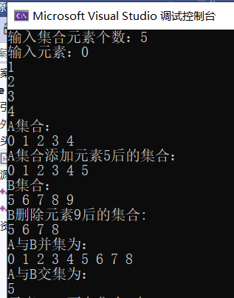

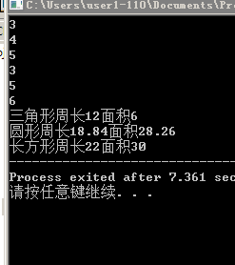

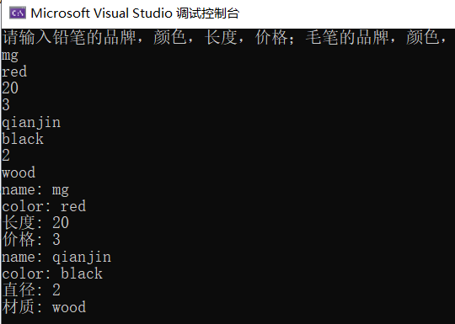

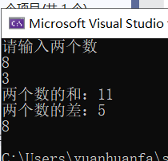

4 源代码

第一题
#pragma once
#include <iostream>
using namespace std;
class jh
{
private:
int num[100];
int len;

public:
jh() { len = 0; };
jh(int data[], int n);
void get();
void select();
void show();

friend bool add(jh& A, int n);
friend void del(jh& A, int n);
friend jh jiao(jh& A,jh& B);
friend jh bing(jh& A, jh& B);
friend bool judge(jh& A, int n);
};

#include "jh.h"
jh::jh(int data[], int n)
{
len = n;
for (int i = 0; i < len; i++)
num[i] = data[i];
select();
}
void jh::get()
{
cout << "输入集合元素个数：";
cin >> len;
cout << "输入元素：";
for (int i = 0; i < len; i++)
cin >> num[i];

select();
}

void jh::select()
{
for (int i = 0; i < len; i++)
{
for (int j = i + 1; j < len; j++)
if (num[i] == num[j])
{
for (int k = j; k < len - 1; k++)
num[k] = num[k + 1];

len--;
j--;
}
}
}
void jh::show()
{
for (int i = 0; i < len; i++)
cout << num[i] << " ";
cout << endl;
}

bool add(jh& A, int n)
{
if (A.len == 100)
return false;
else
A.num[A.len++] = n;

A.select();
return true;
}

void del(jh& A, int n)
{
for (int i = 0; i < A.len; i++)
{
if (A.num[i] == n)
{
for (int j = i; j < A.len - 1; j++)
A.num[j] = A.num[j + 1];
A.len--;
break;
}
}
}
jh bing(jh& A, jh& B)
{
jh C;
C.len = A.len;

for (int i = 0; i < A.len; i++)
{
C.num[i] = A.num[i];
}

for (int i = 0; i < B.len; i++)
{
int index = 0;
for (index; index < A.len; index++)
{
if (A.num[index] == B.num[i])
break;
}
if (index == A.len)
C.num[C.len++] = B.num[i];
}
return C;
}

jh jiao(jh& A, jh& B)
{
jh C;
for (int i = 0; i < A.len; i++)
{
for (int j = 0; j < B.len; j++)
{
if (A.num[i] == B.num[j])
{
C.num[C.len++] = A.num[i];
break;
}
}
}

return C;
}

bool judge(jh& A, int n)
{
for (int i = 0; i < A.len; i++)
{
if (A.num[i] == n)
return true;
}
return false;
}

#include <iostream>
#include "jh.h"
int main()
{
int n[5] = {5,6,7,8,9 };
jh A, B(n, 5), C;
A.get();
cout << "A集合："<<endl;
A.show();
cout << "A集合添加元素5后的集合："<<endl;
add(A, 5);
A.show();
cout << "B集合：" << endl;
B.show();
cout << "B删除元素9后的集合: "<<endl;
del(B, 9);
B.show();
cout << "A与B并集为："<<endl;
C = bing(A, B);
C.show();
cout << "A与B交集为："<<endl;
C = jiao(A, B);
C.show();
if (judge(A, 2019))
cout << "元素2019在集合A中" << endl;
else
cout << "元素2019不在集合A中" << endl;
return 0;
}

第二题
#include "Shape.h"
#include<iostream>
using namespace std;
double Shape::area()
{return 0;}
double Shape::girth()
{return 0;}
void Shape::show()
{
cout<<"Shape Object"<<endl;
}
#ifndef SHAPE_H
#define SHAPE_H
class Shape
{
public:
double area();
double girth();
void show();
private:
};

#endif

#ifndef TRIANGLE_H
#define TRIANGLE_H
#include "Shape.h"
class Triangle : public Shape
{
public:
Triangle();
~Triangle();
double area(double ,double,double);
double girth(double ,double,double);
void show();
private:
double a,b,c,g,s;

};

#endif

#include "Triangle.h"
#include<iostream>
#include"math.h"
using namespace std;
Triangle::Triangle()
{

}

Triangle::~Triangle()
{
}
double Triangle::area(double a,double b,double c)
{
double p=(a+b+c)/2;
s=sqrt(p*(p-a)*(p-b)*(p-c));
return s;
}
double Triangle::girth(double a,double b,double c)
{
g=a+b+c;
return g;
}
void Triangle::show()
{
cout<<"三角形周长"<<g<<"面积"<<s<<endl;
}

#define CIRCLE_H
#include "Shape.h"
class Circle :
public Shape
{
public:
Circle();
~Circle(void);
double area(double );
double girth(double );
void show();
private:
double cs,r,cl;
};

#include "Circle.h"
#include<iostream>
#include"math.h"
using namespace std;

Circle::Circle()
{

}

Circle::~Circle(void)
{
}
double Circle::area(double r)
{
cs=3.14*r*r ;
return cs;
}
double Circle::girth(double r)
{
cl=2*r*3.14;
return cl;
}
void Circle::show()
{
cout<<"圆形周长"<<cl<<"面积"<<cs<<endl;
}

#ifndef RECTANGLE_H
#define RECTANGLE_H

#include "shape.h"

class Rectangle : public Shape
{
public:
Rectangle();
~Rectangle();
double area(double ,double);
double girth(double ,double);
void show();
private:
double x,y,rs,rl;
};

#endif

#include "Rectangle.h"
#include<iostream>
using namespace std;
Rectangle::Rectangle()
{
}
Rectangle::~Rectangle()
{
}
double Rectangle::area(double x,double y)
{
rs=2*x*y;
return rs;
}

double Rectangle::girth(double x,double y)
{ rl=x+y;
return rl;
}
void Rectangle::show()
{
cout<<"长方形周长"<<rl<<"面积" <<rs;

}

#include"Circle.h"
#include"Rectangle.h"
#include"Triangle.h"
#include <iostream>
using namespace std;
int main()
{
double a ,b ,c,r,x,y;
cin>>a>>b>>c>>r>>x>>y;
Triangle T1;
Circle C1;
Rectangle R1;
T1.area(a,b,c);
T1.girth(a,b,c);
T1.show();
C1.area(r);
C1.girth(r);
C1.show();
R1.area(x,y);
R1.girth(x,y);
R1.show();
return 0；
}

第三题
#pragma once
class pen
{
public:
pen(char*n,char*c);
~pen();
void show();

private:
char* name;
char* color;
};

#include "pen.h"
#include <iostream>
#include "string"
#pragma warning(disable:4996)
using namespace std;
pen::pen(char*n,char*c)
{
name = new char[100];
color = new char[100];
strcpy(name, n);
strcpy(color, c);
}
pen::~pen()
{
if (name!=NULL)
{
delete[]name;
}
if (color!=NULL)
{
delete[]color;
}
}
void pen::show()
{
cout << "name: " << name << endl;
cout << "color: " << color << endl;
}
#pragma once
#include"pen.h"
class pencil:public pen
{
public:
pencil(char*n,char*c,int*l,int* p);
~pencil();
void show();
private:
int* length;
int* price;
};

#include "pencil.h"
#include "string"
#include <iostream>
#pragma warning(disable:4996)
using namespace std;
pencil::pencil(char* n, char* c, int* l, int* p) :pen(n, c)
{
length = l;
price = p;
}
pencil::~pencil()
{
if (length!=NULL)
{
delete[]length;
}
if (price != NULL)
{
delete[]price;
}

}
void pencil::show()
{
pen::show();
cout << "长度: " <<*length << endl;
cout << "价格: " << *price << endl;
}

#pragma once
#include"pen.h"
class maopen:public pen
{
public:
maopen(char* n, char* c, int* z, char* cz);
~maopen();
void show();
private:
int* zhijing;
char*caizhi;
};

#include "maopen.h"
#include "string"
#include <iostream>
#pragma warning(disable:4996)
using namespace std;
maopen::maopen(char* n, char* c, int* z, char* cz) :pen(n, c)
{
zhijing=z;
caizhi = new char[20];
strcpy(caizhi, cz);
}
maopen::~maopen()
{
if (zhijing!= NULL)
{
delete[]zhijing;
}
if (caizhi!= NULL)
{
delete[]caizhi;
}

}
void maopen::show()
{
pen::show();
cout << "直径: " << *zhijing << endl;
cout << "材质: " << caizhi<< endl;
}

#include <iostream>
#include "pencil.h"
#include "maopen.h"
using namespace std;
int main()
{
char *name=new char[20];
char* color=new char[10];
int* length = new int[10];
int* price = new int[20];
char* name1 = new char[20];
char* color1 = new char[10];
int* zhijing = new int[10];
char* caizhi = new char[20];
cout << "请输入铅笔的品牌，颜色，长度，价格；毛笔的品牌，颜色，直径，材质" << endl;
cin >> name >> color>> *length>>*price >> name1 >> color1 >>*zhijing >> caizhi;
pencil s(name, color, length, price);
s.show();
maopen m(name1, color1, zhijing, caizhi);
m.show();
return 0;
}

第四题
#pragma once
class fushu
{
public:
fushu();
fushu(double x);
//fushu operator * ( fushu& c2);
fushu operator ==(fushu& c2);
fushu operator + (fushu& c2);
fushu operator - (fushu& c2);
void display();
private:
double a;

};

#include "fushu.h"
#include <iostream>
using namespace std;
fushu::fushu()
{
}
fushu::fushu(double x)
{
a = x;
}
fushu fushu::operator+(fushu& c2)
{
return fushu(a + c2.a);
}
fushu fushu::operator-(fushu& c2)
{
return fushu(a - c2.a);
}
fushu fushu::operator==(fushu& c2)
{
return fushu(a = c2.a);
}

#include "fushu.h"
#include <iostream>
using namespace std;
int main()
{
double x, y;
cout << "请输入两个数" << endl;
cin >> x >> y;
fushu c1(x), c2(y), c3;
c3=c1 + c2;
cout << "两个数的和：";
c3.display();
cout << "两个数的差：";
c3=c1 - c2;
c3.display();
c3 == c1;
c3.display();
return 0;

}

