程序设计基础（实验九）
学号： 姓名： 专业：

1.目的：熟练掌握在vc环境下类的建立。

2 题目：

（1）定义圆类，完成面积的求解；定义圆柱体类，其中一数据成员为圆类，要求编写函数完成圆柱体体积和表面积的求解。

（2）定义stack类，完成栈功能的实现，包括push函数、pop函数、构造函数（完成空间的分配）、析构函数（完成空间的释放），添加断点，。

（3）类的建立与访问，添加私有成员number，添加静态私有成员obj_num
要求1：在构造函数中初始化number的值，生成对象obj1，并利用函数返回私有成员number的值
要求2:利用obj_num统计对象的个数，生成两个对象，利用函数读取obj_num的值
要求3：利用new函数生成该类的对象，调用delete函数进行删除，观察该过程是否调用了构造函数和析构函数（截图说明）

3 程序结果贴图（注意标明对应题号和进行简短说明）

题目一1

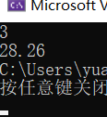

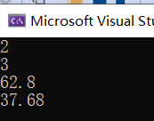

题目二
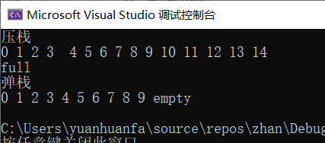

题目三
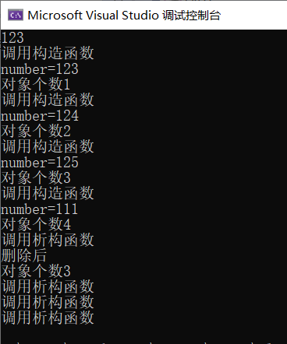

4 编程过程中碰到的问题及总结

5 附源代码：

题目一
1
class circle
{
public:
double input(int r);
double area( int r);
private:
double r, s;
};

#include "circle.h"
double circle::input(int r)
{
int R;
R = r;
return R;
}
double circle::area(int r)
{
double s;
s = 3.14 * r* r;
return s;

}
#include"circle.h"
#include <iostream>
using namespace std;
int main()
{
circle c1;
double r,s;
cin >> r;
c1.area(r);
s=c1.area(r);
cout << s;
return 0;

2
class yuanzhu
{
public:
double input(double r,double h);
double area(double r, double h);
double vc(double r ,double h);
double output();
private:
double r, h, s, v;
};

#include "yuanzhu.h"
#include "circle.h"
circle c1;
double yuanzhu::input(double r,double h)
{
return r,h;
}
double yuanzhu::area(double r, double h)
{
return c1.area(r) * 2 + 2 * 3.14*r * h;
}
double yuanzhu::vc(double r, double h)
{
return c1.area(r) * h;
}
#include"circle.h"
#include "yuanzhu.h"
#include <iostream>
using namespace std;
int main()
{
yuanzhu c1;
double r,s,h,t;
cin >> r>>h;
s=c1.area(r,h);
t = c1.vc(r, h);
cout << s<<endl<<t;
return 0;

}

}

题目二
#pragma once
class stack
{
public:
stack(int s);
~stack();
int pop(int& num);
int push(int num);
private:
int* data;
int mem;
int size;
};
#include "stack.h"
stack::stack(int s)
{ if (s>0)
size = s;
else
size = 100;
data = new int[size];
mem = 0;
}
stack::~stack()
{
delete[]data;
}
int stack::pop(int& num)
{
if (mem == 0)
return 0;
num = data[--mem];
return 1;
}
int stack::push(int num)
{
if (mem == size)
return 0;
data[mem++] = num;
return 1;

}

#include "stack.h"
#include <iostream>
using namespace std;
int main()
{
int num, a[100];
stack s1(10);
cout << "压栈"<<endl;
for (int i=0;i<11;i++)
{
if (s1.push(i) == 0)
{
cout << "full"<<endl;
}
else
cin >> a[i];
}
cout << "弹栈" << endl;
for (int i = 0; i < 11; i++)
{
if (s1.pop(num) != 0)
{
cout << a[i]<<" ";
}
else
cout << "empty"<<endl;
}
}

题目三
#pragma once
class test
{
public:
test(int n);
int getobjnum();
int getnumber();
~test();

private:
static int objnum;
int number;

};

#include "test.h"
#include <iostream>
using namespace std;
test::test(int n)
{
number = n;
objnum++;
cout << "调用构造函数" << endl;
}
int test::objnum = 0;
int test::getnumber()
{
return number;
}
int test::getobjnum()
{
return objnum;
}
test::~test()
{
--objnum;
cout << "调用析构函数" << endl;
}
#include <iostream>
#include "test.h"
using namespace std;
int main()
{
int n;
cin >> n;
test obj1(n);
cout <<"number="<<obj1.getnumber()<<endl;
cout << "对象个数" << obj1.getobjnum() << endl;
test obj2(n + 1);
cout << "number=" << obj2.getnumber() << endl;
cout << "对象个数" << obj1.getobjnum() << endl;
test obj3(n + 2);
cout << "number=" << obj3.getnumber() << endl;
cout << "对象个数" << obj1.getobjnum() << endl;
test* obj4 = new test(111);
cout << "number=" << (*obj4).getnumber() << endl;
cout << "对象个数" << obj1.getobjnum() << endl;
delete obj4;
cout << "删除后" << endl;
cout << "对象个数" << obj1.getobjnum() << endl;
return 0;
}

