## 8.1

直接插入排序算法分别在什么情况下可以达到最好和最坏的情况？分别要比较和移动多少次？相应的时间复杂度分别是多少？

最好情况：待排序数组已有正序，循环一共只需要比较n-1次，每次循环移动2次，一共移动2（n-1）次，时间复杂度O（n）。

最坏情况：待排序表是逆序，循环一次比较次数为i，2=<i<=n,此时需要比较（（n+2）*（n-1）/2）次

循环一次移动i+1次，2=<i<=n,移动次数为（（n+4）*（n-1）/2）次，时间复杂度O()。

## 8.2

直接插入排序能否保证在每一趟都能至少将一个元素放在其最终的位置上？是否是最稳定的排序算法？

不能保证。可以拿下面的第三题为例，可以看出不能保证每一次将元素放在其最终位置上。是最稳定的排序算法。

### 第三题

## 直接插入排序

|  |  |  |  |  |  |  |  |  |  |  |  |  |  |  |  |  |
| --- | --- | --- | --- | --- | --- | --- | --- | --- | --- | --- | --- | --- | --- | --- | --- | --- |
| i | 0 | 1 | 2 | 3 | 4 | 5 | 6 | 7 | 8 | 9 | 10 | 11 | 12 | 13 | 14 | temp |
| 原序 | **50** | 30 | 120 | 25 | 3 | 85 | 40 | 100 | 12 | 90 | 15 | 60 | 35 | 9 | 110 | 30 |
| **排序**1 | **30** | **50** | 120 | 25 | 3 | 85 | 40 | 100 | 12 | 90 | 15 | 60 | 35 | 9 | 110 | 120 |
| 2 | **30** | **50** | **120** | 25 | 3 | 85 | 40 | 100 | 12 | 90 | 15 | 60 | 35 | 9 | 110 | 25 |
| 3 | **25** | **30** | **50** | **120** | 3 | 85 | 40 | 100 | 12 | 90 | 15 | 60 | 35 | 9 | 110 | 3 |
| 4 | **3** | **25** | **30** | **50** | **120** | 85 | 40 | 100 | 12 | 90 | 15 | 60 | 35 | 9 | 110 | 85 |
| 5 | **3** | **25** | **30** | **50** | **85** | **120** | 40 | 100 | 12 | 90 | 15 | 60 | 35 | 9 | 110 | 40 |
| 6 | **3** | **25** | **30** | **40** | **50** | **85** | **120** | 100 | 12 | 90 | 15 | 60 | 35 | 9 | 110 | 100 |
| 7 | **3** | **25** | **30** | **40** | **50** | **85** | **100** | **120** | 12 | 90 | 15 | 60 | 35 | 9 | 110 | 12 |
| 8 | **3** | **12** | **25** | **30** | **40** | **50** | **85** | **100** | **120** | 90 | 15 | 60 | 35 | 9 | 110 | 90 |
| 9 | **3** | **12** | **25** | **30** | **40** | **50** | **85** | **90** | **100** | **120** | 15 | 60 | 35 | 9 | 110 | 15 |
| 10 | **3** | **12** | **15** | **25** | **30** | **40** | **50** | **85** | **90** | **100** | **120** | 60 | 35 | 9 | 110 | 60 |
| 11 | **3** | **12** | **15** | **25** | **30** | **40** | **50** | **60** | **85** | **90** | **100** | **120** | 35 | 9 | 110 | 35 |
| 12 | **3** | **12** | **15** | **25** | **30** | **35** | **40** | **50** | **60** | **85** | **90** | **100** | **120** | 9 | 110 | 9 |
| 13 | **3** | **9** | **12** | **15** | **25** | **30** | **35** | **40** | **50** | **60** | **85** | **90** | **100** | **120** | 110 | 100 |
| 14 | **3** | **9** | **12** | **15** | **25** | **30** | **35** | **40** | **50** | **60** | **85** | **90** | **100** | **110** | **120** | -- |

## 希尔排序

|  |  |  |  |  |  |  |  |  |  |  |  |  |  |  |
| --- | --- | --- | --- | --- | --- | --- | --- | --- | --- | --- | --- | --- | --- | --- |
| 50 | 30 | 120 | 25 | 3 | 85 | 40 | 100 | 12 | 90 | 15 | 60 | 35 | 9 | 110 |

取增量15/3+1=4，相同颜色排序再插入

|  |  |  |  |  |  |  |  |  |  |  |  |  |  |  |
| --- | --- | --- | --- | --- | --- | --- | --- | --- | --- | --- | --- | --- | --- | --- |
| **50** | **30** | **120** | **25** | **3** | **85** | **40** | **100** | **12** | **90** | **15** | **60** | **35** | **9** | **110** |

第一次排序后

|  |  |  |  |  |  |  |  |  |  |  |  |  |  |  |
| --- | --- | --- | --- | --- | --- | --- | --- | --- | --- | --- | --- | --- | --- | --- |
| **3** | **9** | **15** | **25** | **12** | **30** | **40** | **60** | **35** | **85** | **110** | **100** | **50** | **90** | **120** |

取增量4/3+1=2

|  |  |  |  |  |  |  |  |  |  |  |  |  |  |  |
| --- | --- | --- | --- | --- | --- | --- | --- | --- | --- | --- | --- | --- | --- | --- |
| **3** | **9** | **15** | **25** | **12** | **30** | **40** | **60** | **35** | **85** | **110** | **100** | **50** | **90** | **120** |

第二次排序后

|  |  |  |  |  |  |  |  |  |  |  |  |  |  |  |
| --- | --- | --- | --- | --- | --- | --- | --- | --- | --- | --- | --- | --- | --- | --- |
| **3** | **9** | **12** | **25** | **15** | **30** | **35** | **60** | **40** | **90** | **50** | **85** | **110** | **100** | **120** |

取增量2/3+1=1

|  |  |  |  |  |  |  |  |  |  |  |  |  |  |  |
| --- | --- | --- | --- | --- | --- | --- | --- | --- | --- | --- | --- | --- | --- | --- |
| **3** | **9** | **12** | **25** | **15** | **30** | **35** | **60** | **40** | **90** | **50** | **85** | **110** | **100** | **120** |

最后一次排序后

|  |  |  |  |  |  |  |  |  |  |  |  |  |  |  |
| --- | --- | --- | --- | --- | --- | --- | --- | --- | --- | --- | --- | --- | --- | --- |
| **3** | **9** | **12** | **15** | **12** | **30** | **35** | **40** | **50** | **60** | **85** | **90** | **100** | **110** | **120** |

## 冒泡排序

起始状态

|  |  |  |  |  |  |  |  |  |  |  |  |  |  |  |
| --- | --- | --- | --- | --- | --- | --- | --- | --- | --- | --- | --- | --- | --- | --- |
| 50 | 30 | 120 | 25 | 3 | 85 | 40 | 100 | 12 | 90 | 15 | 60 | 35 | 9 | 110 |

第一次排序

|  |  |  |  |  |  |  |  |  |  |  |  |  |  |  |
| --- | --- | --- | --- | --- | --- | --- | --- | --- | --- | --- | --- | --- | --- | --- |
| 30 | 50 | 25 | 3 | 85 | 40 | 100 | 12 | 90 | 15 | 60 | 35 | 9 | 110 | 120 |

第二次排序

|  |  |  |  |  |  |  |  |  |  |  |  |  |  |  |
| --- | --- | --- | --- | --- | --- | --- | --- | --- | --- | --- | --- | --- | --- | --- |
| 30 | 25 | 3 | 50 | 40 | 85 | 12 | 90 | 15 | 60 | 35 | 9 | 100 | 110 | 120 |

第三次

|  |  |  |  |  |  |  |  |  |  |  |  |  |  |  |
| --- | --- | --- | --- | --- | --- | --- | --- | --- | --- | --- | --- | --- | --- | --- |
| 25 | 3 | 30 | 40 | 50 | 12 | 85 | 15 | 60 | 35 | 9 | 90 | 100 | 110 | 120 |

第四次

|  |  |  |  |  |  |  |  |  |  |  |  |  |  |  |
| --- | --- | --- | --- | --- | --- | --- | --- | --- | --- | --- | --- | --- | --- | --- |
| 3 | 25 | 30 | 40 | 12 | 50 | 15 | 60 | 35 | 9 | 80 | 90 | 100 | 110 | 120 |

第五次

|  |  |  |  |  |  |  |  |  |  |  |  |  |  |  |
| --- | --- | --- | --- | --- | --- | --- | --- | --- | --- | --- | --- | --- | --- | --- |
| 3 | 25 | 30 | 12 | 40 | 15 | 50 | 35 | 9 | 60 | 80 | 90 | 100 | 110 | 120 |

第六次

|  |  |  |  |  |  |  |  |  |  |  |  |  |  |  |
| --- | --- | --- | --- | --- | --- | --- | --- | --- | --- | --- | --- | --- | --- | --- |
| 3 | 25 | 12 | 30 | 15 | 40 | 35 | 9 | 50 | 60 | 80 | 90 | 100 | 110 | 120 |

第七次

|  |  |  |  |  |  |  |  |  |  |  |  |  |  |  |
| --- | --- | --- | --- | --- | --- | --- | --- | --- | --- | --- | --- | --- | --- | --- |
| 3 | 12 | 25 | 15 | 30 | 35 | 9 | 40 | 50 | 60 | 80 | 90 | 100 | 110 | 120 |

第八次

|  |  |  |  |  |  |  |  |  |  |  |  |  |  |  |
| --- | --- | --- | --- | --- | --- | --- | --- | --- | --- | --- | --- | --- | --- | --- |
| 3 | 12 | 15 | 25 | 30 | 9 | 35 | 40 | 50 | 60 | 80 | 90 | 100 | 110 | 120 |

第九次

|  |  |  |  |  |  |  |  |  |  |  |  |  |  |  |
| --- | --- | --- | --- | --- | --- | --- | --- | --- | --- | --- | --- | --- | --- | --- |
| 3 | 12 | 15 | 25 | 9 | 30 | 35 | 40 | 50 | 60 | 80 | 90 | 100 | 110 | 120 |

第十次

|  |  |  |  |  |  |  |  |  |  |  |  |  |  |  |
| --- | --- | --- | --- | --- | --- | --- | --- | --- | --- | --- | --- | --- | --- | --- |
| 3 | 12 | 15 | 9 | 25 | 30 | 35 | 40 | 50 | 60 | 80 | 90 | 100 | 110 | 120 |

第十一次

|  |  |  |  |  |  |  |  |  |  |  |  |  |  |  |
| --- | --- | --- | --- | --- | --- | --- | --- | --- | --- | --- | --- | --- | --- | --- |
| 3 | 12 | 9 | 15 | 25 | 30 | 35 | 40 | 50 | 60 | 80 | 90 | 100 | 110 | 120 |

第十二次

|  |  |  |  |  |  |  |  |  |  |  |  |  |  |  |
| --- | --- | --- | --- | --- | --- | --- | --- | --- | --- | --- | --- | --- | --- | --- |
| 3 | 9 | 12 | 15 | 25 | 30 | 35 | 40 | 50 | 60 | 80 | 90 | 100 | 110 | 120 |

第十三次

|  |  |  |  |  |  |  |  |  |  |  |  |  |  |  |
| --- | --- | --- | --- | --- | --- | --- | --- | --- | --- | --- | --- | --- | --- | --- |
| 3 | 9 | 12 | 15 | 25 | 30 | 35 | 40 | 50 | 60 | 80 | 90 | 100 | 110 | 120 |

第十四次

|  |  |  |  |  |  |  |  |  |  |  |  |  |  |  |
| --- | --- | --- | --- | --- | --- | --- | --- | --- | --- | --- | --- | --- | --- | --- |
| 3 | 9 | 12 | 15 | 25 | 30 | 35 | 40 | 50 | 60 | 80 | 90 | 100 | 110 | 120 |

## 快速排序

|  |  |  |  |  |  |  |  |  |  |  |  |  |  |  |
| --- | --- | --- | --- | --- | --- | --- | --- | --- | --- | --- | --- | --- | --- | --- |
| 50 | 30 | 120 | 25 | 3 | 85 | 40 | 100 | 12 | 90 | 15 | 60 | 35 | 9 | 110 |

选取40为中间数

|  |  |  |  |  |  |  |  |  |  |  |  |  |  |  |
| --- | --- | --- | --- | --- | --- | --- | --- | --- | --- | --- | --- | --- | --- | --- |
| 50 | 30 | 120 | 25 | 3 | 85 |  | 100 | 12 | 90 | 15 | 60 | 35 | 9 | 110 |

X=40腾位，右侧选取9放到空位

|  |  |  |  |  |  |  |  |  |  |  |  |  |  |  |
| --- | --- | --- | --- | --- | --- | --- | --- | --- | --- | --- | --- | --- | --- | --- |
| 50 | 30 | 120 | 25 | 3 | 85 | 9 | 100 | 12 | 90 | 15 | 60 | 35 |  | 110 |

左侧选取50放到右侧空位

|  |  |  |  |  |  |  |  |  |  |  |  |  |  |  |
| --- | --- | --- | --- | --- | --- | --- | --- | --- | --- | --- | --- | --- | --- | --- |
|  | 30 | 120 | 25 | 3 | 85 | 9 | 100 | 12 | 90 | 15 | 60 | 35 | 50 | 110 |

重复以上方法

第三次操作右侧选35

|  |  |  |  |  |  |  |  |  |  |  |  |  |  |  |
| --- | --- | --- | --- | --- | --- | --- | --- | --- | --- | --- | --- | --- | --- | --- |
| 35 | 30 | 120 | 25 | 3 | 85 | 9 | 100 | 12 | 90 | 15 | 60 |  | 50 | 110 |

第四次操作, 左侧选120

|  |  |  |  |  |  |  |  |  |  |  |  |  |  |  |
| --- | --- | --- | --- | --- | --- | --- | --- | --- | --- | --- | --- | --- | --- | --- |
| 35 | 30 |  | 25 | 3 | 85 | 9 | 100 | 12 | 90 | 15 | 60 | 120 | 50 | 110 |

第五次操作右侧选15

|  |  |  |  |  |  |  |  |  |  |  |  |  |  |  |
| --- | --- | --- | --- | --- | --- | --- | --- | --- | --- | --- | --- | --- | --- | --- |
| 35 | 30 | 15 | 25 | 3 | 85 | 9 | 100 | 12 | 90 |  | 60 | 120 | 50 | 110 |

第六次操作左侧选85

|  |  |  |  |  |  |  |  |  |  |  |  |  |  |  |
| --- | --- | --- | --- | --- | --- | --- | --- | --- | --- | --- | --- | --- | --- | --- |
| 35 | 30 | 15 | 25 | 3 |  | 9 | 100 | 12 | 90 | 85 | 60 | 120 | 50 | 110 |

第七次操作右侧选12

|  |  |  |  |  |  |  |  |  |  |  |  |  |  |  |
| --- | --- | --- | --- | --- | --- | --- | --- | --- | --- | --- | --- | --- | --- | --- |
| 35 | 30 | 15 | 25 | 3 | 12 | 9 | 100 |  | 90 | 85 | 60 | 120 | 50 | 110 |

第八次，左侧选100

|  |  |  |  |  |  |  |  |  |  |  |  |  |  |  |
| --- | --- | --- | --- | --- | --- | --- | --- | --- | --- | --- | --- | --- | --- | --- |
| 35 | 30 | 15 | 25 | 3 | 12 | 9 |  | 100 | 90 | 85 | 60 | 120 | 50 | 110 |

第九次放回40到空位

|  |  |  |  |  |  |  |  |  |  |  |  |  |  |  |
| --- | --- | --- | --- | --- | --- | --- | --- | --- | --- | --- | --- | --- | --- | --- |
| 35 | 30 | 15 | 25 | 3 | 12 | 9 | 40 | 100 | 90 | 85 | 60 | 120 | 50 | 110 |

40左侧的序列，选取15为中间数

|  |  |  |  |  |  |  |
| --- | --- | --- | --- | --- | --- | --- |
| 35 | 30 |  | 25 | 3 | 12 | 9 |

右侧选9

|  |  |  |  |  |  |  |
| --- | --- | --- | --- | --- | --- | --- |
| 35 | 30 | 9 | 25 | 3 | 12 |  |

左侧选35

|  |  |  |  |  |  |  |
| --- | --- | --- | --- | --- | --- | --- |
|  | 30 | 9 | 25 | 3 | 12 | 35 |

右侧选12

|  |  |  |  |  |  |  |
| --- | --- | --- | --- | --- | --- | --- |
| 12 | 30 | 9 | 25 | 3 |  | 35 |

左侧选30

|  |  |  |  |  |  |  |
| --- | --- | --- | --- | --- | --- | --- |
| 12 |  | 9 | 25 | 3 | 30 | 35 |

右侧选3

|  |  |  |  |  |  |  |
| --- | --- | --- | --- | --- | --- | --- |
| 12 | 3 | 9 | 25 |  | 30 | 35 |

左侧选25，

|  |  |  |  |  |  |  |
| --- | --- | --- | --- | --- | --- | --- |
| 12 | 3 | 9 |  | 25 | 30 | 35 |

15放回空位

|  |  |  |  |  |  |  |
| --- | --- | --- | --- | --- | --- | --- |
| 12 | 3 | 9 | 15 | 25 | 30 | 35 |

15左侧序列选12为中间数

|  |  |  |
| --- | --- | --- |
|  | 3 | 9 |

右侧选9，12放回空位

|  |  |  |
| --- | --- | --- |
| 9 | 3 | 12 |

12左侧的数列选9为中间数，进行排序

|  |  |
| --- | --- |
| 3 | 9 |

15右侧的序列选25为中间数，排序后

|  |  |  |
| --- | --- | --- |
| 25 | 30 | 35 |

根据上述步骤40左侧序列排序完毕为

|  |  |  |  |  |  |  |
| --- | --- | --- | --- | --- | --- | --- |
| 3 | 9 | 12 | 15 | 25 | 30 | 35 |

同理40右侧序列排序为

|  |  |  |  |  |  |  |
| --- | --- | --- | --- | --- | --- | --- |
| 50 | 60 | 85 | 90 | 100 | 110 | 120 |

总序列为

|  |  |  |  |  |  |  |  |  |  |  |  |  |  |  |
| --- | --- | --- | --- | --- | --- | --- | --- | --- | --- | --- | --- | --- | --- | --- |
| 3 | 9 | 12 | 15 | 25 | 30 | 35 | 40 | 50 | 60 | 85 | 90 | 100 | 110 | 120 |

## 简单选择排序

|  |  |  |  |  |  |  |  |  |  |  |  |  |  |  |  |
| --- | --- | --- | --- | --- | --- | --- | --- | --- | --- | --- | --- | --- | --- | --- | --- |
| 原序 | 50 | 30 | 120 | 25 | 3 | 85 | 40 | 100 | 12 | 90 | 15 | 60 | 35 | 9 | 110 |
| **排序**1 | **3** | 30 | 120 | 25 | **50** | 85 | 40 | 100 | 12 | 90 | 15 | 60 | 35 | 9 | 110 |
| 2 | 3 | 9 | 120 | 25 | 50 | 85 | 40 | 100 | 12 | 90 | 15 | 60 | 35 | 30 | 110 |
| 3 | 3 | 9 | 12 | 25 | 50 | 85 | 40 | 100 | 120 | 90 | 15 | 60 | 35 | 30 | 110 |
| 4 | 3 | 9 | 12 | 15 | 50 | 85 | 40 | 100 | 120 | 90 | 25 | 60 | 35 | 30 | 110 |
| 5 | 3 | 9 | 12 | 15 | 25 | 85 | 40 | 100 | 120 | 90 | 50 | 60 | 35 | 30 | 110 |
| 6 | 3 | 9 | 12 | 15 | 25 | 30 | 40 | 100 | 120 | 90 | 50 | 60 | 35 | 85 | 110 |
| 7 | 3 | 9 | 12 | 15 | 25 | 30 | 35 | 100 | 120 | 90 | 50 | 60 | 40 | 85 | 110 |
| 8 | 3 | 9 | 12 | 15 | 25 | 30 | 35 | 40 | 120 | 90 | 50 | 60 | 100 | 85 | 110 |
| 9 | 3 | 9 | 12 | 15 | 25 | 30 | 35 | 40 | 50 | 90 | 120 | 60 | 100 | 85 | 110 |
| 10 | 3 | 9 | 12 | 15 | 25 | 30 | 35 | 40 | 50 | 60 | 120 | 90 | 100 | 85 | 110 |
| 11 | 3 | 9 | 12 | 15 | 25 | 30 | 35 | 40 | 50 | 60 | 85 | 90 | 100 | 120 | 110 |
| 12 | 3 | 9 | 12 | 15 | 25 | 30 | 35 | 40 | 50 | 60 | 85 | 90 | 100 | 120 | 110 |
| 13 | 3 | 9 | 12 | 15 | 25 | 30 | 35 | 40 | 50 | 60 | 85 | 90 | 100 | 120 | 110 |
| 14 | 3 | 9 | 12 | 15 | 25 | 30 | 35 | 40 | 50 | 60 | 85 | 90 | 100 | 110 | 120 |

#### 堆排序

无序堆

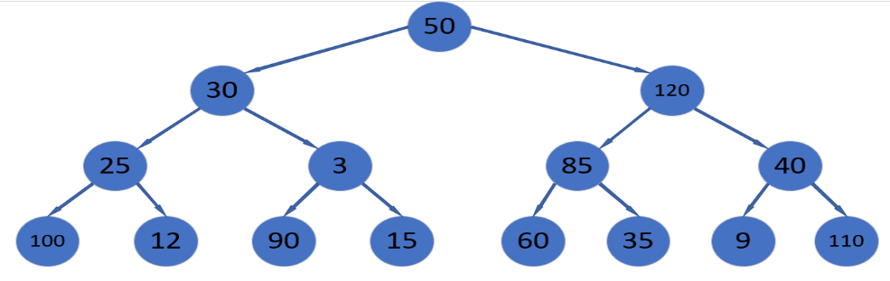

构建大顶堆

从最后一个非叶子结点40开始从左到右从下倒上调整，红色是进行过调整操作的

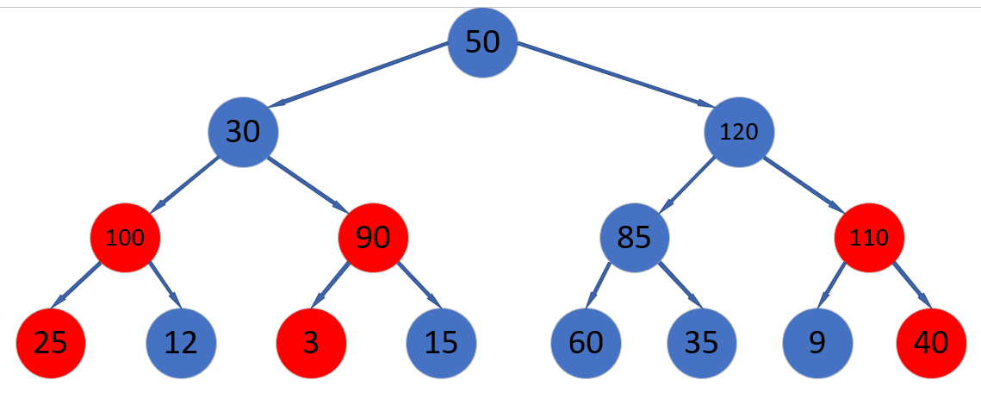

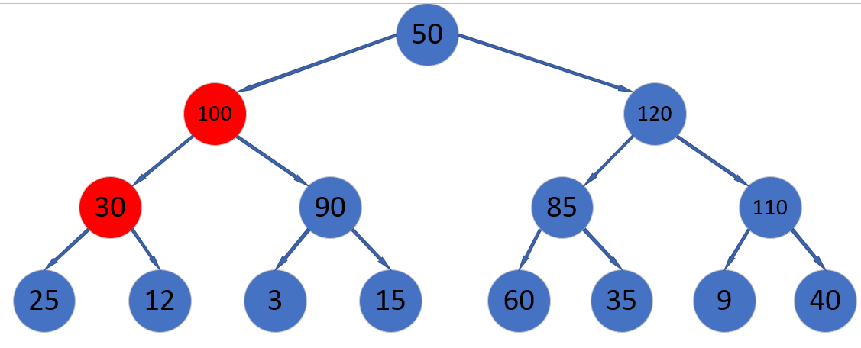

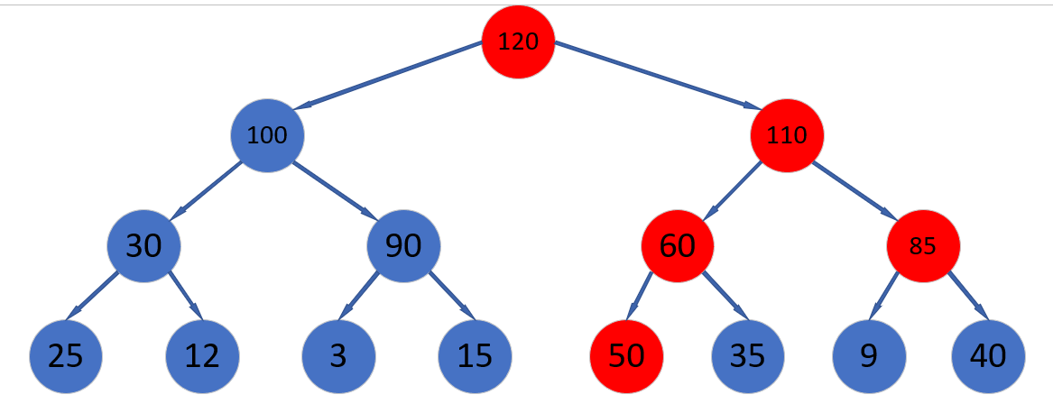

最终得到的堆

|  |  |  |  |  |  |  |  |  |  |  |  |  |  |  |
| --- | --- | --- | --- | --- | --- | --- | --- | --- | --- | --- | --- | --- | --- | --- |
| 120 | 100 | 110 | 30 | 90 | 60 | 85 | 25 | 12 | 3 | 15 | 50 | 35 | 9 | 40 |

堆顶元素与末尾元素调换然后调整保证符合堆的定义，红色部分表示不再参与操作

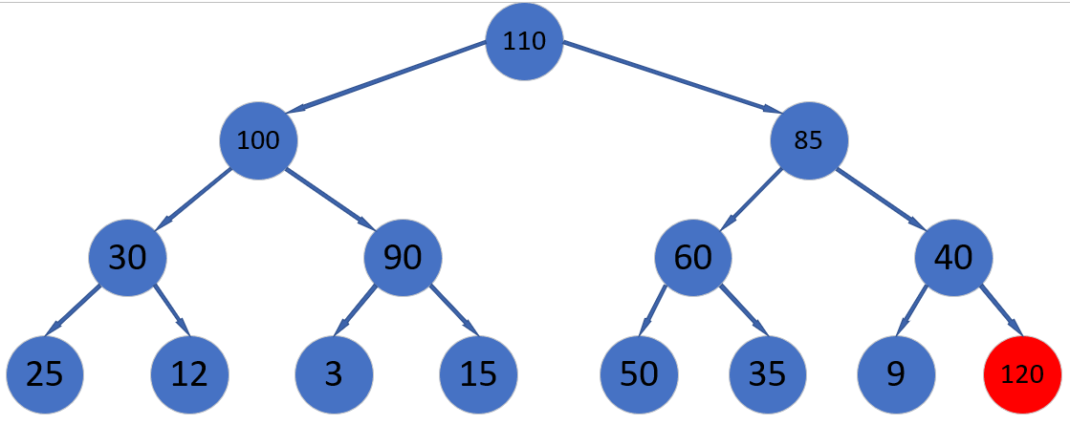

继续交换末尾与堆顶，并进行调整

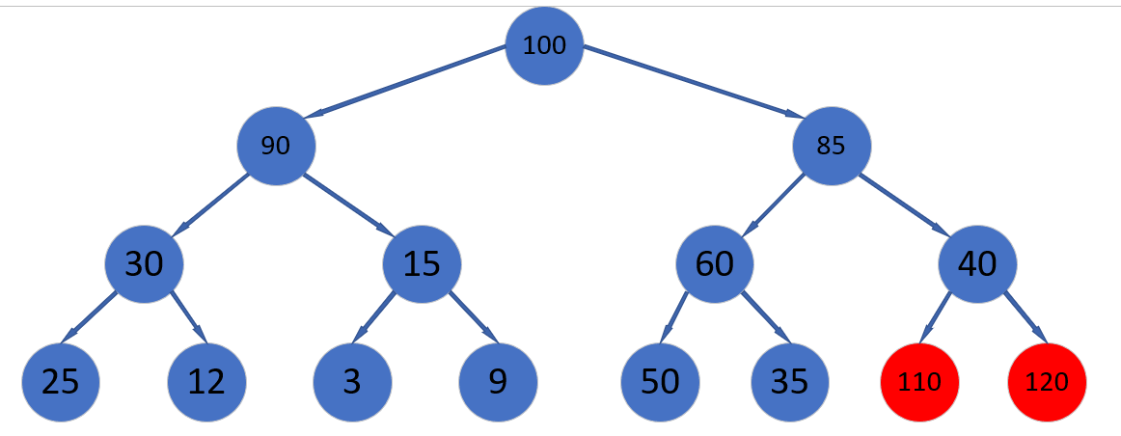

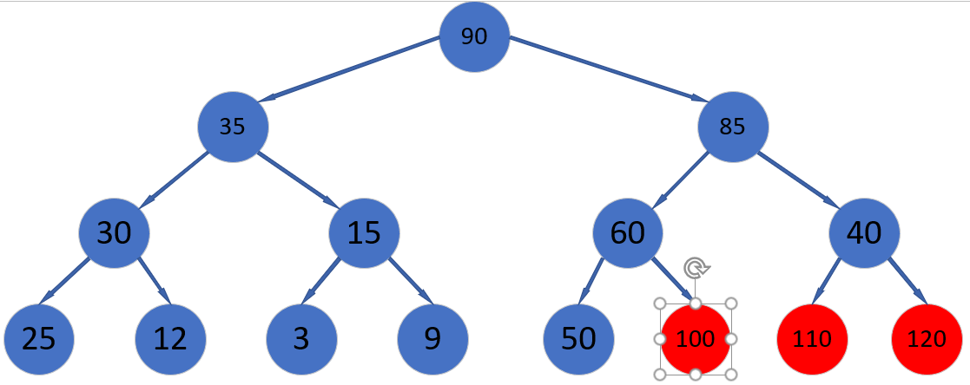

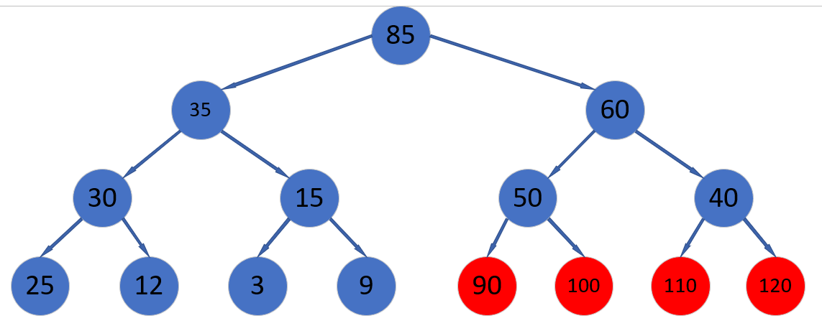

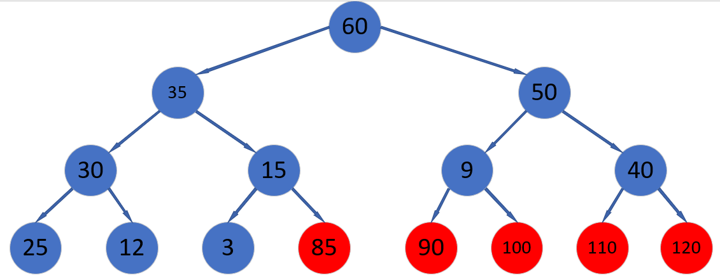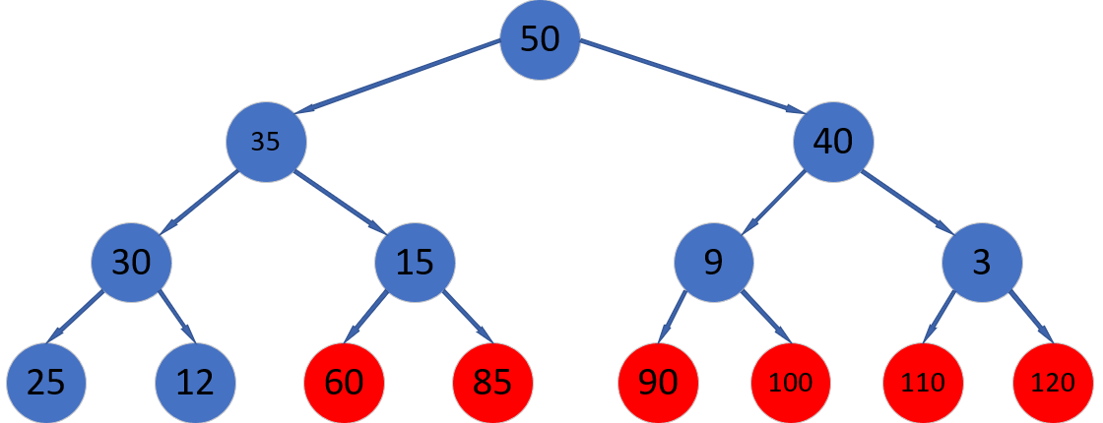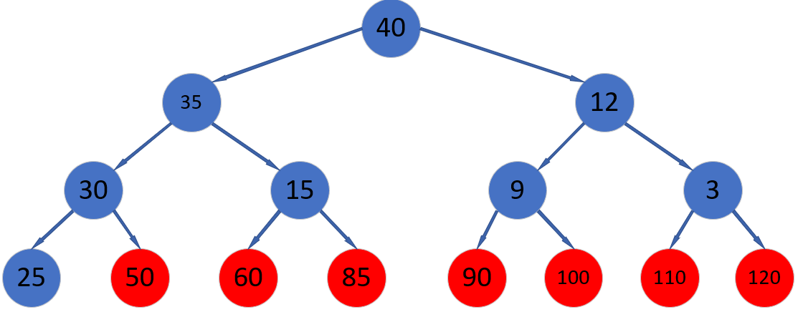

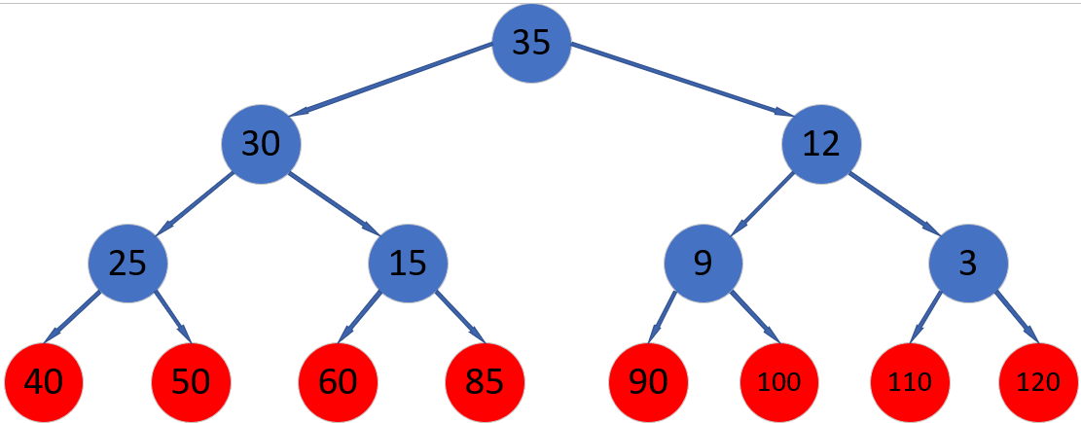

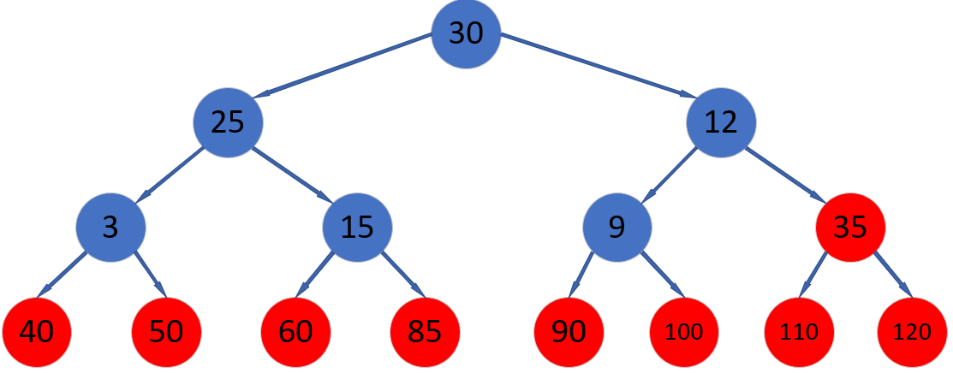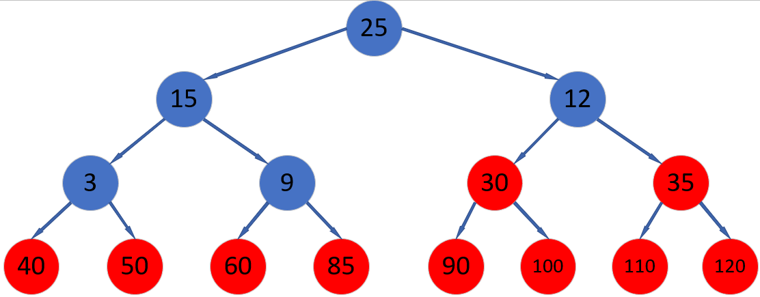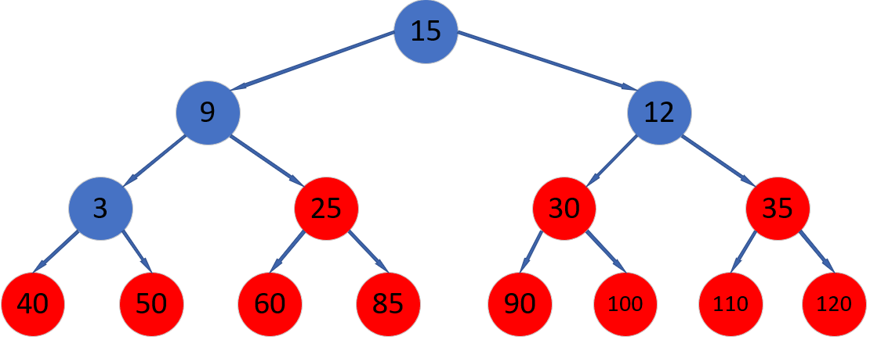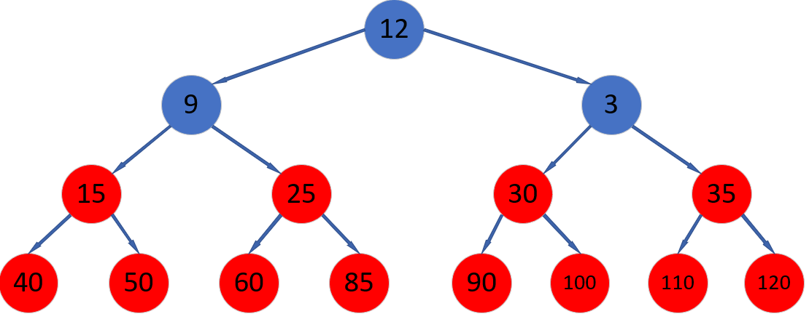

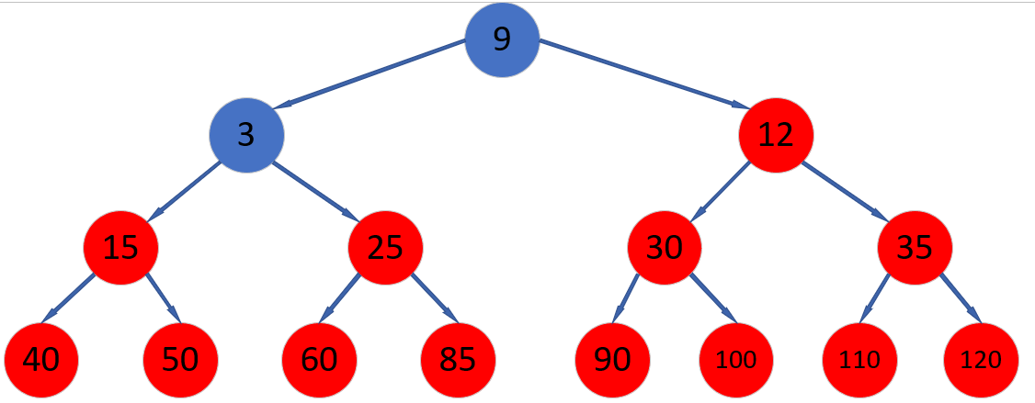

最终堆为

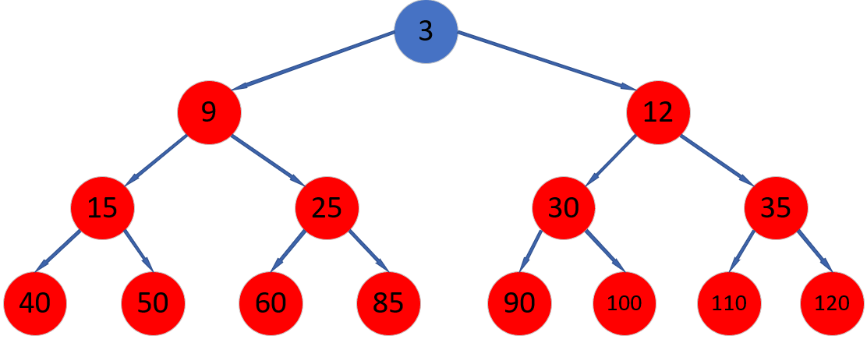

|  |  |  |  |  |  |  |  |  |  |  |  |  |  |  |
| --- | --- | --- | --- | --- | --- | --- | --- | --- | --- | --- | --- | --- | --- | --- |
| 3 | 9 | 12 | 15 | 25 | 30 | 35 | 40 | 50 | 60 | 85 | 90 | 100 | 110 | 120 |

#### 归并排序

|  |  |  |  |  |  |  |  |  |  |  |  |  |  |  |
| --- | --- | --- | --- | --- | --- | --- | --- | --- | --- | --- | --- | --- | --- | --- |
| 50 | 30 | 120 | 25 | 3 | 85 | 40 | 100 | 12 | 90 | 15 | 60 | 35 | 9 | 110 |

|  |  |
| --- | --- |
| 50 | 30 |

两两分组归并

|  |  |
| --- | --- |
| 120 | 25 |

|  |  |
| --- | --- |
| 3 | 85 |

|  |  |
| --- | --- |
| 40 | 100 |

|  |  |
| --- | --- |
| 12 | 90 |

|  |  |
| --- | --- |
| 15 | 60 |

|  |  |
| --- | --- |
| 35 | 9 |

|  |
| --- |
| 110 |

|  |  |  |  |
| --- | --- | --- | --- |
| 25 | 30 | 50 | 120 |

|  |  |  |  |
| --- | --- | --- | --- |
| 3 | 40 | 85 | 100 |

|  |  |  |
| --- | --- | --- |
| 9 | 35 | 110 |

|  |  |  |  |
| --- | --- | --- | --- |
| 12 | 15 | 60 | 90 |

|  |  |  |  |  |  |  |  |
| --- | --- | --- | --- | --- | --- | --- | --- |
| 3 | 25 | 30 | 40 | 50 | 85 | 100 | 120 |

|  |  |  |  |  |  |  |
| --- | --- | --- | --- | --- | --- | --- |
| 9 | 12 | 15 | 35 | 60 | 90 | 110 |

|  |  |  |  |  |  |  |  |  |  |  |  |  |  |  |
| --- | --- | --- | --- | --- | --- | --- | --- | --- | --- | --- | --- | --- | --- | --- |
| 3 | 9 | 12 | 15 | 25 | 30 | 35 | 40 | 50 | 60 | 85 | 90 | 100 | 110 | 120 |

#### 基数排序

原序列

|  |  |  |  |  |  |  |  |  |  |  |  |  |  |  |
| --- | --- | --- | --- | --- | --- | --- | --- | --- | --- | --- | --- | --- | --- | --- |
| 50 | 30 | 120 | 25 | 3 | 85 | 40 | 100 | 12 | 90 | 15 | 60 | 35 | 9 | 110 |

按个位数排序

|  |  |  |  |  |  |  |  |  |  |  |  |  |  |  |
| --- | --- | --- | --- | --- | --- | --- | --- | --- | --- | --- | --- | --- | --- | --- |
| 50 | 30 | 120 | 40 | 100 | 90 | 60 | 110 | 12 | 3 | 25 | 85 | 15 | 35 | 9 |

按十位数排序

|  |  |  |  |  |  |  |  |  |  |  |  |  |  |  |
| --- | --- | --- | --- | --- | --- | --- | --- | --- | --- | --- | --- | --- | --- | --- |
| 100 | 3 | 9 | 110 | 12 | 15 | 120 | 25 | 30 | 35 | 40 | 50 | 60 | 85 | 90 |

按百位数排序

|  |  |  |  |  |  |  |  |  |  |  |  |  |  |  |
| --- | --- | --- | --- | --- | --- | --- | --- | --- | --- | --- | --- | --- | --- | --- |
| 3 | 9 | 12 | 15 | 25 | 30 | 35 | 40 | 50 | 60 | 85 | 90 | 100 | 110 | 120 |