<softeng25-34>
Software Requirements Specification
Version <1>

Revision History
Date | Version | Description | Author
<MM/DD/YYYY> | <version> | <description> | <author>

Table of Contents
Revision History 2
Table of Contents 3
Introduction 4
Purpose 4
Scope 4
Definition, Acronyms and Abbreviations 4
References 4
Overall Description 4
Problem Statement 4
Background 4
Objectives 4
Constraints 4
Functional Requirements 4
Use Cases 4
Requirements 5
User Requirements 5
Technical Requirements 5
Performance 5
Scalability 5
Security 5
Maintainability 5
Usability 5
Localization Support 5
Auditing and Logging 5
Availability 6
Hardware Requirements 6
Network 6
Client Computers 6
Deployment Requirements 6
Nodes 6
Components 6
Artifacts 6
Other Requirements 6
Appendices 6

Introduction
<Introduction of this Software Requirements Specification. What will be covered in this document? What is the aim of this document? What are the main focuses? >

Purpose
<Purpose of this document. Do you write this document to define the system to be developed? Do you expect the end user will gain a better understanding by reading this document? Do you expect designer and developer to gain understanding of the system by reading this document?>

Scope
<Scope of this document. What parties or systems will be mentioned or focused? Will you describe the company that hire your team? Will you talk about the stakeholders, the existing system and even the as-is business process?>

Definition, Acronyms and Abbreviations
<Collection of terms to be used in this document, with their definition. For example, you may want to describe the word RAID that appears in your hardware requirement section>
Term | Definition

References
<A list of reference material used by this document.>

Overall Description

Problem Statement
<Description of problems that the end user is currently facing. E.g. lack of functionalities of the existing system, slow performance, etc>

Background
<Description of why the problems stated in the problem statement exists. For example, a slow performance of system can be due to an increasing amount of users, arising from changes in the business environment, or from a change of business policy.>

Objectives
<Describe what your system will achieve.>

Constraints
<Honestly list out the limitations of the system to be implemented. E.g. poor scalability, can only run on Windows, etc)

Functional Requirements
<Detailed description of system features. >

Use Cases

Use Case Diagram1
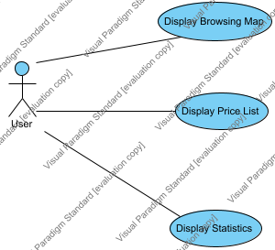

Use Case | Description
Display Browsing Map
Display Price List
Display Statistics

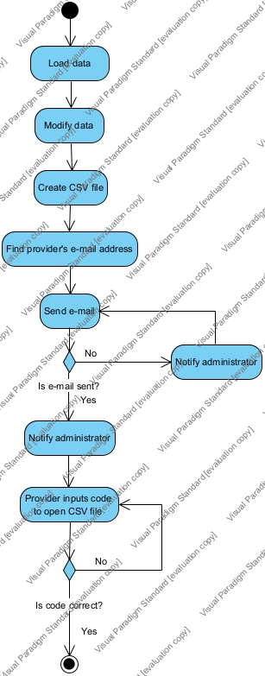

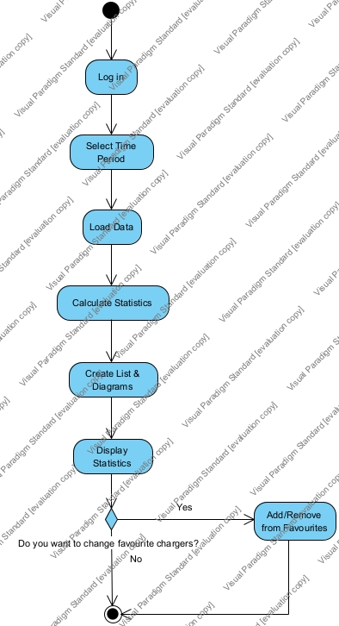
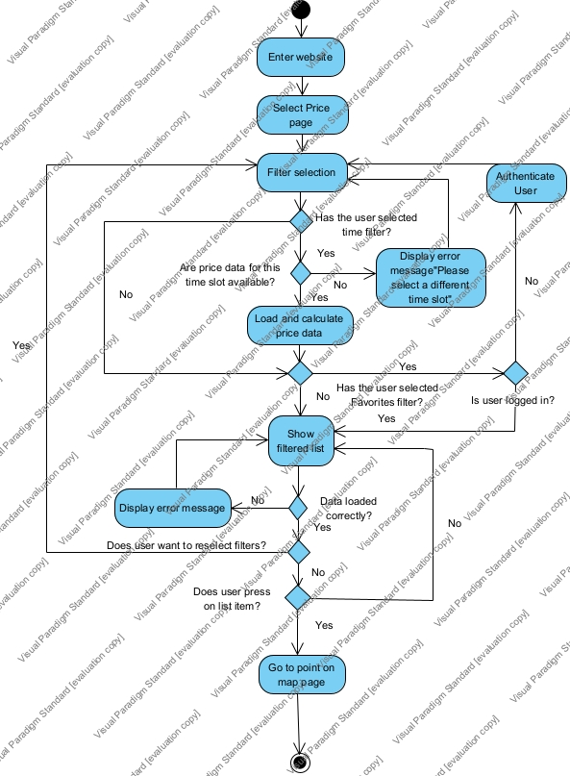
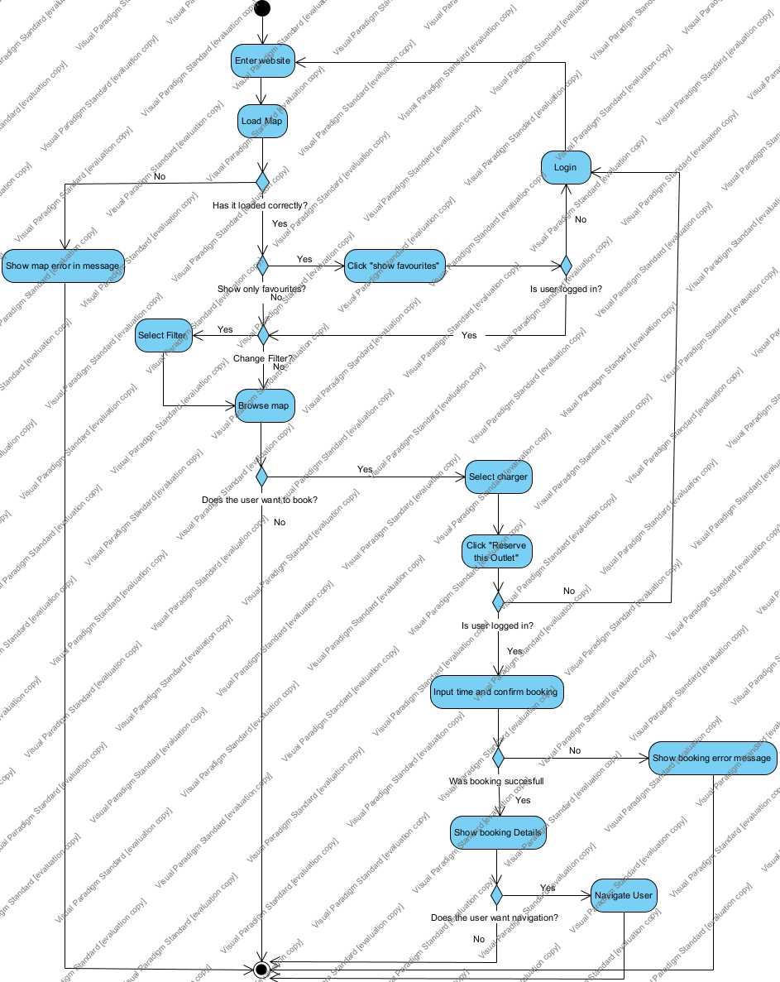

Requirements

Requirement Diagram
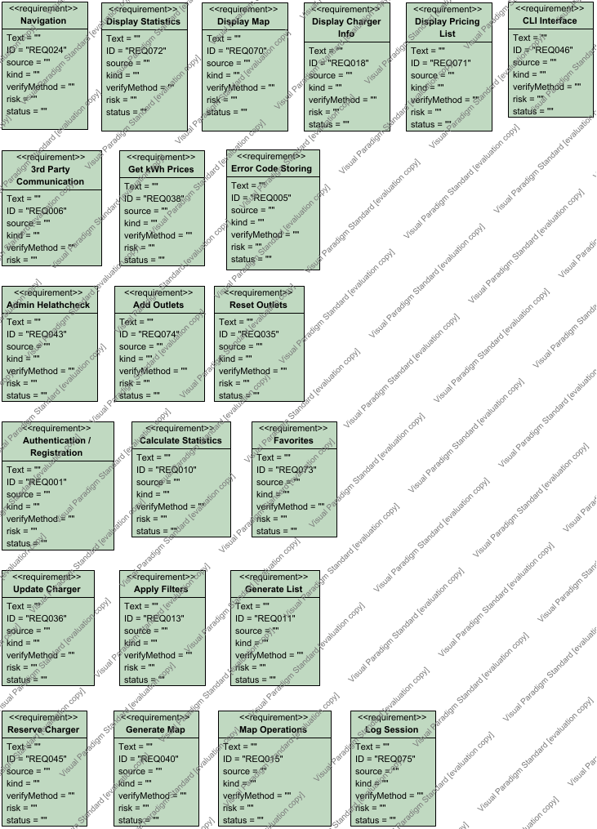

Requirement | Description
3rd Party Communication
Add Outlets
Admin Helathcheck
Apply Filters
Authentication / Registration
Calculate Statistics
CLI Interface
Display Charger Info
Display Map
Display Pricing List
Display Statistics
Error Code Storing
Favorites
Generate List
Generate Map
Get kWh Prices
Log Session
Map Operations
Navigation
Reserve Charger
Reset Outlets
Update Charger

User Requirements
<Description of the intended users of your system. You should clearly define who will be using your system and the environment(s) in which it will be used>
Actor | Description
User

Technical Requirements

Performance

Scalability

Security

Maintainability

Usability

Localization Support

Auditing and Logging

Availability

Hardware Requirements
<Description of hardware requirements to install and run your system>

Network

Client Computers

Deployment Requirements

block diagram
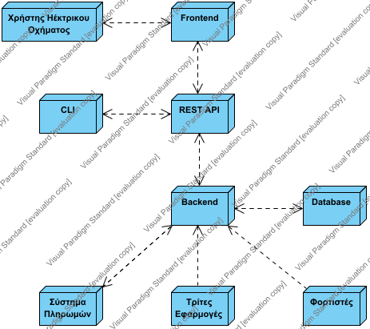

Deployment
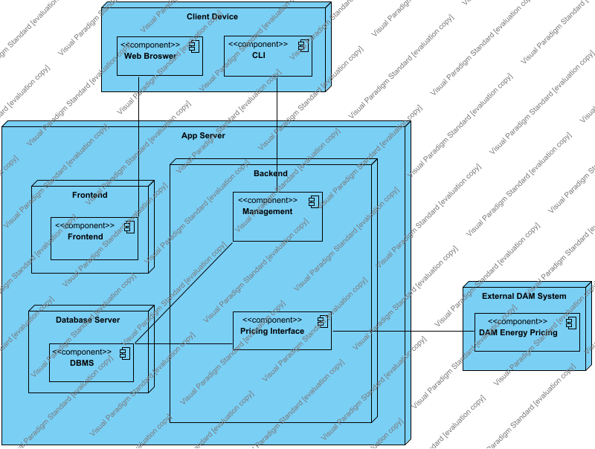

Nodes
Name | Description
unnamed
App Server
Backend
Backend
Backend
CLI
CLI παρόχου
Client Device
Database
Database
Database Server
External DAM System
Frontend
Frontend
Frontend
REST API
REST API
Σύστημα πληρωμών
Σύστημα Πληρωμών
Τρίτες Εφαρμογές
Τρίτες Εφαρμογές
Φορτιστές
Χρήστης Ηέκτρικου Οχήματος
Χρήστης Ηλεκτρικού Οχήματος

Components
Name | Description
unnamed
Chargers (IoT)
Charging Management System
CLI
CLI
Component
DAM Energy Pricing
DBMS
DBMS
Frontend
Frontend
Management
Management
Management
Outlet Management
Payment Service Provider
Pricing Interface
Pricing Interface
Pricing Interface
Reservations and Sessions Management
sdfgsd
Station and Infrastructure
Third-Party Applications
User Information
User Information2
Web Broswer
Web Broswer

Artifacts
Name | Description

Other Requirements

Appendices

