**Додаток А**

**Схема даних в MySQL**

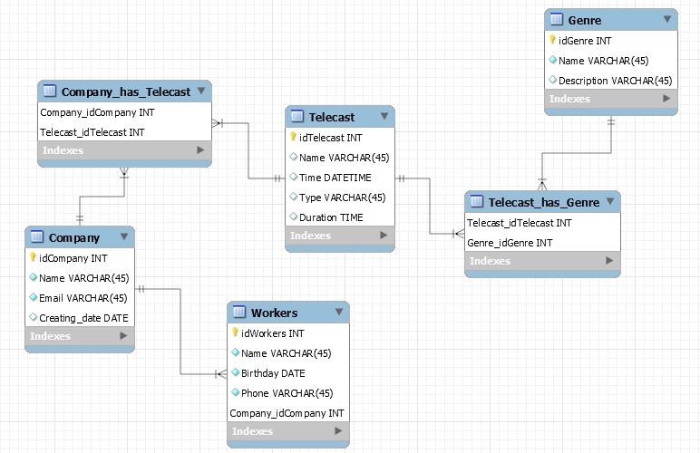

**Додаток Б**

**SQL-код бази даних**

*CREATE SCHEMA IF NOT EXISTS `folizyuk` DEFAULT CHARACTER SET utf8 ;*

*USE `folizyuk` ;*

*-- -----------------------------------------------------*

*-- Table `folizyuk`.`Telecast`*

*-- -----------------------------------------------------*

*CREATE TABLE IF NOT EXISTS `folizyuk`.`Telecast` (*

*`idTelecast` INT NOT NULL AUTO_INCREMENT,*

*`Name` VARCHAR(45) NULL,*

*`Time` DATETIME NULL,*

*`Type` VARCHAR(45) NULL,*

*`Duration` TIME NULL,*

*PRIMARY KEY (`idTelecast`))*

*ENGINE = InnoDB;*

*-- -----------------------------------------------------*

*-- Table `folizyuk`.`Genre`*

*-- -----------------------------------------------------*

*CREATE TABLE IF NOT EXISTS `folizyuk`.`Genre` (*

*`idGenre` INT NOT NULL AUTO_INCREMENT,*

*`Name` VARCHAR(45) NOT NULL,*

*`Description` VARCHAR(45) NULL,*

*PRIMARY KEY (`idGenre`))*

*ENGINE = InnoDB;*

*-- -----------------------------------------------------*

*-- Table `folizyuk`.`Company`*

*-- -----------------------------------------------------*

*CREATE TABLE IF NOT EXISTS `folizyuk`.`Company` (*

*`idCompany` INT NOT NULL AUTO_INCREMENT,*

*`Name` VARCHAR(45) NOT NULL,*

*`Email` VARCHAR(45) NOT NULL,*

*`Creating_date` DATE NULL,*

*PRIMARY KEY (`idCompany`))*

*ENGINE = InnoDB;*

*-- -----------------------------------------------------*

*-- Table `folizyuk`.`Workers`*

*-- -----------------------------------------------------*

*CREATE TABLE IF NOT EXISTS `folizyuk`.`Workers` (*

*`idWorkers` INT NOT NULL AUTO_INCREMENT,*

*`Name` VARCHAR(45) NOT NULL,*

*`Birthday` DATE NOT NULL,*

*`Phone` VARCHAR(45) NOT NULL,*

*`Company_idCompany` INT NOT NULL,*

*PRIMARY KEY (`idWorkers`, `Company_idCompany`),*

*INDEX `fk_Workers_Company1_idx` (`Company_idCompany` ASC) VISIBLE,*

*CONSTRAINT `fk_Workers_Company1`*

*FOREIGN KEY (`Company_idCompany`)*

*REFERENCES `folizyuk`.`Company` (`idCompany`)*

*ON DELETE NO ACTION*

*ON UPDATE NO ACTION)*

*ENGINE = InnoDB;*

*-- -----------------------------------------------------*

*-- Table `folizyuk`.`Telecast_has_Genre`*

**Закінчення додатку Б**

*-- -----------------------------------------------------*

*CREATE TABLE IF NOT EXISTS `folizyuk`.`Telecast_has_Genre` (*

*`Telecast_idTelecast` INT NOT NULL,*

*`Genre_idGenre` INT NOT NULL,*

*PRIMARY KEY (`Telecast_idTelecast`, `Genre_idGenre`),*

*INDEX `fk_Telecast_has_Genre_Genre1_idx` (`Genre_idGenre` ASC) VISIBLE,*

*INDEX `fk_Telecast_has_Genre_Telecast_idx` (`Telecast_idTelecast` ASC) VISIBLE,*

*CONSTRAINT `fk_Telecast_has_Genre_Telecast`*

*FOREIGN KEY (`Telecast_idTelecast`)*

*REFERENCES `folizyuk`.`Telecast` (`idTelecast`)*

*ON DELETE NO ACTION*

*ON UPDATE NO ACTION,*

*CONSTRAINT `fk_Telecast_has_Genre_Genre1`*

*FOREIGN KEY (`Genre_idGenre`)*

*REFERENCES `folizyuk`.`Genre` (`idGenre`)*

*ON DELETE NO ACTION*

*ON UPDATE NO ACTION)*

*ENGINE = InnoDB;*

*-- -----------------------------------------------------*

*-- Table `folizyuk`.`Company_has_Telecast`*

*-- -----------------------------------------------------*

*CREATE TABLE IF NOT EXISTS `folizyuk`.`Company_has_Telecast` (*

*`Company_idCompany` INT NOT NULL,*

*`Telecast_idTelecast` INT NOT NULL,*

*PRIMARY KEY (`Company_idCompany`, `Telecast_idTelecast`),*

*INDEX `fk_Company_has_Telecast_Telecast1_idx` (`Telecast_idTelecast` ASC) VISIBLE,*

*INDEX `fk_Company_has_Telecast_Company1_idx` (`Company_idCompany` ASC) VISIBLE,*

*CONSTRAINT `fk_Company_has_Telecast_Company1`*

*FOREIGN KEY (`Company_idCompany`)*

*REFERENCES `folizyuk`.`Company` (`idCompany`)*

*ON DELETE NO ACTION*

*ON UPDATE NO ACTION,*

*CONSTRAINT `fk_Company_has_Telecast_Telecast1`*

*FOREIGN KEY (`Telecast_idTelecast`)*

*REFERENCES `folizyuk`.`Telecast` (`idTelecast`)*

*ON DELETE NO ACTION*

*ON UPDATE NO ACTION)*

*ENGINE = InnoDB;*

**Додаток В**

**Результати виконання запитів MySQL та PostgreSQL**

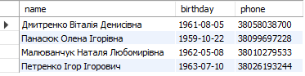

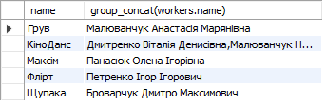

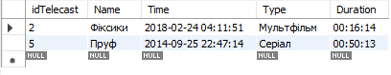

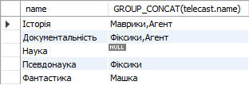



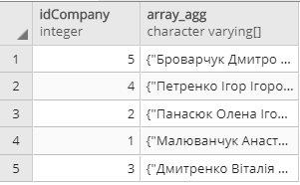

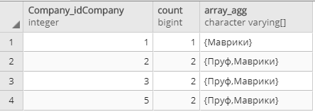

**Закінчення додатку В**

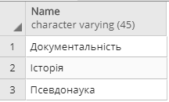

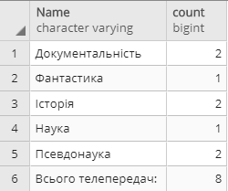

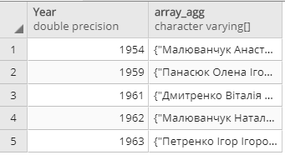

**Додаток Г**

**Заповнені таблиці MySQL та PostgreSQL**

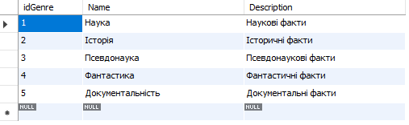

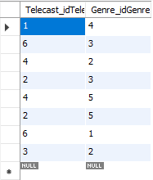

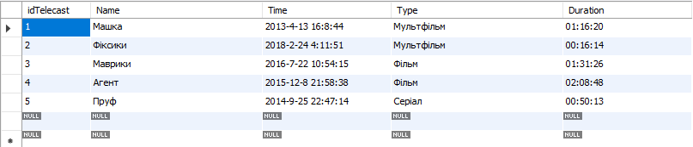

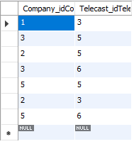

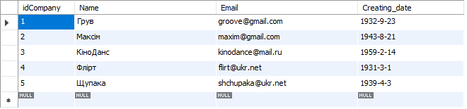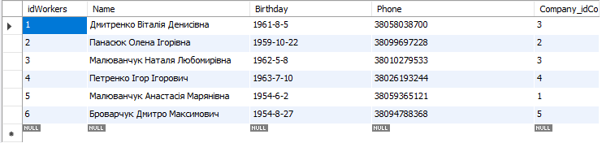

**Продовження додатку Г**

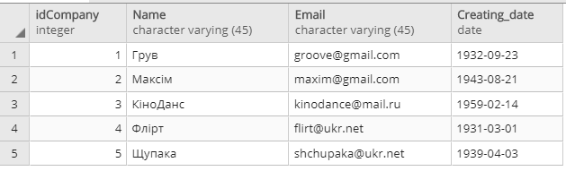

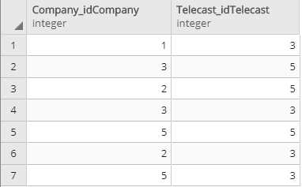 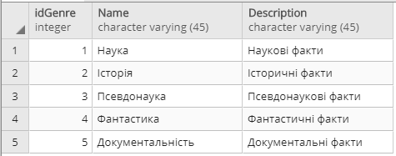 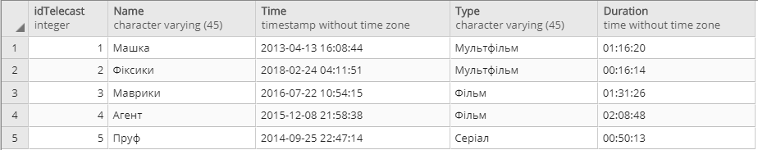

**Закінчення додатку Г**

